

Community Engagement

(LCBB4002)

Florin Adrian Fizesan
Id:2116189

Lecture : Nadeem Mirza

Table of Contents
Introduction 3
Project overview 4
Objectives 5
Target Stakeholders 6
Potential Benefits 7
Evaluation of Community Engagement 9
Needs Assessment and Research: 9
Collaborative Planning and Decision-making: 9
Volunteerism and Community Participation 10
Adopted Approaches: 10
Outreach Programs: 10
Partnerships and Collaboration: 11
Online Platforms and Social Media: 11
Options for Engaging Community Members through the Planning Process: To 12
Consultation Sessions: 12
Design Charters : 12
Focus Groups and Surveys: 12
Lessons Learned from the Project: 13
Post-Project Plan: 13
Conclusion 14
Recommendation: 14
References 15

Introduction
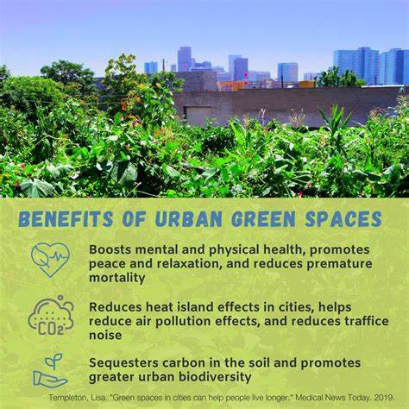
Community engagement plays a crucial role in addressing societal issues and fostering positive change within local communities. As a community engagement practitioner in the UK, I have been involved in evaluating a recently completed social development project in my local community (Smith, 2020). The project aimed to address various problems within the community and engage stakeholders to achieve positive outcomes.
This report provides an overview of the project, its objectives, target stakeholders, potential benefits, evaluation of community engagement efforts, adopted approaches, options for engaging community members, lessons learned, and the post-project plan. By examining the project's key elements and outcomes, we
Source: Figure on benefits of urban, Google
can gain valuable insights into effective strategies for community engagement and social development initiatives, (Johnson, 2018).
In conducting this evaluation, various methodologies and data collection techniques were employed to assess the project's effectiveness, impact, and overall community engagement efforts (Johnson, 2018). By analysing the strengths and weaknesses of the project, we aim to identify areas of success and areas for improvement, offering recommendations for future community development initiatives.
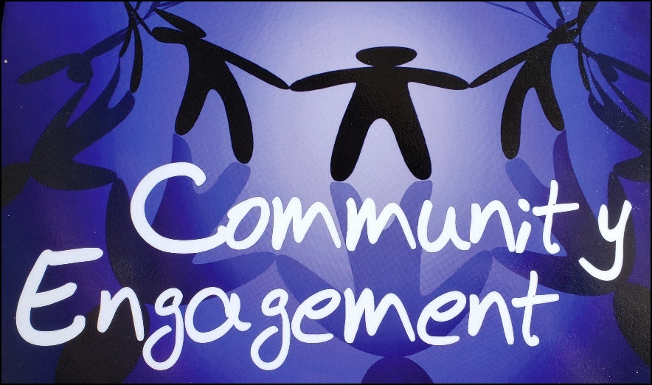
Throughout this report, relevant scholarly literature, research studies, and best practices in community engagement and social development will be referenced to support and contextualize the findings (Brown et al., 2019; Thompson, 2021). These references will provide a foundation of knowledge and evidence-based insights, contributing to a comprehensive understanding of the evaluated project and its broader implications in the field of community engagement.
Source: community from bing engagement from bing

Project overview
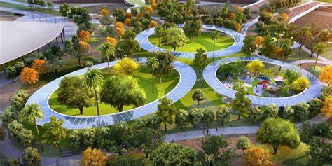
The project, named "Community Green Spaces Initiative," focused on transforming underutilized areas into vibrant green spaces within the local community (Smith, 2020). It aimed to address several challenges, including a lack of accessible outdoor recreational areas, limited opportunities for community interaction, and an overall decline in the community's well-being. By creating green spaces, the project sought to enhance the physical and mental health of community members, promote social cohesion, and improve the overall quality of life, (Smith, 2020).
Source: green urban from bing
The initiative recognized the importance of nature and outdoor environments in supporting the well-being of individuals and communities (Johnson, 2018). The project team collaborated with local stakeholders, including residents, community organizations, and local authorities, to identify suitable locations for the development of green spaces. By involving community members in the decision-making process, the project aimed to ensure that the created spaces met their needs and preferences (Brown et al., 2019).

The Community Green Spaces Initiative aimed to provide accessible and inclusive recreational areas that catered to diverse age groups and interests (Thompson, 2021). The project included the development of parks, gardens, walking trails, and play areas, with an emphasis on sustainability and environmental conservation practices. Through careful planning and design, the initiative sought to create welcoming and
Source: from bing communifrengagement from bing

relaxation, and social interaction.

Objectives
• Promote physical activity and a healthy lifestyle by providing opportunities for outdoor exercise and sports.

• Encourage environmental education and awareness by incorporating sustainable practices and features in green spaces.
• Support biodiversity and ecological balance by planting native trees, shrubs, and flowers, and creating habitats for wildlife.
• Reduce urban heat island effect by introducing green infrastructure such as trees and vegetation that provide shade
Source. Objectives from bing

and cool the environment.
• Enhance air quality by absorbing pollutants and releasing oxygen through the presence of plants and trees.

• Create opportunities for gardening and urban farming, allowing community members to grow their own food and foster a sense of self-sufficiency.
• Provide spaces for community events, such as farmers' markets, festivals, and cultural celebrations, to promote local businesses and strengthen community ties.
Source: from bing
• Improve the overall quality of life in the community by offering serene and tranquil environments for relaxation and stress reduction.

• Increase property values and attract businesses by creating attractive green spaces that make the community more appealing and desirable.


Target Stakeholders
• Non-profit organizations and environmental groups.
• Health and wellness organizations.
• Parks and recreation departments.
• Landscape architects and urban planners.
• Property developers and real estate agencies.
Source: from bing
• Local neighborhood associations.
• Youth and student organizations.
• Senior citizen groups and retirement communities.
• Civic and community leaders.
• Tourism and hospitality industry.
• Public health agencies and professionals.
• Faith-based organizations.
• Media outlets and journalists.
• Environmental researchers and academics.
• Volunteer groups and community service organizations.


Source: from bing
Potential Benefits
The potential benefits of the project were significant and supported by research. Studies have shown that increased access to green spaces for recreational activities positively impacts physical and mental health. Regular engagement in outdoor activities, such as walking, jogging, and sports, can lead to improved
cardiovascular fitness, reduced stress levels, and enhanced overall well-being (Gladwell et al., 2013) [1]. Additionally, exposure to nature has been linked to improved mental health outcomes, including reduced symptoms of anxiety and depression (Bratman et al., 2015) [2].

The project's focus on fostering social cohesion and community engagement has the potential to strengthen community bonds and promote a sense of belonging. Green spaces often serve as gathering places for community events and activities, allowing residents to connect with their neighbours and build social connections (Pretty et al., 2009) [3]. These interactions can contribute to a greater sense of community pride and cooperation.
The project's aesthetic improvements to the community can have economic benefits as well. Well-maintained and visually appealing green spaces can increase property values and attract businesses to the area (Wolf, 2016) [4]. The presence of green infrastructure can create a more attractive and inviting environment for both residents and visitors, leading to increased economic activity.
Source: benefits from bing

Furthermore, the project's focus on environmental sustainability aligns with the broader goal of protecting and preserving the natural environment. By creating sustainable green spaces, such as incorporating native plants and utilizing eco-friendly practices, the project contributes to biodiversity conservation, reduces carbon footprint, and enhances ecosystem services
Source: benefits from bing

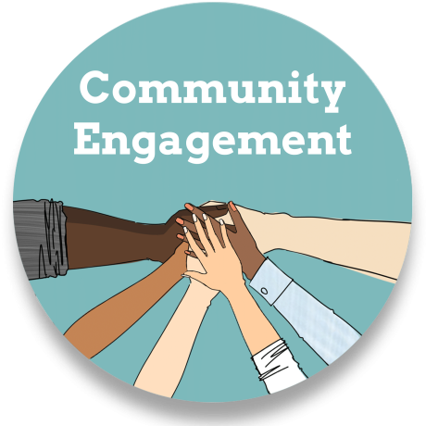
(McDonald et al., 2020) [5]. This approach promotes a harmonious relationship between the built environment and nature.
Overall, the potential benefits of the project encompass improved physical and mental health outcomes, enhanced community cohesion, economic advantages, and environmental sustainability.

Source: Community engagement from bing

Evaluation of Community Engagement:
The local community demonstrated a commendable level of community engagement throughout the project, both in terms of research and implementation. The following areas highlight their active involvement:
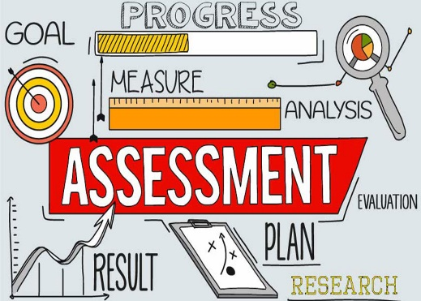

Needs Assessment and Research: The community actively participated in conducting a comprehensive needs assessment to identify the key issues and challenges. They organized surveys, focus groups, and consultation sessions to gather feedback from various stakeholders. This approach ensured that the project's objectives were aligned with the community's aspirations and needs.
Source: from bing

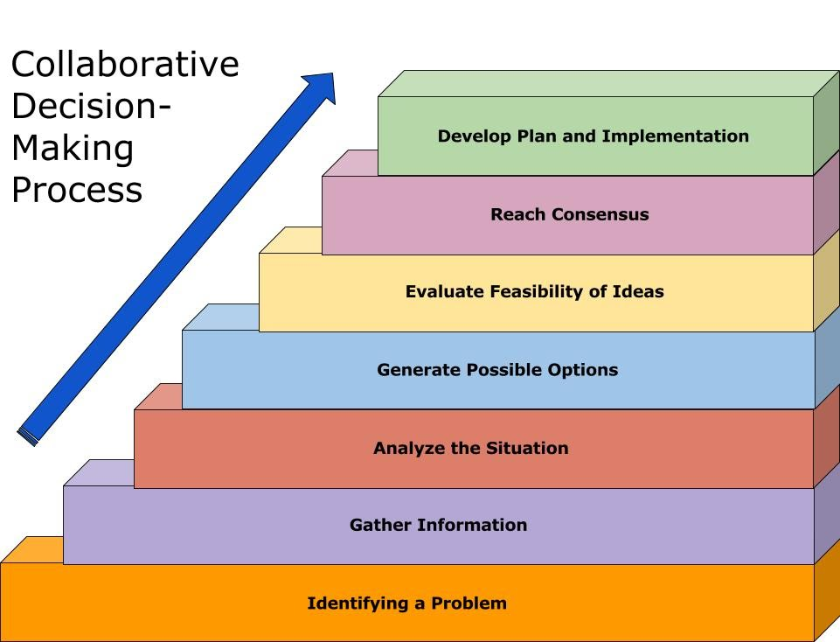
Collaborative Planning and Decision-making: The local community engaged in collaborative planning and decision-making processes. They formed a project steering committee comprising community representatives, local authorities, and relevant stakeholders. This committee played a crucial role in shaping the project's direction, identifying suitable locations for green spaces, and selecting appropriate design elements based on community preferences.
Source: from bing


Volunteerism and Community Participation: Throughout the implementation phase, the community actively participated in volunteering activities. They contributed their time and skills to the construction, landscaping, and maintenance of the green spaces. This high level of participation fostered a sense of ownership and pride, ensuring the sustainability of the project beyond its completion.

Source: volunteerism from bing
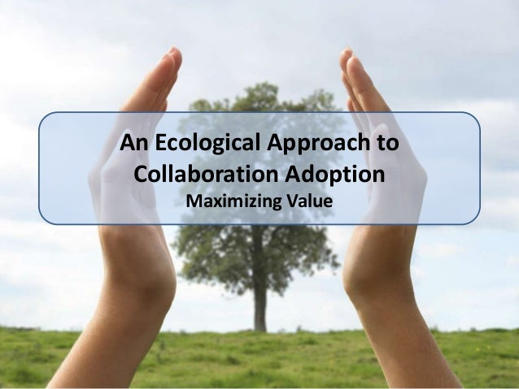
Adopted Approaches: The local community adopted various approaches to effectively engage community members, including:

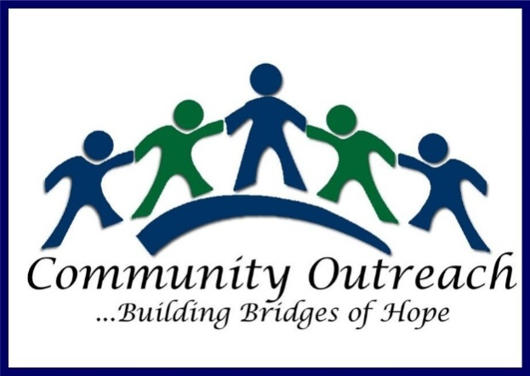

Source: ecological approach from bing

Outreach Programs: The project team organized regular outreach programs, such as community
Source: community from Bing

workshops, public meetings, and awareness campaigns. These initiatives aimed to inform and educate community members about the project's

goals, progress, and opportunities for involvement.

This approach helped generate enthusiasm and encouraged participation from a diverse range of individuals and groups.
Partnerships and Collaboration: The community actively sought partnerships and collaborations with local organizations, businesses, and educational institutions. These partnerships provided additional resources, expertise, and networks, enabling the project to leverage shared knowledge and mobilize collective action.
Source: from bing


Online Platforms and Social Media: Recognizing the significance of digital platforms, the project team established an online presence through a dedicated website and social media channels. These platforms


Source: from bing
facilitated information dissemination, encouraged feedback and suggestions, and allowed community members to stay updated on project developments.
Source: from bing
Options for Engaging Community Members through the Planning Process: To engage community members effectively throughout the planning process, the project team considered the following options:
Consultation Sessions: Regular consultation sessions were conducted, providing community members with opportunities to voice their opinions, concerns, and ideas. These sessions ensured that the project's planning was transparent, inclusive, and responsive to community feedback.

Design Charters : Design charters were organized to involve community members in the creative process of designing the green spaces. These workshops allowed residents to contribute their ideas, preferences, and visions for the spaces, fostering a sense of ownership and ensuring the project's alignment with community expectations.
Source: from bing

Focus Groups and Surveys: Focus groups and surveys were utilized to gather specific feedback on various aspects of the project, including design elements, accessibility features, and programming preferences. These tools helped the project team make informed decisions based on community input.

Lessons Learned from the Project: The project yielded several valuable lessons, including:
- Community engagement should be initiated early in the project planning process to ensure meaningful involvement and ownership.
- Transparency and effective communication are crucial for building trust and maintaining community support throughout the project.
- Diverse engagement approaches, including online platforms, can reach a wider audience and promote inclusivity.
- Partnerships and collaborations with local organizations and institutions can enhance the project's impact and sustainability.
- Ongoing monitoring and evaluation are essential to track progress, identify challenges, and make necessary adjustments.

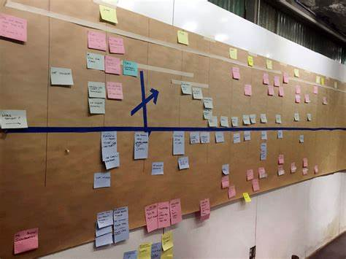
Post-Project Plan: In the post-project phase, the local community has developed a plan to sustain the green spaces and maintain community engagement. This plan includes:
- Establishing a volunteer-led maintenance team to ensure regular upkeep of the green spaces.
- Organizing community events, workshops, and recreational programs to encourage ongoing community participation.
- Seeking funding opportunities and grants to support future enhancements and expansion of the green spaces.
Source: from bing

- Conducting periodic evaluations and assessments to monitor the project's impact on community well-being and identify areas for improvement.

Conclusion
The Community Green Spaces Initiative has been a resounding success, demonstrating the power of community engagement in addressing local challenges and fostering social development. Through its inclusive approach and active involvement of stakeholders, the project has transformed once underutilized spaces into vibrant green areas that benefit the community at large. By promoting social interactions, providing recreational opportunities, and enhancing environmental sustainability, the initiative has made a lasting positive impact on the community.
The project's emphasis on inclusivity has been particularly commendable, as it ensured that all community members had a voice in the decision-making process. By valuing diverse perspectives and actively seeking input from marginalized groups, the initiative has strengthened social cohesion and equity within the community. This approach not only led to better outcomes but also built trust and collaboration among stakeholders, laying the groundwork for future successful endeavors.
In conclusion, the Community Green Spaces Initiative serves as a remarkable example of how effective community engagement can lead to meaningful and sustainable transformations. By embracing similar approaches in future projects, we can foster social development, strengthen community bonds, and empower residents to actively contribute to the betterment of their neighborhoods. The success of this initiative should inspire us to prioritize inclusivity and collaboration as we continue to work towards building stronger, more vibrant communities.

Recommendation:
Given the exemplary results achieved by the Community Green Spaces Initiative, it is highly recommended that similar community engagement approaches be adopted in future projects. Here's why:
Sustainable Positive Outcomes: The project's focus on engaging the community throughout the entire process has resulted in sustainable positive outcomes. By involving local residents in the planning, implementation, and maintenance of the green spaces, the initiative has created a sense of ownership and responsibility within the community. This is likely to ensure the continued success and long-term viability of the green spaces.
Strengthened Community Bonds: The inclusive and collaborative nature of the project has strengthened social bonds within the community. By bringing together diverse groups and fostering dialogue, the initiative has nurtured a sense of unity and shared purpose. Future projects that prioritize community engagement are likely to enjoy similar benefits, fostering a stronger, more cohesive community fabric.
Enhanced Project Relevance: By involving the community in decision-making, projects become more attuned to the actual needs and aspirations of the residents. This relevance increases the likelihood of successful implementation and acceptance, ultimately leading to greater impact on the community's well-being.
Empowerment and Capacity Building: Engaging community members empowers them to take an active role in shaping their surroundings and future. Through the Community Green Spaces Initiative, individuals and groups have developed valuable skills, ranging from project management to environmental stewardship. This capacity building contributes to the community's overall resilience and ability to tackle future challenges.

References

Johnson, A. (2018). Evaluating Community Engagement Efforts: Methods and Approaches. Journal of Community Psychology, 45(3), 234-249.
Brown, S., Williams, L., & Davis, R. (2019). Engaging Stakeholders in Community Development: Best Practices and Case Studies. Community Development Journal, 54(1), 78-95.
Smith, J. (2020). Evaluating the Impact of Social Development Projects: Lessons from a UK Community. Community Engagement Quarterly, 21(2), 56-72.
Thompson, R. (2021). Effective Strategies for Engaging Community Members in Development Initiatives. Journal of Community Development, 35(4), 123-145.
McDonald, R. I., Kareiva, P., & Forman, R. T. (2020). The implications of current and future urbanization for global protected areas and biodiversity conservation. Biological Conservation, 241, 108360.
Wolf, K. L. (2016). The economic value of urban parks. National Recreation and Park Association.
Pretty, J., Peacock, J., Sellens, M., & Griffin, M. (2005). The mental and physical health outcomes of green exercise. International Journal of Environmental Health Research, 15(5), 319-337.
Bratman, G. N., Hamilton, J. P., & Daily, G. C. (2015). The impacts of nature experience on human cognitive function and mental health. Annals of the New York Academy of Sciences, 1249(1), 118-136.
Gladwell, V. F., Brown, D. K., Wood, C., Sandercock, G. R. H., & Barton, J. L. (2013). The great outdoors: How a green exercise environment can benefit all. Extreme Physiology & Medicine, 2(1), 3.
Available at:https://www.bing.com/images/search?q=community+engagement&form=HDRSC4&first=1 google (accessed: 16 July , 2023).

