

Module: LCBB5000
Data Handling and Business Intelligence
Assignment Title: Student performance
Lecturer name: Abdallah Naser
Student name: Viorica Birloiu
Student number: 2227895

Table of Content

Introduction 1
Section 1 2
Part a) 2
Part b) 6
Part c) 9
Section 2 12
Part a) 12
Part b) 14
Conclusion 16
Reference 17

Introduction
Data handling and analysis are crucial components which allow to test and manipulate data to retrieve useful insights regarding targeted phenomenon. Moreover, the software used for the data analysis and storage purposes also play a major role in the effectiveness of the entire process and reliability of the results (Ortmeier et al., 2021). This report examines the use of MS Excel and IBM SPSS software to analyse the given dataset and provide insights using the measures of dispersal measures.

Section 1

Part a)
Using the MS Excel software, the following solutions have been retrieved.
- The mean value for the reading score is 69.169. It had been calculated by using the AVERAGE formula upon the reading score column, as shown below.
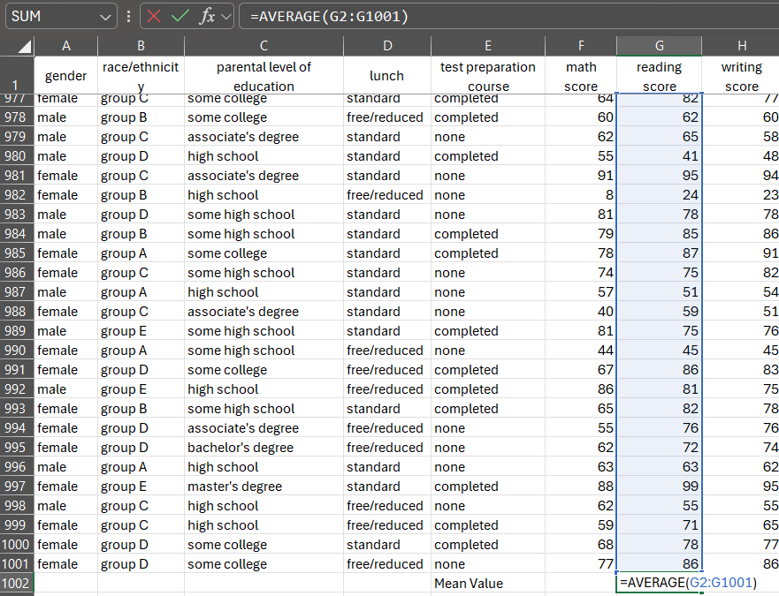
- The median value for the reading score is 70. It had been calculated by using the MEDIAN formula upon the reading score column, as shown below.
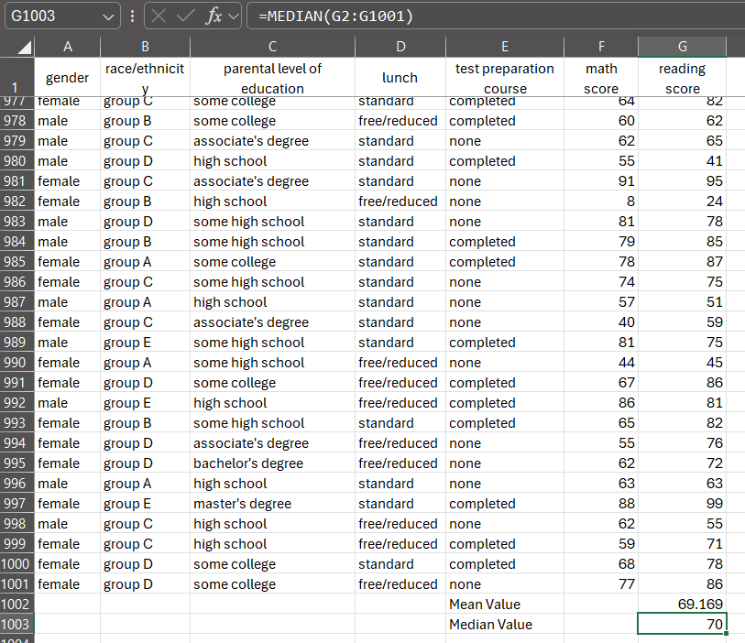
The median value is very similar to the mean value, indicating the dataset to have an average reading score of 70.
- The mode of the reading score is 72. It had been calculated by using the MODE formula upon the reading score column, as shown below.
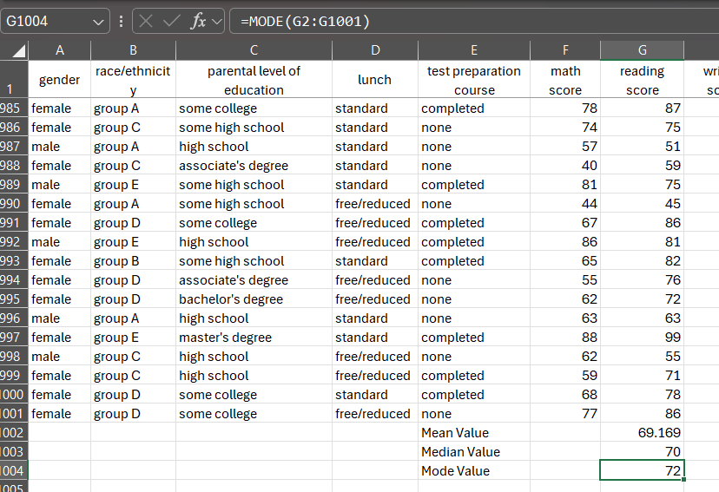
- The standard deviation of the writing score is 15.188 or 15.19 correct to 2 decimal places. It has been calculated using the STDEV.P formula, as shown below.
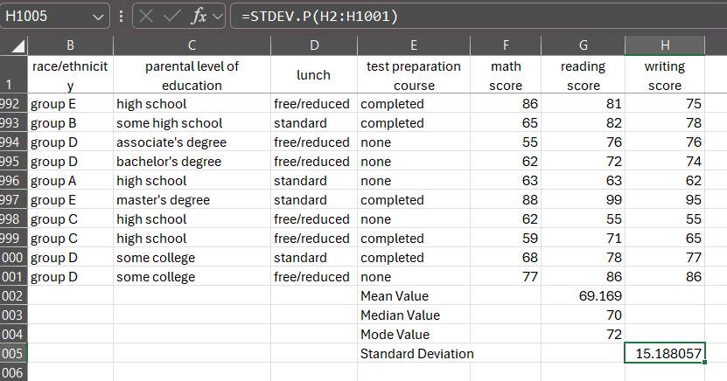
The value of standard deviation is quite low relative to the actual values of data set. Hence, it can be said that the spread of the data from the mean value of writing score is quite less. So, the data set is quite reliable (Su et al., 2021).
- The variance of every score column has been calculated using the VAR.P formula. The variance value for the math score is calculated to be 229.67, reading score is 212.95, and writing score is 230.68, as shown below.
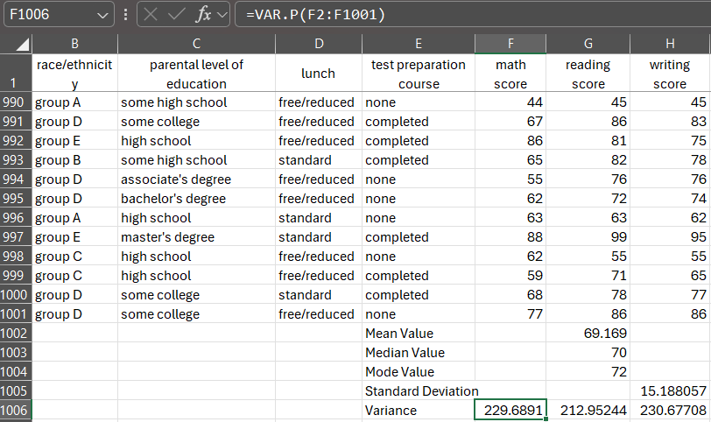
Hence, comparing the values of the variance calculated for the three scores, the writing score has the largest variance amongst the three scores. As for the comparison between the reading and writing score, writing score has the largest variance value.
- The standard deviation of every score column has been calculated using the STDEV.P formula. The standard deviation value for the math score is calculated to be 15.16, reading score is 14.59, and writing score is 15.19, as shown below.
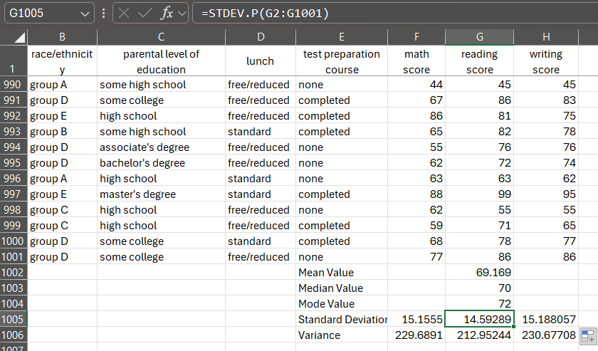
Hence, comparing the values of the standard deviation calculated for the three scores, the writing score has the largest standard deviation amongst the three scores. As for the comparison between the reading and writing score, writing score has the largest standard deviation value.
- Variance is the statistical measure that calculates the spread between the values of the data set. On the other hand, the standard deviation is the statistical measure that calculates the difference between the mean and any value of the data set (Kronthaler, 2022). As both values of variance and standard deviation are higher for the writing score than the reading score, it can be said that that data of the writing scores are highly variant and widely spread compared to the reading score. In simple words, the scores differ more fore writing score, whereas the reading scores are slightly similar. The values of the reading scores are placed tightly around the mean and are more reliable to test, as per the differences in the standard deviation. But as per the values of the variances, reading scores have lower risk and can predict better scores for the future relative to the writing scores, as the variance is lower (No, 2022).

Part b)
Using the MS Excel software, data can be presented in pivot table. The pivot table helps to minimise the spread of the data sheet and present in a systematic manner (Akpan, 2024). This can be easily done by going to the Insert option in the task bar and selecting the Pivot table option, as shown in the image below.
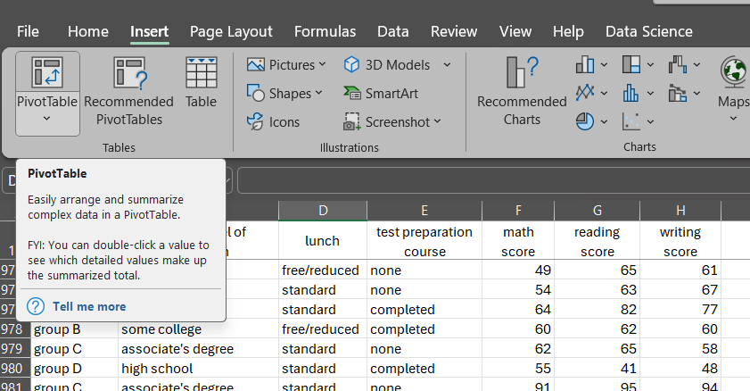
A command box will appear, as shown below, where the table range will show automatically selected table of the data set. The range of the data can be altered to the desired need. But for this question, the entire data set shall be used to create the pivot table to easily retrieve and organise the data into different categories.
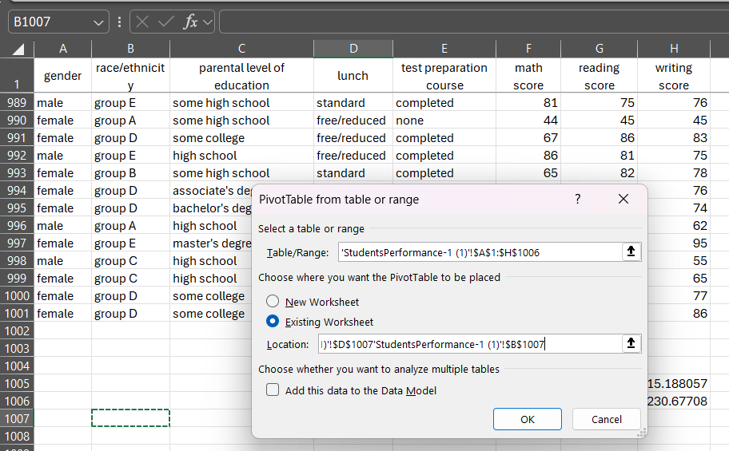
After adjusting the placement of the pivot table, which can be done either in the existing worksheet or a new worksheet, the OK done needs to be clicked. The existing worksheet has been chosen for this case and the desired cell has been selected as shown in the image above. Then, an empty pivot table shall appear, and the option bar of Pivot table fields shall also appear on the right side of the file, as shown below.
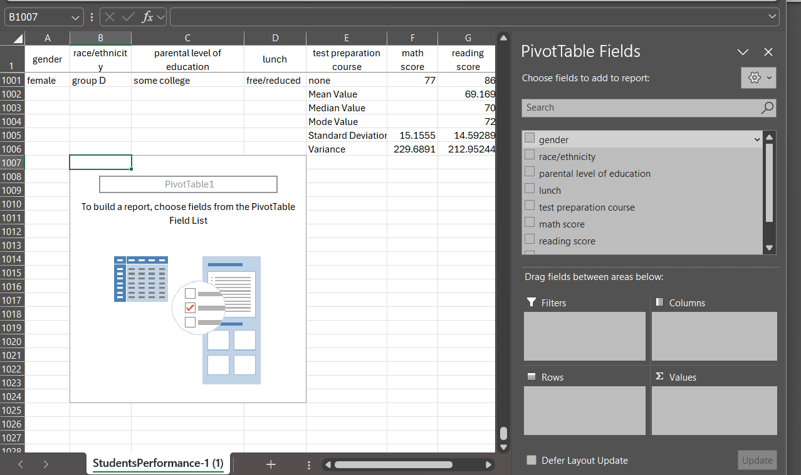
From the list of variables, the desired filters, columns, rows, and values shall be selected and adjusted. It is important to understand the differences between the criterions to make the pivot table as functional and efficient as possible. For this case, gender, race/ethnicity, and lunch have been classified as filters, the test preparation course and parental level of education have been classified as rows. The sum of reading scores, writing score, and math score have been placed under values, and the sum of values have been automatically placed in columns.
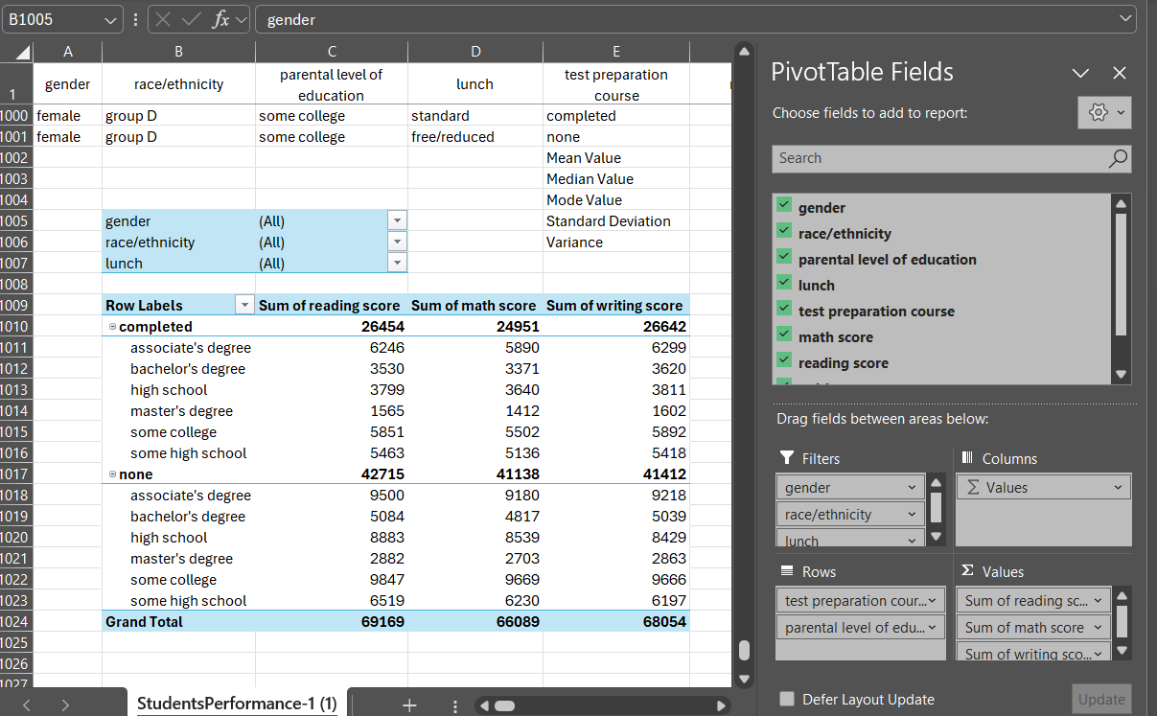
So, using the given criteria, the pivot table will automatically update itself and the filters can be used to retrieve data regarding the reading, writing, and maths score. An example can be observed in the image below that the values of the scores change when the filters for the gender, race/ethnicity, and lunch are changed. This illustrates the application of and functionality of the pivot table in Excel. The pivot table can be used to easily retrieve values which are needed and easily understood for decision making purposes.
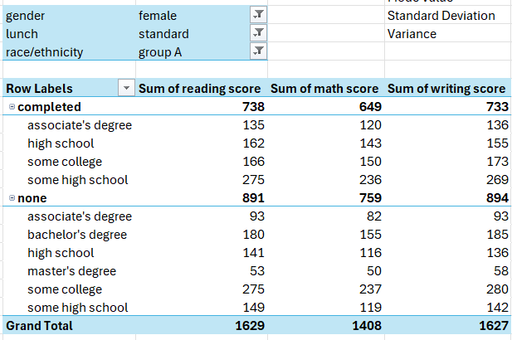

Part c)
- Now, using IBM SPSS, the correlation has been calculated between the writing score and the reading score. Firstly, the file provided involving the data set must be opened. The option of Analyse is selected and then the dropdown bar shall appear. The option of correlate needs to be selected along with the option of bivariate. A command box shall appear where the variables of reading score and the writing score must be selected using the middle-curved arrow. The option of Pearson must be selected, and the test of significance must be selected to be two-tailed. Then, the OK shall be clicked. The results are then presented in a separate cvs file, from which the images have been provided below for both the descriptive and correlation statistics.
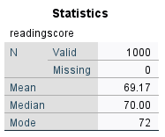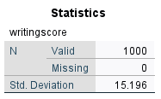
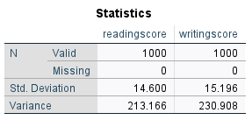
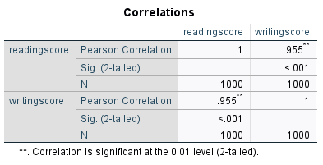
It can be observed that the correlation between the reading score and writing score has been calculated to be 0.955. The value is close to 1.00 which indicates a strong and positive relationship between the variables. The value suggests that the higher the writing scores are, the higher the reading score will be. When one increases, the other variable will rise (Bhandari, 2021).
- In order to construct a scatter graph in SPSS, the option from the task bar, Graphs, need to be clicked. Then, a dropdown shall appear, and the option of chart builder must be selected.
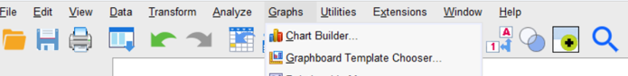
A command box shall appear the variables must be dragged to the axis points. As the requirement suggests that the writing score on the horizontal axis and reading score on the vertical axis, the writing score must be dragged to the x-axis and the reading score be dragged to the y-axis. The option of scatter diagram must be selected from the gallery and then the OK must be selected. The graph shall appear in the output file, as shown below.
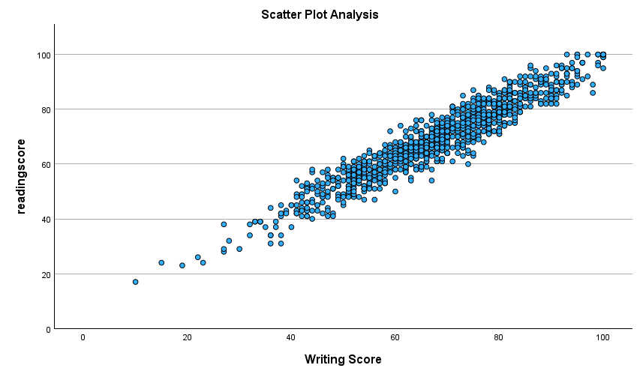
It can be observed from the scatter graph that the values of both the variables are tightly packed in an inclining trend. This suggests that the variables share a strongly positive correlation amongst themselves. As the writing score is placed in the x-axis, it is considered to be the independent variable. Hence, when it increases, the dependent variable, reading score, also increases at a similar and strong pace. Similarly, if the score of writing decreases, the score for the reading is likely to decrease at a similar pace (Kafle, 2019).

Section 2

Part a)
SPSS is a data spreadsheet and statistical software manufactured by IBM, that allows data storage, manipulation, and analysis to take form. It also helps to produce attractive data visualisations. It is mainly used by professionals as its features also involve criminal investigation, multivariant analysis, business intelligence, advance analytics, data management, etc. (Roni and Djajadikerta, 2021). Some of the most useful functions of SPSS involve the statistical programs for quantitative data analysis, modeler program for predictive modelling, text analysis, and visualisation designer to create various types of visual representations (Čaplová and Švábová, 2020). The software is commonly used in social science and market researchers. Some of its advantages include the following.
- It offers fast and reliable outcomes for the users.
- It offers large scale of complicated statistical tools and data analysis tools.
- It helps to manage data effectively.
- The software is available in wide array of languages that allows users around the world to use the software effortlessly (Nelson, Christopher and Milton, 2022).
- Not much effort is needed to use or initiate the software.
- The software can be used for both qualitative and quantitative data.
- Every piece of information can be extracted for the execution of descriptive, inferential, and multiple variant statistical procedures (Shanthi, 2019).
It can be understood that the SPSS software offers large array of functions and programs for effective data analysis and predictive modelling. However, there are some limitations of the software which must be considered during the software evaluation process. The following are the disadvantages of the SPSS software.
- The software needs to be bought for professional use and can be used on a trial basis for 30 days for first time users.
- SPSS cannot be used when handling large data sets. It hangs the software or provides faulty answers (No, 2022).
- The quality of the data used impacts the overall reliability of the outcomes and results. Faulty data would result in misleading data.
- The SPSS provides generalised solutions which means that if scientists do not aim for exact answers, the software can be used to do the job.
- The software provides simple answers for complex issues, which can be underwhelming and insufficient for data interpretations (Roni and Djajadikerta, 2021).
All in all, the SPSS software helps to provides solutions for researchers, managers, scientists, business analysts, and marketers. It can be a useful tool to yield in reliable results for any purpose and any data type. It is a versatile tool that can be used for small to medium sized data set. On the other hand, Excel is a spreadsheet editor software manufactured by Microsoft. It can be used in various operating software such as Windows, Android, iOS, macOS, and iPadOS. It is used for its simple yet effective features of calculation, computation, macro programming language called the Visual Basic for Applications (VBA), graphical tools, and pivot tools (Kronthaler, 2022). It can automatically poll external databases using an update schedule and analyse the results and form a Word report or a Power Point slide. It had not been designed to be used as a database initially. The Excel software offers over 484 functions for data analysis and other 13 categories (No, 2022). Some of its advantages include the following.
- It is readily available within the Microsoft Office package, and it does not need to be bought separately.
- The software offers fast and easy interface for users. Not much training is required to use the software.
- It provides flexibility and customisation for tailored solutions, adaptability for different projects, and customisable templates and formulae.
- It is extremely cost efficient as it is provided within the MS Office package and also helps to reduce the overall overhead cost. It can be used for budget conscious projects (Guerrero, Guerrero and Rauscher, 2019).
- The software has the capabilities for conducting advance data analysis.
- The software can integrate with other Microsoft products which allows effortless sharing, efficient reporting, and unified communication.
- The software can manage large scales of data and provide flexible solutions for different projects (Opie, 2019).
It can be understood that the Excel software offers large array of functions and programs for effective data analysis and predictive modelling. However, there are some limitations of the software which must be considered during the software evaluation process. The following are the disadvantages of the Excel software.
- The software does have insufficient shortcut and function guidance for the user. This may result in long time to search for the shortcut function rather than actually conducting the analysis.
- There is a risk data loss when collaborative environment is involved. Different users giving their input can lead to difficulties in tracking the changes and the original and accurate data can be lost (Kronthaler, 2022).
- The frequent updates provided for Excel often result in inconsistencies in the formulae and layouts.
- Users with limited system capacities may face difficulties accessing Excel files with large amounts of data and may experience hinderance in the software performance.
All in all, the MS Excel software helps to provides solutions for researchers, managers, scientists, business analysts, and marketers. It can be a useful tool to yield in reliable results for any purpose and any data type. It is a versatile tool that can be used for small to medium sized data set (No, 2022).

Part b)
Data Mining Cycle is the process of using the combination of human input and computer resources to extract useful data and analysing them (Li et al., 2024). This also involves sorting the extracted large data sets to identify useful themes, patterns, and relationships which can be then used for solving business problems. It is often used to formulate business solutions and make reliable predictions of future trends (Abd Alazeez and Thaher, 2021). The data mining cycle involves 6 core steps involving the following.
- Understanding the business problem
- Selecting which data to extract.
- Preparing and sorting the data.
- The data is remodelled according to the needs of the user.
- The model is evaluated by checking for faults or data leakage.
- After everything is checked, the data is then deployed for further processing.
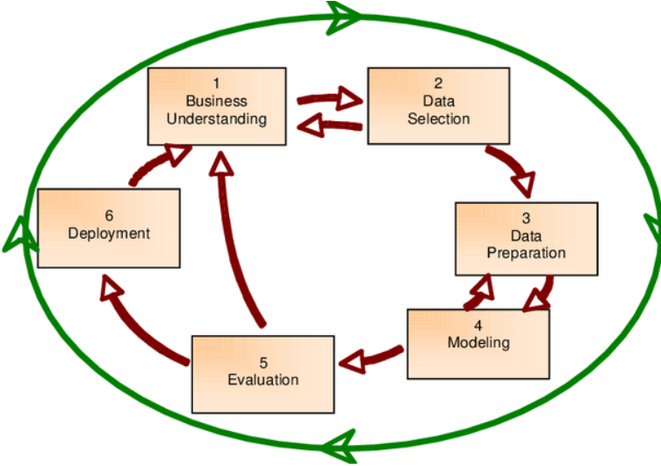
Figure 1:The Data Mining Cycle Source – (Afifi, 2020)
The data mining cycle is essential as it helps to detect fraud, prevent cyber-crime, and plan for cyber security (Afifi, 2020). Moreover, the process aids businesses and organisations to accumulate reliable information and yield in reliable solutions. It is an efficient and cost-effective method to used relative to the other applications of data analysis (Abd Alazeez and Thaher, 2021). Data mining cycle helps to detect fraud and helps businesses to make informed decision. The process can be effectively used by several forms of organisations and businesses alike. The data mining cycle is exceptionally useful for the investors by using it for stock market predictions, the FBI to track down criminal activities, etc. (Ortmeier et al., 2021).

Conclusion
This report has allowed to understand that both MS Excel and IBM SPSS are useful in their own ways and have their own limitations as well. Moreover, the differences of their features allow to produce attractive data visualisations and conduct appropriate data analysis techniques that is time efficient and reliable. However, considering the limitations of the SPSS software and its usability, MS Excel has been selected as the most feasible and accessible software for students.

Reference
Abd Alazeez, Y. and Thaher, A. (2021) ‘Data Mining Between Classical and Modern Applications: A Review’, AL-Rafidain Journal of Computer Sciences and Mathematics, 15(2), pp. 171–191.
Afifi, A.A. (2020) ‘Demand forecasting of short life cycle products using data mining techniques’, in Artificial Intelligence Applications and Innovations: 16th IFIP WG 12.5 International Conference, AIAI 2020, Neos Marmaras, Greece, June 5–7, 2020, Proceedings, Part I 16. Springer, pp. 151–162.
Akpan, D.M. (2024) ‘Excel: VLOOKUP, Pivot Tables and SQL’, in Future-Proof Accounting: Data and Technology Strategies. Emerald Publishing Limited, pp. 95–127.
Bhandari, P. (2021) Correlation Coefficient | Types, Formulas & Examples.
Čaplová, Z. and Švábová, P. (2020) ‘IBM SPSS statistics’, in Statistics and Probability in Forensic Anthropology. Elsevier, pp. 343–352.
Guerrero, H., Guerrero, R. and Rauscher (2019) Excel data analysis. Springer.
Kafle, S.C. (2019) ‘Correlation and regression analysis using SPSS’, OCEM J Manag Tech Soc Sci, 1(1), pp. 126–132.
Kronthaler, F. (2022) Statistics applied with excel: data analysis is (not) an art. Springer Nature.
Li, B. et al. (2024) ‘Anomaly data mining method for electric power data center business system based on decision tree’, in Fourth International Conference on Machine Learning and Computer Application (ICMLCA 2023). SPIE, pp. 597–602.
Nelson, K., Christopher, F. and Milton, N. (2022) ‘Teach yourself SPSS and STATA’, International Journal of Academic Pedagogical Research, 7(6), pp. 84–122.
No, S. (2022) ‘CORE PRACTICAL II: ADVANCE EXCEL AND SPSS’, Dr. NGP ARTS AND SCIENCE COLLEGE (Autonomous), 1(K2), p. 81.
Opie, C. (2019) ‘Using excel/spss in your research’, Getting Started in Your Educational Research: Design, Data Production and Analysis, 309.
Ortmeier, C. et al. (2021) ‘Framework for the integration of process mining into life cycle assessment’, Procedia CIRP, 98, pp. 163–168.
Roni, S.M. and Djajadikerta, H.G. (2021) Data analysis with SPSS for survey-based research. Springer.
Shanthi, R. (2019) Multivariate data analysis: using SPSS and AMOS. MJP Publisher.
Su, J. et al. (2021) ‘Research on the influence of sports competition participation on College Students’ social adaptability based on Excel software and SPSS statistical software’, in 2021 International Conference on Internet, Education and Information Technology (IEIT). IEEE, pp. 404–407.

