To maintain sustainability within our future generations in our united nations policy, it states that every Child always has rights within an educational setting and all Teachers and LSA’s must honour this in a working practice (Welsh Government, 2015).
SJIE4006
Scrapbook – How Theoretical approaches to learning underpin classroom practice
Abraham Maslow
Maslow’s hierarchy of needs is a five-tier basic structure of human needs. Therefore, without having the basics you are unable to climb the structure of the pyramid because you must have the essentials first.
The 5 main structures are;
- Physiological needs
- Safety needs
- Belongingness and love need
- Esteem needs
- Self-actualisation
The inclusive approach to this would be running breakfast’s clubs in local schools. This is referred as some children don’t have breakfast at home due to them being from a vulnerable home of uncertainty and sustainability.

Abraham Maslow
Maslow’s hierarchy of needs is a five-tier basic structure of human needs. Therefore, without having the basics you are unable to climb the structure of the pyramid because you must have the essentials first.
The 5 main structures are;
- Physiological needs
- Safety needs
- Belongingness and love need
- Esteem needs
- Self-actualisation
The inclusive approach to this would be running breakfast’s clubs in local schools. This is referred as some children don’t have breakfast at home due to them being from a vulnerable home of uncertainty and sustainability.

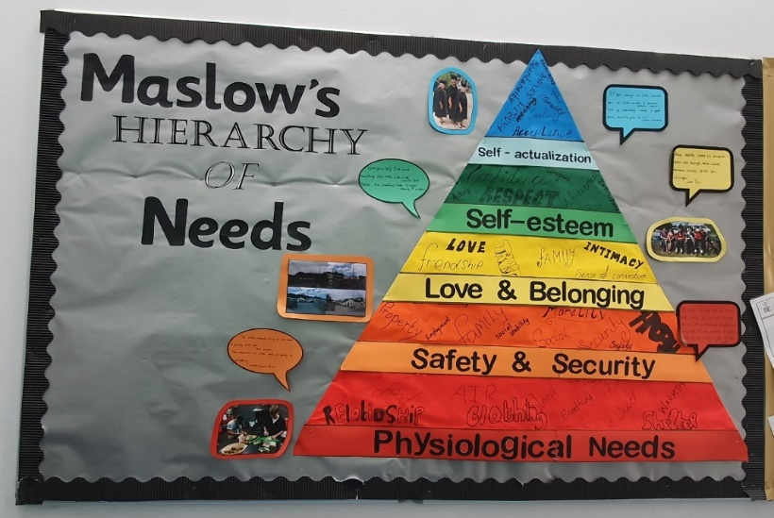
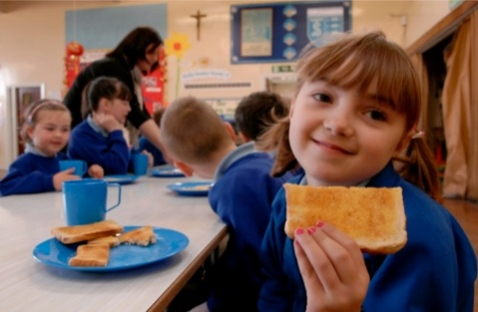
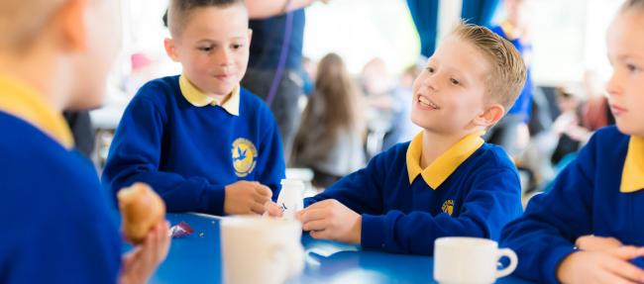
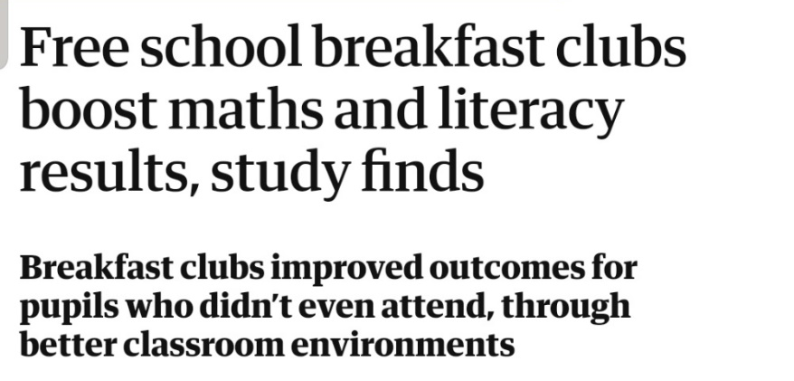
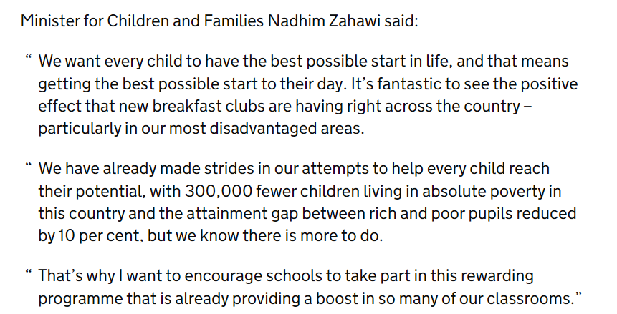
“Every Child Matters” policy (Gov.uk, 2003). For the purpose that every Child should be given the right essentials provided to be able to be safe and healthy and to provide a positive approach within their learning. As every child should be able have a chance to work towards a goal. (Barker, 2008)
(Roberts, 2019)
(Zelna, 2018)
(Richard Adams, 2016)
(Malta Today Staff, 2014)
(Malta Today Staff, 2014)
(Maslow, 2013)
(Government, Wales - Nadhim Zahawi MP, 2018)
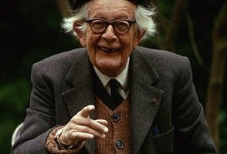
“Piaget believed that Children think differently to adults and his theory and research identified milestones within the mental development of stages”.

The person-centred therapy is Carl Rodgers, in his humanistic approach in Psychology. He believed that everyone can learn but it’s up to each individual of how they perceive them self. It is up to them to be able to grow and reach their full potential. This therapy helps them build self-esteem, self-confidence and values within their self-worth (Saul McLeod, 2014).
(Piaget, 2019)
(Piaget, 2011)
- Sensorimotor stage – 0-2 years: imitation, memory and thought begin to be utilized.

- Preoperational stage- 2-7 years: language development.

and recognizing symbolic form
- Concrete operational stage- 7-11 years: able to solve hands-on problems logically.

- Formal operational stage- 11-15 years: able to solve abstract problems in a logical fashion.

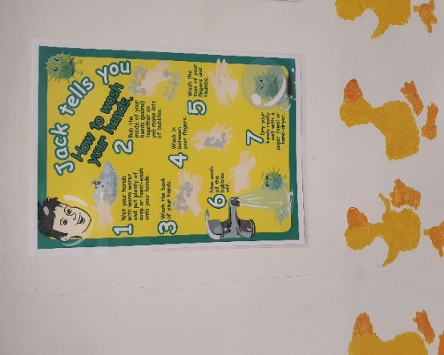
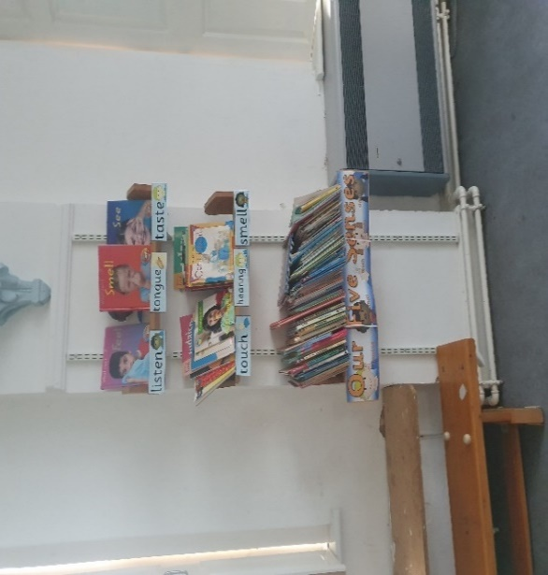
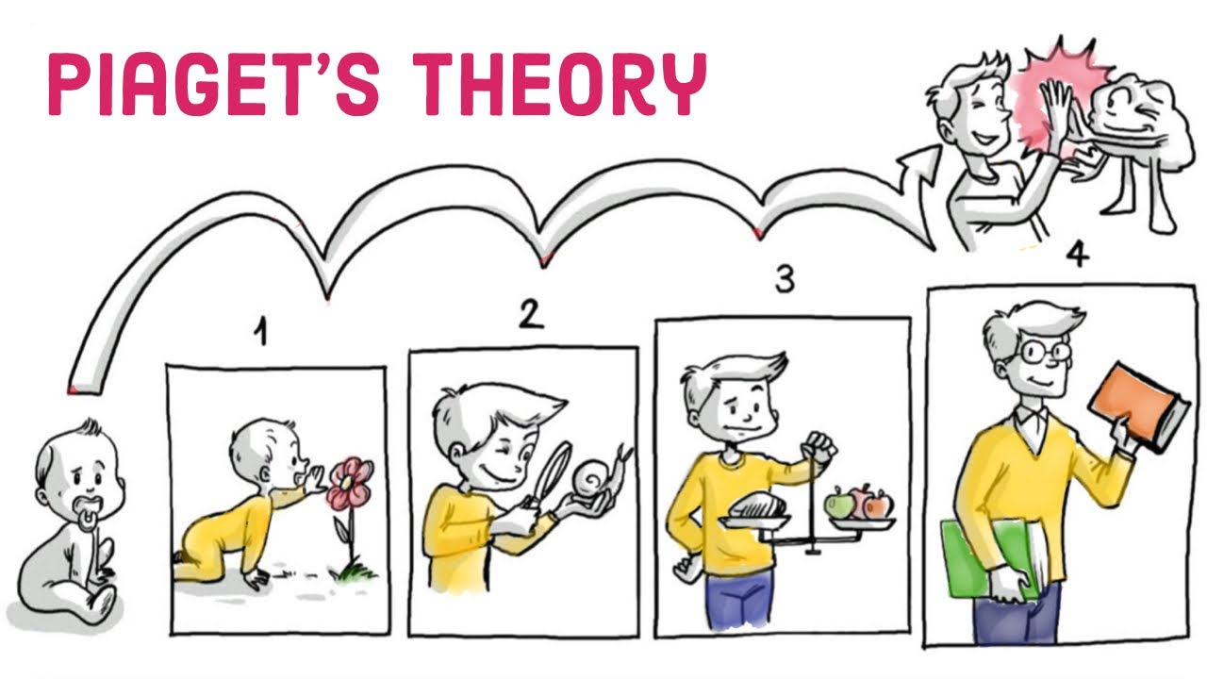
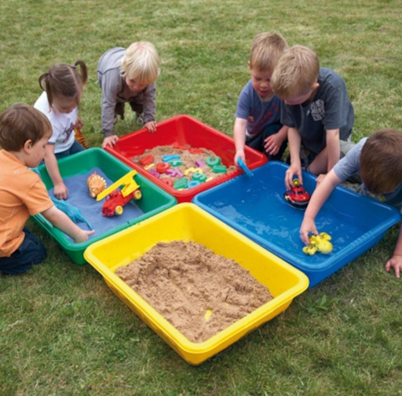
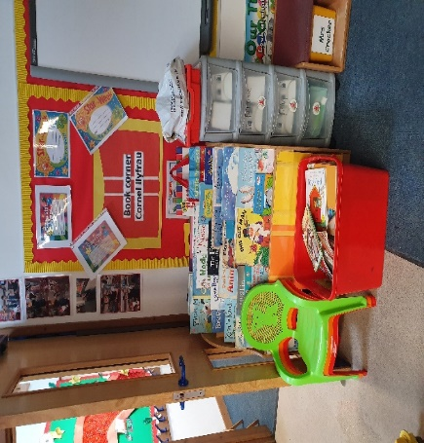
(Piaget, 2019)
This approach is used in the school toilets to show the basic stages of how to wash your hands correctly.
(Pearson, 2019)
This inclusive approach is having a quiet area for reading, this is where children can sit down and read.
- Reading has lots of benefits, it enables children’s imagination to grow.

- They have a better understanding of different words and a wider vocabulary.

- It improves their ability to have more confidence and independence.
(Piaget, 1954-2004)
The Children most benefited to this theory would be early childhood referred to as the foundation stage, it is also used for special educational needs and additional needs. This would come under the ALN (Welsh Government, 2017) code of practice to adapt different interventions to help Children achieve. Multi- sensory play is learning through the five senses. The foundation phase is all about creativity and imagination through play.
This can be expressed in many ways such as playing with sand and water. Exploring through paints and objects to make learning fun and easy for Children, because the more interaction in a Child the more they want to learn, and it also improves their self-centred person approach development.
This also enhances their cognitive process and their social skills with other peers (Nielson, 2017).

(Sprouts, 2018)
(Google, 2019)
(Roberts, 2019)
(Roberts, 2019)
(Roberts, 2019)
(Slideshare, 2013)
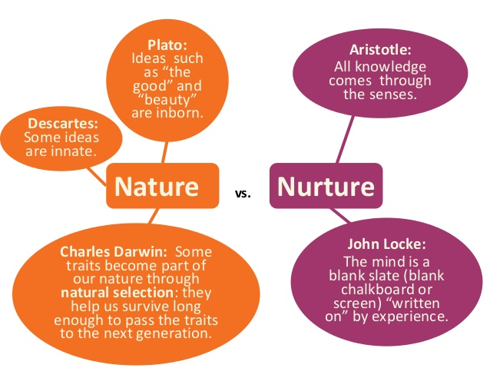
Role play enhances learning as they do this on a day to day basis. This is what they learn to develop over time from their parents, this would be referred to as the big discussion of nature Vs nurture within Darwin’s theory of revolution which observes to Piaget.
Many different skills can be developed through this approach within the classroom.
- Numeracy and literacy skills
- Social and interaction skills
- Team building
- Learning how to be polite and respectful
- Cognitive development
- Develops wider range imagination
(Sue Rodgers and Julie Evans, 2008)





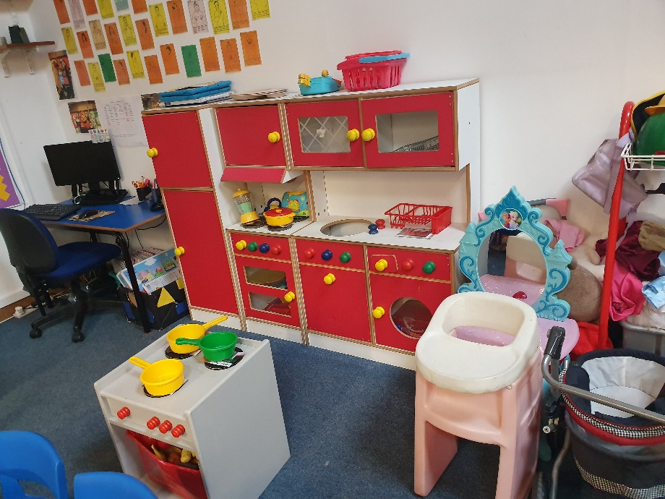
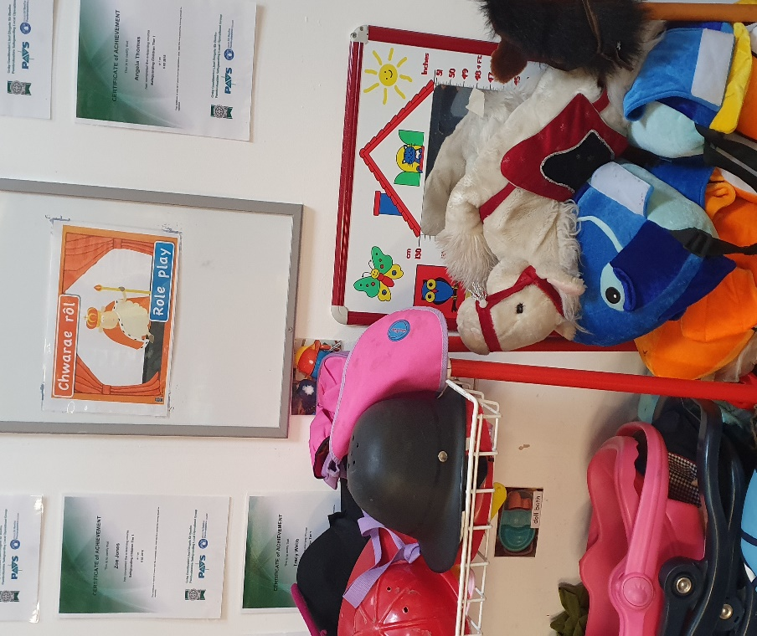
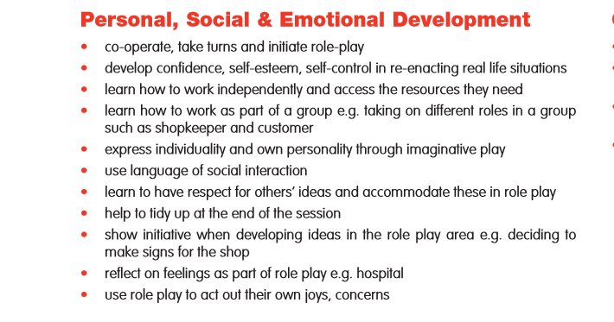
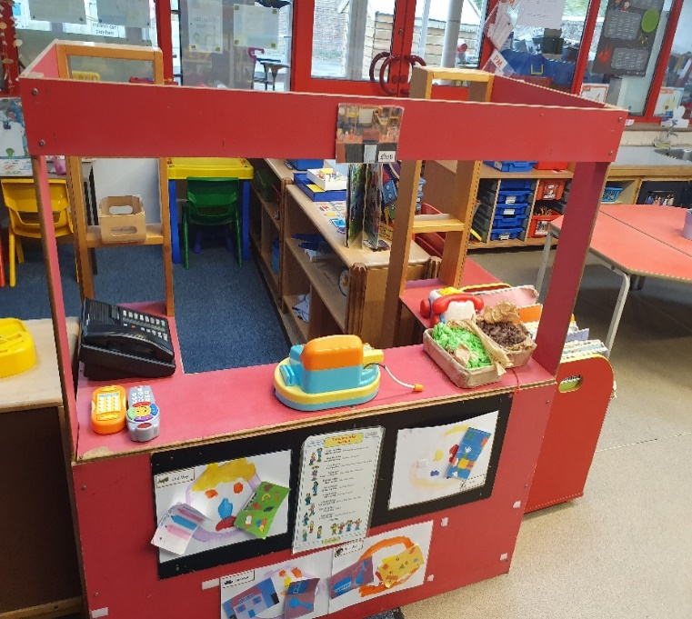
(Roberts, 2019)
(Roberts, 2019)
(Roberts, 2019)
(Craft, 2002)

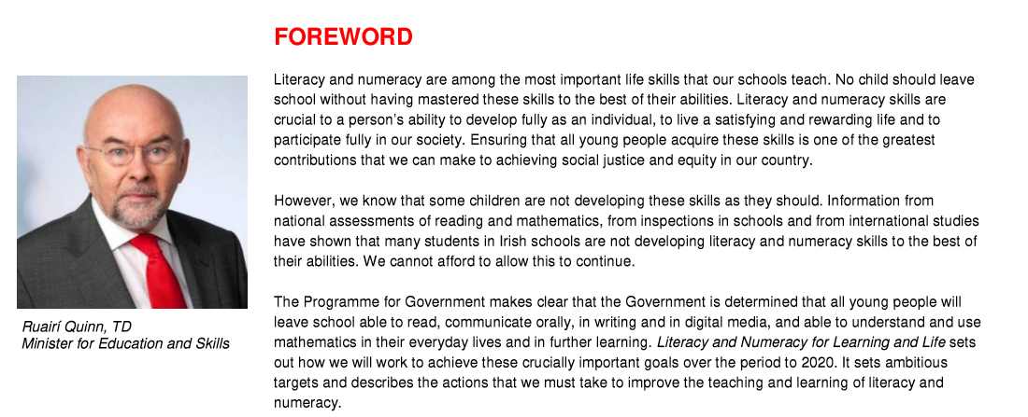
The zone of proximal development was influenced by Vygotsky. This enhances Children to learn through different stages in comparison to piagets theory. However this intervention used Is the scaffolding process (Laura E. Berk, 2010).
This is learning with peers or their formal Teacher to be able to learn what the subject is and to evaluate a better understanding of it.

(Quinn, 2011-2020)
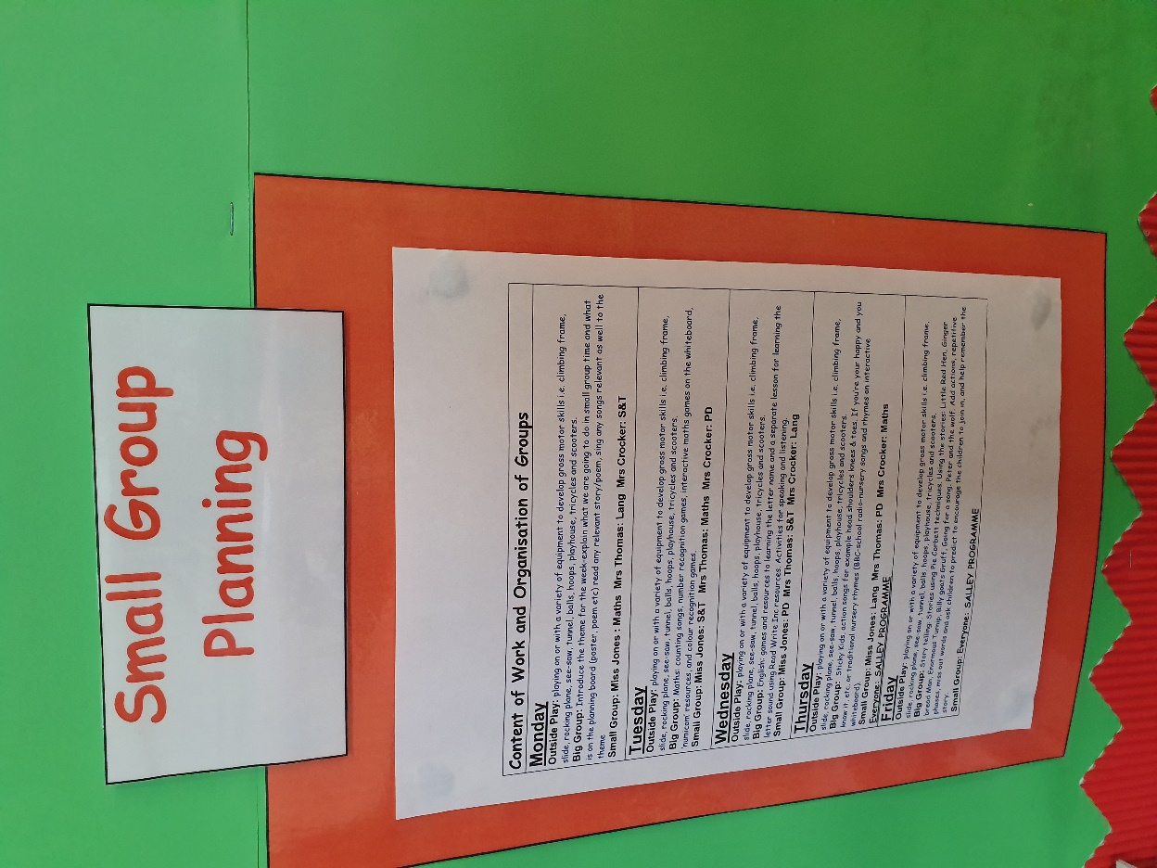
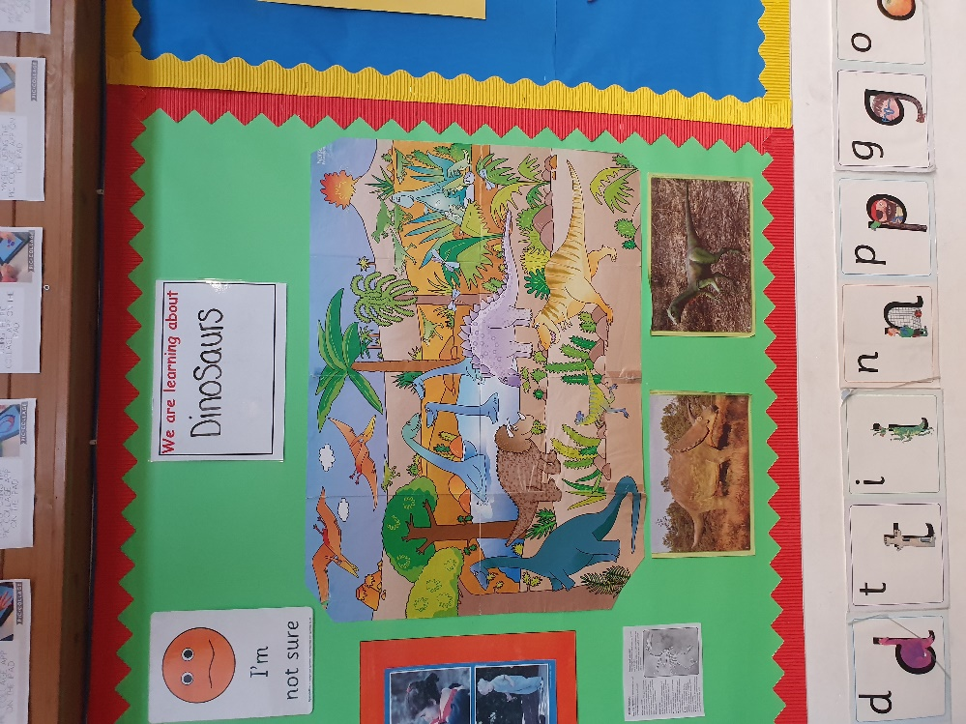
The inclusive approach of this is explaining what they are doing during the week.
However, they are also put into small groups for a better understanding in allowing children to learn at an appropriate level.
This represents Vygotsky’s theory by using the scaffolding process by learning with their teachers to be able to widen their use of skills between numeracy and literacy (Laura E. Berk, 2010) and embedding it in to the curriculum.

(Roberts, 2019)
(Roberts, 2019)
This is the topic of the week, what they are learning in their classroom. This is a good approach as it develops the child to not forget about what they are learning and to see it visual.
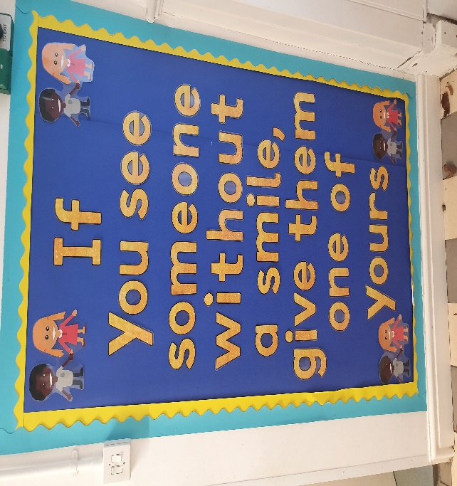
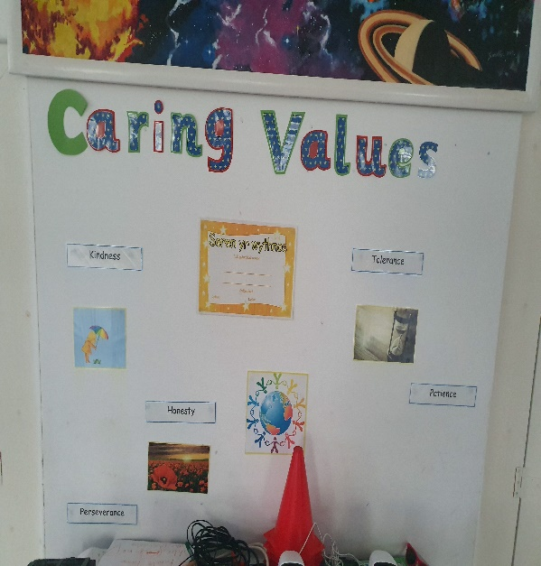
This is allowing a positive and caring school community; this is important as it allows everyone to gain good relationships with their peers and teachers. This allows children to care for others and have respect for them.
This school has a great approach to caring and their value within their health and well-being policy.
(Monkton Priory Community Primary School, 2019)

(Roberts, 2019)
(Roberts, 2019)

(Google, 2019)
The strategy for, negative reinforcement is that a “naughty child” would be given time out, this is were the Child will reflect on their bad behaviour and rethink to not do it again. This also makes them understand that they are missing out on play time with their peers (Policy, 2012).


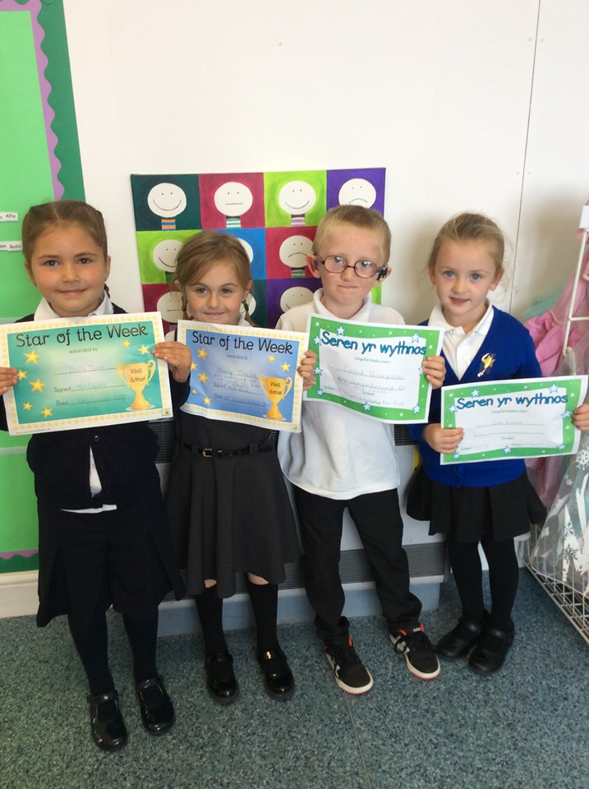
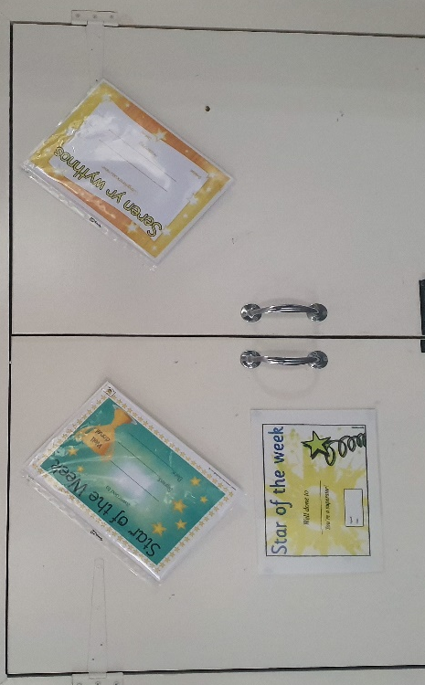
B F Skinner believed in behaviourism. His positive reinforcement was to be able to reward Children for being good and a negative reinforcement for being bad.
Skinner agreed with the statement of methodological behaviourism is to be able to define behaviour and being able to control it by reflecting on the positive and negative reinforcement (B.F.Skinner, 1974).
In a working school practice to promote good behaviour it is essential to have a rewards chart.
The one I find works well in school is having a star reward chart.
Every time they did something good, they would be rewarded a star for their chart, then at the end of the week they would be rewarded by a little gift and the one with the most stars would win this.
This reward encourages good behaviour. It will also improve their behaviour between others by promoting positive role models amongst their peers (B. F. Skinner, 1997-2014).

The “Star of the week” approach Is used within the whole school and every week 1 person from each class is rewarded to be the “star of the week”. They then get presented with this in assembly in front of the whole school.
This works well and encourages Children to be good as they look up to their peers of the older ages. This is also known as the scaffolding process (Monkton Priory Community Primary School, 2019).
(Roberts, 2019)
(Roberts, 2019)

Bibliography
B. F. Skinner, C. B. F., 1997-2014. Schedules of Reinforcement. 2015 ed. s.l.:B. F. Skinner Foundation, 2015.
B.F.Skinner, 1974. About Behavourism. 1st ed. New York: Vintage Books Edition.
Barker, R., 2008. Making Sense of Every Child Matters: Multi-professional Practice Guidance. New Edition ed. s.l.: Policy Press; New Edition edition.
Craft, A., 2002. Creativity and Early Years Education: A lifewide foundation. London: s.n.
Curriculum, N., 2019. Learning Through Play - Early Years. s.l.:s.n.
Google, 2019. Sensory Education. [Online]
Available at: https://www.cheapdisabilityaids.co.uk/coloured-desktop-sand-and-water-tray-fun-pack-of-4-16823-p.asp
Google, 2019. Star Chart Reward. [Online]
Available at: https://www.google.co.uk/search?biw=1536&bih=751&tbm=isch&sa=1&ei=H-26Xd2jB5HyaqXlidAJ&q=star+reward+chart+in+school&oq=star+reward+chart+in+school&gs_l=img.3...14659.17676..17897...1.0..0.63.548.11......0....1..gws-wiz-img.......0j0i67j0i30j0i5i30j0i8i30
Gov.uk, 2003. Every Child Matters - Policy Paper. [Online]
Available at: https://www.gov.uk/government/publications/every-child-matters
Government, Wales - Nadhim Zahawi MP, 2018. Thousands more school children receiving a nutritious breakfast. Thousands more school children receiving a nutritious breakfast , pp. 1-2.
Laura E. Berk, A. W., 2010. Scaffolding Children's Learning. California: National Association for the Education of Young Children, 1995.
Malta Today Staff, 2014. Primary schools to offer Breakfast Club during coming school year. [Online]
Available at: https://www.maltatoday.com.mt/news/national/43042/primary_schools_to_offer_breakfast_club_during_coming_school_year#.XbjEKm52tPY
[Accessed 4th September 2019].
Maslow, A. H., 2013. A Theory of Human Motivation. s.l.:s.n.
Monkton Priory Community Primary School, 2019. Emotional Health and Well-Being Policy.
Nielson, B., 2017. Faster Cognitive Development. 3 Reasons Why You Should Be Using Multisensory Teaching Techniques, p. 1.
Pearson, 2019. Why is reading so important?. [Online]
Available at: https://www.pearson.com/uk/learners/primary-parents/learn-at-home/help-your-child-to-enjoy-reading/why-is-reading-so-important.html
Piaget, J., 1954-2004. The Construction of Reality in the Child. Oxon: Taylor and Francis Group.
Piaget, J., 2011. Jean Piaget: Cognitive Development in the Classroom. [Online]
Available at: https://www.funderstanding.com/educators/jean-piaget-cognitive-development-in-the-classroom/
Piaget, J., 2019. Linking with the Author. [Online]
Available at: http://seminarbgroup6.weebly.com/activities-5-and-6.html
Policy, T. O., 2012. Policy and Guidance within a Classroom setting for time out. Vale Of Glamorgan, pp. 1-13.
Quinn, R., 2011-2020. Literacy and Numeracy for Learning for Life, s.l.: Education and Skills.
Richard Adams, 2016. Free school breakfast clubs boost maths and literacy results, study finds. The Guardian, p. 1.
Roberts, K., 2019. Miss. s.l.:Owners own Photo.
Saul McLeod, 2014. Carl Rogers - Humanistic Approach. [Online]
Available at: https://www.simplypsychology.org/carl-rogers.html
Slideshare, 2013. Thinking Critically with Psychological Science. [Online]
Available at: https://www.slideshare.net/kimappel/chapter-1-25342655
Sprouts, 2018. Piaget's Theory Of Cognitive Development, s.l.: YouTube.
Sue Rodgers and Julie Evans, 2008. Inside role play in early Childhood Education. In: Inside role play in early Childhood Education. s.l.:s.n.
Welsh Government, 2015. Well-being of Future Generations (Wales) Act 2015. [Online]
Available at: https://futuregenerations.wales/wp-content/uploads/2017/02/150623-guide-to-the-fg-act-en.pdf
[Accessed May 2015].
Welsh Government, 2017. Additional learning needs (ALN) transformation programme. [Online]
Available at: https://gweddill.gov.wales/docs/dcells/publications/1700412-aln-transformation-programme-en.pdf
Zelna, A., 2018. Nutrition For Healthy kids. [Online]
Available at: http://askzelna.com/nutrition-for-healthy-kids/

