

Investigation of Static Electricity Buildup During Energetic Material Mixing Processes
Sam Parker

Supervisor: Jordan Jenkins

Project submitted as part of the requirements for the award of BEng (Hons) OME

July 2025

Declaration of Originality

I, Sam Parker declare that I am the sole author of this Project; that all references cited have been consulted; that I have conducted all work of which this is a record, and that the finished work lies within the prescribed word limits.

This work has not previously been accepted as part of any other degree submission.

Signed: 

Date: 13.07.2025

FORM OF CONSENT

I Sam Parker hereby consent that my Project, submitted in candidature for the BEng (Hons) OME degree, if successful, may be made available for inter-library loan or photocopying (subject to the law of copyright), and that the title and abstract may be made available to outside organisations.

Signed:

Date: 13.07.2025

© Crown copyright (2025), Dstl. This information is licensed under the Open Government Licence v3.0. To view this licence, visit https://www.nationalarchives.gov.uk/doc/open-government-licence/.
Where we have identified any third-party copyright information you will need to obtain permission from the copyright holders concerned. Any enquiries regarding this publication should be sent to: centralenquiries@dstl.gov.uk.

Abstract
This project aimed to investigate static electricity generation during energetics processing. To do this, a novel test methodology was developed with an instrument known as an electrostatic voltmeter. Development occurred by a series of different experiments using both inert and live energetic material on an appropriate process, known as a tapping rig. Some of the key findings from this study were that voltage magnitudes can vary significantly, despite having identical experimental conditions. An example of this can be seen in Table 14, where the difference in measured voltages for repeats 2 and 3 was 125 V for Position 1. Another example was between Inert Experiments 1 & 2, where a maximum voltage difference of 2422 V was observed between identical measurement conditions. Other factors such as the effect of an external guard and the presence of a grounding wire have been investigated during this study, and have been shown to have an impact on the measured voltage.
Through these continued experiments, a suitable test methodology has been developed that allows measurements to be taken during experiments that involve energetic materials, showing the success of the project. Future work could look to further develop this test methodology (e.g. with calibration experiments) and to deploy it on further energetics processes, such planetary mixing.

List of Figures
Figure 1 – An example of the triboelectric series [11] 3
Figure 2 – Electrostatic Voltmeter Circuit Representation [20] 5
Figure 3 – SK-H050 [22] 7
Figure 4 – Experimental Setup 9
Figure 5 – Metal Base Pot 10
Figure 6 – Energetics Trial Experimental Setup 12
Figure 7 – Conducting Bag Setup 13
Figure 8 – Metal Plate Setup 14
Figure 9 – Tape Measurement Setup 15
Figure 10 – Glass Container Experimental Setup 15

List of Tables
Table 1- Method Development Experimental Results 29
Table 2 – Inert Experiment 1 30
Table 3 – Inert Experiment 2 31
Table 4 – Inert Experiment 3 32
Table 5 – Inert Experiment 4 33
Table 6 – Inert Experiment 5 34
Table 7 – Measurement Technique Testing 35
Table 8 – Sugar Tap, No Wire During Tap 36
Table 9 – Sugar Tap, Wire Present During Tap 37
Table 10 – Explosive Material 1 38
Table 11 – Explosive Material 2 39
Table 12 – Empty Tube Experiment 40
Table 13 – Sugar Experiment 41
Table 14 – Conductive Bag Measurements 42
Table 15 – Metal Plate Measurements 42
Table 16 – Repeatability Experiment Data (Split over two tables for readability) 48
Table 17 - Statistical Analysis of Repeatability Experiment 49
Table 18 – Intentional Triboelectric Charging Attempts 49
Table 19 – Surface Mechanism Experiment 49
Table 20 – SK-H050 [24] 51
Table 21 – Risk Assessment Matrix 53

List of Graphs
Graph 1 – Method Development Experimental Results 29
Graph 2 – Inert Experiment 1 30
Graph 3 – Inert Experiment 2 31
Graph 4 – Inert Experiment 3 32
Graph 5 – Inert Experiment 4 33
Graph 6 – Inert Experiment 5 34
Graph 7 – Measurement Technique Testing 35
Graph 8 – Sugar Tap, No Wire During Tap 36
Graph 9 – Sugar Tap, Wire Present During Tap 37
Graph 10 – Explosive Material 1 38
Graph 11 – Explosive Material 2 39
Graph 12 – Empty Tube Experiment 40
Graph 13 – Sugar Experiment 41
Graph 14 – Using Conductive Bag 43
Graph 15 – Using Conductive Bag 43
Graph 16 – Using Conductive Bag 44
Graph 17 – Using Conductive Bag 44
Graph 18 – Using Conductive Bag 45
Graph 19 – Using Metal Plate 45
Graph 20 - Using Metal Plate 46
Graph 21 – Using Metal Plate 46
Graph 22 – Using Metal Plate 47
Graph 23 – Using Metal Plate 47
Graph 24 – Repeatability Experiment 48
Graph 25 – Surface Mechanism Experiment 50

List of Equations
Equation 1 – Rate of Charge Dissipation [12] 3

Table of Contents
Abstract iii
List of Figures iv
List of Tables iv
List of Graphs iv
List of Equations v
Chapter 1 – Introduction 1
Chapter 2 – Literature Review 2
2.1 – An Overview 2
2.2 – Static Dissipation 3
2.3 – Utilised Mitigation 4
2.4 – Relevant Studies 4
2.5 – Viable Static Measurement Devices 5
Chapter 3 – Methodology 6
3.1 – Market Research 6
3.2 Method Development 7
Chapter 4 – Experimental Results 9
4.1 – Introduction 9
4.2 – Initial Development 9
4.3 – Inert Experiments 1 & 2 10
4.4 – Inert Experiments 3 – 5 11
4.5 – Energetic Material Trials 11
4.6 – Further Development 13
4.7 – Background Interference Testing 13
4.8 – Repeatability Experiment 14
4.9 – Intentional Charging Investigation 14
Chapter 5 – Discussion 16
5.1 – Introduction 16
5.2 – Initial Development 16
5.3 – Inert Experiments 1 & 2 16
5.4 – Inert Experiments 3 – 5 17
5.5 – Energetic Materials Trials 18
5.6 – Further Development 18
5.7 – Background Interference Testing 19
5.8 – Repeatability Experiment 19
5.9 – Surface Phenomena Investigation 20
Chapter 6 – Evaluation 21
Chapter 7 – Conclusion & Recommendations 22
Chapter 8 – Reflection 23
References 24
Bibliography 26
Appendix A – Experimental Results 29
1.1 – Initial Development Results 29
1.2 – Inert Experiments 1 & 2 Results 30
1.3 – Inert Experiments 3 – 5 Results 32
1.4 – Energetic Materials Trials Results 35
1.5 – Further Development Results 40
1.6 – Background Interference Testing Results 42
1.7 – Repeatability Experiment Results 48
1.8 - Intentional Charging Investigation Results 49
Appendix B – Supplementary Information 51
1 – Static Meter Specifications 51
2 – Safe Systems of Work Summary 52
3 – Further Work Recommendations 54

Chapter 1 – Introduction
This study investigates static electricity build-up during energetic material processing scenarios and will contribute towards the final year project of the Ordnance Munitions and Explosives degree apprenticeship. Some energetic material is sensitive to electrostatic discharge (ESD) and hence static electricity build-up is often controlled during processing. The ignition energies for sensitive primary explosives can range from 0.01 – 0.1 mJ, which fall within the amount of energy that can be generated via static electricity – typically from: discharges from clothing, corona discharge and weak Radio Frequency pick-up. Walking across a carpet can generate a static charge of approximately 20 mJ and several thousand volts, which is more than enough to cause a detonation in an electrostatic discharge (ESD) sensitive explosive [1].
The aim of the project is to develop a test methodology to measure static electricity generation during a process involving energetics. Examples of variables to be investigated include: the magnitude of the static electricity generated during a process, if the charge is localised to specific points on a material, how quickly the charge dissipates after the process has stopped, along with others. If the test methodology provides useful insight into static electricity, then the information can be used to influence safety aspects of explosive work going forward. This test methodology will be developed through a series of experiments, using both inert materials and live energetics.
As Dstl currently does not employ a static testing regime when carrying out energetic work, the degree to which static electricity is being generated remains unknown. Although there are appropriate control measures in place to mitigate against static electricity generation, where the Safe Systems of Work (SSoW) dictates, it would be useful information and aide in the understanding of the hazard if numerical values could be placed on the amount of static electricity being generated.
The following chapters will include a literature review, a section on how the test methodology has been developed, any experimental results with relevant discussion, with finally conclusions, recommendations and reflections at the end.

Chapter 2 – Literature Review

2.1 – An Overview
To understand how to measure static electricity, first some background fundamentals should be covered. Static electricity is generated via an imbalance of electric charges on a material. The imbalance is caused by electrons being transferred, leading one material to be positively charged (deficient of electrons) and the other material being negatively charged (excess of electrons). Electron transfer can occur when materials come into contact. This is known as friction or triboelectric charging. The work done in keeping the positive and negative charges separate results in the generation of a potential difference across the boundary e.g. between a powder and its container. This is known as charge separation and typically occurs between a good and poor electrical conductor, or two poor electrical conductors. If the local electric field exceeds a threshold value, then a static discharge can occur [2]. Trace amounts of impurity within a homogeneous material also facilitate static electricity generation, and materials properties such as surface resistivity are also important [3] [4].
A material that is a conductor has a high number of charge carriers, that are readily available to be mobile (e.g. electrons in a metal) and have at least partially, overlapping conduction and valence bands. A valence band is a term used in solid-state physics and chemistry that describe how electrons behave. It refers to the outermost electrons (known as valence electrons) that are bound to a particular atom. As these electrons are bound to the atom, they do not contribute to electrical conduction. The conduction band, however, lies just above the valence band in terms of its energy level and can be empty or partially filled. The electrons present in the conduction band are available for movement and hence give a material its conductive properties. Electrons can be promoted from the valence band to the conduction band, providing they have enough energy. The difference in energy between the valence band and conduction band is known as the band gap [5]. Insulators on the other hand, have much lower electrical conductivity, due to a lack of available charge carriers and large gaps in the conduction / valence bands.
The relative humidity (RH) is also important when considering static electricity. Moisture in the air can form a thin layer on the surface of a material, and as water is electrically conducting material, it will contribute the electrical conductivity. The presence of this surface water will reduce the surface resistivity of a material, and therefore make it less susceptible to static electricity build-up [6].
The degree to which a material gains a positive or negative charge is down to where they appear on the triboelectric series. For example, a material that appears higher up in the series (e.g. aluminium) would be expected to gain a positive charge, when against a material that appears below it in the series (e.g. polytetrafluoroethylene (PTFE)). However, the triboelectric series cannot be completely relied upon as environmental factors such as temperature, humidity, the roughness of the surface and how soft a material is, can alter its order. Figure 1 below shows an example of some materials listed in terms of their position on the triboelectric series.
However, it has been reported that the fundamental principle that governs the exact order of the triboelectric series is still unknown, especially in insulating materials, such as polymers. A charge would be present after contacting charging a material if either an electron, ion or small quantity of material moves from one contact surface to the other, and proving the mechanism that is happening is extremely challenging. All data that has been collected is purely empirical, generated by performing contact charging experiments over the course of the past 250 years, and some tests are not always reliably repeatable [7]. There have been a number of different reports suggesting different physical properties that define the triboelectric series, ranging from molecular orbital energy levels [8] to a molecules ionisation potential [9]. Additionally, it has been suggested that contact charging between two insulating materials proceeds via a different mechanism that between an insulator and a metal [10]; therefore, it is unclear how trustworthy a given example of the triboelectric series really is.

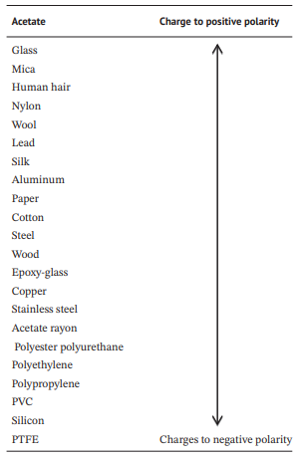
Figure 1 – An example of the triboelectric series [11]

2.2 – Static Dissipation
To understand the dissipation, first the fundamentals of bulk conduction should be considered. Bulk conduction occurs on the surface of a material and is the mechanism by which the generated static charge is dissipated. The charge will flow from an area of high potential to low potential (e.g. to ground). The basic equation for modelling the rate of charge dissipation is as follows:
$$σ= σ_{0}{ e}^{- \frac{γt}{ε}}$$
Equation 1 – Rate of Charge Dissipation [12]
Where σ₀ is the initial charge density, t is the time, ε is the permittivity of the material and γ is the conductivity of the material. The rate of charge dissipation is a crucial design consideration for many applications. For example, when handling some sensitive explosives static dissipative gloves are worn, which means that they efficiently conduct the electricity, helping to mitigate the electrostatic discharge (ESD) risk [12].

2.3 – Utilised Mitigation
Lightning strikes provide a potential source of electrical charge that can impact explosive processes. In the now withdrawn DSA03 OME Part 2: In-Service and Operational Safety Management of OME Chapter 17, there was a dedicated section on Thunderstorm best practice. To summarise, the Met Office are able to provide live updates to sites where hazardous energetics processing is taking place. In the event of a thunderstorm, normal practice is to immediately cease all operations with energetic material present. Extra care should be taken when handling primary explosives or electro-explosive detonators (EEDs). Modern day processing facilities often include external lightening protection systems. These work by providing a metal point for the lightening to hit, above the highest point on the processing building. If the lightening hits this point, then it is safely dissipated to ground [13]. Energetics is not the only industry affected by thunderstorms, and sectors such as aviation have also invested in research looking at early warning systems [14].
The Energetics Materials Testing Assessment Policy of Tests (EMTAP) manual states the different types of tests that need to be done to characterise energetics materials, also known as Small Scale Hazard Testing (SSHT). Test 7, known as the ESD or electric spark test specifically targets the energy from a spark and whether it provides enough stimulus to detonate an energetic material. This is a vital safety step when commissioning new explosives and testing old ones, further highlighting the importance of considering static electricity when handling explosives [15].

2.4 – Relevant Studies
There is very little available relevant literature into static measurements during energetic processing and using electrostatic voltmeters in general. Matsusaka has conducted an extensive review into the triboelectric charging of powders, however the methods covered were not feasible to be implemented during this work [16]. One relevant study however looked at measuring electrostatic charging during the flight of an aircraft. Relevant key findings were that the static meter would correctly read 0 V when a static wire reached ground and that the static meter provided a good estimation for the voltage, even when used outside its intended stand-off range [17].
Spray drying is a technique that is currently used to alter the particle size and morphology of explosive material. Handling issues have been seen in the product of the procedure, which have been attributed to the amount of static electricity present in the sample. A study has investigated the static electrification of powders during spray drying, and although energetics were not used, the results still provide useful insight into static electricity during the process. Lactose and mannitol were used in the study, which aimed to investigate exactly where static electricity is being built up during the process. The static meter used was set 15 mm from each target location. It was found that particles became charged as they left the spray nozzle, and when they hit the sides of the drying chamber, but not significantly in the cyclone separator. Particles were readily able to exchange charge with the walls of the glass chamber in the early stages of drying. As the walls become more covered in spray dried matter, with less glass exposed for charge exchange collisions, the rate of charge transfer, and hence the build-up of static electricity rapidly falls [18]. Interestingly, it was reported that the electric field lines were able to penetrate the glass and provide a response on the static meter. This provided a basis that a non-contact measurement device could be used for static measurements during the experiments of this research project.
It has also been documented that static electricity accumulates in bulk explosives during producing, transferring and storing energetic powders. There have been investigations into additives that can be used to decrease static charge in HMX and PETN. Examples include Polyvinylpyrrolidone (PVP) and 1-Hexyl-3-methyl imidazolium chloride ([Hmim][Cl]), an ionic liquid. It was found that [Hmim][Cl] increased electrical conductivity and volumetric resistance when compared to PVP. Certain configurations, and weight percentages of the two materials have been found to have antistatic properties, with the total reduction of static charge in HMX and PETN with 94% AND 98% respectively [19].

2.5 – Viable Static Measurement Devices
To make static measurements, a static meter would be needed. Two types of static measuring instruments that are available are electrostatic voltmeters and electrostatic fieldmeters, with the main difference being internal circuitry. Electrostatic fieldmeters are more suitable for measurements applied over relatively large areas and are highly dependent on the probe to surface distance. Electrostatic voltmeters on the other hand, tend to be more accurate over the shorter distances. They are also designed in a way that prevents discharge between the probe and the measurement surface – an important safety feature should the instrument be used with energetics [20]. With this information in mind, it was decided that an electrostatic voltmeter would be the most suitable type of device for use on this project. Additionally, the model chosen was the same one used in the aircraft charging study, reinforcing its suitability.
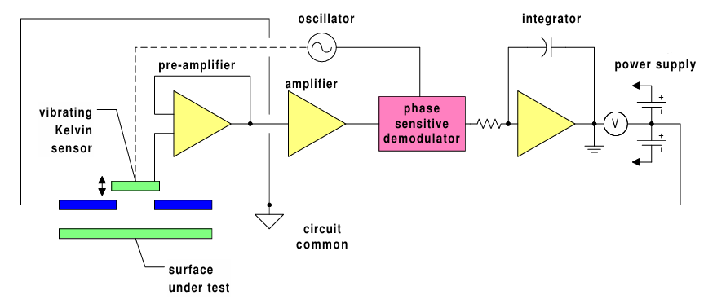
Figure 2 – Electrostatic Voltmeter Circuit Representation [20]
Faithou et al has investigated the ‘Measurement of surface potential of non-uniformly charged insulating materials using a non-contact electrostatic voltmeter’. The conclusions from this study provide useful insight that were considered in the experimental design of this project. The probe measures the charge distribution in a circular zone, which is dependant on the probes aperture, and the distance between it and the measured surface [21]. Therefore, with the knowledge of this information, a consistant distance for the measurements in this project would be used.

Chapter 3 – Methodology

3.1 – Market Research
Initially a market survey was undertaken to assess appropriate options for the static meter. This process involved reading technical specifications for different advertised instruments and reaching out to manufacturers to obtain quotes. Alternative models investigated included the Simco-Ion FMX004 and the SMC IZH10. A suitable instrument was then procured, which was the Keyence SK-H050 electrostatic sensor. Some of the key reasons this device was chosen were that it is capable of recording both the temperature and humidity, which are factors that can affect static electricity build up and discharge. Another desirable design feature that the static meter possessed was that it was hand-held and portable. This was essential for allowing it to be deployed across a range of different activities and tasks. The static meter also used a non-contact method for taking measurements. This is vital for use with explosives, as the meter could be setup at a safe distance, and not interfere with the energetic material present. It also came equiped with a laser standoff, which allowed the user to accurately set the standoff between the probe and the measurement surface, ensuring that the measurment distance is being accounted for – a point that was critical in Faithou’s assessment [21]. Finally, the SK-H050 was operated in High-Precision mode, for which details can be found in the product specification, located in Appendix B.
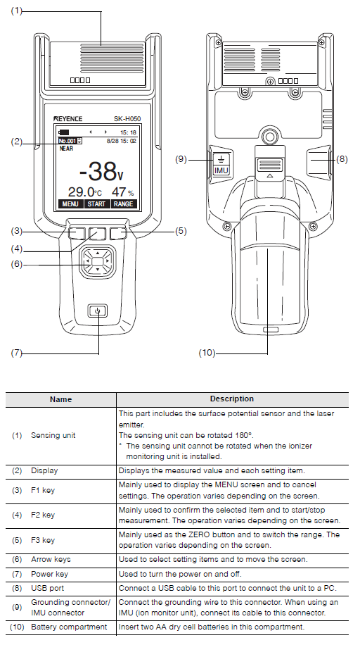
Figure 3 – SK-H050 [22]

3.2 Method Development
After the static meter had been procured, an experimental design would be required so that it could be used across different processes. There was an upcoming energetics trial that would utilise an instrument known as a tapping rig (also known as a tapper). Therefore, this tapping rig was selected for inert method development, prior to the energetics trial. A tapping rig is an instrument whereby a sample tube is placed on top of a holder, which moves up and down and rotates when the tapper is turned on. The aim of the tapper is to simulate the action and force experienced as if something was being carried on a person as they are walking. There are numerical controls on the tapper that can control the number of ‘steps’ that the tapper imitates. For all experiments using the tapping rig, the control module was set to 300 unless stated otherwise. This value was chosen because it has been used in previous trials involving the tapping rig and energetic materials.
The first set of method development studies utilised a sample tube placed on top of the tapping rig to establish a suitable testing setup. All experimental data and the relevant discussion will be provided in a subsequent section of this report. Conducting conditions are often used in energetics processing, to mitigate the static electricity hazard. Different experiments will utilise this condition, to investigate how it impacts results.
The next task was to generate a SSoW, to allow the static meter to be used for research experiments. Each company has a different SSoW process, and it was decided that this work would require a method statement (MS) and risk assessment (RA). Supplementary information regarding the SSoW can be found in Appendix B. Important consideration was taken regarding the safety of the laser when used with energetic material [23], but as it was a Class 1 laser, extra mitigation was not required. These documents were peer reviewed before being signed off. With the SSoW in place, experimental work could be undertaken.

Chapter 4 – Experimental Results

4.1 – Introduction
This chapter presents the results of experiments conducted using the static meter. It should be noted that, due to the novel nature of the study, the experimental conditions were revised iteratively, with appropriate adjustments made, based on the analysis of the previous section. The section will be broken down according to the aims of each individual experiment, with a short introduction to the context of why it was undertaken. The discussion on the results will follow in a latter section. Figure 4 below shows the experimental setup that was used for the majority of tests.
The respective tables and graphs can be found in Appendix A.
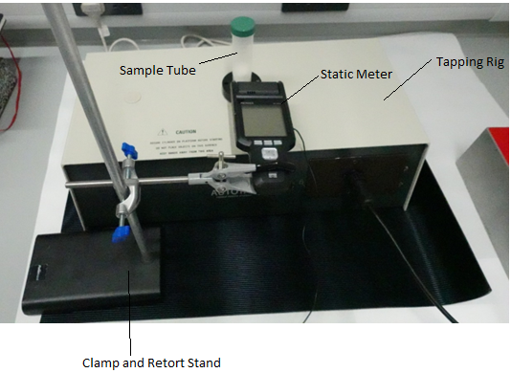
Figure 4 – Experimental Setup

4.2 – Initial Development
The first time using the static meter for method development utilised inert materials in a plastic sample tube. These were placed on top of the tapping rig in different combinations, without turning it on. The results from this experiment can be seen in Table and Graph 1 respectively.
The X-axis corresponding to the Point of Measurement (mL) was not representing a physical quantity of liquid that was being measured, but instead represented the point on the sample tube that the laser standoff had aligned to. The ‘Lid’ measurement was taken on the screw cap lid of the sample tube. The voltage measured was the reading that was displayed at this point on the sample tube via the static meter. The 4 different experimental conditions represent the different combinations that were investigated. The blue line signalling the glove represented a nitrile glove(s) that had been packed into the sample tube. The addition of the guard was a measure that would need to be taken while the tapper was in use, and so was included in the method development. The guard consisted of a 3D printed polymer, that would keep the sample tube in place as the tapper moved up and down / rotated while it was in use. The title of the graph was used to signify the type of sample tube that was used (in this case the normal base pot) as well as record the temperature and relative humidity that was displayed on the static meter. The normal base pot refers to the sample tube being made entirely of plastic. Whereas in subsequent experiments a metal base pot has been referred to. This was a modification that was made, where the base of the pot was replaced with another piece of plastic, containing a metal magnet in the centre. An image of this metal base pot can be seen in figure 5. There was also a magnet in the sample holder in the base of the tapper, further helping keep the sample tube in place, as well as the guard previously mentioned. It was from this initial set experiments that the SSoW was generated.
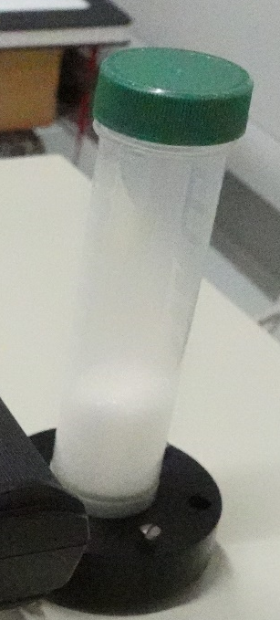
Figure 5 – Metal Base Pot

4.3 – Inert Experiments 1 & 2
This set of experiments used an inert simulant for energetic material. As most explosives are made from organic molecules, table sugar was deemed to be a suitable inert representation. Clearly, factors such as the particle size and functional groups present are not the same, which will have an effect on how static electricity is generated. The materials did belong to the same class; crystalline organic compounds, which was a better representation than if something such as table salt were used, which is an ionic compound.
The data from first set of inert experiments is shown in Table and Graph 2. As can be seen, 6 different measurement scenarios were used.
- Empty on bench was a measurement of the empty sample tube on the bench before anything had been carried out.
- Empty on rig was just the sample tube on the tapping rig.
- Rig + sugar was the sample tube on the tapping rig filled with sugar.
- Rig, sugar, guard was the same as 3, but now with the guard in place to keep it fixed on the tapper.
- Post tap is a measurement immediately after the tapping rig had finished its cycle, with the guard still in place.
- Bench post tap was the sample tube placed back on the bench, after removing the guard.
As can be seen from the title of the graph, the metal base pot previously discussed was used in this experiment. Additionally, the work was carried out in a conducting laboratory. As discussed previously, some energetic materials are sensitive enough whereby small amounts of energy, provided by static electricity can cause them to detonate. For this reason, specialist facilities have been built that utilise conductive materials throughout. Depending on the energetic material being used, it may be stipulated in the SSoW that conductive conditions must be used.
The missing data points for 5, 10 and 15 mL Points of Measurement for the first and last test respectively were due to physical limitations with the test setup. With the sample tube on the bench, the lowest position that the static meter was able to measure was the 20 mL graduation mark. Additionally, the table now refers to a quench time for each of the experimental types. This was a time allocated to allow any static electricity potentially caused by the movement in assembly (e.g. placing the sample tube on the rig or adding sugar to the sample tube) to dissipate before a measurement was taken. The post tap column had a zero-quench time because the desired data was that immediately after the tapping had finished, not giving any static electricity that was generated the chance to dissipate.
Table and Graph 3 show a repeat of the same experiment.

4.4 – Inert Experiments 3 – 5
Experiments 3 to 5 were identical to 1 and 2, but instead took place in a standard non-conducting laboratory. Additionally, the AM vs PM reference in the table is according to what time of the day the experiment was conducted in. This data was captured because there was a chance that getting the equipment out at the start of the day, induces some static electricity as it was being moved around. Leaving it setup on the bench for the morning could allow this static to dissipate. Differences in the AM and PM results could be due this dissipation, hence why the data was recorded.

4.5 – Energetic Material Trials
The trial taking place was investigating its own experimental aims, that had nothing to do with static electricity generation. The static electricity measurements were a bolt-on process that was not part of the trial. For this reason, measurements were only able to be taken as time permitted, and the ability to get repeat data would be down to if another run was required for the purposes of the trials data, and not for static measurement purposes.
Upon initial setup on the energetics trial, it became clear that the previous measurement system of measuring the graduated point along the sample tube was not going to be practical. This was because in order to move the static meter up and down along the retort stand and be in line with the graduation point, it required the laser standoff to be used for each measurement. It was written into the SSoW that the laser would not be turned on while there was energetic material present, meaning that the static meter could not be moved up and down to take a measurement. Therefore, the measurement method was slightly adapted, so that the same point on the sample tube was measured each time, removing the need to reset the laser standoff between each measurement. To design this new measurement technique, some inert trial runs were conducted prior to the introduction of any energetic material. The sample tube used in these experiments was different from the one used in the method development. This can be seen in Figure 6, along with the guard that had yet to be installed in place.
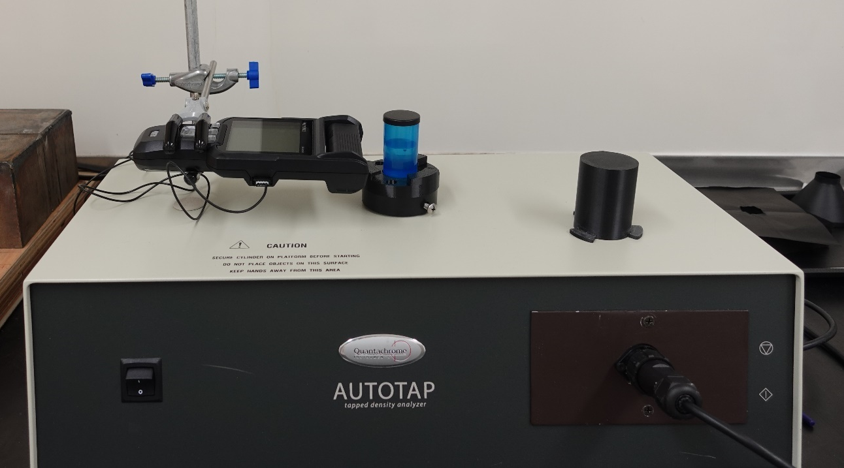
Figure 6 – Energetics Trial Experimental Setup
Due to earlier observations on the trial, and concerns with static electricity buildup, it was requested that a grounding wire was used while the tapper was in operation. A wire could not simply be attached to the sample tube, as it would get twisted as the tapper rotated, therefore an engineering solution was required. The solution came by exposing a copper wire that was attached at the other end to an earthing point. The exposed copper ends of the wire were then suspended above the sample tube. To the lid of the sample tube, a piece of copper tape was attached. When contact between the suspended ends of the wire and the copper tape on the lid was made, the sample tube would be connected to earth. As the tapper moves up and down during its operation, the distance closed enough between the wires and the tape on the lid to make contact. This meant each time the sample tube moved up and down as the tapper was in process, contact was made and broken repeatedly until the end of the operation.
The data from this trial runs can be seen in Table and Graph 7. Where previously the point on the sample tube was reported, now the ‘Measurement condition’ was used. This represented that state the sample tube was in during the measurement. The guard and grounding wire steps were repeated to investigate what affect the grounding wire was having on the reading. For this set of experiments, the tapper was not turned on. Additionally, the metal base pot used in earlier method development was used for all experiments during this trial and all work was carried out under conducting conditions.
The tapper was turned on for the next set of inert experiments. The aim these next inert runs was to investigate if there was a difference between having the new grounding wire touch the sample tube in the manner that has been described previously, or just at the end of the experiment. Data from these experiments can be seen in Graphs and Tables 8 and 9 respectively. Additionally, at the start of these experiments the decision was made to ‘Zero’ the static meter. This step was taken so that just the effect of the process was being measured, reducing the impact of the state of the experimental setup before a process had started.
It was decided that the experimental condition, where the wire was present during the tapper operation was to be used for the experiments involving energetics. Graphs and Tables 10 and 11 show data that was collected from the processing of two different molecular explosives. Note that a step with a three-minute soak / quench was present in the measurement conditions. This was a safety step as live energetics were being used.

4.6 – Further Development
With the addition of the zeroing step to the method, some further inert tests were carried out to investigate if this had any impact on the results. Furthermore, the impact of prolonged soak / quench times had not yet been properly investigated, and so longer times were added during these next experiments. Graphs and Tables 12 and 13 respectively show the data from this further development. Work was conducted in a non-conducting laboratory, using the metal base pot and sugar as an inert simulant. As the magnet was strong enough to keep the pot in place during the tapping operation, the guard was not used. Additionally, a rubber mat was placed under the tapping rig during these experiments. As rubber is a known insulator, this was done in an effort to try and increase reliability of results by aiming to provide a more consistent environment for each experiment. Graphs and Tables 12 and 13 show the data that was obtained during these experiments. Initial refers to the conditions that were recorded by the static meter, prior to zeroing the instrument.

4.7 – Background Interference Testing
The next series of tests aimed to investigate if the position of the static meter within the laboratory would affect the voltage measured. The setup used two different variations that were moved to different positions in the lab, where a measurement was made. The first setup had the static meter measuring the surface of a conductive bag, used to store explosives, kept in position by a clamp and retort stand. The second setup utilised a metal plate, supported by a clamp stand to keep it upright that the static meter took readings from instead. All work was conducted on the rubber insulating mat and was carried out in a fully conductive laboratory. Tables 14 and 15 show the raw data, and graphs 14 to 23 display the results. The temperature across all tests was 17°C and the RH was 56%. The two different experimental setups can be seen in Figures 7 and 8.
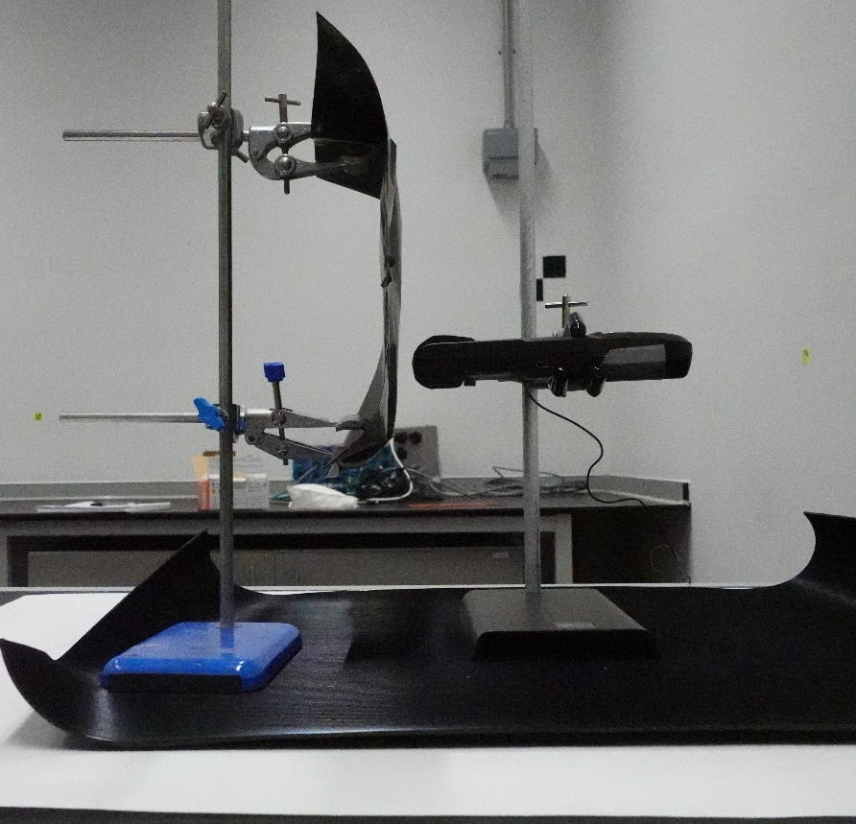
Figure 7 – Conducting Bag Setup

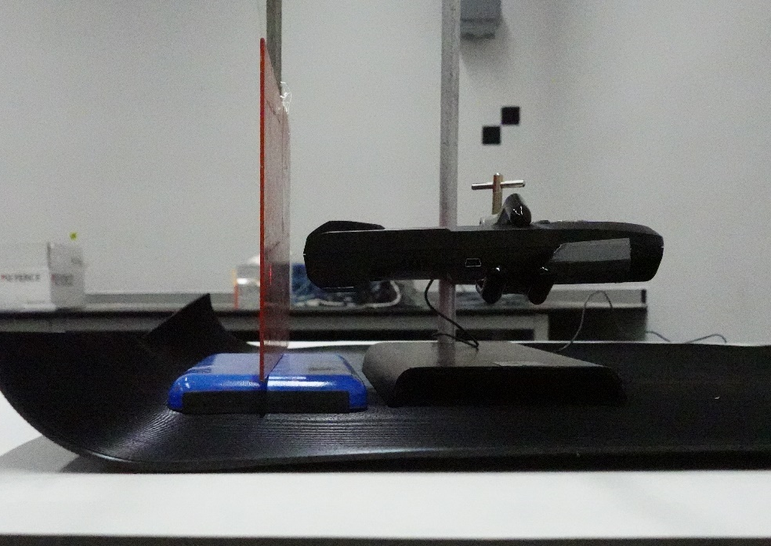
Figure 8 – Metal Plate Setup

4.8 – Repeatability Experiment
This experiment was carried out to assess how repeatable the results are from the static meter. By using a larger set of runs than previous experiments, and keeping the conditions identical throughout, the hope was that it would show that the results are reliable. Table 16 and 17 show the data collected, and Graph 24 provides the visualisation. The work was carried out in a non-conducting laboratory, using the metal base pot, the tapping rig and sugar as the inert simulant. The tapper control cycle was set to 50, instead of the usual 300. The measurement was taken approximately at the mid-point of the sample tube. To ‘restart’ a run, the sample tube would be placed onto the bench and left for 1 minute before starting the next run.

4.9 – Intentional Charging Investigation
As has been pointed out in the relevant literature section of this report, static electricity is believed to be a mechanism that proceeds on the surface of materials. Thus far, the experiments have been measuring the surface of the sample tube used in energetics processing. It is possible, that static charge is being generated within the material, but not being transferred into the collection pot. This would mean that the build-up of static charge has not necessarily been measured. Common laboratory materials were intentionally rubbed together, in an effort to generate a static charge. A summary of the different items attempted, and the measured affect can be seen in Table 18. Note that the static meter was zeroed before each measurement.
No change is voltage was detected when using nitrile gloves. A range in values indicate that the voltage would change depending on the point on the surface being measured. For the final attempt using the Sellotape using and lid of the container pot, the two different values represent the voltages seen on the two different surfaces. Figure 9 below shows the experimental setup.
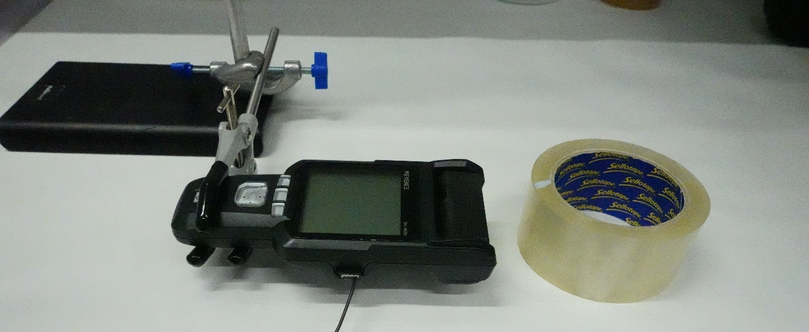
Figure 9 – Tape Measurement Setup
Finally, to assess if the static meter was able to penetrate and measure a voltage through a surface a new experiment was designed, shown in figure 10. First, the charge on the face of the tape was zeroed and measured. The Sellotape was intentionally charged by rubbing up and down in one direction on the rubber insulating mat. The charge was generated along at one point on the face of the Sellotape roll, not over the whole area. The charge on this point of the roll was measured, before it was lowered into a borosilicate glass container. Once the roll was in the container, another measurement was taken, where the laser standoff was set to the surface of the tape inside the glass container where another measurement was taken. The Sellotape was then removed from the glass container, and a final measurement was taken of just the glass, with no Sellotape present. Table 19 and Graph 25 present the data.
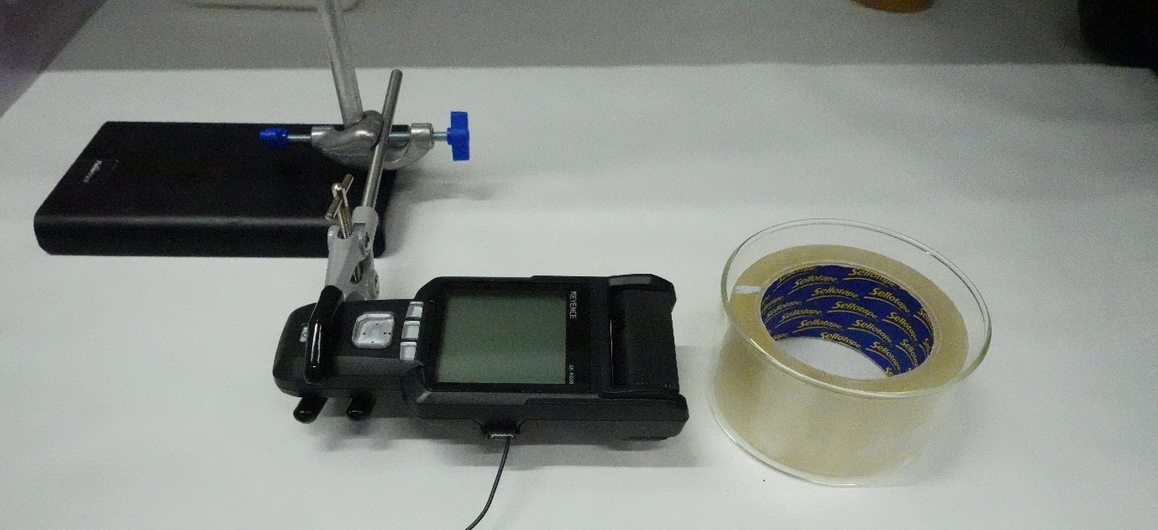
Figure 10 – Glass Container Experimental Setup

Chapter 5 – Discussion

5.1 – Introduction
This section will now discuss the results and any observations from the previous section, ordered and broken down according to the different experimental titles that have been given.

5.2 – Initial Development
Early observations from this work show that the voltage measured decreases as you move away from the base of the tapping rig from the data presented in Graph 1. The 5 mL measuring point is the closest part of the sample tube to the sample holder of the tapper, and was consistently the highest voltage reading, even though the tapper had not been used. In both instances, the addition of the glove appears to produce a slightly higher voltage across most of the measurements. There is however a sudden drop in the voltage with just the glove, as shown by the blue line when measuring towards the top of the sample tube. Some additional experimental observations captured as notes during the experiments were that the value given by the static meter would naturally decrease over time when a glove had been placed into the sample tube. It was this observation that prompted the use of quench / soak times in future experiments.

5.3 – Inert Experiments 1 & 2
Graph 2 shows some interesting results, the most significant being the high similarity between the ‘Rig, sugar, guard’ measurement and the post tap measurement. The post tap measurement was taken immediately after the tapper had finished in the ‘Rig, sugar, guard’ setup, with no changes made. The fact that the results were so similar is an indication that the action of the tapping rig had not generated any static electricity. Another observation that can be made from the data shown in Graph 2 is that putting the sample tube on the tapping rig, is having an effect on the voltage reading on the static meter. The empty on rig measurement shows significant variation from the empty on bench measurement, with the first comparable reading having a 253 V difference. Additionally, having the sample tube on the bench, both before and after the tapping operation show extremely similar results, as indicated by the green and orange lines. This could be because the metal in the base of the pot is allowing any charge to easily dissipate through the conducting surface of the bench, which is also connected to earth. From the results it appears that placing the tube on top of the rig is changing the static conditions that the sample tube sees. Additionally, the high difference in results from the addition of the guard, shown by the grey and yellow lines suggest that the presence of the guard might be impacting results.
Graph 3 reinforces the observations that can be made from Graph 2. These two experiments are identical, and although show fairly significant variations in the voltages (e.g. 342 V for the 50 mL measurement point in Inert Experiment 2, and -140 V for the same point in Inert Experiment 3) that have been measured, follow the same patterns as discussed above. Again, the two measurement conditions where the sample tube is on the bench provide similar, and flat readings. The addition of the sample tube onto the tapper sees the value rise, but then the addition of the sugar sees the voltage drastically fall. The similarity between the dark blue and yellow lines again suggests that the operation of the tapper itself is not having a large effect on the static reading. At this stage, it was difficult to suggest an explanation as to why the addition of the sugar had such a significant impact on the measured voltage. Could the action of pouring the sugar into the sample tube be generating a significant charge, or was the sugar statically charged prior to its introduction? A measurement of the sugar while it was on stored in its plastic container on the lab bench was taken, which produced a reading of approximately 20 V, suggesting the former.

5.4 – Inert Experiments 3 – 5
As stated, this used an identical experimental approach to the previous runs discussed in Graphs 2 and 3, but in a non-conducting lab. The results, as seen in Graph 4 from Inert Experiment 3 again demonstrate previous similarities. While there are again differences when the sugar has been added to the sample tube, they are not nearly as pronounced as they were in the conducting lab. Additionally, the two lines (grey and light blue respectively) are of similar shape this time, which was not seen previously. Additionally, there is a characteristic change in the measured voltage when the lid is measured while the sample tube is on the tapping rig. A couple of reasons for these observations could be that the different material is changing the value, or the action of screwing it on is generating a small static charge. It can be pointed out that this observation is also present for the data in Graphs 2 and 3.
Graph 5 from Inert Experiment 4 provides the first real deviations from the patterns that have been previously discussed. The sample tube when measured on the bench shows discrepancies between the initial and final measurements, and adding the guard appears to have made little difference to the voltage readings. One consistent observation however, is that the presence of the sugar within the sample tube has a large impact on the voltage measurement. A plausible theory for the discrepancies in the measurements could be the fact that as the lab was no longer conducting, and Normal base pot was being used. These factors could be preventing any static charge from readily dissipating. Evidence for this was not seen in Graph 4, which also used the same conditions. This contrast in findings has made suggesting a cause for the discrepancies a point for further discussion, which will be covered in a summary section for these experiments.
Moving onto Graph 6 and Inert Experiment 5, the trend in sample tubes being measured on the benchtop had returned, as demonstrated by the green and red lines respectively. This time however, the addition of the sugar to the sample tube had made the smallest difference compared to all other experiments. Where the addition of the guard made little difference from Experiment 4, the data suggests that in Experiment 5 it was a significant factor contributing to the voltage measurement. Another interesting observation from comparisons of the different experiments is that graphs were showing results similar to the ones seen in Graph 1, where the position of measurement closest to the base of the tapping rig, gave the highest voltage readings. All graphs presented this far exhibit this type of behaviour, whereby measurements near the base of the tapping rig produces different voltage readings to those as you move away. The only time the reading remained relatively constant was when the sample tube is on the bench or the measurement point was towards at the top point physically.
In summary, Experiments 3 to 5 have generally supported previous experimental observations that have been made. Discussed variations in the results, however, could come from a wide range of external factors. For example, it is important to note that when the operator would touch the sample tube, both when on the tapping rig and on the bench, the voltage measurement would change. This change could be as small as a 20 V difference, but could range up to approximately 80 V. This change in voltage was also seen when working under conducting conditions. The discrepancies in results could be due to the operator imparting a static charge on the sample tube, without having given enough of a quench time for effective dissipation. An explanation into why the voltage changes with the introduction of the guard could be due to how it is attached to the tapping rig apparatus. To keep the guard in place there were three screws and the action of fixing the screws in place could cause static charge to generate. This is because the internal friction generated between the screw and the walls of the threaded hole.
Graph 6, where the results appear to be most similar for each data series, was the last run of the day and all lab equipment had been on the bench for the longest time. This could be influencing the results as it could be statically equilibrating throughout that whole time. Additionally, there are small differences in the RH and temperature for each of the experiments. While unlikely, due to the small differences, their influence on results cannot be totally ruled out. Another important observation that was made during these initial experiments was that the voltage reading on the static meter would also change as the tube was rotated. For all measurements reported, the only change in measurement position has been along the Y axis of the sample tube. Rotating the in the X direction could also yield variations in the voltage, but would always measure the same as the first reading upon full rotation. This could suggest localised regions of static charge on the face of the sample tube, although it is not clear how these regions would materialise.

5.5 – Energetic Materials Trials
As discussed in the experimental results section, adaptations to the practical setup had to be made during this round of testing. There are however useful parallels that can be found in these results and the ones discussed above.
Graph 7 again shows the impact if attaching the guard to the experimental setup, with a significant peak seen under three of the tests. Importantly, the grounding wire appeared to neutralise this voltage, and cause any remaining voltage measurements to plateau. It is also worth noting even when the grounding wire was removed (e.g. the Condition of Measurement, Guard) the voltage measured remained the same, indicating that any static charge present had been successfully dissipated. Reattaching the grounding wire after the first time did not appear to alter results, further reinforcing this observation. It is not clear why Sugar Repeat 1 did not exhibit the same behaviour, but the likely cause is external environmental factors and not the reliability of the static meter.
Graphs 8 and 9 further reinforce the previous observation relating to the guard. This time however, the magnitude of the change had decreased. In Graph 7 the voltage measurement would change by a maximum of 80 V, whereas for Graphs 8 and 9 the maximum change was 28 V. An explanation could be due to environmental factors. The results from these experiments also highlight the impact of the grounding wire for static measurements. Graph 8 shows a similar result to Graph 7, whereby there was an immediate plateau in the measured voltage once the wire had made contact. Graph 9 however, shows some slight variation as the voltage did change after the grounding wire had been added. As the magnitude of this difference is a very low voltage, measurements seen in previous experiments and could be due to the ± 10 V accuracy of the static meter.
Results from the testing with explosive material 1 and 2 support the observations made above relating to the guard and impact of the grounding wire. These tests, however, saw the addition of another measurement condition. The guard was removed and another voltage reading was taken, as denoted by ‘No guard, post tap’ along the X axis. Upon removal of the guard, a drop in the voltage measurement was seen each time. While it is possible that the guard was holding some sort of charge, which would explain the drop in the voltage on its removal; it is also possible that the process of removing it is generating a negative charge, in comparison to the rest of the test apparatus.

5.6 – Further Development
These experiments were aimed at investigating the zeroing step, and if longer soak / quench times would impact the results. Repeat 1 of the empty tube experiment, as shown in Graph 12 indicates that the action of tapping had some effect on the sample tube regarding its static charge. Additionally, after the quench time of 30 minutes, the sample tube had still not equilibrated, and the voltage value was still rising. Repeat 2 and 3 of this experiment also demonstrate this behaviour, but with less magnitude. One theory that could explain the result seen in repeats 2 and 3 is that the zeroing step was only a temporary measure, and that the sample tube was gradually moving back towards its resting state as the quench time increased. It could also be true that the sample tube was reacting to external factors, such as the RH, and the gradual change was equilibration with the surrounding environment.
Addition of sugar into the sample tube slightly changes the voltage response given, as can be seen in Graph 13. Repeat 1 looked very similar in magnitude and shape to the same repeat with the empty tube experiment, except for the voltage reading plateauing with the quench time. The subsequent repeat runs for the sugar experiment show a consistent plateau across the measurements. As the magnitude of the change is so low, there is little observation that can confidently be made, as the difference could be due to environmental noise factors or the accuracy of the static meter. The fact that for both variations of repeat, the initial voltage was so low indicates the storage environment for the sample tube had a significant effect.

5.7 – Background Interference Testing
For all experiments, barring Graph 20 Repeat 2 and Graph 23 Repeat 3, the voltage decreased with the two-minute quench time. This indicates either the environment that the measurement system was in was causing a change in the measured voltage, or the physical act of moving the test apparatus was causing the change in the initial reading and that there was charge to dissipate. Additionally, as there is significant variation in each position and each repeat test with both test materials, it was not possible to come away with any clean scientific conclusions. From such varied results however, it was evidence that changing the local environment of the measurement system, was having an impact on the voltage readings, although the exact reasons remain unclear. These results could also be used as evidence in reinforcing the differences between previous identical experiments, further highlighting that the trends from the data were the important findings.

5.8 – Repeatability Experiment
The data in Graph 24 shows consistent results across all twenty repeats. Table 17 shows statistical analysis of the results. The fact that the standard deviation is lower for both the ‘Post Tap’ and ‘2 Min Quench’ is an indication that variance is decreasing, therefore suggesting that the process is having a measured effect on the process and potentially cutting out some of the instrument noise. Considering the accuracy of the static meter provided by the manufacturer, all readings for this lie within this value of the mean. Given there has been large variations in magnitude under identical conditions in previous experiments, this experiment does show good repeatability in results. However, the accuracy of the static meter is clearly an issue for these experiments where there is a very low magnitude change in the voltage. In practice, the value on the static meter would typically oscillate by approximately 5 V for a given measurement. Therefore, the value captured was at the moment the data was recorded.
Three key observations can be made from this experiment. First is that there is significant variation in voltage measurements under identical initial conditions. This could be due to background interference, or noise from the static meter measurement. Second is that operating the tapping rig is clearly generating a measurable increase in the static charge reading. This can be clearly seen as all measurements increased from the ‘Zero’ to ‘Post Tap’ measurement conditions. Finally is that the quench time appears to be allowing for static charge to dissipate. Although some of the data shows an increase in voltage between ‘Post Tap’ and ‘2 Min Quench’, the general trend is a decrease in voltage. Variation could be due to insufficient time given for the quench, or because of the accuracy of the static meter.

5.9 – Surface Phenomena Investigation
These results are likely some of the most important of the whole project. The fact that some materials were unable to be intentionally charged, when some were, is a factor that is beyond the scope of this study that plays into some of the uncertainty in the ordering of the triboelectric series and the mechanism by which charge is transferred. Important observations were the range of voltages measured from one charging scenario. From Table 18, the Sellotape on rubber mat charging experiment saw values range from 100 – 900 V. This range occurred as you move away from the point of charging. For example, the point at which the rubber and tape made contact, where there was the intentional friction saw the largest voltage of approximately 900 V. Moving the point of measurement away from this contact area caused the voltage reading to quickly drop. It is believed that this drop in voltage was a result of the area that the static meter is measuring over. As you move away from the point of contact, less of the statically charged area is visible to the measurement probe and therefore the value is decreasing. This means that the static meter is not measuring a single point, but instead a small area around where the laser standoff has been aligned, a point raised previously in the literature review [21]. This could be a source of error for readings using the collection tube previously mentioned, as the radius of the measurement circle could be larger than the face of the tube, compounded by the fact that it is measuring a curved surface, as the standoff is therefore only accurate for one point. Another key observation that can be taken from Table 18 is that in the instance where both friction surfaces were measured, opposite charges were seen. This confirms that the static meter is measuring the charge and that the triboelectric effect can be measured.
Finally, the Surface Mechanism Experiment provides another crucial observation for the work carried out in this project. The fact that the static meter reading could not penetrate through the borosilicate glass, to get a measurement of the charged tape lying inside provides evidence that the static electricity was only present on the surface of the tape. This however is an unexpected result, and it contrasts with what was found in the spray drying study [18]. This difference could be because the tape was not touching the face of the glass in the same way the powders were in the spray dryer. A possible explanation for the rise in voltage after the tape had been removed could be due to the measurement area radius discussed above. If a small amount of the static charge is being measured above the edge of the glass container when the tape was present, then the removal could lead to a change in the voltage and a truer measurement of the glass beaker. Alternatively, the static charge could be dissipating rapidly, causing the drop as the different measurement conditions were setup.

Chapter 6 – Evaluation
Discussions around each experiment and their results have been covered in the previous section. This chapter will tie together any findings and review outcomes overall. Drawing conclusions from the numerical data generated from the experiments in this study is challenging, given that the mechanism behind charge generation and factors influencing the triboelectric series are still not fully understood. As we have seen, voltage magnitudes can vary significantly between experiments that were identical in design. Explanations for these variations are difficult to provide, given that experimental conditions were supposed to be identical. There are many external variables that could not be reasonably controlled, such as static dissipative storage facilities for equipment, that will have had an impact on results. Even variables such as the RH, while recorded, were impractical to keep constant for all experiments.
Useful conclusions can be found in the correlations between the data; both from repeats of the same experiments and comparisons between different ones. Examples of this include: the impact of the guard during the tapping experiments and the impact of adding the grounding wire, as has been discussed previously. While theories regarding the change in voltage with the presence of the guard have been discussed, there is still no certain answer. However, the plateau in results when using a grounding wire is what you would expect to see, as you are offering a path for any charge to reach ground, which it will always follow. The soak / quench time is another important aspect that would benefit from further experimentation. It could be the case that longer soak times are needed in all cases for the static charge to dissipate, or it could be true that the required soak time is dependent on the environment that the test apparatus is in as well as the material properties highlighted in Equation 1. While the result from the spray drying experiment of recording the voltage increase through the collection vessel / glassware has not been repeated with the tapping rig, this could be because the process is simply not generating static. However, other factors such as difference in materials could also be a factor. Finally, the conclusions drawn from the repeatability experiment are valuable for the effect that the tapping rig is having, and the effect of the quench time.
The original aim of this project was to develop a testing regime that could be applied to different energetic material processes, and in that regard the project has been a success. It has been shown that the static meter can detect a static electricity charge, generated via triboelectric charging and that a suitable test methodology can be employed to capture this data, both with inert and explosive materials. Further experiments have been undertaken to better understand static electricity, and factors that contribute to its generation, but these have been for method refinement and are not an indication that the procedure is unfit for purpose.
If it is the case that this static meter is only capable of measuring the voltage on the surface of a material, where the internal charge does not penetrate through, this is not a significant issue. Understanding the static charge on the collection vessel is still vitally important for energetics processing, as it will likely be the first thing an operator touches at the end of the experiment. If it can be shown that a static charge has not been generated on this collection vessel, this aids with confidence that it will be safe to handle.

Chapter 7 – Conclusion & Recommendations
To summarise, this project has developed, from scratch, a new test method for measuring static electricity during energetic material processes. As has been shown, the experimental setup is adaptable and can be altered to better suit a particular task, while still collecting valuable data. Project steps have included: market research to identify a suitable device, SSoW generation to allow practical experiments to take place, initial experiments to develop an experimental methodology, implementation of this methodology on live energetics trials and subsequent research to better understand static electricity and help develop the method further. With this method in place, it could be applied to a process under development prior to the introduction of energetic material, adding to safety preparations for the task.
This research project has only scratched the surface of static electricity measurements. There are a huge number of options for potential further work in this field. Steps that could be conducted with the current equipment and facilities are utilising the static meter on different energetics processes. A more comprehensive list of further experiments can be found in Appendix B. One example would be a type of mixing apparatus, for example a bread mixer. These types of devices are often used to mix explosive formulations, and the static meter could measure the actual material in the mixing bowl, instead of the surface of the collection vessel. Additionally, the difference that fully conductive conditions could be explored further, as this is a key area for explosives work. Future work could involve the procurement of an inline probe that measures the inside of collection vessels, where the current static meter cannot. This would require significant method development however, as you could potentially be introducing physical contact between the measurement probe and the energetic material in question.

Chapter 8 – Reflection
Upon reflection a great deal has been learned from this research project. Developing a test methodology from scratch is not an easy task, especially in a field such as static electricity, where there was very little prior knowledge. Method development and being open to iterations on experimental design has been a vital learned skill during this project.
For future work, an approach that could benefit would be developing a greater understanding in the foundations of the subject, as well as more time spent reading to understand the fundamental science. Tying back the voltage readings to equations that govern their presence would have been a valuable addition but was not carried out in this project.

References

[1] | I. Shaluf, “An Overview on Static Electricity,” vol. 17, no. 2, pp. 212-220, 2008.
[2] | L. Britton, Avoiding Static Ignition Hazards in Chemical Operations: a CCPS Concept Book, John Wiley & Sons, 2010.
[3] | G. Luttgens, S. Luttgens and S. Wolfgang, Static electricity: understanding, controlling, applying, John Wiley & Sons, 2017.
[4] | D. Pieloth, H. Wiggers and P. Walzel, “Influence of thermodynamic, material, and bulk properties on electrical resistivity of particle layers,” Chemical Engineering & Technology, vol. 37, no. 4, pp. 627-634, 2014.
[5] | P. Atkins, J. De Paula and J. Keeler, Atkins Physical Chemistry, Oxford: Oxford University Press, 2017.
[6] | C. Reuben and e. al, “Cruise, Reuben D., et al. "The effect of particle size and relative humidity on triboelectric charge saturation,” Journal of Physics D: Applied Physics, vol. 55, no. 18, p. 185306, 2022.
[7] | Z. Xuan and e. al., “Rationalizing the triboelectric series of polymers,” Chemistry of Materials, vol. 31, no. 5, pp. 1473 - 1478, 2019.
[8] | R. Veregin, “A bidirectional acid-base charging model for triboelectrification: Part II. Experimental verification by inverse gas chromatography and charging of metal oxides,” Journal of Imaging Science and Technology, vol. 50, no. 3, pp. 288-293, 2006.
[9] | D. A.F and R. Felix-Nacarro, “Diaz, A. F., and R. M. Felix-Navarro. "A semi-quantitative tribo-electric series for polymeric materials: the influence of chemical structure and properties,” Journal of Electrostatics, vol. 62, no. 4, pp. 277-290, 2004.
[10] | M. Williams, “Williams, Meurig W. "Triboelectric charging in metal–polymer contacts–How to distinguish between electron and material transfer mechanisms,” Journal of Electrostatics, vol. 71, no. 1, pp. 53-54, 2013.
[11] | J. Smallwood, The ESD Control Program Handbook, John Wiley & Sons, 2020.
[12] | C. K. Ao and e. al, “Balancing Charge Dissipation and Generation : Mechanisms and Strategies for Achieving Steady State Charge of Contact Electrification at Interfaces of Matter,” Journals of Materials Chemistry, vol. 10, no. 37, pp. 19572-19605, 2022.
[13] | Ministry of Defence, “DSA03 OME part 2: In-Service and Operational Safety Management of OME,” 18 June 2020. [Online]. Available: https://assets.publishing.service.gov.uk/media/5ee8ccb8e90e070429b2d2fc/DSA_03_OME_PART_2__JSP_482__CH_17__Nov_19__-_mod_gov_uk.pdf. [Accessed 04 July 2025].
[14] | National American Space Association, “The Long Range Lightening Detection Network,” [Online]. Available: https://ghrc.nsstc.nasa.gov/uso/ds_docs/gailong/gailong_dataset.html. [Accessed 04 July 2025].
[15] | Ministry of Defence, Energetic Materials Testing and Assessment Policy Committee (EMTAP) Manual of Tests, UK Government, 2017.
[16] | S. Matsusaka, “Triboelectric charging of powders: A review,” Chemical Engineering Science, vol. 65, no. 22, pp. 5781-5807, 2010.
[17] | J. Per Thaastrup and A. Mynster, “Practical measurement of aircraft electrostatic charging,” in 2021 IEEE International Joint EMC/SI/PI and EMC Europe Symposium, Virtual, 2021.
[18] | M. Murtomaa and e. al, “Static Electrification of Powders During Spray Drying,” Journal of Electrostatics, vol. 62, pp. 63-72, 2004.
[19] | H. Lotfzadeh, K. Fatemeh and M. Fathollahi, “Reduction of electrostatic charging PETN and HMX explosives by PVP and ionic liquid,” Journal of Electrostatics, vol. 108, p. 103513, 2020.
[20] | M. Noras, “Non-contact surface charge/voltage measurements,” Capacitive Probe - Principle of Operation 3001, pp. 1-8, 2002.
[21] | A. Faithou and e. al., “Measurement of surface potential of non-uniformly charged insulating materials using a non-contact electrostatic voltmete,” IEEE Transactions of Dielectrics and Electrical Insulation, vol. 23, no. 4, pp. 2377-2384, 2016.
[22] | Keyence, Handheld Electrostatic Sensor Instruction Manual, Osaka: Keyence, 2024.
[23] | UK Health Security Agency, “Laser Radiation: Safety Advice,” May 2006. [Online]. Available: https://www.gov.uk/government/publications/laser-radiation-safety-advice/laser-radiation-safety-advice. [Accessed 03 July 2025].
[24] | Keyence, “Electrostatic Sensor,” Keyence, [Online]. Available: https://www.keyence.co.uk/products/static/electrostatic/sk/models/sk-h050/. [Accessed 22 July 2025].

Bibliography
A.F, D., & Felix-Nacarro, R. (2004). Diaz, A. F., and R. M. Felix-Navarro. "A semi-quantitative tribo-electric series for polymeric materials: the influence of chemical structure and properties. Journal of Electrostatics, 62(4), 277-290.
Ao, C. K., & al, e. (2022). Balancing Charge Dissipation and Generation : Mechanisms and Strategies for Achieving Steady State Charge of Contact Electrification at Interfaces of Matter. Journals of Materials Chemistry, 10(37), 19572-19605.
Atkins, P., De Paula, J., & Keeler, J. (2017). Atkins Physical Chemistry. Oxford: Oxford University Press.
Bisheng, T. (2017). Insight into electrostatic initiation of nitramine explosives. Journal of molecular modelling, 23(1), 10.
Britton, L. (2010). Avoiding Static Ignition Hazards in Chemical Operations: a CCPS Concept Book. John Wiley & Sons.
Chubb, J. (2002). Measurement of tribo and corona charging features of materials for assessment of risks from static electricity. IEEE Transactions on Industry Applications, 36(6), 1515-1522.
Chubb, J. (2002). New approaches for electrostatic testing of materials. Journal of Electrostatics, 54(3-4), 233-244.
Deng, T., Garg, V., & Bradley, M. (2023). Electrostatic Charging of Fine Powders and Assessment of Charge Polarity Using an Inductive Charge Sensor. Nanomanufacturing, 3(3).
Egan. (2017). Learning lessons from five electrostatic incidents. Journal of Electrostatics, 88, 183-189.
Faithou, A., & al., e. (2016). Measurement of surface potential of non-uniformly charged insulating materials using a non-contact electrostatic voltmete. IEEE Transactions of Dielectrics and Electrical Insulation, 23(4), 2377-2384.
Fujiwara, O. (1992). New approaches for measurement of static electricity toward preventing ESD. EICE Transactions on Communications, 75(3), 131-140.
Gabor, D., & al, e. (2019). Gabor, Dan, et al. "Study of methods for assessment of the ignition risk of dust/air explosive atmospheres by electrostatic discharge. Calitatea, 20(S1), 93.
Glor, M. (2003). Ignition Hazard Due to a Static Electricity in Particulate Processes. Powder Technology, 135, 223-233.
Henry, P. (1953). Henry, P. S. H. "Survey of generation and dissipation of static electricity. British Journal of Applied Physics, 4(S2), S6.
Kacpryzk, R. (2012). Measurements of electrical potential of constant charge objects. IEEE Transactions on Dielectrics and Electrical Insulation, 19(1), 134-139.
Kassebaum, J. (2002). Controlling static electricity in hazardous (classified) locations. Transactions on Industry Applications, 33(1), 209-215.
Keyence. (n.d.). Electrostatic Sensor. Retrieved June 24, 2025, from Keyence: https://www.keyence.co.uk/products/static/electrostatic/sk/models/sk-h050/
Lenzhofer, M., & al, e. (2022). Development of a Compact Wireless Sensor for Electric Field Measurements. Sensors and Measuring Systems; 21th ITG/GMA-Symposium (pp. 1-2). Berlin : VDE.
Lokre, V., Borkar, D., & Bankar, L. (1983). Electrostatic Charge Measurements on Initiators and Explosive Powders. Propellants, Explosives, Pyrotechnics, 8(5), 146-148.
Lotfzadeh, H., Fatemeh, K., & Fathollahi, M. (2020). Reduction of electrostatic charging PETN and HMX explosives by PVP and ionic liquid. Journal of Electrostatics, 108, 103513.
Luttgens, G., Luttgens, S., & Wolfgang, S. (2017). Static electricity: understanding, controlling, applying. John Wiley & Sons.
Matsusaka, S. (2010). Triboelectric charging of powders: A review. Chemical Engineering Science, 65(22), 5781-5807.
Ministry of Defence. (2017). Energetic Materials Testing and Assessment Policy Committee (EMTAP) Manual of Tests. UK Government.
Ministry of Defence. (2020, June 18). DSA03 OME part 2: In-Service and Operational Safety Management of OME . Retrieved July 04, 2025, from Gov UK: https://assets.publishing.service.gov.uk/media/5ee8ccb8e90e070429b2d2fc/DSA_03_OME_PART_2__JSP_482__CH_17__Nov_19__-_mod_gov_uk.pdf
Molinie, P. (2013). Modeling static charge dissipation on solids: An historical perspective. Journal of Electrostatics, 71(3), 591-596.
Molinie, P. (2024). How fast does a static charge decay? An updated review on a classical problem. Journal of Electrostatics, 129, 103930.
Murtomaa, M., & al, e. (2004). Static Electrification of Powders During Spray Drying. Journal of Electrostatics, 62, 63-72.
National American Space Association. (n.d.). The Long Range Lightening Detection Network. Retrieved July 04, 2025, from Global Hydrometeorolgy Resource Center: https://ghrc.nsstc.nasa.gov/uso/ds_docs/gailong/gailong_dataset.html
Noras, M. (2002). Non-contact surface charge/voltage measurements. Capacitive Probe - Principle of Operation 3001, 1-8.
Ohsawa, A. (2011). Statistical analysis of fires and explosions attributed to static electricity over the last 5 years in Japanese Industry. 13th International Conference on Electrostatics . Bangor: IOP Publishing.
Per Thaastrup, J., & Mynster, A. (2021). Practical measurement of aircraft electrostatic charging. 2021 IEEE International Joint EMC/SI/PI and EMC Europe Symposium, (pp. 609-614). Virtual.
Pidoll, U. v. (2009). An overview of standards concerning unwanted electrostatic discharges. Journal of Electrostatics, 67(2-3), 445-452.
Pieloth, D., Wiggers, H., & Walzel, P. (2014). Influence of thermodynamic, material, and bulk properties on electrical resistivity of particle layers. Chemical Engineering & Technology, 37(4), 627-634.
Povschenko, O., & Bazhenov, V. (2023). Analysis of Modern Atmospheric Electrostatic Field Measuring Instruments and Methods. Industrial & Technology Systems, 72(4), 16-24.
Reuben, C., & al, e. (2022). Cruise, Reuben D., et al. "The effect of particle size and relative humidity on triboelectric charge saturation. Journal of Physics D: Applied Physics, 55(18), 185306.
Sandu, I. (n.d.). Static Electricity Incident Review. Quincy: Fire Protection Research Foundation.
Shaluf, I. (2008). An overview on static electricity. Disaster Prevention and Management: An International Journal, 17(2), 212-220.
Shaluf, I. (2008). An Overview on Static Electricity. 17(2), 212-220.
Shoush, K., & al, e. (2013). Measurement of static electricity generated from contact and separation of clothes and car seat covers. nternational Journal of Scientific & Engineering Research, 4(10), 1-6.
Skinner, D. (1998). Electrostatic Discharge Ignition of Energetic Materials. Propellants, Explosives, Pyrotechnics, 23(1), 34-42.
Smallwood, J. (2020). The ESD Control Program Handbook. John Wiley & Sons.
Stofleth, J., Dinallo, A., & Medina, A. (2009). Technical Advisory Team (TAT) report on the rocket sled accident of October 9 2008. Albuquerque: Sandia National Laboratories.
Tilmatine, O., & al, e. (2022). Effect of ambient air relative humidity on the triboelectric properties of polypropylene and polyvinyl chloride slabs. Journal of Electrostatics, 115, 103651.
UK Health Security Agency. (2006, May). Laser Radiation: Safety Advice. Retrieved July 03, 2025, from https://www.gov.uk/government/publications/laser-radiation-safety-advice/laser-radiation-safety-advice
Veregin, R. (2006). A bidirectional acid-base charging model for triboelectrification: Part II. Experimental verification by inverse gas chromatography and charging of metal oxides. Journal of Imaging Science and Technology, 50(3), 288-293.
Weir, C., Pantoya, Michelle, & Daniels, M. (2013). The role of aluminium particle size in electrostatic ignition sensitivity of composite energetic materials. Combustion and Flame, 160(10), 2279-2281.
Williams, M. (2013). Williams, Meurig W. "Triboelectric charging in metal–polymer contacts–How to distinguish between electron and material transfer mechanisms. Journal of Electrostatics, 71(1), 53-54.
Xuan, Z., & al., e. (2019). Rationalizing the triboelectric series of polymers. Chemistry of Materials, 31(5), 1473 - 1478.
Yao, J., Zhou, F., & Zhao, Y. (2016). Charge Generation and Electrostatic Equilibrium for Single Granules During Sliding. Particuology, 126-134.
Zhang, L., Bi, X., & Grace, J. (2015). Measuremetns of Electrostatic Charging of Powder Mixtures in a Free-fall test Device. 102, 295-304.

Appendix A – Experimental Results

1.1 – Initial Development Results
Table 1- Method Development Experimental Results
Point on tube (mL) | Voltage Measured (V)
Point on tube (mL) | Empty | Glove | Empty + Guard | Glove + guard
5 | 250 | 250 | 374 | 365
10 | 99 | 225 | 192 | 230
15 | 44 | 133 | 85 | 179
20 | 20 | 95 | 46 | 155
25 | 6 | 74 | 35 | 142
30 | 0 | 64 | 25 | 130
35 | -5 | 45 | 23 | 127
40 | -12 | 34 | 23 | 109
45 | -25 | 10 | 22 | 100
50 | -39 | -30 | 35 | 95
Lid | -55 | -36 | 80 | 107

Graph 1 – Method Development Experimental Results

1.2 – Inert Experiments 1 & 2 Results
Table 2 – Inert Experiment 1
Metal Base Pot |  | 18° | 58% RH
Quench time (min) | Voltage Measured (V)
Quench time (min) | 0 | 5 | 5 | 5 | 0 | 0
Point of measurement (mL) | Empty on bench | Empty on rig | Rig + Sugar | Rig, sugar, guard | Post tap | Bench post tap
5 | - | 79 | -630 | -6 | 90 | -
10 | - | 120 | -801 | -188 | -54 | -
15 | - | 195 | -1020 | -393 | -265 | -
20 | -17 | 236 | -1210 | -511 | -412 | -40
25 | -10 | 232 | -1320 | -492 | -523 | -36
30 | -10 | 341 | -1390 | -485 | -564 | -37
35 | -15 | 398 | -1420 | -479 | -553 | -37
40 | -22 | 441 | -1460 | -442 | -523 | -36
45 | -25 | 462 | -1790 | -382 | -495 | -34
50 | -20 | 485 | -2080 | -354 | -465 | -36
Lid | -4 | 401 | -1710 | -77 | -117 | -39

Graph 2 – Inert Experiment 1

Table 3 – Inert Experiment 2
Metal Base Pot |  | 19° | 61% RH
Quench time (min) | Voltage Measured (V)
Quench time (min) | 0 | 5 | 5 | 5 | 0 | 5
Point of measurement (mL) | Empty on bench | Empty on rig | Rig + Sugar | Rig, sugar, guard | Post tap | Bench post tap
5 | - | 52 | -245 | -25 | 113 | -
10 | - | 75 | -194 | -46 | -23 | -
15 | - | 92 | -334 | -99 | -117 | -
20 | -40 | 160 | -357 | -143 | -221 | 22
25 | -36 | 220 | -352 | -139 | -238 | 33
30 | -24 | 263 | -404 | -225 | -274 | 27
35 | -32 | 332 | -398 | -219 | -253 | 41
40 | -22 | 342 | -453 | -363 | -290 | 35
45 | -25 | 398 | -496 | -338 | -322 | 24
50 | -31 | 342 | -482 | -374 | -360 | 24
Lid | -36 | 376 | -426 | -123 | -174 | 24

Graph 3 – Inert Experiment 2

1.3 – Inert Experiments 3 – 5 Results
Table 4 – Inert Experiment 3
Normal Base pot | AM | 19° | 61 % RH
Quench time (min) | Voltage Measured (V)
Quench time (min) | 0 | 5 | 5 | 5 | 0 | 5
Point of measurement (mL) | Empty on bench | Empty on rig | Rig + Sugar | Rig, sugar, guard | Post tap | Bench post tap
5 | - | -191 | -102 | 37 | 7 | -
10 | - | -182 | -124 | -32 | -37 | -
15 | - | -165 | -130 | -51 | -50 | -
20 | -33 | -160 | -119 | -65 | -65 | -27
25 | -30 | -150 | -119 | -75 | -57 | -31
30 | -25 | -140 | -110 | -71 | -60 | -30
35 | -23 | -140 | -109 | -67 | -57 | -30
40 | -21 | -140 | -110 | -66 | -56 | -30
45 | -21 | -137 | -110 | -67 | -52 | -30
50 | -20 | -140 | -109 | -57 | -55 | -26
Lid | -22 | -115 | -89 | -36 | -35 | -20

Graph 4 – Inert Experiment 3

Table 5 – Inert Experiment 4
Normal Base pot | PM | 19° | 66% Rh
Normal Base pot | Voltage Measured (V)
Quench time (min) | 0 | 5 | 5 | 5 | 0 | 5
Point of measurement (mL) | Empty on bench | Empty on rig | Rig + Sugar | Rig, sugar, guard | Post tap | Bench post tap
5 | - | -35 | 140 | 230 | 203 | -
10 | - | -40 | 59 | 110 | 109 | -
15 | - | -51 | 62 | 75 | 57 | -
20 | 52 | -55 | 79 | 55 | 42 | -44
25 | 50 | -60 | 62 | 51 | 32 | -40
30 | 20 | -64 | 45 | 51 | 32 | -38
35 | 10 | -65 | 41 | 55 | 36 | -33
40 | 1 | -70 | 38 | 61 | 44 | -28
45 | 6 | -67 | 42 | 70 | 52 | -21
50 | 1 | -66 | 40 | 74 | 50 | -15
Lid | 2 | -55 | 25 | 45 | 26 | -9

Graph 5 – Inert Experiment 4

Table 6 – Inert Experiment 5
Metal Base Pot | PM | 20° | 63% RH
 | Voltage Measured (V)
Quench time (min) | 0 | 5 | 5 | 5 | 0 | 5
Point of measurement (mL) | Empty on bench | Empty on rig | Rig + Sugar | Rig, sugar, guard | Post tap | Bench post tap
5 | - | 85 | 165 | 265 | 175 | -
10 | - | 45 | 62 | 145 | 62 | -
15 | - | 11 | 20 | 94 | 23 | -
20 | -41 | -3 | -9 | 63 | -1 | -42
25 | -32 | -8 | -19 | 50 | -10 | -36
30 | -32 | -13 | -23 | 43 | -16 | -37
35 | -32 | -15 | -25 | 42 | -17 | -37
40 | -31 | -19 | -29 | 38 | -19 | -36
45 | -30 | -26 | -35 | 32 | -23 | -34
50 | -40 | -35 | -42 | 28 | -22 | -36
Lid | -45 | -40 | -45 | 25 | 4 | -39

Graph 6 – Inert Experiment 5

1.4 – Energetic Materials Trials Results
Table 7 – Measurement Technique Testing
Measurement Condition | Empty Pot |  | Sugar
Measurement Condition | Measured Voltage (V) |  | Measured Voltage (V)
Measurement Condition | Repeat 1 | Repeat 2 | Repeat 1 | Repeat 2
No guard | -125 | -130 | -147 | -127
Guard | -205 | -184 | -140 | -179
Guard, grounding wire | -151 | -145 | -135 | -147
Guard | -150 | -144 | -138 | -141
Guard, grounding wire | -144 | -144 | -137 | -148

Graph 7 – Measurement Technique Testing

Table 8 – Sugar Tap, No Wire During Tap
Measurement Condition | Voltage Measured (V)
No guard | 0
Guard | -16
Guard, post tap | -10
Guard, wire, post tap | 13
guard, post tap | 13
guard, wire, post tap | 13

Graph 8 – Sugar Tap, No Wire During Tap

Table 9 – Sugar Tap, Wire Present During Tap
Measurement Condition | Voltage Measured (V)
No guard | -2
Guard | -26
Guard, wire | -5
Guard, wire, post tap | 3
Guard, wire, post tap, 2 min soak | 5
Guard, post tap | 5
Guard, wire, post tap | 5

Graph 9 – Sugar Tap, Wire Present During Tap

Table 10 – Explosive Material 1
Measurement Condition | Voltage Measured (V)
Measurement Condition | Repeat 1 | Repeat 2
No guard | 0 | 0
Guard | 75 | 275
Guard, wire | 45 | 165
Guard, wire, tap, 3 min soak | 43 | 144
Guard, post tap | 43 | 135
No guard, post tap | -95 | 76

Graph 10 – Explosive Material 1

Table 11 – Explosive Material 2
Measurement Condition | Voltage (V)
No guard | 2
Guard | 365
Guard, wire | 105
Guard, wire, tap, 3 min soak | 92
Guard, post tap | 93
No guard, post tap | -20

Graph 11 – Explosive Material 2

1.5 – Further Development Results
Table 12 – Empty Tube Experiment
Measurement Condition | Voltage (V)
Measurement Condition | Repeat 1 | Repeat 2 | Repeat 3
Initial | -147 | 71 | 22
Zeroed | 0 | 0 | 0
Post Tap | -50 | -20 | -20
10 min quench | 20 | -3 | -5
15 min quench | 32 | 0 | -3
20 min quench | 46 | 5 | 2
25 min quench | 54 | 11 | 12
30 min quench | 70 | 16 | 21

Graph 12 – Empty Tube Experiment

Table 13 – Sugar Experiment
Measurement Condition | Voltage (V)
Measurement Condition | Repeat 1 | Repeat 2 | Repeat 3
Initial | -110 | 5 | 10
Zeroed | 0 | -5 | -2
Post Tap | -28 | -11 | -7
10 min quench | 0 | -3 | -7
15 min quench | 1 | 0 | -5
20 min quench | 1 | -1 | -6
25 min quench | 4 | 6 | -8
30 min quench | 5 | 9 | -8

Graph 13 – Sugar Experiment

1.6 – Background Interference Testing Results
Table 14 – Conductive Bag Measurements
 |  | Conducting Bag
Repeat No. |  | Position 1 |  |  |  | Position 2 |  |  |  | Position 3 |  |  |  | Position 4 |  |  |  | Position 5
 |  | Voltage Measured (V) |  |  |  | Voltage Measured (V) |  |  |  | Voltage Measured (V) |  |  |  | Voltage Measured (V) |  |  |  | Voltage Measured (V)
 |  | Initial |  | 2 minute quench |  | Initial |  | 2 minute quench |  | Initial |  | 2 minute quench |  | Initial |  | 2 minute quench |  | Initial |  | 2 minute quench
1 |  | 15 |  | 10 |  | 111 |  | 100 |  | 80 |  | 65 |  | 70 |  | 55 |  | 190 |  | 110
 | 2 |  | 75 |  | 59 |  | 50 |  | 27 |  | 160 |  | 120 |  | 45 |  | 30 |  | 125 |  | 90
 | 3 |  | 200 |  | 30 |  | 175 |  | 130 |  | 17 |  | 9 |  | 10 |  | -5 |  | 85 |  | 62

Table 15 – Metal Plate Measurements
 | Metal Plate
Repeat No. | Position 1 |  | Position 2 |  | Position 3 |  | Position 4 |  | Position 5
Repeat No. | Voltage Measured (V) |  | Voltage Measured (V) |  | Voltage Measured (V) |  | Voltage Measured (V) |  | Voltage Measured (V)
Repeat No. | Initial | 2 minute quench | Initial | 2 minute quench | Initial | 2 minute quench | Initial | 2 minute quench | Initial | 2 minute quench
1 | 60 | 45 | -20 | -25 | 20 | 10 | 47 | 5 | 31 | 7
2 | 44 | 25 | -31 | -30 | 84 | 57 | 62 | 21 | 33 | 15
3 | 42 | 27 | 3 | -5 | 26 | 3 | 34 | 22 | 3 | 7

Graph 14 – Using Conductive Bag

Graph 15 – Using Conductive Bag

Graph 16 – Using Conductive Bag

Graph 17 – Using Conductive Bag

Graph 18 – Using Conductive Bag

Graph 19 – Using Metal Plate

Graph 20 - Using Metal Plate

Graph 21 – Using Metal Plate

Graph 22 – Using Metal Plate

Graph 23 – Using Metal Plate

1.7 – Repeatability Experiment Results
Table 16 – Repeatability Experiment Data (Split over two tables for readability)
Measurement Condition | Voltage Measured (V)
Measurement Condition | Run Number
Measurement Condition | 1 | 2 | 3 | 4 | 5 | 6 | 7 | 8 | 9
Initial | -13 | -5 | -1 | -9 | -6 | 4 | -9 | -9 | -6
Zero | 0 | 0 | 0 | 0 | 0 | 0 | 0 | 0 | 0
Post Tap | 9 | 17 | 3 | 11 | 17 | 9 | 7 | 12 | 8
2 Min Quench | 10 | 9 | 5 | 9 | 15 | 11 | 7 | 10 | 10

Measurement Condition | Voltage Measured (V)
Measurement Condition | Run Number
Measurement Condition | 10 | 11 | 12 | 13 | 14 | 15 | 16 | 17 | 18 | 19 | 20
Initial | -2 | -4 | -5 | -8 | -8 | 2 | -8 | -6 | -3 | -12 | -7
Zero | 0 | 0 | 0 | 0 | 0 | 0 | 0 | 0 | 0 | 0 | 0
Post Tap | 16 | 9 | 11 | 6 | 12 | 18 | 9 | 9 | 15 | 9 | 10
2 Min Quench | 11 | 10 | 7 | 2 | 10 | 16 | 5 | 7 | 11 | 7 | 9

Graph 24 – Repeatability Experiment
Table 17 - Statistical Analysis of Repeatability Experiment
Measurement Condition | Mean | Range | Mode | Std Dev
Initial | -5.35 | 17 | -9, -8, -6 (3x) | 4.48
Zero | 0 | 0 | 0 | 0
Post Tap | 10.6 | 15 | 9 (5x) | 3.53
2 Min Quench | 9.05 | 14 | 10 (4x) | 2.82

1.8 - Intentional Charging Investigation Results
Table 18 – Intentional Triboelectric Charging Attempts
Items | Voltage Measured (V)
Nitrile glove on nitrile glove | 0
Nitrile glove on container pot | 0
Nitrile glove on foam packaging | 0
Roll of Sellotape on rubber mat | 100 – 900
Roll of Sellotape on cotton | -100 to -250
Roll of Sellotape on container pot | 80
Roll of Sellotape on lid of container pot | 45 (Tape), -150 (Lid)

Table 19 – Surface Mechanism Experiment
Measurement Condition | Voltage (V)
Measurement Condition | Run No.
Measurement Condition | 1 | 2 | 3
Tape (pre charge) | 0 | 0 | 0
Tape (Charged) | -300 | -250 | -225
Tape in glass container | -20 | -20 | -15
Glass beaker only | 5 | 1 | 5

Graph 25 – Surface Mechanism Experiment

Appendix B – Supplementary Information

1 – Static Meter Specifications
Table 20 – SK-H050 [24]
Model |  |  | SK-H050
Charge potential measurement | Measurement mode |  | High-precision mode, Wide-range mode
Charge potential measurement | Measuring distance | High-precision mode | 25 mm
Charge potential measurement | Measuring distance | Wide-range mode | 100 mm
Charge potential measurement | Measuring range | High-precision mode | ±2 kV
Charge potential measurement | Measuring range | Wide-range mode | ±50 kV
Charge potential measurement | Measuring accuracy | High-precision mode | ±10 V^{*1}
Charge potential measurement | Measuring accuracy | Wide-range mode | ±100 V^{*1*2}
Charge potential measurement | Display resolution |  | 0 to 999 V : 1 V, 1.00 to 9.99 kV : 0.01 kV. 10.0 kV and higher : 0.1 kV
Charge potential measurement | Sampling cycle |  | Approx 1.4 ms
Temperature measurement | Measuring range |  | 0 to +40°C
Temperature measurement | Measuring accuracy |  | ±1°C^{*3}
Temperature measurement | Display resolution |  | 0.1°C
Temperature measurement | Sampling cycle |  | 1 s
Humidity measurement | Measuring range |  | 10 to 85% RH
Humidity measurement | Measuring accuracy |  | ±5% RH^{*3}
Humidity measurement | Display resolution |  | 1% RH
Humidity measurement | Sampling cycle |  | 1 s
Charge monitor function | Ion balance measuring mode | Ion balance measuring range | ±1 kV^{*4}
Charge monitor function | Ion balance measuring mode | Measured voltage display resolution | ±10 V^{*4*5}
Charge monitor function | Ion balance measuring mode | Measured voltage display resolution | 1 V^{*4}
Charge monitor function | Static elimination time measuring mode | Charge voltage | ±1400 V^{*4}
Charge monitor function | Static elimination time measuring mode | Static elimination time display resolution | 0.1 s^{*4}
Charge monitor function | Static elimination time measuring mode | Measuring time | 0 to 99 s^{*4}
Laser class |  |  | Class 1 Laser Product (IEC60825-1: 2014 FDA(CDRH)Part1040.10^{*6})
PC interface |  |  | USB 2.0 Full Speed
Power supply |  |  | 2 AA alkaline dry-cell batteries
Power supply | Operating time |  | 8 hours (in charge potential measuring mode)
Environmental resistance | Ambient temperature |  | 0 to +40 °C (No freezing or condensation)
Environmental resistance | Relative humidity |  | 10 to 85 % RH (No condensation)^{*7}
Material |  |  | SK-H050 : PC-ABS, PC, SUS/SK-H055 : PC, SUS, PTFE, PVC
Weight |  |  | SK-H050: Approx. 240 g, SK-H055: Approx. 220 g

2 – Safe Systems of Work Summary

2.1 – Method Statement
The task will involve using the static meter to measure the build-up of static electricity in different processes. This method statement is only for generic use of the static meter, and not the process it is being applied to. The process on which the static meter is investigating static electricity build up will have its own SSoW relating to the specific materials that are being used.

An example use for this method is to measure build-up of static during tapping on an upcoming trial series. The vessel on the tapping rig will be filled with an energetic material, while under test. The amount of static electricity generated during, immediately after, and after a ‘quenching period’ will be measured using the static meter (also referred to as an electrostatic fieldmeter and surface potential meter). The static meter does not come into direct contact with the measured surface, and instead utilises a standoff.

The static meter works by surface potential and measures DC voltage. The manufacturer of the static meter has stated that a detailed breakdown of how the meter works is proprietary information. An overview on how the instrument works is as follows:

A surface potential meter works by detecting the electric field created by the surface charge of the material being measured. When the probe is positioned near a charged surface, the electrostatic potential is induced in the sensing electrode, which is proportional to the surface potential due to the electric field from the surface charge. This allows for non-contact static measurements to occur, whereby the measured voltage is proportional to the distance between the probe and the measured surface. Additionally, the static meter must remain grounded (via the supplied grounding wire) throughout its operation.

Static meter and tapping rig testing operation checklist:
- Ensure the locking mechanism for the battery compartment is engaged and taped over on the static meter.
- Turn on the static meter.
- Set the standoff from the static meter to the part of the process that is being measured using the laser, while no energetic material is present. (e.g. sample tube on tapping rig)
- Turn off laser in settings.
- Zero the static meter.
- Proceed with process setup, as dictated in the relevant SSoW.
- Start the static meter measurement.
- Note static meter reading before the process starts.
- If required, set up remote viewing camera on static meter display.
- Start the process that is being measured.
- Record static measurement during the process.
- Record static measurement after an appropriate quench time once the process has finished.
- Proceed with clean-up process according to the process SSoW.

2.2 – Risk Assessment
Table 21 – Risk Assessment Matrix
Hazard  (Description) | How might they be harmed | L | S | Inherent Risk | Control measures | L | S | Residual risk
Electrical discharge from measuring face of the static meter | Electric shock from touching the metal plate used for static measurements.  Injuries could include small burns that require minor first aid | 3 | B | Low | - Staff have received sufficient training, and are competent in using the static meter, and know not to touch the metal plate whilst the meter operating  - Adequate time will be allocated to ensure that staff have sufficient opportunity to complete the task carefully, without the pressure of rushing or making errors  - A grounding connection clip is provided with the static meter and must be used whenever performing static measurements | 2 | B | Low
Negligence by staff operating the static meter | By parts interacting with energetic material, providing sufficient stimulus for a detonation.  Injuries could be life changing if in close proximity to an event. | 2 | C | Low | - The user will ensure that the battery compartment locking mechanism is securely engaged before use, and is properly taped over  - Batteries must only be changed in area where contraband restrictions for operating with explosives are not in place  - The laser will be used to set the standoff, and then must be turned off while the process is being undertaken | 1 | C | Low

3 – Further Work Recommendations

3.1 – Calibration Experiments
This experiment would use a surface or area of known voltage for the static meter to take measurements from. An example could be a conductive copper plate with a fixed voltage applied across it. The static meter could then be aligned and a voltage measurement taken to see how closely the measurement matches the known value. This method could be applied to both the High-precision mode and Wide-range mode described in the Table 19, Appendix B. The known voltage could also be cycled across a range, to test how the static meter handles changing voltages. These experiments could not be carried out during this project, due to a lack of equipment available being able to produce a fixed voltage.

3.2 – Measurement Aperture Experiments
Building upon the previous calibration experiments, potential work could be to investigate the area the area that the probe measures over. It has been pointed out during the relevant discussion that the prove does not measure a single point, and will instead measure a circular area, scaling with the distance between the probe and the measured surface. To investigate this, a target-based experiment could be designed, using the style of an archery target.
At the centre of the target, would be a metal circle where a known voltage is applied. Moving away from the centre, expanding concentric rings would be spaced at fixed distances (e.g. every 2.5 cm). The static meter would take a measurement on each of these rings, to investigate how the measured voltage changes as you move away from the central, known voltage point. This experiment could again be conducted across the different range modes that the static meter offers.

3.3 – Mixing Surface Experiments
To further investigate the effect directly measuring the surface has on the voltage reading, a bread mixer could be used. Initially, practice runs using inert materials would be conducted in a similar fashion to this study. The work could then progress onto live energetics, as formulations are often mixed in bread-style mixers. As the static meter measurement probe can be rotated through 180°, the probe could be aimed onto the surface of the material being mixed from above the mixing bowl. As the mixing is being conducted, voltage measurements could be taken. Development of this method could seek to investigate how the voltage changes over the distance from the mixing rod in the bowl. It could be the case that the charge is only localised to the point of contact between the material and the mixing blade, or the charge could spread as the material moves throughout the bowl.

3.4 – Particle Size and Mixing Material Experiments
If the results from the experiments suggested in 3.3 above yielded results suggesting static charge is being generated, then further investigations utilising the setup could be conducted. Some of the variables that could be analysed include how the effect of particle size and how the addition of different materials to create a blended formulation (e.g. metal particles) change the voltage measured.

3.5 – Dissipation Experiments
Using a similar setup to the calibration experiments, further dissipations studies could be carried out. A material could be provided with a known charge, which is measured by the static meter. The current would then be cut from the material, and the static meter would measure how long the charge takes to dissipate, when the material is still connected to ground. Next, the material could then be charged to a known voltage again, but this time electrically isolated from ground, after the voltage had been applied. The static meter would still be measuring at this time, and the difference in time taken for the charge to dissipate could be investigated.

