HOW TO STOP/START MYSQL SERVER from Workbench:

Open MySQL Workbench

Select Local Instance:
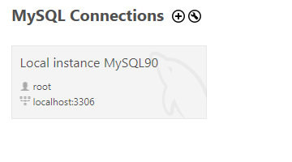
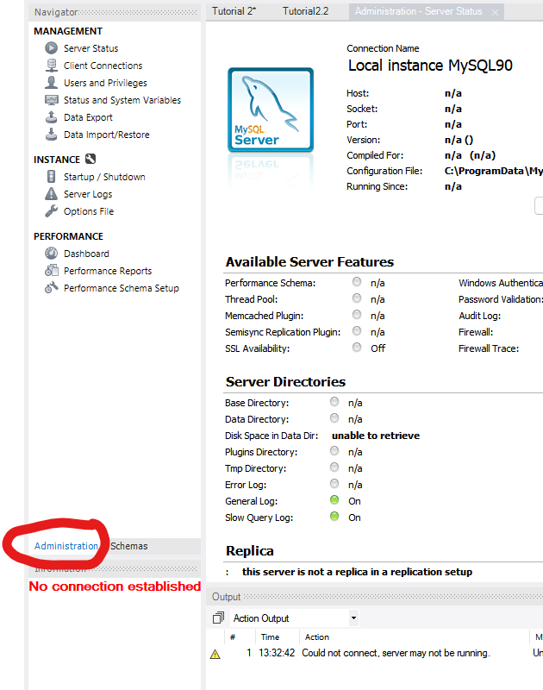
Click on Administration tab :

Select Startup/Shutdown:
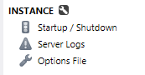

Select Start or Stop Server:


