Thomas Evans
P145653
Course: Web Development
Module: Web Development
ASP.NET Web development
Kemi Ademoye

Table of Contents
Introduction
Implementation
Evaluation
References
Bibliography

Introduction
This report has been written to accompany an asp.net web application designed and developed for the web development module. This report will cover the purpose of the application as well as its target audience and how the web application is relevant. There will be a section covering the desired features that the application should contain as well as a set of screenshots of the finished application. The final section of the report will be an evaluation section which will discuss the testing of the application and will outline some of the errors that were encountered during the development cycle of the application. There will be a section covering the look and feel of the website covering the websites usability and content. Finally there will be a section reflecting on the content of the application with recommendations on possible improvements that could be made in the future to complete the application.

Implementation
The web application designed for the purpose of this assessment is intended to be a festival booking site. The system will keep records of all acts and their performances. The application will include tables for act, performances, customers, and bookings. The application should allow the user to create an account and then allow them to make a booking. The application should allow them to select a certain performance when making a booking for it. The application should contain a database that can store any bookings as well as data on the acts and performances available. The database’s tables should contain a set of relationships to connect all the tables inside of the database.
Requirements
Must Have – The application should contain have a working database. The database should include all of the needed tables and relationships. The database should include enum’s for the stages and genres that are available at the event that can be used on the performance and act tables. There should be an application user table that extends the customer class and these classes should be connected by a relationship. The act and performance tables should be connected by a one to many relationship so that one act can have many performances. The customer and booking table should be connected via a one to many relationship so that one customer may have many bookings. As should the booking and performance table should be connected by a one to many relationship so that one performance can have many bookings. All inputs into the database should be validated to ensure the correct data is being run into the database. For example a phone number only being allowed to include characters that are numbers and only being to include 11 numbers.
Should Have – The application should have a series of controllers that allow the user to use these tables to create bookings and create customer profiles. There should also be section that allows festival staff to add act and performance details. These controllers should be kept in the controller file in the web project.
Could Have – There could be some security for the application. For example a login section could be added so that only users who have registered on the customers table can make bookings. Also general users should not be able to make changes to the act of performances tables. This would cause disruptions in the application. A feature that could be added to the project would be a feature that could allow the user to view previous bookings for tickets and access those bookings via the application.
Won’t Have - a feature that could be added to the application but won’t be at this stage of the applications development would be to add images to all of the acts fields with images of the bands or performers and then display these on the controllers. This would be a small feature but could greatly improve the applications look and feel. A feature to allow customers to cancel bookings could be implemented. Also a feature to restrict the amount of bookings that can be made on a certain performance depending on the stage the performance could be implemented and would ensure events are not overcrowded when taking place.

Screenshots
The below screenshots show databases working and the tables that the databases contains using the entities created earlier in the project. The second screenshot shows the application running. Unfortunately there were no views added to the project and therefore the screenshot only shows the default display for the asp.net core application. No controllers were able to be created due to the lack of option to add a scaffolding item when working on the project.
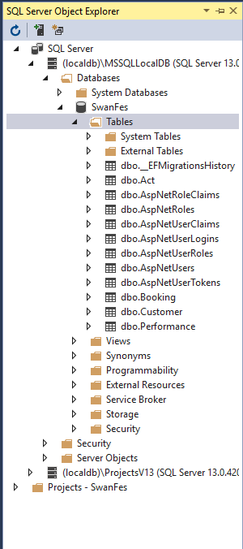
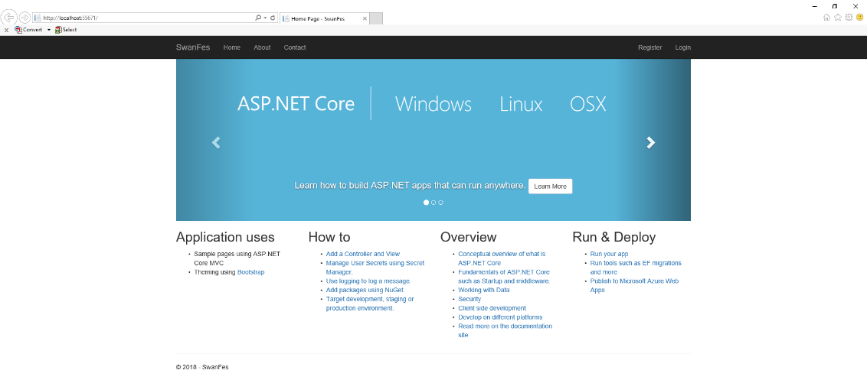

Evaluation
When creating the applications database there were many errors encountered that would at first stop the database from being built. One of the errors encountered was due to an old version of the web project being added when first creating the project. This cause a minor delay as the web project needed to be recreated with the up to date version.
When creating the one too many relationships during the build of the database there were issues as the ‘[Foreign key = “ActID”]’ section of the code kept revealing errors with the window returning errors saying that the ‘ActID’ was being overused. This was fixed by removing that section of the code. The database then built correctly.
When moving on to the creating controllers for the web project there was a problem that was come across. Visual Studio for some reason would not allow scaffolding items to be created inside of the web project. An unknown reason that could not be fixed. When trying to create the controllers on a different computer the application would allow scaffolding items to be created but would not allow the from the data project. This problem re occurred on several of the computers tried when trying to complete this section of the assignment but unfortunately a solution could not be found for this issue.
Sadly it is quite difficult to evaluate the look and feel of the application as an interface was not created due to the problems encountered when creating the controllers. Therefore this would need to be addressed in the future if the project is revisited.
Although the application remains unfinished due to issues encountered. The database is working and contains the correct tables and relationships that were intended to be included when first creating this project. Unfortunately the inability to create controllers has rendered the application a failure. If the project were to be revisited the scaffolding item issue would need to be addressed before progressing and then the views that would allow the user to interact with the database would need to be created. Once these things have been implemented it would be important to implement some security measures to protect the database from such security issues as SQL injection and malicious file uploads.

Bibliography
Moodle.uwtsd.ac.uk. (2018). UWTSD Moodle 17/18: Log in to the site. [online] Available at: https://moodle.uwtsd.ac.uk/course/view.php?id=2290 [Accessed 13 Jul. 2018].
W3schools.com. (2018). W3Schools Online Web Tutorials. [online] Available at: https://www.w3schools.com/ [Accessed 13 Jul. 2018].
W3schools.com. (2018). ASP Tutorial. [online] Available at: https://www.w3schools.com/asp/ [Accessed 13 Jul. 2018].
Docs.microsoft.com. (2018). Getting Started on ASP.NET Core - New database - EF Core. [online] Available at: https://docs.microsoft.com/en-us/ef/core/get-started/aspnetcore/new-db [Accessed 13 Jul. 2018].
Docs.microsoft.com. (2018). Overview of ASP.NET Core Security. [online] Available at: https://docs.microsoft.com/en-us/aspnet/core/security/?view=aspnetcore-2.1 [Accessed 13 Jul. 2018].

