Student Self Evaluation Form

Common Assessment Criteria Applied
Common Assessment Criteria Applied | REFER |  | D |  | C |  | B | A
 | OUTRIGHT FAIL | UNSATISFACTORY | SATISFACTORY | GOOD |  | VERY GOOD |  | EXCELLENT
1. Subject Knowledge and Understanding (which includes using research-informed literature and knowledge and understanding of the subject)
 |  |  |  | X
2. Intellectual Skills (Analysis)
2. Intellectual Skills (Analysis) |  |  | X
3. Pedagogic and Professional Applications (Practical Application and Deployment)
 |  |  |  | X
4. Key Transferable Skills
4. Key Transferable Skills |  |  |  | X
This section repeats in brief the common assessment criteria detailed on previous pages. The extent to which these are demonstrated by you determines your mark. Using these criteria, tick the box that best indicates the level of achievement you feel you have achieved with regard to each of them.
PLEASE COMMENT ON AREAS IN WHICH YOU FEEL THAT YOU HAVE PERFORMED WELL | PLEASE COMMENT ON AREAS you feel that you need TO DEVELOP
I feel I have performed well in providing literature of the research methods that were adopted. Also, I have been able to illustrate the key findings appropriately. | I think I need to develop my analysis skills, I will work on this in preparation for the next assignment.

ECPP7001-C
1301172
Word count: 6230

Table of Contents
Aim, focus and purpose of the research…………………………………..Page 4.
Short Overview of the Relevant Literature………………………………..Page 5.
Explanation of your Lesson Study Design…………………………………Page 9.
Ethical Considerations……………………………………………………..Page 14.
Lesson Study 1 and analysis……………………………………………….Page 15.
Lesson Study 2 and analysis………………………………………………..Page 18.
Discussion of the research findings…………………………………………Page 21.
Conclusion…………………………………………………………………..Page 24.
References…………………………………………………………………..Page 28.
Appendices………………………………………………………………….Page 32.

Aim, focus and purpose of the research
This research will be focusing on whether mini plenaries improve pupils’ engagement during independent tasks. It is a small scale study and the aim of this research is to improve our own practice and allow us to become enquiring practitioners. The reason for choosing this topic was because as a pair, my research partner and I found that in our professional teaching experience (PTE), keeping the children engaged during the independent tasks was an issue. Therefore we were interested in investigating whether using mini plenaries could be an effective way of helping children keep on task during their independent learning. Together our research question is, ‘Do mini plenaries improve pupil involvement during independent learning in a key stage 2 classroom?’
The research took place in two separate primary schools, School A is situated in a large town in Carmarthenshire, and the School B is located on the outskirts of Swansea. My class is a year 4 class with 36 pupils, there are 14 children with Additional Learning Needs (ALN) and 4 with English as an Additional Language (EAL). My partner’s class is a year 3/4 group and has 30 pupils. School A has 39% of children on free school meals (FSM) and many of the children have issues in keeping engaged and involved during the independent task. We are aware that with our findings from this research we will not be able to generalise it to every child, however it is a way of improving our teaching knowledge and investigating children’s involvement and whether mini plenaries can be used as a useful tool within the classroom. Research questions will include questions such as; did the mini plenaries help children’s understanding of the work? Were the mini plenaries useful for keeping the children engaged and involved in their independent tasks? Did the children find the mini plenaries helpful in between intervals?

Short overview of relevant literature.
Previous literature states that the use of mini plenaries within the class are concerned with the completion of a task and is a form of ‘scaffolding’ children’s learning during a task instead of at the end (Joyce-Gibbons 2016). Furthermore, Quintana and colleagues (2004) states that by introducing mini plenaries a teacher is modelling the standard of delivery and reflection which the pupils will need in order to solve a problem during the task.
According to DfES (2004, p.10) plenaries can take place as a series of short plenaries throughout the lesson, also known as ‘mini plenaries.’ Furthermore, DfES (2004) stated that pupils who are lower-attaining benefit from having many starters and plenaries during a lesson, in order to review their learning at regular intervals. In a case study, there was evidence that children were often distracted during independent tasks and work was often left unfinished by the end of a lesson. DfES (2004) states that telling pupils how much time they have left to complete the task helps keep them focused, this refers to our findings in the two lesson studies we did, which will be mentioned in the lesson study analysis and the discussion section.
It is suggested that a successful mini plenary will allow children time to reflect on their learning, make reference to the learning that is taking place during the lesson and the steps to success (DfES 2004, Hillcrest Academy (date unknown). Furthermore, Price and O’Donovan (2006) states that in order for a child to reach their full potential in a task, the students need to understand the task and the success criteria. This also encourages children to self-assess their work independently against the success criteria. Therefore, during a mini-plenary there should be motivation for the children to self-assess their own work and ensure that they have met the lesson’s learning aims using the lessons steps to success (success criteria), as well as consolidating the lessons learning, addressing misconceptions and making links to future learning (Hillcrest academy (date unknown).
What is involvement?
Involvement has been described as a quality of a human’s activities which is recognised through their concentration and persistence (Starbuck and Webster, 1991, Laevers 1994, p.162). Moreover, a pupil’s involvement indicates that development is taking place in their learning and a child’s involvement in class is detrimental to their level of learning. Laevers (1994, p. 167 and p.168) concluded from research using the Leuven involvement scale that teacher and school characteristics contain some of the characteristics which are responsible for a child’s level of involvement within the classroom. Furthermore, they stated that a treatment variable with involvement could include “support ongoing through stimulating impulses and enriching interventions” (Laevers 1994, p168). Thus, bringing in mini plenaries as an ongoing process throughout the lesson to support the children could be introduced as a way of encouraging children’s involvement in their work. This is referred to as “implementation involvement” (p, 168).
Lack of involvement in class.
There has been research which suggests that children’s lack of participation in a school environment can be due to a lack of confidence (Bouffard et al 1996). Some children may be afraid of asking a question or saying something wrong in the fear that it comes across as foolish and therefore withdraw themselves from participation. Bringing more mini plenaries in during the lesson to support children’s learning will ensure children know what they are doing as they are constantly being referred back to the success criteria without children having to ask questions. It has been found that children’s engagement in the classroom with peers, teachers and work is related to their development of self-regulating (Zimmerman 2000, Wilford et al 2013). Furthermore, they found that when pupils were positively engaged with teachers and actively engaged with their work, they made greater gains in task orientation.
Studies using the Leuven Involvement Scale.
Laevers (2011) developed the Leuven Involvement Scale which was concerned with observing how involved and engaged children are. When observing a child’s involvement, it refers to the pupil’s concentration on a task, if a child is interested in the work then the pupil will operate at the limits of what they are capable of – ensuring the child is working to their best ability. According to literature, involvement is seen as a measure of ‘deep learning,’ and when deep learning occurs, this is when individuals are reaching their full learning potential (Nelson Laird 2005, Laevers 2011). Furthermore, deep level learning is an example of deep level processing, which focuses on substance of information and understanding the meaning of the information through using various strategies (Biggs 1989). Additionally, deep learning occurs in a satisfying experience, whereby a child is engaged in the task and is suggested to result in pupils achieving higher grades (Biggs 1988, Tagg 2003).
Previous research using the Leuven Involvement scale has suggested that the involvement levels within a setting are inclined to be stable (Laevers 1994). It is suggested that involvement is the result of the interactions between the context and the children’s characteristics. Moreover, it is expected that the more proficient the teacher, the higher the involvement levels will be.
To conclude, involvement is an important aspect in a child’s learning as it is seen as one of the contributing factors for ‘deep learning’ (Laevers 2011). Thus, ensuring the best learning for a pupil. Also, mini-plenaries are a useful tool to use throughout the independent task as there are continuous and various stops during the children’s independent task – which can be of great benefit to pupils with lower attainment (DfES 2004). There is no literature surrounding research on involvement and mini-plenaries together, however we have decided that due to the lack of literature in this area that we would like to research mini-plenaries and involvement to see if there are any interesting findings which can improve our teaching practice, in the hope of filling the gap in the literature. In this research, we will be exploring whether mini plenaries show any improvement in children’s involvement during an independent task.

Explanation of your lesson study design.
Lesson Study
The methodology used is Lesson Study (LS) research which is described as a form of classroom investigation in which teachers do a joint plan, teach, observe, revise and share the results collaboratively, and this was introduced by Peter Dudley in 2002 (Dudley 2014). The aim of a Lesson study is to develop teacher practice knowledge through the use of observation and reflection and also to improve pupils’ attainment (Dudley 2014). Refining took place in our LS upon reflecting and observing, this was done through my partner and me collecting the findings collaboratively after each lesson study and amending the approaches if needed, therefore some adjustments were made.
Qualitative data.
For this research, we triangulated the study, therefore ensured that we used more than one method (Taber 2007). Triangulation refers to when multiple observers and different methodologies are used, and was originally conceptualised in order to develop an approach which uses more than one method and subsequently, has greater confidence in findings (Denzin 1970, p310, Webb et al 1966 cited in Bryman 2008). We included focus group interviews, observations and the lesson study approach as our methods in completing the research, thus adopting a qualitative research approach as qualitative research primarily gathers data by means of interviews and observations (Strauss and Corbin 1998 p, 11). An interpretivist approach was adopted to carry out the research, as Bernstein (1985) suggests that an interpretivist approach is more suitable for studying human beings in comparison to a positivist approach. The interpretivist approach, similarly to qualitative research also depends on methods such as interviews and observations (which we used in our research). Strauss and Corbin (1998) state that qualitative research can be critiqued by quantitative researchers as they argue that it gives no valid findings as they are findings are only based on a few cases. However, as stated in the introduction we are not aiming to generalise our findings but simply research involvement and mini plenaries working together.
Sample
For the sample, we chose to adopt a non-probability sample. Whereby the researcher chooses the participants instead of random selection. Tansey (2007) states that the aim of a non-probability sample is to reduce randomness as much as possible, the three target children were chosen from mixed ability groups to ensure a variety in the findings. The advantages of adopting this sample is that it controls the over selection process, however, it can be critiqued for selection bias and limited potential to generalise (Tansey 2007, p.13). This has been taken into account, as we are not aiming to generalise the findings from the three target children for every child, but instead research whether mini plenaries have found to be helpful with the three target children and that it could have an impact on children’s involvement in their independent tasks.
Non-participant observation and focus group interviews.
We adopted a mixed methodology approach, which included non-participants observations and focus group interviews. DeMunck and Sobo (1998) state that observations allow researchers to gain highly detailed interpretations on an individual’s behaviour. For the observations a non-participant observation was adopted, this method is seen as non-obstructive, whereby a researcher observes with their knowledge, but does not take an active part in the situation (Williams 2008). Furthermore, in a non-participant observation the observer will minimise their interaction with the participants and their purpose is to focus on the events only (Burns 2000 p,413).Therefore, in our research the observer did not take part in the lesson but concentrated on observing the three participants’ involvement during the independent tasks in line with the mini plenaries.
In the research we used Leuven’s ‘Involvement Scale for Young Children’ which was developed by Professor Ferre Leavers (1994). This scale consists signals which can be observed such as; concentration, energy, complexity and creativity, posture and facial expression, persistence, precision, reaction time, language and satisfaction (Bertram et al, 2002). We have developed our own observation schedule based on the Involvement Scale (see appendix A).
The focus group interviews took place after the observation with the three target pupils – It has been suggested that focus groups allows for group interaction to collect data with ‘high face validity’ and is suggested to receive better responses than individual interviews (Lewis 1992, Krueger 1994). However, this statement can be challenged by Fern (1982) who found that interviews provided more ideas, however amount of ideas cannot be compared to quality of answers and ideas. We ensured that all of the focus group participants felt as comfortable as possible, and reminded them that they were able to opt out at any time. The focus group interviews involved questions in regard to their learning in the lesson and the use of the mini plenaries, in order to hear their opinion on whether mini plenaries helped with their independent tasks and involvement or not. The focus group interviews were semi-structured which involves following a set of questions, however there is flexibility to elaborate to these question. We decided to select a semi-structured interview as it allows more flexibility and freedom in allowing additional questions if an interesting point arises from the participant. Therefore, if a pupil makes an interesting point we could elaborate and add more questions surrounding the topic, also semi structured interviews allow for the order of questions to be modified if the interviewer deems as most appropriate (Bryman 2008, Byrne 2004, p.182). Additionally, ‘a qualitative research interview seeks to cover both a factual and a meaning level’ (Kvale 1996).
However, there are limitations of using focus group interviews. Lewis (1992) suggests that in focus groups, children may state certain points which other pupils have raised instead of proposing their own opinion. This is a limitation we were aware of and therefore tried to encourage each target child to give their opinions for the different questions.
The focus group interviews were recorded and later transcribed, according to Bryman (2008), the recording of conversations and interviews is considered mandatory in qualitative research. Recording and transcribing interviews helps correct the natural limitations of memory, as relying only on memory is not valid and it allows for a more detailed examination of what the interviewee’s say (Bryman 2008, p. 451).
Minimising subjectivity.
As a pair, we decided to adjust the involvement scale in order to ensure that what we were observing was more specific to our question as initially the involvement scale was rather broad. Also, it ensured that my partner and I were observing and looking for the same behaviour and involvement, increasing the validity of the research and minimising subjectivity. We also adopted a shared interest therefore, data was gathered and reviewed as a pair, meaning that we had to find consistency in our findings in order for the findings to be considered legitimate and containing some truth. This ensured the research was internally reliable and internally valid.
Reflection.
For reflection, we will use Rolfe et al (2001)’s reflective model, there is a combination of theorists in this model such as Kolb (1974) and Gibbs (1998). Our reason for choosing this method of reflection is as it has many different theorists in it, it means that it has a combination of approaches; therefore, a more thorough reflection. My partner and I will refer to the observation schedule and bring our findings together, along with the use of the focus group recordings and notes, in order to see whether the pupils benefitted from the mini plenaries in regard to children’s focus and completion of work, and also their involvement in their independent tasks.

Ethical considerations.
Before carrying out the research, my research partner and I completed an ethics form to ensure the research was ethically informed. There are ethical considerations with doing research in the classroom, the lesson that we carried out during the research was considered ‘normal practice’ and all pupils were treated equally. All pupils within the class took part in the lesson as any other normal school day. However, only specific pupils were observed and consent forms were sent out to all pupils parents (see appendix B), children were only observed if we had parental consent from their parents and verbal assent from the children themselves, as well as a signed signature from the teacher as proof of children’s assent (see appendix C). All pupils were given information at the start of the lesson as to what the research entails (see appendix D). The feedback will be conducted at the end of the lesson within the classroom to ensure that the pupils feel comfortable and at ease. The focus group task will take place within the classroom and the door will be open at all times. For all the data collected, we ensured that all pupils, as well as the school were kept anonymous and that no personal information was collected or recorded. All data was stored on a password protected computer and any physical copies were destroyed. We were aware of the schools proto-calls and procedures before carrying out the research in regard to the pupils’ well-being and safety. Therefore, we were prepared for any safeguarding issues that may arise. Only myself and my fellow partner will have access to the data generated. The lesson adhered to the EWC Code of Conduct and the guided principle was the Well-being and safeguarding policy (BERA 2011, UWTSD 2017).

Lesson study 1 and analysis.
The first lesson study took place in a school in a large town in Carmarthenshire (School A), we began by collecting in the consent forms that had been given back, and chose our three participants from this collection (mixed ability). Along with this we gave the information to the class in order to gain their verbal assent that they were happy to take part in the lesson, along with a signed signature from the class teacher as proof of witnessing the verbal assent from the children. We did a literacy lesson on poetry patience (see appendix E), we mixed up words of a poem and handed these words to the children, and they had to make their own poem by using these words. During the introduction we went over the main features of a poem such as the structure, rhyming, adjectives etc. While going through this as a class we created a ‘success criteria’ which was put on the board. During the independent tasks, the children were stopped every 10 minutes and told how much they should have written by that point and questioned as to whether they had included certain features from the success criteria.
During the last mini plenary the children were told how much time they had left to complete the work and the observer noticed that doing so, increased the children’s involvement in the task and the pace they were working at. This is supported by DfES (2004) from the literature review, that telling pupils how long they have left to complete the task would increase their involvement in the task. The observation schedule for the first Lesson Study showed that pupils’ involvement level increased at the end due to the time scale being included in the mini plenary. According to Dfes (2004) this time allowance helps to inject a sense of pace for the children and motivates them to keep engaged in their independent tasks.
At the end, in the plenary the children got to read out their poems, and every child had met the lesson’s success criteria. Each poem had included the features needed to succeed in the task and meet the requirements of the success criteria. Therefore, we were confident that the children had met the lesson’s success criteria.
10 minute intervals between mini plenaries.
During the focus group interview with the three target participants, the children stated that they found the mini plenaries happened frequently enough – not too much, not too little. Therefore, we decided that for the second observation that we would keep the amount of mini plenaries during the independent task the same.
Transcript from Focus Group LS 1
Observer: what did you think when Miss was stopping every 10 minutes to tell you what you should have done by that point?
Child A: They were helpful, because when Miss would say you need to have added this and that in or should have done this amount it makes you write more.
Child B: Yeah I found them helpful.
Observer: So when Miss Evans was stopping do you think she did it enough times? Not enough?
Child A: just about right.
Child C: Yes just about right because it really helped us with writing the poem.

Benefits of providing pupils with how much time they have left.
Furthermore, the children also stated that being told how much time they had at the end was helpful and useful as it motivated them to do enough work in the short space of time they had left to complete the work. This led to myself and my partner adjusting the mini plenaries slightly for the next lesson by including how much time was left for each mini plenary. Along with this, the children stated during the focus group interview, that more adjectives in the worksheet would have been helpful and that they had learnt during the lesson how to write a poem, how to rhyme and became familiar with harder words and their spellings.
Success criteria and the mini-plenaries.
According to Hillcrest Academy (date unknown) mini plenaries are successful if they encourage children to self-assess that they have met the lesson’s aims and are including the features needed to meet the success criteria. We found during this lesson study, that although the involvement dropped during the middle of the independent task the children stated that being told what they needed to include in the task during the mini plenary was beneficial. As child A stated:
“When Miss was saying have you got an adjective in your work? Or have you got a rhyme in your work? It made me look and check my work and then I knew that I needed to add those things in.”
Upon reflection, the observation schedule (see appendix F) showed an improvement at the last mini plenary due to the time limit being put in. Although there was a slight decrease in the children’s involvement during the independent task the children never dropped below moderate. However, we were aware that some changes needed to be made for the next lesson, to ensure a better involvement during the whole of the independent task. The adjustments we made were adding more adjective and connectives onto the worksheet and adding in the time limits for each mini plenary. We decided to keep the amount of mini plenaries the same (every 10 minutes) as the children stated that it was helpful and that we stopped just enough times. During this lesson study, the children did not have constant involvement throughout the lesson, therefore we hoped that including the amount of time the children had left into the mini plenaries may encourage and help keep the involvement level high to extremely high (level 4 and 5).

Lesson study 2 and analysis.
For the second lesson study in School B, we had adapted the mini plenaries to include reference to how much time they had left, so instead of only being at the end the time was included in every mini plenary (see appendix G ). My partner and I had also included more adjectives and connectives in the poem patience in order for the children to have more choice of words to include in their poem.
As we can see from the Lesson Study 2 observation schedule, (see appendix H), the involvement level was more consistent in this lesson study and the involvement level never dropped below 3 (moderate). This suggests that including the time in the mini-plenaries improves children’s involvement. We feel that we met the lesson goal more closely in this lesson study, as the children were more involved during the middle of the independent task instead of the level of involvement only increasing near the end.
Benefits of providing children with how much time they have left and referring back to the success criteria in the mini plenaries.
Similarly to lesson study 1, the children stated that they found the amount of mini plenaries were enough, and that the mini plenaries were beneficial to their learning. Furthermore, they stated that as well as the time, the mini plenaries were helpful in providing them with information on how much work they should have done by that time and referring back to the success criteria. As it kept them focused on the task and encouraged them to self-assess their own work, thus making them active citizens in their own learning. This has taught us that adding the time left into the mini plenaries is shown to be beneficial to children’s involvement in their task, therefore we will use this in future. Also, the amount of time we left in between mini plenaries, which was every 10 minutes was viewed as a good amount for the children’s learning.
Transcript from focus group LS 2.
Interviewer: Do you remember Miss was stopping at certain points? What did you think of this?
Child D: I found it helpful because if you have 10 minutes left and you didn’t tell us, then we would think.. Oh it’s fine we can take as much time as we want.
Child E: Yeah and it helped us with our work because Miss kept telling us what we needed to have in it.
Interviewer: Ok brilliant, so do you think Miss stopped enough or not enough or just about right?
Child F: About enough times I think.

Stable involvement
In this lesson study we also found that regardless of the attainment of the child, the involvement for the three target children (mixed ability and attainment) remained consistent. This is shown in our second lesson study observation schedule (see appendix H). There was not one target child that had a much higher involvement than the others, all three of the children remained in the level 4 and 5 scale of involvement (high and extremely high).
Mini plenaries and self-assessing.
As we included referring back to the success criteria within the mini-plenaries, there was evidence that this encourages children to self-assess their work. The peer observer noticed that during the mini plenaries, when they were asked whether they had included certain features from the success criteria, the children were self-assessing their work. The children were excited to share their work with the rest of the class and this showed an increase in the involvement in their work as they were focused on achieving the goals of the success criteria. This shows that deep-level learning could have been occurring, as Tagg (2003) states that deep level learning happens when a child is involved in an enjoyable experience.
A problem occurred during the second LS focus group interview, as child F was reluctant to answer questions in comparison to child D and E. In order to encourage answers, we specifically asked some questions just to child F, to ensure that every target child got the chance to give an answer and their opinion. Consequently, ensuring validity in the findings.

Discussion of research findings in relation to literature.
Bringing the two lesson studies together, there were main themes that were found; these themes will be discussed in relation to previous literature and research within the literature review.
10 minute intervals between mini plenaries are considered an ‘appropriate amount.’
As we can see from the transcript from the two focus group interviews, the target children from each class agreed that the teacher stopping every 10 minutes to do a mini-plenary was considered ‘just about right.’ Therefore, we decided to keep the amount of mini-plenaries the same for both of the lesson studies, and in future while doing mini-plenaries we would aim to deliver one every 5 minutes.
Including how much time is left into the mini plenaries.
As we can see from the first lesson study observation schedule the children benefitted from being told in the last five minutes how much time they had left to complete the work as every target child’s involvement increased by at least one level by the end of the lesson. Furthermore, the children stated that being told how much time they had left in the last mini plenary was beneficial and referring back to the reflections (see appendix I), I noticed an improvement in the children’s involvement near the end once Ii had added the amount of time they had left into the mini plenary. Therefore, we adjusted the mini-plenaries slightly for the lesson study 2 by including the amount of time the children had left into the mini plenaries. The focus group interview for Lesson study 2 and LS 2 observation schedule showed evidence that the children benefitted from this, as it made them work harder. This is supported by Dfes (2004)’s statement that giving children a countdown in their work of how much time they have left to complete it helps the children keep focus on the independent task.
Stable involvement across the 3 target children.
We found that in the second LS, there was a rather stable involvement across the three target children. Each target child surfaced between level 4 and 5 predominantly, regardless of their attainment level. Referring back to the literature, this is supported by Dfes (2004)’s statement lower-attaining pupils tend to benefit from having a number of starters and plenaries throughout a lesson.
Referring back to the success criteria in the mini-plenaries.
Referring back to the success criteria showed to be beneficial for the participant’s development in their learning. Hillcrest Academy (date uknown) suggests that a mini plenary should encourage children to ensure they are following the steps to success – better known as the success criteria. Price and O’Donovan (2006) states that in order for a child to work to their fullest potential, the children must understand the task and the success criteria. There is evidence from the reflections (see appendix I), that the children had met the requirements of the success criteria due to the reinforcement of referring back to the success criteria during the mini-plenaries.
Mini plenaries and involvement in self-assessment.
We noticed across the two lesson studies, that referring back to the success criteria encouraged children to self-assess their work. Price and O’Donovan (2006) states that mini-plenaries encourage children to self-assess their work and that a pupil will not reach their full potential without an understanding of the success criteria.
During this research, there is evidence that suggests that mini plenaries could be used as a useful tool that supports children’s learning and involvement during independent tasks. Our teaching knowledge has improved as through during this research we have discovered that introducing the time left into the mini plenaries is an useful tool, which is supported by dFes (2004), who state that providing children with how much time they have left encourages their focus and engagement in a task. Furthermore, referring back to the success criteria is an important part of mini plenaries, as in our focus group interviews they stated that this reminds them what needs to be included in their work and that it is a way of them assessing their own work independently. Referring back to the literature, Hillcrest Academy (date unknown) stated that mini plenaries are used as motivation for the children to check that they have met the lesson’s success criteria.

Conclusion
This research has provided me with evidence that mini plenaries are a useful tool within the classroom, and it suggests that mini plenaries can be used to help keep children’s focus on a task. We are aware that within the classroom, there are many distractions therefore, a continuous amount of mini-plenaries throughout the lesson (every 10 minutes) helps children refer back to the work and is used as a motivation tool. Furthermore, including the time left, what the children should have included and how much they should have done by that point into the mini-plenaries has shown to be a motivation in children completing their work and focusing on the task in hand.
Upon reflection, there were strengths and limitations of the way we collected the data. For example, in our focus group interview the questions were semi-structured however, some of the questions may not have been relevant enough to the research question whilst others were very useful. A limitation of using focus group interviews was that due to the age of the children, they were unable to extend the answers as much as an adult would during the interviews, which made the interviews not as detailed, however the interviews provided my partner and myself with enough information to produce some interesting findings. Furthermore, focus group interviews can be criticised for lacking validity, as children may give answers they think the researcher wants to hear (Donaldson 1978, Lewis 1992). We tried to ensure that during the focus group interview we sat on the floor with the children, in order to remove emphasis on the adult and children relationship. Kortesluoma et al (2003) states that the interviewers approach towards making a child gain confidence and feeling comfortable is one of the main factors of successfully interviewing children.
Another limitation which needs to be taken into account is that the children may have been aware that they were being observed, which may have caused a change in their behaviour. This is known as the ‘Hawthorne effect,’ in which the participants in a study are aware of the observer (Merrett 2006). We tried to eliminate this being a large problem, as we ensured that the observer sat quietly out of the way, not to distract the lesson or the children too much. Although the methods have their limitations, I do believe we adopted the best methods which fit with our research, and each limitation was taken into account before the research took place and minimalised as much as possible.
- Did the mini plenaries help children’s understanding of the work?
The focus group interviews showed that the three target children felt that the mini plenaries were helpful for completing their work, due to referring back to the success criteria. Therefore, this could suggest that it is the referring back to the success criteria which makes the mini plenaries useful in supporting children’s understanding of the work.
- Were the mini plenaries useful for keeping the children engaged and involved in their independent tasks?
The observation schedule for the second LS showed better involvement and engagement during the independent task. Before the second LS we had adjusted the mini-plenaries slightly by including how much time the children had left for every mini-plenary. This could explain the better involvement levels in the second LS, also the children in the second LS focus group interview stated that being told how much time they had left made them concentrate on their work more in order to complete the task in time.

- Did the children find the mini plenaries helpful in between intervals?
The children stated that the mini-plenaries were helpful as they reminded them of the success criteria and it encouraged them to self-asses their work.

‘Do mini plenaries improve pupil involvement during independent learning in a key stage 2 classroom?’
Although we can’t generalise the findings and give a specific answer to our research question, the research suggests that there is a relationship between mini plenaries and pupil involvement. We have identified the key features needed in a mini plenary in order for it to be successful in developing a child’s learning. The findings highlighted that the children find mini plenaries useful and that it encourages them to compare their work against the success criteria and motivates them to focus more thoroughly on completing their task. Therefore, if mini plenaries can help improve a child’s involvement on a task this would be of great benefit to their capabilities in their learning, this is supported by literature which states that involvement is detrimental to a child’s development in learning and that if a child is focused on their task they will operate at the limits of what they are capable of (Laevers 2011, Laevers 2014).
Moving forward, as the research findings suggest that using mini-plenaries in the classroom helps encourage pupils involvement in independent tasks we will use this in our future practice. Furthermore, doing this research has provided us with useful findings as to what works in a mini plenary. Therefore, we have found that including how much time the children have left, how much they should have done by that point and referring back to the success criteria has shown an improvement in their overall involvement and also helps with their development in learning. We have collected these findings in the most appropriate way, and not by just following one method, but adopting a few different methods which improves the validity of the findings. Through the use of non-participant observations using the Leuven involvement scale, focus group interviews and adopting a Lesson study approach we have been able to observe pupils behaviours and also listen to their personal opinion on the use of mini-plenaries in the classroom. If there was to be further research on mini-plenaries and involvement, it would be recommended to use the designs we used as they were the most appropriate for the topic and research question. Involvement and mini-plenaries should have further investigation for future research, in order to explore mini-plenaries in more detail and in more various ways in relation to involvement and if there is a pattern or relationship between the two.

References
Bernstein, R. J (1985). Beyond objectivism and relativism: Science, hermeneutics, and praxis. Philadelphia: University of Pennsylvania Press.
Bertram, T., Pascal, C., Bokhari, S., Gasper, M. & Holterman, A. (2002). Early excellence Centre pilot programme: second evaluation report, 2000-2001. Research report RR361. London: DfES.
British Education Research Association (2011) Ethical Guidelines for Educational Research. London: BERA
Biggs, J.B. (1988). Approaches to learning and to essay writing. Buckingham: Open University Press. In R.R. Schmeck (ed.) Learning Strategies and Learning Styles. New York, NY: Plenum.
Biggs, J.B. (1989). Approaches to the enhancement of tertiary teaching. Higher Education Research and Development, 8, 7-25.
Bouffard, M., Watkinson, E. Thompson, L., Dunn, J. and Romanow, S. (1996). A Test of the Activity Deficit Hypothesis with Children with Movement Difficulties. Adapted Physical Activity Quarterly, 13(1), pp. 61-73.
Bryman, A. (2008). Social research methods. Oxford: Oxford University Press.
Burns. R. (2000). Introduction to research methods. London: Sage.
Byrne, B. (2004) 'Qualitative Interviewing', in Seale, C. (ed) Researching Society and Culture (2nd edition) (Sage Publications: London)
Corbin, J. and Strauss, A. (1998). Basics of qualitative research.
deMunck, Victor C. & Sobo, Elisa J. (Eds) (1998). Using methods in the field: a practical introduction and casebook. Walnut Creek, CA: AltaMira Press
Denzin, N.K. (1970), The Research Act in Sociology. Chicago: Aldine.
DfES (2004). Pedagogy and practice: Teaching and Learning in Secondary Schools: DfES.
Donaldson. M. (1978). Children's minds. London: Fontana Press.
Dudley, P. (2014). Lesson Study: a Handbook. Lesson Study UK (First published 2003 by NCSL).
Joyce-Gibbons, A. (2016). Observe, interact and act: teachers’ initiation of mini-plenaries to scaffold small-group collaboration. Technology, Pedagogy and Education, 26(1), pp. 51-68.
Kvale S. (1996) Interviews An Introduction to Qualitative Research Interviewing, Sage.
Fern, E. F. (1982). The use of focus groups for idea generation: The effects of group size, acquaintanceship, and moderator on response quantity and quality. Journal of Marketing Research, 19, 1-13.
Gibbs, G. (1988). Learning by Doing. A Guide to Teaching and Learning Methods.. Oxford: Oxford Brookes Further Education Unit.
Hillcrest Academy (date unknown). Impact, learning, teaching, achievement, quality and evaluate. Teaching and Learning Guidance.
Kolb, D. (1974). Toward an applied Theory of experiental learning. 1st ed. Cambridge: MIT.
Kortesluoma, R.-L., Hentinen, M., & Nikkonen, M. (2003). Conducting a qualitative child interview: Methodological considerations. Journal of Advanced Nursing, 42(5), 434-441.
Krueger RA (1994) Focus Groups: A Practical Guide for Applied Research. Thousand Oaks, CA: Sage Publications.
Laevers, F., (Red.), (1994) The Leuven Involvement Scale for Young Children. Manual and video. Experiential Education Series, No 1. Leuven: Centre for Experiential Education. (44 pp).
Laevers, F. (1994). Defining and assessing quality in early childhood education. Leuven: Leuven University Press.
Laevers, F., Daems, M., De Bbruyckere, G., Declercq, B., Moons, J., Siikens, R., Snoeck, G., and Van Kessel. M. (2005) Siks-Ziko. Leuven University, Belgium: Research Centre for Experiential Learning Leuven University.
Laevers F. (2011) Experiential Education: Making Care and Education More Effective Through Well-Being and Involvement. In: Tremblay RE, Boivin M, Peters RDeV, eds. Bennett J, topic ed. Encyclopedia on Early Childhood Development.
Lewis, A. (1992). Group child interviews as a research tool. British Educational Research Journal, 18, 413-421.
Merrett, F. (2006). Reflections on the Hawthorne Effect. Educational Psychology, 26(1), pp. 143-146.
Nelson Laird, T. F., Shoup, R., and Kuh, G. D. (2005) Measuring deep approaches to learning using the National Survey of Student Engagement. Chicago, IL.
Price, M. and O’Donovan, B. (2006). Improving performance through enhancing student understanding of criteria and feedback. In: C, Bryan and K, Clegg, ed, Innovative Assessment in Higher Education. New York: Routledge.
Quintana, C., Reiser, B., Davis, A., Krajcik, J., Fretz, E., Duncan, R., Soloway, E. (2004). A scaffolding design framework for software to support science inquiry. Journal of the Learning Sciences, 13, 337–386.
Rolfe Et Al (2001) Reflective model. (2015). 1st ed. Cumbria: University of Cumbria, pp.1-2.
Starbuck, W. and Webster, J. (1991). When is play productive?. Accounting, Management and Information Technologies, 1(1), pp.71-90.
Taber, K. (2007). Classroom-based research and evidence-based practice.
Tagg, J. (2003). The learning paradigm college. Boston, MA: Anker.
Tansey, O. (2007). Process Tracing and Elite Interviewing: A Case for Non-probability Sampling. PS: Political Science & Politics, 40(04), pp. 765-772.
University of Wales, Trinity Saint David (2017). Research Ethics & Integrity Code Of Practice.
Webb, E.J., Campbell, D. T., Schwartz, R. D., and Sechrest, L. (1966) Unobtrusive Measures: Nonreactive measured in the Social Sciences. Chicago: Rand McNally.
Williams, J. (2008). Sage Encyclopedia of Qualitative Research Methods, Publisher: Sage, Editors: Lisa M. Given, pp.561-562.
Williford, A., Vick Whittaker, J., Vitiello, V. and Downer, J. (2013). Children’s Engagement within the Preschool Classroom and Their Development of Self-Regulation. Early Education & Development, 24(2), pp.162-187.
Zimmernman, B. (2000). Attaining Self-Regulation. A Social Cognitive Perspective. InL M. Boekaerts, P. Pintrich and M.Zeidner, ed, Handbook of Self-Regulation.

Appendices.Appendix A – Blank Observation schedule.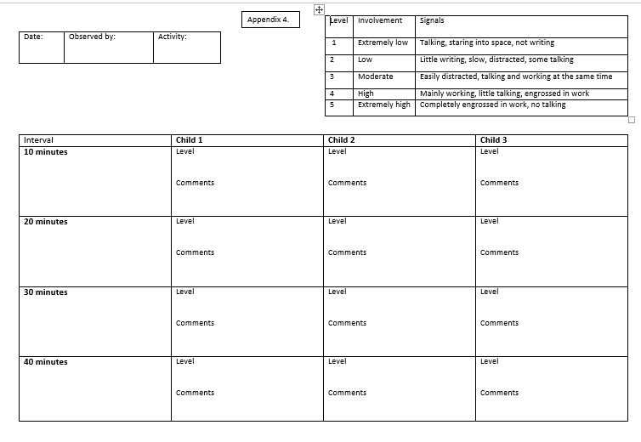

Appendix B – Consent form example.


Appendix C – Pupils assent form.


Appendix D – Information for the children.


Appendix E – Lesson plan.



Appendix F – Observation schedule LS 1.
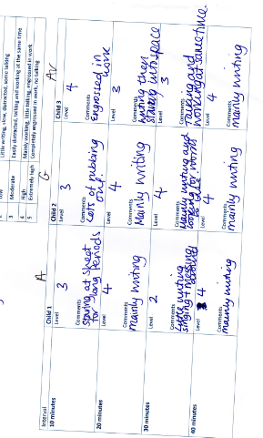

Appendix G – Plenary adjusted for LS 2.
- Check the chn have included one of the features (from the success criteria).
- Tell them how much they should have written by this time.
- Check for understanding and any questions the children have.
- Tell them how much time they have left.

Example of 1 mini plenary:
- Have you got rhyming?
- You should have done around 3 lines by now –
- Is everyone working OK?
- You have 20 minutes to complete the task.

Appendix H – LS 2 observation schedule.
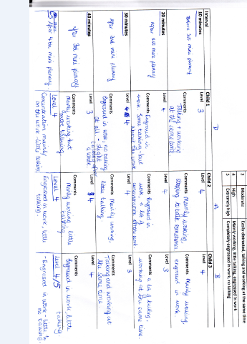

Appendix I – ARC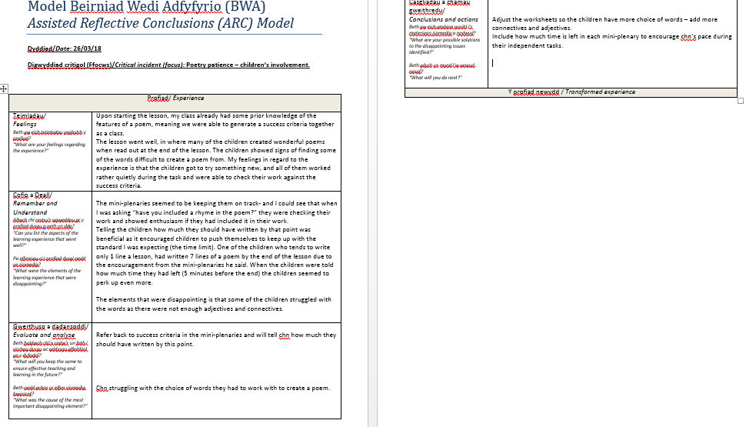

Appendix J – Focus group questions.
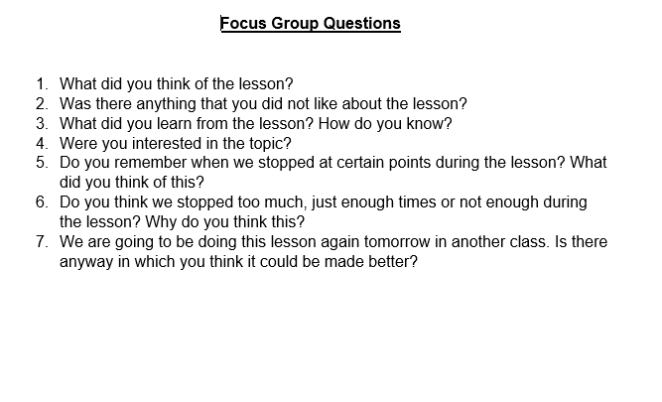

Appendix K – Focus group LS 1 notes.

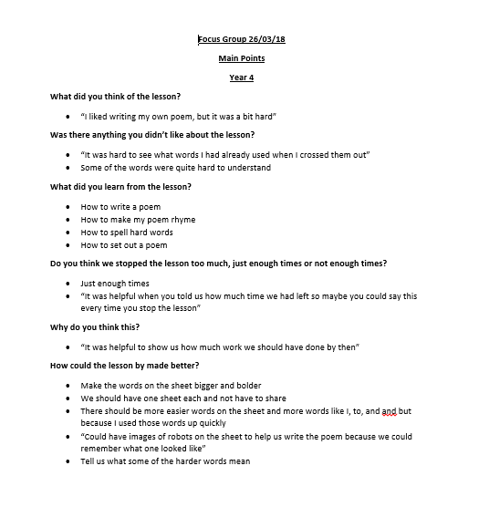

Appendix L – Focus group LS 2 notes.



