

Cover Page

Changemakers: Building Your Personal Brand for Sustainable Employment
BSc Health and Social Care
Module code: BMHP5015
Student Name: Mahmoona Sadaqat
Student ID:2321821

Task 1 – Personal Brand

Building a solid personal brand is crucial to reaching my long-term career objectives. Being flexible, inquisitive, and dedicated to lifelong learning are the key elements of my personal brand. I consider myself to have strong communication and problem-solving skills, as well as technical knowledge, both of which are highly valued in today's challenging job market. As a prospective social worker, my personal brand is based on reliability, protection, and empathy. I consider myself to be dedicated to strengthening people and communities. who value social justice. I will focus on establishing a noticeable online presence through business networking sites like LinkedIn to enhance this brand. I can strengthen my reputation and draw in opportunities by sharing my knowledge, participating in industry debates, and highlighting my successes. Shepherd (2005) states that having a personal brand enables people to stand out from the competition and become well-known in their industry. As a result, it will be essential to keep my real and online presence consistent.
According to Montoya and Vandehey (2009) personal branding is about controlling assumptions and continuously providing value. I will build a brand that represents competence and individuality by coordinating my behaviours, values, and talents with my professional ambitions. This will help me achieve my work objectives.

Task 2 - Network Map and Rationale
Create a map of your own network considering career, support, social and community dimensions. Additionally, you should provide a supporting rationale explaining and critically assessing this (200 words- 2 referenced sources).

Teacher colleagues
Parents Sibling
Projects

Career
Support
contacts

Friends
Mahmoona
volunteer
Healthcare

community
social

Family
local group charity
university
Friends

Community
Carer
social
Support
Stronger
Weaker
I would describe my network as hybrid. This is because it combines aspects of a tight network (strong relationships with family, friends, and close coworkers) and an open network (weak ties with others, community members, and online professional contacts). I mostly rely on a few close contacts, which reduces the range of viewpoints I may consider. Develop strong networks and stay in touch regularly to strengthen relationships (Johnson, 2006). Outside of my close circle, I have many strong ties to larger professional or community groups. Join professional groups, volunteer for community initiatives, and go to industry events to network with individuals from all backgrounds. For advice and assistance, look for mentoring possibilities, make connections with people. Participate in organisational networks (Phillips, 2014). This stability enables me to get emotional support and trust while likewise opening new possibilities, viewpoints, and ideas. I must increase my professional network by attending more events, joining pertinent groups, and participating on platforms to make progress in weak domains.

Task 3- Blog

Introduction
Examining medical staff training via blog is crucial as it helps spread the word about the ongoing education required to deliver safe, high-quality care. Blogs also function as a teaching tool that promotes introspection and dialogue among managers, legislators, and healthcare professionals. Medical and nursing staff training is more crucial than ever in today's rapidly changing medical field. Whether it is learning new technology, comprehending current safety regulations, or increasing patient communication, continuing training ensures that healthcare professionals can provide safe, compassionate, and effective care (Conde-Caballero et al., 2019).
Main body
Training in the UK health and social care industry is critical to sustaining high-quality service and ensuring staff confidence. All healthcare personnel must complete mandated training in infection control, safety, equality and diversity, and communication skills. These programs not only improve technical knowledge but also encourage empathy and cultural awareness, key components in patient-centred care (NHS England, 2023). However, access to training remains uneven. Some frontline care providers confront challenges such as inadequate budgets, time limits, and a lack of digital skills. Addressing these discrepancies through flexible online learning platforms and employer-sponsored study time can help close the gap. When medical professionals feel supported in their learning, retention rates improve, lowering burnout and turnover within the industry (Skills for Care, 2024).
Conclusion
In conclusion, providing high-quality, secure, and compassionate care requires medical workers in the UK health and social care sector to receive training. Staff members can stay up to date with changing patient demands, medical procedures, and advances in technology.

Task 4- NHS Equality, Diversity and Inclusion Quiz (250 words equivalent)
- What is the primary goal of the NHS Equality, Diversity, and Inclusion Improvement Plan?

The primary objective is to provide a fair, inclusive, and equal NHS workplace that increases a feeling of belonging for all employees, improves staff experience, and reduces discrimination.
- How does the NHS EDI Improvement Plan propose to tackle the gender pay gap?

It requires companies to examine pay data based on protected characteristics and execute improvement strategies, such as flexible working arrangements and Mend the Gap suggestions for both medical and non-medical personnel.

- What is meant by the term ‘intersectionality’ as used in the NHS EDI Improvement Plan?

The concept of intersectionality acknowledges that people have several overlapping identities, and that these elements might combine to produce certain kinds of discrimination or disadvantage.

- Why is it important for the NHS to create a psychologically safe work environment?

A psychologically safe work environment enhances cooperation, well-being, and patient safety by enabling employees to voice concerns, confess errors, and speak up without fear.

- How does the NHS EDI Improvement Plan suggest improving the experience of internationally recruited staff?

To make international recruits feel appreciated and supported, it advocates for a thorough introduction, cultural sensitivity training for teams, and equitable access to growth opportunities.

- What role does leadership play in advancing EDI objectives according to the NHS Improvement Plan?

Leaders are accountable for defining the company culture, having measurable EDI goals, and exhibiting inclusive and caring actions that promote equality.

- Identify one way the NHS EDI Improvement Plan aims to reduce health inequalities within the workforce.

The NHS improvement plan, by encouraging wellness discussions, could lower bullying and harassment, and collaborate with neighbourhood groups to enhance job advancement and social mobility.

- Why does the NHS EDI Improvement Plan emphasise the importance of collecting and analysing data on protected characteristics?

The importance of collecting accurate data is used to uncover discrimination, track progress, and guarantee responsibility in reaching equality and diversity goals for all groups.

- Explain how flexible working policies can contribute to equality and inclusion in the NHS workforce.

Flexible work arrangements promote work-life balance, assist in keeping employees who have caregiving duties, and allow a wide variety of workers to advance in their professions.

- What is one strategy mentioned in the NHS EDI Improvement Plan to combat bullying and harassment in the workplace?

For organisations to be fair and compassionate, they must implement proactive preventative strategies, offer victims psychological help, and evaluate their disciplinary procedures (NHS 2023).

Task 5- A Letter to Yourself
Think of a time in the past when you may have been experiencing issues or difficulties, and after considering what you have learned in this module about emotional intelligence and resilience, write a letter to your younger self explaining how these attributes were important at that time and perhaps how developing these areas could have been useful (250 words)

Dear me,
I understood disappointment on the day when I failed my first driving test.I thought I was finally ready after weeks of preparation and practice in all types of weather. It seemed like a personal failure when the examiner informed me that I had failed. I felt irritated, ashamed, and even doubted my skills. I felt like giving up entirely, lost drive, and trust in myself plummeted. I wish I could tell that failing that test was only a part of my path and not the end of the world. I would have responded to the situation differently if I had been better knowledgeable about resilience and emotional intelligence. The ability to identify and control your emotions as well as those of others is known as emotional intelligence (Mangal and Mangal, 2015).
One of the essential components of emotional intelligence is self-regulation, which I might have practised by keeping myself composed and concentrated on getting better rather than feeling discouraged. According to Herrman et al (2011) Resilience is the capacity to bounce back from setbacks fast, adjust well to hardship, and have a positive attitude. It is a talent that may be built by self-awareness didn't know that failure might strengthen patience and courage, but I learnt from my mistakes. I requested extra practice, paid close attention to, and worked even harder to get ready. When I passed on my second try. I was demonstrating to myself that I could overcome challenges. Emotional intelligence and resilience helped me into the person I am now throughout that trying time. I now understand that it doesn't define who I am, even if I experience another setback—life will bring many. How I react, improve, and proceed is what really makes me who I am.
Task 6- GANTT Chart (200 words equivalent)
Compile a Gantt chart which illustrates the tasks you have to complete to achieve your future employment goals

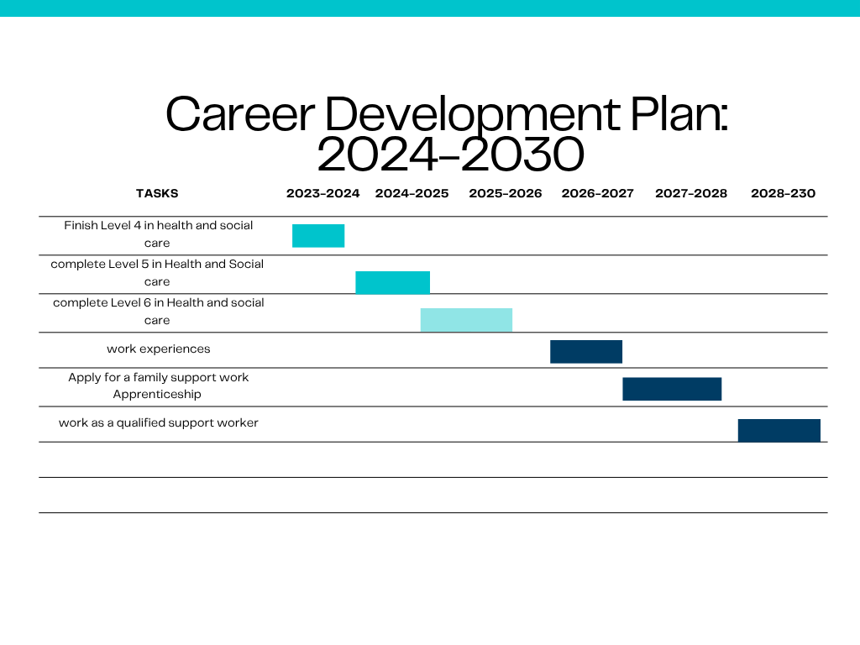
Task completed
Task continues
To be completed

Task 7- Making Changes- Report

Digital Care Planning in a Care Home
Introduction:
Digital Care Planning Implementation in a Care Facility. I intend to replace paper-based records with a digital care planning system in my role as a care home manager. Accuracy, efficiency, and person-centred care are the goals of this modification (Brittain, 2020).
Management
Using Kotter's 8-Step Change Model, I will start by instilling a feeling of urgency and include important employees in the planning process (Kotter, 1996).
Because handwritten notes can be uncertain, time-consuming, and prone to mistakes, this modification is necessary. To lead the transformation, train personnel, and progressively move from paper to digital forms, I will first install a sense of responsibility and include key workers in the planning process. I will also assemble a team of senior caretakers. In line with government directives on the digital transformation of health and social care, the objective is to improve the accessibility, security and responsiveness of care records to residents’ requirements (NHS England 2022).
Challenges
Lack of training, staff aversion to technology, or fear of change are examples of potential obstacles. To get over this, I'll provide practical instruction and make it obvious how using digital tools can lighten their job and enhance care (Cameron, 2004). To help staff members become more resilient and self-assured, I will also offer continuous assistance during the time of change.

Task 8- Self-Reflection

Self-Reflection (Using Gibbs’ Reflective Cycle, 1988)
Description:
One of the most important lessons I learnt from this session was finishing the change management assignment. I had to plan a practical change and think like a care home manager. I first struggled to comprehend how to apply ideas like Kotter's Change Model to actual circumstances.
Feelings: I had never planned a career transition before, so at first, I felt nervous and uncertain. But as I completed the assignment, I began to feel more assured and driven. I discovered that I found it enjoyable to consider how great leadership may improve people's lives.
Evaluation: I think my research and application of theory to practice went well. I could have strengthened my work, though, by asking for comments sooner and managing my time better.
Analysis: I now have a better understanding of the value of cooperation, leadership, and communication in the health and social care sectors. It also demonstrated to me that taking my time to comprehend and use information instead of hurrying through assignments boosts my confidence.
Conclusion: This taught me that self-analysis enables me to realise how I might advance both professionally and personally. It also served as a reminder that resilience may be developed by learning from difficulties (Gibbs,1988).

Reference List

Brittain, G. (2020) Electronic care planning and care worker engagement. Nursing and Residential Care, 22(11), pp.1-19.
Cameron, E. (2004) Making Sense of Change Management: A Complete Guide to the Models, Tools and Techniques of Organizational Change Management. 1st edn. London: Kogan Page.
Conde-Caballero, D., Castillo, C.A., Ballesteros-Yáñez, I. and Mariano-Juárez, L. (2019) Blogging as a tool for the acquisition and dissemination of knowledge in health sciences: A preliminary evaluation. International Journal of Educational Technology in Higher Education, 16(1), p.30.
Gibbs, G. (1988) Learning by doing: A guide to teaching and learning methods. Further Education Unit.
Herrman, H., Stewart, D.E., Diaz-Granados, N., Berger, E.L., Jackson, B. and Yuen, T., (2011) ‘What is Resilience?’, Canadian journal of psychiatry, 56(5), pp. 258–265. Available at: https://doi.org/10.1177/070674371105600504.
Johnson, J.L. (2006) ‘Brokerage and Closure: An Introduction to Social CapitalBrokerage and Closure: An Introduction to Social Capital, by BurtRonald S. Oxford: Oxford University Press, 2005’, The Academy of Management review, 31(3), pp. 757–759. Available at: https://doi.org/10.5465/amr.2006.21318931.
Kotter, J.P. (1996) Leading Change: Boston: Harvard Business School.
Mangal, S.K. and Mangal, S.(2015) Emotional intelligence: Managing emotions to win in life. PHI Learning Pvt. Ltd..
Montoya, P. and Vandehey, T. (2009) The brand called you. New York, NY: McGraw-Hill.
NHS (2023) Equality diversity and inclusion improvement plan. Available at: https://www.england.nhs.uk/publication/n(Accessed: 16 October 2025).
NHS England (2022) What Good Looks Like: Digital Transformation Directorate. Available at: https://transform.england.nhs.uk/digitise-connect-transform/what-good-looks-like/
NHS England (2023) NHS Long Term Workforce Plan. Available at https://www.england.nhs.uk/long-read/nhs-long-term-workforce-plan/ (Accessed: 16 October 2025).
Phillips, S. (2014) The complete guide to professional networking: the secrets of online and offline success. Kogan Page Publishers.
Shepherd, I.D. (2005) From cattle and coke to Charlie: Meeting the challenge of self marketing and personal branding. Journal of marketing management, 21(5-6), pp.589-606.
Skills for Care (2024) State of the Adult Social Care Sector. Available at :https://www.skillsforcare.org.uk/Adult-Social-CareThe state of the adult social care sector and workforce in England, 2024 (Accessed: 16 October 2025).

