Carys Davies
Student: 1203378
Abstract
With an increase of mental health cases are the police’s powers being used and abused or are they best equipped to deal with this complex issue.
Are South wales police experiencing an increase in mental health related incidents, and if so, is it their responsibility?
Criminal Justice and Policing Master Dissertation
Table of Contents
Abstract | Page 1
Introduction | Page 2-4
Literature Review | Page 5-6
Aims and Objectives | Page 7
Research Methodology | Page 8-11
Ethical Considerations | Page 12
Research Limitations | Page 12
Research Validity | Page 13
Resources and Planning | Page 13
Reference List | Page 14-15

List of Figures
- ‘incidents involving mental health are rising’ graph | Page 4
- ‘Difference between qualitative and quantitative methods’ diagram | Page 9
- Saunders’s Research Onion | Page 9

Abstract
The number of people seeking help for, and being diagnosed with, mental health is a growing public health concern. Mental illnesses can vary and includes, depression, anxiety, schizophrenia, bi-polar, obsessive-compulsive disorder and ADHD. These illnesses are defined by The National Institutes of Health US (2012) as ‘a health condition that changes a person’s thinking, feeling, or behaviour (or all three) and that causes the person distress and difficulty in functioning’.
According to Mind UK ‘1 in 4 people will experience a mental health problem each year…and 1 in 6 report experiencing a common mental health problem in any given week’ (2013a). Due to the increase in mental health among communities’ police have inadvertently become ‘frontline professionals who manage these persons when they are in crisis’ (Lamb et al, 2002, p1266).
This dissertation will explore the issues and effects caused by the increase of mental health incidents within the police, specifically on the officers and control room operators. I aim to discover whether officers and operators feel they are the most appropriate service to be dealing with such complex issues or whether a jaded stigma has left police feeling as though they are being used to fill the void left by an absent NHS system.

Introduction
It is set in common law that the main responsibility of police officers is to protect the public through detecting and preventing crime. Police powers are regularly identified within three sub-categories explained by Brown (2020 p3) these categories are:
- Powers to investigate crime
- Powers to prevent crime
- Powers to dispose of criminal cases
Within each category the overall purpose is to protect communities, the public and the vulnerable. However, as mental health illnesses continue to grow, the police’s powers to protect the vulnerable are being misconstrued and are ultimately being taken advantage of. As other public services like social services and the NHS fail to meet the demand, the police are having to fill the ever-growing void. Lamb et al (2002, p1266) explains that the common law principles:
provide the rationale for the police to take responsibility for persons with mental illness: their power and authority to protect the safety and welfare of the community and their parens patriae obligations to protect individuals with disabilities.
Mental health related incidents reported to the police have risen, according to figures obtained by BBC Radio 5, between 2014-2018 there was a rise of approximately 28%. As figure 1 shows, in 2018, a total of 494,159 incidents were identified, which is an overall increase of more than a quarter over four years (Jones, 2019). As a result of the rise in figures police officers do not have adequate time to resource and investigate crimes, thus resulting in more pressure on officers and dissatisfaction in communities. According to Dodd (2018) the rise in mental health related incidents has highlighted that the police service has been left to ‘pick up the pieces of a broken mental health system’.

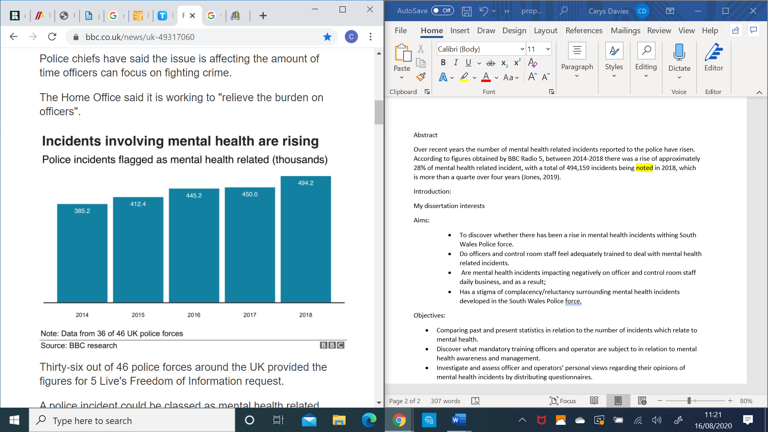
(Jones, 2019)
Figure 1.

Literature Review
Since 2014, an annual assessment led by the HMICFRS evaluates the 43 police forces in England and Wales on their effectiveness, efficiency and legitimacy. Each police force is scored from outstanding, good, requires improvements or inadequate, with findings published in the annual PEELS report. For 2019 the HMICFRS gave a good rating to South Wales Police and within the effective category the force identified vulnerability well and ‘officers and staff are aware of the importance of identifying and handling, vulnerability appropriately. Protecting vulnerable people is a clear priority for the force’ (HMICFRS, 2019)
According to a report by Mind UK the police encounter individuals suffering with mental health frequently whether it be as a victim of crime, witness or offender. Consequently, the report states that officers have a ‘crucial role in working with and supporting people with mental health problems’ (Mind UK, 2013b, p4). When dealing with mental health related incidents Welsh police have two main powers under the Mental Health Act 1983, section 135 and section 136. Section 135 ‘allows the police to enter a person’s home and take a person to a place of safety so that a mental heath assessment can be done’ (Welsh Government, 2019, p1) but officers must acquire a warrant to do so. Section 136 however allows officers to do the same as s135 without a warrant. Due to their powers the police are working alongside health care agencies to divert people suffering with mental health away from the criminal justice system. Due to the powers provided to officers and their access to mental health professionals the police are becoming first responders, expected to assess and refer mental health patients, which ca be argued is not their job.
However, the term diversion is one of ‘the biggest barriers because it means we get into ownership issues’ (Bradley report, 2009, p15). The police are expected to attend mental health related incidents which may be better suited to professions and as a result Dodd (2017) reports how some suffering with their mental illnesses are now committing crimes in order to gain access to treatment. ‘Nationally, police believe a significant number of those about whom they get calls are already under the care of NHS mental health services’ (Dodd, 2017) which is now effecting the policing.
Chief Constable of South Wales Police, Matt Jukes, announced ‘9 out of 10 calls are not new crimes being reported’ and the forces ability to ‘carry out its core duties is coming under increasing pressure because of the rise in mental health related calls’ (Rees, 2019). Officers are now feeling used as they believe incidents primarily concerning someone having a mental health crisis should not be passed for police to attend. Jukes believes the force are having to respond to those in crisis as they operate 24/7 unlike mental health professions. Rees (2019) summarises Jukes frustrations, ‘the police played a role in supporting vulnerable people, but he would rather focus on the more complex cases line online crimes and sexual violence’.

Aims and Objectives
Aims:
The overall aim of this research is to discover whether South Wales Police officers and control room staff are experiencing a rise in mental health related incidents and if so, are they adequately equipped and trained to deal with the complexity of the issues. As a result of officers and operators becoming first responders to mental health related incidents it will also be interesting to discover whether it is negatively impacting on daily business and therefore created a stigma of reluctancy.
In order to fulfil my aims a list of objectives will be clearly defined. According to Thomas and Hodges (2010, p39) ‘objectives indicate in more detail the specific research topics or issues the project plans to investigate’ these objectives will build on the main theme of the research evident in the overall aim. The objectives are therefore tasks which need to be completed in order to achieve the overall aim.
Objectives:
- Comparing past and present statistics in relation to the number of incidents which relate to mental health reported to South Wales Police.
- Discover what mandatory training officers and operator are subject to in relation to mental health awareness and management.
- Investigate and assess officer and operators’ personal views regarding their opinions of mental health incidents by distributing questionnaires.

Methodology:
In order to ensure a clear outline for the research it’s imperative to identify a specific research design or methodology. Morgan (2014, p21) explains that ‘effective research design is equally about why you are doing your research and how you will do it’ and therefore choosing a research design ‘requires careful attention to both the purpose behind your research and the procedures you use to address those purposes’. The research design, ‘should describe, as fully as possible, the research techniques to be used in the project’ (Thomas and Hodges, 2010, p54). The type of research design is dependant on the style of research.
Research can be conducted in various ways, generally the two most used methods include, qualitative and quantitative research. Qualitative research can be defined as, ‘a naturalistic, interpretative approach, concerned with exploring phenomena from the interior and taking the perspectives and accounts or research participant as a starting point’ (Oflazoglu, 2017, p1). Quantitative on the other hand attempts to explain ‘phenomena by collecting numerical data tat are analysed using mathematically based methods’ (Aliaga and Gunderson 2000, cited in Muijs 2011 p1). Figure two shows the difference between both types of research and the different methods to collect data. Quantitative research is primarily done through closed question questionnaires or surveys, observations recorded as numbers and secondary data, whereas qualitative research can be conducted through interviews, focus groups, observations and written accounts.

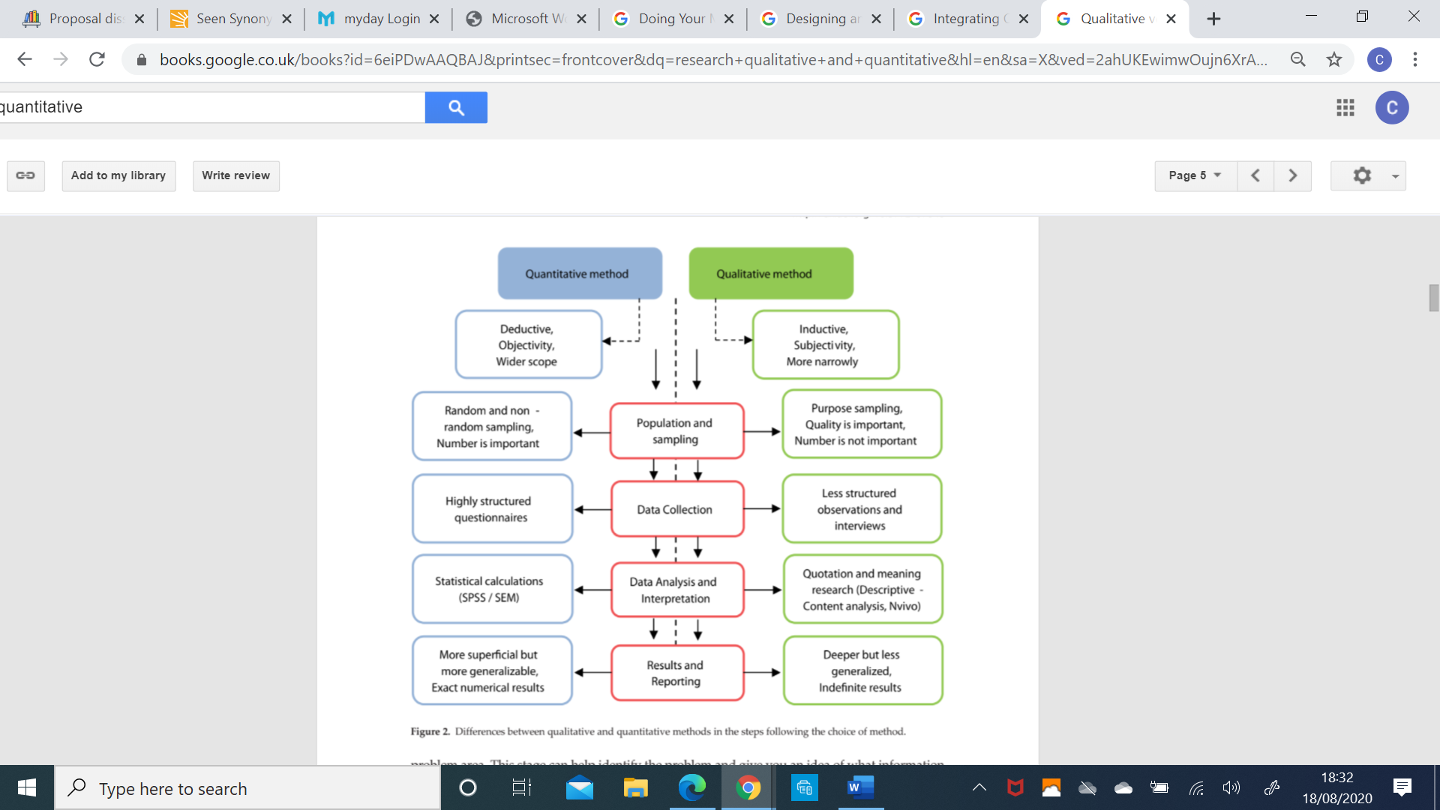
Figure 2
(Oflazoglu, 2017, p5).


To collect both qualitative and quantitative research Saunders et al 2007 developed the research onion, which if displayed in figure three. The research onion is commonly used as a tool in research design. The research onion consists of six layers which represent the six stages of research, each stage has a different role which all aid in forming the methodology of research.
Figure 3
(Zefeiti and Mohamad, 2015, p3)

Masmoudi and Ahman Al’A’ali (2020 p188) explains that ‘the first layer consists of the philosophies and this acts as the starting point to reach the appropriate research approach which is the second layer’. Research philosophies include positivism, interpretivism, pragmatism and realism. According to Zefeiti and Mohamad (2015, p2) research philosophies are ‘a belief or an idea about the collection, interpretation, and analysis of data collected’ and therefore when choosing a philosophy the ‘researchers specific view and opinion of the association between knowledge and the process by which it is developed’ plays a part in the decision making. An interpretivist approach will be suitable for this research as it is ‘based and depends on what the researcher’s interests are’. Due to the fact I work in the same environment I am more likely to naturally choose an interpretivist philosophy shared with a realistic philosophy which is ‘based on assumptions that are necessary for the perception of subjective nature of the human’ (Zukauskas et al, 2018).
A mixed research approach will be adopted throughout this research. There are two types of research approaches; deductive and inductive, Zefeiti and Mohamad (2015, p3) defines each approach as the following,
deductive approach concentrates on using the literature to identify theories and ideas that the researcher will test using data. In contrast, the inductive approach involves collecting data and developing a theory based on the results of data analysis.
A deductive approach will be taken during my research as I will be using statistics published by South Wales Police to form a notion, which I will then test by disseminating questionnaires to obtain employee opinions.
The third stage ‘focuses of the different strategies or methods which can be approached for the research’ (Masmoudi and Ahman Al’A’ali, 2020 p188). Research strategies as seen in figure 3 includes case study which will be the chosen strategy for the research. Robson (2002 cited in Saunders et al, 2016, p145) explains a case study as that which, ‘involved an empirical investigation of a particular contemporary phenome non within its real-life context using multiple sources to evidence’.
Due to both questionnaires (qualitative) and published figures (quantitative) approach being taken a mixed method choice in relation to the fourth layer of the research onion will be followed. Following on from research choices is time horizons which crucial to the planning of research as it sets a time frame for the research to be undertaken in. A longitudinal approach calls for ‘repeated studies over a period of time to identify a correlation’ whereas a cross sectional approach ‘means that the focus of the research is on the current situation’ (Rafael, 2016). Due to this research being completed in a specific time frame a cross-sectional approach is best suited.
Finally, at the centre of Saunders’ research onion is the techniques and procedures. This research will incorporate questionnaires as well as collecting secondary numerical information.

Ethical considerations
Ethical principles applied during this research include written consent, anonymity and confidentiality. Written consent will be issued to all completing questionnaires to show that they have been fully informed in the reason for completing the questionnaire. When completing questionnaires candidates will not provide their details other than their role (i.e police officer/control room operator) thus ensuring anonymity. Secondary information will also only reflect statistics and will not be personal to anyone. Finally, the research will only be shared with the University, during the research all files and paperwork will be kept secure to assure confidentiality.
Limitations
The main limitation for research will be constrains due to Coronovirus. Completing research may be difficult as current government guidelines impose restrictions to the amount of people, we are allowed contact with and places we can visit. However, to overcome restrictions I am prepared to issue questionnaires electronically to reduce the amount of contact with others.
Another limitation is the completion time along with work commitments. Time guidelines for each part of the research has been published by the University. As I work full time completing each section by the allocated date may prove difficult.

Validity
The validity of the research depends on the processes and data collected. All secondary data refers to numerical statistics collected by South Wales Police and therefore will be valid. In order to ensure questionnaires are valid closed-ended questions will be asked this limiting the responses.
Resources and planning
In order to successfully achieve this research access to a PC and the internet will be required as well as access to books, journals and news articles of relevant nature to the research. I will also require access to South Wales Police incident records specifically related to mental health incidents, as I am an employee of South Wales Police, I am able to source these figures via my work computer.

Reference List
Brown, J. (2020). Police powers: an introduction. In: Briefing Paper. London: House of Commons Library.
Dodd, V. (2017). Police dealing with record level of phone calls on mental health. The Guardian. [online] 28 Aug. Available at: https://www.theguardian.com/society/2017/aug/28/police-phone-calls-mental-health-nhs [Accessed 17 Aug. 2020].
HMICFRS (2019). South Wales Police 2018/19 PEELS report. [online] HMICFRS. Available at: https://www.justiceinspectorates.gov.uk/hmicfrs/peel-assessments/peel-2018/south-wales/ [Accessed 15 Aug. 2020].
Jones, L. (2019). Police “dealing with more mental health incidents.” BBC News. [online] 2 Sep. Available at: https://www.bbc.co.uk/news/uk-49317060 [Accessed 4 Aug. 2020].
Lamb, H.R., Weinberger, L.E. and DeCuir, W.J. (2002). The Police and Mental Health. Psychiatric Services, 53(10), pp.1266–1271.
Masmoudi, M. and Ahmad Al-A’ali, E. (2020). Ethical consumerism and comparative studies across different cultures : emerging research and opportunities. Hershey, Pa: Business Science Reference.
Mind UK (2013a). How common are mental health problems? | Mind, the mental health charity - help for mental health problems. [online] Mind.org.uk. Available at: https://www.mind.org.uk/information-support/types-of-mental-health-problems/statistics-and-facts-about-mental-health/how-common-are-mental-health-problems/ [Accessed 5 Aug. 2020].
Mind UK (2013b). Police and mental health: how to get it right locally. Police Federation.
Morgan, D.L. (2014). Integrating qualitative and quantitative methods : a pragmatic approach. United States of America: Sage Publications, Inc.
Muijs, D. (2011). Doing quantitative research in education with SPSS. Los Angeles: Sage Publications.
National Institutes of Health US (2012). Information about Mental Illness and the Brain. [online] Nih.gov. Available at: https://www.ncbi.nlm.nih.gov/books/NBK20369/ [Accessed 5 Aug. 2020].
Rafael, C. (2016). Understanding the research onion: an illistration. Available at: https://nairaproject.com/blog/understanding-the-research-onion-methodology.html [Accessed 10 Aug. 2020].
Rees, J. (2019). South Wales Police: Mental health calls squeeze force. BBC News. [online] 2 Jan. Available at: https://www.bbc.co.uk/news/uk-wales-46738600 [Accessed 20 Aug. 2020].
Sainsbury Centre (2018). Briefing 36: The police and mental health. United Kingdom: Sainsbury Centre for Mental Health.
Saunders, M., Lewis, P. and Thornill, A. (2016). Research Methods for Business Students. 5th ed. England: Pearson.
Sonyel Oflazoglu (2017). Qualitative versus Quantitative Research. Croatia: Intech.
Thomas, D.R. and Hodges, I. (2010). Designing and managing your research project : core skills for social and health research. Los Angeles: Sage.
Welsh Government (2019). Detentions under Section 135 and 136 of the Mental Health Act. Welsh Government.
Zefeiti, S.M.B.A. and Mohamad, N.A. (2015). Methodological Considerations in Studying Transformational Leadership and its Outcomes. International Journal of Engineering Business Management, 7(1), p.10.
Žukauskas, P., Vveinhardt, J. and Andriukaitienė, R. (2018). Philosophy and Paradigm of Scientific Research. Management Culture and Corporate Social Responsibility.
‌

