
Institute of Inner-City Learning Birmingham Campus
BSc (Hons) Health and Social Care

Component 2
Element 2 (Academic Methods Poster)
AND
Element 3 (Dissertation)

Student name: Mary Tetteh
Student ID:

Module name: Independent Project
Module code: BMHP6020

Table of Contents
Element 2: Academic Methods Poster 5
Element 3: Dissertation 1
Declaration 2
Acknowledgements 3
Abstract 4
Chapter 1: Introduction 5
1.1 Introduction 5
1.2 Definitions and Terminology 5
1.3 Background and Current Context 6
1.4 Rationale for Research 7
1.5 Aim and Objectives 8
1.6 Conclusion 8
Chapter 2: Background Information and Analysis 9
2.1 Introduction 9
2.2 Historical Background 9
2.3 Theoretical Background 10
2.4 International Context 12
2.5 National/Local UK Context 13
2.6 Conclusion 14
Chapter 3: Methods and Search Strategy 15
3.1 Introduction 15
3.2 Search Strategy 15
3.3 Searching for Information 15
3.4 Research Validation 16
3.5 Inclusion and Exclusion Criteria 20
3.6 Analysing Research 20
3.7 Ethical Considerations 22
3.8 Chapter Conclusion 22
Chapter 4: Findings and Discussion 23
4.1 Introduction 23
4.2 Thematic Analysis 23
4.3 Theme 1: Adoption and Delivery of Integrated Elderly Care Services in NHS England 23
4.4 Theme 2: Impact of Integrated Elderly Care Services on Health Outcomes and Quality of Life among Older Adults 26
4.5 Theme 3: The effectiveness of integrated elderly care services on reducing re-admissions and continuity of care 29
4.6 Theme 4: Problems with the system, policy weaknesses and solutions for delivering integrated elderly care in NHS England 32
4.7 Chapter Conclusion 35
Chapter 5: Conclusion and Recommendations 36
5.1 Overall Conclusion 36
5.2 Recommendations 36
Reference List 40
Appendices 49
Appendix 1: Search Process Using Boolean Operators 49
Appendix 2: Thematic Coding Approach with Colour Coding 50

Element 2: Academic Methods Poster

The impact of integrated elderly care services on health outcomes and hospital readmission among older adults in NHS England
01 Introduction and Research Aim  The method chapter refers to the elements involved in carrying out the research study (Pyo et al., 2023). These include research design, data collection methods, search strategy, criteria for selecting articles, analysis techniques, and ethics used. The current research study followed a secondary qualitative method and used thematic analysis.  Research aim  This research study aims to evaluate the impact of integrated elderly care services on health outcomes and hospital readmission among older adults in NHS England. Through this research study, the researcher can effectively evaluate the effectiveness of integrating elderly care services with health care services. | 02 Search Strategy  Search strategies refer to a structured way of searching for information regarding the research through the use of selected databases and keywords (Shaheen et al., 2023). The keywords used to form the search strategy of this review are: "integrated elderly care," "older adults," "hospital readmission," "health outcomes," and "NHS England." They were combined using the Boolean operators (AND/OR).  The academic sources used to conduct this literature search include PubMed and Google Scholar. Filters were used to identify appropriate, recent articles from the UK.
03 Searching for Information  Secondary research entails a process of analysis of available evidence with regard to a particular research problem (Ratajczak et al., 2025). The secondary information was found from the credible sites such as Google Scholar and PubMed.  Steps to identify information in this research study  - Identification of important research concepts, such as Integrated care, Elderly care, Hospital re-admission, and NHS England  - Formulation of keywords and alternative keywords  - Utilisation of Boolean operators (AND/OR) for more accurate searching.  - Use of date filters from 2022 to 2026 for relevant literature.  - Selecting peer-reviewed journal articles, NHS reports, and UK Government policy papers. | 04 Picture / Graph / Visual Aid / Statistics  In England, a large number of elderly individuals constitute a percentage of the patients hospitalised. The delivery of integrated health care has been adopted with the intention of reducing hospital admissions.  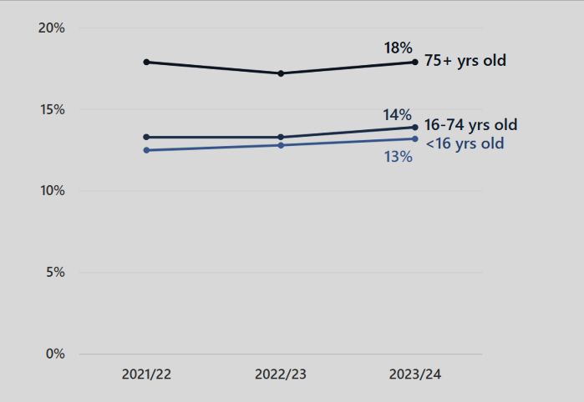  Figure 1: Percentage of cases in which the patient was admitted to a hospital within 30 days  (Source: CQC, 2024)
05 Research Validation and Analysis
The validity of research ensures that secondary sources are credible, reliable, and academically relevant. For the current study, the main emphasis was on using peer-reviewed journals, NHS-approved sources, and UK government publications in terms of credibility in research.
Thematic analysis was used to detect recurring themes within secondary sources, which included:
- Effectiveness of care coordination
- Patient health outcomes
- Hospital admission reduction
- Barriers to integration
One of the drawbacks of secondary research is the dependence on published sources of information.

06 Inclusion Criteria  - Studies conducted in the UK.  - Articles published between 2022 and 2026.  - Academic peer-reviewed articles.  - Open access articles.  - Dealing with elderly care and health services integration. | 07 Exclusion Criteria  - Articles published before 2022.  - Non-UK healthcare settings.  - Non-peer-reviewed articles.  - Sources lacking empirical evidence.  - Non-English sources.
08 Ethical Considerations
The data for secondary research were identified from credible resources. The paper has been written using the right Harvard referencing to avoid plagiarism as well as to maintain research credibility. The GDPR guidelines have been followed to avoid data theft or breach.

Element 3: Dissertation

Research Title:
The impact of integrated elderly care services on health outcomes and hospital readmission among older adults in NHS England

Declaration
This is hereby to confirm that this dissertation is completely an original piece of work, and it has not been presented for the award of any other qualification. All sources of information have been duly acknowledged, and references have been cited according to academic conventions.

Signed……………………………………………
Date………………………………………………

