Teodora Premyanova (1918695)
Professional Career Development (BMSW4005)
Professional Career Development
Barbara Chinyani
Health and Social Care (Term 2)

Introduction

In any field of work, self-reflection is vital. Being able to reflect on yourself, your understandings, your strengths and weaknesses, and your long-term goals is what makes you a productive, effective individual. However, alongside self-reflection is the capability of self-development, career choosing, and eventually, career development. It is important we have a clear understanding what happens and why it happens – in this case, making a career choice is your ‘what’, as it is the event that is occurring (Brown, 2002, p. 9). Personally, I am working towards becoming a teaching assistant. I have come to the realisation that this is the most appropriate job for me since it is an occupation I can see myself enjoying. I am willing to develop my career-exploration and self-exploration, as in order to achieve my career goal, I have to understand myself and my career, so I can then work upon my skills. In this report, I will be reflecting on my career ambitions and readiness, together with my roleplay demonstrated in class. I hope that carrying out this self-reflection will eventually lead me to a process of self and career development, and that through writing this report, I can further develop my plans for the future and my future employment.
I will be illustrating my roleplay reflection using the Gibbs reflective cycle, which consists of description, feelings, evaluation, analysis, conclusion and action plan.

Career ambitions

As I briefly discussed before, my current future goal is to become a teaching assistant. A teaching assistant provides essential support to teachers in school settings and has to complete duties such as class preparation and supervising children’s behaviour and learning. I believe this is a job I would like to pursue, due to the fact that I enjoy taking care of children, supporting others, building relationships with people, and helping people make progress. In my opinion, the career path I am planning on taking will give me the opportunity to do all of those things. In ‘Certificate in Higher Education: Skills for the Workplace Student Yearbook’ (Maund, Schriek, Tinkler, 2017) proposes a point that the more you know about a career, the more effectively you will be able to understand how your skills align with this position. Therefore, in order to become a teaching assistant, it is important I enlighten myself on the requirements of the job, and how my personal attributes line up with them. If I were to get an understanding of the precise skills a teaching assistant must possess, I can work on those skills personally. I know that to be a teaching assistant, there are certain responsibilities – for instance, managing challenging behaviour, handling different situations (such as a child being in pain, which links to healthcare), preparing classrooms, providing extra support for those who need it, and contributing to the planning of class activities. To be able to complete these responsibilities effectively, you should possess specific skills. Planning class activities requires creativity, managing challenging behaviour requires patience, and handling different situations requires problem-solving. A teaching assistant must demonstrate all of those skills, along with others such as friendliness, organisation, and a positive attitude. I possess patience and creativity, as I can work on a specific goal for a long period of time whilst remaining calm. I also have a creative mind and can propose different ideas.

Roleplay reflection
As part of my academic assessments, I had to work on a job interview roleplay, where I was asked questions regarding my chosen occupation. I also had to ask questions to my partner, regarding theirs. After the roleplay was over, I received feedback based on how well I did, and what areas I should improve in.
During my feedback, I was told that I had confidence, and I was sure of myself and my answers whilst speaking. Confidence is crucial in the world of work, because it increase your job performance and helps you productively use your abilities. In my SWOT analysis, for my internal weaknesses, I wrote that I have a lack of experience when it comes to working in schools. This may eventually lead to a gap in my self-confidence; therefore, I have to make sure that no matter how stressful my potential job could become, I continue to be self-confident.
Nevertheless, I also received feedback relating to the things I can improve on. This included having more enthusiasm and passion, and not speaking in a monotone voice. I understand why this is important – if you do not show enthusiasm through your speech, others may get the impression that you do not care about the quality of your work, and that you are not willing to put in good effort.
Overall, I believe that this interview went well, and I am proud of my feedback. Whilst I was being interviewed, I was feeling slightly anxious, but I tried to conceal my emotions and behave confidently and professionally. The roleplay, in general, went smoothly, and I did not forget any of the answers I pre-planned. Out of this experience, I can revisit the feedback I received and use it for my future benefit when I am in a real job interview, applying for a teaching assistant. I will also revisit my SWOT analysis (See Appendix A and B). Currently, however, my external opportunities are limited, and there are a few threats to the job I am pursuing, due to COVID-19. However, I will use my strengths to achieve my accessible opportunities, such as contributing to the career market by planning activities for students. In a genuine interview, prior preparation would be completely necessary – not only regarding my emotions, but every other factor that I may be lacking. I need to put myself in the perspective of the interviewer, and ensure I am fitting into their concept of a successful employee. I need to understand what questions they have in mind: is this candidate likely to perform well? Are they likely to do so at a sustainable level within the organisation? Will they fit into the culture of the workplace? (Morgan, 2017, p. 367). Comprehending their point of view would help me grow accustomed to the qualities they look for in candidates, and what I could do in the future to demonstrate these qualities effectively.

Career readiness

Throughout my life, I have experienced many challenging, tiring situations which made me doubt my abilities. What I had to adapt to and learn during years of experience was self-motivation. A book I read that helped me understand self-motivation was ‘The Seven Habits of Highly Effective People’ (Covey, 1989), as there were many ideas from there that particularly stood out to me. For example, that our nature is to act, instead of being acted upon. This idea to me means that if you become accustomed to acting upon your goals instead of letting people get in the way of them, you can have control over your life choices and begin to take the initiative. Thus, I completed a self-motivation test, which is a test that gives you an overall result based on how you are doing on self-motivation, and specific results in a variety of aspects. The test consisted of 12 statements, and I had to pick whether these statements apply to me, and how much. My total result was 43 out of 60, and I was curious to find more advice on why I received that exact score, so I viewed my results on the different aspects. For the first aspect (self-confidence and self-efficacy), I scored 16 out of 20. The advice given in order to improve in that factor was to think more about the achievements in your life and examine your strengths and capabilities. I often have found myself struggling with self-confidence and accepting the fact that I am capable of achieving my goals. This has sometimes led to a pause in self-motivation and in inability to set and work towards goals. I will be applying the advice given in the future, as in my opinion, it can help me fill this gap I need to work on. For the second aspect (positive thinking, and positive thinking about the future), I scored 15 out of 20. I was not surprised with this result, as sometimes I have caught myself questioning my future and having a pessimistic mindset towards my personal abilities. This can result in me making negative choices and having an uncertain outcome to my goals and future. The advice given is things that I have already tried before, due to the fact that I have always practised having a positive attitude: challenging your negative thoughts, picturing achieving your goals, and developing personal statements that you can repeat to yourself throughout the day. As for the third aspect (focus and strong goals), I scored 5 out of 10. This result was disappointing to me, and I was confused as to where I was not succeeding. For that reason, alongside the advice given to me, I did some further reading. In ‘Goals! How to Get Everything You Want – Faster Than You Ever Thought Possible’ Tracy believes that (2003, p.1) goal setting is to accept entire responsibility for your life, and for everything that happens in it. I have always been hesitant and reluctant when it comes to goal setting. This means that I did not know where to begin, or where my limit stands, and I made plenty of excuses in order to avoid accepting failure or responsibility. Lastly, the fourth aspect is motivating environment, for which I scored 7 out of 10. In my opinion, I have a motivating environment already, due to the fact that I have my family, who make me feel more comfortable when I am feeling unmotivated or overwhelmed. That being said, however, the test itself says ‘’you cannot just rely on the environment or outside elements alone to motivate you’’ (How Self-motivated Are You?, n.d). This is something that I have learned and can prove through my experiences, as I am aware that even though I have a supportive family, I still clearly struggle with various aspects of self-motivation.

In a short-term timeframe, I would like to successfully pass my assessments, which would enable me to get my certificate. In a mid-term time frame, I would have applied as a teaching assistant and hopefully, I will secure an employment and begin my career path. I also will be continuing my education for the 5th and 6th level and manage to excel to get my diploma. Finally, in a long-term time frame, I would like to have developed my career and moved to a higher position, where I can continue to work. In order to achieve these goals, both short, mid, and long term, I need to work upon specific skills and knowledges. For instance, I need to work upon my IT skills and build up more experience. To do so, I can volunteer for more opportunities and take educational courses that can help me with my IT abilities.

Conclusion

In conclusion, in this report, I discussed the career I am working towards, a teaching assistant, and what is required from somebody striving to achieve that career. I explained how my personal skills and attributes align with that of a teaching assistant, and I reflected on what skills I lack. This led me to understand the process of further developing and improving these skills. Also, I reflected on the job interview role-play I performed, and I analysed the feedback I received using the Gibbs reflective cycle. I also briefly discussed my SWOT analysis, because to understand your ideal career, you need to understand what positive and negative qualities you have, what opportunities you have, and where your job may be at a threat. Lastly, I took a self-motivation test and discussed my various results and my PDP for the next several years. I personally believe that writing this report and focusing on my career ambitions, role play, and my self-motivation really helped me become closer to achieving my goals. I am aware of where I struggle, as I have been told during my role-play feedback, and my self-motivation test results. I analysed the advice I received, and did further research, which as a whole, allowed me to perform a successful self-reflection.

References
Brown, D. (2002). Career Choice and Development. Fourth Edition. San Francisco: Jossey-Bass, p. 9.
Covey, S. (1989). The 7 Habits of Highly Effective People. [s.l.]: Free press.
Maund, A. and Schriek, M. and Tinkler, P. (2017). Certificate in higher education: Skills for the Workplace Student Yearbook. [s.l.]: SAGE Publications Ltd.
mindtools.com, (n.d). How Self-Motivated Are You? [online] Available at: https://www.mindtools.com/pages/article/newLDR_57.htm
Morgan, P. (2017). The Business Student’s Guide to Study and Employability. [s.l.]: SAGE Publications Ltd, p. 367.
Tracy, B. (2003). Goals! How to Get Everything You Want – Faster Than You Ever Thought Possible [s.l.]: Berrett-Koehler Publishers, p. 1.

Appendix A

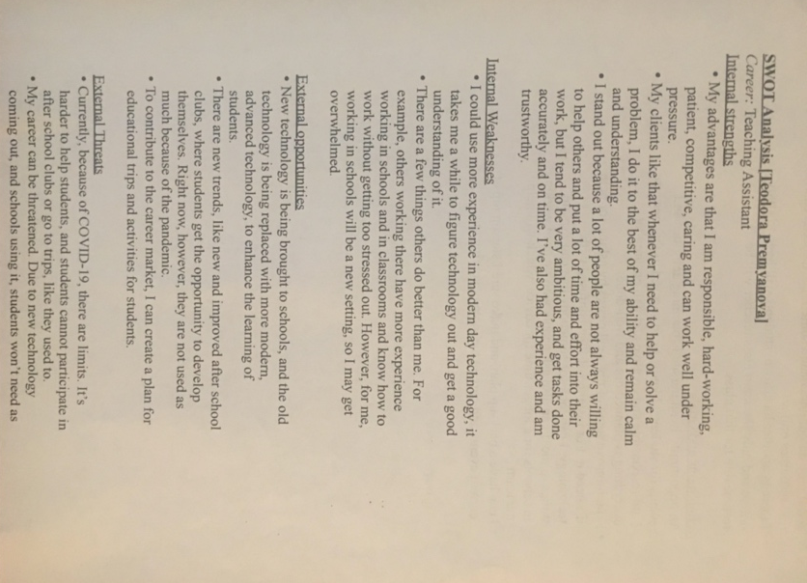

Appendix B

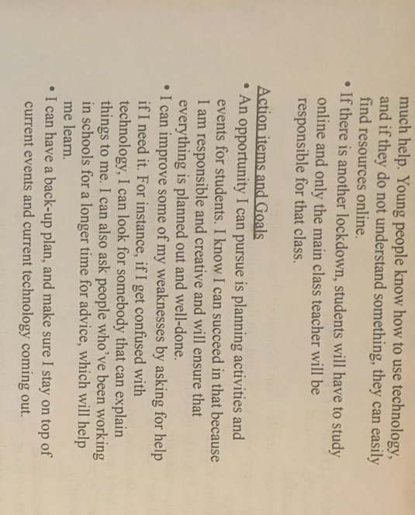

Appendix C

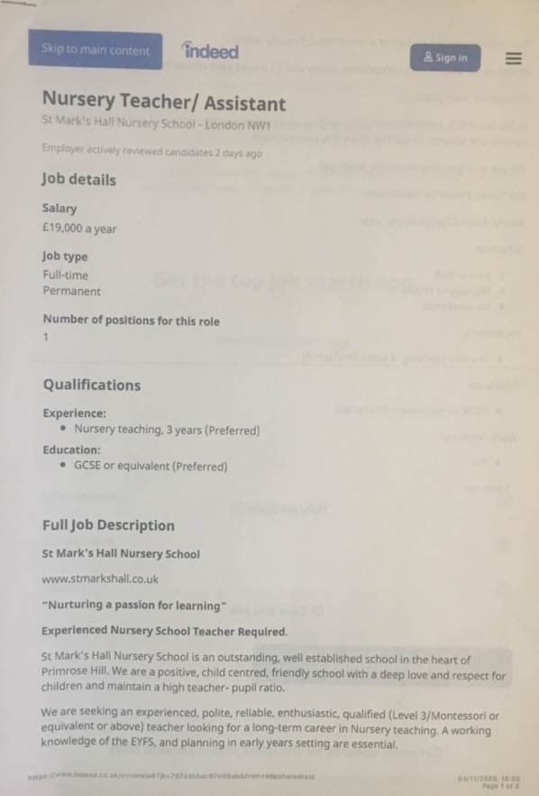

Appendix D



