


.

CAN
FEA REPLACE
PHYSICAL TESTING?

Emanuele Di Crosta
P151088
DATE
28/03/2020
COURSE
BEng Motorcycle Engineering Course

Contents

1 Introduction 1
2 Task 1: FEA along physical testing, why? What it is FEA? 2
3 Task 2: How Physical tests are correlated to FEA? How FEA works? 6
4 Task 3: FEA can/should replace physical testing? 10
5 Recommend Further Work 14
6 Conclusion 15
7 References 16

Figure 1 Project cycle scheme 2
Figure 2 FEM steps 7
Figure 3 2D and 3D mesh shapes 8
Figure 4 Experiment layout 10
Figure 5 FEA 10
Figure 6 Mesh differences (5 mm vs 1 mm) 12
Figure 7 Measurement point 13

Graph 1 Function 6

Table 1 Material Properties 11
Table 2 Experiment and FEA data 12

Introduction
Performance, durability and robustness are some of the key features of a better product and therefore their analysis under certain conditions is fundamental. Physical prototyping requires time and therefore has a cost, that is when the engineering field had introduced finite element analysis, FEA.
The following report will present explanation on why the industry uses FE along side physical testing, presenting some of the mathematical principles and the computational cycles used by the software behind a structural analysis.
It will be discussed furthermore, how FEA packages works, which are the steps to perform a simulation to best understand why a physical test is still very important to the validation of the results.
Finally, throughout the simulation of a simple physical experiment it will be highlighted how, even though FEA provides accurate results, the software is very sensible to certain set-ups affecting accuracy.

Task 1: FEA along physical testing, why?
What it is FEA?

The finite element method, FEM, it used by the industry to break down and solve the time-consuming mathematical operations, pillars of structural analysis computation. FE is used to analyse and predict structures’ behavior under static and dynamic loading or to investigate material’s reaction (Simscale, 2010).
FEA is a numerical-based process to model and analyze complex systems, the analysis occurs in a virtual environment which results are validated in a cross-referencing way.
In the engineering fields, it is used to calculate strength, behavior and characteristics of a component under various scenario: stress, deflection and vibration
Prior 1990, FE analysis was exploited and restricted to the aeronautical, defense and nuclear industries (Manor , 2016) due to the high cost of the software and computational power required. Nowadays, FEA is reaching a major audience of users thanks to more accessible costs than before as well as the high computational power commonly available.

Figure 1 Project cycle scheme
The main reason FEA is largely used by the industry is highlighted in Figure 1 and explained further on.

An analysed component is identified in space with a global coordinate system, and is broken down into smaller sections, which will be identified by a local coordinate system that can be aligned or not with the overall one. This subdivision allows the software to understand how the overall structure will behave under an external influence.
The resulting structure has the shape of a fishing net and is the so-called mesh, where each sub-region which is constituted by is defined by boundaries, making every element a finite one (Hearn, 1997).
Each finite element is in relation one to the other by discrete points, at their corners or at the midpoints, called nodes. A node is a single point either is in a 2-dimensional or 3-dimensional element and holds information of its location and of the material properties.
Each node-to-node connection is what defines an element to be the finite.
The mesh embraces the entire element/component analysed and could be denser according to the level of precision of the results wanted: intuitively a denser mesh comprehends a larger number of elements, therefore nodes, resulting in a more complex computation (Manor , 2016).
Each finite element is defined by multiple set of equations, holding information regarding its displacements, acceleration, inertia, stress, material properties etc and each function is in relation to the finite elements nearby; all the equations are solved simultaneously to determine how each node responds to an external input. To solve such equation’s web the governing equations are organized in matrix form.
Each element, therefore, under applied loads, adjusts its equations which will create or relieve stresses, modifying its borders and the neighbour ones. The computation is used to solve each finite element equation considering its relation to the near elements and combining them all to achieve the overall solution
The industry therefore exploits the computational capability of repeating calculations to solve simultaneously the governing equations organized in matrices form, more of these later.
It will not be discussed and presented the calculations behind the research of the element’s stiffness; however, it must be remembered that each node holds information of various nature. During structural analysis, to put into relation each node’s information the system is simplified to multiple spring models each one connected to the neighbour one.
Each node can be free to move (rotate or translate) and this possibility is represented by the degree of freedom (DOF): in a 2-dimensional system, each node has three degrees of freedom, two translational, one perpendicular to the other, and a rotational one (Erochko, 2016), in a 3-dimensional system instead there are six DoF per each node, translational motion along x,y,z axis and a rotational one around x,y and z.
Hook’s law and Young’s modulus definition are applied per each node and then combined to identify the overall element stiffness:
$F_{elastic}=k*$ $δ Length$ ; $E=\frac{stress }{strain}={\frac{Force}{Area}}/{\frac{δ Length }{Length}}$
$$k=\frac{Area*E}{Length}$$
To find k value, each node is evaluated as a single spring and combined to next one in a matrix form as:
$\left\{\begin{matrix}F_{1} \\ F_{2}\end{matrix}\right\}=\left(\begin{matrix}k_{1} & {-k}_{1} \\ {-k}_{1} & k_{1}\end{matrix} \right) \left(\begin{matrix}x_{1} \\ x_{2}\end{matrix}\right)$ (1)
Where $\left(\begin{matrix}k_{1} & {-k}_{1} \\ {-k}_{1} & k_{1}\end{matrix} \right)$ is the stiffness matrix; the above matrix (1) is the one generated by a single element with two nodes; however, a mesh is constituted by numerous elements which have many nodes and the equivalent stiffness matrix for the entire structure is the sum of all matrixes depending on each node, as below. The equivalent matrix ‘s dimension dictates the number of degrees of freedom.
$$\left\{\begin{matrix}F_{1} \\ F_{2} \\ F_{3}\end{matrix}\right\}=\left(\begin{matrix}k_{1} & -k_{1} & 0 \\ {-k}_{1} & k_{1}+k_{2} & -k_{2} \\ 0 & -k_{2} & k_{2}\end{matrix}\right)\left(\begin{matrix}x_{1} \\ x_{2} \\ x_{3}\end{matrix}\right)$$
{F} = k (x)
Another reason why FEA is carried out by the industries is for the computational work done to align each element to a single coordinate system, transforming local ones into global, throughout matrix manipulation and trigonometry.
It is therefore, highlighted one of the main reasons why industry relies on FEA: the time saving and higher precision that computational power has over hand-calculations.
FEA’s smaller time constrains allows benefits within the entire development process of a component: the virtual prototyping allows a higher number of new model’s attempts, i.e. different characteristics can be tried, and so higher quality and more efficient products are generated in less design cycles i.e. time (Manor , 2016).
Directly related to time is cost, therefore the development process will be cheaper also due to a new development cycle that allows prototyping to be left only at the final stages, close to the defined end-product. Multiple simulations for different designs, materials and shapes can be run in hours instead of days or more, therefore discovering or confirming suspect results at early stages, avoiding expensive physical tests.
To do so, FEA packages permit the user to assume or define, prior the simulation, regions of interest where stresses concentration might be and improve the analysis by the usage of a more refined mesh. The power and time required to compute therefore, can be manipulated and influenced preventing to overlook parameters since the early design stages, resulting in an increased material accuracy. In fact, it is possible to evaluate the entire structure either inside and outside and determine where failure might occur.

Task 2: How Physical tests are correlated to FEA?
How FEA works?
Throughout the production process of a component, physical tests still plays a fundamental role for the development of it; the reason of their importance lays in the process and rules which FEA packages runs on: the finite element method has been invented by engineers to solve structural equations (e.g. calculate the stresses raised by a truck passing on a bridge or the effect of wind on a building). It is used to solve differential equations, which represents nature and its continuous problems, and transform them into discrete ones, which computers are capable to solve (Science, 2013).
For clarity purpose, it is identified with the word discrete, a finite number of unknowns in a system whilst continuous describes an infinite number of unknowns (Manor , 2016).

The results are achieved throughout approximations, based on what can be called a S.I.M.P.L.E. process. These assumptions affect the results therefore engineering judgement is used as well to take decisions.
To run a structural simulation a mesh is a fundamental requirement to replicate the structure; calculations per each element are carried out and then combined, generating a map like graph 1.
Polynomials approximations are used to interpolate each element’s information. The slope of a function is calculated as the difference between two points, however the accuracy lays in the degree of the polynomial used to “curve fit” the connecting line between the two points. (Simscale, 2010)
Graph 1 Function
Values are known at specific points within the element, nodal points, but not elsewhere, for instance it is known the deflection at two specific points but not how the deformation under a load interpolates the flection between these two. The accuracy of the slope therefore is dependent on the polynomial approximations which can be linear, quadratic, cubic etc. Furthermore, FE method can be identified by three steps: pre-processing, solution and post-processing.
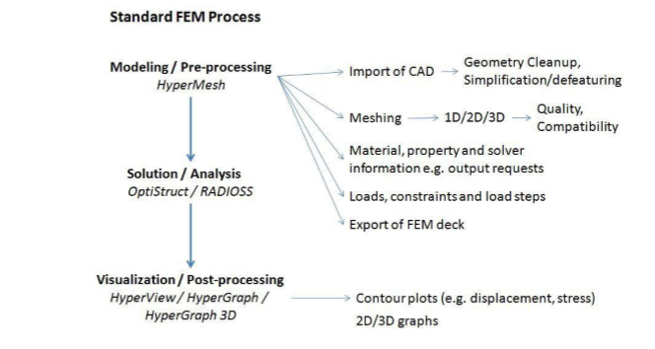
Figure 2 FEM steps
It can be said that FEA’s key step around which the entire analysis is dependent is pre-processing. Each set-up, assumption or feature used during the pre-processing is vital for the simulation and its correctness.
The model’s geometry is the first control: open surfaces or detached ones would result in not valuable simulations.
The mesh is then created, to approximate the geometry and, because is the first step for numerically solve the partial differential equations, a fundamental role is played by its quality.
The quality of the mesh identifies a group of factors that affect the performance of the simulation.
For clarity of the argument it must be known that there are two kind of meshes: a structured and an unstructured. The first one is also called a grid mesh due to the regular shapes that the elements have, making easy to identify neighbour cells and points.
The second kind is a more arbitrary mesh, it could have any geometry shape and is used for complex geometries.
These cells types can be 2-dimensional or 3-dimensional

Figure 3 2D and 3D mesh shapes
Mesh quality therefore controls different characteristics of the mesh it-self:
- Node’s coincidence: if elements shear nodes.
- Free edges: if each element is connected to the neighbor one, only boundary elements should have free edges.
- Mid-sides nodes position: if the mid-side node is not at the medium point along the element’s side will generate distortions and degrade the element performance.
- Internal angles: too small or too large can affect other parameters and therefore cause distortion. For quadrilateral elements the idea internal angle is 90°, for triangular 60°.
- Warping: is the deviation of the element shape from a planar reference. It is appreciable the solidity and advantage of a triangular shape over a quadrilateral one, no-matter the unevenness of the supporting surface.
- Distortion: the deviation of the shape from the original one, identified with the aspect ratio.
(Hearn, 1997)
Once the mesh is completed are then defined material properties and finally the loads and constraints.
The validity of the simulation is therefore dependent on the set-ups parameters used and on engineering judgment: for instance, critical thinking and decision are made for the loads and constraints step. Very important is to identify all the possible load situations that occur on the structure and determine which one/ones to use for the simulation. (Altair University, 2019)

Task 3: FEA can/should replace physical testing?
To understand the influence that certain parameters or engineering assumptions have over the simulation, a simple experiment was conducted and then replicated into FEA.
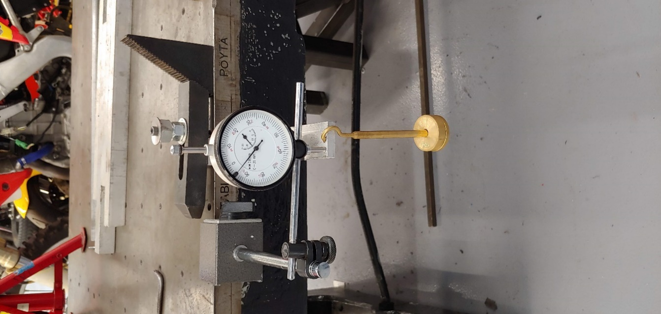
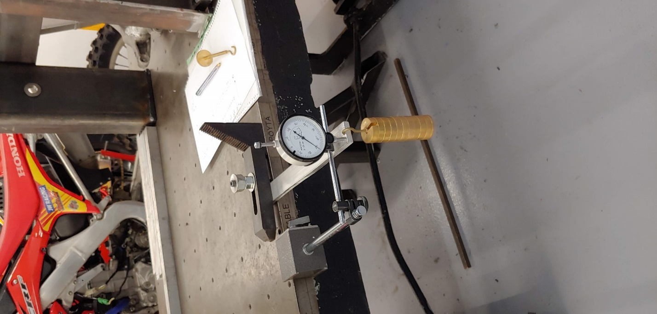
An aluminum bar (6061-T6 SS) of 260x28 millimeters, with a 7.6 mm width, was loaded at one extreme with 50 grams at the time, up to 600 grams total, and through a dial gauge it was read its displacement at the extreme were the load was applied.
Figure 4 Experiment layout
The experiment was then replicated into Solidworks:
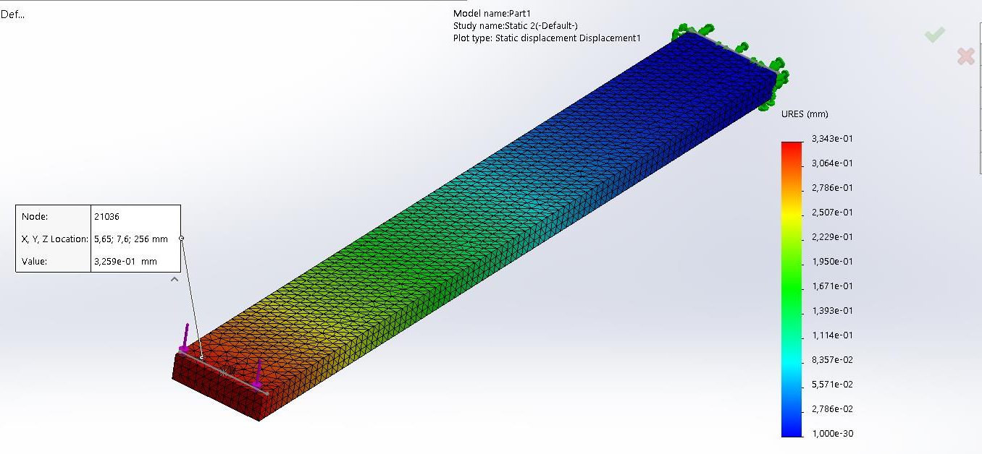
Figure 5 FEA

The simulations have been conducted to understand the influence of mesh, material, load application and constraints: a first set of simulations was run by varying the mesh’ size, starting with a 5 mm, then a 2.5 mm and, due to computational power and time constraints, stopped at a 1 mm mesh. The same mesh’s variations have been used with a different material. Finally, a set of simulations have been conducted by varying the location of the load.
PROPERTIES | 6061-T6 SS | 6063-T6 | UNITS
Elastic Modulus | 6900.00067 | 69000 | N/mm^2
Poisson's Ratio | 0.33 | 0.33 | N/A
Shear Modulus |  | 25800 | N/mm^2
Mass Density | 2700 | 2700 | Kg/m^3
Tensile Strength | 310 | 240 | N/mm^2
Yield Strength | 275 | 215 | N/mm^2
Thermal Expansion Coefficient | 2.4e05 | 2.34e-05 | /K
Thermal Conductivity |  | 209 | W/(m*K)
Specific Heat |  | 900 | J/kg*K
Hardening Factor | 0.85 |  | N/A
Table 1 Material Properties
Furthermore, some engineering assumptions have been used for the pre-processing stage as well and secondly changed to prove their influence: even though the length of the bar was 260 mm, for the simulation the bar was reduced to 230 mm instead due to the clamping solution used in the experiment. Therefore, it was assumed no influence of the remaining bar’s section under the clamping device. As well, the clamping element was replicated into the simulation as a fixed constraint along the width of the bar.
EXPERIMENT |  | SIMULATION
weight | displacement | material: | 6061_T6 SS |  |  | 6063_T6
weight | displacement | mesh: | 5 | 2,5 | 1 | 5 | 2,5 | 1
weight | displacement | load location: | top edge |  |  | top edge
weight | displacement | load | displacement |  |  | displacement
50 | 0,01 | 0,4905
100 | 0,05 | 0,981 | 0,05 | 0,05 | 0,05 | 0,03 | 0,03 | 0,03
150 | 0,07 | 1,4715
200 | 0,1 | 1,962 | 0,1 | 0,1 | 0,1 | 0,09 | 0,09 | 0,09
250 | 0,13 | 2,4525
300 | 0,15 | 2,943 | 0,16 | 0,16 | 0,16 | 0,14 | 0,14 | 0,14
350 | 0,18 | 3,4335
400 | 0,21 | 3,924 | 0,21 | 0,21 | 0,21 | 0,19 | 0,19 | 0,19
450 | 0,23 | 4,4145
500 | 0,26 | 4,905 | 0,27 | 0,27 | 0,27 | 0,25 | 0,25 | 0,25
550 | 0,29 | 5,3955
600 | 0,31 | 5,886 | 0,32 | 0,32 | 0,32 | 0,3 | 0,3 | 0,3
Table 2 Experiment and FEA data
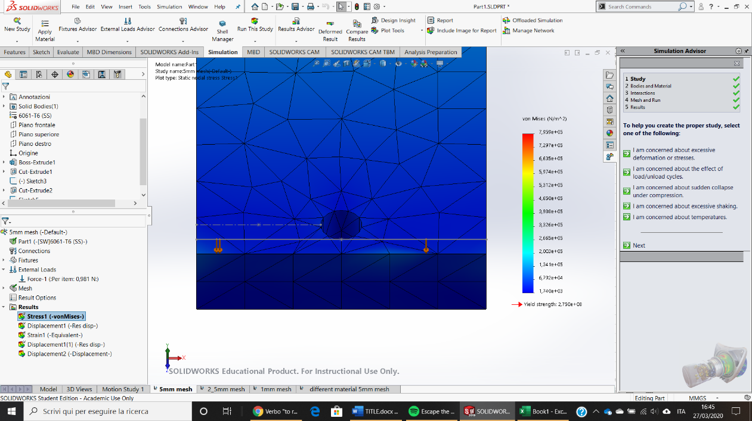
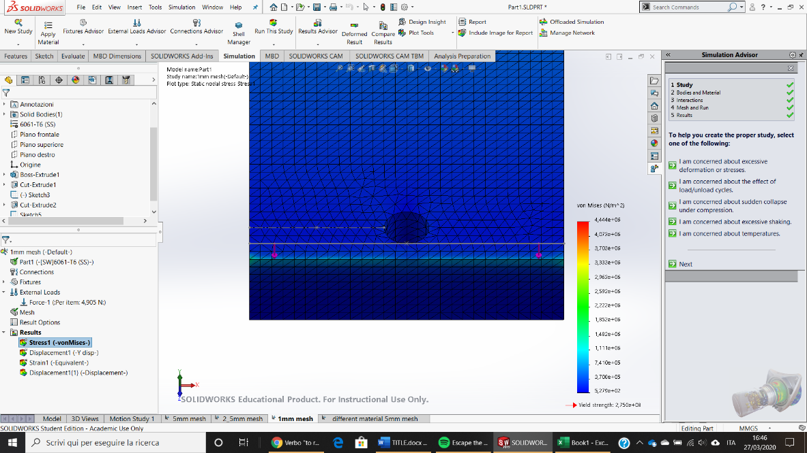
As the table highlights, the simulation was not repeated per each weight increment; furthermore, it is highlighted the influence that material has over the simulations. On the contrary, mesh’s dimension does not affect the displacement results however its influence is over the accuracy of other parameters, as strain and stresses. The below picture highlights how, along the same edge, stress is only visible with the smaller mesh and its magnitude is at the same time, influenced, as the legend on the side suggests.
Figure 6 Mesh differences (5 mm vs 1 mm)

The load application was simplified to a single force acting along the top edge (figure), instead of the used hook hanged to the center hole. However, it was tried to apply the load to the entire side face of the bar, but no differences were found.
However, once all the parameters and assumption used are considered to be correct, there is still a very important variable that can affect the results when is the post-processing step: as the below figure highlights, displacement’s readings were heavily affected by where the probe tool was placed.
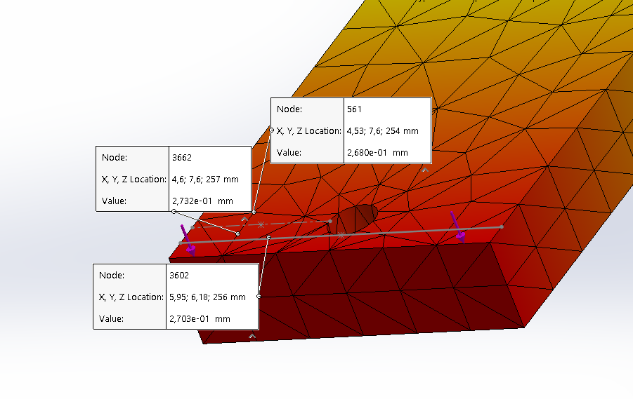
Within a range of less than one millimeter, the readings were giving a 0.52 mm maximum difference between the points.
Figure 7 Measurement point

Therefore, the number of variables that can affect the correctness and validity of the results are many:
- Material definition
- Component Constrains: the real ones and the ones replicated into the software
- Load application location on the component
- Displacement’s result readings (global o local)
FEA can therefore, be used as a verification tool to the physical experiments or vice versa highlighting how physical test are correlated to FE models, can be used to improve, optimize the existing model

Conclusion
In conclusion, it was understood that FEA takes complex problems and subdivide them into smaller simpler ones that can be solved.
Companies carry out FEA alongside physical testing due to the repeatability of simulations in a fixed environment, exploiting the computational power, capable to closely resolve the mathematical equations behind structure analysis.
However, it was understood that the principles behind the compute of the solutions are based around specific approximations therefore, it is highlighted the importance of physical testing alongside FEA, to validate either results.
However, using FEA allows the company to produce better quality products, in a shorter design cycle and with less waste of material i.e. more nature friendly.
In conclusion, the author does not believe that FEA will ever replace the physical testing, at least not soon, due to the principles used by it to solve structural problems. Furthermore, FEA software packages can provide very accurate results that hand calculations will not, however, it was highlighted how easily affected the results can be according to which set-ups, parameters and engineering assumptions are made in the pre-processing stages.

References
Altair University, 2019. Practical Aspects of finite element simulation. fifth a cura di s.l.:Altair University .
Erochko, J., 2016. Learn about structures. [Online]
Available at: http://www.learnaboutstructures.com/Degrees-of-Freedom
[Consulted 26 March 2020].
Hearn, E. J., 1997. Mechanics of material 2. third a cura di Warwick: Butterworth-Heinemann.
Manor , 2016. Manortool. [Online]
Available at: https://www.manortool.com/finite-element-analysis
[Consulted 2020].
Science, S., 2013. Finite element method - Gilbert Strang [Interview] (23 December 2013).
Simscale, 2010. simscale. [Online]
Available at: https://www.simscale.com/docs/
[Consulted 24 March 2020].

