Targets | How you have worked on this | An example can be found on
Target 1  Consider future research to the questions you raise on page 12. | Target 1  N/A | N/A
Target 2  Continue with the excellent range of reading to support your writing. | I have continued to use many reading materials to demonstrate I have read widely and deeply. | Page 9 onwards.

Component 2:
How a school develops one aspect of its SDP: a report that critically reflects on the actions, impact and evidence base.

Learners, Schools & Communities: where am I teaching?

Anna Jenkins
Word count: 2439

For the purpose of this writing, the school referred to within this report will be known as School X to anonymise all data, adhering to BERA guidelines (BERA, 2018). School X is a community school situated on the edge of a large housing estate in Swansea and is part of a community which is socially and economically disadvantaged. Data from Estyn (2012) substantiates this by stating that approximately 92% of pupils attending School X live within the 30% most deprived areas of Wales and around 55% of pupils claim Free School Meals (FSM). These figures are well above both the local authority and national averages of 23.4% and 21.3% (My Local School, 2021; StatsWales, 2021). Considering these statistics, it could be suggested that pupils who attend School X may face challenges related to poverty which could potentially impact upon their education, achievement, self-esteem and behaviour (Chowdry et al. 2010). In attempt to prevent these possible issues, a priority of School X’s School Development Plan (SDP), which will act as a focus for this writing, focuses on the implementation of whole-school approaches to emotional, mental and physical well-being (School X, 2022). Furthermore, the objective of this report aims to analyse how this priority has been developed, its actions and impacts, whilst using an evidence-based approach.

According to Welsh Government (2014; 2021b), SDP’s are strategic plans that set out to enable improvement and outline the actions taken, in line with its priorities, for how to utilise staff and funding to ultimately improve learner outcomes. Moreover, Kyriakides and Campbell (2004) add that the two main goals for school self-evaluation is to improve the quality of the organisation and to better teaching and learning. The notion that schools in Wales are encouraged to operate as Learning Organisations aims to support them to prepare for the implementation of Curriculum for Wales (CfW) and is said to allow for adaptation to take place, where improvements are made through the co-construction of all stakeholders within the school (Education Wales, 2018; Welsh Government, 2022). Appendix 1 illustrates seven goals and aspirations that support the transformation of schools into Learning Organisations, placing the Four Purposes of the curriculum at the centre, maintaining their significant role in the functionality of Learning Organisations in creating a learning atmosphere, culture and climate (OCED, 2016). CfW reflects the influence that self-evaluation plays on improving teaching and learning, encouraging schools to examine their approaches concerning the implementation of curriculum, assessment and planning. Subsequently, aiming to develop teaching and learning that supports progression for learners which is then demonstrated in daily practice (Welsh Government, 2020a).

Although Chang (2008) highlights that strategic planning is said to be impossible to conduct flawlessly, there are generic stages that can be implemented to support the process, including; analysis, planning, implementation and evaluation. Common phases can be found in guidance set out by Welsh Government (2021a) that outline planning processes specifically for schools in Wales (See Appendix 2), encouraging them to consider how they can make their aspirations for improvement materialise. One of the tools that schools use as part of their improvement process is data, where the information used aims to identify goals which are often connected to the prevalent and fundamental aim of improving the quality of teaching and learning for pupils (Schildkamp, 2019). Schmoker (2003) suggests that if data aims to help improve teaching and learning, then it is said to be important to consider the needs of teachers, since the way they use data has the greatest baring on student performance. Furthermore, when two main questions are asked by teachers, which are; ‘how many students are succeeding in the subjects I teach?’ and ‘within those subjects, what are the areas of strength or weakness?’, targeted and collaborative efforts can be facilitated for students to achieve (Schmoker, 2003).

School X’s SDP (2022) outlines four priorities that each address a different area of improvement based around a rationale, giving an evidence base for why it is a priority to the school, remaining in line with Welsh Government (2014) guidance. The aforementioned focus for this report encompasses the notion of well-being, which is argued by O’Connell et al. (2009) to be impacted by poverty amongst children. In view of School X’s socioeconomic status and high levels of poverty, this focus deems an appropriate choice as a priority for school development.

CfW highlights how essential well-being is for pupils by explicitly naming one of the Areas of Learning Experience (AoLE) ‘Health and Well-being’, recognising that they are important domains to enable successful learning (Welsh Government, 2020b). Furthermore, when engaged with appropriately as a whole-school approach, much like a holistic web, all aspects of school life are positively impacted due to its interdependence and interconnection with other areas (Thomson, 2010; Welsh Government, 2020b). There are said to be four dimensions of well-being, namely; emotional, behavioural, social and school, to which research has suggested that children with higher levels of all four of dimensions of well-being generally achieve better academically and are more engaged with school (Gutman and Vorhaus, 2012). Furthermore, according to Welsh Government (2010), providing support and attention to emotional health and well-being can bring about significant benefits to learners and their schooling, conducive to improved classroom and whole-school atmosphere, thus contributing to effective teaching and learning, behaviour and attendance. Therefore, it could be concluded that well-being for learners is an imperative responsibility for schools to maintain an education that facilitates better prospects for pupils.

Although schools across Wales vary in their demographic and subsequent need, social justice persists to be fundamental in providing equal opportunities for all learners. Hage, Ring and Lantz (2011) believe that issues regarding social justice and correlated to collective well-being of families, communities and society. This highlights the validity of School X’s priority to develop well-being of its learners, which simultaneously contribute to address social justice, providing them with an education and schooling that equips them for the realities of life (Smith, 2018). Substantiating this is evidence which suggests that good teachers can make a positive difference to pupils from disadvantaged backgrounds, however, teachers must have an understanding and commitment to delivering social justice and high academic attainment for these learners if this is to be achieved (Ellis, et al. 2016).

School X (2022) have devised a bespoke school solution through the means of their SDP, which is said to be greatly important, particularly in schools that serve impoverished communities, such as School X (Thomson, 2010). This was apparent when rationalising well-being as a priority, where the school demonstrated an understanding of the learners needs, placing them at the centre, as exemplified in Appendix 3. Welsh Government (2015; 2020a) state that knowing, recognising and supporting learners’ needs and background is imperative to progression. Another strength in this decision-making process is that School X’s well-being priority aligns with national priority, maintaining goals of The Well-being of Future Generations Act 2015 which concerns the well-being of Wales, encompassing social, economic, environmental and cultural factors (Future Generations Commissioner for Wales, 2022). These well thought out rationales for the well-being priority exhibit how School X have considered both national perspectives simultaneously with the learners context and needs.

Self-evaluation was the first stage that School X undertook as part of their school development process, where they considered; how well they are performing to better well-being, areas of strength concerning improving well-being, what needs to be improved to better well-being and what actions to take to make those improvements (Welsh Government, 2014). However, the cycle of self-evaluation and development planning is said by Welsh Government (2014) to be down to individual schools to manage, in light of what works best for them as a school. Furthermore, strategic planning is most effective when all stakeholders and school partners are involved (Welsh Government, 2014). Brighouse and Woods (2005) define key stakeholders as those who play a part in the schools’ success, such as teachers, governors and parents. Moreover, School X (2022) place significance on the role of the wider community to enrich the well-being priority by evidencing in the SDP the links that are made to support well-being, including; working with community facilities to develop Health and Well-being, such as sporting facilities, and support wider community well-being e.g., working with local charities and care homes, enriching the curriculum and providing valuable resources for the school (Welsh Government, 2016). However, it could also be suggested that School X would benefit from collaborating with other schools to share expertise, resources and best practice to enable improvement of well-being (Estyn, 2019). Pupils at School X also play a part in the development of priorities, which raises their self-esteem when they realise their contribution is recognised as valued (Education Scotland, 2018). This also incorporates Article 12 of the United Nations Convention on the Rights of the Child, that states that all children have the right to express their views, feeling and wishes that affect them (UNICEF, 2022).

School X (2022) outline actions and accompanying milestones within the well-being priority as part of their strategic planning process and additionally, success criteria were generated to suggest what is to be achieved in order to evidence the development and progress of well-being within learners (Welsh Government, 2014; School X, 2022). This concept is taken from an element within Assessment for Learning that supports learners to comprehend what they need to do to achieve the learning objectives by sharing the success criteria with them (Clarke, 2008). One of the statements of success criteria within School X’s SDP include; the term ‘well-being’ is understood by all pupils (School X, 2022). This was carried out though Red-Amber-Green rating where each area was reviewed and colour coded accordingly. However, it is noted that schools must remember that it is outcomes that are being evaluated, not a check list for whether they have been carried out or not (Arnold, 2017). It could also be argued that this is difficult to evaluate accurately, as there is no universally agreed method to measure well-being, therefore data collected is based on subjectivity (Huppert, 2017). Consequently, questions arise, such as; how do School X know that all learners have understood the term well-being? Furthermore, can they then accurately use this as success criteria to determine whether the priority has been achieved as part of the strategic planning and data analysis?

School X (2022) analyse data from Thrive performance data, which aims to assess how learners are developing within their well-being, forming part of how the school measures the impact of actions taken to improve well-being. Thrive is a programme delivered in schools by trained staff that aims to promote children’s and young people’s positive mental health, meeting their social and emotional needs (Thrive, 2022). The Thrive performance data uses tools such as questionnaires and observations of learners to collect data on their well-being, gathering qualitative data, which Lincoln and Guba (1985) point out that it is not always possible for such data to be credible. It could also be argued that staff members collecting this information on learners’ well-being may be closely bound to the pupils and therefore could impact on the reliability of the data (Denscombe, 2010). Kutsyuruba, Klinger, and Hussain (2015) report that there is a correlation between well-being of students and their achievement, which could suggest that analysing test results of pupils from School X may provide another alternative in identifying if they are progressing in their well-being levels.

Attempts have been made by School X to ensure the development of well-being as a priority from the SDP is achieved successfully. One of the main ways this has been carried out is through the re-introduction of extra-curricular and after school clubs, post COVID. These are said to give children time to play, socialise, participate in sports and relax (Posner and Vandell, 1999). Activities have been unable to run due to the COVID-19 pandemic, and such disruptions are said to likely have the greatest impact on disadvantaged learners (Welsh Government, 2021c). Although the implementation of afterschool clubs aims to provide opportunities for well-being, it must be considered that not all pupils will, for varying reasons, be able to attend. Similarly, the idea suggested by the Education Endowment Foundation (2022) that parental engagement strategies risk the increase of attainment gaps if parents that engage are primarily from affluent backgrounds, could be considered an alike challenge for after school clubs- that the learners who would most benefit from after school activities to improve well-being may be the groups of learners who would not participate. Therefore, a recommendation for School X could be suggested that extra-curricular activities and clubs occur during the school timetable, ensuring that all learners have equal opportunities to attend.

Although the school implements Thrive to support pupils emotional and mental well-being, this is only accessed by a certain number of learners who are deemed ‘in need’ of the provision, failing to address a whole-school approach. Therefore, it could be suggested that all learners are to be given the opportunity to participate in Thrive well-being activities, through whole class programmes and sessions that include all learners. ‘Check-ins’ are another strategy used by School X to support the development of well-being amongst its learners. It is said that methods such as these, aid learners to deal with, process and manage their emotions, which in turn, helps them to recognise how they can support their well-being, creating independence and resilience (Mentally Healthy Schools, 2018). However, it is recognised by School X (2022) in their SPD that they need to develop more age-appropriate check in resources for their Key Stage 2 pupils, to encourage participation and meaningful well-being monitoring.

This report encompasses how schools in Wales use development processes to improve outcomes for their learners through stages of, self-evaluation, strategic planning, action and reviewing impact (Welsh Government, 2014). Simultaneously, consideration is given to different factors that may impact on learners’ progress and achievement, enabling to best serve the learners and their needs and background. Through analysing School X’s priority of well-being, it has also reenforced the pivotal function that well-being has on learners schooling, education and progress. Consequently, I will be making conscious and mindful decisions to implement well-being strategies within my future class.

Analysing and reviewing School X’s SPD has given me insight into the complex and detailed processes of school improvement, supporting me to engage in practices with an inquiring disposition (Orchard and Winch, 2015). Therefore, looking ahead, I have reflected upon the notion that as a future practitioner, I will not be limited to the responsibility of the achievements, attainment and outcomes for my pupils that I teach directly, but I will be required to collaborate with other key stakeholders to impact upon whole school change.

References:

Arnold, M. (2017) ‘How to write and implement an effective school improvement plan’ Effective School Improvement Plan [blog]. 2 August.
Available at: https://www.oneeducation.co.uk/news-blog/effective-school-improvement-plan
(Accessed: 30 April 2022).

BERA (2018) Ethical guidelines for Educational Research
Available at: https://www.bera.ac.uk/publication/ethical-guidelines-for-educational-research-2018
(Accessed: 26 February 2022).

Brighouse, T. and Woods, D. (2005) How to imrpove your school. London: Routeledge.

Chang, G.C. (2008) Strategic planning in education
Available at: http://www.dr-ama.com/wp-content/uploads/2013/04/strategic-education.pdf
(Accessed: 28 April 2022).

Chowdry et al. (2010) Poorer children’s educational attainment: how important are attitudes and behaviour?
Available at: https://www.jrf.org.uk/sites/default/files/jrf/migrated/files/poorer-children-education-full.pdf
(Accessed: 28 April 2022).

Clarke, S. (2008) Active Learning Through Formative Assessment. United Kingdom: Hodder Education.

Denscombe, M. (2010) The Good Research Guide. 4th Ed. Maidenhead: McGraw-Hill Education.

Education Endowment Foundation (2022) Parental Engagement
Available at: https://educationendowmentfoundation.org.uk/education-evidence/teaching-learning-toolkit/parental-engagement
(Accessed: 1 May 2022).

Education Scotland (2018) How good is OUR school? A resource to support learner participation in self-evaluation and school improvement
Available at: https://files.eric.ed.gov/fulltext/ED604830.pdf
(Accessed: 30 April 2022).

Education Wales (2018) Exploring Schools as Learning Organisations
Available at: https://podcasts.google.com/feed/aHR0cHM6Ly93d3cuc3ByZWFrZXIuY29tL3Nob3cvMjg5OTk4NC9lcGlzb2Rlcy9mZWVk/episode/aHR0cHM6Ly9hcGkuc3ByZWFrZXIuY29tL2VwaXNvZGUvMTYzOTI2ODg?sa=X&ved=0CAUQkfYCahcKEwi4yNyS67b3AhUAAAAAHQAAAAAQAQ
(Accessed: 28 April 2022).

Ellis, S. et al. (2016) ‘Student teachers’ perceptions of the effects of poverty on learners’ educational attainment and well-being: perspectives from England and Scotland’, Journal of Education for Teaching, 42(4), pp.483-499
DOI: 10.1080/02607476.2016.1215542

Estyn (2012) A report on School X
Available at: https://primarysite-prod-sorted.s3.amazonaws.com/clwyd-cps/UploadedDocument/91c1367978134a5f9b6baada5f8491df/inspection-report-clwyd-community-primary-school-2012-english-only_0.pdf.pdf.pdf.pdf.pdf.pdf.pdf.pdf.pdf.pdf.pdf.pdf
(Accessed: 28 April 2022).

Estyn (2019) Working collaboratively on school improvement
Available at: https://www.estyn.gov.wales/effective-practice/working-collaboratively-school-improvement
(Accessed: 29 April 2022).

Future Generations Commissioner for Wales (2022) Well-being of Future Generations (Wales) Act 2015
Available at: https://www.futuregenerations.wales/about-us/future-generations-act/
(Accessed: 29 April 2022).

Gutman, L.M. and Vorhaus, J. (2012) The Impact of Pupil Behaviour and Wellbeing on Educational Outcomes
Available at: https://assets.publishing.service.gov.uk/government/uploads/system/uploads/attachment_data/file/219638/DFE-RR253.pdf
(Accessed: 29 April 2022).

Hage, S.M. Ring E. and Lantz M.M. (2011) ‘Social Justice Theory’, Levesque R.J.R. (eds) Encyclopaedia of Adolescence, pp.2794-2801
DOI: 10.1007/978-1-4419-1695-2_62

Huppert, F.A. (2017) ‘Challenges in defining and measuring well-being and their implications for policy’, Future directions in well-being, pp.163-167.
DOI: 10.1007/978-3-319-56889-8_28

Kutsyuruba, B. Klinger, D.A. and Hussain, A. (2015) ‘Relationships among school climate, school safety, and student achievement and well‐being: a review of the literature’, Review of Education, 3(2), pp.103-135.
DOI: 10.1002/rev3.3043

Kyriakides, L. and Campbell, R.J. (2004) ‘School self-evaluation and school improvement: A critique of values and procedures’, Studies In Educational Evaluation, 30(1), pp.23-36.
DOI:10.1016/S0191-491X(04)90002-8

Lincoln, Y. and Guba, E. (1985) Naturalistic Enquiry. Newbury Park, CA: SAGE.

Mentally Healthy Schools (2018) Emotional check-in: coping strategies
Available at: https://www.mentallyhealthyschools.org.uk/media/2003/emotional-check-in.pdf
(Accessed: 1 May 2022).

My Local School (2021) Clwyd Primary School
Available at: https://mylocalschool.gov.wales/School/6702069?lang=en
(Accessed: 28 April 2022).

OCED (2016) What makes a school a learning organisation? A guide for policy makers, school leaders and teachers
Available at: https://www.oecd.org/education/school/school-learning-organisation.pdf
(Accessed: 28 April 2022).

O’Connell, M.E. et al. (2009) Preventing mental, emotional, and behavioural disorders among young people: Progress and possibilities. Washington DC: National Academy of Sciences.

Orchard, J. and Winch, C. (2015) ‘Philosophical Perspectives on Education Policy. What training do teachers need? Why theory is necessary to good teaching’, Impact, 2015(22), pp. 1-34.
DOI: 10.1111/2048-416x.2015.12002.x

Posner, J.K. and Vandell, D.L. (1999) ‘After-school activities and the development of low-income urban children: a longitudinal study’, Developmental psychology, 35(3), p.868.
DOI: http://dx.doi.org/10.1037/0012-1649.35.3.868

Schildkamp, K (2019) ‘Data-based decision-making for school improvement: Research insights and gaps’ ,Educational Research, 61(3), pp. 257 273
DOI: 10.1080/00131881.2019.1625716

Schmoker, M. J. (2003) First Things First: Demystifying Data Analysis : to Improve Student Achievement Results, Use Data to Focus on a Few Simple, Specific Goals. United States: EBSCO Publishing.

[School X] (2022) [School X’s] School Development Plan. Swansea: [School X]
Available at: https://primarysite-prod-sorted.s3.amazonaws.com/clwyd-cps/UploadedDocument/199f3a31-5dbc-451e-91da-0e9808efceb2/sdp22.pdf

Smith, E. (2018) Key Issues in Education and Social Justice. London: SAGE.

StatsWales (2021) Pupil Level Annual School Census summary data by local authority (pupils aged 5 to 15 in primary, middle or secondary schools)
Available at: https://statswales.gov.wales/Catalogue/Education-and-Skills/Schools-and-Teachers/Schools-Census/Pupil-Level-Annual-School-Census/pupillevelannualschoolcensussummarydata-by-localauthority
(Accessed: 28 April 2022).

Thrive (2022) What is Thrive?
Available at: https://www.thriveapproach.com
(Accessed: 30 April 2022).

Thomson, P. (2010) Whole school change: a literature review
Available at: http://old.creativitycultureeducation.org/wp-content/uploads/cce-lit-review-whole-school-change-255.pdf
(Accessed: 29 April 2022).

UNICEF (2022) A summary of the UN Convention on the Rights of the child
Available at: https://downloads.unicef.org.uk/wp-content/uploads/2019/10/UNCRC_summary-1_1.pdf?_ga=2.143193141.1055300075.1613650754-306809253.1613650754
(Accessed: 30 April 2022).

Welsh Government (2010) Thinking positively: Emotional health and well-being in schools and Early Years settings
Available at: https://gov.wales/sites/default/files/publications/2018-12/thinking-positively-emotional-health-and-well-being-in-schools-and-early-years-settings.pdf
(Accessed: 26 April 2022).

Welsh Government (2014) School development plans
Available at: https://gov.wales/sites/default/files/publications/2018-03/school-development-plans.pdf
(Accessed: 26 April 2022).

Welsh Government (2015) Person-centred practice in education: a guide for early years, schools and colleges in Wales
Available at: https://gov.wales/sites/default/files/publications/2019-01/person-centred-practice-in-education-a-guide-for-early-years-schools-and-colleges-in-wales.pdf
(Accessed: 1 May 2022).

Welsh Government (2016) Theme 1: Leadership for a self-improving system
Available at: https://gov.wales/sites/default/files/publications/2018-12/theme-1-leadership-for-a-self-improving-system-resources-1-7.pdf
(Accessed: 30 April 2022).

Welsh Government (2020a) Curriculum for Wales guidance
Available at: https://hwb.gov.wales/storage/b44ad45b-ff78-430a-9423-36feb86aaf7e/curriculum-for-wales-guidance.pdf
(Accessed: 26 April 2022).

Welsh Government (2020b) Health and Well-being
Available at: https://hwb.gov.wales/curriculum-for-wales/health-and-well-being
(Accessed: 29 April 2022).

Welsh Government (2021a) Planning and implementing improvement
Available at: https://hwb.gov.wales/evaluation-improvement-and-accountability/the-national-resource-evaluation-and-improvement/evaluation-and-improvement-principles/planning-and-implementing-improvement/
(Accessed: 28 April 2022).

Welsh Government (2021c) Renew and reform: supporting learners' wellbeing and progression
Available at: https://gov.wales/renew-and-reform-supporting-learners-wellbeing-and-progression-html
(Accessed: 1 May 2022).

Welsh Government (2021b) The national resource: overview
Available at: https://hwb.gov.wales/evaluation-improvement-and-accountability/the-national-resource-evaluation-and-improvement/the-national-resource-overview/
(Accessed: 26 April 2022).

Welsh Government, (2022) Schools as learning organisations
Available at: https://hwb.gov.wales/professional-development/schools-as-learning-organisations/
(Accessed: 26 April 2022).

Appendix:

Appendix 1- Developing Schools in Wales as Learning Organisations
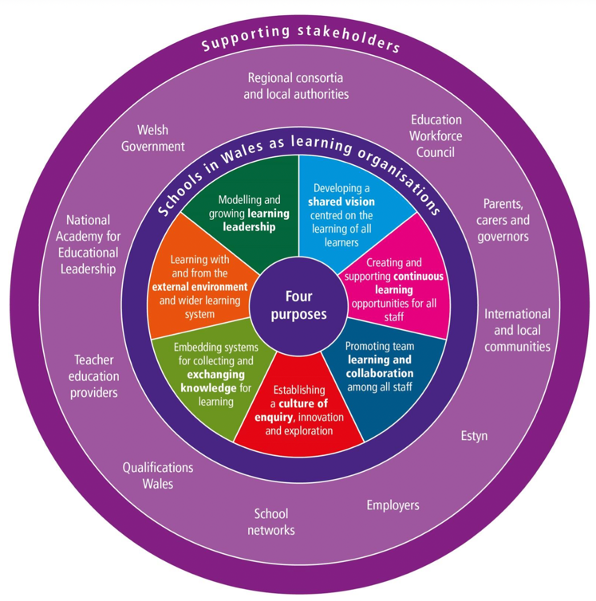
Source: Welsh Government (2018)

Appendix 2- Implementing improvement strategy
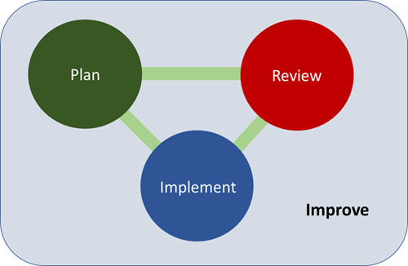

Source: Welsh Government (2021)

Appendix 3: Assessment and the new curriculum
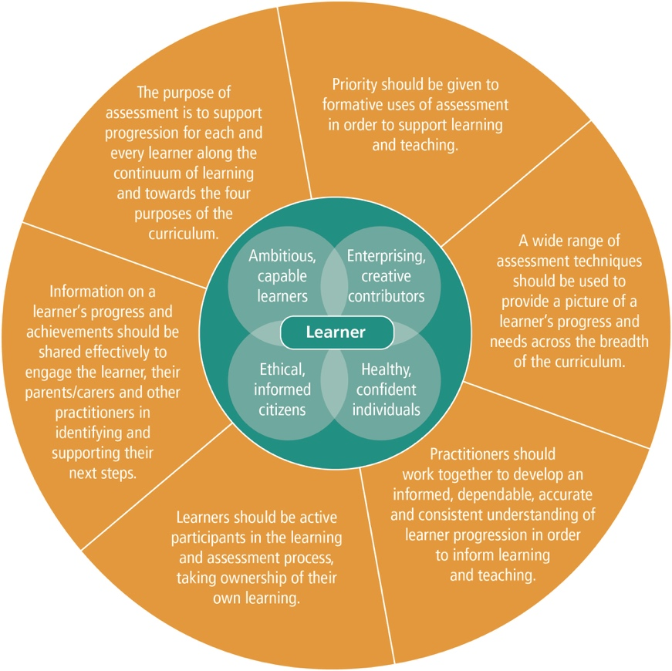
Source: Welsh Government (2019)

