DS 1 Template

My Screenshots/Photos
- Please add 4–6 screenshots or photos of your digital life.
- You can use your phone or laptop.
- For each screenshot, write one or two sentences explaining what it shows.

Screenshot/Photo 1
[Insert Photo/Screenshot below]
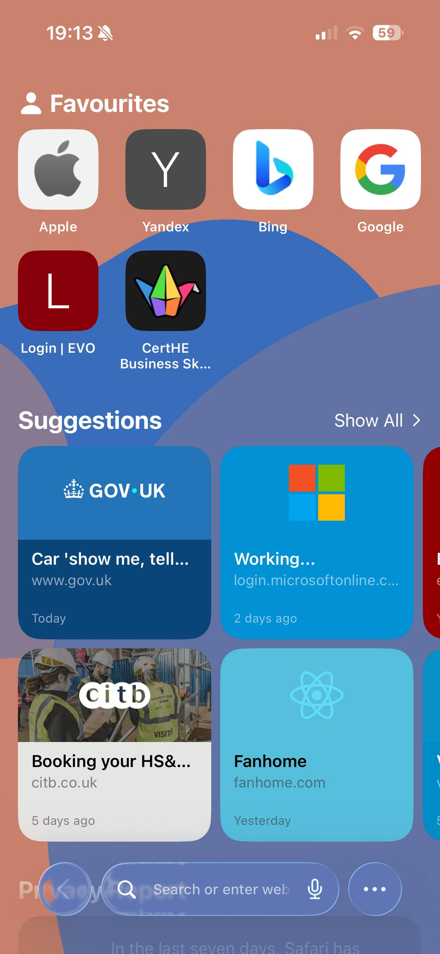
It’s “Safari” and I use it to search for information

Screenshot/Photo 2
[Insert Photo/Screenshot below]
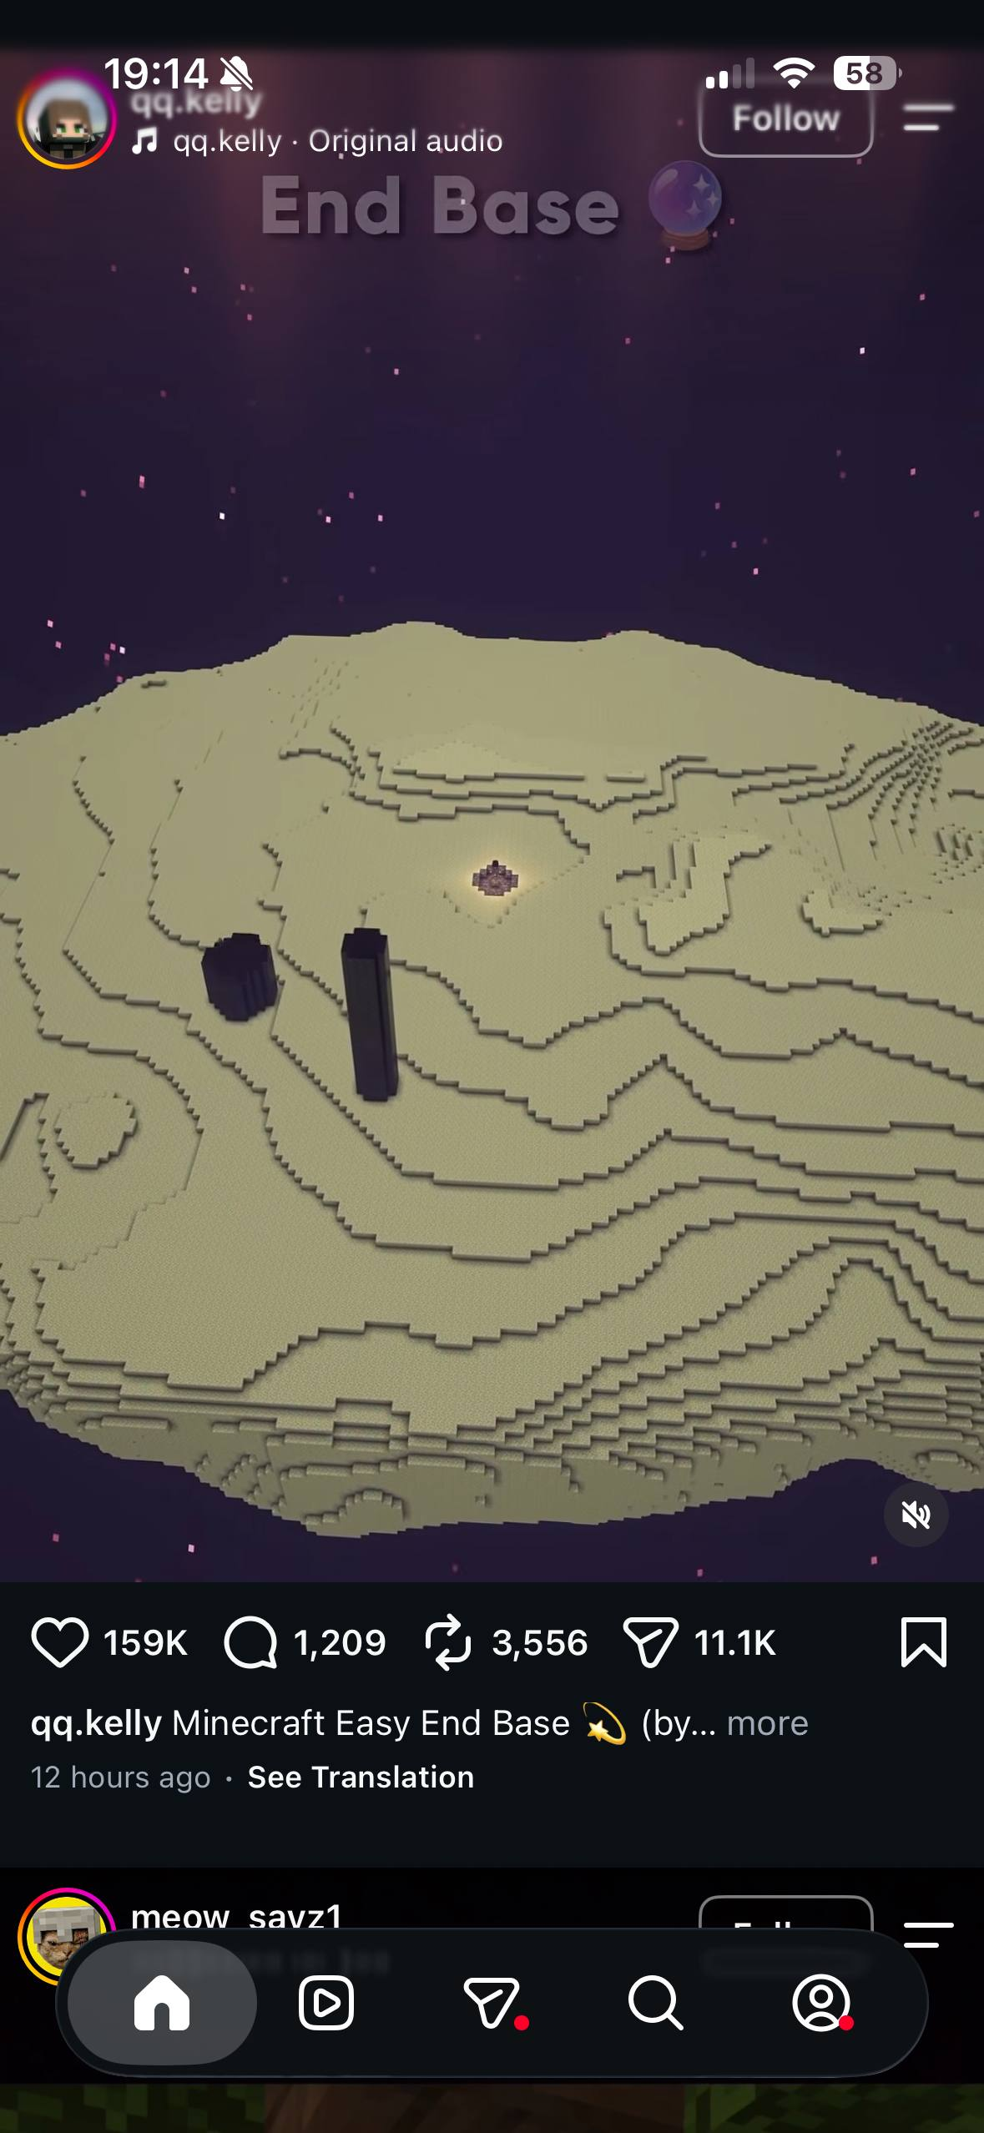
I use Instagram to watch some content and communicate with people

Screenshot/Photo 3
[Insert Photo/Screenshot below]
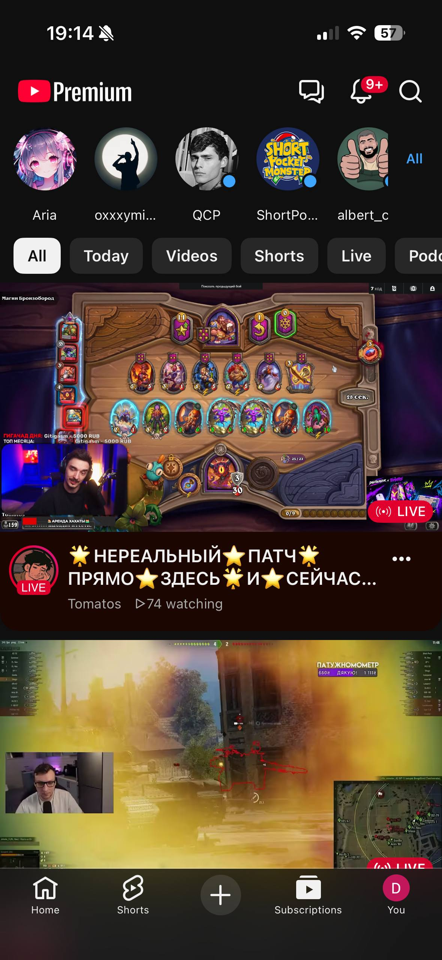
YouTube – for relaxing and watching videos

Screenshot/Photo 4
[Insert Photo/Screenshot below]
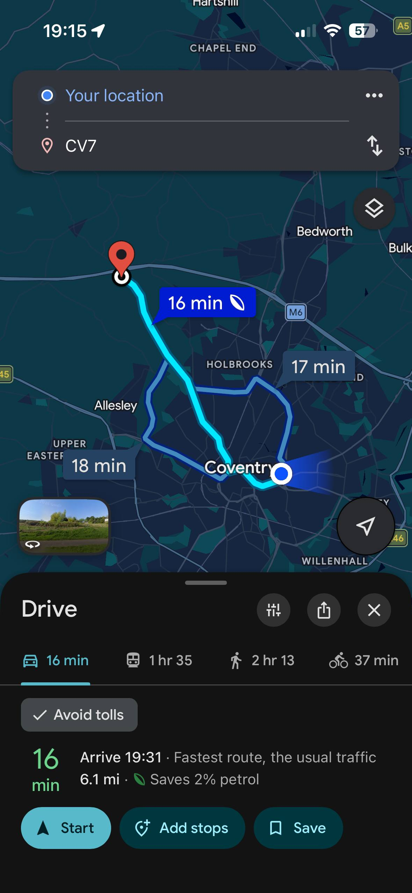
It’s map and I use for the shortest route application

Screenshot/Photo 5
[Insert Photo/Screenshot below]
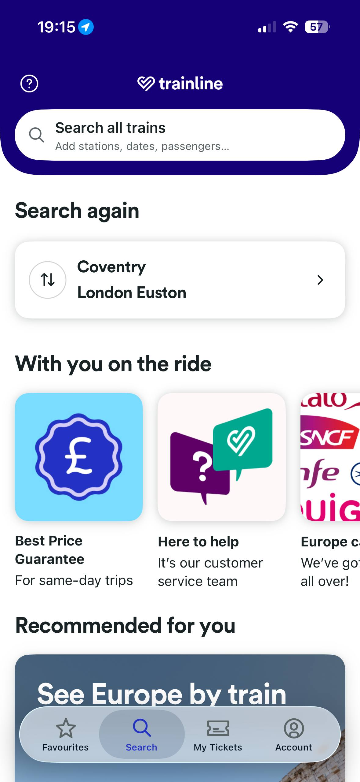
Its’s Trainline and I use for travelling

My Short Reflection
- Write 5–8 simple sentences about your digital life.
- You can use the sentence starters below if helpful.
I use digital tools to search for information, reminders and communication.
I feel confident when I find the correct and reliable information. And when all gadgets are charged.
I want to improve computer skills. I often use these tools: maps, YouTube, Google and so on.
I sometimes feel nervous about can’t find the right and reliable information.
I hope this module will help me distinguish between faces and originals information.

Sentence starters
- I use digital tools to …
- I feel confident when I …
- I want to improve …
- I often use these tools: …
- I sometimes feel nervous about …
- I hope this module will help me …
- Digital skills are important for me because …
You can write more if you want.

Submission Checklist
Before you submit, please check:
​​​ ☒ I added 4–6 screenshots
☒ I wrote short sentences for each screenshot
☒ I wrote my short reflection
☒ My work is my own
☒ My file opens correctly
​​☒ My file opens correctly

