MARKETING MANAGEMENT
ASSESSMENT 1

Student ID:2215087
Course Name: MBA General management
Subject Name: Marketing management

Table of Contents
Introduction 5
Background of the company 5
Marketing strategies for brand awareness 5
Marketing approaches of a company to deal with environmental challenges 6
How company evaluate customers through different communication channels 8
Challenges of marketing management in changing business environment 9
Benefits and strengths of the marketing department of the organisation 11
Relationship between the marketing department and value addition 13
Managerial approaches of the organization towards stakeholders satisfaction 14
Conclusion 15
References 15

Introduction
Marketing management is referred to as the tools and strategies that are used in promoting a business. The business utilizes marketing management techniques to identify opportunities for its growth and improve its market. Marketing of a business is the process of developing, delivering and communicating, and exchanging offers that have value for partners and customers. In this report, marketing strategies for increasing brand awareness will be analyzed. The marketing approaches to deal with environmental challenges will also be considered in the report. The report shall reflect how the company uses communication channels to analyze the customers. Furthermore, the report will also discuss the relationship between value addition and the marketing department and the benefits of the marketing department of the organization.

Background of the company
The Albrecht family founded ALDI in 1961 as the international first discount grocery store in Germany. In 1976, the first Aldi store of Aldi was opened in Iowa. presently, its headquarters are in Illinois and Batavia, and has grown to more than 200 stores in 36 states and has employees of more than 25,000.

Figure 1: Logo of ALDI
(Source: ALDI 2022)

Marketing strategies for brand awareness
Over the last decades, ALDI prides itself as they are selling the most economical quality items. ALDO's marketing strategy aims to grow globally, and are trying to make sure everyone has nearby Aldi stores, this Indesit helped the company to increase awareness about its brand due to which it becomes the third largest grocery brand in Australia and year 2022 placed it track third largest in the US. Some of the marketing strategies which the company has used to increase brand awareness are below.
Ads promote USP- As opined by Makrides et al., (2020, p. 17), there is no marketing department of ALDI in Germany, it promotes its strategy in the UK, US, and in Australia. The company makes efficient use of electronics, prints, and displays media which helps the company to promote its different stores and enables them to increase the number of customers due to which it has achieved efficient success. In these countries, the company runs copies such as Swap and save and Like brands to grab customers from competitors and has been able to build trust in their products, which is the reason the company has significantly increased brand awareness (Simons et al., 2019, p. 138).
Engaging with followers- is one of the best marketing strategies to increase awareness about a brand, so by engaging with its flowers, ALDI can create loyalty to its brand. A fan-favorite survey has been run by the company since 2019, where fans are provided with lottery up to 1000 dollars in ALDI gift cards as the fans have tas to vote for their favorite product of the company, this strategy helps the company to activate its following, which turns their fans into marketers as they encourage other people to use company product for the hashtag, which helps the company to aware more people about their products (Mahdi et al., 2019, p. 334).
Good different new brand positioning- As mentioned by Ansari et al., (2019, p. 7), ALDI is using this strategy as it has a low price for its products which makes the company stand out against all other competitors. To increase awareness about the company's uniqueness, the marketing strategy of the company in Australia incorporated new brand positioning. Good Different, which reinforced that the ALDI's low price leads them to conscientious practices such as the company was able to source their products ethically and was able to treat their suppliers and their staff with respect. The Good different campaign reveals to its customers that the prices of the company's products are better because the ALDI is better, which enables the company to increase awareness about their company across the world (Team 2022)

Marketing approaches of a company to deal with environmental challenges
The company had efficiently used marketing approaches to deal with challenges as it has various competitive retail stores and was able to receive over 1,200 products awarded since 2017, which involves the BrandSpark American Trust Study most discount Grocery store chain. A few marketing approaches for companies to deal with challenges are.
Brand equity- competitive pricing is one of the marketing approaches of ALDI, as it can provide high-quality products at a reasonable price since the company purchases them in huge quantities which enables the company to improve its efficiency. The fact that a company buys a huge amount of items is that it allows the company to make significant opportunities to negotiate the most affordable prices together with their suppliers. The company was able to open one store every week in Britain, because its production is uncomplicated, which enabled the company to deal with challenges as the various retailers are also providing the same products and are trying to grab their customers (Singh et al., 2019, p. 211).
As mentioned by Tien et al., (2019, p. 138), The social responsibility approach-ALDI is aware of the high standards that shoppers in the millennial and Gen-Z generations have set for their brand. The top management of the company has expressed a desire to make a difference in the world. Which is a result of the fact that the company can focus on and continually discuss its CSR efforts, which helps the company to provide effective products across several states. Because of this focus, the company has been able to generate earned media, which is significantly more influential than paid media. Because of this, the company has been successful in luring a greater number of customers than its competitors. The EPA has ranked ALDI 15th on its green power partnerships. The company has effective stakeholders and the company is always remaining in contact with them which has helped the company to become one of the top grocery stores in the world (ALDI 2022)
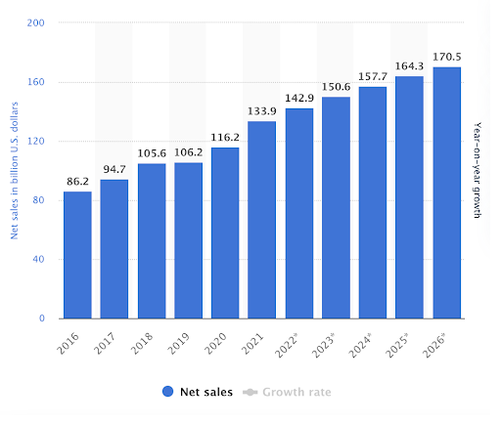
Figure 2: Sales of ALDI
(source: Singh et al., 2019, p. 211)

How company evaluate customers through different communication channels
There are different communication channels utilized by the ALDI to evaluate their customers about their products and this has helped the company to access people that have not reached previously.
Social media- As reported by Febriyantoro et al., (2020, p. 1787), As the company manages a strong social media presence, the company has boosted approximately 2.8 million Facebook followers, 830,000 Instagram followers, and 106,000 Twitter followers, which has helped the company to evaluate more customers. Social media helps the brand to reach wider potential customers than any other tool. ALDI uses its social media in a variety of ways, but Twitter is the platform that has proven to be the most successful for the company in terms of engaging its customers and providing prompt responses to their inquiries. I tweets offer both engagement and entertainment. Customers are drawn to the business as a result of the compelling content that is posted on social media. Every day, the company generates approximately 182 social media posts that are related to its brand. A variety of ads on radio and TV has helped to develop connections with the public and attract new customers. The results of the company were visited by 1.1 million customers in their stores.
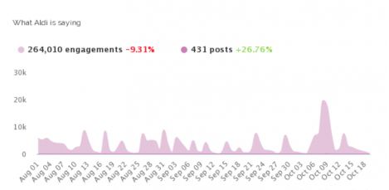
Figure 3: Customer engagement with ALDI
(Source: Kohtamäki et al., 2020, p. 1198).

ALDI’s eCommerce website- ALDI, despite having no sound, is one of the most highly evaluated retail brands because they are experts in the conversation surrounding eCommerce. The eCommerce website of ALDI is efficient; however, it could be improved with the assistance of several different online tools. ContactPigeon's Omnichannel Chat is one of the online tools that will assist the company in engaging a greater number of customers. This chat feature enables the company to respond to their customers quickly and prevents their customers from having to wait for an extended period for a response, which maximizes the satisfaction of their customers and their loyalty to the company. This allows the company to cultivate positive relationships with its clientele, and it has also enabled the company to develop an innovative form of automation that provides a personalized eCommerce experience for its users and gives them the impression that they are physically present in the store (Kohtamäki et al., 2020, p. 1198).
Omnichannel transformation- As stated by He et al., (2020, p. 182), the strong Omni channel presence decreased friction with their customer's journey and has helped the company to create and strengthen its brand quickly. ALDI's omnichannel has been melded in online and offline channels and has invested in click and collect which enables the customer to shop online and pick up their order from the store, this channel has significantly involved a huge number of customers. Apart from this channel, the company has partnered with delivery services like Deliveroo and instacart, which enabled their customers who are living far away from their store but it seems that they are doing shopping at the physical store. Due to its thrifting practices and affordable pricing the company has targeted middle- income class across the globe and has positioned itself as the most affordable retailer, the company offers products that are 30 % cheaper than Walmart which has helped the company to target both men and women who are in the middle income (Ephec Panel Conso GFK | PDF | Conformateurs | Sodles. 2021)

Challenges of marketing management in changing business environment
The increasing globalization and the penetration of advanced technologies have completely changed the path of business and the way of marketing. With these changing business environments, the company is facing challenges in doing its marketing. According to a survey in 2020, the global population which is active on the internet is 4.5 billion, more than 59 % of the entire global population.
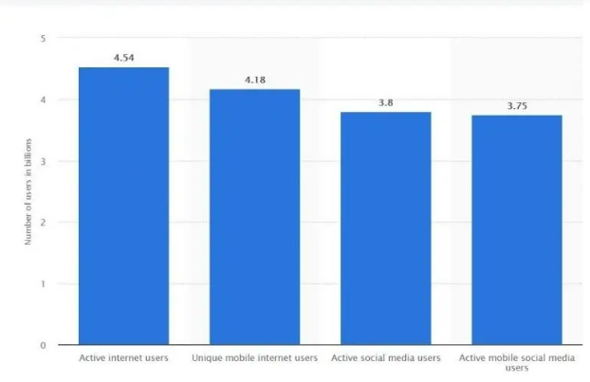
Figure 4: Digital population in 2020
(Source : Szabo et al., 2021, p. 719)
The penetration of the internet and its use has increased in the daily life of everyone. Today, companies like Amazon and Facebook are changing society effectively. On Amazon, customers can order their products from any corner of the world and get them delivered in a few days, which has changed many other countries. The challenges faced by marketing management are discussed below.
Increased competition- As evidenced by Olajire et al., (2020, p. 102817), the challenge for marketing management in a changing business environment does not mean that there is an increase in competitors but the way they are operating fully on the internet which enables any company to easily access the market. It means the physical business can operate locally but a digital one can access across the world. The management has to make sure that they are offering the products according to the needs of the customers which can be done by having advanced technology. There are various competitors of Aldi like Walmart, Tesco, and Kroger which are also offering similar products and services. Other grocery companies are also using advanced technology to expand their business which is becoming a challenging factor for marketing management (Szabo et al., 2021, p. 719).
The threat of new Entrants and substations- As observed by Prieto et al., (2019, p. 1473), Because of the competitive nature of the grocery business, there is a chance that new competitors will enter the market shortly. This possibility arises as a result of the rapid development of globalization. The purchasing power of the Australian dollar is said to be high and has increased significantly since 2018. This is according to Santander. The trend among consumers is toward increasing their purchases of goods manufactured in other countries. The enormous consumer demand in the Australian market makes it an attractive prospect for supermarket chains based in other countries to set up shop there. The business strategies utilized by ALDI are straightforward enough to be adopted by competing retailers. There are already some retailers who are offering the same products, so the company faces the risk of substitutes. Additionally, the company faces the risk of new foreign retailers that can sell similar products, which will make it a significant obstacle for the company to contend with the business environment( Mehta 2022)
Making the most out of data- Another factor that makes international online marketing difficult is the fact that the company must contend with the fact that the performance dates vary depending on the country. And to be more specific, advertisers are said to utilize costs per lead and costs per click as primary metrics to estimate the efficiency of other companies in terms of their investment. The fact that some countries will have a higher CPL and CPC is a challenging factor. This means that running campaigns in those countries will require a larger budget to achieve the same level of success as running campaigns in other countries.

Benefits and strengths of the marketing department of the organization
When it comes to promoting an organization's business as well as its mission, the marketing department plays a crucial role. They carry out a wide variety of tasks for the corporation, both inside and outside the organization. They are beneficial to the organization since they assist them in expanding its operations to new regions throughout the world. A company's marketing department offers a variety of advantages to the organization as a whole.
Boosted engagement levels- Because of the efforts of the marketing department of the firm, the overall level of employee involvement within the business has risen. The ALDI department has continually funded ways to reduce the costs for operations to improve the company's performance in the market. For example, they have introduced a cart rental system, which has enabled the company to maintain the cart while simultaneously increasing the number of customers.
Strong content Quality- As opined by Cadez et al., (2019, p. 14), Utilising marketing teams has many benefits, one of which is the ability to produce high-quality content. This is because the job of marketing teams is specifically focused on producing high-quality content for audiences or followers. It is the responsibility of the marketing department to ensure that customers are kept happy to prevent other businesses from poaching them, which in turn helps the company to improve its productivity across the world.
Increase products- The expansion of the company's product line is yet another important advantage provided by the marketing department. If the organizations offer their products to their customers, the team assists the company in promoting and drawing attention to these products so that the organizations can increase sales. This can help inform the customers who are being targeted about the products that are being offered and the benefits of the products so that more and more customers can purchase these products (Itani et al., 2019, p. 87).
Improves customer Relationship- Through effective communication, the organization, which has a robust marketing department, can improve an already productive relationship. The department makes use of communication automation software and a variety of channels to personalize the messages about the brand that are delivered to each customer. This allows the company to grow its customer base, which is beneficial to the department because it helps the department create positive bonds with the audience through communication.
Advanced company growth- It is also thought of as one of the potential benefits that could accrue to businesses that have a department dedicated to marketing. Because this department of the company assists them in increasing the engagement level with their customers, their employees, and their stakeholders, strong content, and maintaining the long-lasting relationship with the consumers of the company, which assists the company in advancing its growth. Additionally, the department strengthens the loyalty of customers toward the brand, and these departments can rapidly advance growth by making the most of customers' awareness of the brand.
The marketing department makes use of many different tools to improve the efficiency of the organization. One example of this is the use of SEO software by the team, which assists them in optimizing the content that is developed across all of the brand's operations. With the help of this software, they can gain knowledge about the outcomes of online searches and provide strategies that are tailored to the resulting list of queries, thereby attracting more clients to the business.

Relationship between the marketing department and value addition
As mentioned by Ritter et al., (2020, p. 214), The marketing department of each company is a significant source that is utilized to develop and expand the possibilities for the generation of income. However, the value-addition practices that take place through marketing operate in a two-way manner (Phillips et al., 2019, p. 28). On the one hand, these practices help to increase revenue and gain a better understanding of customers. On the other hand, these practices help to attract customers with a variety of products and services. In addition to this, value is added to the prices of products. When reviewing the marketing techniques used by Aldi, it is clear that these methods have a substantial impact on the sales of the organization. Brand image and worth are both attainable through good marketing strategies (Bhasin 2018) Marketing strategies, on the one hand, are responsible for an increase in the organization's revenue, but on the other hand, they are responsible for an increase in the cost of products. This is because the promotional and advertising campaigns run by management add to the costs of products, which in turn leads to an increase in the overall pricing of the company's offerings (Aldi Supermarket’s Strategic Management | Free Essay Example. 2022)
However, the marketing manager of ALDI is focused on some of the key areas that are used to increase sales and improve the customer experience. These key areas include providing high-quality products at reasonably low prices, offering exclusive brands, and limited variants of products that help the customer make a decision quickly and do not let them get confused by providing a large range of products. Aldi's limited stock-keeping unit (SKU) strategy is widely regarded as an important approach that has a significant bearing on both aspects of the value-adding process (Cugueró et al., 2019, p. 6086). This is because it enables the company to cut operational costs, and acquire less storage and warehousing capacity for the company and it has major effects on the purchasing patterns and decision-making processes related to purchasing that are carried out by customers. Companies can enjoy the benefits of increased sales of high-margin products, reduced expenditures for maintenance and other expenses, and an improved ability to provide a better experience for customers with the assistance of this technique. Because of this, management is better able to make judgments on the expansion or contraction of any product line or category, which is heavily dependent on the degree to which customers are drawn to a specific product.
Therefore, taking into consideration what has been stated above about Aldi's marketing approach and how it assists management in increasing the amount of income generated, It is possible to assert that the process of adding value and marketing are intricately intertwined with one another. Furthermore, with the assistance of inventive strategic solutions and the participation of technology, the capabilities of the organization have been increased while the costs have been kept under control through the utilization of efficient supply chain management. That can be evaluated by first comprehending and then analyzing the case of Also and its successful marketing approaches, which are being channeled to reduce costs, focus on customer experience and expectation, and at the same time increase the revenue through number and sales and high margin products (Mikalef et al., 2020, p. 1031).
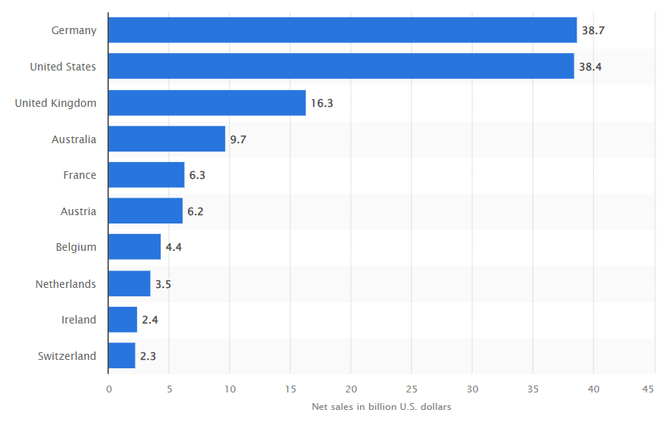
Figure 5: Net sales of Aldi-worldwide
(Source: Mikalef et al., 2020, p. 1031)

Managerial approaches of the organization towards stakeholders’ satisfaction
Customers make up a significant portion of Aldi's stakeholder population. Customers make payments to the company, which is how the business stays afloat and can continue to operate. Aldi will be forced to close its doors if its customers are unwilling to spend money at the store by shopping and buying products. The company receives financial support from its customers, which, in addition to the financial support received from other investments in the company, results in financial benefits for the company. After that, the money is invested in the company to fund the purchase of new products, the payment of wages to employees, and the overall profit for the company. As a result, customers play a significant role in this context. If they are not present, the company will not make any progress, and it will suffer a loss. If people are unwilling to contribute money, it will have an impact on the overall situation of the company, including the number of employees and the amount of profit the company makes. Because of this, having customers who are willing to give the company money is extremely important for the company to be able to carry out all of its processes. The government agencies are also the stakeholders of ALDI, Because the company takes the necessary precautions to adhere to the regulations and does a good job of paying its taxes, it has been able to win the approval of various government agencies. Additionally, the suppliers are provided with a positive environment, which enables the suppliers to effectively supply their products to the customers. Because the company has developed productive working relationships with its reliable suppliers, those suppliers have the impression that the company values them just as much as it values the company, which in turn drives up the company's sales (Davidescu et al., 2020, p. 6086).

Conclusion
From the above report, it can be concluded that the report considered the background of ALDI and also discussed the marketing strategies for improving the awareness of the brand. The marketing approaches to deal with issues of changing business environments were also analyzed in this report. How companies evaluate their customers through different communication channels was also reflected in this report. Furthermore, how the company has satisfied its stakeholders and the relationship between value addition and the marketing department were efficiently analyzed in the report. Challenges and benefits of the market department of an organization were also discussed in the report.

References
Aldi Supermarket’s Strategic Management |. 2022. Available at: https://studycorgi.com/aldi-supermarkets-strategic-management/ [Accessed: 28 December 2022].
ALDI. n.d. Our Purpose and Core Values | ALDI US | ALDI US. Available at from: https://corporate.aldi.us/en/about-us/our-purpose-and-core-values/ [Accessed 28 December 2022].
Ansari, S., Ansari, G., Ghori, M.U. and Kazi, A.G., 2019. Impact of brand awareness and social media content marketing on consumer purchase decision. Journal of Public Value and Administrative Insight, 2(2), pp.5-10.
Bhasin, H. 2018. Marketing strategy of Aldi. Available at: https://www.marketing91.com/marketing-strategy-of-aldi/ [Accessed: 28 December 2022].
Cadez, S., Czerny, A. and Letmathe, P., 2019. Stakeholder pressures and corporate climate change mitigation strategies. Business Strategy and the Environment, 28(1), pp.1-14.
Cugueró-Escofet, N., Ficapal-Cusí, P. and Torrent-Sellens, J., 2019. Sustainable human resource management: How to create a knowledge sharing behavior through organizational justice, organizational support, satisfaction and commitment. Sustainability, 11(19), p.5419.
Davidescu, A.A., Apostu, S.A., Paul, A. and Casuneanu, I., 2020. Work flexibility, job satisfaction, and job performance among Romanian employees—Implications for sustainable human resource management. Sustainability, 12(15), p.6086.
Ephec Panel Conso GFK | PDF | Consommateurs | Sodles. [no date]. Available at: https://fr.scribd.com/presentation/93818823/Ephec-Panel-Conso-GfK [Accessed: 28 December 2022].
Febriyantoro, M.T., 2020. Exploring YouTube Marketing Communication: Brand awareness, brand image and purchase intention in the millennial generation. Cogent Business & Management, 7(1), p.1787733.
He, H. and Harris, L., 2020. The impact of Covid-19 pandemic on corporate social responsibility and marketing philosophy. Journal of business research, 116, pp.176-182.
Itani, O.S., Kassar, A.N. and Loureiro, S.M.C., 2019. Value get, value give: The relationships among perceived value, relationship quality, customer engagement, and value consciousness. International Journal of Hospitality Management, 80, pp.78-90.
Kohtamäki, M., Parida, V., Patel, P.C. and Gebauer, H., 2020. The relationship between digitalization and servitization: The role of servitization in capturing the financial potential of digitalization. Technological Forecasting and Social Change, 151, p.119804.
Mahdi, O.R., Nassar, I.A. and Almsafir, M.K., 2019. Knowledge management processes and sustainable competitive advantage: An empirical examination in private universities. Journal of Business Research, 94, pp.320-334.
Makrides, A., Vrontis, D. and Christofi, M., 2020. The gold rush of digital marketing: assessing prospects of building brand awareness overseas. Business Perspectives and Research, 8(1), pp.4-20.
Mehta, K. 2022. The Thrifty Business Model of Aldi. Available at: https://thestrategystory.com/2022/02/02/aldi-business-model/ [Accessed: 28 December 2022].
Mikalef, P., Krogstie, J., Pappas, I.O. and Pavlou, P., 2020. Exploring the relationship between big data analytics capability and competitive performance: The mediating roles of dynamic and operational capabilities. Information & Management, 57(2), p.103169.
Olajire, A.A., 2020. The brewing industry and environmental challenges. Journal of cleaner production, 256, p.102817.
Phillips, S., Thai, V.V. and Halim, Z., 2019. Airline value chain capabilities and CSR performance: the connection between CSR leadership and CSR culture with CSR performance, customer satisfaction and financial performance. The Asian Journal of Shipping and Logistics, 35(1), pp.30-40.
Prieto‐Sandoval, V., Jaca, C., Santos, J., Baumgartner, R.J. and Ormazabal, M., 2019. Key strategies, resources, and capabilities for implementing circular economy in industrial small and medium enterprises. Corporate Social Responsibility and Environmental Management, 26(6), pp.1473-1484.
Ritter, T. and Pedersen, C.L., 2020. Analyzing the impact of the coronavirus crisis on business models. Industrial Marketing Management, 88, pp.214-224.
Simons, R., 2019. The role of management control systems in creating competitive advantage: new perspectives. In Management Control Theory (pp. 173-194). Routledge.
Singh, S.K., Chen, J., Del Giudice, M. and El-Kassar, A.N., 2019. Environmental ethics, environmental performance, and competitive advantage: Role of environmental training. Technological Forecasting and Social Change, 146, pp.203-211.
Szabo, S. and Webster, J., 2021. Perceived greenwashing: the effects of green marketing on environmental and product perceptions. Journal of Business Ethics, 171(4), pp.719-739.
Team, M.S., no date, ALDI Marketing Strategy & Marketing Mix (4Ps) | MBA Skool, ALDI Marketing Strategy & Marketing Mix (4Ps) | MBA Skool.
Tien, N.H., Phu, P.P. and Chi, D.T.P., 2019. The role of international marketing in international business strategy. International journal of research in marketing management and sales, 1(2), pp.134-138.

