Alexander Price
2306891@student.uwtsd.ac.uk
Traffic light control
Electronics 1 assignment

Contents
Abstract 2
Introduction 3
Background research 3
Traffic Flows 3
Phasing 4
Stages 4
Circuit Design 4
PIC16F877A 5
STOP/GO Lights 5
Lights And Timers 5
C Code 6
Arrays 6
For Loop 6
Simulation And Testing 6
Conclusion 9
Bibliography 9
Appendix A 10

Figure 1 Crossing Cars 2
Figure 2 Circuit Diagram 4
Figure 3 Traffic Lights at 4 seconds 6
Figure 4 Traffic Lights at 7 seconds 6
Figure 5 Traffic Lights at 35 seconds 7
Figure 6 Flowchart of system 7

Abstract
The paper below has, in detail, shown how to create a traffic lights system in the proteus 8.17 development environment. It uses the array system and iterates through these arrays to display the correct output to each of the external devices in the circuit. These being the traffic lights, 7 segment displays and walk lights for pedestrians. This study also details traffic light specifications and how they played a key factor into how the researcher designed the system. This includes specific rules and regulations that the researcher has successfully followed to be able to create a functional and safe system to implement into infrastructure.

Introduction
The paper is a study of how to build traffic light systems and the rules and regulations these systems must follow to keep drivers and pedestrians safe. This includes UK regulations that apply to the design the researcher created.

Background research
Traffic lights in the UK have to adhere to a lot of rules and regulations. The main document dictating this is the Traffic Signs Manual Chapter 6, which defines how traffic lights need to be installed and operated in the UK [1]. The key section that are of interest is section 6.1. This document goes into detail about how traffic lights should operate and the timings of the cycles, along with recommended setups and implementations on roads.

Traffic Flows
To start with, the cycle time is one of the most important factors to consider when deploying a traffic light system, as to defines the traffic flow of the area. The system that has been built and will be deployed into a high-traffic area, as the timings are so narrow. Another key point to note is the use of the pedestrian crossing; this crossing is activated every half a minute for 10 seconds. This also implies that foot traffic in the area is extremely large, as the use of 10-second periods for foot traffic is very uncommon unless in extremely built environments like city centres, outside large sporting arenas, or places of entertainment.
This shows that the control strategy implemented is very pedestrian-focused and has allowed for a great amount of movement across the roads to get people where they need to go. [2] The control strategy of this traffic light system also shows a very heavy focus on the use of only one light system at once. Unlike other systems, where two lanes at a T-junction could be used, this system only opts for one. This could have been done for a multitude of reasons. However, the most prominent reason would be traffic flow optimisation, as with two lanes that intersect head-on, traffic trying to cross the other lane gets stuck in their lane waiting for a break in traffic, and this overall will cause greater delays.
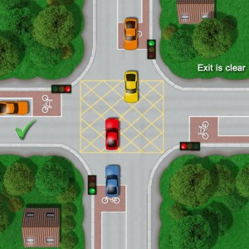
As shown in Figure 1, the problem of having 2 lanes of traffic flowing at the same time comes with the red and/or yellow cars being stuck in their lanes, holding up traffic flow in the system.
Figure 1 Crossing Cars

Phasing
Phasing is the process of circuit layout and labelling in the system. This is critical as if maintenance or upgrades need to be carried out on the junction, then the engineers can execute this without being confused by how the system is designed and implemented. In the system under design, the naming and descriptions are used to make it simple for engineers in the field to use a circuit diagram provided to diagnose faults, or upgrade the system. The recommendation from the Department of Transport is to use alphabetical and numerical naming schemes. This has been implemented in the system, and logical choices have been made to make the phase easier to understand. The phase for a traffic control system like this applies to all three intersecting lanes and their supporting infrastructure. This will be 3 lights and 3 pedestrian control lights. These will all be in a loop circuit that connects all the lanes of traffic and all walkways accessible from the pavement. [3] [4]

Stages
Stages are where the logic of traffic control systems is implemented. Stages are assigned to phases. The two main implementations of traffic lights are sensor based or timing based. Sensor based phases build off an adaptive demand-based system. These are far more complex and use depth and object detection to see what demand each lane is giving to the system and determine the cycle based on that data. Whilst these systems are advantageous in some regards, they are far more expensive. So, this usually leads to the second stage being chosen, which is based on timers. This is far easier to implement and can be run on extremely simple hardware, unlike the sensors used in more complex systems, which means less hardware downtime and easier development and deployment. [2]
This is one of the most important implementation decisions to be made, as the more complex sensor-based design is good for medium flow traffic scenarios; however, it sometimes breaks down when all sensors are overloaded and have maximum traffic flow, as would be the case in the setup designed. So, a timer-based solution was decided to be used as it is simple and allows for even flow of traffic on all 3 branches and high pedestrian flow without the pedestrians bottlenecking the vehicular flow. [4]

Circuit Design
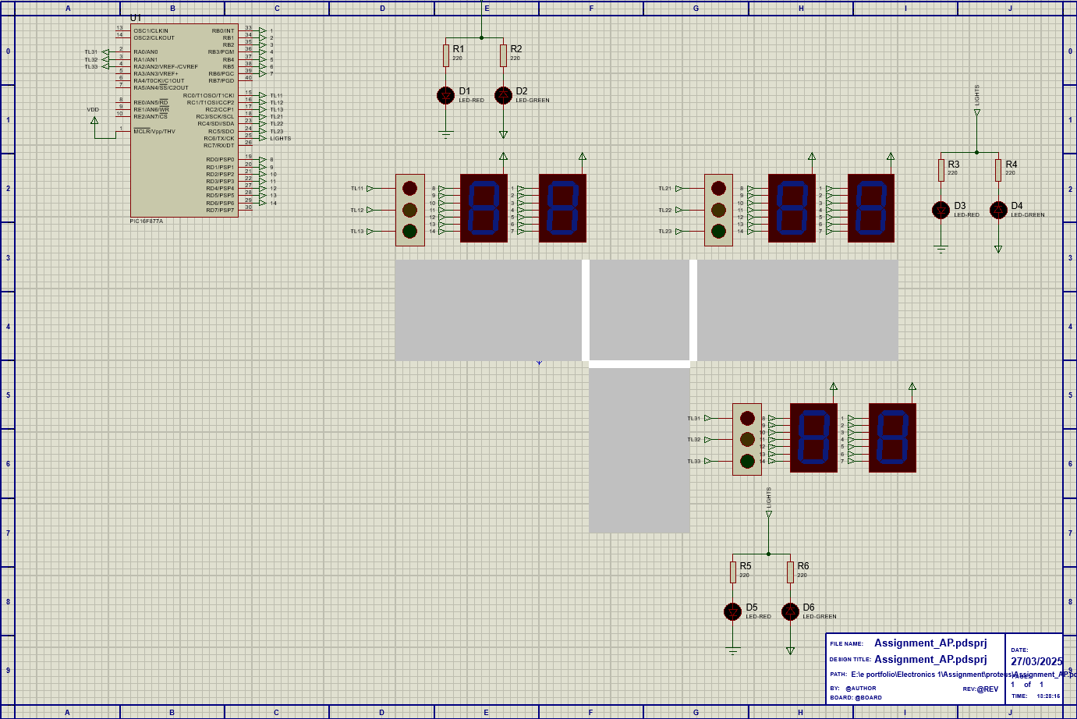
Figure 2 Circuit Diagram

PIC16F877A
The circuit design is shown above in figure 2. The main considerations considered were the choice of PIC processor. The PIC16F877A was chosen for multiple reasons, the most important being the number of pinouts. With the PIC16F887A having 40 pins this means there was the perfect number of pins to connect to all the external I/O in the system. Another key consideration was the performance and particularly storage on chip, as shown below in appendix A the code uses arrays and these consume a larger amount of storage then most programs. This therefore means the chip will need to have more Random-Access Memory (RAM). The PIC16F877A comes with 368 bytes of memory, far more than some other less powerful chips. [5] The final key reason was the cost of the chip, the average cost is £6 a chip, this means that the system will be relatively inexpensive to deploy when compared to commercial off the shelf products. [6]

STOP/GO Lights
The stop and go light system in the schematic are using a logic level indicator circuit. It has been implemented by taking input from the microcontroller and this changes the LED that is turned on. Its implementation works with the following logic. If the ‘lights’ output is low then the anode of the red LED is forward biased (+5V) and therefore turned on. LED D4 (green) will henceforth be off as the anode is reverse biased (+0V). This is due to the 2 voltages both being +5V so there is no potential difference. As ‘lights’ is turned on this changes the LEDs that are on. This is because the green LED is now forward biased as +5V is flowing through the anode but only +2.5V through the cathode so therefore the cathode is reverse biased, allowing the LED to illuminate. The red LED is caught in a current sink due to the resistor above it so therefore 0V passes through the LED and it stays turned off. This was a novel yet simple solution to the problem of addressing the stop and go lights and is efficient as it only uses 1 pinout when compared to the normal technique that would use 2. [7]

Lights And Timers
The traffic lights are an arbitrary electronic component held within the proteus electronics library. However, models like this exist [8] and are often simple to interface with only taking a high or low input for each traffic light individually. This would achieve the same effect if inputted into the traffic control system. For the 7 segment displays they use a scheme of referring each segment to a pin. The pins are then set high or low depending on what wants to be displayed. [9]

C Code
The code written for this programme is an extremely simple programme. There are 2 main components:
- Arrays of hexadecimal values
- For loop for timing control

Arrays
The arrays in the code are used to hold hexadecimal values of a binary string to set the correct pins on the PIC high. The method in which PIC addresses the pins is as follows. The Most significant bit (MSB) representing the highest value pin e.g. PIN_C7 in port C of the PIC16F877A. [5] The Least significant bit (LSB) therefore represents the lowest value pin e.g. PIN_C0. This addressing mode allows for a method of addressing that gives unlimited freedom in implementation. The way the researcher implemented this was to give a binary string to each port that updates every second, giving the correct balance between control of the lights but not adding unnecessary computation by updating too often. There are 4 arrays corresponding to different components on the board. For example, the array named ‘SEG_DISP1’ hold the correct binary values for updating the seconds component of the 7 segment display timers.
The other arrays are all based upon the wiring of the circuit and how the connections are made. As each array applies to a separate port there are 4 arrays being used. This means there is some I/O still available in case more functionality is required for example adding it to another set of traffic lights. These arrays take up 1,280 bytes (1.28kB) this means that the 8K of flash memory included in the PIC16F877A [5] there is no requirement for an external memory chip which brings costs down for the overall system and implementation.

For Loop
The for loop in this code is the main processing element to the program. As shown in appendix A, the value x increments from 1 to 40 representing the 40 second cycle. At each second the outputs for the 4 registers increment through an array, changing the output shown to each external device. This simple system only relies on the correct binary values being stored to output correctly. Once the 40 second cycle completes the system loops back to the start and begins again.

Simulation And Testing
The simulation was run in proteus 8.17 this IDE is a circuit designer and an embedded C programming environment in combined. The code starts with all lights but 1 on red and the other showing green, see figure 3. This will then transition to having an orange light showing on the light that is currently green and on the next traffic light to turn from red to green as shown in figure 4 later in the sequence this repeats through all the lights and finally once each light has been green for 10 seconds they will all turn red and the pedestrian lights will turn green and let pedestrians walk across the walkways. See figure 5 for this pattern.
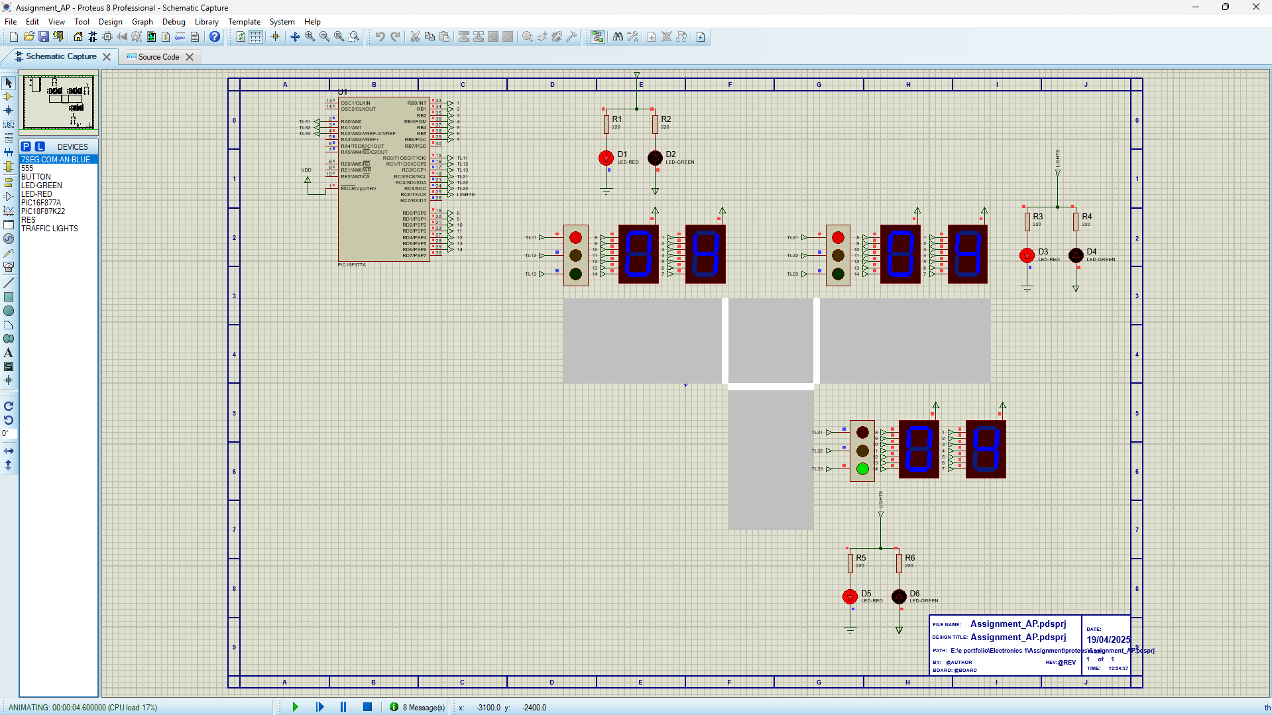
Figure 3 Traffic Lights at 4 seconds
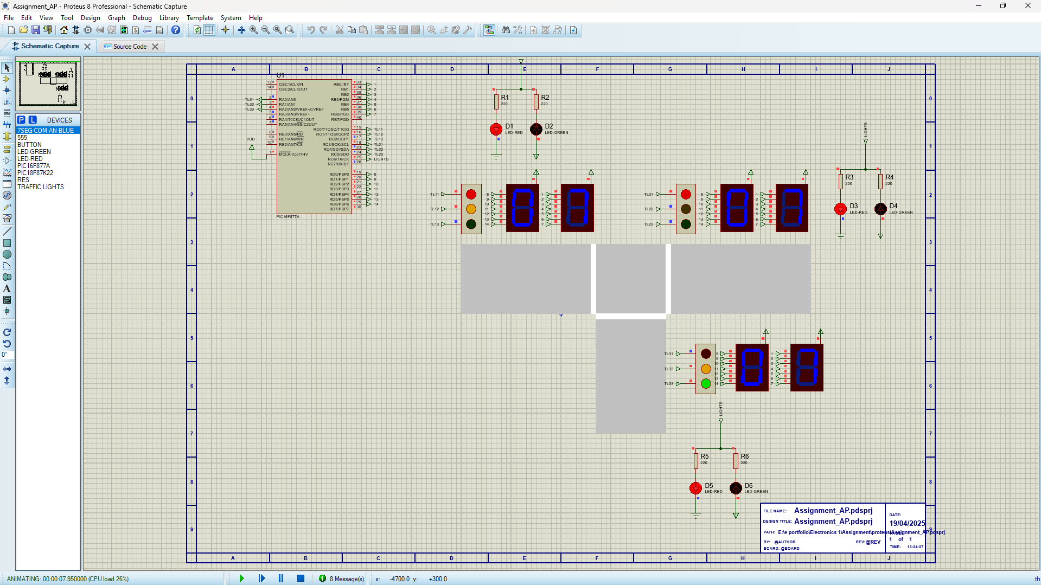
Figure 4 Traffic Lights at 7 seconds
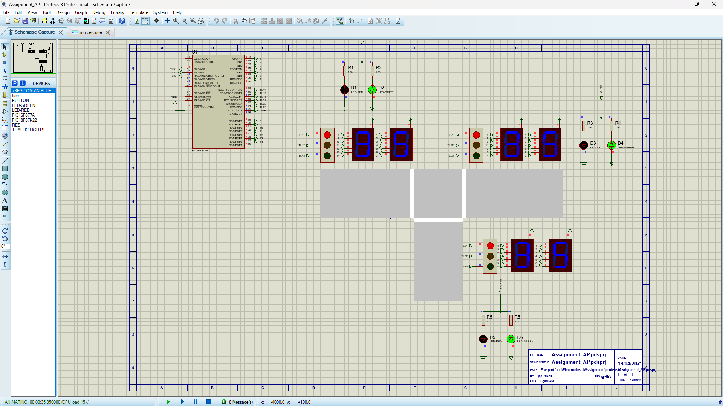
Figure 5 Traffic Lights at 35 seconds
Below is the flowchart for the whole system and how the traffic lights will cycle throughout the 40 second cycle:
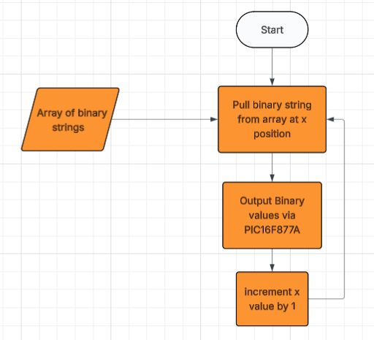
Figure 6 Flowchart of system
Figure 3 describes the first state of the machine with traffic light 3 being green and traffic light 1&2 being red. This is the main process of the code and allows one lane at a time to filter through the junction. This cycle repeats 3 times and allows for each branch of the T-Junction to pass through the road. Figure 4 describes the next state for the lights. With traffic light 3 changing from green to red using the amber light to signify the change is imminent and traffic light 1 changing to green from red again using the amber light to show the change. This allows ample time for drivers to come to a safe and slow stop at the junction. This cycle then repeats another 2 times until the final cycle that is illustrated in figure 5. This cycle lasts for 10 seconds and stops the flow of vehicular traffic and allows pedestrians to cross safely to move through the junction.

Figure 6 is the flowchart of the code at a high level of abstraction. It shows the data array with a pointer being ‘x’. The flowchart is helpful to aid reviewers of the code to give a higher level overview of how the system works.

Conclusion
To conclude a traffic light system has been designed and implemented onto a road network. It operates across a T-Junction and allows the traffic to flow smoothly and also allows for pedestrians to cross the roads safely. It also describes the rules and regulations in the UK.

Bibliography

[1] | Department for Transport , “Traffic Sign Manual, Chapter 6,” Department for Transport, London, 2019.
[2] | “TD101 Traffic Signalling Systems,” National Highways , London, 2022.
[3] | AECOM, “Introduction to traffic signals (UK),” AECOM , Birmingham , 2022.
[4] | P. Jeffrey W. Buckholz, “Introduction to Traffic Signal Phasing,” Introduction to Traffic Signal Phasing, New Jersey, 2009.
[5] | Microchip, “PIC16F87XA Data Sheet,” Microchip, 2003.
[6] | DigiKey, “PIC16F877A,” DigiKey, [Online]. Available: https://www.digikey.co.uk/en/products/detail/microchip-technology/PIC16F877A-I-P/446143. [Accessed 14 April 2025].
[7] | W. H. Paul Horowitz, The art of electronics, 3rd edition, New York: Cambridge University Press, 2015.
[8] | 38-3D, “5V Mini Traffic Light Module,” 38-3D, [Online]. Available: https://38-3d.co.uk/products/5v-mini-traffic-light-module?variant=47494533710120&country=GB&currency=GBP&utm_medium=product_sync&utm_source=google&utm_content=sag_organic&utm_campaign=sag_organic&gQT=1. [Accessed 14 April 2025].
[9] | Farnell Electronics, “7 Segment Display data sheet,” 15 May 2016. [Online]. Available: https://www.farnell.com/datasheets/2095789.pdf. [Accessed 14 April 2025].

Appendix A

