

Dissertation title
Resilience in the hospitality sector; A critical study of the opportunities the hospitality industry has had from using online and digital services through the current pandemic.

Hannah Kilburn

Student number - 1805552

BA Business and Management

2020/2021

Declaration

By submitting this research project, I agree and confirm that this piece of writing is my own original work, except for when referencing is present where the authors work has been noted in the references chapter. I have followed University of Wales Trinity Saint David’s guidelines and understand that plagiarism is not accepted.
Signed - Hannah Louise Kilburn
Date of submission - 19th April 2021

Acknowledgements

To begin with, I would like to thank all the lecturers at the University of Wales Trinity Saint David in Carmarthen Business School who have guided me through the past three years and given me the knowledge I have today. The biggest thank you is to my dissertation supervisor Dr Roisin Mullins for all her guidance, assistance and understanding to help create the dissertation along with research ideas and direct me when needed.
I also want to thank all my fellow students for the support and every individual that took part in the questionnaire and interviews that were conducted for my primary research. Their responses helped me investigate and find conclusions to how the hospitality industry has adapted to digital systems and how the general public are managing with the pandemic.
I would finally like to thank all my family and friends for their continued support through the dissertation but also through the three years of general studies to complete my Business and Management degree.

Abstract

The hospitality industry is huge, and any major change can disrupt every individual business in a variety of ways. The current Coronavirus pandemic has hit every business in the world, in this dissertation, through secondary and primary research, an investigation will be created to view whether SME hospitality businesses have found opportunities by using digital systems. Technology and social media have been the best way to communicate with everyone during the pandemic, so as the investigation takes place, the question whether any opportunities from using online services have been found, will be answered.
The research that will be collected will come from secondary sources from online sites, books and theorist views which will then correspond with the primary research conducted by the researcher to be able to answer the main question, along with further aims and objectives which will be highlighted through the dissertation. Specific aims and objectives will be analysed, and all data found will relate to answering the main topic title.

Contents Page

Declaration 2
Acknowledgements 3
Abstract 4
Contents Page 5
Chapter 1 7
1. Introduction 7
Chapter 2 13
2. Literature Review 13
2.1 – Introduction 13
2.2 – Current use of digital technologies in SME hospitality businesses 13
2.3 – How the hospitality industry provides towards GDP, employment status and the Wales wellbeing act 16
2.4 – Impact on hospitality since the pandemic began 18
2.5 – How hospitality will focus on technologies for the short, medium and long term 22
2.6 – Social media and businesses 24
3.Research Strategy and Methodology 27
3.1 - Introduction 27
3.2 – Planning and Ethical Consideration 27
3.3 – Research Approach 28
3.4 – Research Choice and Time 29
3.5 – Research Design 29
3.6 – Questionnaire 31
3.7 – Interview 32
3.8 – Conclusion 33
4. Finding and Analysis 34
4.1 – Introduction 34
4.1 – Results 35
4.1.1 – Age chart 35
4.1.2 – Gender chart 35
4.1.3 – Employment chart 36
4.1.4 – Social Media Usage chart 36
4.1.5 – Technology devices used 37
4.1.6 – Most Used Social Media App 37
4.1.7 – Which Online Ordering Service Has Been Used 38
4.18 – Importance of an Online Ordering System 38
4.1.9 – Benefits of online ordering 39
4.1.10 – Worries of online ordering 39
4.1.12 – SPSS Crosstabulations 40
4.2 – Analysis 42
4.3 – Interview Analysis 45
5.Discussion and Conclusion 47
6. Conclusion 50
7. References 52

Chapter 1

Introduction

This topic will largely be focussed on SME hospitality groups in Wales and how the different restaurants and cafes have found opportunities from using different forms of technology through the coronavirus pandemic in 2020/2021.
The hospitality industry is one of the biggest and most successful industries in the world. The hospitality industry is linked to a selection of businesses and services that provide leisure, customer satisfaction and catering experiences. (Revfine, 2020) The hospitality industry is a broad service and contains 5 different components including food and beverage, events, tourism, transportation and a lodging service which can be a forever changing experience and provides customer satisfaction. (Landman, 2020) The SME hospitality industry was set to grow strongly in 2019 but since the global pandemic there has been considerable damage caused to growing businesses. (IBISworld, 2020) It has been shown that the SME hospitality businesses have lost 52% of their monthly business income in 2020 meaning they are some of the hardest industries in the UK to compete with. With the corona virus pandemic being to blame for the many lockdowns and restrictions that businesses have had to face, profits have been at a loss for many individuals. (Addy, 2020)
The main questions that will be answered include –
- What opportunities the hospitality industry has had from using online and technology services through the global pandemic?
- What positives have come out of using the different online and digital services?
- How the smaller businesses can now look into the future with their new plans and systems?
There will be plenty of research to find how many opportunities have been found and any positive changes that have arisen to benefit the smaller businesses. There will also be research into looking for any negatives that may have had an impact on the businesses and if using any different systems has caused any new problems.
Some negatives that may be outlined include –
- Whether the businesses model has changed in terms of the value to the customers, extra cost for training staff and if anything has changed from the government giving extra financial support and technical support.
There will be many impacts on the general cost of running the business as costs for training staff will increase, providing the correct PPE for employees and applying the government and technical support that has been used to assists the businesses for any issues that could arise.
Michael Leboeuf says "If you believe that training is expensive, it is because you do not know what ignorance costs. Companies that have the loyalty of their employees invest heavily in permanent training programs and promotion systems." (Leboeuf, 2020)
There will be research conducted to analyse whether the marketing sales of laptops, tablets and mobiles have increased as more people have been working from home and using online systems to contact friends, family and colleges also food industries have created online systems to take orders and take payments from customers.
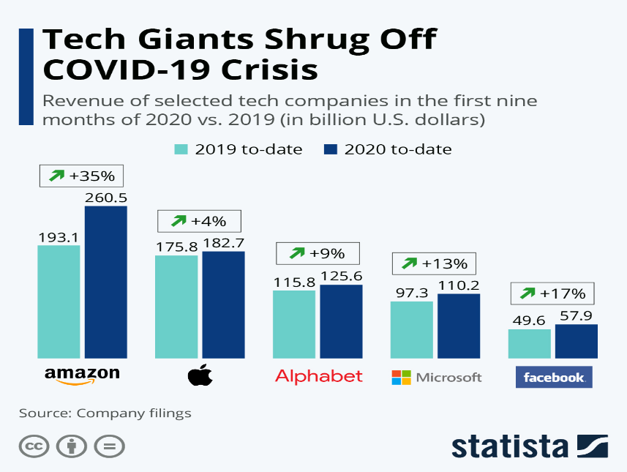
As shown in the graph it is clear that technology sales for different brands has increased in each sector that promotes using technology to communicate with others and possibly be used for business purposes. (Richter, 2020) (Google-Images, 2020)
The aim of the study is to outline any opportunities that the hospitality industry can use to look forward and look for profitable services that may not have come around if the pandemic didn’t happen. There may have been many negatives that businesses have faced with closures and staff loses, but other more established businesses were able to use online services to promote take away systems and allow their staff to be furloughed.
Some of the main objectives which will be analysed are –
- Objective 1 - Assess the current use of digital technologies in the SME hospitality sector and how these helped the businesses prepare during the pandemic.
- Objective 2 - Define and explore the notion of hospitality and how they provide towards the country’s GDP, employment status and if there are any contributions towards the Wales Act with health and wellbeing.
- Objective 3 - Research how the hospitality industry has been impacted since the pandemic began. What happened in terms of the different actions taken before, during and after the pandemic.
- Objective 4 - Determine resilience and the impact actions to help hospitality focus in technologies that offer short term, medium term and long term use to sustain their business and to look at the sales of technology which may have been used for working from home or to contact colleagues, friends and family.
- Objective 5 - Conduct firm research to back up any theory found and look at figures and graphs that may show a pattern in what job industry has been affected the most.
This topic will be very relevant to the study as the current pandemic is forever changing people’s lives and definitely every business has been affected on how they will work in the future. It will be important to look at the benefits and negatives that the industry has had to face to be able to look at possible recommendations to go forward and be at a secure place and be gaining a more substantial profit.
The Welsh Government has recently created support for businesses to follow where they have made 5 key principles to keep Wales safe at work. These include –
- Care: our health and well-being come first
- Comply: the laws that keep us safe must be obeyed
- Involve: we will share responsibility for safe work
- Adapt: we all need to change how we work
- Communicate: we must all understand what to do (GOV.Wales, 2020)
The method that would benefit this research at the moment would be a quantitative method to gather as much information from different industries, and to investigate and conduct the best research possible. Hopefully using questionnaires via online services will also demonstrate how easy it is to gather information and spread through the different social media platforms that businesses may have used to spread information about their services and to focus more on the restaurant and café industry.
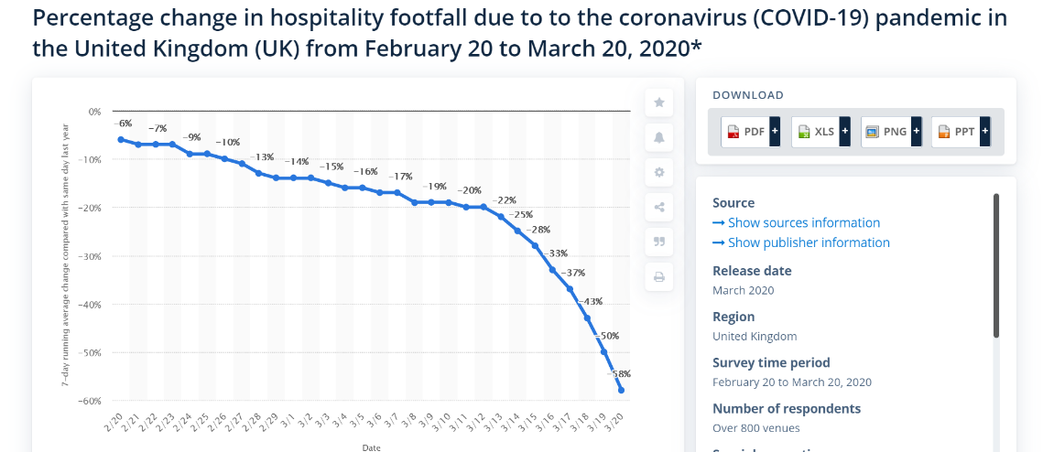

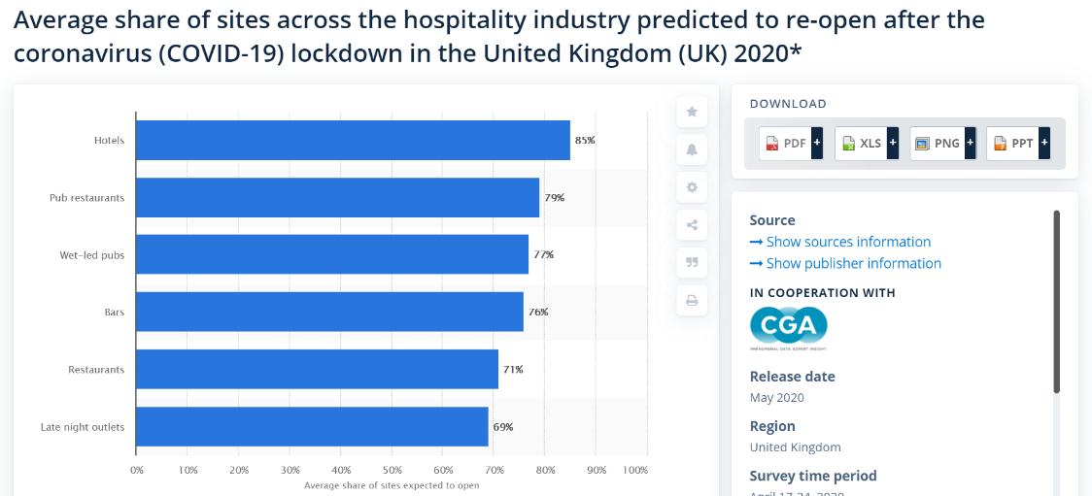
As the image shows above, it is clear to see that there is a heavy decline in the amount of people entering a hospitality premises as the global pandemic hit and a national lockdown hit forcing all hospitality businesses to close. It declined very quickly over a short amount of time which has impacted on every small business which carried on through most of the year. (Statista.com, 2020)

As the global pandemic hit, it has been very unpredictable for all businesses big and small to plan and prepare for the future and what new ideas and opportunities they can find to still create an income but also follow the government guidelines which were constantly changing, making the future unsecure. (Statista., 2020)
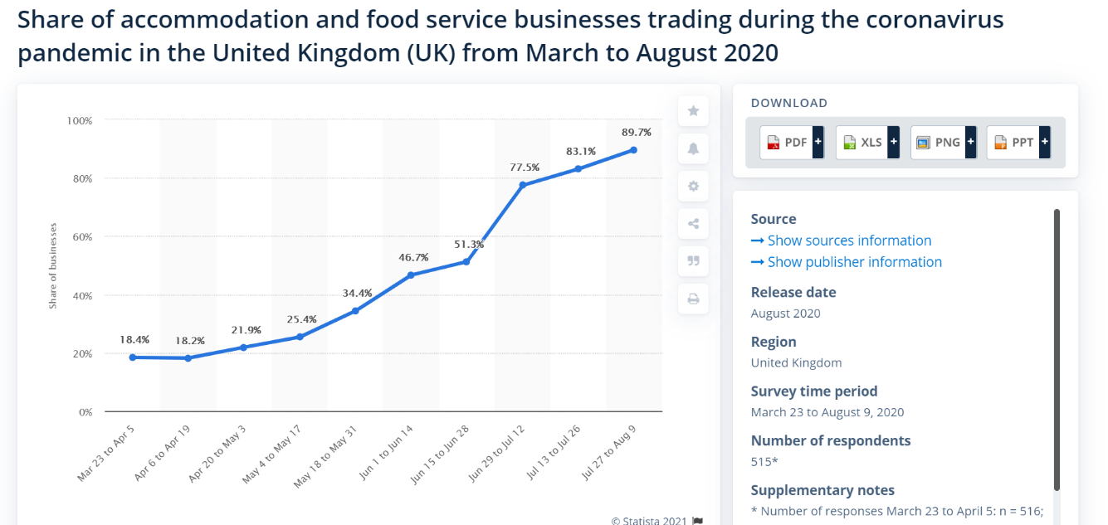
Hospitality is one industry that had the chance to still trade food items through a takeaway service as long as all government guidelines were followed by staff, managers and customers. Technology would be a main factor to contact the hospitality premises and place orders to pick up through customers mobile phones possibly through an app service or using social media to contact and place an order which could all be payed for immediately so no contact would have to be made for longer than necessary. (statista, 2020)

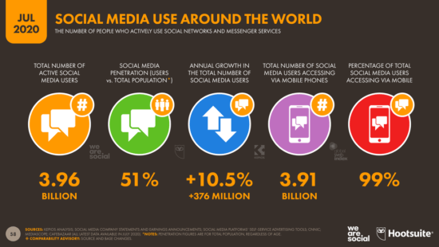

The image above shows the amount of social media usage which shows that businesses have a strong advantage of using these different social platforms to promote their businesses and provide a contactless service to still create an income to secure the industry for the long term. Most people will use their phones to contact other people and connect with each other, this gives the hospitality industry a great opportunity to create a gateway to use mobile phones and apps to interact with customers and suppliers. (Chaffey D. , 2020) This refers to how popular the internet is and how businesses can use these systems to their advantage.
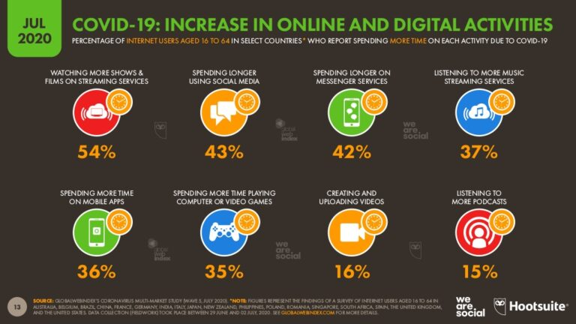

It is clear to see that there has been a general increase in all digital technologies which is a great opportunity for any company to look into, but for the hospitality industry it is important to promote their offers and entice people to show their customers they are different and can offer great things for great prices at a safe and secure position. (Chaffey D. , 2020)

Chapter 2

2. Literature Review

2.1 – Introduction

The hospitality industry is a huge variety of companies and businesses that are ever-changing through the change in customers wants and needs for certain products and services. Technology is a huge driving factor in how we communicate and change as people towards one another, during the current pandemic technology has become an even bigger element to communicating and keeping businesses running. “Digital businesses use technology to create new value in business models, customer experiences and the internal capabilities that support its core operations. The term includes both digital-only brands and traditional players that are transforming their businesses with digital technologies.” (Liferay, 2020)
The first research objective which will be reviewed in this literature review is - Assess the current use of digital technologies in the SME hospitality sector and how these helped the businesses prepare during the pandemic.
To be able to find the correct information that is accurate and reliable is to use the UWTSD online library and a variety of theories and online websites to help answer each individual objective. The main purpose of the literature review is to provide knowledge and understanding of the topic raised in the title and to explore the objectives that have been created for this dissertation.

2.2 – Current use of digital technologies in SME hospitality businesses

The food and service industry are the main areas that will be highlighted through this dissertation and the technologies that they use to provide the best quality products with as little contact with people as possible to follow government guidelines from the global pandemic. This refers to the first objective of how digital technology is currently being used.
The hospitality industry is quite an advanced area as they are a very popular industry that works closely with the tourism industry which is one of the biggest in the world. Many people rely on getting access to the internet wherever they are which proves that digital technologies are attached to people wherever they go, also the access to social media where people can leave reviews, take photos and “check in” to some of their favourite locations which can help promote businesses. (Aurecongroup, 2019)
Some of the uses of technology which are already in place to help out the small hospitality industry include contactless payment which is one of the easiest and quickest ways to pay via a card, this form of payment has become a very important way of purchasing items due to the current global pandemic which has increased the contactless payment amount of £30 to £45, it is also seen as a far more hygienic way of paying for a product or service. (Revfine., 2020) Guests are able to check in and collect products via a totally contactless system which is starting to look more futuristic than ever. Motion sensors for lighting systems, voice activated appliances and the use of apps and social media allow contactless transactions to be made to ensure the customers and the employees safety. (Werner, 2020) The availability of the search engine Google has allowed people to search for everything and anything they want, even what food recommendations that are popular in the customers area with the access to reviews and food options of every kind possible. Owners of restaurants and food industries allow people to communicate through mobiles phones and technology where orders can be places and feedback can be shared either privately from customer to host or on social media pages for friends and competitors to see. (Norton, 2019)
According to Markus and Robey, they explain how technology is changing our culture and creating new innovation plans which are changing how we communicate through society. (Markus & Robey, 1988)

The idea of a virtual food environment has become a growing idea since March 2020 when the pandemic hit and lockdown in the UK was announced, with people ordering from the internet or using online platforms as it is seen as a much more convenient way of having food delivered or being able to pick up through a contactless system. The virtual food environment consists of four different sections including the consumer, online food services, online food retailers, and the delivery services. Small delivery food boxes with a variety of choice and options have also been made by smaller restaurants to provide them with an income, these boxes have also been associated with special occasions. According to data it has been said that “78% of the population in the UK had halted visits to restaurants” and also “53% of adults in the UK reported that they had ordered online food delivery, whilst 1 in 8 adults reported getting delivery from a virtual food environment for the first time or more often than usual.” (Pineda, 2020)
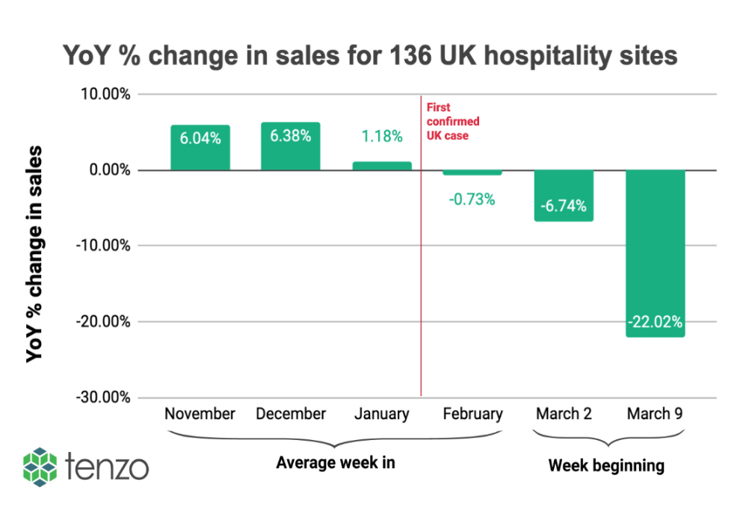
Apps have been created to order food from the table in some restaurants and the idea of any contact when ordering is now a thing of the past as the internet and mobile phone usage has expanded since Coronavirus hit, people can order food and drink at their leisure which has been a huge positive for many, payment can also be completed through these apps, it seems this idea is here to stay for the comfort of customers and ease for employees. (Guszkowski, 2020) Restaurants were slightly behind when using technology for ordering until the pandemic hit. This caused restaurants to take a step up and find new systems which would allow them to take orders and take payments which would limit the amount of contact between people which would follow the government guidelines, track and trace also had to be accounted for so people were able to place all their details in booking systems and when ordering. QR codes have become the best way to scan for menus and customers are able to access what they need; they are able to order food and drink and pay the bill without having to wait to speak to a member of staff. (BigHospitality, 2020)

2.3 – How the hospitality industry provides towards GDP, employment status and the Wales wellbeing act
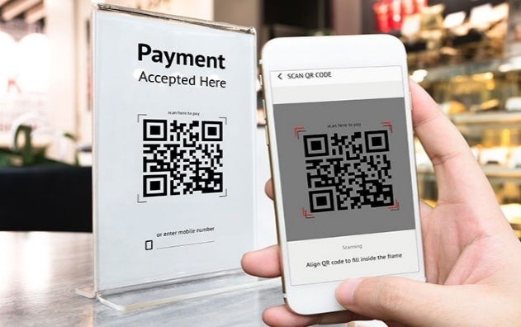
As expected, it looks as though the hospitality industry will take a huge hit when giving back to the economy and working towards the GDP by falling by around 2.6% in a month which fell down to 8.5% from the pre-pandemic stage. (McAllister, 2021)
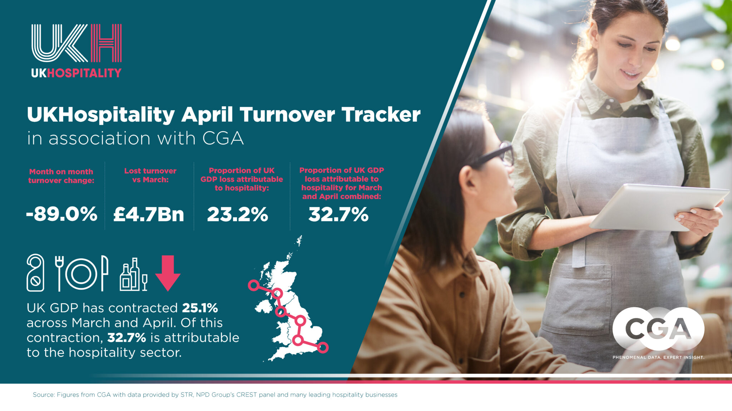
The hospitality industry in the UK has been responsible for nearly a quarter of the GDP loss in the months of March and April, the total GDP in the UK fell by around 20.4% in April and the hospitality turnover dropped by 90% In the same month. “The UK’s hospitality sector employs over 3 million people and is a huge generator of revenues for the Government. Reopening is as soon as possible is vital not just for these businesses, but to enable the whole economy to be able to recover,” (Banks, 2020)
Hospitality can be a great industry to work in for all ages, it provides a variety of skills and builds on communication and customer service which can be vital for any job that involves serving and selling to people. In November 2020, there were 819,000 fewer employees on the pay roll for the hospitality industry than at the start of the pandemic which has caused issues for many people all over the UK, but not only has the hospitality industry taken the impact, any small business has been affected, there are around 1.9 million jobless individuals who have been hit even harder by the pandemic. This all links to objective two of the dissertation.
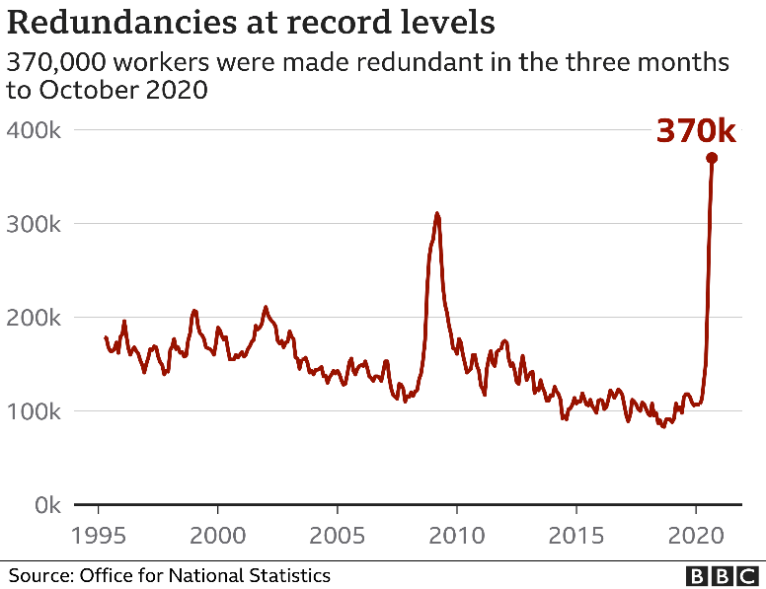
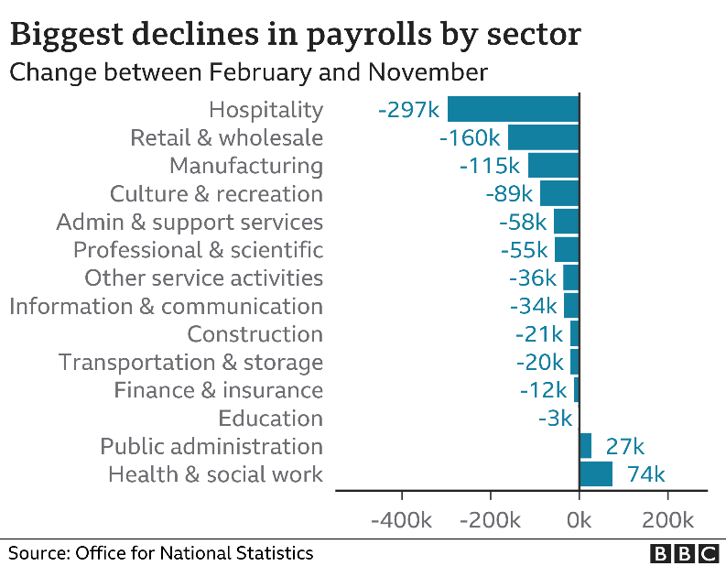
The hospitality sector has been hit hard as it seemed the government hit these companies with new challenges and filed many different new rules and regulations with further closures which have caused businesses to close completely. Furlough has been a huge help to many people who are unable to work all over the UK, involves the government paying employees around 80% of their average wage, the government have kept this up but the cost to repay this in the future which totals up to be around £280 billion and the scheme hasn’t come to an end yet, it is thought it will carry on to September 2021.

As shown in the images above it is clear that the hospitality industry has taken a huge impact compared to all the other industries. Public administration and health and social work has actually increased as there have been people in need and working from home has become much easier and safer as people are not coming into contact with each other. The redundancies have made a massive increase during 2020 and looks to continue into 2021 and it will be extremely difficult to find and provide the population of the UK with new jobs with the correct experience. As so many people have taken to digital technologies and businesses are becoming far more successful at home people are now communicating through social media and the internet which can be an issue if you do not have any access to WIFI and technology systems all the time. (Thomas, 2020)
There are 7 different section in the Welsh Well Being Act which companies look for to being sustainable and successful for the future generations when they take on and start businesses themselves. The different goals include -
- “a prosperous Wales
- a resilient Wales
- a healthier Wales
- a more equal Wales
- a Wales of cohesive communities
- a Wales of vibrant culture and thriving Welsh language
- a globally responsible Wales
These goals have been put in place to improve the social, economic, environmental, and cultural well-being of Wales. They are contained in law under the Well-being of Future Generations (Wales) Act 2015.” (GOV.UK, 2020)

2.4 – Impact on hospitality since the pandemic began

Due to the coronavirus pandemic businesses had to close almost immediately due to the new government guidelines which meant everyone had to stay home, this was a huge hit and worry to many business owners and employees. Almost every restaurant or café was advised to only provide take away options which would be a brand new service to many, so business owners had to come up with new plans as quickly as possible and advertising strategies. When restaurants were allowed customers, strict guidelines were in place which included a reduced number of visitors, social distancing and to use contactless payments where applicable. A research project conducted by Journal of Hospitality Marketing and Management found that over 50% of participants were not immediately willing to eat in a restaurant after the first lockdown from March and most customers, again over 50% were not willing to travel to stay at a hotel which implies that people didn’t feel comfortable or safe enough to enter a new unknown environment. The effect of all of these closure has had a detrimental effect on mangers, business owners, employees and customers as the unknown is forever changing at a rapid rate. (Gursoy, 2020)
An eat out to help out scheme was specifically created for the month of August 2020 which was in place to help out restaurants and cafes to create a comeback after the recent pandemic which forced so many businesses to close temporarily, for some unfortunately it meant for good. The scheme was on a Monday to Wednesday basis which meant restaurants were busy on these days, but it led to a fall in footfall during the other days of the week. Although this helped out many businesses to get back on their feet, it wasn’t long before the cases began to increase, and another lockdown was approaching. The government have managed to help out and provide business loans for the hospitality industry and given out small business grants to ensure the safety of these businesses. (Hutton, 2021)
In the month of September, after the eat out to help out scheme had ended it seemed that businesses were seeing a similar amount of customers that they were before the pandemic hit, which showed that the help seemed to bring comfort to the public and allowed restaurants to start serving as close to normal as possible. There are some longer term impacts that business owners of restaurants, pubs and cafes will have to face, as these areas were made for socialising, it can be hard to allow this to happen safely through the guidelines provided which include the two metre social distancing between people out of your own household. Another huge impact is the job industry and how it will recover in this sector as many people will be earning and working less, eating out becomes more of a luxury and unemployment leads to more people eating home cooked meals due to the cost. (Matheson, 2020)
There was a 163% increase on job losses in the restaurant industry in the UK during 2020, and also branch closures by the hospitality industry have risen by more than 75%. “UK restaurants and casual dining firms recorded almost 30,000 job losses in 2020 as the Covid-19 pandemic drove a 163% jump in redundancies.” Due to the multiple closures there was a tier system introduced for both England and Wales which clearly impacted the hospitality industry with new rules and regulations depending on location, this also caused confusion for many as business owners were unsure to what was allowed and what wasn’t. (The-Guardian, 2021)
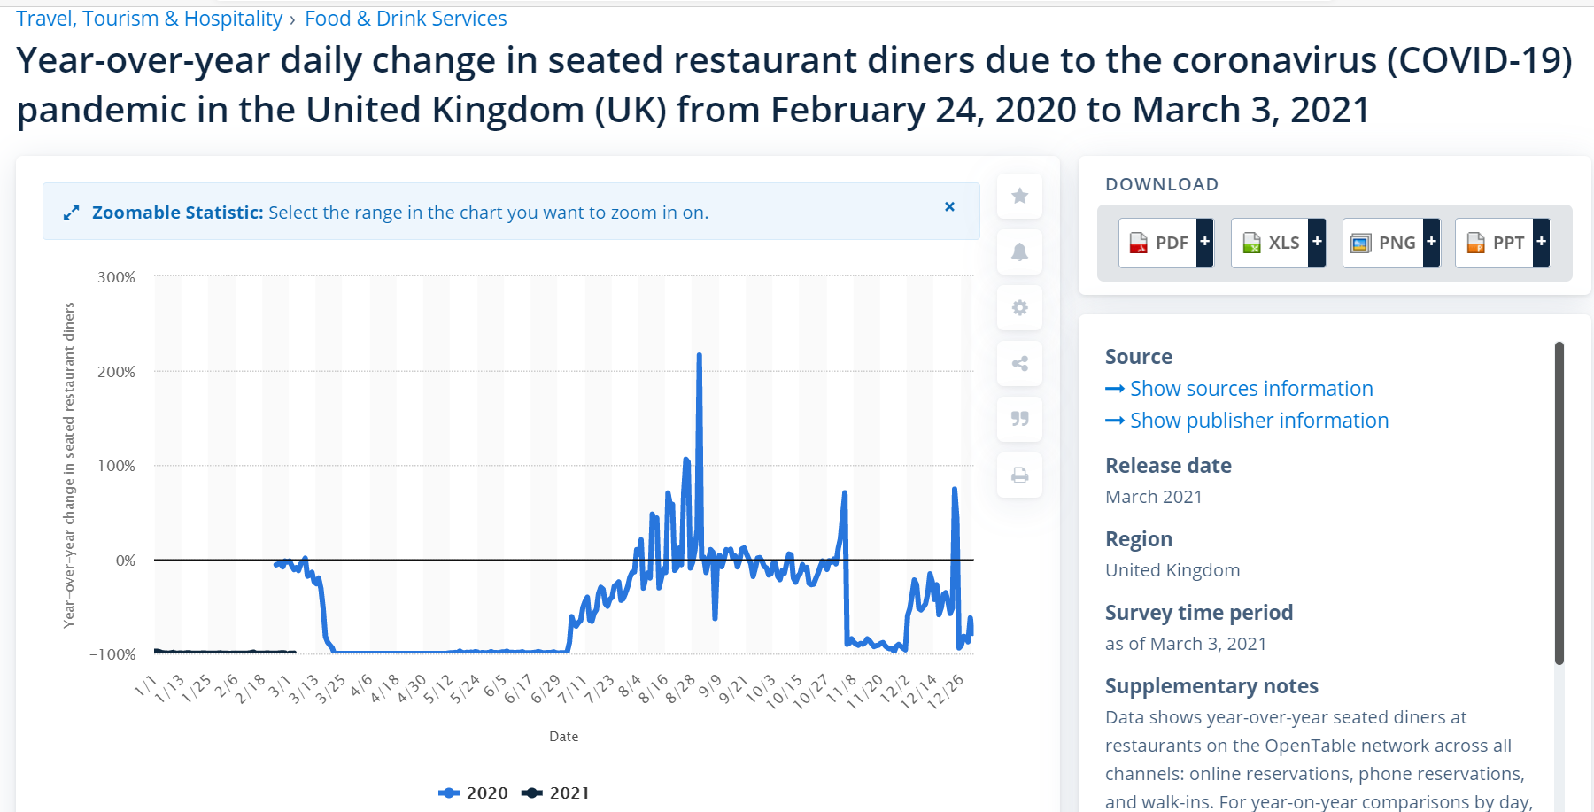

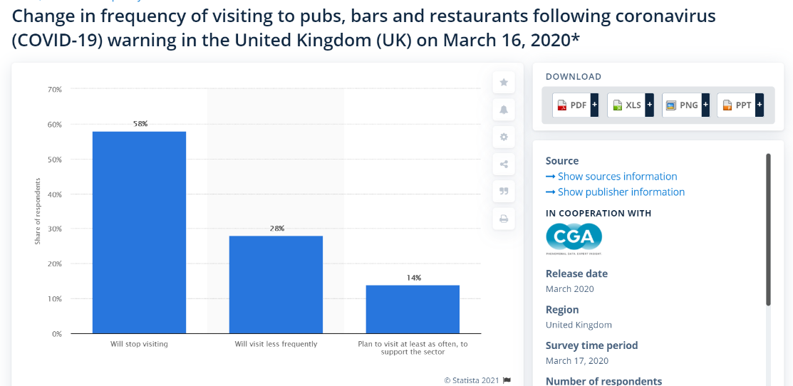
As the graph above shows from February 2020 there has been a huge fluctuation in the amount of people entering restaurants to dine in, during the end of August when the eat out to help out scheme was introduced there was a huge increase by over 200% which boosted businesses and dramatically changed the outlook to a far more positive way of moving on, although this was not the case. Since December 2020 to March 2021 there has been a -100% decrease as no one has been able to open up restaurants or cafes in the UK for months due to a national lockdown where everyone has to stay home unless for essential travel. With the vaccine being introduced, there is a more positive outlook for the Summer of 2021 to begin loosening restriction and beginning to start a normal life back again for everyone. (Statista, 2021)

The graph above shows how the public felt about going to restaurants, cafes and pubs at the beginning on the pandemic in March 2020. Most people were going to stop visiting completely and only 14% were willing to visit on a support basis which clearly shows that people will help when needed but restriction were stopping this from happening. (Statista.uk, 2020)
Regarding the technology impact it seems that coronavirus has speeded up the digital technology industry and boosted sales and created many new changes that might not have been though about for years to come. “The Covid-19 pandemic has resulted in the adoption of digital technology in the NHS and changes to the way services are delivered at an incredible pace.” (Hutchings, 2020)
Technology is seen to have a huge positive impact on the restaurant industry and businesses are able to create as unique and creative experience for customers and providing the most efficient, best quality products and services and the most convenient way of working for everyone. A mobile app can help restaurants in a number of ways, some of these include –
- Being able to reach potential new customers and send notifications and emails including coupons and benefits to entice people to purchase their products safely.
- Convenient way of arranging a pickup or delivery service which is easy and reliable.
- New payment options which are contactless and secure.
- Customers were able to book a table which shows all available times without having to call.
Usually, customers will return to restaurants from the quality of the food and helpfulness and friendless of the staff, this will lead to customers leaving reviews and posting on personal social media sites and business pages with different comments and sharing photos and offers. Due to the way technology works, it stores data from everyone’s phones and apps including location and personal information, our mobiles are then clever enough to display adverts at the right time on our social media sites that will entice us to purchase a certain item or order from a food service.
Online food ordering isn’t necessarily a new idea as it has been happening for years, although since the pandemic it has increased as more small business restaurants have had to take on this new technology and there are many new opportunities to come with this idea of ordering and delivering in a way to suit the customer. (Tripleseat-News, 2020)

2.5 – How hospitality will focus on technologies for the short, medium and long term

The new technology changes would have impacted on every industry in many different ways, and companies will deal with these changes in a unique manor depending on how dramatic the changes have been. Many companies have taken advantage and reached out for any benefits that the new digital products have given them, ensuring that they are easy and secure to give to customers. As restaurants needed a new way to perform with the regulation, many new systems began and online systems were created, although this wouldn’t work for everyone. To use the ordering systems, the customer would have to own their own mobile phone which not everyone had, and some people may find the technology system confusing and even the business having readily available WIFI in every spot could be an issue. These new systems are currently short term as they are new and can change rapidly as customers and business owners will find advantages and disadvantages of using these new technologies. Data protection is an area which needs to be studied in-depth to reduce any issues that could occur and cause security problems which could cost businesses a lot of money. For the long term, businesses could see a spike in technology being sold more and more and communication will mostly be made through a digital device instead of customer to employee, this could lead to an increase in job losses and a huge change for many industries as well as hospitality. (Ton, 2020)

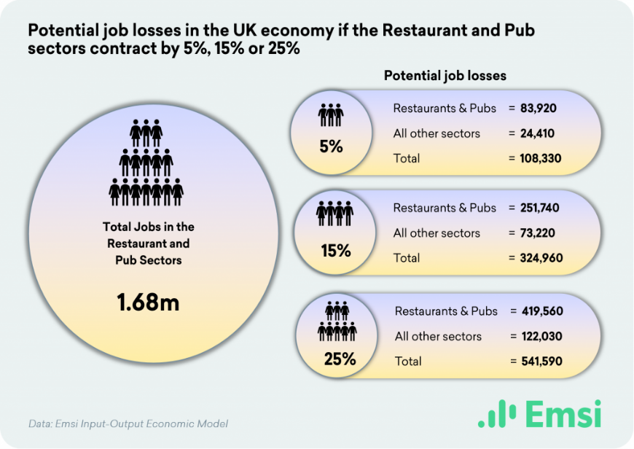
The short term is how businesses have dealt with the lockdown and the opportunities they have taken to ensure they reopen once the government allowed them to. The medium term is the initial recovery once restaurants and cafes have reopened and what actions they must take to gain back a profit and be fully independent again, this is also considering any future lockdowns and the new rules and regulations which have to be followed. Stock and supply must be monitored closely as the number of customers could easily change on a daily basis, managers must be able to take control and short notice and provide the best they can to ensure a successful turn out. As for the long term there will be many questions as to how each individual business will stay up and running and how they intend to return to “normal” once the pandemic reaches an end, there will be new technology and social demands which means new training and equipment will have to be considered to allow a quick change which could lead to a new future in the business.
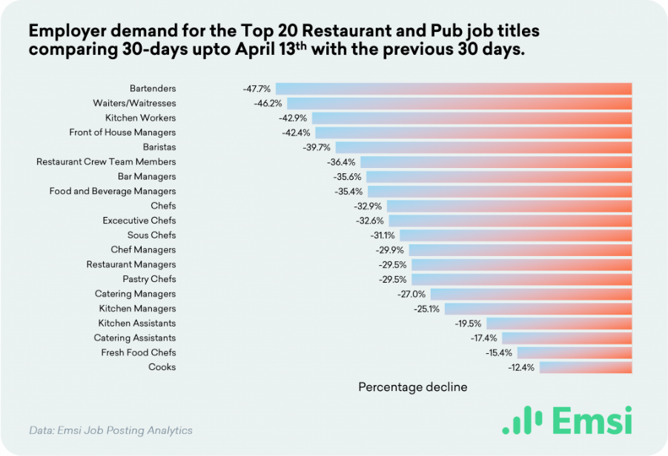
In the images above it shows the different employee changes and how severely people have been impacted by the change from the pandemic and what it could potentially look like in the future, although the government will try to get everyone back into work, whether it is from home or in the workplace, these places will change and become the new normal which everyone will have to adapt to. (Slane, 2020)

2.6 – Social media and businesses

“Social media is a collective term for websites and applications which focus on communication, community-based input, interaction, content-sharing and collaboration. Forums, microblogging, social networking, social bookmarking, social curation, and wikis are among the different types of social media.” (Wigmore, 2020)
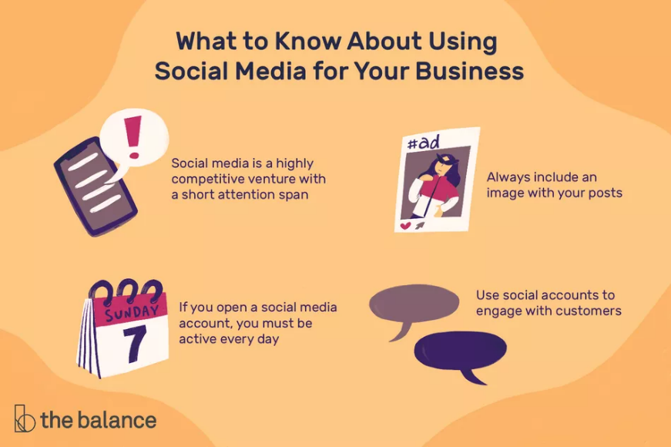

Social media allows people to share content and information quickly and is a great way to promote any business and share reviews and photos with a variety of advertisements to grab people’s attention. Many people use mobile apps to access social media, such as Facebook, Twitter and Instagram and it’s a great way to communicate with others wherever and whenever individuals want, as long as there is a secure internet connection. Businesses can use social media as a huge advantage and to promote their new ideas, products and services and it’s a key marketing aspect that must be kept professional with care, respect and attention. Images are key to increase the chances of people sharing and having a vision of what the business can produce, building up plenty of likes and followers where the customers can communicate and converse with employees and business owners. (Hudson, 2020)
“Over one-fifth of an individual's online time is spent on social media.” So many people spend so much time on many different social media sites so businesses must look at how they can encourage new customers and keep existing customer coming back for more with great unique quality. (DOLLARHIDE, 2020)
Social media is a huge part of over 3.6 billion peoples lives all over the world and it is only expected to increase as time goes on and technology becomes readily available for more and more people in a variety of age groups.
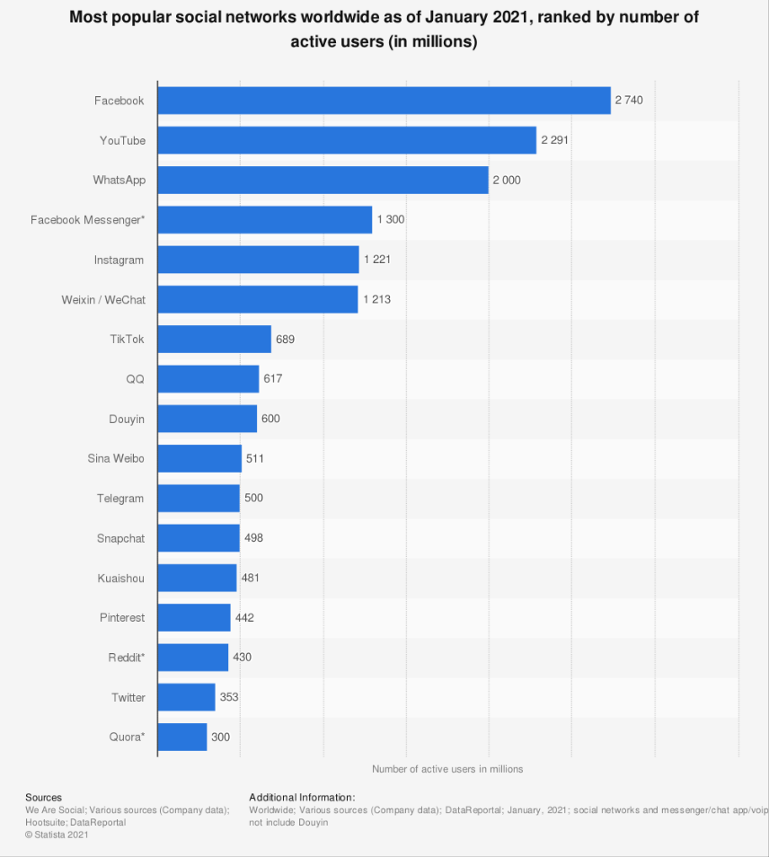

On average, internet users will spend an average of 144 minutes on social media each day, businesses must realise this potential as people will become attracted to a product or service if they see it regularly and may be more tempted to purchase. (Chen, 2021)
Social media has a huge impact in the food and beverage industry as there are trends that come and go due to customer preferences and individual posts mean people will start talking and sharing their own personal thoughts. It is very hard to keep up with the variety of dietary requirements and the healthier living style such as veganism and creating new meal ideas and buying in the correct ingredient replacements. Social media analytics show food and beverage businesses ensures that they can produce the best quality products for what customers are demanding at that time. “94% of marketers and business professionals find data analysis important for their growth.” (Mastorakis, 2020)
Erving Goffman 1959 speaks about social stigma and viewing people’s behaviours, and how they portray themselves in social situations. Since social media has been introduced it can be harder to view people as individuals and they can hide their true selves behind a screen. Customers find it easy to post reviews and posts via social media to mostly promote a business they have attended. (Crossman, 2019)
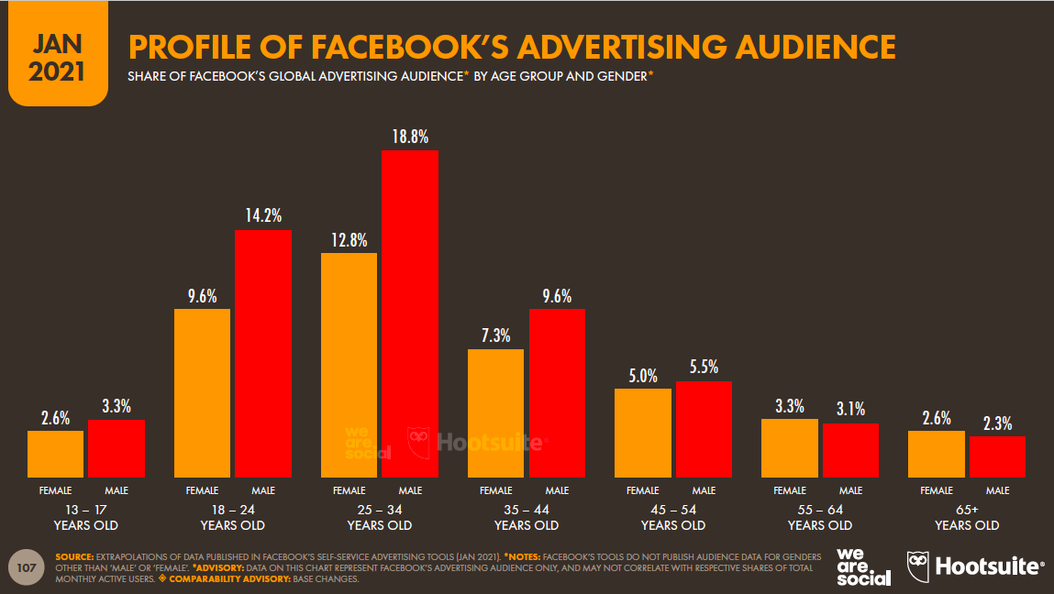
To be successful in using social media to the best of its ability for a business, it is important to have a plan and have plenty of knowledge and understanding to promote services in the most appealing and attractive way. Researching competitors is a great start to investigate and explore how to be unique and establish what other businesses, possibly in the local area, are achieving. Knowing and expanding the company’s audience can greatly improve the target market and making a social media plan can be encouraging to find new trends that can be monitored regularly. Building relationships is an excellent way to build trust, respect and loyalty between customers and employees which is what is needed in every business whether it is small or a huge international business. It is important to use social media with all the benefits it comes with such as creating pages, creating Facebook groups, uploading photos and videos and generally keeping up to date with posting allows businesses to reach its social media potential.
(Newberry, 2021)

3.Research Strategy and Methodology

3.1 - Introduction

“Research is, among other things, an intensive activity that is based on the work of others and generates new ideas to pursue and questions to answer.” (Salkind, 2012, p. 25)
During this chapter, different research methods will be explored, and a description of qualitative and quantitative data will be highlighted. The researcher will discuss the different research methods and what is relevant to the subject area and ensure it is valid and a reliable source. Research methodology is “how a researcher systematically designs a study to ensure valid and reliable results that address the research aims and objectives.” The choices that have been made will be justified and the reasoning behind the chosen data method will be highlighted and explored and whether the expected answers have been found and how it is relevant.
Qualitative data is the use of collecting words and analysing words which are either written or spoken, this data method is a great way of exploring and gathering individual opinions and reasoning behind these choices by understanding people perspectives. Qualitative data can also focus on the body language and visuals when asking the individual each question. The contrast to this method is quantitative data collection which uses numerical data and can look at the difference between to variables which have been applied into a questionnaire or survey. (Warren, 2020)
Reliability and validity are key when conducting primary research, evidence will need to be provided from a number of sources to ensure that there is a secure conclusion and few anomalies that could occur. “The term “validity” refers to the degree to which the conclusions derived from the results of any assessment are “well-grounded or justifiable; being at once relevant and meaningful.” (Cook, 2006)

3.2 – Planning and Ethical Consideration

Planning took place after a meeting with the researcher’s supervisor to confirm any queries with the following data collection methods. The two parts of the data collection goes as follows. The questionnaire was created on google forms and distributed on a social media page for people to share and answer, this was all done via a laptop which was quick and easy to post. The interviews were conducted through email as face to face interview were not advised to be conducted at this time. Both data collections had to have ethical consideration at all times, data collection protection, ethics forms and consent forms both provided by UWTSD, all had to be attached and filled in before the data collection could take place, so everyone was reassured that all information was kept safe and anonymous. As the questionnaire was online, there was no way the researcher would know which individual had completed which question. Only the researcher would have the knowledge of who was who from the interviews, no names will be shared or stored, the individuals were aware of this. (Saunders, 2014, p. 2) Defines that “Anonymity is one form of confidentiality – that of keeping participants’ identities secret. However, confidentiality also includes keeping private what is said by the participants, something only achievable through researchers choosing not to share parts of the data.” Any ethical issues were considered and delt with, no participant was under the age of 18 and all individuals voluntarily took part in the data collection.

3.3 – Research Approach

In this data collection research study, there are two different forms of methods used an online questionnaire which was put onto social media for members to fill in, this was for quantitative data and semi-structured interviews which have been conducted online via an email for the qualitative data. The quantitative data was created and released first to get the view of the customers and public, followed by the interviews that will give the researcher more detail to back up the secondary research with relevant explanations. The questionnaire follows a positivism approach originally created by Comte, which relates to data collection only and interpreting the data given in an objective way and the data collected is purely focussed on the facts of the investigation found from the primary data collected. (Dudovskiy J. , 2008) The questionnaire will allow the researcher to link the main aims and objectives to gain answers and facts which have been investigated through primary and secondary research.
The qualitative piece of data collected is the semi – structured interviews which were conducted via email as face to face interaction was not advised at this current time. The interviewees are all members relating to the hospitality industry that run small food businesses for the local area and how they have used different digital technologies and social media sites to find opportunities for the sales from their business through the tough times of the pandemic. This approach follows the interpretivism method and links to the use of interviews to gather data, this approach gives more specific and unique information. According to Myers (2008) “interpretive researchers assume that access to reality (given or socially constructed) is only through social constructions such as language, consciousness, shared meanings, and instruments”. (Dudovskiy, 2008)

3.4 – Research Choice and Time

The researcher has chosen to use a mixed approach of methods and will use qualitative and quantitative data methods to gather the most accurate and reliable data which is relevant to the main aims and objectives to see whether they can be answered. Both a survey and interviews will take place from customer and business perspective to clearly investigate whether the main aims and objectives are correct and if there are any issues to outline. The estimated time of conducting the data is over a short period, consisting of around two weeks as this seems to be the most appropriate time scale overall to allow the researcher to conduct interviews and gather the responses from the questionnaire created.

3.5 – Research Design

Every piece of data collection will have a set of questions that want to be answered and it is important to choose the correct data methods that are relevant and reliable to the main title question with the sub aims and objectives. It is also key to have a clear planning process to ensure that all data methods reach an effective and secure outcome. A questionnaire will have a selection of demographic questions to begin with and then main topic questions to follow which will gather the most amount of relevant answers. The online questionnaire contained twelve questions with a mixture of open-ended questions and some closed multiple choice questions, although the option of “other” and to extend their answers was possible.
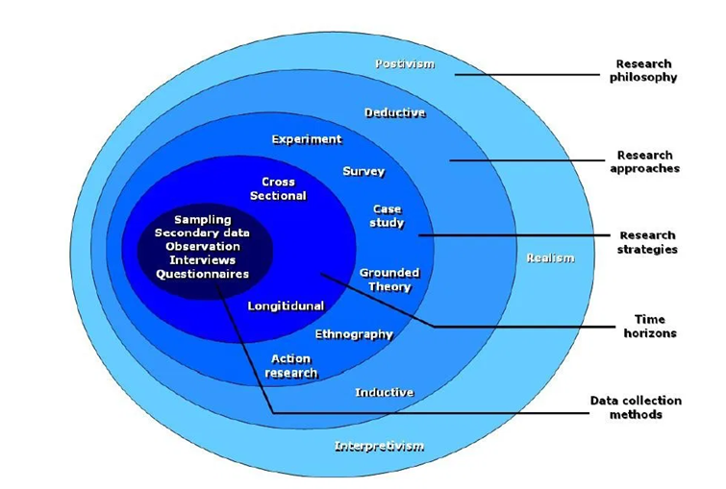

The Saunders research onion allows investigators to follow certain stages created in research work which was originally created by Saunders et al (2007).
“The research onion suggests that strategies can include action research, experimental research, interviews, surveys, case study research or a systematic literature review.” (15writers, 2020) As shown in the image above it gives the appearance of many layers that all have a specific purpose. (Thesismind, 2019) The research onion is a great diagram to follow for researchers as it contains 5 different layers which can be easily placed into sections and can be completed until the researchers gets to the core.
The 5 layers goes as follows –
- The research philosophy
- The research approaches
- The research strategies
- The research choices
- The research time horizon
The philosophy stage is the nature of knowledge and finding ways to define the main goals of the research and the best ways to achieve the best answers and outcomes. There are three main philosophies in this stage which include ontology which is mostly the study of reality, epistemology which relates to more scientific and it far more definite data and axiology which relates to the individual learning about values and opinions which may impact the researchers data collection, Silverman (2013) said that it can really help someone understand the impact of peoples opinions on collecting and analysing research. The deductive approach helps and develops the main hypothesis discovered by pre-existing theory and it can be involved with the positivist approach. Whereas the inductive approach allows the researcher to create a theory of their own rather than focus on pre-existing theory which defines the two approaches. The next layer is the research choice and time horizons. This helps with the decision of whether the data collection will be qualitative, quantitative or a mixture of the two, this also relates to the cross-section and longitudinal study. Saunders uses the mono, mixed and multi options which is the choice of just one method or using a combination. The final layer is the analysis and data collection and looks at the reliability and validity of the whole study. This layer is the last layer to explain how the data has been used, collected and analysed. (thesismind, 2019)

3.6 – Questionnaire

The chosen primary research method was a quantitative method which gathered data through the use of a questionnaire. With this method, the researcher found this to be the most relevant and appropriate to target the public and customers that would use digital and online technologies, including some of the benefits and negatives that come with the chosen topic area. 12 questions were created which linked into what the researcher wanted to find out and connect the details with the main aims and objectives which could be further compared to the secondary research which was found before the primary data was collected. The questions were encouraged by the secondary data that had previously been collected to bring the two data collections together to bring an overall conclusion. Most of the questions were multiple choice, but the participants had an “other” option if they wanted to extend on these questions, there were also an open ended question which allowed the participants to express a more detailed opinion. As the questionnaire was posted on social media, the researcher didn’t have full control of who answered the questionnaire, but any member could relate and answer the questions with ease and clear understanding. Anyone who participated was thanked via a comment which the researcher responded to.
As the researcher had an understanding and plenty of knowledge of the topic in question, bias could have taken place when creating the questions, although the survey was checked by two other members to ensure it didn’t come across as biased or unethical. “Bias is defined as any tendency which prevents unprejudiced consideration of a question.” (Pannucci, 2010)
The questionnaire would follow a snowball effect as the process begins small and then increases over a small amount of time. A definition of this sampling method is “Snowball sampling or chain-referral sampling is defined as a non-probability sampling technique in which the samples have traits that are rare to find.” (QuestionPro, 2021)

3.7 – Interview

The interviews were received from two individuals that were conducted via emails as current guidelines are in place where face to face interviews would not be advised. The data could easily be placed into themes as there were only three main questions where responses could be as detailed as possible. Each individual asked is either part of the hospitality industry or owns a small food business that can be found on social media or through a digital website and takeaway options. It was estimated that participants should spend no longer than 15 minutes answering the questions, although as it was provided through email, the participants could reply at an appropriate time for them.
According to Braun and Clarke, a thematic approach can used to analyse data and report any occurring themes in qualitative data, it enables the researcher to demonstrate a clear understanding of finding and produce a detailed report. The more themes that are discovered, the clearer the understanding of the chosen topic. (Braun & Clarke, 2006)

3.8 – Conclusion

This chapter has been about how the researchers has designed and completed quantitative and qualitative data collection as a primary resource which will aid the answering of the main aims and objectives discussed in chapter 1. The following chapter will focus on the analysis and show graphical data that has been previously collected so the reader is able to gather information and knowledge much quicker.

4. Finding and Analysis

4.1 – Introduction

The first part of this chapter introduces the findings made in the online questionnaire that received 115 responses, the questionnaire was open on social media and no limit was made. There weren’t 115 responses for every question in the questionnaire which changed the percentage of how much was fully completed. The next part of this chapter will be the emailed interviews and the responses the researcher received from there, this was all the primary data collected which can then be finalised and analysed to show the data clearly.
To show the full analysis and in depth findings, along with the graphs that have been created on Microsoft Excel, the software programme IBM SPSS was used to create a variation of crosstabulations, the use of this programme will help to back up any evidence found from the previous secondary and primary data to investigate any correlations between the varying factors from the questionnaire.
“Graphs are a common method to visually illustrate relationships in the data. The purpose of a graph is to present data that are too numerous or complicated to be described adequately in the text and in less space.” (Slutsky, 2014)
Data becomes far easier to read and analyse quickly when put into graph, charts and tables which can be colour coded via themes and patterns which relate to certain parts of data. The questionnaire and the interviews all had the aims and objectives in mind and related back to the main title of the dissertation.
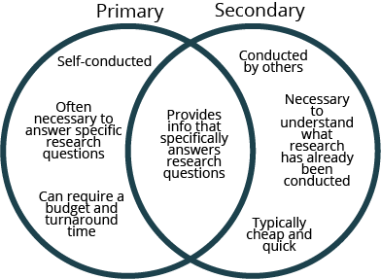
“The goal of primary research is to answer specific questions that directly pertain to the project at hand. This type of research is extremely valuable, yet, due to its nature, takes more time to collect than secondary research.” (McCrocklin, 2018)

4.1 – Results

4.1.1 – Age chart
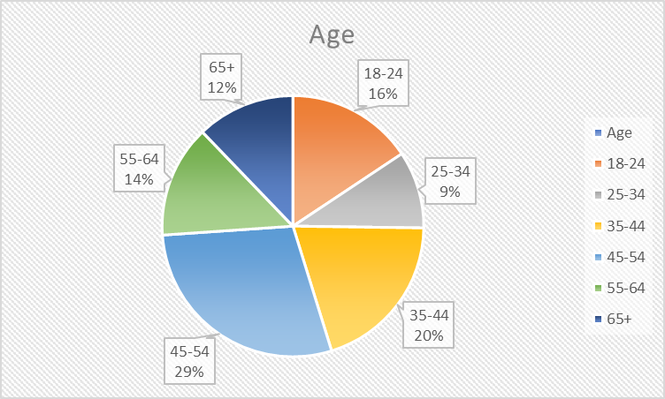

Question one was a demographic question about age. 100% of respondents replied to this question. The graph shows that the most popular age group answering the questionnaire is the 45-54 bracket and the least popular age group answering is the 25-34 bracket.

4.1.2 – Gender chart
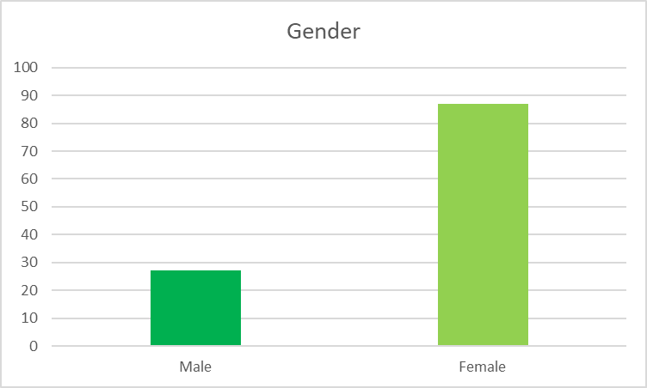

Question 2 shows the demographic gender questions, as shown in the graph it is clear that many more females took part in the questionnaire, 87 females compared to 27 males.

4.1.3 – Employment chart
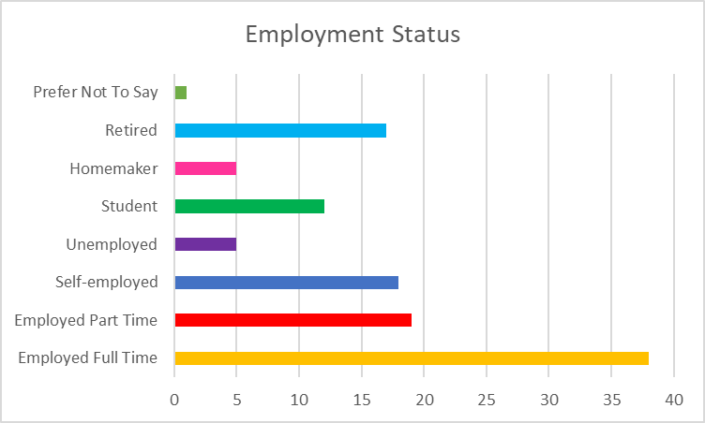

Question 3 has shown the researcher that most of the individuals answering were employed full time which covered 33% of the total percentage. The lowest percentages include the homemaker and unemployed at 4.3% each.

4.1.4 – Social Media Usage chart
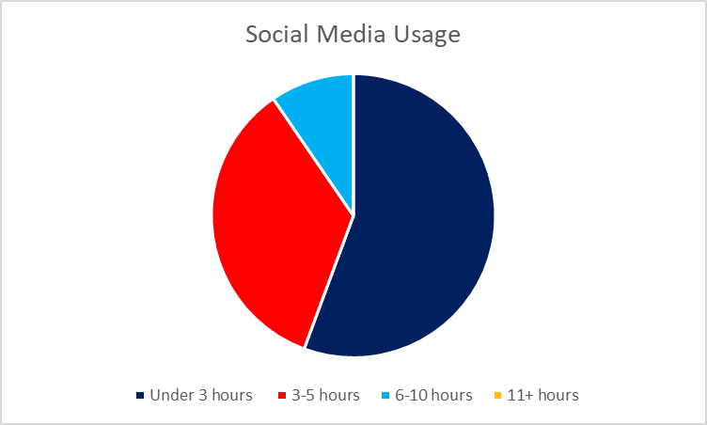

Question 4 was related to how much time the individuals spend on social media, which will give the researcher an idea of how long customers are likely to see business adverts and posts. 55.7% spend less that 3 hours on social media daily, compared to 9.6% that use social media between 6 and 10 hours a day.

4.1.5 – Technology devices used
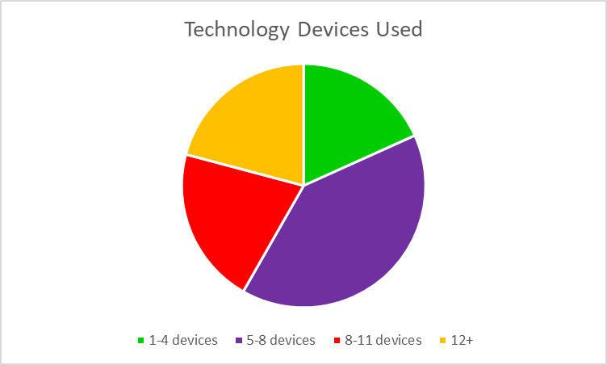

For question 5 there is a small percentage difference between 1-4, 8-11 and 12+ devices and it is clear that with 40% of the results individuals have the average of 5-8 technology devices which included mobile phones, laptops and smart TV’s.

4.1.6 – Most Used Social Media App
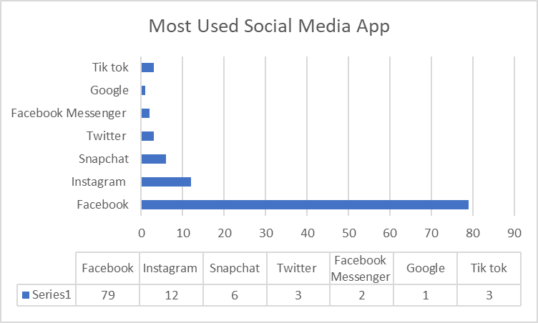

Question 6 showed that is it very clear that Facebook is the most used social media app and businesses should place as many advertisements and promotional posts on this page as it is the most popular with 74.5% of the overall chosen app.

4.1.7 – Which Online Ordering Service Has Been Used
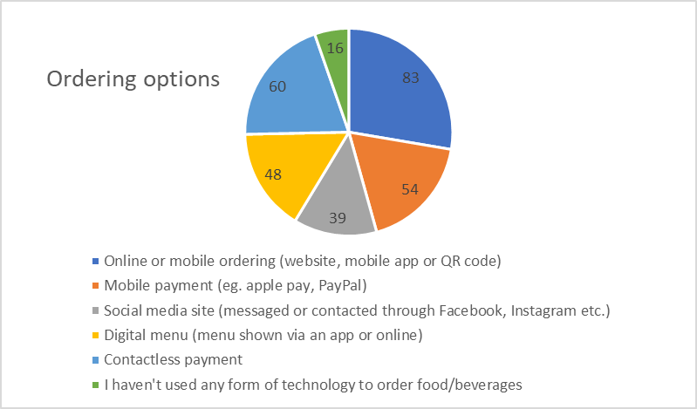

This question was based on the different technologies that people have used when ordering and paying from a restaurant, café or bar that also provide takeaway options, this was a question will multiple choices where one or more answers could be chosen. Online ordering is the most popular with 72.2% choosing this options, possibly along with contactless payment which had a total of 52.2%.

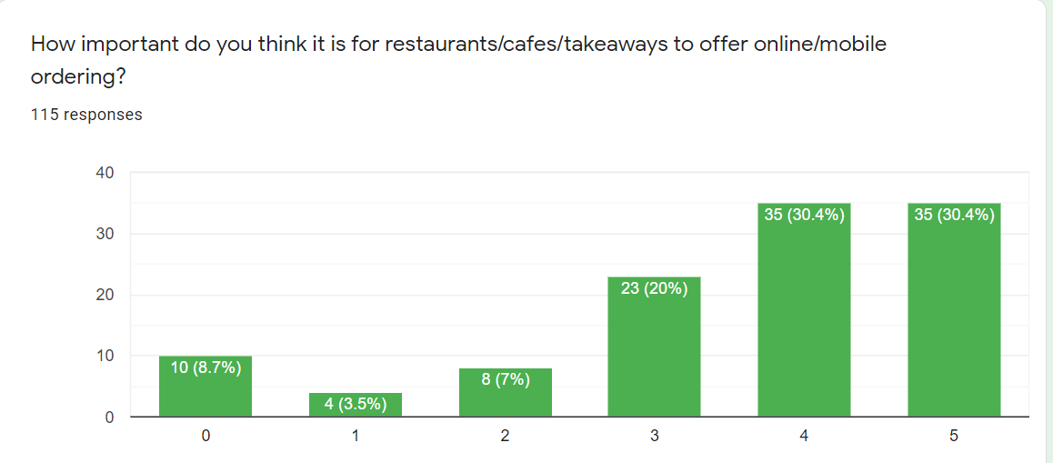
4.18 – Importance of an Online Ordering System

This question focusses on the rating that people gave between 0 and 5, 5 being the most important and 0 being the least. It is clear that more people like the idea of ordering online and having access which is appropriate to the customer.

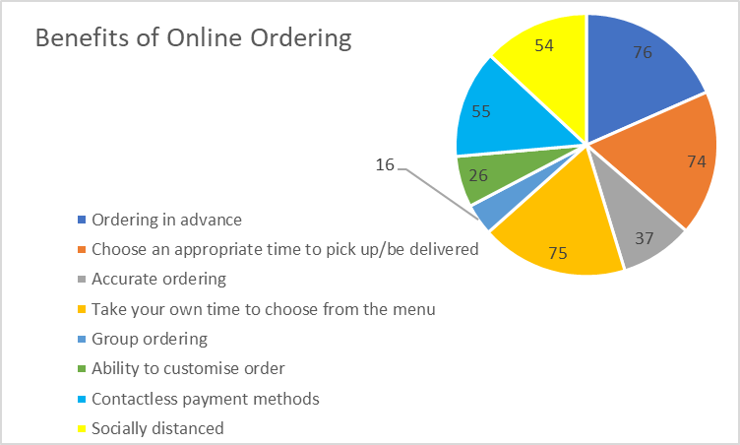
4.1.9 – Benefits of online ordering

This next question was based on the benefits of using online ordering and it seems that the ability to order in advance, choose an appropriate pick up time and taking time to choose from the menu were some of the key benefits that people look for, if businesses have these options they are more likely to get orders.

4.1.10 – Worries of online ordering
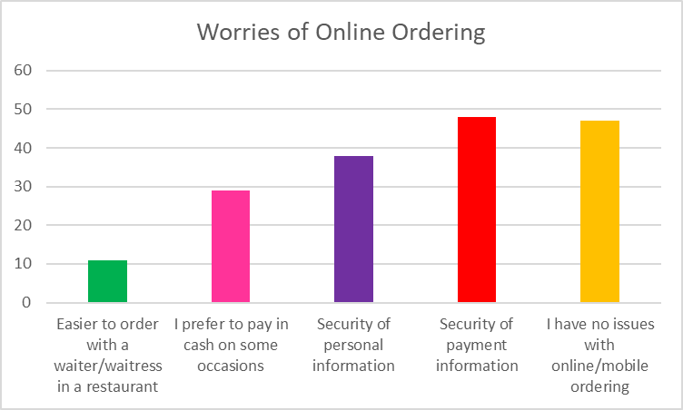

This question was looking at some of the worries that people come across when ordering online. The main worries include the security of payment and their personal information which can be reassured by businesses giving clear instructions and using secure programmes to ensure safety of details.

4.1.12 – SPSS Crosstabulations
Age * Social_media_time Crosstabulation
Count
 |  | Social_media_time |  |  | Total
 |  | Under_3_Hours | 3-5_hours | 6-10 | Total
Age | 18-24 | 5 | 7 | 6 | 18
Age | 25-34 | 6 | 4 | 1 | 11
Age | 35-44 | 14 | 9 | 0 | 23
Age | 45-54 | 18 | 12 | 3 | 33
Age | 55-64 | 12 | 3 | 1 | 16
Age | 65+ | 9 | 5 | 0 | 14
Total |  | 64 | 40 | 11 | 115

Age * Online_ordering_importantce Crosstabulation
Count
 |  | Online_ordering_importantce |  |  |  |  |  | Total
 |  | 0 | 1 | 2 | 3 | 4 | 5 | Total
Age | 18-24 | 2 | 0 | 1 | 3 | 10 | 2 | 18
Age | 25-34 | 0 | 0 | 1 | 2 | 3 | 5 | 11
Age | 35-44 | 2 | 2 | 1 | 5 | 4 | 9 | 23
Age | 45-54 | 0 | 2 | 2 | 5 | 10 | 14 | 33
Age | 55-64 | 4 | 0 | 2 | 3 | 3 | 4 | 16
Age | 65+ | 2 | 0 | 1 | 5 | 5 | 1 | 14
Total |  | 10 | 4 | 8 | 23 | 35 | 35 | 115
For this crosstabulation age and social media were compared to analyse whether there is a clear difference between the age ranges. As shown above under 3 hours in the most popular choice, in nearly all of the age groups the social media time was under 3 hours, apart from the 18-24 year old group where 3-5 was chosen the most.

The importance of online ordering was rated quite highly which shows that many people like the idea of less contact with others and the ease of choosing specifically what the individual wants and at what time.
Gender * Social_media_time Crosstabulation
Count
 |  | Social_media_time |  |  | Total
 |  | Under_3_Hours | 3-5_hours | 6-10 | Total
Gender | Male | 14 | 10 | 3 | 27
Gender | Female | 50 | 29 | 8 | 87
Total |  | 64 | 39 | 11 | 114

As there is a much larger percentage of females that took this questionnaire, it is hard to determine a clear and representable crosstabulation.
Employment_Status * Social_media_time Crosstabulation
Count
 |  | Social_media_time |  |  | Total
 |  | Under_3_Hours | 3-5_hours | 6-10 | Total
Employment_Status | Employed_Full_time | 24 | 11 | 3 | 38
Employment_Status | Employed_Part_Time | 8 | 9 | 2 | 19
Employment_Status | Self_Employed | 10 | 7 | 1 | 18
Employment_Status | Student | 5 | 3 | 4 | 12
Employment_Status | Unemployed | 1 | 3 | 1 | 5
Employment_Status | Retired | 13 | 4 | 0 | 17
Employment_Status | Homemaker | 2 | 3 | 0 | 5
Employment_Status | Prefer_not_to_say | 1 | 0 | 0 | 1
Total |  | 64 | 40 | 11 | 115

Individuals that are either in full time employment or self-employment typically spend the least amount of time on social media, which would be understandable as people don’t tend to use social media while working. Students have a higher percentage of using social media 6-10 hours a day.

4.2 – Analysis

The data above was collected through the use of quantitative and qualitative data as discussed in the methodologies chapter. The data was collected on the purpose of how digital technologies have given SMEs in the hospitality and food industry opportunities to work on during the current pandemic. The questionnaire focussed on what customers thought and their usage of technology and social media, linked with how they have used local restaurants and takeaways and if there has been any change in the ordering process due to social distancing and government guidelines.
There was a total of 115 responses on the questionnaire which was from a variety of ages and with varying use of social media usage and the different ordering changes that have occurred recently since the start of the current pandemic. Out of all the responses, Facebook is the most popular with 79 out of 115 responding to this question, which is great news for businesses who are already advertising on social media and can use this to an advantage. Twitter, Instagram and Snapchat do not get used as much, this may be due to the lack of advertising opportunities and the lack of popularity. This also backs up the secondary research as shown in previous graphs in chapter 2 where Facebook, along with YouTube were the two highest options.
Th researcher was looking for information to back up secondary information and investigating whether restaurants, cafes and food takeaway businesses are offering more digital technologies such as apps and online ordering through websites and social media pages to promote themselves. Most of the respondents to the questionnaire either gave a score of 4 or 5 when it came to the importance of online ordering, 0 being not important at all and 5 being very important, this shows that businesses should provide an online service which allows customers more freedom when placing food orders.
There were plenty of benefits highlighted when it came to online food ordering such as ordering in advance, contactless payment, social distancing is made easier and choosing an appropriate time to pick up food or have it delivered appealed to a huge percentage of the respondents. Only 110 responded to this question, leaving 5 people unaccounted for.
Looking from all perspectives, the researcher included a question about the worries that individuals may have when using all these online services and ordering through apps and websites rather than being in contact with someone face to face. As mobile phones are not available to every individual it can be hard for small businesses to target everyone and their specific needs. Security of payment details and security of personal information was the main concern that arouse, with 48 responding payment safety and 38 responding personal information safety, although 47 responded with having no issues at all with the online ordering system and found it safe to use, although this question had 3 missing responses.
On the questionnaire there was a final open ended question which had 93 responses out of a possible 115, this question asked whether people were ordering differently and if there were any obvious impacts that they thought of from restaurants and takeaways since the pandemic hit. A few people mentioned that this has not changed at all, many said they were now using online takeaways much more than before the pandemic and individuals enjoy the ease of looking through an app and having a delivery service available.
These questions helped to answer some of the main aims and objectives of the whole dissertation including -
“Research how the hospitality industry has been impacted since the pandemic began. What happened in terms of the different actions taken before, during and after the pandemic.”
As businesses have introduced apps, easier ordering and takeaway options it has clearly been a great opportunity to take on board as the public feel more comfortable due to the challenging government guidelines to order safely and still enjoy great food and drink at home, or with less contact when restaurants could open.
Each graph and chart has shown a clear representation of what the customers think to the new online services, the interviews were targeted at business owners and did back up what was being said from the secondary research and the researchers hypothesis of opportunities occurring from the current pandemic situation, although there were some tougher times that many have to endure, many businesses have survived thanks to the advertising on social media and have the correct technology to help out the smaller hospitality and food businesses.
 | Participant A | Participant B
Question 1 - How have you used social media to promote your business? | “Social media has played a huge role in the running of our business. We are able to upload new menu ideas, advertise opening hours and update our customers quickly and efficiently whenever change comes into place. Allowing people to share our posts and photos helps us reach out to new customers. We can apply all our contact details onto our Facebook and Instagram page, so it is easy for customers to order from us.” | “We have used social media generally for years. I'd say our Facebook page is at least 10 years old. It has adapted drastically over the years, as Facebook itself has.  We tend to post on Facebook daily. We use it to promote our services, special offers and keep in touch with our guests. Sometimes the posts fly and other times it's much harder to get them seen. The challenges with a business like ours, is to target different people, from different areas for different reasons.  Recently, our local posts about the park, afternoon teas or just a simple photo of the pool, gets a great reaction. Usually because during the pandemic, they are the things that people are missing the most, or an opportunity to regain some normality. For posts advertising accommodation, these tend to have a much lower reach as so many of our following is fairly local.  For accommodation posts, we generally have to spend some money on advertising to get these seen.”
Question 2 - Have you found any specific positives or opportunities from using technology/digital systems to run or promote your services? | “When restaurants were able to open in the summer, we were able to take contactless orders by creating an app which could be changed from any digital device such as my phone or iPad, payments could also be taken this way. We were able to create takeaway options for people in the local area and deliver items such as ready to heat meals and afternoon teas via delivery with the help of our team. Technology has been a huge help in ensuring we are able to keep running the business safely and improves how we can serve our customers when we had to close temporarily through the various lockdowns. The cost of the new digital systems we had to install such as purchasing an iPad and purchasing the ability to create an app was high, although the positives of keeping our staff and customers safe outweighed this.” | “Facebook was a tool in order to communicate with our guests and direct them to our website. I've always believed that we shouldn't rely on it too much as the system is out of our control. Should Facebook decide tomorrow to stop allowing businesses onto its platform, it would be a huge blow to anyone who's marketing is solely reliant on it. However, we have also experienced issues with our website which has prevented people from accessing it. Social media has become more important while we get this fixed. We're currently building a new site.  We use Instagram as another platform. Though this is less regular with us, the reach and following is lower, we do tend to get more leads per follower here. This is something I'd like to develop more as time goes on.
Question 3 - Do you think you would have used social media and digital websites/systems to its full potential if the current pandemic hadn't of happened? | “Social media has always played a part in our business and we previously updated customers on new menus and events before the pandemic hit. We have tried our best as a team to use social media to its full potential by posting our products and services throughout each lockdown. As for the digital systems, we would still be using the traditional waiter and paper method as using an app to order was yet to cross our minds, although now we have it in place, I can see it staying for the long term as it has made ordering easier, and the contactless payment system has let the customers and staff feel more at ease. Although this system has come with its problems, once used and learnt it has followed the government guidelines in every way possible. | “The pandemic has, as you know, made us embrace technology more than we may have done. We have moved our check in system, food ordering, staff rota system, restaurant reservation systems, spa booking systems, spa consultation forms, all online. Our guests now order their breakfast via Whatsapp from their room, to cut down the time they spend at the table. The summer of 2020 taught me that this system, though excellent, didn't work for everyone. We will carry on with these systems when we reopen, however we plan to allow people to use a paper system in the restaurant for food ordering too. Unfortunately, though trying to follow guidelines, I believe we put some people off. By giving them the choice as to whether they want to order online or with the server, I believe we could be more successful. As a hospitality business, though we want to ensure everyone’s safety, we don't want to do this at the COST of the customer. We still need to be able to provide a high quality level of customer service and for that, we require our wonderful service team's personalities to shine through. Something that technology just can't replace.  The pandemic has really made us change the way we work across the business. We now spend far less on old-style marketing, but it does still have its place.

4.3 – Interview Analysis

The researcher emailed the three questions to ten different businesses although only two responded in the two week time frame which seemed appropriate to gather enough information from the questionnaire also. It is clear to see from both businesses that social media has made a huge impact on how they have pushed their business and manage to create a service for people to enjoy, even when the stay at home rule was in place. Social media sites such as Facebook and Instagram seem to be used in both businesses, this links with the customers main choice of spending the most amount of time on Facebook. Communication is key when running any kind of business, but it seems as though it has been really important over the past year to communicate with customers, employees and suppliers with updates, new information and upcoming events where everyone can be informed of anything new that may affect the individual. The pandemic has had a huge impact on everyone around the world and everyone has had to adapt to the many changes that have occurred. As stated by participant two, new systems have had to be put in place to ensure that customers and staff are all kept safe. Having a well-managed team and communicating with other staff members is one of the best ways to succeed and have the best outcome possible, especially since the pandemic has affected everyone’s lives in many different ways, it is good to ensure that every member feels comfortable and happy in their work environment. This section answers the main objective of objective one “Assess the current use of digital technologies in the SME hospitality sector and how these helped the businesses prepare during the pandemic.” and objective three “Research how the hospitality industry has been impacted since the pandemic began. What happened in terms of the different actions taken before, during and after the pandemic”. The hospitality industry has taken a huge hit but is now slowly recovering and managing the next few steps carefully as regulations can change from week to week. There have been many positive changes in the way that technology has helped overcome certain issues such as being socially distanced and avoiding contact with others where possible to minimise spread and risk to the most vulnerable, many of these technology changes look to stay well into the future and evolve as more information and knowledge arises about these different digital systems.

5.Discussion

All data from the primary and secondary research has been collected and analysed individually with all aspects of the main question and objectives in mind. All data that was required was outlined through the methodologies chapter and choice of methods have all be explained and outlined in that chapter. In this discussion chapter, the researcher will discuss any similarities and key information found between the secondary and primary research which links to the main title,
“Resilience in the hospitality sector; A critical study of the opportunities the hospitality industry has had from using online and digital services through the current pandemic.”
One of the first aims of the research project was to assess whether digital technologies are currently being used in SME hospitality businesses and if any technologies have helped during the pandemic. From the secondary research plenty was found about what digital systems hospitality businesses were using already, from contactless payments, social media sites to online ordering systems. With 3.91 billion using social media through their mobile phone, it is a must for businesses to respond with advertisements and opportunities (Chaffey D. , 2020). This was then further backed by the primary research from the interviewees which both used social media to promote events, menus and online ordering systems, along with WhatsApp messaging and apps. Customers are also seeing the benefits of having an online ordering system and how important it is to have a more flexible way of ordering. The opportunities of using technology and digital business systems have helped SMEs to carry on with making a businesses and providing for customers with the highest quality possible, and of course, following all the government guidelines that have been in place.
The second objective that the researcher investigated was how much the hospitality industry contribute to the GDP and employment status. The hospitality industry is one of the biggest industries which provides jobs to people everywhere. The industry employs around 3.2 million people in the UK alone from varying age groups and £130 billion to the economic activity, his contributes hugely to the GDP of the area and the general employment status in Wales and the UK. (UKhospitality, 2019)
Businesses have tried their best for the past year since the pandemic hit and caused the hospitality industry to pause for months. From the interviews conducted by the researcher, it is obvious that the smaller hospitality businesses have tried their best to ensure they can provide for their customers and still have a business to run once the government allows the country to open up again. Social media has been key to advertise and communicate with staff and customers, Facebook has proven in both the secondary and primary research as being the most popular way to communicate from the perspective of businesses, the general public and customers with nearly 75% of individuals in the primary research choosing Facebook as their most used social media site. Instagram and Twitter were also mentioned in the primary research although they were nowhere near as popular, YouTube came up as the second most used site in the secondary research. Using new technologies can be costly and with the hospitality industry losing 90% of turnover they have taken one of the biggest impacts.
Although it seems that the pandemic has hit businesses hard and closed many small local businesses, many have found new ways to move forward and use different advertisement sites and social media sites to communicate and promote their service and products. Different till systems, ordering online through apps and websites that have been created especially for individual businesses for their needs and budget. Communication is key with any industry but especially for hospitality where guests and customers ask for specific requirements and order for their own needs and wants.
For objective 5, the researcher conducted plenty of secondary research to find graphs and charts to show that the industry that has taken the biggest hit when losing customers is the hospitality industry, although the footfall decreased dramatically, managers and staff were able to provide online options and takeaway options for food to still be sold. Many new offers have been created to entice new and existing customers back to a safe and clean working environment to enjoy the luxuries of staying in hotels and eating in restaurants when safe to do so.
The aim of the study as to find the resilience of the hospitality industry and whether they have found any opportunities from using digital technologies and online services, which from the secondary and primary research conducted shows that businesses have found ways to work around the current pandemic and find ways to provide and continue to make a profit from the advanced use of technology. Social media, in both primary and secondary research, has proven to be a very popular and in previous graphs and charts shows that around 3.96 billion of the population use it on a daily basis. the government have played a huge part in ensuring that everyone is safe and that every individual followed the government guidelines to stop the spread and get back to opening up every industry as soon as possible.

Conclusion

The opportunities that businesses have come across while researching include –
- The powerful use of social media and their advertising properties
- Online ordering system that appeals to customers and easy to use
- Communication has increased between employees and customers
- New schemes in place to help the hospitality industry improve and get back to “normality” such as the “eat out to help out”
- Government grants have helped small businesses stay open
- The public are supporting local businesses which boosts the local community and GDP of the area
- Higher demand for the use of restaurants, leisure facilities and rooms once the industry can reopen
- Employment rates will begin to increase as the industry reopens
- Many have enjoyed the use of takeaway options to enjoy at home at a time convenient for them
- Health and safety standards have increased, along with general hygiene practice being promoted.

Since the pandemic hit, every industry has tried to promote their products and services in any safe way they can. The hospitality industry has found new online services and new technologies that will be her to stay for the long term for the ease and convenience for customers and to reach out to a new digital future for businesses. As discovered in the literature review, the hospitality industry has taken a great hit from the footfall and employees since the pandemic hit in March 2020, closing nearly every industry that wasn’t classed as essential. Businesses then had to come up with new and creative ideas to still manage to sell items to create some profit, including takeaway options, special events packages such as Mother’s Day, Father’s Day and Christmas offers that could be promoted through the use of social media sites and specially designed websites.
The primary research conducted also determined that people were using more takeaway options than they would have previously and found that there were many benefits that came with an online ordering system which would allow staff to stay socially distanced at all times and payments would be completed successfully through an app or web link. Many opportunities have been found and new skills have been learnt which will be in use in the future as the forever changing digital world has become far faster paced, it looks as though technology will take over a huge part of our everyday lives and we must all begin to adapt to these new changes.
There have been some negatives which have caused issues with many smaller businesses, although this was inevitable as the pandemic caused such a disruption to every individuals life. The safety of everyone was at the heart of the government, so enforcing closures had to be done and new guidelines had to be introduced. The hospitality industry has taken everything on board and provided plenty of safe service to those who desired it most, with new digital systems in place, the future looks as though new plans for online ordering and online checking in services will be staying and continuously being adapted to suit the digital environment.

References
15writers. (2020, December). Retrieved from www.15writers.com: https://15writers.com/research-onion/#:~:text=The%20research%20onion%20suggests%20that%20strategies%20can%20include%20action%20research,the%20purpose%20of%20the%20study.
Addy, R. (2020, May 27). Retrieved from www.foodmanufacture.co.uk: https://www.foodmanufacture.co.uk/Article/2020/05/27/Coronavirus-food-industry-SMEs-hardest-hit-after-hospitality-leisure
Aurecongroup. (2019, December). Retrieved from www.aurecongroup.com: https://www.aurecongroup.com/thinking/insights/aurecons-successful-hotels/technology-in-the-hospitality-industry-exploring-the-very-latest-trends#:~:text=Hotel%20guests%20expect%20to%20be,when%20they%20book%20their%20stay.
Banks, C. (2020, June 12). Retrieved from www.cga.co.uk: https://www.cga.co.uk/2020/06/12/hospitality-responsible-for-a-quarter-of-britains-gdp-fall-says-sector-tracker/
BigHospitality. (2020, October 30). Retrieved from www.bighospitality.co.uk: https://www.bighospitality.co.uk/Article/2020/10/27/Mobile-order-and-pay-technology-restaurants-pubs-bars-coronavirus
Chaffey, D. (2020, August 3). Retrieved from www.smartinsights.com: https://www.smartinsights.com/social-media-marketing/social-media-strategy/new-global-social-media-research/
Chaffey, D. (2020, August 3). Retrieved from www.smartinsights.com: https://www.smartinsights.com/social-media-marketing/social-media-strategy/new-global-social-media-research/
Chen, J. (2021, February 3). Retrieved from www.sproutsocial.com: https://sproutsocial.com/insights/social-media-statistics/
Clarke, B. &. (2006). Qualitative Research in Psychology. In V. B. Clarke2.
Cook, D. A. (2006). Current Concepts in Validity and Reliability for Psychometric Instruments: Theory and Application. In David A. Cook, The American Journal of Medicine (2006) (p. 166).
Crossman, A. (2019, July 1). Retrieved from www.thoughtco.com: https://www.thoughtco.com/the-presentation-of-self-in-everyday-life-3026754
DOLLARHIDE, M. E. (2020, September 6). Retrieved from www.investopedia.com: https://www.investopedia.com/terms/s/social-media.asp
Dudovskiy. (2008, January). Retrieved from www.research-methodology.com: https://research-methodology.net/research-philosophy/interpretivism/#:~:text=Interpretivism%2C%20also%20known%20as%20interpretivist,human%20interest%20into%20a%20study.&text=According%20to%20interpretivist%20approach%2C%20it,to%20appreciate%20differences%
Dudovskiy, J. (2008, January ). Retrieved from www.research-methodology.net: https://research-methodology.net/research-philosophy/positivism/#:~:text=In%20positivism%20studies%20the%20role,that%20lead%20to%20statistical%20analyses.
Google-Images. (2020, October 30). Retrieved from www.google.com: https://www.google.com/search?q=covid+technology+sales+facts+and+figures&tbm=isch&ved=2ahUKEwj4hvP82s3uAhUPQhoKHXELBBMQ2-cCegQIABAA&oq=covid+technology+sales+facts+and+figures&gs_lcp=CgNpbWcQA1CMOlj6QWClRmgAcAB4AIABYogB9AKSAQE2mAEAoAEBqgELZ3dzLXdpei1pbWfA
GOV.UK. (2020, December 3). Retrieved from www.gov.wales: https://gov.wales/wellbeing-wales-2020
GOV.Wales. (2020, December 19). Retrieved from www.gov.wales: https://gov.wales/guidance-for-tourism-and-hospitality-businesses-coronavirus-html
Gursoy, D. (2020, July 5). Retrieved from www.tandfonline.com: https://www.tandfonline.com/doi/full/10.1080/19368623.2020.1788231
Guszkowski, J. (2020, June 29). Retrieved from www.restaurantbusinessonline.com: https://www.restaurantbusinessonline.com/technology/how-coronavirus-reshaping-ordering-payment
Hudson, M. (2020, June 23). Retrieved from www.thebalancesmb.com: https://www.thebalancesmb.com/what-is-social-media-2890301
Hutchings, R. (2020, August 27). Retrieved from www.nuffeldtrust.org.uk: https://www.nuffieldtrust.org.uk/research/the-impact-of-covid-19-on-the-use-of-digital-technology-in-the-nhs#key-points
Hutton, G. (2021, January 8). Retrieved from www.commonslibrary.parliment.uk: https://commonslibrary.parliament.uk/research-briefings/cbp-9111/#:~:text=Impact%20of%20Covid%2D19&text=Restrictions%20on%20trading%20have%20significantly,2020%20compared%20to%20February%202020.&text=41%25%20of%20hospitality%20businesses%20had,to%2013%25%
IBISworld. (2020, August 12). Retrieved from www.ibisworld.com: https://www.ibisworld.com/industry-insider/coronavirus-insights/sme-industries-to-rebound-in-2020-21/
Landman, P. (2020, August 3). Retrieved from www.xotels.com: https://www.xotels.com/en/glossary/hospitality-industry/
Leboeuf, M. (2020, December 18). Retrieved from www.shiftelearning.com: https://www.shiftelearning.com/blog/the-true-cost-of-not-providing-employee-training
Liferay. (2020, December). Retrieved from www.liferay.com: https://www.liferay.com/resources/l/digital-business
Mastorakis, G. (2020, July 15). Retrieved from www.mentionlytics.com: https://www.mentionlytics.com/blog/social-media-monitoring-food-and-beverage-industry/
Matheson, J. (2020, July 2). Retrieved from www.economicsobservatory.com: https://www.economicsobservatory.com/how-has-coronavirus-affected-pubs-cafes-and-restaurants
McAllister, J. (2021, January 18). Retrieved from www.bighospitality.co.uk: https://www.bighospitality.co.uk/Article/2021/01/18/UKHospitality-GDP-figures-highlight-economic-importance-of-hospitality
McCrocklin, S. (2018, October 4). Retrieved from www.geopoll.com: https://www.geopoll.com/blog/primary-vs-secondary-research/
Newberry, C. (2021, March 2). Retrieved from www.blog.hootsuite.com: https://blog.hootsuite.com/social-media-tips-for-small-business-owners/
Norton, E. (2019, December 19). Retrieved from www.blog.gotenzo.com: https://blog.gotenzo.com/2020-tech-trends-revolutionsing-restaurant-industry
Pannucci, C. J. (2010, August). Retrieved from www.ncbi.nlm.nih.gov: https://www.ncbi.nlm.nih.gov/pmc/articles/PMC2917255/#:~:text=Bias%20is%20defined%20as%20any,or%20answer%20over%20others%E2%80%9D%207.
Pineda, D. E. (2020, October). Retrieved from www.imperial.ac.uk: https://www.imperial.ac.uk/media/imperial-college/administration-and-support-services/enterprise-office/public/IBP-Tech-Digest---The-evolving-virtual-food-environment.pdf
QuestionPro. (2021, February). Retrieved from www.questionpro.com: https://www.questionpro.com/blog/snowball-sampling/
Revfine. (2020, November ). Retrieved from www.Revfine.com: https://www.revfine.com/hospitality-industry/
Revfine. (2020, December 17). Retrieved from www.Revfine.com: https://www.revfine.com/contactless-payments-hospitality/
Richter, F. (2020, October 30). Retrieved from www.statista.com: https://www.statista.com/chart/21584/gafam-revenue-growth/
Robey, M. &. (1988). Information Technology and Organizational Change: Causal Structure in Theory and Research. In M. L. Robey.
Salkind, N. J. (2012). Exploring Research (eighth edition) . In N. J. Salkind, Exploring Research (eighth edition) (p. 25). Pearson Education .
Saunders, p. (2014, September). Retrieved from www.journals.sagepub.com: https://journals.sagepub.com/doi/pdf/10.1177/1468794114550439
Slane, R. (2020, May 20). Retrieved from www.economicmodelling.co.uk: https://www.economicmodelling.co.uk/2020/05/22/planning-for-the-short-medium-and-long-term-effects-of-the-crisis-on-your-local-economy/
Slutsky, D. J. (2014). The Effective Use of Graphs. In D. J. Slutsky, Journal of Wrist Surgery (pp. 67-68).
statista. (2020, August). Retrieved from www.statista.com: https://www.statista.com/statistics/1168552/share-of-hospitality-businesses-trading-in-the-uk/
Statista. (2021, March 5). Retrieved from www.statista.com: https://www.statista.com/statistics/1104991/coronavirus-restaurant-visitation-impact-united-kingdom-uk/
Statista. (2020, May). Retrieved from www.statista.com: https://www.statista.com/statistics/1118834/forecast-uk-hospitality-sector-re-opening-post-covid-19/
Statista.com. (2020, March). Retrieved from www.statista.com: https://www.statista.com/statistics/1110280/coronavirus-hospitality-footfall-united-kingdom-uk/
Statista.uk. (2020, March). Retrieved from www.statista.com: https://www.statista.com/statistics/1105193/uk-pub-and-restaurant-visit-behavior-after-covid-19-warning/
The-Guardian. (2021, January 4). Retrieved from www.theguardian.com: https://www.theguardian.com/business/2021/jan/04/covid-pandemic-drives-163-rise-in-restaurant-job-losses-in-uk-in-2020
thesismind. (2019, June 29). Retrieved from www.thesismind.com: https://thesismind.com/analysis-of-saunders-research-onion/
Thesismind. (2019, June 29). Retrieved from www.thesismind.com: https://thesismind.com/analysis-of-saunders-research-onion/
Thomas, D. (2020, December 15). Retrieved from www.bbc.co.uk: https://www.bbc.co.uk/news/business-55313752
Ton, J. (2020, May 12). Retrieved from www.forbes.com: https://www.forbes.com/sites/forbestechcouncil/2020/05/12/whats-next-short-term-and-long-term-impacts-of-the-global-pandemic-on-tech/?sh=7e5e30895cc0
Tripleseat-News. (2020, August 5). Retrieved from www.tripleseat.com: https://www.tripleseat.com/blog/how-technology-is-helping-restaurants-grow/#:~:text=Technology%20has%20always%20had%20a,impact%20on%20the%20restaurant%20industry.&text=Restaurants%20want%20to%20deliver%20a,the%20goals%20of%20the%20restaurant.
UKhospitality. (2019, September). Retrieved from www.youthemployment.org.uk: https://www.youthemployment.org.uk/dev/wp-content/uploads/2018/09/UK-Hospitality-Workforce-Commission-2030.pdf
Warren, D. J. (2020, June). Retrieved from www.gradcoach.com: https://gradcoach.com/what-is-research-methodology/
Werner, H. (2020, December 18). Retrieved from www.mitel.com: https://www.mitel.com/en-gb/blog/top-10-communication-tech-trends-hospitality
Wigmore, I. (2020, December). Retrieved from www.whatis.techtarget.com: https://whatis.techtarget.com/definition/social-media

