MANAGING ENTERPRISE IN 21st CENTURY
Wales Support for bame
By Theodore Toko Manzambi

July 3, 2020
UNIVERSITY OF WALES TRINITY SAINT DAVID
SWANSEA

Managing Enterprise in 21st Century (BMSW4006)


- Name of Business: Wales Support for BAME

0.1 Business Owner: Theodore Toko Manzambi

0.2 Mission statement:

Abrahams stated that a mission statement is an announcement of the organization’s outcome. It is also a word of honour that the organization compel to its service users and its employees. (Abrahams, J. 1999)
Our mission statement is “bringing happiness and hope to the Refugees, Asylum seeker and all the Bame in Wales in order to make a positive difference in their live”.

0.3 Aim and Objectives of Business
0.3.1 Principal Aims:

Haugh (2005) argued that social enterprises are business that deal for a social aim, they plan to achieve social and/or environmental goals and produce at least part of their income from services. Their outcomes therefore include business achievements as well as social/or environmental benefits.
That is to say that, our principal aim is to promote Social inclusion for the public benefit by working closely with people in Swansea and its surrounding areas who are socially excluded on the grounds of their ethnic origin (particularly Asylum Seekers and Refugees) to alleviate their needs and assist them integrate into Society.

0.3 Objectives of Business
Without being exhaustive, Wales support for Bame objectives are as follow:
-Providing a local network group that encourages and enables them to participate more effectively with the wider community;
-Increasing or coordinating opportunities for BAME to engage with service providers, to enable those providers to adapt services to better meet the needs of the community.
-Providing and referring to Education and training in the English language and in vocational skills;
-Social and recreational facilities and events involving the local community;
-Working closely with asylum seekers and newly granted refugee status during their difficulty route until full integration into the community.
1.0 Introduction

One of the most important aspects of business success is earning a profit. However, among several existent types of business is also found a social enterprise, which has specific social objectives as a primary purpose. (Pinso, 2008).
This present report is based on a p posal of a business idea of a new start up called Wales Support for Bame (Black, Asian and Minority Ethnic).

Integrate a new country where rules (immigration, housing, health, finances, education and employment) are different from where you come from requires appropriate support from Government approved organizations to guide you to a successful expatriation.

Moreover, Wales Support for Bame is a new Wales based charity whose purpose is to work closely by giving free support to Asylum Seekers, Refugees, and all Bame in different issues they face in their journey of integration in the United Kingdom in general and particularly in Wales.
By the fact, the word integration is known to be used for the first time in 1620 which has different meaning according to the use. Namely, integration is the act or process into of integrating such as incorporation as equals into society of individuals of different groups (such as races) (Dictionary, Merriam-webster,2020).

Therefore, uncertainty and challenges arise in people’s lives such as not knowing what integration does, not knowing what the challenges are, not knowing how to manage post-integration issues, not knowing where to seek help and so on.
To put it in simply, Wales Support for Bame will be providing such useful free of charge support starting by welcoming people and helping them until their full integration into the society.
1.1. Business target Market /Services to provide
A target market involves to a group of potential customers to whom an organization wants to hand over its products and services. (Kotler & Keller, 2015). This group also includes specific customers to whom a company directs its marketing efforts. It is also known as one part of the total market for a good or service.
Our business target market is based on:
-All Asylum Seekers sent in Swansea through Dispersal Accommodation (Nass- Support);
-Refugees granted and accommodated in Swansea;
-Black African and Minority Ethnic (BAME) living in Swansea and its areas.
According the UK Government, most of people arriving in the country are from foreign language, which already create a need of integration for those people. As it has been shown from the figure below the 20 most country where people come from. Fig.1
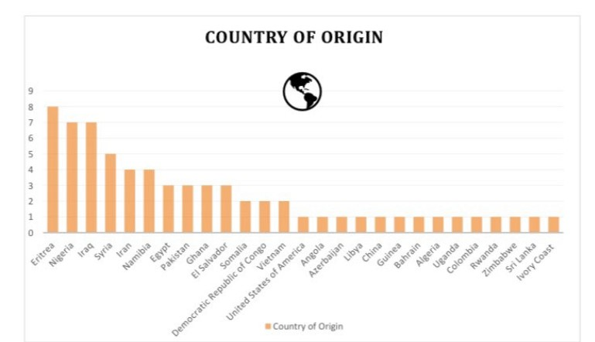
Fig.1: Visas and immigration-Gov.Uk
This is likely to show how huge is the market and why we have opted for a Social organisation. In addition, the Welsh Government argued, “Equality and human rights are central to the work of the Welsh Government and our vision for Wales. We believe in fair treatment of every person, especially those who are most marginalised by social systems that prevent people from meeting their basic needs. We work to ensure a fairer future which enables equitable access to services and human needs to support every individual to thrive.” (Nation of Sanctuary, January 2020).
However, the how, why and where will be shown on the following lines as they have already had existent organization before in our Swansea area and we will be explaining the difference with this new start up organisation and those are already operational.
2.0 The Marketing Mix
Several authors have defined the term “Marketing Mix”, the following definitions retained our attention.
Kotler et al stated that a marketing mix is a prepared combine of elements that make up the marketing plan of a product or service. (Kotler et al, 2019).
It also relates to a combination of elements that can be managed by an organisation to affect consumers or service users to purchase or acquire its products. Those elements are constituted by a set of marketing tools that the organisation use to implement their strategy and called the mix of the 4 Ps strategy or the 4 Ps marketing matrix. We will be developing those tools on the following lines. Similarly, a questionnaire will be written through the module “Digital Skills and Research Methods” to measure the importance or the necessity to set up a such type of business.
2.1 Price
Collins English Dictionary defines the price as the amount of money for which a thing is bought or the cost at which something is obtained. (Collins English Dictionary,2011).
However, the price is object of number of factors to consider when coming to a pricing decision. As previously explained that the Welsh Government has been taking some measurable actions to make Wales a Nation of Sanctuary. These actions will not be practicable without the support and engagement of key stakeholders, such as the UK Government, Welsh local authorities, the Welsh Refugee Coalition, Welsh communities and people seeking sanctuary to ensure that the plan is leading to positive change. By Welsh Refugee Coalition, it is easy to
understand a group of all the existent organization in Wales within the third sector, Wales support for Bame included, as it will be part of it.
Furthermore, Refugees and Asylum seekers face considerable challenges upon their arrival in the UK, in the same way the following actions have been taken by the Welsh Government.
- Ensure refugees are supported to transition from asylum accommodation to sustainable accommodation;
- Promote good quality asylum accommodation provided by the UK Government;
- Support asylum seeker tenants to advocate for improvements to their accommodation;
- Support the employability of refugees;
- Work with Business Wales to support refugees to establish their own business;
- Promote financial inclusion for refugees and asylum seekers to avoid destitution, reduce or mitigate the impacts of poverty and improve living conditions for those on low incomes;
- Promote the Welsh Government as a place for refugees to work. The Welsh Government’s strategic Equality Plan objective for 2016-2020 sets the organisation the aim of being an example of diversity and inclusion by 2020;
- Support survivors of violence against women, domestic abuse and sexual violence and so on.
That is to say that, no one will be able to pay such this kind of service and due to the social nature of our organisation, we will be providing a free of charge service as our financial support will be subsidized by funders, the Welsh Government and donation.
Correspondingly, a good launch is required to better set up our organisation in which we will organise a workshop for our promotion.

2.2 Promotion
According to business studies, promotion is a type of communication between the buyer and the seller where the seller tries to convince the buyer to purchase their goods or services through publicities. In addition, it helps people to be aware of a product, service or company. It can also create interest in the memory of buyers and can generate loyal customers.
Above all, a launch will be held to introduce our organization in our operational area in which will be called upon local organisations, members of the Welsh refugee coalition, members of the Welsh Government, and eventually refugees, asylum seekers and all Bame in Swansea.
In addition, we will promote widely the organisation through socio- media by creating a website, opening face book account, twitter, linked in and making some leaflets. Building partnership with organisations that already existed to promote our new service and explain how it is different from that existent service. Also, organising some workshop where people of different background will be invited to participate for more awareness campaign.
Building a good relationship with the Swansea Job centre plus and Moriston Jobcentre plus to
supporting more people with IT and language issues will also be part of what we will be doing.
2.3 Place
Concerning the marketing strategy, an organization needs to find out where best to distribute or to run out a product or service and how to promote it. Businesses use various methods to gain publicity.
Place is the point where products or services are made easily accessible to customers or services user. As Swansea had existent organisations before such as the better welcome Swansea, African Community, Unity in Diversity, Swansea Asylum Seeker Support and so on who work with Asylum Seekers, our purpose is to cover a gap that had always existed in working closely with Asylum Seekers and Refugees. From my own past experience since when I first arrived in United Kingdom, the pre-existent organisations in Swansea offer moral, physics and languages support without giving support which help people standing on their feet as a Chinese proverb said:” if you give a man a fish, he once fed. If you teach him to fish, he will feed himself all his life”.
That is to say, that our place will be considerable by the time among many existent charities and the location has been duly chosen in the Swansea City centre.
2.4 Product
A product can be defined as one of the prominence elements of marketing mix. Service users’ needs and wants can be satisfied through product.
All other things being equal, and given that our objectives are to support Asylum Seekers and Refugees, this means that our principal product is centred on “services we will be providing to all the minorities who will register with us individually or as a whole”.
As people are the focal point of our organisation, we have to ensure that their well-being is guarantee and that their benefits from the various services are properly observed.

2.5 Marketing activities
Despite of different common criteria known to set up a new business, measuring service on what to propose to the market and how to propose it can be tricky. For example, how might you measure an improvement in given services, trust or mental health. Due to this, an activity has been conducted through Digital Skills and Research methods to evaluate the necessity of what service we will be offering and its impact to the community.
Consequently, a questionnaire has been written for that purpose in which, type of services we will be running were explained to help us assessing the top- priorities of our beneficiaries need.
Based on these questionnaire responses, it has been shown clearly that there is a greater need for the type of support that our organisation will be offering to the public. Details on the questionnaire and summary can be seen in the appendices of this present report.
Due to this, it is highly Important to continue with the following steps as Legal aspect, physical resources, buying equipment’s, financial resources, planning human resources, and doing swot analysis to determine our place in the market.
3.0 Legal Aspects of Business
One of another external aspect with huge impact while setting up a business is the legal aspects. These aspects set of laws that guide business. Most of various forms of legal business are directed by business law regulations such as sole proprietors, social enterprises, partnerships, and registered companies with limited liabilities.
Padhi declared: “business laws serve several purposes. One of them is the smooth functioning of business operations. Business people need to have confidence in their dealings with other individuals, and these laws are meant to address their genuine concerns” (Padhi, 2013, p.XXIII).
Specifically, running business can get a little confusing as there is a lot to manage between what you want and your employees, partners and event the law. For example, below are some common business legal challenges that we can try to avoid.
-Employees: dealing with employees and their rights;
-Harassment: avoiding to be accused of harassment or discrimination;
-Immigration: always make sure that any employee has the right to work legally in this country;
-Upset customers and service users: people should be treated ethically, fairly and by using the golden rule.
4.0 Physical Resources
4.1 Location
As explained previously, our location will be in Swansea at Elysium Gallery on 34a Orchard Street, SA1 5AW where we will have two studios as premises.
4.2 Cost of location
Two studios will be used as the building has its own reception hall.
Two Studios x £ 120 = £ 240 per Month.
4.3 Choice made
This choice has been made by following both the price and its convenience to the city centre of any service that we will need. Most of service provider and partners that we need for a good implementation of our service are by 5 or 12 minutes by walking.
For example, Job centre plus which is a nightmare of newly granted refugee status is situated by 3 minutes of walking; council on the other hand is located by 12 minutes of walking and so on.
In addition, the Gallery has its own event room, which is free for Tenant and can gather more than 75 people and its own reception hall.
4.4 Equipment
To run effectively our business during this computerization’ s time, we need the following equipment without being exhaustive that could be added accordingly to our need.
One software to purchase for immigration data purposes as it should follow a certain rule of pre-existent organisations and Government requirements as stipulated previously at legal aspects section.
4.4.1 Need for premises
Inform: £ 500
4 office chairs for Employees: 1 * £ 65/Argos and 3* £ 28.39 /Amazon
4 office tables*: 1*£183.60/High Street and 3*74.99
8 visitors’ chairs: 8*£ 27.25
1 chair in front of each desk*4= 4 chairs *£ 12
4 office computers* £ 449.95/ John Lewis
1 Multifunction Printer -£ 253/Printer base
1 computer for public/helping the community to free internet, research, training, translation of documents and printing. 1* £ 300
2 kits of talktalk broadband for the office and for public * £ 25
1 Kettle* £ 20
Office Filing cabinets* £ 128/ Argos
Whiteboard *£ 54.90 /Amazon
Projectors * £ 110/ Amazon
Flipchart paper *£ 20

5. Finance
Every enterprise, even big, medium or small needs finance to keep on its operations and to achieve its targets. Finance is so indispensable today that it is appropriately said that it is the lifeblood of an enterprise. Without sufficient finances, no enterprise can possibly realize its objective.
5.1 Definition
Financing is the action of providing funds for business activities, making purchases, or investing. It can also be understood as the funds and credit employed in the business. (Hadar, 2018)
5.2 Sources of Funding
Businesses can be financed by different sources of finance such as Own Capital, Family and Friends, Banks, Small Business Loans, Personal loans, Trade credit, Private Equity Firms, Venture Capital Firms and Crowdfunding.
In addition, sources of finance can also be broken down into Short-Term, Medium-Term and Long-Term.
- For Short- term like Bank overdraft, trade creditors and factoring;
- For Medium- term such as Bank loans, leasing, hire purchase and Government grants;
- For Long-term as share capital, retained profits, venture capital, mortgages and long- term bank loans.
However, for this specific study, the mains sources of finance will be our Own Capital and Governments grants that will not be detailed, as it was not the purpose of our study.
5.2.1 Capital
Our own capital is determined by our previous saving as a beginning of £ 4 000 (Pounds four thousand)
5.2.2 Other sources of Funding
As the sector in which we will be developing will have a positive impact in the community and the Government, we will be contacting other financial organisation for a better support of our business, the Wales Government included. For example, the SCVS (Swansea Council For Voluntary Service) will be contacted firstly within an application that can help regarding IT materials in addition of our own capital.
For example, our support will help people to go through employment and once they got employment, they will be able to pay taxes. By the fact, isolation and domestic abuse will be reduced; also, drugs dealers will change drastically.
Moreover, three other applications will be made in order to guarantee our business in a short and a Medium- term as explained below.
- Application for the project and Equipment: The National Lottery Fund wales;
- Application for Staff salaries: WCVA (wales Council for Voluntary Action)
- Application for the service to be rendered and the whole project: The Welsh Government.
Once we have been confirmed by the successful of our applications as additional funds for our business, we will be able to recruit people while organising the structure within the Human Resource Management.
6.0 Human Resource Management
Human Resource management involves tasks, which are outlined and allocated for coordination of human resources of an organisation.
Human resource management can be defined as the virtual option and utilization of workers to best carry out the strategic aims of an organisation. Similarly, essential human resource management functions consist of human resource planning, recruitment and selection, training and development, compensations and benefits, personnel administration, safety and security.
To put it in another way, the figure below summarises as best as possible the various functions of human resources. Due to the counting and limitations of words, the human resource management has clearly been illustrated as explained in Figure 2.

Fig2: Various functions of Human resources
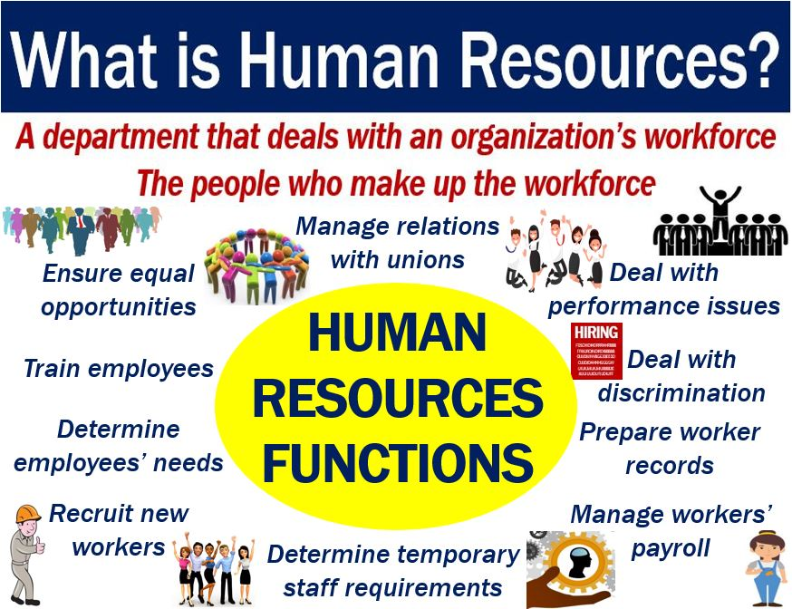
6.1 Employees
Hamilton and Medoff (1990) argued that it is necessary to examine the quality and the quantity of jobs while hiring people in smaller businesses. As a start-up, Wales support for Bame will be working with four people multi skilled and able to bring their strengths and weaknesses together for a good productivity. Furthermore, an employee induction pack will be handed to each new employee when he/she is hired in which will be expressly written the regulation or the policy and principles to respect. That is to say, that from policies, awareness, and equality to other policies such as ways to complain as we promote the value of each employee and volunteers, our service user included.
6.2 Employees
As detailed above that Wales support for Bame will be working primarily with four experienced people and will be updating its administration gradually as things progress.
However, to start helping asylum seekers & refugees integrate easily, volunteers will be trained among their service user to empower them gradually and to help them familiarising with professional terms. Due to counting words, only details and responsibilities of the coordinator who is also the founder will be given below.
6.3 Founder and Coordinator (Theodore Toko Manzambi)
In order to minimise cost and maximise profit, people who are multi-skilled and multi-tasks will be working and supporting each other for a good productivity and better boost the organization. By extension, the following section such as from the Personal profile of the Founder and Coordinator (6.3.1 to 6.4) to the Job description and swot analysis will be detailed in appendices.
7.0 Conclusion
Under these circumstances, it has been proved from the beginning of our study how valuable will be our start up within the community. By various studies from the questionnaire to our swot analysis on the one hand to the well qualified and experienced employees who will run the business on the other hand.
In addition, it has been clearly demonstrated that our beneficiaries are facing challenges on filling applications form and other matter related to the jobs, one of the integration factors.
Being held by people who have experienced the same issues during their integration and who are aware on existent gaps on primary support given to people. Beneficiaries or services users will not be only people who are seeking sanctuary in the United Kingdom but also local people.
Some studies have been shown that most of young native people in Swansea have joined bad activities in selling drugs and need to be reintegrate as well into the community. This will likely be our second step once our business is set up by working closely with those missed people into the society to bring them back in order to them to become useful to the community.
In conclusion, this business will be a good support for the local Government and to monitor and complete the gap which has existed for a long period.
The full business plan will be added in appendices to properly materialize the financial plan of the project and the cash flow table will be added.
8.0 Appendices
This section will include some useful details on the analysis made by completing the questionnaire (2.5) and all the respondents for the whole business. In addition, we will insert from the personal profile of the founder to the swot analysis table (6.3.1 to 6.4) as previously explained. By the fact, the job description of the other three employee who will be hired will not appear in this present study but will still follow the requirement on employment matter as detailed above.

Caseworker (following)

6.5 Cash flow forecast of WSB
The cash flow as presented below generates a negative final net balance of £ 1 393.63. This is due to the initial investment in equipment’s and the delay caused by Funders while assessing our applications.
In addition, the first application submitted was not granted in full, but to 80%, thus reducing the project estimates. It should also be noted that another complementary application is being studied with The National Lottery Fund Wales for approval in order to cover the deficit.
In conclusion, starting from our marketing study, we were able to demonstrate by the use of the questionnaire, the need of people in services to provide in the community.
Furthermore, various necessaries and sufficient strengths that the staff and the business are assets for the launch of the business. However, being a start- up demonstrates a small weakness in gaining the trust of other partners. It is essential that the team work hard to quickly gain notoriety and publicize the organization. An aggressive marketing with a good partnership with other organizations will extend its connection for rapid development and good expansion.
Finally, seeking to seize the current opportunity where everyone works online during this pandemic period should be an occasion to promote for a better visibility in social networks such as Facebooks, twitter, Instagram and others. Moreover, forging relationships with pre-existing organizations would also be useful occasions to palliate likely threats that could arise.

9.0 Acknowledgement
This report would not have a good structure without a step by step support of Brynach Heffernan, one of the lecturers of Manging Enterprise in the 21st sanctuary.
My thanks also go to my wife and children for my prolonged absence during this uncertain period of the pandemic of Covid-19.

10. References

- Abrahams J. (1999), The Mission Statement Book: 301 Corporate Mission Statements from America’s Top Companies, Second ed., Ten Speed Press.
- Annacchino M.A (2011), the Pursuit of New Product Development: The Business Development Process, Elsevier.
- Blundel, R. & Ippolito, R. (2008), Effective Organisational Communication, Third Edition, Pearson Education.
- Gimson A (2012), An Internaional Journal, Development and Learning in Organizations, Volume 17 issue 1-Volume 34 issue 3,Emeral Publishing Ltd
- Gimson A (2012), Understanding Social Enterprise: Theory & Practice, Development and Learning in Organizations, Vol.26 N°6, Emerald Group Publishing Ltd.
- Governance Institute of Australia (2018), Business; Management & Public Relations, Journal Vol.70 issue 11, Sydney.
- Greetham, B. (2014), How to write your Undergraduate Dissertation, Second Edition, Palgrave.
- Hadar, I.B-H (2018), Education Finance, Equality, and Equity, Springer International Publishing.
- Haugh H. (2005), International Journal of Entrepreneurship and Small Business.
- https://www.merriam-webster.com/dictionary Integration.
- Integration (2020), Merriam-Webstar.com, Dictionary, Merriam-Webstar.
- Jansson H. (2020), International Business Strategy in Complex Market, 2^{nd edition}, Elgar
- Kotler, P et al (2019), Marketing Management, 4th European Edition, Pearson Education Ltd
- Kotler, P. & Keller K.L (2015), Marketing Management, Global Edition Paperback, Pearson.
- Maund, A. et al (2016), Certificate in Higher Education: Skills for the Workplace Student Yearbook, Sage.
- Morgan P. (2017), The Business Student’s Guide to Study and Employability, Sage
- Mpiana, S. (2020), Swansea Diversity, Biggest Bame Magazine, Business Edition, CLV photography
- Oxford University Press, A Dictionary of Finance and Banking, The Authoritative A-Z Guide to the World of Money, 5th Edition, Oxford University Press.
- Padhi P.K. (2013), Legal Aspects of Business, PHI Learning Private Limited
- Pinson L. (2008), Anatomy of a Business Plan, the step by step guide to building a business and securing your company’s future, 7th edition, Out of your Mind... and Into the Marketplace.
- Storey D.J (2000), Understanding the Small Business Sector, Thomson Learning.
- Wilkinson A. & Johnstone S. (2016), Encyclopaedia of Human Resource Management, Elgar.
- Young R.D (2017), Financing Non-profits and Other Social Enterprises, A Benefits Approach, Edward Elgar Publishing Ltd.

