Electronic Ignition & Fuel Injection Systems
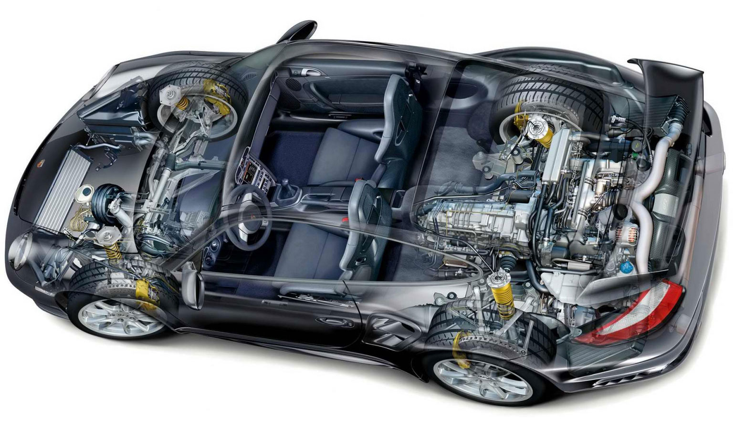
By
YOUSOUF BOUKRA
1700055

Submitted to the Faculty of engineering
Automotive/Motorsport Department
University of Wales trinity Saint David

An assignment for the Engine Control Systems Module
April 2018

Table of Contents

List of Tables 3
List of Figures 3
1. Introduction: 4
2. Research: 5
2.1 Electronic management system 5
2.2 LE3 Jetronic system 6
2.3 Motronic system 6
3. Methodology and Equipment used: 6
3.1 Health and Safety 6
3.2 Equipment 7
3.3 Testing Process 7
4. Results interpretation: 9
4.1 LE3 Jetronic ECU 9
4.2 Motronic ECU 10
4.3 LE3 Jetronic Results 11
4.4 Motronic Results 15
5. Data Analysis 18
6. LE3 System Upgrading: 23
6.1 Merging the ignition and fuelling to one ECU: 23
6.2 Knock Sensor: 23
6.3 Catalytic converter: 23
6.4 Oxygen sensor (Lambda): 23
6.5 Injection system: 24
6.6 CMP sensor: 24
6.7 Air management system: 24
Evaluation: 25
References 26
Appendices 27

List of Tables

Table 1 jetronic pins identification ignition ECU 10
Table 2 jetronic pins identification fuel ECU 10
Table 3 Amplifier pins identification 10
Table 4 Motronic ECU pins identification 11
Table 5 jetronic pins voltage ignition ECU 12
Table 6 jetronic pins voltage fuel ECU 13
Table 7 Amplifier Pins voltage 13
Table 8 Jetronic System Warm-up phase results 13
Table 9 Motronic resistance testing results 16
Table 10 Motronic ECU voltage 16
Table 11 Motronic System Warm-up phase results 17

List of Figures

Figure 1 Jetronic NTC2 graph 14
Figure 2 Jetronic Injection on-time graph 14
Figure 3 Motronic NTC2 graph 17
Figure 4 Motronic Injection on-time graph 18
Figure 5 NTC2 motronic Vs NTC2 jetronic graph 18
Figure 6 primary winding waveform 19
Figure 7 Injector waveform 20
Figure 8 Crankshaft sensor waveform 20

1. Introduction:
Over the years, a lot of advancements have been made in the automotive industry. And in today’s car engines need to meet the regulations of low exhaust emissions, good fuel economy and excellent driving performance under all driving conditions. And by precisely controlling the air-fuel mixture ratio and spark timing, engines are now capable to run efficiently and produce more power with low emissions gases. However engines had to go beyond the simple mechanical control system which rely on carburettors, that’s brought-up the electronic engine management system, a system that consists of a microprocessor-based electronic control unit (ECU) and a lot of electronic and electromechanical sensors and actuators. (Eric Chowanietz, 1995).
In automotive industry, the term ECU used to refer to Engine Control Unit or Engine Control Module ECM. It is the heart of the electronic engine management system, taking the input voltages and currents from sensors and deciding what action the actuators should take by sending output voltages or currents. (Stewart R, 1994). It is then the job of this system to provide accurate control of air-fuel mixture ratio and that is done by the fuel injection system, assure accurate and precise ignition timing via electronic ignition system, and monitor/control numerous additional parameters such as idle speed, air conditioner operation, fuel evaporative emissions and exhaust-gas recirculation.
At the University of Wales Trinity Saint David Engine testing Laboratory, an investigation has been done upon two engines that have different engine management systems, Early 90’s Motronic system and LE3 Jetronic system managing two Vauxhall engines 2.0 ohc, both of those two engines has been examined under the same testing conditions in order for a comparison to be made. The examination consists of testing the EMS of each engine by checking the potential difference voltage of ECU input pins (Signals coming from sensors) and ECU output pins (signals sent to actuators) by using a multimeter and Bosch engine diagnostic system, also resistance of multiple elements such as NTC2 has been determined. Data of both engines was recorded during live testing at different operating conditions: Ignition on, Engine cranking, Engine warm-up, Acceleration, Deceleration, and Idle speed. After analysing all the gathered data, the LE3 Jetronic system will be exposed to multiple technical solutions aiming to upgrading it to meet the European emission regulation 3.

2. Research:

2.1 Electronic management system
Today’s vehicles are highly advanced with enormous amount of technology, that enhancement been forced by costumers high-standard requirements of vehicle performance, fuel economy, lower emissions and safety improvement. The engine fitted to today’s car still maintain the same operation principles of four-stroke cycle of induction, compression, power and exhaust. The main difference now is that all engines are fully controlled by advanced EMSs. Earlier engine-control systems managed the ignition and fuel systems separately and that’s the case for the LE3 Jetronic system found on the Vauxhall engine which has been tested and analysed further more on that assignment, now both of fuelling and ignition systems are merged together in one unit that is known as engine controlled module/unit (ECU), similar type to that ECU found on the second engine tested on that report. (Hillier, 2014).
Electronic control unit (ECU) in vehicle is also an embedded system. It is the electronic brain that controls all electrical systems on board, the ECU is protected in a box and is usually installed either in the passenger area or in the engine bay. (Hillier, H.J.d. 2014-pp86).
All ECUs share the same operating principle, detect the signal coming from sensors, evaluates them and send output to activate actuators. Input signals: sensors and control elements supply electrical signals to ECU via the wiring harness and connectors over different interfaces, Analog interface to forward analog values measures by sensors to the ECU such as engine temperature and intake-manifold pressure, Digital interface for digital input signals which can be evaluated directly by the ECU as they have just two states ‘high=logic 1’ and ‘low=logic 0’ examples; switching signals of control elements, speed signals from a hall-effect sensor for measuring wheel or engine speed. Signal Processing: the signals provided by sensors and interfaces to other systems for example CAN bus serve as input variables, they are checked for plausibility in the microcontroller which have a control algorithms aided by the ECU software, that software is stored in the read-only memory and the calculated intermediate values are saved in the data memory (RAM). Output signals are then calculated by the software to activate the actuators. Output signals: the output signals are then used by the microcontroller to activate the output stages that delivery sufficient power for direct connection of the actuators. . (Bosch. 2014).

2.2 LE3 Jetronic system
The LE Jetronic is a fuel injection system that is developed by Robert Bosch between 1981 and 1991, the system is electronically commanded and injects the amount of fuel exactly dosed in the intake manifold. Injection valves spray the fuel simultaneously which mean they are all driven at the same time, and injection command unit is only control the fuel system in LE Jetronic.
The Engine Control Unit in that system receive a various input signals from sensors to identify the engine operating condition and calculate the appropriate fuel injection time through an electrical signal (Injection Time), there is no memory possible damage on that system, what is to say it has no fault lamp for the injection system because the LE Jetronic is an analog system. (Bosch-automotive, [Online]).

2.3 Motronic system
The Motronic is a multipoint system, it differentiate from the LE-Jetronic for having an ignition system incorporated in the ECU in addition to the injection system, It has also a lambda probe installed in the exhaust pipe, and a tank ventilation valve (known as canister valve) it release fuel vapours, which are highly toxic and that reduced engine pollution which is the main advantage of the electronic injection.
Motronic system is digital. It has adaptation memory and malfunction lamp. The ignition timing control (spark) is commanded by Rotation sensor in vehicles that those not have distributor. The rotation sensor is installed in the engine flywheel (static system). (Bosch-automotive, [Online]).

3. Methodology and Equipment used:
Before going through the investigation process and equipment used to test the engines, a brief explanation of health and safety requirement that must be followed prior doing any workshop examination will be discussed below.

3.1 Health and Safety
Safety is not just a word written on a poster in the workshop area, safe behaviours and habits keep students or employees pain free and highly reduce accidents and injuries. And because it is very important matter, a university lecture has been delivered prior starting all university courses and workshop examinations and laboratories work, thus to inform students and aware them about the issue of health and safety. Personal protective equipment (PPE) must be worn at any time using workshop, either for self and group project or during coursework examination. PPE include safety glasses, dust coat, steel-toed shoes, gloves, bump cap to protect the head under-vehicle objects and the pads of the lift, and also all kind of jewellery must be removed before accessing the workshop area. (James D. 2011).
In addition of PPE instructions, students or employees must follow specific safety tips and techniques designed depending on the workshop condition and work dedication. For that particular engine testing examination accomplished, students followed techniques that include; engine operator must announce the fire-up before firing the engine, rest of students must keep hands-off engine when firing is announced while keeping a close-eye on engine for any suspicious oil/water leakage, shutter door was open to keep working environment clean of any exhaust gases from the engines even though the exhaust hose (extractor) was connected to the exhaust pipe.

3.2 Equipment
Diagnostic of both engines was done using the same equipment, Multimeter was used to test the voltage and resistance on static mode, a digital multimeter is an essential tool for working on vehicle electrical and electronic systems. However for more accurate reading and deep interpretation a dedicated Bosch FSA-740 Engine Diagnostic System was used, it is an engine analyser that based on a personal computer, this allow more facilities for engine diagnostic and fault testing and more accurate reading through coloured waveforms displayed on a VGA monitor which can be frozen or recalled to look for intermittent faults, the station also come with a standard printer to be used when hard copy of the test results is needed. (Denton. 2000).

3.3 Testing Process
Four hours of live testing has been booked for a team of four students to complete the investigation of the two engines provided on engine main testing room. Live testing involved of examining both engines management systems (EMS) on different operating condition including A- ignition on (engine not running), B- engine cranking (from cold), C- engine warm-up, D- acceleration, E- deceleration, and F- idle speed (engine at operating temperature). Live testing should be performed on a fully controlled environment, however because of safety matter the shutter door of the testing room was open and that make the testing environment exposed to the exterior climate conditions. The climate conditions can highly affect the engine operating performance and if the engines tested in a different climate conditions it would be impossible to compare the end results. Therefore engineers and companies like Horiba-mira have designed a dedicated testing chambers that are fully controlled, that mentioned company created a whole-vehicle environmental test chambers for extreme temperature testing with humidity and solar loading options, those chambers can be programmed to perform different conditions such as; hot and cold start tests, heating and air conditioning performance evaluations …etc. (horiba-mira, 2018)
Diagnostics testing performed by the student can be also identified as Off-Board diagnostic, because this term applies to the type of testing that is done in the workshop using dedicated test equipment. (Allan, 1998).
The Data presented below are not 100% accurate, and that because of the reason mentioned above (uncontrolled environment), but as a matter of learning, knowledge and skill developing, the investigation in such environment was perfect for student to cover those aspects.
Before starting the testing of the ignited EMS, the system has been checked at ignition-Off to make sure there is no faults, After that The testing started with A- ignition on (engine not running), at this stage a multimeter was used to determine the voltage of the input values coming to the ECU via the sensors (both fuelling and ignition ECU was checked for Jetronic because it have two separate control units), than on the Jetronic system the resistances of throttle switch, auxiliary air valve, injectors, kettering coil, and HT-leads were recorded and compared with the Vauxhall handbook manual. On the Motronic system the throttle potentiometer, airflow sensor, air temperature sensor, idle speed control valve, injector valves, king lead and HT-leads were tested for resistance and also compared to the related handbook. After the resistances are checked and confirmed to be in working order, the next stage of B- engine cranking (from cold) was pursued. For the case of LE3 Jetronic the cold cranking was conducted at 17.3°C, and at 17.5°C for the Motronic engine, simultaneously the Bosch KTS 740 engine diagnostic system was prepared and set on the recommended voltage scale while ECUs were probed during cranking to acquire injection on time (Pin n3 on Jetronic / Pin n16 on Motronic), the data then has been recorded by pausing the projection of the waveform of live cranking on the Bosch screen.
After injection on time has been recorded at cold cranking, the followed step of live testing was C- engine warm-up. The testing for both engines started at 20°C engine temperature where the resistance of NTC2 (coolant temperature sensor) was recorded at static mode using a mutimeter. During LE3 Jetronic testing the engine ignition turned-on at that temperature and secondary voltage of the cylinder been recorded using Bosch system by probing on Pin n8 on the fuelling control unit than probing again on Pin n3 in the same ECU with engine running to acquire injection on time. For Motronic system, at ignition-on the voltage of NTC2 was checked by probing on Pin n45, than probing on Pin n16 to check the injection timing while engine is running, probing again on Pin n4 to measure the percentage of the rotary idle air control valve, Pin n5 which was the fuel tank vent valve side and that to check at what temperature the charcoal solenoid started to function, and finally Pin n28 to check at what temperature lambda sensor start functioning. More data were collected at engine temperature of 30°C, 40°C, 50°C, and 60°C using the same procedures which has been followed to collect data at engine temperature of 20°C described, After that the fan switched-on so that data can be collected at 65°C for Jetronic and at 70°C, 80°C for Motronic system. In addition to those Pins, Pin number 44 at the Motronic ECU which represent the air temperature send from the sensor located in the airflow meter, is also been tested at 20°C and at 80°C of engine temperature.
D- acceleration; the engines has been revved-up to get them accelerated while the ECUs were probed in the correct pins numbers to collect data of injection on time during snap acceleration and that by freezing the waveform on the Bosch screen. The same data has been collected during E- deceleration stage and that by freezing the waveform while engine is decelerating.

4. Results interpretation:
Before going through the results recorded during live testing, ECUs output and input pins of both engines will be identified, the engine management system pins meaning has been discussed and explained by the lecturer prior the testing sessions to ensure that students are well aware about what they are testing and diagnosing when dealing with engine control units.

4.1 LE3 Jetronic ECU
Ignition Control Unit:
Pin number | Identification
1 | Earth
2 | NTC2 Earth
3 | Ignition Supply voltage
5 | Speed Signal for ECU
6 | Throttle Switch Idle Control
7 | NTC2 (coolant temperature)
8 | Octane plug side1
10 | Octane Plug side2
11 | Crank angle Sensor
12 | Crank angle Sensor
13 | Amplifier Signal
14 | Throttle Switch Wide Open
15 | Load
Table 1 jetronic pins identification ignition ECU
Fuelling Control Unit:
Pin number | Identification
1 | Speed Signal
2 | Voltage Supply
3 | Injectors
4 | Earth
5 | Earth
8 | NTC2 (Coolant Temperature)
10 | Ignition Load Signal
12 | Tachometric Relay Supply
14 | Throttle Switch Wide Open - Fuel (for Snap Acceleration)
15 | Throttle Switch Idle - Fuel
Table 2 jetronic pins identification fuel ECU
Amplifier:
Pin | Identification
Pin 1 | Primary Wave Form
Pin 2 | Earth
Pin 3 | Amplifier Supply
Pin 4 | Signal from Ignition ECU

Table 3 Amplifier pins identification

4.2 Motronic ECU
Pin N | Identification
1 | Coil Signal
2 | Earth
3 | Fuel Pump
4 | Rotary Idle Valve
5 | Tank Vent Valve
6 | Fuel Tell-tale Lamp
7 | Airflow meter Load Signal
10 | Earth
12 | Throttle Potentiometer and Airflow meter Supply Voltage
13 | Diagnostic socket supply Voltage
14 | Earth
16 | Injectors (Dual bank)
17 | Injectors (Dual bank)
18 | ECU Memory Live Supply
19 | Earth
22 | Engine tell-tale Lamp (Warning Light)
24 | Earth
26 | Earth
27 | Ignition Supply Voltage
28 | Lambda Sensor Output
32 | On-board Computer Output
36 | Control Unit and Auxiliaries Supply
37 | Control Unit and On-board Computer Supply
40 | AC
41 | AC
42 | Transmission Earth
44 | NTC1 (Air temperature in Airflow meter) Output
45 | NTC2 (Coolant temperature) Output
46 | Input of Octane plug
48 | Crankshaft (Speed sensor) Output
49 | Crankshaft (Speed sensor) Output
53 | Throttle Potentiometer Output
55 | Diagnostic Socket Earth
Table 4 Motronic ECU pins identification

4.3 LE3 Jetronic Results
The resistance results of the Throttle switch ‘closed’ which has been checked between terminal 2 and 18, it was identified to be 0 ohms in the Vauxhall handbook and the test results were 0 ohms, therefore they are within tolerance. Also the handbook indicates that the resistance value between terminal 3 and 18 should be infinity, and the test results were confirmed as infinity, therefore the test was successful. After that the auxiliary air valve resistance between the two terminals has been checked to be found as 46.5ohms (specification at the handbook note it to be 40ohms). Resistance of Kettering coil was tested as well using a multimeter and readings received were 1ohms at primary and 7450ohms at secondary. Lastly the resistance of the HT-leads were tested from 1 to 4 and the results were 8560ohms, 8560ohms, 7460ohms and 5070ohms respectively, it was noticed that the resistance on the longer leads were higher than the short leads.
The battery voltage was checked and recorded as 12.46V. The tables below show the results obtained when testing the voltage of the Ignition control unit, Fuel control unit and Amplifier pins at Ignition-Off/Ignition-On.

Ignition ECU
Pin Number | Voltage (ignition-off) | Voltage (ignition-on)
1 | 0 | 0.07
2 | 0 | 0.17
3 | 0 | 12.24
5 | 0 | 0.19
6 | 0 | 0.02
7 | 0 | 1.32
8 | 0 | 1.20
10 | 0 | 0.18
11 | 0 | 0.12
12 | 0 | 0.18
13 | 0 | 0.26
14 | 0 | 5.01
15 | 0 | 0.16
Table 5 jetronic pins voltage ignition ECU
Fuel ECU
Pin Number | Voltage (ignition-off) | Voltage (ignition-on)
1 | 0 | 0.32
2 | 0 | 12.30
3 | 0 | 0
4 | 0 | 0.02
5 | 0 | 0.03
8 | 0 | 0.82
10 | 0 | 0.15
12 | 0 | 12.35
14 | 0 | 5.02
15 | 0 | 0.02
Table 6 jetronic pins voltage fuel ECU
Amplifier
Pin Number | Voltage (ignition-off) | Voltage (ignition-on)
1 | 0 | 12.23
2 | 0 | 0.02
3 | 0 | 12.20
4 | 0 | 0.18
Table 7 Amplifier Pins voltage
After testing the voltages and the resistance mentioned above, the engine cranked from cold at 17.3°C and simultaneously Injection on time was measured and found to be 51 milliseconds, this is clearly a long pulse of fuel that has been delivered by the injectors and that to make the mixture of air-fuel ratio richer to help the engine starting at this low temperature, a richer mixture is needed to compensate for fuel condensation and improve drivability. (Denton. 2000). This extra fuel provided to enrich the mixture at cold-start can either be achieved by a separate cold-start injector, or by increasing the injection timing, in other word opening the injectors for longer periods which is the case of the Jetronic system studied. (Trevor. 1987).
Warm-up phase results
Temperature(°C) | NTC2 – Ohms (Ω) | NTC2 – Volts (v) | Injectors – ms
20 | 1822 | 1.5 | 4.7
30 | 1047 | 1.1 | 3.3
40 | 749 | 0.8 | 3.2
50 | 538 | 0.6 | 2.9
60 | 401 | 0.6 | 2.7
65 | 552 | 0.6 | 2.5
Table 8 Jetronic System Warm-up phase results
By probing on Pin number-8 (NTC2) and Pin number-3 (Injectors) on the fuelling ECU, the data on the table above has been collected.

Figure 1 Jetronic NTC2 graph
Graph n01 represent the change of voltage and resistance versus the change on engine temperature. The resistance of the NTC2 significantly dropped from 1822Ohms at 20°C to 401 Ohms at 60°C, however it slightly rose back to 552Ohms as engine reached 65°C and that because the fan turned on to cools the system causing the increase on resistance at NTC2. In other-hand the Voltage followed a steady decrease as it changed from 1.5v to 0.6v at 20°C and 50°C respectively, the voltage stayed constant after that as the temperature rose to 65°C.

Figure 2 Jetronic Injection on-time graph
It is mentioned before that the injection on time was 51ms when engine cranked from cold at 17.3°C, and on graph n2 above, the injection on time started with 4.7ms at 20°C engine temperature which is the starting point of the warm-up testing, that clearly shows the wide difference again of the long pulse of the cold cranking injection. The Injection timing continuously get shorter as the engine temperature increase and reach 65°C, at this point the injection timing was 2.5ms. The amount of fuel injected is controlled by the mass of air inducted through the air flow sensor, speed, the position of the throttle switch, coolant temperature and fuel temperature. The fuel ECU will calculate those variables coming from the mentioned sensing parameters to correct the mixture at warm-up running, making it more efficient and allowing the engine to run economically as this will decrease the fuel consumption. (Trevor. 1987).

4.4 Motronic Results
The resistance of the contents have been checked following a similar manner to that of the Jetronic system. Table below shows the results of testing parallel with the specification from the appropriate handbook.
 | Testing Results (resistance) | Specifications  (resistance)
Throttle potentiometer Closed (terminal 1 and 2)  Open (terminal 1 and 3) | 2000 Ohms  2540 Ohms | 1900-2000 Ohms  1000-2000 Ohms
Air flow sensor (terminal 4 and 2)  (terminal 4 and 3) | 329 Ohms  536 Ohms | 8-2500 Ohms  300-550 Ohms
Air Temperature sensor (terminal 4 and 5) cold  (terminal 4 and 5) 80°C | 2690 Ohms  246 Ohms | 1500-3300 Ohms  280-360 Ohms
Idle speed control valve (ignition-off check) | 8 Ohms | 8 Ohms
Primary windings  Secondary Winding | 0.6 Ohms  7720 Ohms | Non  Non
HT Leads N1  N2  N3  N4 | 1000 Ohms  1750 Ohms  1500 Ohms  2140 Ohms | Non  Non  Non  Non
Injector valves (1,2,3,4) | 16 Ohms | 15-17 Ohms
Table 9 Motronic resistance testing results
All the tested components were confirmed adequate, except the open throttle potentiometer at close position as it shows a reading of 2540, that resistance was 540 Ohms higher than the specified resistance.
ECU Ignition-Off/Ignition-On Voltage
Pin N | Voltage (ignition-off) | Voltage (ignition-on)
1 | 0 | 12.31
2 | 0 | 0.03
3 | 0 | 12.2
4 | 0 | 9.85
5 | 0 | 12.18
6 | 0 | 11.48
7 | 0 | 0.31
10 | 0 | 0
12 | 0 | 5.07
13 | 0 | 10.23
14 | 0 | 0.02
16 | 0 | 12.18
17 | 0 | 12.18
18 | 12.54 | 12.16
19 | 0 | 0.02
22 | 0 | 0.91
24 | 0 | 0.03
26 | 0 | 0.05
27 | 0 | 12.28
28 | 0 | 0.46
32 | 0 | 11.46
36 | 12.21 | 0.28
37 | 0 | 12.18
40 | 0 | 0.05
41 | 0 | 0.05
42 | 0 | 0.03
44 | 0 | 3.7
45 | 0 | 3.7
46 | 0 | 5.07
48 | 0 | 0.05
49 | 0 | 0.09
53 | 0 | 0.62
55 | 0 | 11.15
Table 10 Motronic ECU voltage
After the voltage testing, the engine has been cranked from cold at 17.5°C and the injection on time reading was 28.2ms, clearly it is a big difference between the cold cranking acquired by the Jetronic system as the injectors pulse was much longer (51ms) at 17.3°C. This proves the Motronic system is further advanced than the Jetronic because it is more economical and efficient which are the main two aims for EFI system.
Motronic warm-up test results
Temperature (°C) | Pin 45  NTC2  (Ω) | Pin 45  NTC2  (v) | Pin 16  Injectors  (ms) | Pin 4  (%) | Pin 5  Charcoal  Solenoid | Pin 28  Lambda
20 | 1442 | 3 | 3.5 | 45 | Off | Off
30 | 1090 | 2.6 | 3.3 | 43 | Off | Off
40 | 712 | 2.1 | 3 | 43 | Off | On
50 | 472 | 1.7 | 2.8 | 42 | On | /
60 | 354 | 1.4 | 2.8 | 42 | / | /
70 | 264 | 1.1 | 3 | 44 | / | /
80 | 246 | 0.8 | 2.7 | 45 | / | /
Table 11 Motronic System Warm-up phase results
In addition to the Injection on-time, NTC2 resistance and voltage, which also been tested on the Jetronic system, the Motronic control Unit has more sensing parameters to aid the adjustment of mixture on cold crank, warm up, acceleration and deceleration.
Pin 4 is the rotary idle valve keying ratio opening percentage, whereas Pin 5 is the charcoal solenoid which didn’t start working till engine temperature was at 50°C.
Also the lambda sensor didn’t detect any signal until the engine reached 40°C, this is because lambda sensor does not work when the engine is cold.

Figure 3 Motronic NTC2 graph
The resistance and the voltage of the NTC2 gradually dropped from 1442 Ohms and 3 volt at 20°C to 246 and 08 volt Ohms at 80°C.

Figure 4 Motronic Injection on-time graph
The graph n4 above illustrate the Injection on-time changes against temperature, the injection period started at 3.5 milliseconds when engine temperature was 20°C and dropped gradually to 2.8 ms at 60°C. However, as the fan turned on at this period the injectors pulsed longer because the fan created an electrical load, injection on-time rose back to 3ms at 70°C before it drops again to reach its minimum of 2.7ms at 80°C.

Figure 5 NTC2 motronic Vs NTC2 jetronic graph
The graph above presents the NTC2 resistance values of both systems. the Motronic resistances values was always lower than the Jetronic, it started with 1442Ohms at 20°C while Jetronic started higher at 1822Ohms, and it end up at 246Ohms at 80°C for Motronic where as for the Jetronic the lowest value was at 60°C and read as 401Ohms. It can be concluded from those values that the Jetronic NTC2 resistance is higher than the Motronic during the rise of engine temperature (warm-up).

5. Data Analysis
Multiple signal waveforms have been recorded from the Bosch diagnostic system during testing both engines. Those forms will be technically analysed on this section aiming to compare the engine management system of those engines.

5.1 Primary Winding
Appendix 1 Motronic:
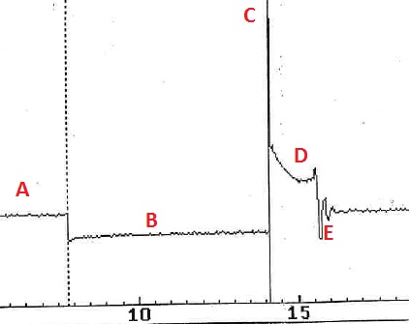
Because the ignition coil circuit is open a battery voltage is presented on point (A) which shown on the primary winding waveform (figure1), at this point the component is not operating. Point (B) is the dwell period where the driver transistor provides a ground path for current to flow to complete the primary circuit of the control module, the current will keep flowing through the coil until it become saturated, this dwell period last between 3ms to 8ms at a voltage of 0 to 0.3v. the peak voltage presented on point (C) it display the back EMF (electro-motive force), this is happen at the primary winding when the ignition coil circuit switched off, this voltage measured as 129.2v, simultaneously a large voltage is sent through the secondary winding to build up the spark arc at the plug. Point (D) represent the spark voltage and it is normally between 40v and 80v lasted for 1.47ms (it can be between 1.5ms and 4ms). The oscillations displayed on point (E) known as ringing and it is caused by the flow of the current between the two sides trying to flow to ground.
Figure 6 primary winding waveform
Appendix 2 Jetronic:
This is the primary winding waveform of the LE3 Jetronic system.
5.2 Injector Waveform
Appendix 3 Motronic:
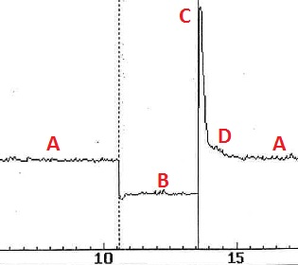
The waveform on appendix 3 represent the injection voltage, at point (A) the injector is not operating, and battery voltage is displayed because the injector circuit is open, the ground happens at point (B) when the control module has completed the injector circuit providing a ground path for the current to flow, the voltage here normally is between 0v and 0.3v. point (C) represent a back EMF induced into the injector winding as the injector circuit is switched off, this voltage is normally clipped by the control module between 50v and 70v, it is measured on the tested system to be 68v. point (D) represent the deflection of the voltage which happen on its way back to open circuit voltage, this indicate that the injector valve is fully closed at this point.
Figure 7 Injector waveform
Appendix 4 Jetronic:
This waveform shows the injector voltage of the Jetronic system, the back EMF on that system is measured to be 62v.
5.3 Crankshaft sensor Waveform
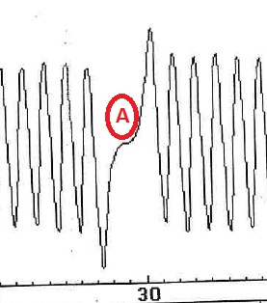
Appendix 5 Motronic:
Figure 8 Crankshaft sensor waveform
the waveform here represents the crankshaft sensor or speed sensor, the size of the waves is affected by the speed of the crankshaft rotation, when the height of the wave is big the reading is crank going fast and when the height of the wave is short the reading is crank going slow. Point (A) on the figure above represent the missing tooth on the flywheel, therefore the crankshaft position sensor used the missing tooth to trigger the sensor pulse. (Hillier, Andrew. 2014-pp68). This is used in injection systems that are not combined directly with ignition, it takes signal from coil negative terminal. (Denton. 2000)pp193.
Appendix 6 Jetronic:
The waveform on this appendix shows the speed reference for fuel ECU in the Jetronic system, the voltage must change to a peak value and switch back to 0v so that it can be read by the ECU as an on/off signal.
5.4 Injection on Acceleration
Appendix 7 Motronic:
This waveform shows the injection on time during acceleration, the injector pulses more fuel because the grounding of the injector last longer which mean that is stayed open for long period (measured as 8ms) before it switched off and back EMF happen. (Hillier. 2014-pp225)

Appendix 8 Jetronic:
LE3 Jetronic Injector waveform on acceleration mode.
5.5 Injection on Deceleration
Appendix 9 Motronic:
This waveform shows the injection on time during deceleration, the injector pulses less fuel because the grounding of the injector last shorter, injector stayed open for only 1.5ms before it cut-off the fuel. (Hillier. 2014-pp225)
Appendix 10 Jetronic:
LE3 Jetronic Injector waveform on deceleration mode.
5.6 Secondary voltage Waveform
Appendix 11 Motronic:
the waveform shows the secondary voltage waveform, the peak value of voltage represents the rise of the secondary voltage from 0 to 6.5kv to breakdown the gap between plug electrodes and cause ionization of the air-fuel mixture and it last only for about 10ns. The voltage after that drop to 3kv and stayed table for 2ms, this is referred to as spark line (period) where the energy from the coil is dissipated in the arc between the plug electrodes. after that the voltage decreased because all energy is used, and the rest of the voltage create a damped oscillation before it stabilizes on the dwell period, dwell period measured here as 60% of the complete cycle. (Eric Chowanietz, 1995-pp97).
Appendix 12 Jetronic:
Secondary voltage of the Jetronic System, on that system the firing line voltage was higher than the Motronic and it reached 11kv.
5.7 Injectors (pin16 and 17)
Appendix 13 Motronic:
The waveforms of both pins represent the voltage of the injectors, the injection happen on the same time (simultaneous injection type) because both injectors pulses on the same time and that clearly shown on the waveforms as the voltage changes of the pins happens at one time.

5.8 Supply and Earth Waveforms
Appendix 14 Motronic:
This is the waveforms of pin 27 and pin2 of ignition supply and earth, when the ignition supply is at the battery voltage (ignition not operating) the earth shows no voltage value. when the ignition supply is grounded and that can be seen on the voltage drop from 12.46v (battery) to 10v, the earth shows a voltage between 2v and 4v.
5.9 Rotary idle valve
Appendix 15 Motronic:
The waveform of the rotary idle valve can be described as a percentage of opening (keying ratio), it was measured at 80°C to be 45% open and that can be seen at the voltage changes between 0v and 15v. the opening period is read when the voltage is at 0v and the closing period read when the voltage acquire (between 14v and1 18v).
5.10 Lambda sensor Voltage
Appendix 16 Motronic:
The waveform present lambda sensor voltage (exhaust gas oxygen sensor), this sensor sends information to the ECU on exhaust gas oxygen content, that information will be analysed by the control unit to aid on the correction of the required engine fuelling for optimum performance and emission control. (Denton. 2000-pp190). when the voltage is at its highest (measured between 0.6v and 0.8v) it indicates that the fuel mixture is rich. When the voltage is at its lowest (between 0.1v and 0.3v) it indicates that the mixture is lean. The waveform keep switch from rich to lean and that is an indication of a good sensor, the sensor indicates rich for a period of 7s and lean for 2s.

6. LE3 System Upgrading:
This section will cover the technical solutions proposed to upgrade the engine managed by the LE3 Jetronic system, the aim for this is to allow the engine to pass the Euro emissions standards 3 (1 January 2000 regulations). Multiple sensors will be added to aid the system analysing what is happening during different operating condition allowing the control unit to gather maximum information for accurate ignition and injection, doing this will advance the engine on fuel efficiency and low emission gazes, which are the main target to pass the Euro regulation 3.

6.1 Merging the ignition and fuelling to one ECU:
The system fitted on that engine was invented on mid 80’s where the technology was not yet advanced to be able to have a one ECU controlling both ignition and fuel system. By merging both control units, all the information gathered from sensors fitted to the engine will be analysed at one ECU which will make a very precise control of fuel and ignition. Therefor fuel economy will be improved as well the performance and emissions. That is clearly confirmed by hillier on page 217 in motor vehicle technology book.

6.2 Knock Sensor:
Adding a knock sensor to the engine will make it generate maximum power for minimum fuel consumption with low emissions. This is because the knock sensor detects the vibration within the cylinder walls and send it to the ECU as a voltage signal which varies between 1v and 10v, this will aid the control unit to retard or advance the ignition timing. This is known as a close-loop control. (Hillier. 2014-pp223).

6.3 Catalytic converter:
Fitting a catalytic converter on the engine will highly reduce the harmful gases resulted during the combustion process. The catalytic converter job is to convert the harmful gases which are monoxide (co), hydrocarbons (Hc), nitrogen oxide (Nox) to harmless gases which are, water (H2O), oxygen (O2), carbon dioxide (Co2), and nitrogen (N2). (Hillier. 2014-pp223). However, an oxygen sensor need to be fitted as well on the engine for the catalytic converter to accurately operate.

6.4 Oxygen sensor (Lambda):
By installing two lambda sensors one pre-catalyst and the other post-catalyst, the ECU will receive feedback signals enabling by that a closed-loop control of the air-fuel ratio. The signal will be send as a voltage output from the sensors to the control unit, those voltages are inversely proportional to the oxygen content of the exhaust gases. Doing that will cause a perfect combustion. (Hillier. 2014-pp224).

6.5 Injection system:
Changing the injection system from simultaneous injection to sequential will be better as the system fitted does not deliver a precise metered fuel quantity as a sequential injection. This system opens the injectors in sequence parallel with the ignition order (1,3,4,2) and once every engines cycle, therefore all four injectors need to be grounded separately. this timing of the injectors is controlled by the ECU aided with the camshaft phase sensor which will be discussed below. (Hillier, Brain. 2014-pp161).

6.6 CMP sensor:
Installing a camshaft sensor on the upper area of the engine, will assess the position of the camshaft in relation to the crankshaft, it is a hall sensor which will be used to inform the ECU of the precise ignition and fuel injection timing order. (Hillier, Brain. 2014-pp162).

6.7 Air management system:
The system is fitted with a vane (flap) type of mass air flow meter, this system restricts the air flow that enter the engine and can be replaced by a hot-film type air-mass sensor which is much more advanced technology. This sensor sent voltage signal to the ECU which will be interpreted as air flow volume, this system does not restrict the air entering to the engine as it only uses a thin film resistor made from platinum, this amount of air it is very important factor to monitor and measure. (Hillier. 2014-pp219).

Evaluation:
The testing of both systems has been performed successfully, all data and results were collected and the interpretation has been completed with full details along with the comparison of both management systems used on different engines. However, if the examination of both engines has been performed on a highly controlled environment, the results would have been much more accurate allowing a full comparison of both engines. also the testing was done once for each engine and that is far from what is required from an engineer to do to validate the results, the testing should have been done for at least 3 times for the data to be considered as a valid data, but as a student project, one testing was enough to gain the necessary basic skills and knowledge required to test an engines electronic system. The modification applied to the LE3 Jetronic system for the purpose of allowing the engine to pass the Euro regulation 3 can be evaluated as successfully done as the solution proposed will 90% advance the engine to Euro emissions 3.

References

Allan W.M. Bonnick. (1998), Vehicle Electronic Systems and Fault Diagnosis, London: Arnold, Hodder headline group.
Bosch Automotive. 2017, ‘petrol injection systems’, [Online]. Available: http://br.bosch-automotive.com/en/internet/parts/parts_and_accessories_2/motor_and_sytems/benzin/injection_system/injection_system_3.html, [2018, March 27].
Eric Chowanietz. (1995), Automobile Electronics, Oxford: Butterworth-Heinemann Ltd, Elsevier plc group.
Mellard Trevor. (1987), Automotive Electronic Systems, Oxford: Heinemann professional publishing Ltd.
Robert Bosch. (2014), Automotive Handbook, (9th Ed), Sussex: Robert Bosch Gmbh.
Stewart Robertson. (1994), Automotive Electrical Maintenance, London: Edward Arnold.
Tom Denton. (2000), Automobile Electrical and Electronic Systems, (2nd Ed), London: Arnold, Hodder headline group.
Halderman James D. (2011), Automotive Engines Theory and Servicing, (7th Ed), New Jersey: Pearson education Inc.
Horiba-Mira. 2018, ‘Vehicle Environmental Test Chambers’, [Online]. Available: https://www.horiba-mira.com/our-services/vehicle-environmental-chambers, [2018, March 27].
Hillier. (2014), Fundamental of Motor Vehicle Technology, (6th Ed), Oxford: oxford university press.
Hillier. Hamza M, Jon S, Diane C. (2014), Fundamental of Automotive Electronics, (6th Ed), Oxford: oxford university press.

Appendices

Appendix 1:
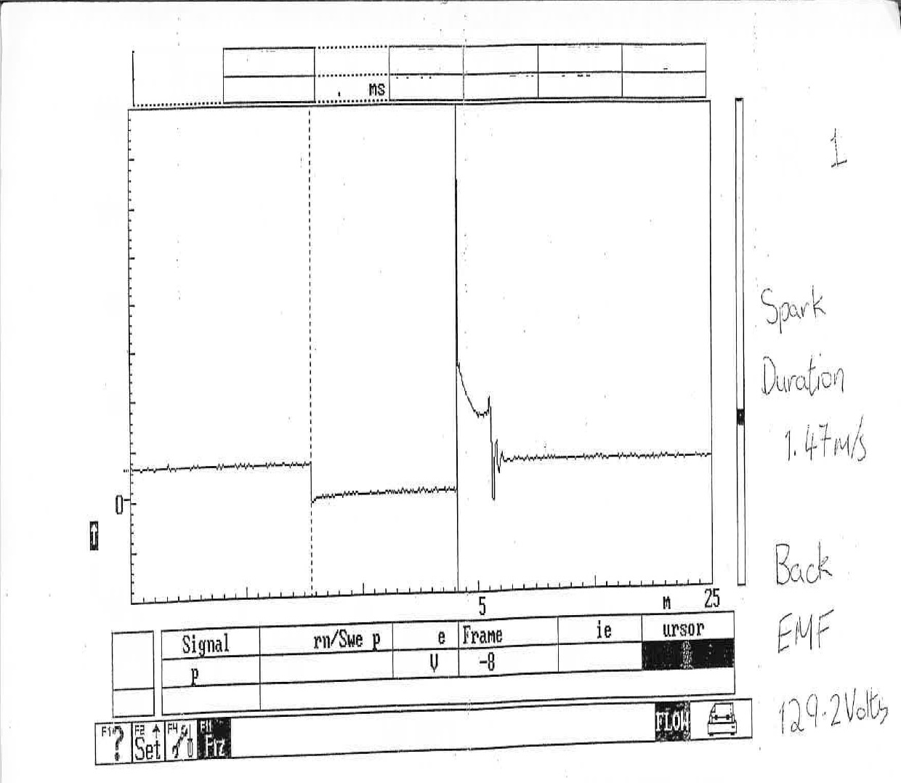
Appendix 2:

Appendix 3:
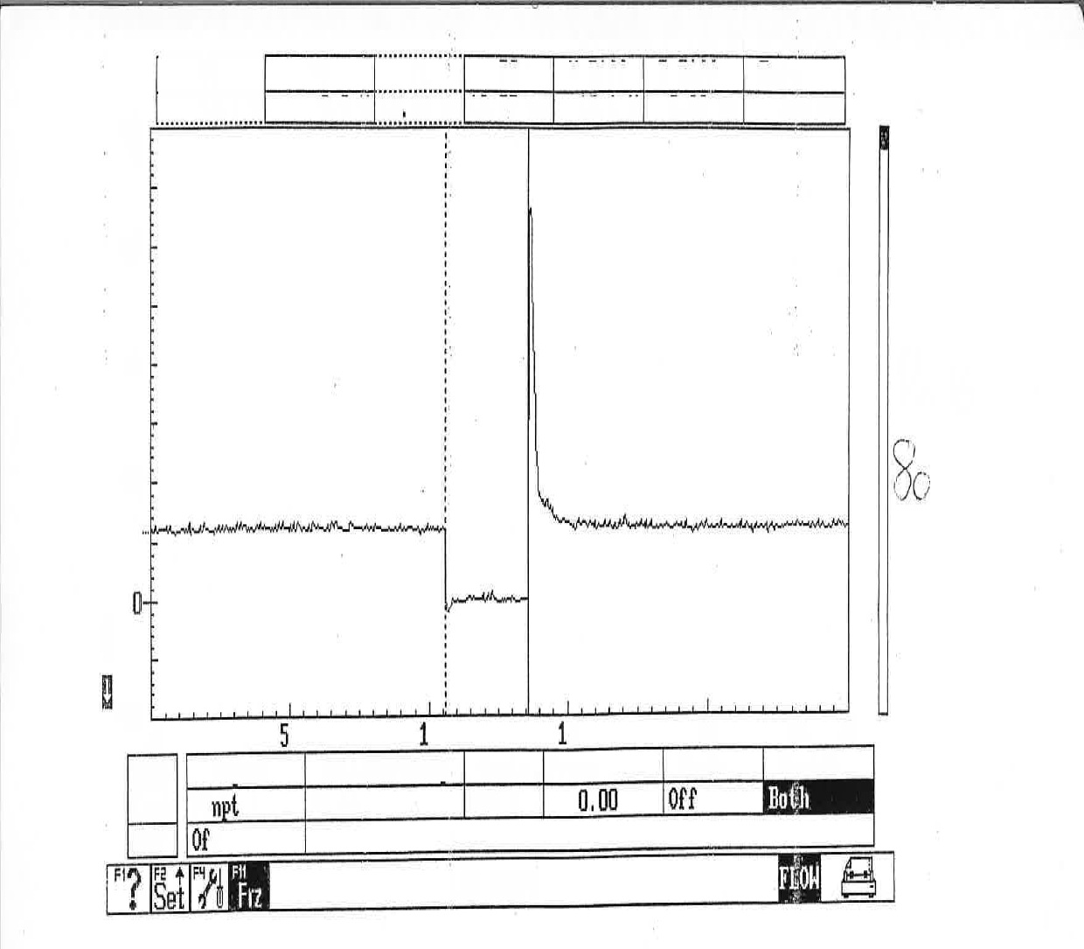
Appendix 4:

Appendix 5:
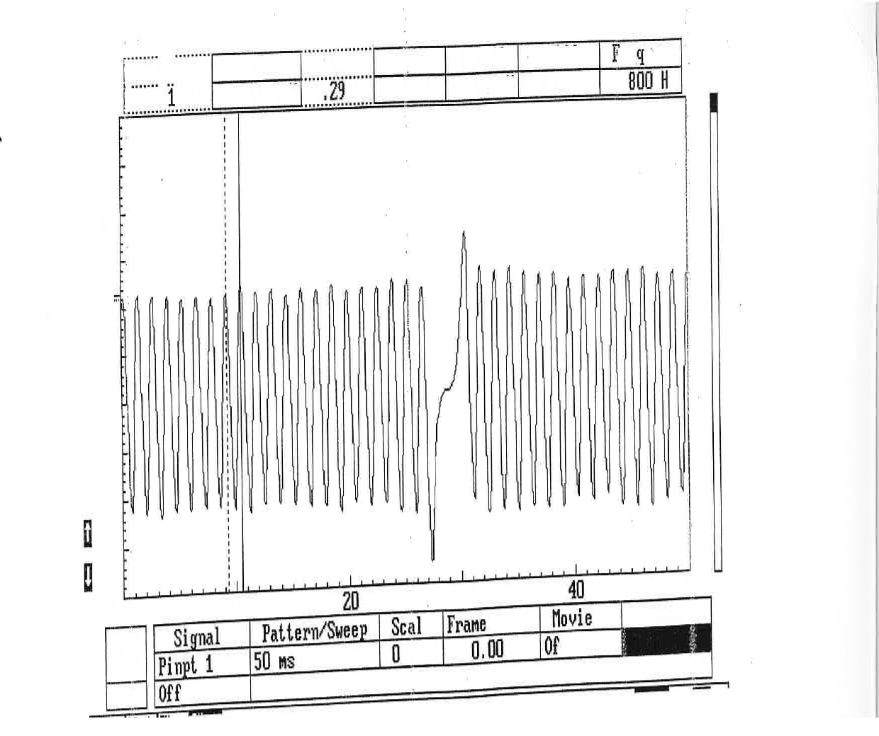
Appendix 6:

Appendix 7:
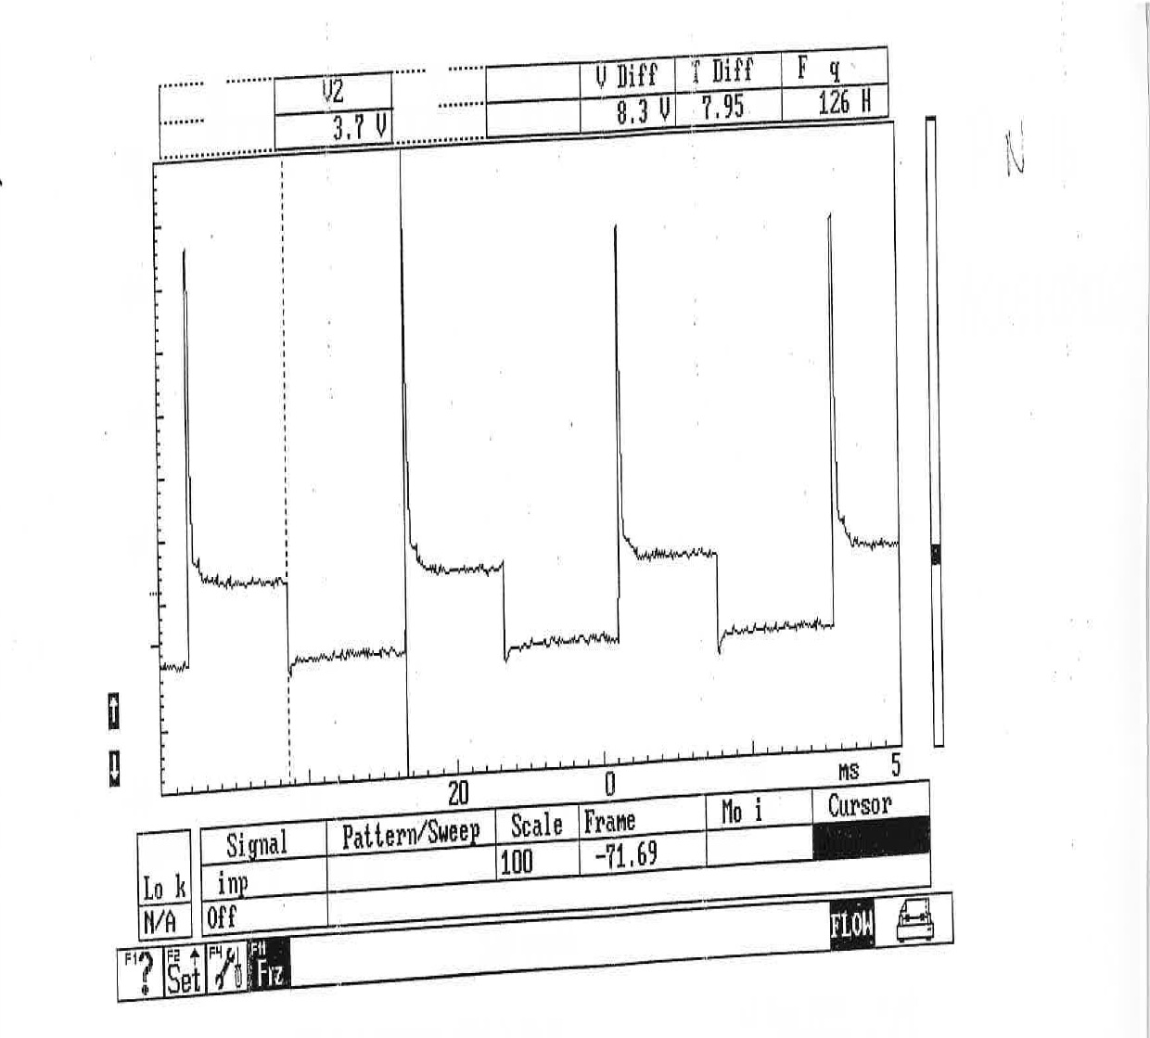

Appendix 8:

Appendix 9:
Appendix 10:

Appendix 11:
Appendix 12:

Appendix 13:

Appendix 14:

Appendix 15:

Appendix 16:

