

University of Wales Trinity Saint David Effective Teamwork and Communication Module
BMSW4009 March 2025

STUDENT NAME: Oana Emilia Sterpu
STUDENT ID: 2412489

Contents
1. Introduction 2
2. Main Findings 3
2.1. Understanding Relationships and Effective Teamwork 3
2.2. Application of Theories and Models 3
2.2.1. Tuckman’s Team Development Model (1965) 3
2.2.2. Belbin’s Team Roles (1981) 5
2.2.3. Lencioni’s Five Dysfunctions of a Team (2002) 5
2.2.4. Transactional Analysis (Berne, 1964) 6
2.3. Personal Experiences and Learning Outcomes 7
3. Conclusion 7
4. Appendices 9

Introduction
Effective teamwork is essential for achieving common goals and fostering collaboration within any group or organisation. According to Katzenbach and Smith (1993), successful teamwork relies on commitment, mutual accountability, and complementary skills. Additionally, Salas et al. (2005) identify key components such as communication, trust, leadership, and adaptability as crucial to high-performing teams.
My natural role within teams aligns with Belbin’s (1981) team roles model, identifying me as a People-Oriented team member, primarily fulfilling the roles of Teamworker and Implementer. As a Teamworker, I prioritize harmony and cooperation, ensuring that team dynamics remain positive. As an Implementer, I focus on turning ideas into practical actions, ensuring efficiency and organization. My preference for avoiding conflict aligns with Tuckman’s (1965) team development theory, as I strive to maintain group cohesion, particularly during the storming phase.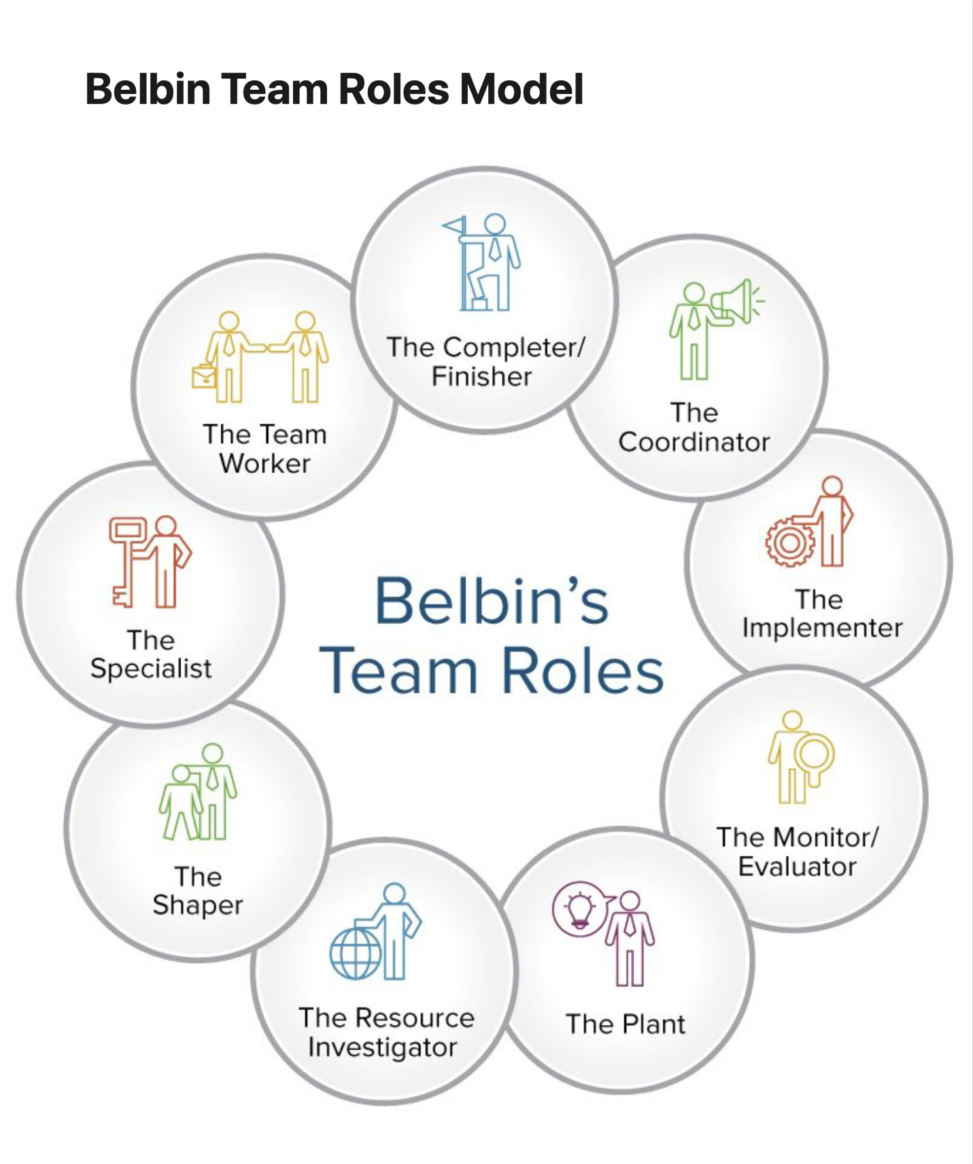Figure 1. Belbin’s Team Roles

Main Findings

Understanding Relationships and Effective Teamwork

During this module, I have gained valuable insights into the dynamics of teamwork and the importance of relationships. The Belbin model has reinforced my understanding of how my People-Oriented strengths contribute to group effectiveness by fostering collaboration and communication. Additionally, Transactional Analysis (Berne, 1964) has helped me recognize the different ego states (Parent, Adult, Child) that influence interpersonal interactions, improving my ability to manage team relationships constructively. This awareness has enabled me to approach interpersonal challenges with greater clarity, choosing responses that are more reflective and less emotionally driven.

Application of Theories and Models

Tuckman’s Team Development Model (1965)
Tuckman’s Team Development Model (1965) outlines how teams progress through stages. Initially, team members bond and establish roles. Conflicts arise as roles are clarified, followed by the development of trust and collaboration. Finally, the team reaches a stage of high performance, working effectively towards their goals.

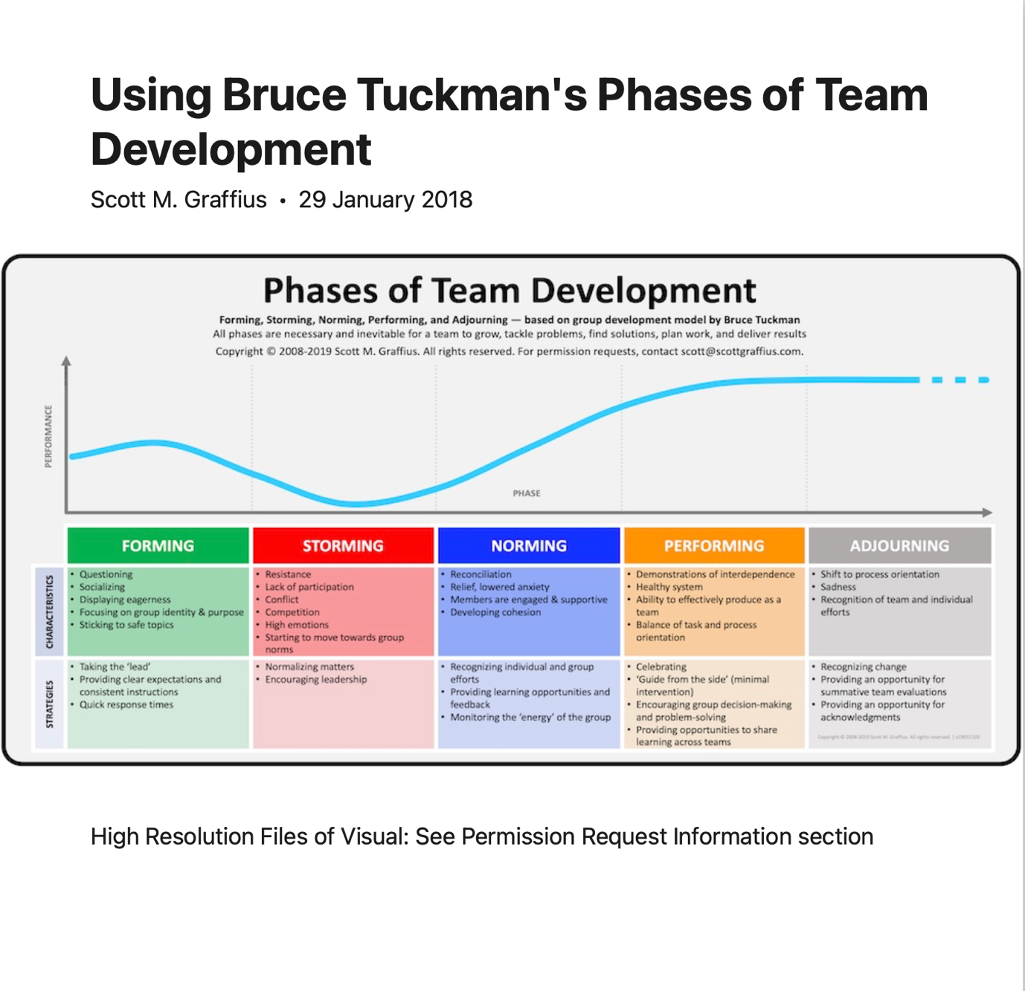Figure 2: Phases of Team Development

My conflict-avoidant nature meant I initially struggled during the storming phase. However, applying insights from the Thomas-Kilmann Conflict Management Model (1974), I recognised my primary conflict management style as Avoiding (Turtle). This means I tend to withdraw from conflict rather than engage directly. While this approach helps maintain group harmony, I have learned that in some cases, addressing conflict constructively can lead to better team outcomes. To improve, I am working on incorporating a more compromising approach, balancing assertiveness and cooperation to maintain team harmony without neglecting challenges. (See Appendix B). By doing so, I believe I can navigate disagreements more effectively, fostering a team environment where issues are resolved rather than ignored.

Belbin’s Team Roles (1981)

Belbin’s team roles framework has been an invaluable tool in understanding the dynamics of team participation. As an Implementer and Teamworker, I feel my contribution lies in ensuring tasks are completed efficiently and ensuring positive interpersonal relationships. These roles complement each other, as my focus on organisation and efficiency supports the collaborative spirit needed for teamwork to succeed. In contrast, recognising the importance of the roles played by others, such as the Monitor-Evaluator or Resource Investigator, has taught me to appreciate diverse approaches within teams, making my own input more balanced.

Lencioni’s Five Dysfunctions of a Team (2002)
Lencioni (2002) identifies five common dysfunctions that hinder teamwork: absence of trust, fear of conflict, lack of commitment, avoidance of accountability, and inattention to results. I have found this model particularly useful in understanding why some team challenges arise and how to overcome them. By recognizing my natural tendency to avoid conflict, I have worked on building trust within my teams and ensuring commitment to group objectives. Moreover, applying this model has made me realise that fostering a culture of open communication and accountability is essential to mitigate these dysfunctions.

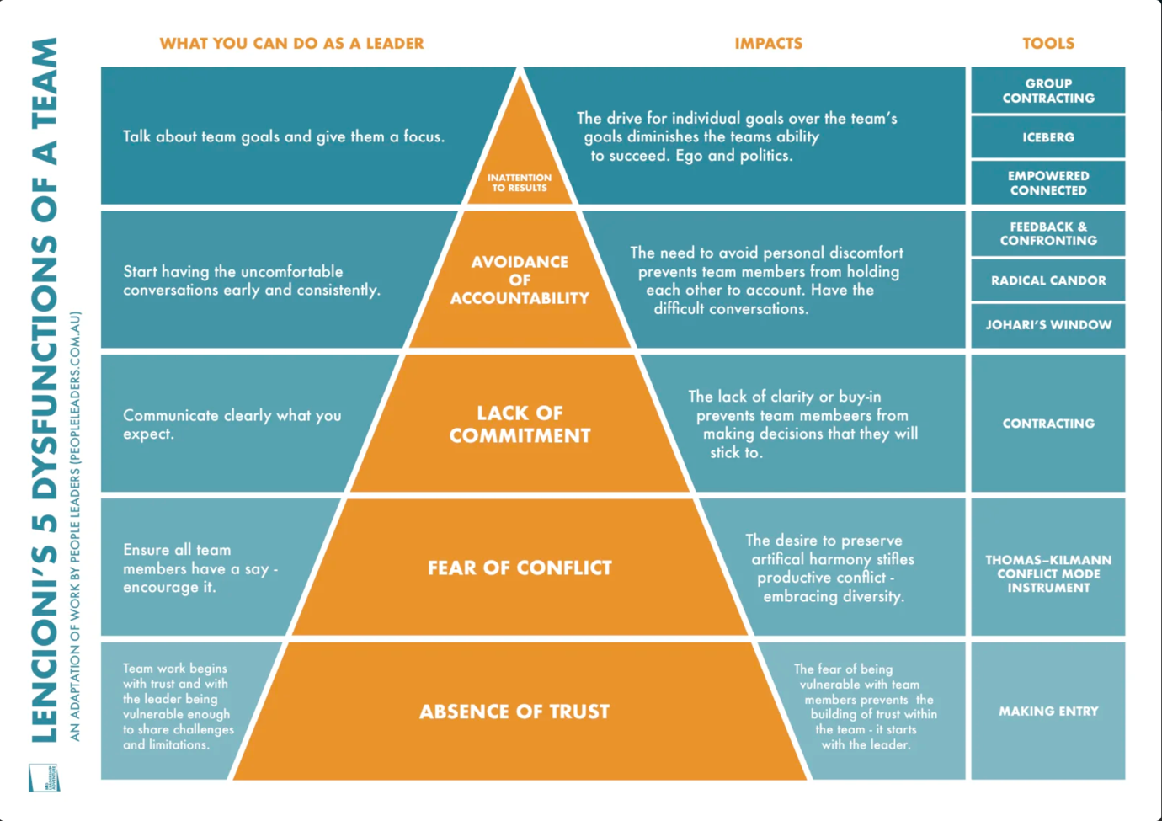
Figure 3: Lencioni’s 5 Dysfunctions

Transactional Analysis (Berne, 1964)
Applying Transactional Analysis has enhanced my interpersonal skills by helping me engage in adult-to-adult communication, which fosters logical and effective discussions. This was particularly useful in resolving misunderstandings during team meetings, ensuring that conversations remained solution-focused rather than emotionally driven. Utilising this method has also helped me recognise when I might unconsciously slip into the Parent or Child ego states, allowing me to realign my approach and maintain a more balanced, respectful dialogue with my team members. (See Appendix C)

Personal Experiences and Learning Outcomes
One significant learning experience came from a group assessment task, where I encountered team members with differing working styles. Initially, there were challenges in decision-making, as some members took a more dominant approach, while others, including myself, sought consensus. Applying Tuckman’s model, I recognized that our team was in the storming phase, and I used my strengths as a Teamworker to mediate discussions and establish a positive environment. Meanwhile, my Implementer role ensured that tasks were executed effectively, reducing inefficiencies. Through this experience, I learned the importance of balancing differing opinions and facilitating cooperation, even in the face of conflict.
Additionally, I used the Thomas-Kilmann model to assess my conflict management style. My tendency to avoid conflict (Turtle) has helped me maintain group cohesion, but I have also realized the importance of addressing issues when necessary. I am now focusing on developing a more collaborative and compromising approach to ensure that all perspectives are considered while maintaining harmony.
This shift in my conflict resolution approach is also helping me understand that embracing constructive disagreement can actually strengthen team relationships by making everyone feel heard.

Conclusion
Through my experiences in teamwork, I have learned that my strengths as a Teamworker and Implementer contribute to a positive and structured team environment. However, my tendency to avoid conflict can sometimes restrict open discussions and decision-making. By applying theories such as Belbin’s Team Roles, Tuckman’s Team Development Model, and the Thomas-Kilmann Conflict Management Model, I have gained a better understanding of my role and areas for improvement. Moving forward, I aim to become more assertive in addressing conflicts, recognising that this will help me and my team to perform more effectively. In the future, I will actively seek to use these tools to not only improve my own performance but also help foster an environment where all team members can work together more harmoniously and efficiently.

Future Actions for Improvement:
- Improve assertiveness in the storming phase by using structured feedback techniques.
- Develop active listening skills to understand diverse perspectives better.
- Enhance conflict resolution skills by practicing constructive confrontation.
- Ensure efficiency in teamwork by refining my Implementer role to prioritize adaptability.
- Encourage balanced participation in group discussions by ensuring all voices are heard.
- Gradually shift from an avoiding conflict style (Turtle) to a more collaborative and compromising approach in situations where conflict resolution is necessary.

Appendices
Appendix A: Completed Belbin’s questionnaire- https://drive.google.com/file/d/1ZayXmbuWIdbLQUZOKS2T6X8muxSazYKN/view?usp=sharing
Appendix B: Completed Thomas-Kilmann questionnaire- https://drive.google.com/file/d/1bqqBeZiJLykLaWkJKOOMdeZ5S006lYUb/view?usp=sharing
Apendix C:
Transactional Analysis (TA), developed by psychiatrist Eric Berne in the 1950s, is a psychological framework that examines interactions (transactions) between individuals to understand and improve communication and relationships.
Key Components of Transactional Analysis:
- Ego States: Berne identified three distinct ego states that individuals operate from:
  - Parent: Incorporates attitudes and behaviors learned from authority figures.
  - Adult: Processes information objectively and responds to the present moment.
  - Child: Embodies feelings, behaviors, and thoughts from childhood experiences.
- Transactions: These are the fundamental units of communication between individuals. Analyzing transactions helps in understanding which ego states are interacting and identifying patterns that may lead to misunderstandings or conflicts.
- Life Positions: TA posits that individuals adopt certain life positions based on their early experiences, influencing their interactions and perceptions.
- Games: Repetitive, unconscious patterns of behavior that people engage in to fulfill hidden motives. Recognizing these "games" can lead to more authentic and constructive interactions.
Applications of Transactional Analysis:
- Psychotherapy: TA is used to help individuals understand their behavior patterns and develop healthier communication strategies.
- Education: Educators apply TA principles to improve teacher-student interactions and create positive learning environments.
- Organizational Development: TA assists in enhancing communication, leadership, and team dynamics within organizations. (SAGE Publications, n.d)

References
Belbin, R. M. (1981). Management Teams: Why They Succeed or Fail. Heinemann.
Berne, E. (1964). Games People Play: The Psychology of Human Relationships. Grove Press.
Big Education. (n.d.) Lencioni’s 5 Dysfunctions [Image]. Big Education. Available at: https://bigeducation.org/leadershiptools/lencionis-5-dysfunctions/ (Accessed: 3 March 2025).
Experianta (n.d.) Belbin team roles model. [Image]. Available at: https://experianta.com/directory/concepts/belbin-team-roles-model/ (Accessed: 10 March 2025).
Graffius, S. (n.d.) Five phases of team development [Image]. Scott Graffius. Available at: https://www.scottgraffius.com/blog/files/tag-five-phases-of-team-development.html (Accessed: 3 March 2025).
Katzenbach, J. R., & Smith, D. K. (1993). The Wisdom of Teams: Creating the High-Performance Organization. Harvard Business Review Press.
Lencioni, P. (2002). The Five Dysfunctions of a Team: A Leadership Fable. Jossey-Bass.
SAGE Publications (n.d.) An Introduction to Transactional Analysis. Available at: https://uk.sagepub.com/sites/default/files/upm-binaries/40597_9780857029089.pdf (Accessed: 12 March 2025).
Salas, E., Sims, D. E., & Burke, C. S. (2005). "Is There a 'Big Five' in Teamwork?" Small Group Research, 36(5), 555-599.
Thomas, K. W., & Kilmann, R. H. (1974). Thomas-Kilmann Conflict Mode Instrument. Xicom.
Tuckman, B. W. (1965). "Developmental Sequence in Small Groups." Psychological Bulletin, 63(6), 384-399.
West, M. A. (2012). Effective Teamwork: Practical Lessons from Organizational Research. BPS Blackwell.

