

Methods and Search Strategy Academic Poster

Student name: Irene Nzeza Nlandu
Student ID: 2245428

Module name: Independent Project
Module code: BMHP6020_BIRM


Exploring the Impact of Digital Transformation in Social Media on Children and Adolescents in the UK
01 Introduction and Research Aim  The purpose of a methods chapter is to detail the processes used to select, collect and analyse data in research (Saunders, Lewis and Thornhill, 2023). This poster outlines the methodological approach used in this research. These include the search strategy, data analysis and data collection methods. The aim is to explore how digital transformation in social media has influenced the wellbeing, development and behaviour of children and adolescents in the UK. | 02 Search Strategy  A search strategy is a structured and systematic process helpful for seeking relevant literature. It works by identifying keywords, using databases and inclusion criteria (University of Sydney, n.d.). Keywords identified included: “digital transformation”, “children and adolescents”, “social media”. Boolean operators (AND, OR, NOT) were used to refine results. Fo example, searching ‘UK studies NOT international’ found results relating to UK context and not global research.
03 Searching for Information  Information was searched for by:  - Identifying key terms from the research title.  - Generating synonyms and key terms.  - Using academic databases such as Google Scholar, PubMed, Google and UWTSD Library.  - Applying filters (e.g. region, date, full-text access).  - Selecting peer-reviewed sources.  This process ensured the studies were reliable, relevant and UK-focused. | 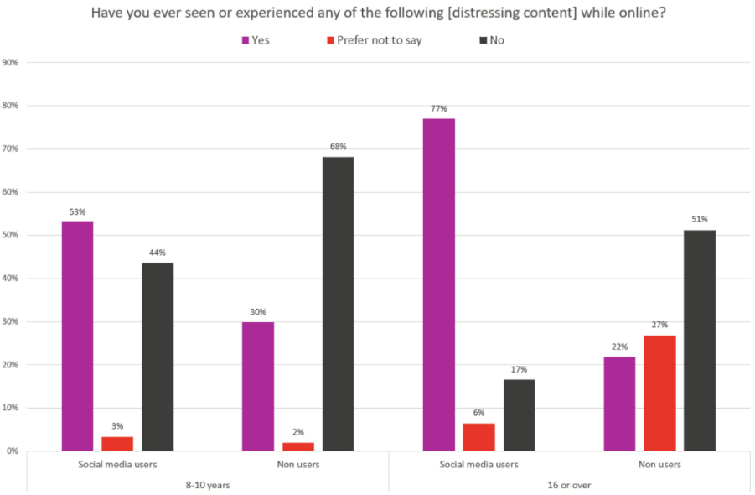  04 Picture / Graph / Visual Aid / Statistics
05 Research Validation and Analysis
Validation within secondary research makes sure that the research collected is reliable, trustworthy and from authentic sources (Bryman, 2016). This is important in the dissertation as it ensures that any studies used were consistent with the aim of the study. Research validation includes benefits such as increased reliability whereas limitations include potential publication bias. Secondary research analysis is where pattens and themes are identified. Themes were selected for by using a thematic analysis approach – highlighting repeating ideas developing them into themes.
06 Inclusion Criteria  - Recently published studies (within last 10 years)  - Peer-reviewed journals  - UK specific research  - Studies focused on children and adolescents  - Easy online access | 07 Exclusion Criteria  - Studies published more than 10 years ago  - Non-English publications  - Studies focused on adults  - Non-peer reviewed journals  - Inaccessible sources
  - Ethical Considerations
Ethics involve using data in a way that is responsible, that avoids plagiarism and that accurately represents findings (Resnik, 2020)

References
Saunders, M.N., Lewis, P. and Thornhill, A. (2023). Research Methods for Business Students. [online] ResearchGate. Available at: https://www.researchgate.net/publication/240218229_Research_Methods_for_Business_Students.
University of Sydney (n.d.). Search strategies. [online] www.library.sydney.edu.au. Available at: https://www.library.sydney.edu.au/support/searching/search-strategies.
Bryman, A. (2016). Social Research Methods. 5th ed. Google Books. Oxford University Press.
Ofcom (2023). Children and Parents: Media Use and Attitudes. [online] Ofcom. Available at: https://www.ofcom.org.uk/siteassets/resources/documents/research-and-data/media-literacy-research/children/childrens-media-use-and-attitudes-2023/childrens-media-use-and-attitudes-report-2023.pdf?v=329412.
Resnik, D. (2020). What is ethics in research & why is it important? [online] National Institute of Environmental Health Sciences. Available at: https://www.niehs.nih.gov/research/resources/bioethics/whatis.

