Module: LCBB6004 Strategic Management and Sustainability
Module Lecturer: Dr. Stephen Asafo

Student: Danica Kanchevska
Student ID: 2124692

Table of Contents
Introduction 2
Company Background 3
Ansoff Matrix 3
Market Penetration 4
Market Development 5
Product Development 5
Diversification 5
VRIO Framework 6
Value 6
Rarity 7
Imitability 7
Organisation 7
Porter’s Generic Strategies 7
Cost Leadership 8
Differentiation 8
Focus Strategy 9
Sustainability 9
Future Decisions & Recommendations 10
Conclusion 10
References 10

Introduction
In the present-day financial services landscape, it is pivotal for businesses and organisations that strive to achieve and sustain competitive advantage, to develop an effective strategic management. These businesses must develop and implement robust strategies to effectively navigate and tackle challenges, which are becoming increasingly complex, such as, global markets, technological advancements and evolving customer expectations.
The aim of this report is to identify and critically evaluate the strategic approach of Lloyds Banking Group plc by utilising known and well-established strategic frameworks such as Value Chain Analysis, Porter’s Generic Strategies, VRIO Framework and the Ansoff Matrix. Through this analysis and evaluation, the report will further explore how strategic choices can shape organisational performance, enable market positioning and foster long-term success in the highly competitive financial services landscape. Moreover, the employment of these strategic models will provide insights of how Lloyds in structured in terms of its operations and resources, and how it manages to meet the demands of its stakeholders as well as adapt to the dynamic environment.

Company Background
Formed in 2009, Lloyds Banking Group PLC is one of the UK’s biggest and most influential financial services organisations. The group, with its headquarters in London, operates across retail banking, insurance, wealth management and commercial banking, through popular brands such as Lloyd’s bank, Bank of Scotland, Scottish Widows and Halifax. With its roots tracing back to the mid-1700s, Lloyds has become a cornerstone of the UK’s financial industry.
Blending traditional banking with modern digital innovation, as well as a commitment to a customer centric approach, is a key element of Lloyds’ strategic stance. By heavily investing in digital transformation, the group has developed advanced online and mobile banking platforms that enhance customer experience and operational efficiency. When it comes to finances, Lloyds has shown strong resilience, supported by a strong capital base and diversified revenue streams, especially during economic deteriorations like the COVID-19 pandemic and the global financial crisis between 2007 and 2009 (Howcroft B., 2005).
Initiatives aimed at supporting communities, promoting financial inclusion and reducing environmental impact, suggest that Lloyds is also significantly committed to sustainability and corporate social responsibility. Furthermore, Lloyds remains focused on strengthening its digital capabilities and overall growth, despite challenges such as the impacts of Brexit, regulatory pressures and competition from other financial service and fintech companies.
With rich history, strong market presence and a forward-looking innovative strategy that aims for continued success, Lloyds is a pivotal player in the UK financial landscape (Lloyds Banking Group).

Ansoff Matrix
According to Loredana M., (2017) The term “The Ansoff Matrix” is a term used to refer to a particular framework that is utilised for understanding the growth strategies of a company through four different aspects:
-Market Penetration
-Market Development
-Product Development
-Diversification.
Lloyds Banking Group has utilised every single of one these avenues to varying degrees to drive growth and expand its market presence.
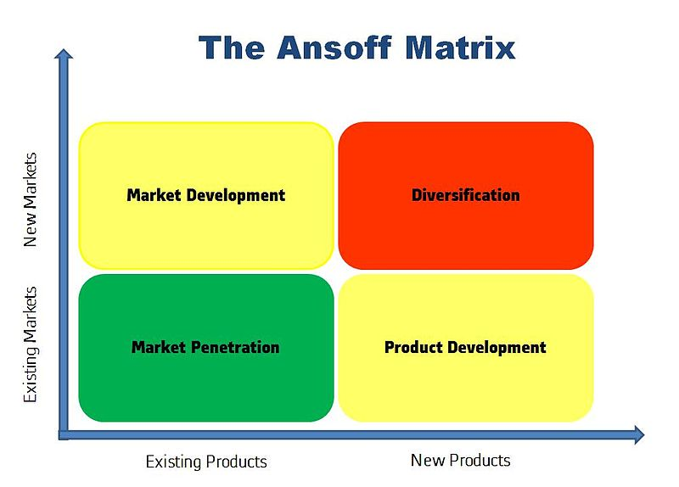
Fig. 1 The Ansoff Matrix (Wikipedia 2023)

Market Penetration
The first sector of the Ansoff Matrix framework is called Market Penetration and it involves increasing market share within already existing markets using current products. Lloyds has successfully achieved market penetration within the UK, where it holds a significant share of the retail banking market (Harvey, M., 2020).
Lloyds has employed multiple tactics with the aim to deepen its penetration in the UK market. One example of this is the expansion of its digital banking services, which have become increasingly popular among customers in present day, as it offers both accessibility and convenience. By offering similar prices as its competitors on its products such as credit cards, savings accounts and personal loans, Lloyds has been able to attract new customers and increase its share among already existing customers. In addition to these pricing strategies, Lloyds has also leveraged customer loyalty programs to further increase its retention and encourage repeat business. For example, “Club Lloyds”, offers customers a range of benefits, including interest on current account balances, preferential rates on savings accounts and discounts on banking services. Lloyds has maintained strong customer base and high engagement level with its services due to these loyalty incentives (Webb A., 2023).

Market Development
The second aspect of the Ansoff Matrix framework is called Market Development. This aspect is focusing on using existing products and services to expand into new markets.
An example of an initiative regarding this aspect has been Lloyds’ targeting of small and medium sized enterprises (SME). By recognising the potential of these businesses, Lloyds has developed specialised banking services to meet the specific needs of these businesses. These services include utilities such as advisory services, cash management solutions and tailored loans (Campbell, C., Fox, K., 2023).
Lloyds has also targeted younger customers by enhancing its digital banking application with features that appeal to the younger demographic. For instance, the app includes budgeting tools & spending insights, which the younger generation of customers would find convenient and easily accessible (Harvey, M., 2020).

Product Development
Product Development is the third part of the framework and it involves the creation of new products and services with their purpose being of serving existing markets.
The development of digital-only banking products has been one of Lloyds main focus areas. These aforementioned products are specifically designed so that they cater to customers who prefer having all of their finances entirely online. The development of “Lend a Hand” mortgage is an example of product development, and is aimed at helping first-time buyers, with the help of their family members, get onto the property ladder (Collinson, P., 2019)
Growing customer demand for ethical and environmental responsible solutions, has motivated Lloyds to expand its range of sustainable investment products. Lloyds now offers a variety of green finance products that allow customers to invest in renewable energy and energy efficient projects. An example of product that allows customers to do so is the “Green Building Tool”, which allows customers to fully utilise their properties in terms of making it sustainable and energy efficient (UK GBC 2021).

Diversification
Lastly, diversification is the name of the fourth part of the Ansoff Matrix, and it revolves around entering new markets with new products. This is done so that new revenue streams are explored.
A notable example of diversification related to Lloyds, is its expansion into the insurance and wealth management fields. With the acquisition and integration of Scottish Widows, Lloyds has broadened its product offering to include life insurance, pensions and investment management services. Customers who bank with Lloyds and also encouraged to use its insurance and wealth services, thereby Lloyds is allowed to tap into existing customers from a different perspective and create cross selling opportunities (Fuentes, C., 2022).

VRIO Framework
According to Bresser (K., F., B., 2012) VRIO framework tool is used to analyse the internal resource as well as capabilities of an organisation to determine their potential for providing a sustained competitive advantage. Value, Rarity, Imitability and Organisation are the four criteria that the VRIO framework uses to assess the resources and how they are based.
Resource | Valuable | Rare | Inimitable | Organised | Competitive Advantage
Strong Brand Reputation | Yes | Yes | Yes | Yes | Sustained Competitive Advantage
Extensive Customer Base | Yes | Yes | No | Yes | Temporary Competitive Advantage
Advanced Digital Infrastructure | Yes | No | Yes | Yes | Temporary Competitive Advantage
Sustainability Initiatives | Yes | No | Yes | Yes | Temporary Competitive Advantage
Deep Customer Insights | Yes | Yes | Yes | Yes | Sustained Competitive Advantage
Table 1: VRIO Framework (created by author)

Value
Resources such as customer base, strong brand reputation and advanced digital infrastructure, enable Lloyds to offer a wide range of financial services efficiently and effectively, thereby meeting the diverse needs of its customers. For example, the bank’s reputation, built on a legacy of trust and reliability, attracts and retains customers and contributes to its strong market position. In addition, the enhanced digital platform provides customers with convenient access to their accounts and financial services, thus enhancing the overall customer experience.
Furthermore, the bank’s ability to generate significant revenues from its diverse product offerings is proof that the bank’s resources are well distributed and enhanced. Moreover, the aforementioned wide range of services provided by Lloyd’s bank, such as wealth management, insurance, retail and online banking, is a testament to how successful Lloyds is at cross-selling products to its existing customer base, and therefore maximising revenue opportunities (Statista 2023)

Rarity
Even though the banking field is highly competitive, Lloyds combination of strong market presence within the UK, commitment to sustainability, ethical banking and comprehensive service portfolio is relatively rare. These attributes help Lloyds to stand out and differentiate from its competitors. The commitment to sustainability which resonates with a lot of its customers as well as its dominant position, gives Lloyds a unique position in the market and provides it with a competitive edge.

Imitability
When it comes to the imitability aspect of Lloyds when analysed using the VRIO framework, Lloyds finds itself in a decent spot as it is not easy to imitate Lloyds complex infrastructure and advanced digital platform which has taken years to create and develop into what it is now. This suggests that it would take a lot of time and financial investment for somebody to imitate it. In addition, Lloyds boasts its reputation and ability to build long standing deep relationships with its customers, which means that it has the ability to gain insightful data regarding customer behaviour and preferences. This unique knowledge of its customers further adds to Lloyds being a hard company to imitate (Harvey M., 2020).

Organisation
Lloyds governance structure, strategic focus, investment in technology and human capital ensure that it can effectively deploy its resources to maintain its competitive edge. The bank’s organisational structure also supports its strategic goals by promoting efficient decision-making and clear lines of responsibilities. Strong risk management and ethical standards contribute towards the company operates in a manner that is both consistent and adequate with its regulatory requirements. All of these organisational aspects, allow Lloyds to leverage its resources in order to maintain sustainable growth and competitive edge over other companies within the finance field (Harvey M., 2020).

Porter’s Generic Strategies
According to Topuzovska et al. (2020), Porter’s generic strategies framework, organisations are able to achieve competitive advantage by utilising three different bases: cost leadership, differentiation and focus. Porter refers to these bases as generic strategies. In regard to Lloyds, the banking group has mostly pursued a cost leadership strategy while also integrating elements of differentiation to a certain extent, thus indicating a hybrid approach.
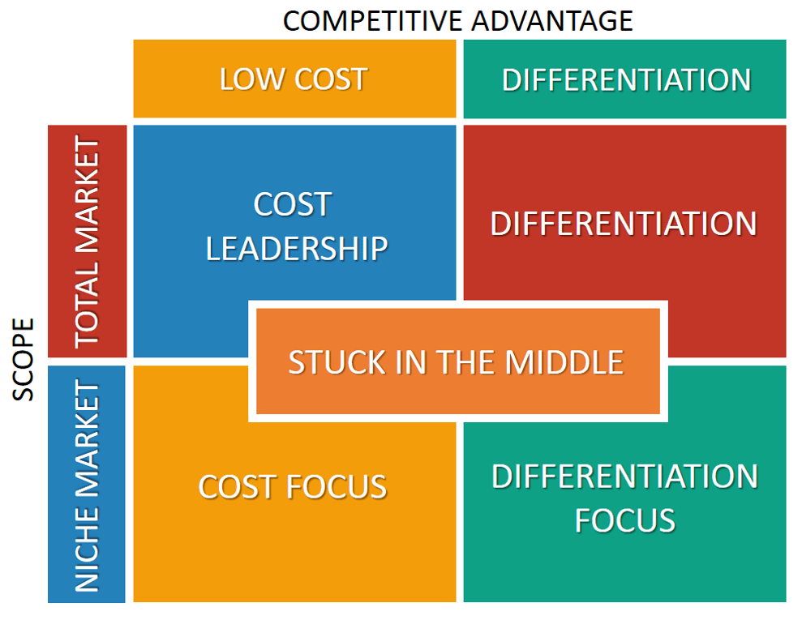
Fig 2. Porter Generic Strategies (Bruin 2021)

Cost Leadership
Lowering the cost of products and or services in order to gain a competitive advantage, falls under the first strategy of the Porter’s framework and is known as cost leadership strategy. When it comes to Lloyds, this is their main strategy used in various consumer markets. Lloyds has now long focused on minimising operational costs to offer competitive pricing to its customers. In particular, the bank’s emphasis on digital transformation has played a crucial role in reducing costs, as suggested by its extensive investment in digital banking platforms. Lloyds has managed to significantly lower its reliance on physical location and therefore reduce overhead expenses by encouraging customers to use digital services. This structure or strategy has allowed Lloyds to offer competitive rates on services such as deposits and loans, therefore attracting a broad customer base.
in addition, Lloyds also often offers various packages such as discounts and coupons which help increase brand popularity and further encourage consumption (Burner A., 2018).

Differentiation
When it comes to the differentiation strategy aspect, Lloyds bank uses this strategy to further drive its competitive edge. By enhancing customer experience through personalised banking services, as evidenced by Lloyds capabilities to offer tailored financial services and thus catering to specific needs of specific customers, we can conclude that Lloyds as a financial service provider, tries to differentiate itself from others as much as possible. Other differentiation factors highlighted by Lloyds are their brand reputation as one of the oldest and most trustworthy banks. Moreover, using a distinct logo for more than 100 years, has embedded a strong brand image in their customers’ mind.
In addition, Lloyds commitment to ethical banking as well as sustainability differentiates the bank further from its competitors, appealing to socially conscious consumers (Burner A., 2018).

Focus Strategy
The third generic competitive strategy called “focus”, is related to how companies serve specific market segments, and base their competitive advantage on niche marketing. Lloyds focus strategy is evident in its concentrated operation within the UK market. By specialising in the domestic market, the bank has managed to develop insights into local customer needs and expectations, regulatory requirements and economic trends. This focus allows Lloyds to optimise its services for the domestic market, thus strengthening its market position (Burner A., 2018).

Sustainability
According to Bellucci et al. (2023) when it comes to the sustainability aspect of Lloyds banking group, we can conclude that the group’s strategic emphasis on sustainability is integral to its long-term success and competitive edge. Lloyds commitment to ESG (environmental, social and governance) principles is reflected throughout analysis, and is evidenced in Lloyds efforts to reduce its carbon footprint, promote financial inclusion and the aforementioned green finance services it provides. Lloyds has managed to mitigate risks associated with climate change and regulatory requirements by integrating sustainability in its core. This focus on sustainability enhances not only Lloyds reputation but also aligns with the expectations of its stakeholders, thereby suggesting long-term sustainability. In addition, the sustainability of Lloyds is further enhanced due to factors such as Lloyds being resilient and adaptable, and proof that it is capable of meeting present and past challenges.

Future Decisions & Recommendations
When it comes to future decision and recommendations, in my opinion Lloyds should prioritise further investment in digital innovation and sustainability initiatives. Further enhancing customer experiences via digital banking and deepening its commitment to green finance can not only match growing ethical requirements and expectations but also appeal to more customers in a society that is continuously growing in the ethical aspect. In addition, Lloyds should continue to leverage data analytics to offer tailored packages to specific customers and anticipate market trends. This with the combination with the aforementioned recommendations as well as Lloyds strategic alliances with modern fintech companies should strengthen its market position and thus ensure long term growth and competitive edge to other companies from the sustainability aspect.

Conclusion
In conclusion, Lloyds Banking Group plc has managed to successfully leverage a combination of various strategies, identified above, in order to maintain its competitive edge within the UK as well as maintain sustainability and profitability. In order to meet the evolving market and everchanging customer expectations, Lloyds has developed strategic investments in digital innovation and green finance by offering various packages that are branded as “sustainable”. This not only appears appealing to the customers but also helps Lloyd stay within the regulatory requirements. However, in order for Lloyds to sustain market leadership, it must continue to adapt, innovate and invest in technological advancements and the growing importance of sustainability. By aligning its focus with future market trends, Lloyds can ensure long term resilience and continued success in a very competitive and dynamic field.

References
Bellucci M., Ielasi F., Ferrone L., & Biggeri M., (2023) – “Measuring banks' sustainability performances: The BESGI score”
[Online] Available at: https://www.sciencedirect.com/science/article/pii/S0195925523001828
[Accessed: 24.08.2024]
Byrne T., (2018) – “Value Chain Analysis of Lloyds Banking Group plc”
[Online] Available at: https://www.essay48.com/value-chain-analysis/3182-Lloyds-Banking-Group-plc-Value-Chain-Analysis
[Accessed: 24.08.2024]
Bruin L., (2021) – “Porter’s Generic Strategies: Differentiation, Cost Leadership and Focus”
[Online] Available at: https://www.business-to-you.com/porter-generic-strategies-differentiation-cost-leadership-focus/
[Accessed: 24.08.2024]
Bresser K., F., B., (2012) – “Practical implications of the resource-based view”
[Online] Available at: https://link.springer.com/article/10.1007/s11573-012-0553-4
[Accessed: 24.08.2024]
Burner A., (2018) – “Lloyds Banking Group plc Generic and Intensive Growth Strategies”
[Online] Available at: https://www.essay48.com/3182-Lloyds-Banking-Group-plc-Porters-Generic-Strategies
[Accessed: 24.08.2024]
Campbell C., Fox K., (2023) – “Lloyds Bank Business Loans Review – Pros & Cons”
[Online] Available at: https://www.nerdwallet.com/uk/business-loans/lloyds-business-loan-review/
[Accessed: 24.08.2024]
Collinson P., (2019) – “Lloyds unveils 100% mortgage for first-time buyers”
[Online] Available at: https://www.theguardian.com/money/2019/jan/28/lloyds-unveils-100-mortgage-for-first-time-buyers
[Accessed: 24.08.2024]
Fuentes C., (2022) – “Scottish Widows Demutualization and Acquisition by Lloyds TSB”
[Online] Available at: https://contingencies.org/scottish-widows-demutualization-and-acquisition-by-lloyds-tsb/
[Accessed: 24.08.2024]
Harvey M., (2020) – “Ansoff Matrix of Lloyds Banking Group plc”
[Online] Available at: https://www.essay48.com/3182-Lloyds-Banking-Group-plc-Ansoff-Matrix
[Accessed: 24.08.2024]
Harvey M., (2020) – “VRIO Analysis of Lloyds Banking Group plc”
[Online] Available at: https://www.essay48.com/3182-Lloyds-Banking-Group-plc-VRIN-VRIO-Analysis
[Accessed: 24.08.2024]
Howcroft B., (2005) – “An insight into bank corporate strategy: A Lloyds TSB case study
[Online] Available at: https://onlinelibrary.wiley.com/doi/abs/10.1002/tie.20056
[Accessed: 24.08.2024]
Lloyds Banking Group – “Who we are”
[Online] Available at: https://www.lloydsbankinggroup.com/who-we-are.html
[Accessed: 24.08.2024]
Loredana EM., (2017) – “The Use of Ansoff Matrix in The Field of Business”
[Online] Available at: https://www.utgjiu.ro/revista/ec/pdf/2017-02.Volumul_2_Special/21_EcobiciL.pdf
[Accessed: 24.08.2024]
Statista (2023) – “Global net income of Lloyds Banking Group from 2018 to 2023”
[Online] Available at: https://www.statista.com/statistics/474341/global-income-division-of-lloyds-banking-group-uk/
[Accessed: 24.08.2024]
Topuzovska M., Islami X., – “Linking Porter’s generic strategies to firm performance”
[Online] Available at: https://fbj.springeropen.com/articles/10.1186/s43093-020-0009-1
[Accessed: 24.08.2024]
Webb A., (2023) – “Club Lloyds Review”
[Online] Available at: https://becleverwithyourcash.com/club-lloyds-review/
[Accessed: 24.08.2024]
Wikipedia (2023) – “Ansoff matrix”
[Online] Available at: https://en.wikipedia.org/wiki/Ansoff_matrix
[Accessed: 24.08.2024]

