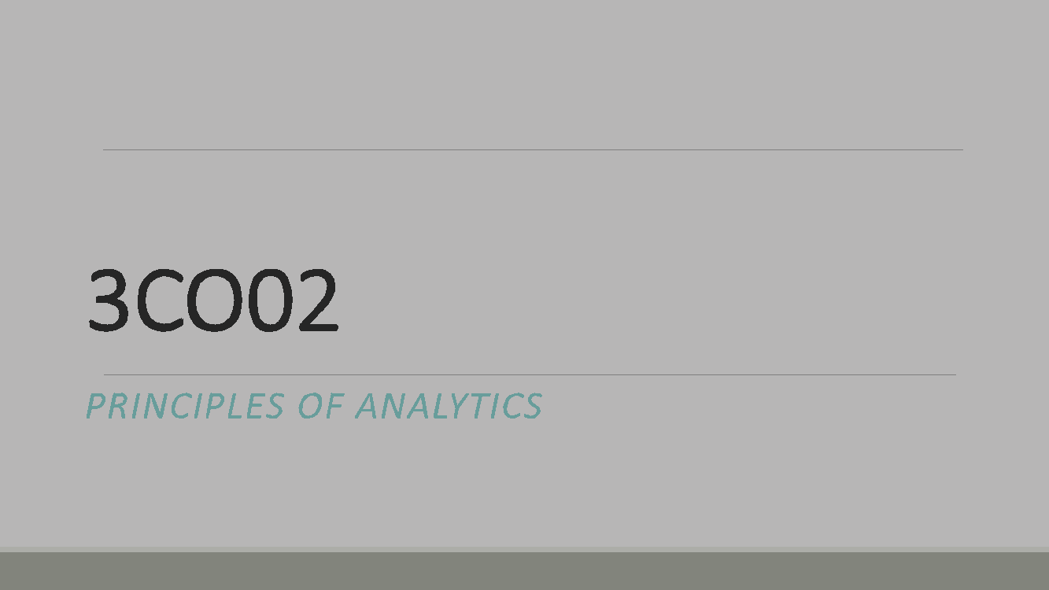

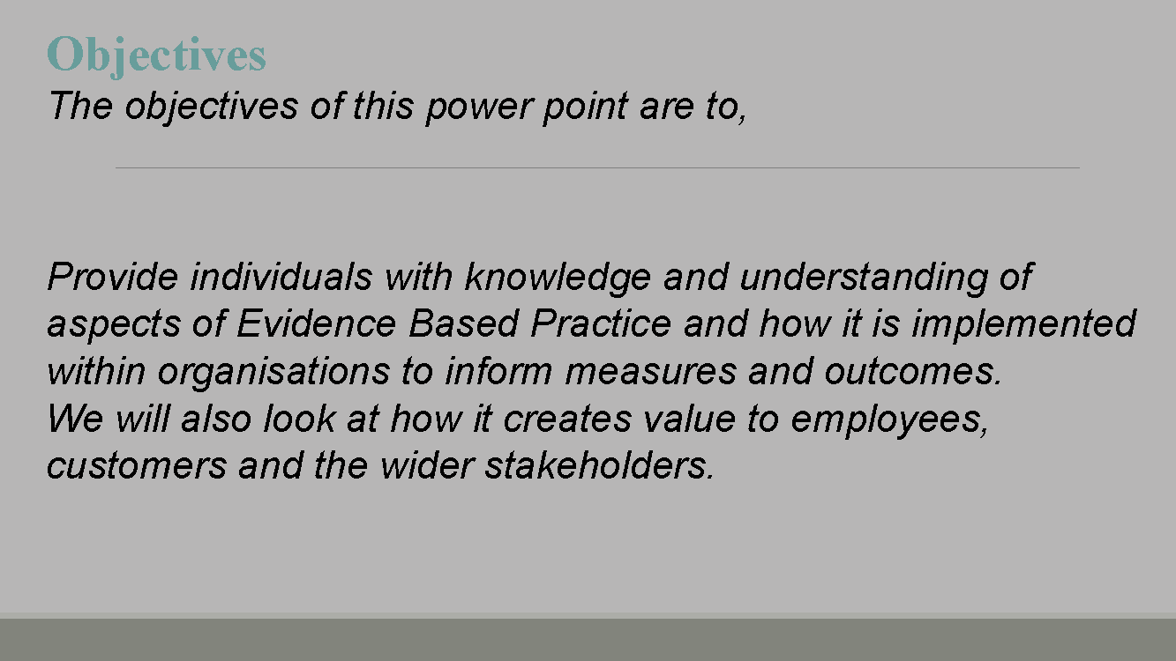

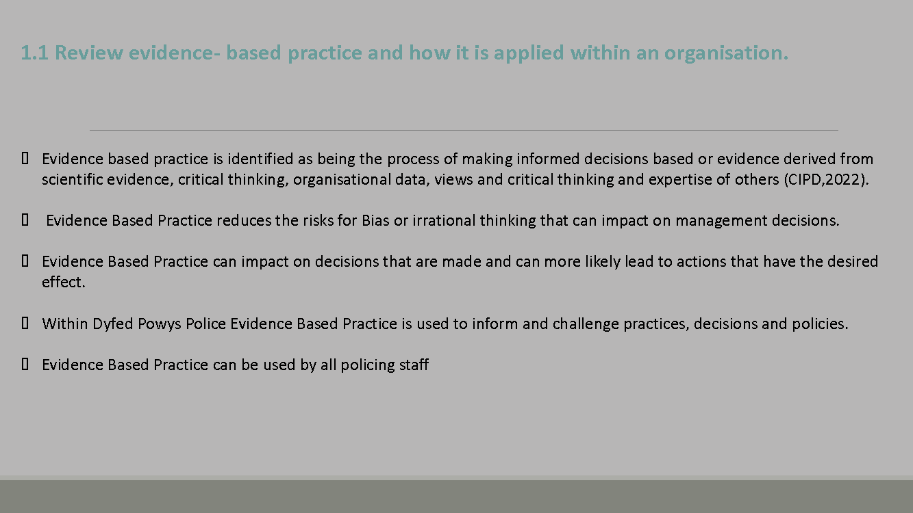

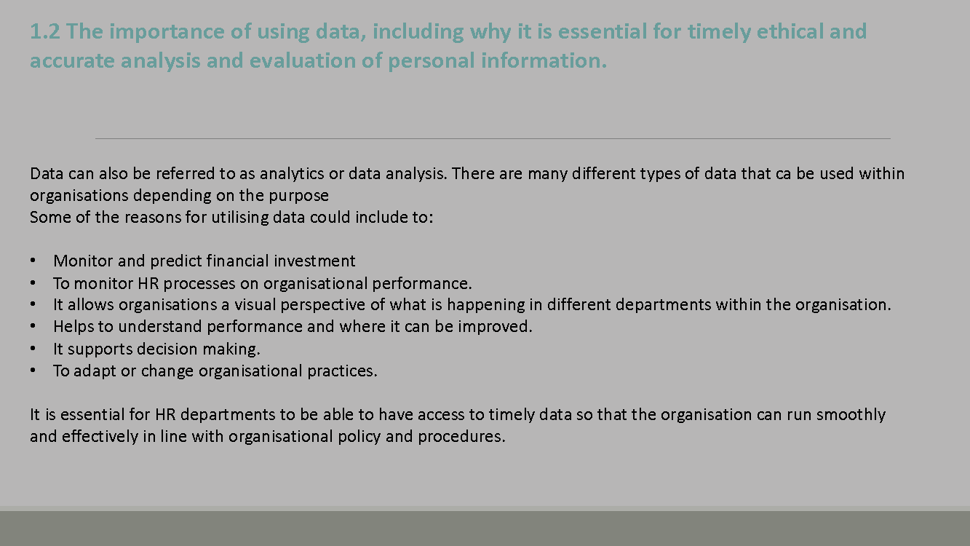

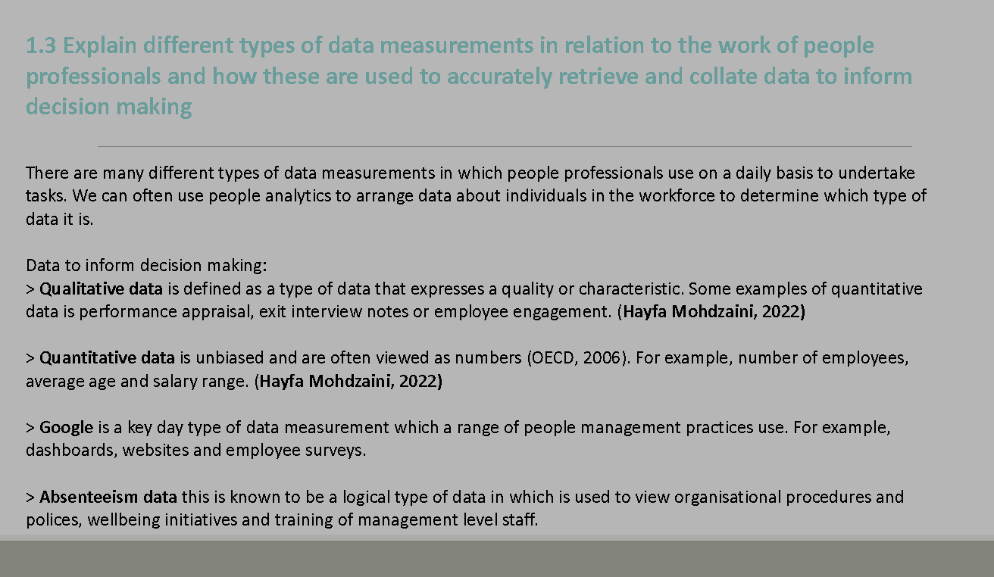

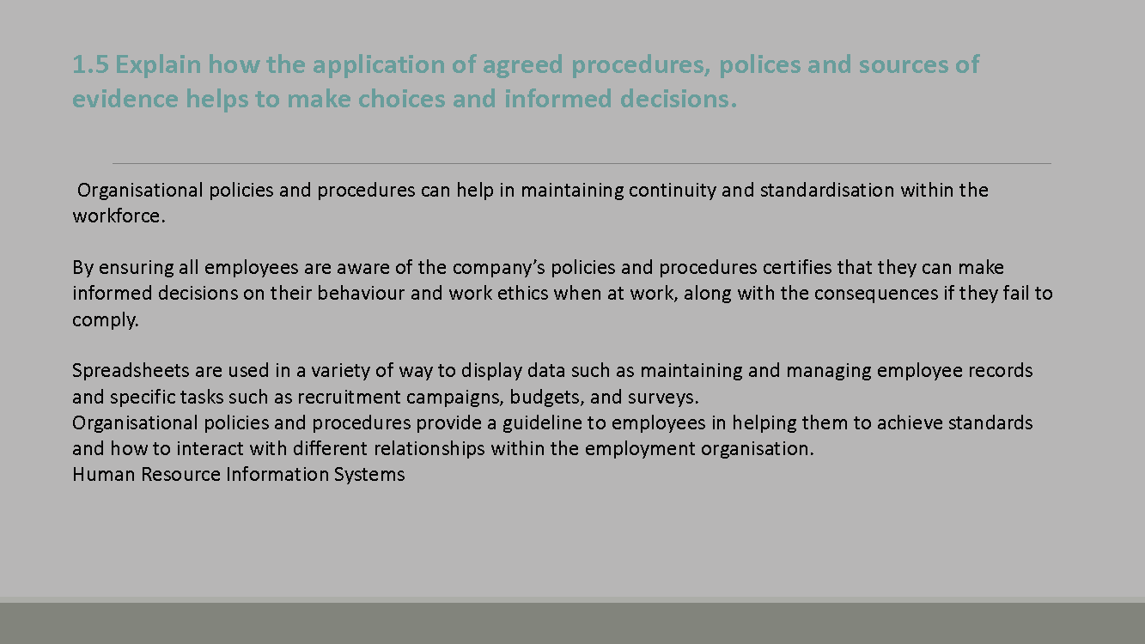
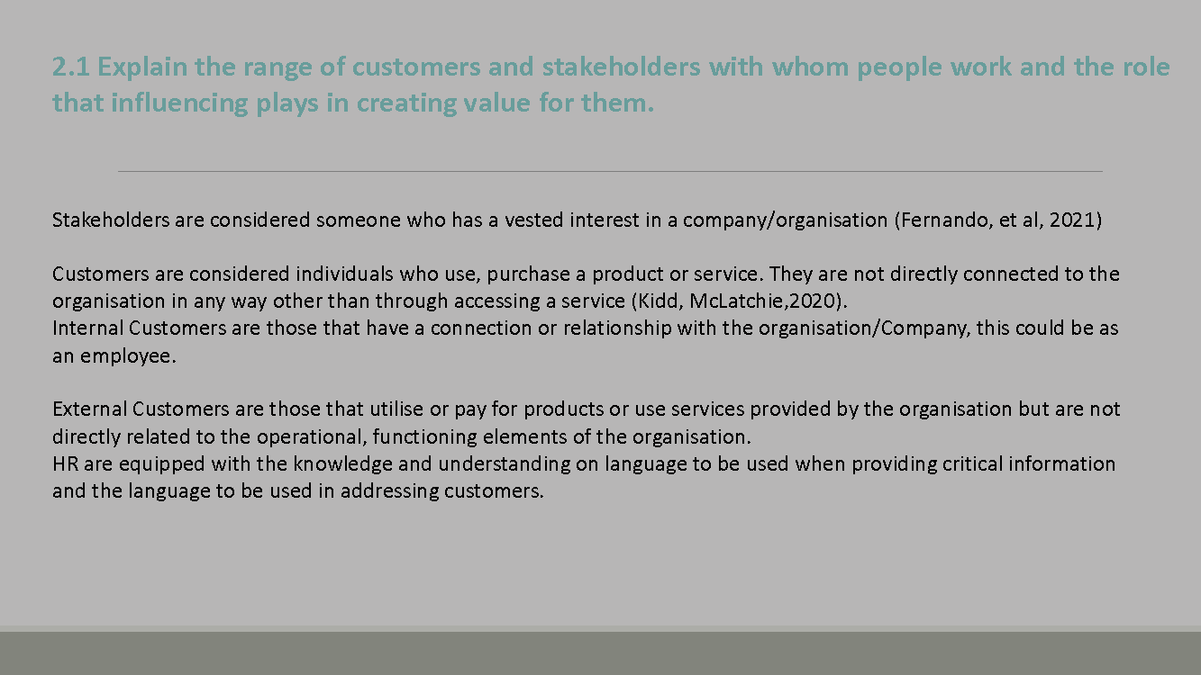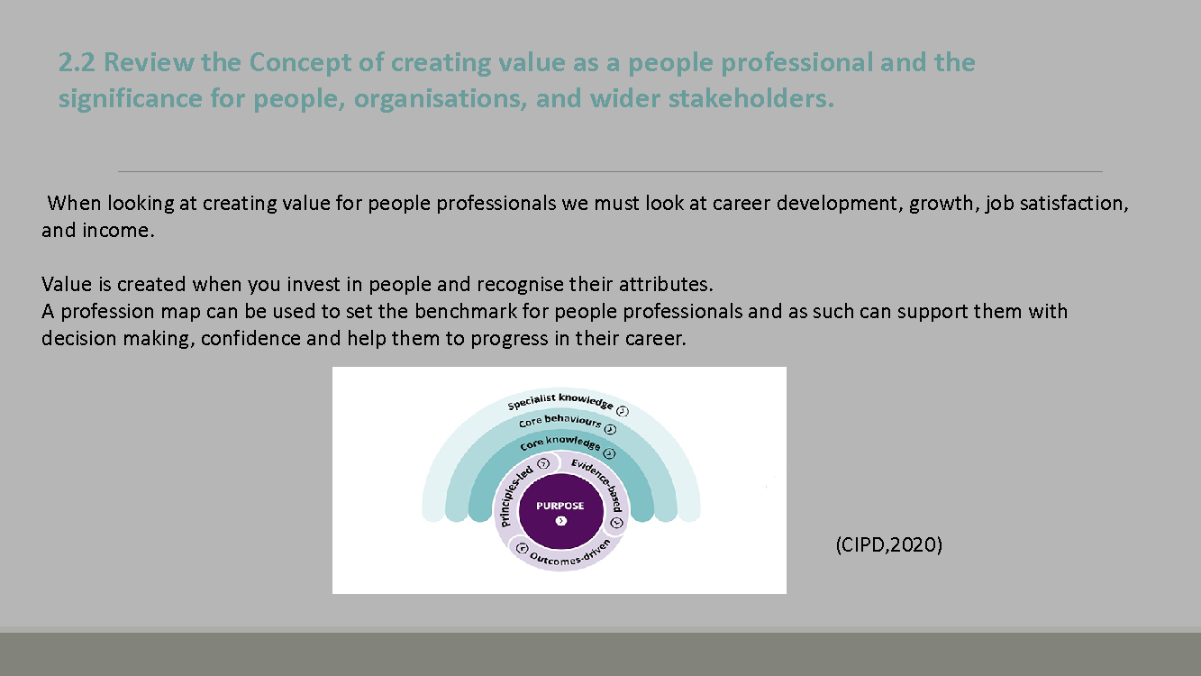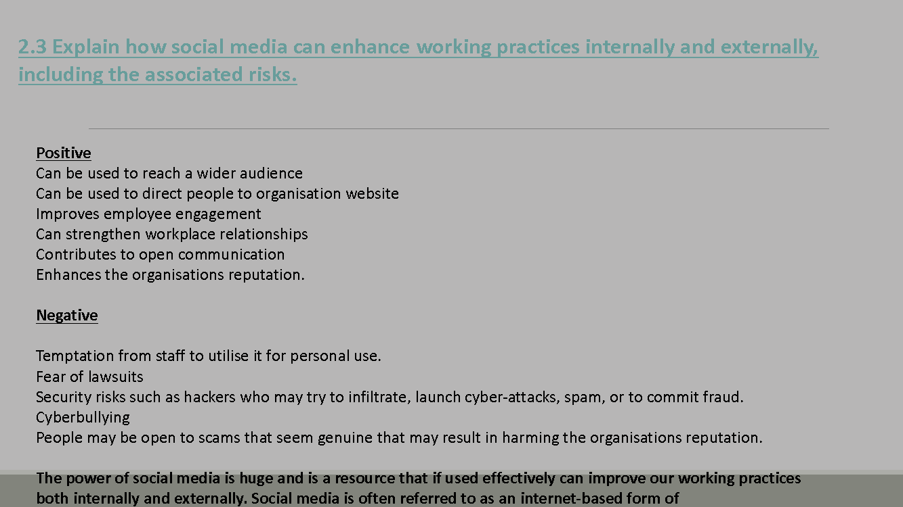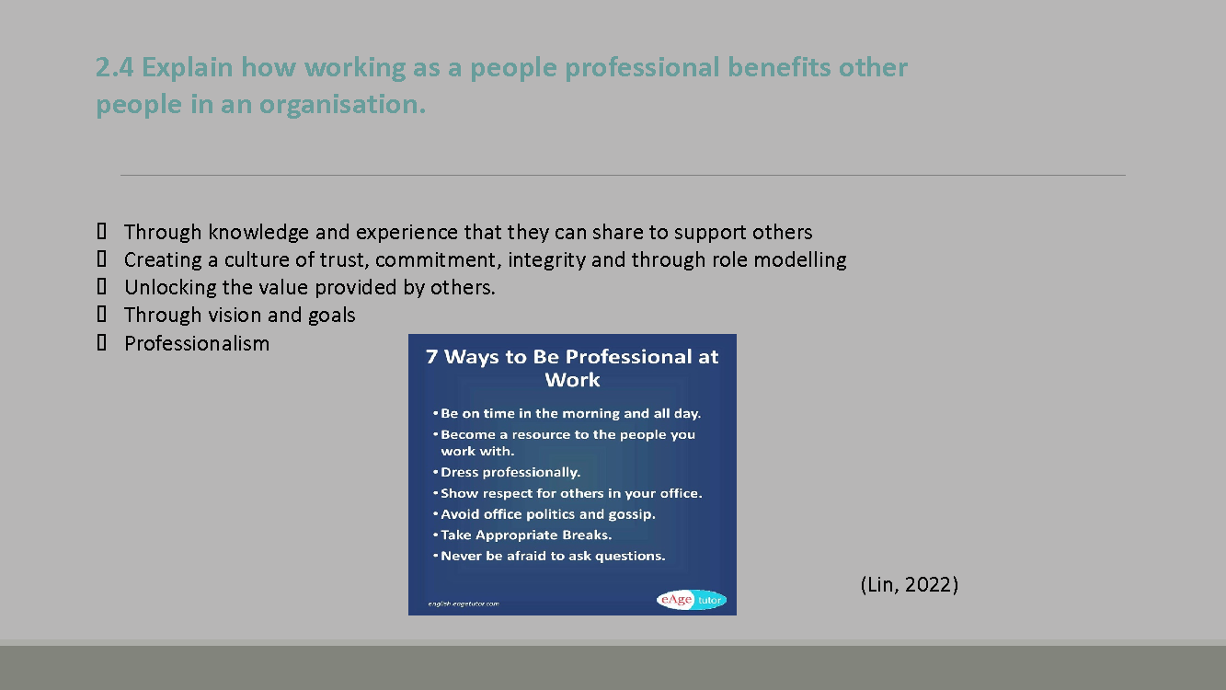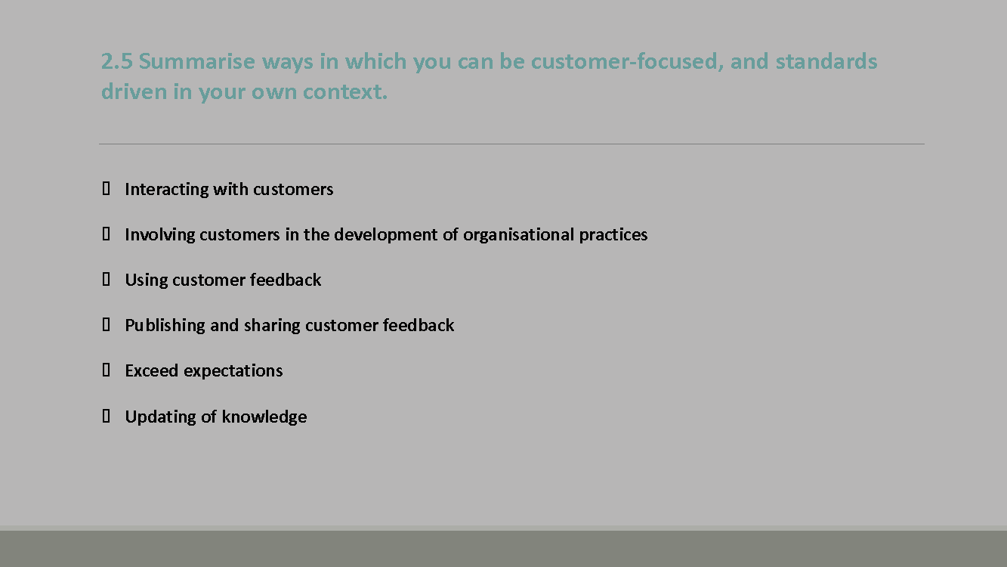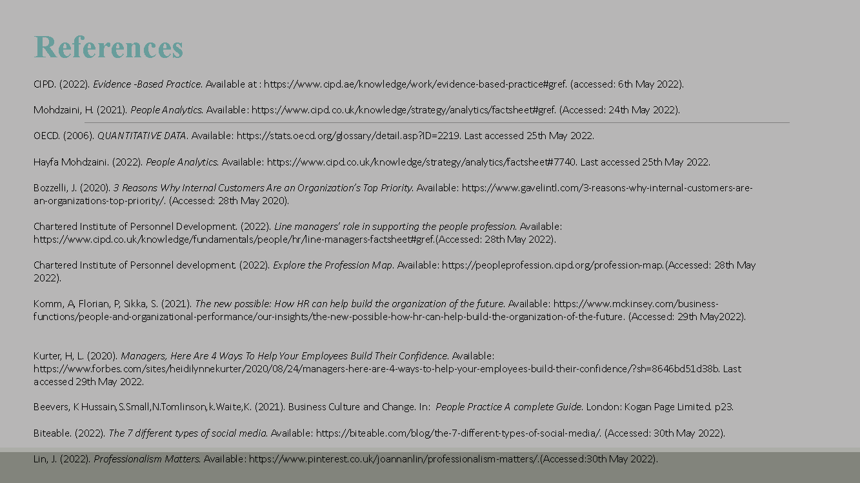

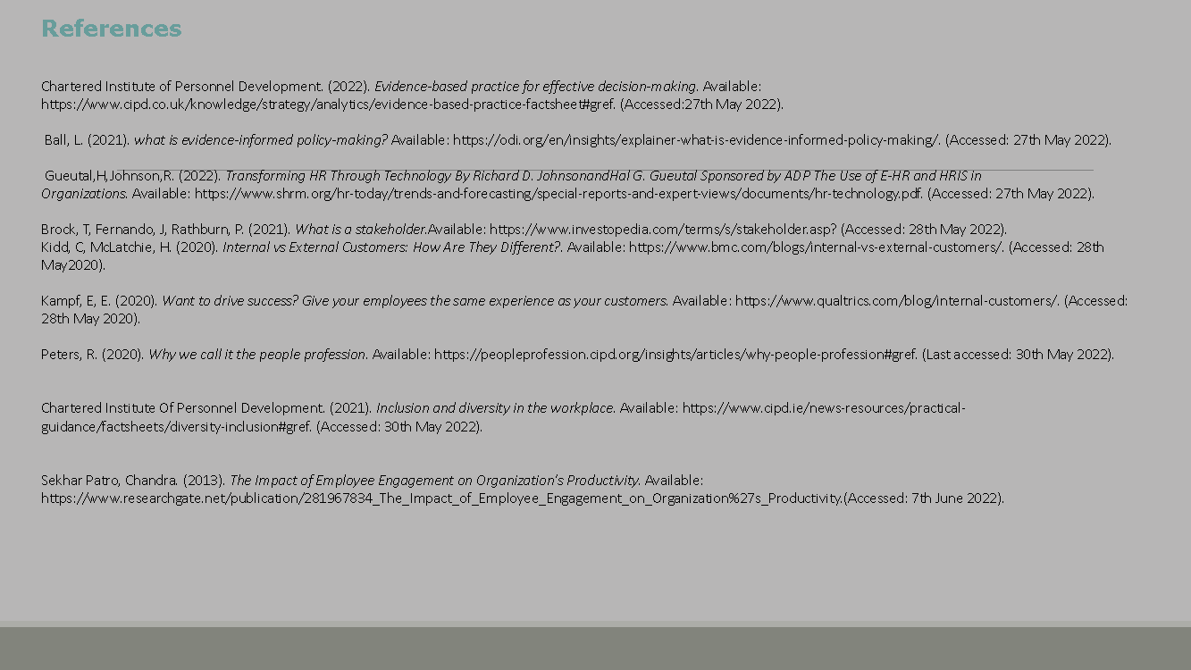

Notes

1.1 We can use evidence-based practice to inform principle-led judgements and outcomes for an organisation by drawing on research and past experiences. This informs organisations to make sound judgements on Organisational practice and how they can impact past and present decisions.
Sekhar Patro (2013) states that employee engagement is integral and can have a positive impact on Organisational performance.

1.2 Within HR there is a need for data for the purpose of ensuring the organisation is capitalising on this technology to back up decision making and to make better choices. Data is a way of understanding and monitoring performance which is a useful way of seeing where individuals are at along with what improvements may be needed.
Data can also be used to help improve organisational processes such as where money and time could be better spent regardless of the size of the organisation. Bernard Marr states in a recent article that regardless of the size of the business, small businesses can still utilise big data as they are considered to be more agile and are able to move swiftly on identified data (Marr,2021).
Mohdzaini (2021) states that there are 5 main reasons for using people analytics and these include measuring a workforce, it enables for more evidence based decisions on both the organisational and workforce performance, it can show the impact that HR policies and procedures can impact on the workforce, it can be used to estimate the return of financial and social return on investment of change initiatives, analytics and creating value is part of core knowledge within the professional map with people analytics being a specialist element within the knowledge element (CIPSD,2021 )

1.5 Within the field of employment, it is essential for employees to not only to be aware of application of policies and procedures but to truly understand how they fit in with their specific roles. Evidence based decision making can help guide the person through to the best course of action. When making decisions it is essential that reliable information is in place. Organisational polices help in maintaining consistency in decision making and is based on and around the combination of critical thinking and the highest quality of evidence available. Employees should adopt this approach rather than rely on personal experiences or the experiences passed down from others that may not be considered trustworthy (Chartered Institute Personnel Development,2022). Evidence is not only within the remit of scientific research it can also be statistical data and evidenced based on evaluation and individual’s voice (Ball, 2021). Within our organisation we have a heavy focus on spreadsheets, these are used in a variety of ways for not only displaying data but for statistical evaluation. With technology constantly making advancements it is now more than ever so accessible for multiple people professionals to access to HRIS this HR resource is a fundamental element of data storing (Gueutal, Johnson, 2022).

2.1 In all organisations there is the requirement for people professionals to have to deal with both internal and external stakeholders and customers. These can range from internal such as employees or individuals who have a relationship with the organisation or external such as testers for biometrics. Internal customers play a fundamental role in the success of the business and therefore it is important that their needs are met. External customers however hold a different value as these are individuals that pay to use or to utilise a product and they are in no way directly related to the functioning of the organisation (Kampf,2020). External customers should be valued and receive a positive experience when interacting with organisation employees and as such it is essential that HR departments ensure that qualified personnel are assigned to the right roles and have the necessary qualifications and experience to be able to deliver an exceptional service (CIPD,2022). Along with this they should be trained on how to interact and use the correct language when addressing customers.

2.2 It is essential especially within the boundaries of HR that value is created, people professionals can create value through support and investment in staff, through identifying potential and supporting learning and development and wellbeing (Komm, et al, 2021). This helps to shape the organisation along with creating a culture of appreciation for staff which in turn builds confidence and may increase motivation which will benefit the organisation (Kurter,2020).
Internal customers such as employees should be valued as they help to shape and build upon the outcomes of the organisation. It is essential that employees’ needs are not only heard but they are met as this helps to develop a strong structure.
External customers hold a critical role in organisations as they play a role in generating revenue (Bozzelli,2020). This is something to consider when determining their place within the organisation but equally important to consider is the role of internal customers and giving them priority place value, as without recognising the essential role they play there may be decreased motivation and appreciation which could affect the organisation.

2.3 communication. It is a way of sharing information and facilitation of conversations in an informal manner, (Beevers, et al, 2021, A). There are a variety of social media applications and can include Twitter, Instagram, Facebook, LinkedIn and WordPress(Biteable,2022).
When used in a safe way both internal and external social media use can enhance practice through strengthening customer relationships and providing a more efficient customer experience. Within the workplace social media can be used as an effective way of communicating with colleagues in a less formal way (Beevers et al, 2021, B). Of upmost importance is the requirement for employees to use social media both internally and externally in the correct way to minimise risks, employees should have training and a good understanding of how to minimise risks such as fraudulent activity, or cyber-attacks and the protocols surrounding these issues.

2.4 People professionals play a fundamental role in organisations and as such they bring knowledge, experience and skills that can not only benefit the organisation but others within it (Peters, 2020).
They have a responsibility for helping to maintain and foster a culture that can be recognised as being open, this is especially important in a diverse workplace as it helps to empower people and develops skills. It also enables us as a workforce to learn form from out collection of diverse colleagues and is good practice and management (CIPD, 2021). People professionals can also benefit others in the organisation by being role models and demonstrating positive behaviors and integrity.

ANALYSIS OF DATA.

1&2
On conversion of the figures across the three departments the analysis has identified the following.

RESEARCH AND DESIGN
The overall theme identified for this department, was the majority of workers had a definite opinion on either agreeing or disagreeing to the statements. Along with this, I recognised that overwhelmingly the employees felt they had a good work home balance and were feeling valued by their manager. They felt secure in their job role and were given the opportunity to use flexi time this looked like it had a positive impact as absence rates are low. Unfortunately, the two overwhelming negatives for this department where they were expected to complete work outside of their contracted hours and they were unaware that the organisation had opportunities for job sharing.

ADMINISTRATION
From this department, the majority of employees took part and the theme I could recognise from the results were mixed. Overwhelmingly, the employees felt that they were overworked had little knowledge of being able to utilise either flexi time, working from home or that the organisation allowed job sharing. Feeling valued was very mixed but with the majority showing they felt their work was not valued by line manager. From the results, it was clear there needs to be further improvement in this department to develop, educate and invest in staff to improve morale and wellbeing.

MARKETING
In this department, it showed the staff felt that they were supported to develop their skills and are supported to use their initiative, they also feel valued by their line manager. This showed that there is a good focus on staff development and staff wellbeing. In this department, there is not enough information passed to staff about opportunities for a better work home balance. The absence rates in the department are low which may indicate a heavy workload as through being absent could add to an additional workload on their return.

3 Research and Design 250 days are lost in a 3-month period for this department.
Administration 31.5 days are lost in 3month period.
Marketing 2.6 days are lost in a 3-month period.

4 Research and Design estimated projected average loss of working days over a 12-month period if the rates were to continue are 1000 days
Administration Estimated projected average loss of working days over a 12-month period if the rates were to continue are 126 days.
Marketing estimated projected average loss of working days over a 12-month period if the rates were to continue are 10 days.

5 Calculation of cost of pay
Research and Design £65,668
Administration £2.962.5
Marketing £560

