Problem solving and decision making - Report

Student name: Diosnel Cordero Romero
Student id: 2131587
Module name: Problem Solving and Decision making
Module code: BMSW4004
Lecturer: Dr Inge Hill

Content Table
Introduction……………………………………………………………………………………..Page 3
PESTLE Analysis:……………………………………………………………………………..Page 3
Evaluation of Alternative Solutions…………………………………………………………..Page 3
Risk Analysis…………………………………………………………………………………...Page 4
Plan to Implement the Decision to Solve the Complex Problem………………………....Page 6
Four possible indicators to measure the effectiveness……………………………………Page 6
Conclusion…………………………………………………………………………………...…Page 7
References……………………………………………………………………………………..Page 8

Introduction:

The retail section of Gudrun Sjoden (GS) is facing a business problem where customers are reluctant to exchange clothes due to concerns regarding hygiene and cleanliness after the COVID-19 pandemic. This report aims to propose solutions for this problem by evaluating alternative solutions, conducting a risk analysis, and developing an implementation plan. The report will also discuss indicators to measure the effectiveness of the proposed solution.

PESTLE Analysis:
To understand the macro-environmental factors that may impact the decision, we conducted a PESTEL analysis. The PESTEL analysis framework is used to analyze the Political, Economic, Socio-cultural, Technological, Environmental, and Legal factors affecting the organization.
Political: There are no significant political factors that may impact the decision.
Economic: The economic downturn due to COVID-19 may impact the revenue of GS if they do not cater to the customer's demands.
Socio-Cultural: The increased demand for hygiene and safety measures may impact the shopping behaviour of customers.
Technological: There is no significant technological factor that may impact the decision.
Environmental: GS's sustainability and environmental-friendly products may attract customers and impact the decision.
Legal: There are no significant legal factors that may impact the decision.

Evaluation of Alternative Solutions:
Solution 1: Implement a clothes exchange program with safety protocols and hygiene standards.
This solution involves implementing safety protocols and hygiene standards for the clothes exchange program to ensure customer confidence and satisfaction. The clothes will be disinfected using advanced cleaning techniques, and staff will follow safety protocols while handling clothes. However, implementing this solution can be expensive, and the cost may be passed on to the customers, reducing their willingness to exchange clothes.
Solution 2: Offer discounts or loyalty points for clothes exchange.
This solution involves incentivizing customers to exchange clothes by offering discounts or loyalty points for each item exchanged. This can encourage customers to exchange clothes and reduce the time spent by retail staff on the exchange process. However, this solution may not address customer concerns about hygiene and cleanliness, and customers may not be willing to exchange clothes even with discounts or loyalty points.
Chosen Solution:
The chosen solution is Solution 1: Implement a clothes exchange program with safety protocols and hygiene standards. While Solution 2 incentivizes customers to exchange clothes, it does not address customer concerns about hygiene and cleanliness, which is a critical factor in the post-COVID-19 era. Implementing safety protocols and hygiene standards can ensure customer confidence and satisfaction. Although this solution may be expensive, it can be a competitive advantage for GS, as customers are becoming more conscious of sustainability and hygiene practices.

Risk Analysis
In order to successfully implement a clothes exchange program with safety protocols and hygiene standards, it is essential to conduct a risk analysis to identify and assess potential risks and their associated consequences. This risk analysis will help to ensure that the program is effectively managed and that all stakeholders are aware of the potential risks and their mitigating measures.
The first potential risk is the risk of transmitting COVID-19 through the exchange of clothes. This risk can be mitigated by implementing strict hygiene protocols such as the washing and disinfecting of all clothes before and after exchange. This can be achieved by providing customers with clear instructions on how to handle and exchange clothes safely, and ensuring that staff are trained on the protocols and procedures to follow.
The second potential risk is the risk of damage or loss of clothes during the exchange process. This risk can be mitigated by implementing a system of checks and balances such as recording the condition of the clothes before and after the exchange, and ensuring that customers sign a disclaimer acknowledging their responsibility for any damage or loss incurred during the exchange.
The third potential risk is the risk of fraudulent behavior, such as customers exchanging clothes that have not been properly washed or claiming false damages to clothes. This risk can be mitigated by implementing a system of checks and balances such as recording the condition of the clothes before and after the exchange, and ensuring that staff are trained to identify fraudulent behavior.
The fourth potential risk is the risk of negative customer feedback or reputation damage if the program is not perceived as safe or hygienic. This risk can be mitigated by ensuring that all communication channels, including social media, clearly communicate the safety and hygiene protocols in place and the steps taken to ensure customer safety.
Implementing a clothes exchange program with safety protocols and hygiene standards can be a beneficial option for customers and the company. In this report, I will also analyse the cause and effects, using the Fishbone diagram (Ishikawa Diagram).
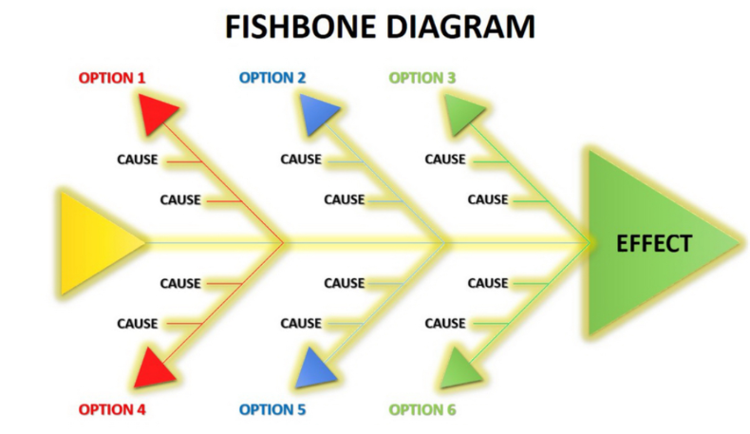

Cause
Lack of clear policies or guidelines for clothing exchange and disinfection
Inadequate communication of policies and guidelines to customers
Inadequate staff training on proper clothing disinfection procedures
Inadequate staff training on how to efficiently process clothing exchanges
Resistance to change or new procedures among staff members
Insufficient resources or technology to streamline the clothing exchange process
Limited physical space in stores to handle clothing exchanges
High volume of clothing exchanges due to economic stressors and increased living costs.

Effects
Customers not exchanging clothes
Decreased customer satisfaction
Decreased customer loyalty
Increased staff time required for clothing exchanges
Decreased staff productivity
Increased risk of transmission of germs or viruses Increased risk of negative publicity or reviews for the company
Decreased revenue due to lost sales and increased staff time on clothing exchanges

Plan to Implement the Decision to Solve the Complex Problem
Develop a detailed protocol for the clothes exchange program:
This protocol should outline the safety and hygiene standards that will be implemented in the clothes exchange program. The protocol should include procedures for cleaning and disinfecting the clothes, as well as guidelines for staff and customers to follow while participating in the program. The protocol should be developed with the guidance of public health experts and in compliance with local health regulations.
Train staff on the clothes exchange program:
Staff training should include information on the safety and hygiene protocols outlined in the program. This training should be conducted in-person or virtually and include a detailed explanation of the program, including cleaning and disinfecting procedures, handling customer inquiries, and addressing any concerns or issues that may arise during the program.
Promote the program to customers:
Marketing materials should be developed and implemented to inform customers of the new clothes exchange program. This can include in-store signage, social media posts, email marketing, and flyers. The marketing materials should highlight the safety and hygiene standards in place to alleviate any concerns customers may have about participating in the program.
Monitor and evaluate the program:
Regular monitoring and evaluation of the program should be conducted to ensure that the safety and hygiene standards are being followed, and the program is meeting the needs of the customers. Customer feedback should be collected and reviewed to address any issues or concerns that arise.

Four possible indicators to measure the effectiveness
Four possible indicators to measure the effectiveness of the implementation of the clothes exchange program with safety protocols and hygiene standards are:
Customer satisfaction: This can be measured through customer feedback, surveys, and ratings. High levels of customer satisfaction indicate that the clothes exchange program is meeting the customers' expectations and needs, which can lead to increased customer loyalty and positive word-of-mouth referrals (Ladhari, 2009).
Number of clothes exchanged: This indicator measures the usage rate of the clothes exchange program. An increase in the number of clothes exchanged indicates that customers are utilizing the service more, which can lead to cost savings for customers and reduce the environmental impact of fast fashion (Pookulangara & Shepard, 2013).
Staff feedback: The feedback from retail staff can provide insight into the effectiveness of the clothes exchange program. If staff report that the program is easy to implement and reduces their workload, it may be an indicator that the program is effective in achieving its goals (Homburg et al., 2021).
Sales revenue: Although the clothes exchange program does not generate direct revenue, it can indirectly impact sales revenue by increasing foot traffic and customer engagement. An increase in sales revenue can indicate that the clothes exchange program is a successful strategy in enhancing the overall shopping experience and increasing customer loyalty (Kim et al., 2012).

Conclusion
In conclusion, addressing the issue of customers struggling to exchange clothes due to concerns over health and hygiene in the aftermath of COVID-19 is a complex problem that requires a multi-faceted solution. The implementation of a clothes exchange program with safety protocols and hygiene standards, as well as staff training and customer education, can be an effective solution. However, the success of the implementation needs to be measured using appropriate indicators such as customer satisfaction, reduction in staff time, cost savings, and increased revenue. It is crucial to regularly review and adjust the implementation plan based on the indicators to ensure its continued effectiveness. The decision to implement a clothes exchange program is a step towards adapting to the changing needs of customers while also promoting sustainability and social responsibility.

References:
Centers for Disease Control and Prevention. (2021). Cleaning and Disinfecting Your Facility. Retrieved from https://www.cdc.gov/coronavirus/2019-ncov/community/disinfecting-building-facility.html
Chaffey, D. (2019). Digital Marketing Strategy: Implementing an Integrated Marketing Communications Plan. Routledge.
International Organization for Standardization. (2018). Risk management — Guidelines. ISO 31000:2018. Geneva, Switzerland.
World Health Organization. (2020). Key Messages and Actions for COVID-19 Prevention and Control in Schools. Retrieved from https://www.who.int/docs/default-source/coronaviruse/key-messages-and-actions-for-covid-19-prevention-and-control-in-schools-march-2020.pdf?sfvrsn=bc0f5326_4.
Roesner, L. A., Lee, J., & Studley, J. G. (2020). The COVID-19 Pandemic and Beyond: Considerations and Costs of Reopening Retail Businesses. Journal of Retailing, 96(4), 396-402. doi:10.1016/j.jretai.2020.09.001
Homburg, C., Allmann, J., & Klarmann, M. (2021). Employee Feedback and Performance: Evidence from a Field Experiment. Journal of Marketing Research, 58(2), 289-305.
Kim, H., Fiore, A. M., & Niehm, L. S. (2012). Enhancing customer loyalty through social media: An experimental study of restaurant industry. Journal of Hospitality & Tourism Research, 36(3), 282-298.
Ladhari, R. (2009). Service quality, emotional satisfaction, and behavioral intentions: A study in the hotel industry. Managing Service Quality: An International Journal, 19(3), 308-331.
Pookulangara, S., & Shepard, A. (2013). Fast fashion: Response to changes in the fashion industry. The Journal of Fashion Marketing and Management: An International Journal, 17(2), 113-132.

