
MSC Engineering Project Management ACHA 7027

Research Methods

Name: MD Niamat Ullah
ID: 2507288

Contents
1. Introduction 1
1.1 Research Rationale 2
1.2 Research Background 2
1.3 Research Aims and Objectives 2
1.4 Research Questions 2
2. Literature Review 4
2.1 Introduction 5
2.2 Factors that Influence the Accuracy of Cost Estimation 5
2.3 Causes of Cost Overruns in Engineering Projects 5
2.4 Methods of Cost Estimation in Project Management 6
2.5 Conceptual Framework 7
3. Methodology 8
3.1 Introduction 9
3.2 Research Philosophy 9
3.3 Research Approach 9
3.4 Research Method 9
3.5 Data Source 10
3.6 Data Collecting Instrument 10
3.7 Importance of the Research 10
3.8 Ethical Consideration 10
3.9 Gantt Chart 11
3.10 Methodology Summary 11
4. Results (Probable) 13
5. References 15

List of figures
Figure 1: Conceptual Framework 7
Figure 2: Gantt Chart 11

1. Introduction

1.1 Research Rationale
One of the major aspects of engineering project management is cost estimation. Numerous major engineering projects are over-budgeted. This puts a strain on the budget and minimises the project's worth. A famous example of cost overrun is the Channel Tunnel. It cost a lot more than initially estimated. This indicates that cost estimation techniques are not necessarily accurate. This study is significant as it will investigate the cause of inaccurate cost estimation. It will also assist the project managers in knowing how to enhance the practice of estimation in future engineering projects.

1.2 Research Background
Engineering projects are usually characterised by complexities and uncertainties. Early estimation of cost is carried out at an early stage of a project. Nevertheless, the accuracy of these estimates can be influenced by a lot of factors. These involve design changes, risks, inflation and poor planning (Behboud et al., 2023) . The Channel Tunnel project, which was completed in the year 1994, links the UK and France. It is among the biggest construction and infrastructure projects in Europe. The project had enormous overruns even after the planning. This case can be used as a good example to examine the issues of cost estimation. It aids in knowing how errors in estimations can affect project success.

1.3 Research Aims and Objectives
The aim of this research is to investigate cost estimation accuracy in engineering project management. These goals are to determine cost overruns causes, conduct an analysis, and learn from the Channel Tunnel project lessons. The research also seeks to recommend how the cost estimation in future projects could be enhanced. The research objectives are provided below:
- To find out the factors that affect the cost in engineering projects?
- To find out the reasons behind large infrastructure projects having cost overruns?
- To find out the impacts of estimation errors on the project of the Channel Tunnel?
- To find out the way of cost estimation enhancement in engineering project management?

1.4 Research Questions
Some research questions are developed to conduct the research smoothly. The questions are given below:
- What are the factors for estimating the cost in engineering projects?
- Why do large infrastructure projects have cost overruns?
- What were the impacts of estimation errors on the project of the Channel Tunnel?
- How can cost estimation be enhanced in engineering project management?

2. Literature Review

2.1 Introduction
This chapter is a review of the literature on cost estimation in engineering projects. It dwells on the influences on the accuracy of the estimations, the reasons for the cost overruns, and techniques in project cost management. The review is useful in developing a good knowledge of the research topic, and it assists in developing the conceptual framework.

2.2 Factors that Influence the Accuracy of Cost Estimation
In engineering projects, cost estimation accuracy is dependent on numerous factors. According to Ibrahim and Elshwadfy (2021), the level of project complexity is one of the factors. Big projects have a lot of activities, and estimation becomes challenging. The availability of accurate data is another consideration. Estimates can be inaccurate when past project data is inadequate or inaccurate. In this case, there is more technical complexity than estimated in the 50-kilometre-long tunnel. Singla and Sridharan, (2022) have stated that uncertainty is also a significant factor. At the early stage of a project, not all details are known. This results in assumptions, thereby decreasing the accuracy of estimations. Cost estimates can also be influenced by inflation and fluctuations in the prices of materials. Long project factors are usually hard to forecast. Sayed et al., (2023) have stated that estimation accuracy is also affected by human factors. Project managers can be overly optimistic in the estimation-making process. This is referred to as optimism bias. In others, estimates are purposely lowered to get approval on the project. This is referred to as strategic misrepresentation. Estimation accuracy can be enhanced by the use of technology. Better estimates can be generated with the help of such tools as cost modelling software and data analytics. Nevertheless, these tools require the quality of input data. According to Al-Gahtani et al., (2024), cost estimation can also be influenced by external forces like political decisions and economic conditions. The project costs can be elevated by alterations in the government policy or regulations. Generally, cost estimation is a complicated process. It needs precise data, appropriate tools, and plausible assumptions. Without proper management of these factors, it is probable to have estimation errors.

2.3 Causes of Cost Overruns in Engineering Projects
Engineering projects are fraught with cost overruns. Durdyev, (2021) has stated that poor initial estimation is one of the major causes. In the case of unrealistic estimates, the actual cost is an increase of the expectations. This usually occurs because the planners do not have the information. Another significant cause is the scope changes. AlKhatib, and Altarazi, (2019) has described that there may be new requirements added during the project. This makes it more expensive and impacts the budget. Continuous changes may be caused by poor scope management. Cost overruns are also caused by risk and uncertainty. The costs can be increased by technical issues, delays or challenges of the environment, which are not expected. Unless risks are identified at an early stage, they may be hard to control in the future. Gomez-Cabrera et al., (2024) have advised that cost overruns can also be a result of poor planning and control of a project. Delays can be experienced if schedules are not managed properly. Delays add to labour and materials expenses. Poor monitoring systems are also not able to identify problems early. Amini et al., (2023) have stated that misunderstandings may arise as a result of communication problems between the stakeholders. This may cause mistakes and rework that add both costs. Coordination among various teams is highly valued in large projects. Costs can also be increased by external factors like inflation and market changes. Project managers are not always able to control these factors. In short, cost overruns can be attributed to internal and external factors. Effective planning, risk management, and communication can help to reduce these issues.

2.4 Methods of Cost Estimation in Project Management
Zhang, (2025) has stated that cost estimation in engineering projects can be done in various ways. Analogous estimation is one of the methods. This is a technique that takes data from other past projects. It is quick but may not always be accurate. The other technique is parametric estimation. This approximates the costs using mathematical models and project variables. It is more precise than similar estimation but demands good data. According to Shen et al., (2025), the bottom-up estimation is a precise approach. It entails the calculation of the cost of every activity and its summation. This technique is time-consuming but more accurate. Another method which comes in handy is three-point estimation. It takes into account three values, which are optimistic, most likely and pessimistic costs. This assists in dealing with uncertainty in estimation. There is also the use of expert judgement. Mohammadi et al., (2023) have stated that estimates are made by experienced professionals. Nonetheless, such an approach can be influenced by personal prejudice. Cost estimation is now carried out using modern tools like software and data analytics. The tools are used to enhance accuracy and minimise human error. Disch, (2024) has noted that both of the approaches come with their own advantages and disadvantages. The methodology to be used varies according to the type of project, the data available, and the time. Estimation accuracy can be enhanced by a mixture of techniques.

2.5 Conceptual Framework
The theoretical guideline of this research is the correlation between the most important variables that have a direct influence on the quality of the cost estimation.
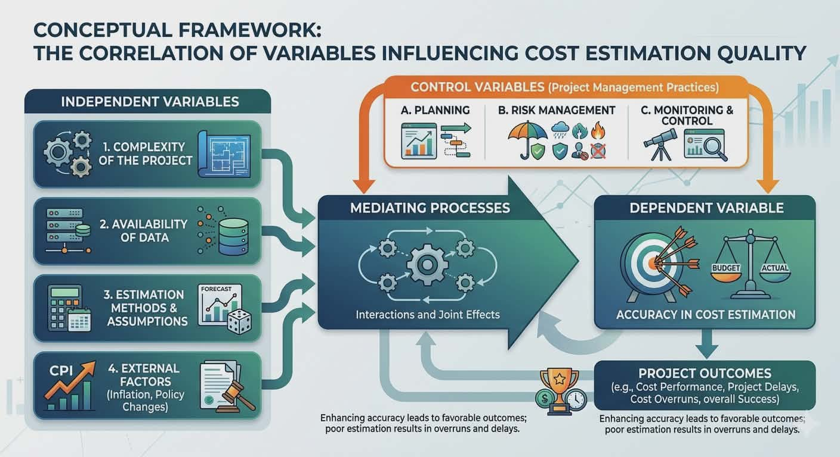
Figure 1: Conceptual Framework
Source: (Mohammadi et al., 2023)
The independent variables are the complexity of the project, availability of data, the estimations and external factors like inflation and policy changes. These variables have an impact on the dependent variable, accuracy in cost estimation. Sohrabi, and Noorzai, (2024), the quality of cost estimation has a direct impact on project outcomes in terms of cost overruns and cost performance. High project costs and project delays are a result of poor estimation. A case study is the Channel Tunnel project, where these relationships are investigated. The role of project management practices like planning, risk management, and monitoring is also taken into account in the framework. Such practices are control variables and can enhance the accuracy of estimation. The framework assists in directing the research and analysing the interactions of various factors in determining the performance of the project cost.

3. Methodology

3.1 Introduction
In this section, the research methods in this study are described. It outlines the philosophy, method, and methods of the research. It also describes the data sources and data collection instruments. The section makes the process of research systematic. The research questions are answered with the methodology. It is concerned with the study of the accuracy of cost estimation on an engineering project. The Channel Tunnel case study is used to provide real-world insights. The methods selected assist with gathering and studying pertinent data.

3.2 Research Philosophy
Positivist research philosophy is followed in this research. This philosophy is concerned with objective evaluation and quantifiable facts. It is appropriate in this research since the estimation of costs deals with quantitative data and actual facts. The study relies on the available information through reports and studies (Muaddi et al., 2024). It does not include personal views and is dedicated to facts. The positivist approach helps to identify patterns and relationships in data. It advocates a systematic and scientific approach to research. This enhances the reliability and validity of the study results.

3.3 Research Approach
The research adopts a deductive model. This method begins with the available theories and verifies them with the actual data. It is appropriate since numerous theories exist concerning cost estimation and project management (Christofi et al., 2024). The paper uses these theories in the case of the Channel Tunnel. The deductive method aids in investigating the validity of the theories in actual contexts. It gives a definite analysis framework. This method also facilitates rational thinking and enables the research questions to be answered.

3.4 Research Method
This study uses a qualitative research method. It deals with establishing why cost estimation can be problematic. The Channel Tunnel project is analysed using the case study method. Qualitative research assists in delving into complicated issues. It enables the researcher to investigate various issues that influence cost estimation. This approach is appropriate since it offers more in-depth findings as opposed to numerical analysis. It aids in comprehending the environment of the project and the challenges.

3.5 Data Source
The study is based on secondary data. These will be academic journals, books, project reports, and credible internet resources. The reason why secondary data is handy is that it gives knowledge on the subject matter that already exists. It saves time and enables access to a large amount of information (Singal et al., 2022). The Channel Tunnel project is well researched; thus, adequate data exists. The secondary data will make the research rely on authoritative sources. It also aids the thorough examination of the cost estimation practices.

3.6 Data Collecting Instrument
The document analysis is the primary method of data collection in the study. This will entail reading of available reports, articles and case studies. The pertinent information is gathered and examined to respond to the research questions. Document analysis is suitable for secondary research. It enables the researcher to obtain in-depth knowledge of the Channel Tunnel project. This technique is easy and inexpensive. It also makes the research data used to be reliable and valid.

3.7 Importance of the Research
This study has academic and practical implications. It assists in enhancing the knowledge of cost estimation in engineering projects. The findings will assist project managers in minimising cost overruns. It also gives lessons from the Channel Tunnel project. The research adds to the literature sources on project management (Ravn, 2023). It emphasises proper estimation. The study can inform the engineering projects of the future. It also assists the students and professionals in learning improved project management practices.

3.8 Ethical Consideration
This study adheres to ethical standards. All information is gathered from trustworthy and open sources. Avoids plagiarism by giving proper references. No personal data is used in the study because it does not involve human participants (Wohlin and Runeson, 2021). The study is both honest and transparent. There is no misrepresentation of information. Ethics are significant to cover the quality of research. Following these guidelines increases the credibility of the study. It also makes the research be done in a responsible manner.

3.9 Gantt Chart
The study will take a definite schedule. The initial phase is the selection of the topic and writing a proposal. The second one is a literature review. Data collection is the third stage. Data analysis is the fourth stage. Report writing and submission are the last stage. The different stages are scheduled to take a particular period of time. This helps to manage time effectively. A Gantt chart will be used to track progress. It makes sure that the research is done in time.
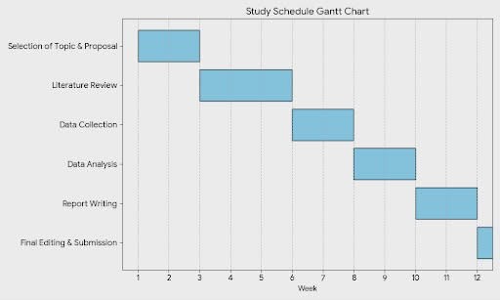
Figure 2: Gantt Chart
Source: (Wohlin and Runeson, 2021)
The study will be done in 12 weeks. Week 1-2 will be devoted to the choice of topics and writing the proposal. The literature review will be carried out in weeks 3-5. Week 6-7 will be dedicated to data gathering in the secondary sources. Data analysis will be done in Week 8-9. Week 1011 will be report writing. The final editing and submission will be done in Week 12. The Gantt chart will assist in time management and make sure that all the stages are performed on time.

3.10 Methodology Summary
This methodology uses a positivist philosophy and deductive approach. It implements a qualitative case study approach. Analysis is done using secondary data. Document analysis is the main data collection tool. The approach ensures reliable and valid results. The research is conducted in accordance with ethical guidelines. The approach is appropriate for estimating the cost accuracy. It assists in responding to the research questions in a clear manner. The systematic procedure enhances the quality of the research.

4. Results (Probable)

The research findings that are likely to be achieved in this research indicate that cost estimation in engineering projects is not usually accurate. It can be concluded that the results will demonstrate that there are several factors that lead to this problem. These are the complexity of the project, inaccurate data and uncertainty during planning (Eliasson, 2025). The research can show that the significance of the optimism bias in the context of estimation errors is significant. Planners of the project can also be underestimating costs in order to be approved. This results in unrealistic budgets. The study will also demonstrate that scope modification in the project causes high expenses (Precious, 2025). With the Channel Tunnel, the findings can be used to point out that financial risks and ineffective forecasting were some of the factors that led to cost overruns. There was high uncertainty and complex engineering in the project. These aspects rendered proper estimation challenging. It is also possible that the study will discover that the conventional estimation techniques are not necessarily efficient when used in large projects. The accuracy can be enhanced with a mix of techniques and new technology. Risk management is also likely to have its significance in estimating costs (Ghartey et al., 2026). In general, the findings will probably imply that improved planning, correct data, and realistic assumptions are required. Better estimation practices have the ability to curb cost overruns. The results will give valuable suggestions to the project managers.

5. References

Al-Gahtani, K.S. K. S., Alsanabani, N. M., Alsugair, A. M., Aljadhai, S. I., and Alotaibi, H. F. (2024) “Dynamic BIM Adoption Impact on Contract Cost Variance Factors Using PLS-SEM Techniques,” Applied sciences, 14(17), p. 8017. Available at: https://doi.org/10.3390/app14178017.
AlKhatib, M. and Altarazi, S. (2019) “A customized root cause analysis approach for cost overruns and schedule slippagein paper-machine-building projects,” Management and Production Engineering Review, 10(2). Available at: https://doi.org/10.24425/mper.2019.129571.
Amini, S. Rezvani, A., Tabassi, M., and Malek Sadati, S. S. (2023) “Causes of cost overruns in building construction projects in Asian countries; Iran as a case study,” Engineering, construction, and architectural management, 30(7), pp. 2739–2766. Available at: https://doi.org/10.1108/ECAM-05-2021-0445.
Behboud, R. arei, A., Azar, A., and Ebrahimi, S. A.(2023) “Failure to develop the world’s largest natural gas field: Lessons from endeavors in the South Pars mega projects,” Energy (Oxford), 272. Available at: https://doi.org/10.1016/j.energy.2023.127091.
Christofi, M. Ηadjielias, E., Hughes, M., and Plakoyiannaki, E.(2024) “Advancing Research Methodologies in Management: Revisiting Debates, Setting New Grounds for Pluralism,” British journal of management, 35(1), pp. 24–35. Available at: https://doi.org/10.1111/1467-8551.12791.
Disch, M. (2024) “Estimating the Costs of Product Development Projects Based on External Data: The New Product Development Cost Benchmarking Method,” IEEE transactions on engineering management, 71, pp. 5117–5128. Available at: https://doi.org/10.1109/TEM.2023.3237543.
Durdyev, S. (2021) “Review of construction journals on causes of project cost overruns,” Engineering, construction, and architectural management, 28(4), pp. 1241–1260. Available at: https://doi.org/10.1108/ECAM-02-2020-0137.
Eliasson, J. (2025) “Cost overruns of infrastructure projects – distributions, causes and remedies,” Transportation research. Part A, Policy and practice, 198. Available at: https://doi.org/10.1016/j.tra.2025.104532.
Ghartey, I. Wahab, A., Enning, S., and Arthur, B. A. (2026) “The role of Quantity Surveyors in mitigating cost overruns: evidence from Ghana’s public infrastructure projects,” International journal of construction management, pp. 1–22. Available at: https://doi.org/10.1080/15623599.2026.2643742.
Gomez-Cabrera, A., Gutierrez-Bucheli, L. and Muñoz, S. (2024) “Causes of time and cost overruns in construction projects: a scoping review,” International journal of construction management, 24(10), pp. 1107–1125. Available at: https://doi.org/10.1080/15623599.2023.2252288.
Ibrahim, A.H. and Elshwadfy, L.M. (2021) “Factors Affecting The Accuracy Of Construction Project Cost Estimation In Egypt,” Jordan Journal of Civil Engineering, 15(3).
Mohammadi, M., Spross, J. and Stille, H. (2023) “Probabilistic Time Estimation of Tunneling Projects: The Uri Headrace Tunnel,” Rock mechanics and rock engineering, 56(1), pp. 703–717. Available at: https://doi.org/10.1007/s00603-022-03022-3.
Muaddi, H. Lovrics, O., Walker, R. J., de Mestral, C., Nathens, A., Stukel, T. A., and Karanicolas, P. J. (2024) “Research methodologies for eliciting patients’ preferences in invasive procedures: a scoping review,” Langenbeck’s archives of surgery, 409(1). Available at: https://doi.org/10.1007/s00423-024-03520-8.
Precious, D. (2025) “Infrastructure project cost overrun and schedule delay in Ghana: Is it an issue of resource misallocation or financial constraints?,” Project leadership and society, 6. Available at: https://doi.org/10.1016/j.plas.2025.100188.
Ravn, S. (2023) “Integrating qualitative research methodologies and phenomenology—using dancers’ and athletes’ experiences for phenomenological analysis,” Phenomenology and the cognitive sciences, 22(1), pp. 107–127. Available at: https://doi.org/10.1007/s11097-021-09735-0.
Sayed, M., Abdel-Hamid, M. and El-Dash, K. (2023) “Improving cost estimation in construction projects,” International journal of construction management, 23(1), pp. 135–143. Available at: https://doi.org/10.1080/15623599.2020.1853657.
Shen, C. Meng, P., Shen, J., and Sun, G (2025) “A construction cost estimation system based on case-based reasoning and exponential smoothing,” Journal of Building Engineering, 113. Available at: https://doi.org/10.1016/j.jobe.2025.114120.
Singal, A.K. Kwo, P., Kwong, A., Liangpunsakul, S., Louvet, A., Mandrekar, P., McClain, C., Mellinger, J., Szabo, G., Terrault, N., Thursz, M., Winder, G. S., Kim, W. R., and Shah, V. H. (2022) “Research methodologies to address clinical unmet needs and challenges in alcohol‐associated liver disease,” Hepatology (Baltimore, Md.), 75(4), pp. 1026–1037. Available at: https://doi.org/10.1002/hep.32143.
Singla, H.K. and Sridharan, S. (2022) “Factors influencing the level of accuracy and compromise in overhead estimation for construction projects in India: an exploratory investigation,” Engineering, construction, and architectural management, 29(10), pp. 4040–4060. Available at: https://doi.org/10.1108/ECAM-04-2021-0362.
Sohrabi, H. and Noorzai, E. (2024) “Risk-supported case-based reasoning approach for cost overrun estimation of water-related projects using machine learning,” Engineering, construction, and architectural management, 31(2), pp. 544–570. Available at: https://doi.org/10.1108/ECAM-05-2022-0450.
Wohlin, C. and Runeson, P. (2021) “Guiding the selection of research methodology in industry–academia collaboration in software engineering,” Information and software technology, 140. Available at: https://doi.org/10.1016/j.infsof.2021.106678.
Zhang, X. (2025) “Dynamic Cost Estimation and Optimization Strategy in Engineering Cost Combining Reinforcement Learning,” Applied mathematics and nonlinear sciences, 10(1). Available at: https://doi.org/10.2478/amns-2025-0844.

