Change Management Portfolio
Student: Cristian Dumitru – 2108821
Module Code: BMSW6103

Lecturer: Prof Dennis Pepple

Table of Contents
Introduction 3
Influence of Lewis model in understanding influence of culture communication, negotiation and feedback practices 4
Ethnocentric and Polycentric Models and their Applicability in People Management 11
Interview Transcript 16
Determination of Lewis model from the Findings of the Interview 17
Recommendations 20
Conclusion 21
References 22
Appendix 31

Introduction
Leadership and management are essential in the context of organisational changes (Bush, 2020). It is because they identify a variety of cultures, and their associated opportunities and challenges. The role of leaders in organisations primarily aims to influence multiculturalism approaches. It means valuing every culture and belief operating in an organisation. Management and leaders are responsible for building effective communication between departments and different cultures, to maintain transparency in the chain of governance. It is stated that leaders foster adaptability in the organisation, providing flexibility to employees. It becomes necessary for multinational companies that have their operations in more than one country. Effective leadership and management through various approaches allow them to take challenges of the organisation as an opportunity. It means leaders and managers solve issues in one organisation and implement it as an example in another.
The UK company Universal Elect Plc was recently acquired by Energy Group which has its operation in UAE. The acquisition process allowed them to derive success beyond borders. However, the company allocated tasks to their employees for building effectiveness, and to complete the successful acquisition process.

Influence of Lewis model in understanding influence of culture communication, negotiation and feedback practices
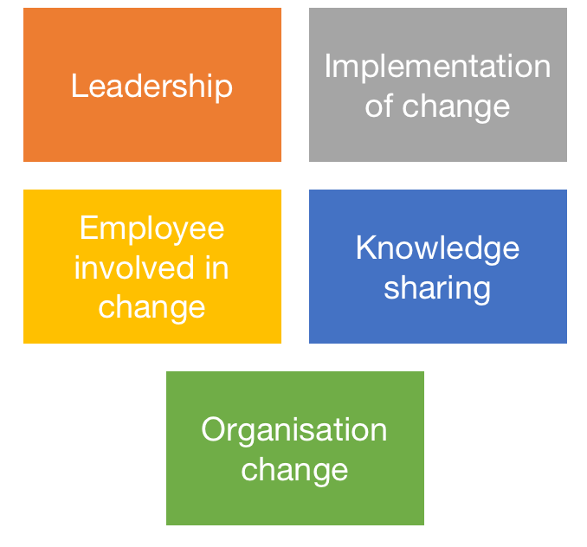
Figure: Lewis Model
Source: (Self-designed)
Employee Involvement in Change
Communication
According to Kazancoglu et al. (2021), organisations that have operations in more than two countries can build communication with a linear active approach. It means workers who are working within the organisation have to specify their outcomes. It is effective for getting positive outcomes in terms of goals. Energy groups from UAE working under linear activities are more straightforward in their goals and implement rules and procedures. For communication, they believe in clarity and on-point facts rather than implicit.
Factors | High context culture | Low context culture
Overtness of message | Many covert and implicit messages, with the use of metaphor and reading between the lines | Many overt and explicit messages that are simple and clear
Locus of control and attributes for failure | Inner locus of control and personal acceptance for failure | Outer locus of control and blame of others for failures
Use of non-verbal communication | Much non-verbal communication | More focus and verbal communication than body language
Expression of recreation | Reserved, inward reactions | Visible, external, outwards reaction
Table I: Hall's Cultural Context Theory
Source: (Self-designed)
Overtness of message
Cosman (2021), illustrated that in the UAE have a high-context culture of an organisation, the overtness of the message is implicit. It means employees choose metaphors for communication such as symbols and actions. The communication for cultural changes is not processed as direct, and the indirect chain of communication operates between employees. It is considered beneficial for people who belong to the same cultural beliefs, as their actions are similar. They can read each other's perspective very well. However, Stahl and Maznevski (2021) added that in a multicultural environment where two companies operate in different countries, the implication is not effective. However, the UK have low context culture is beneficial for people who have different cultural norms. Communication under low context cultural organisation is clear. People can share their values easily and in simple terms. Understanding of people for others’ cultural significance is also higher than high context culture.
Locus of control and attributes of failure
The high context culture of UAE organisations is more focused on personal acceptance and failure. As it is defined, employees from high-context cultures do not communicate well with others. Their passive approach to culture change in the organisation is the primary reason for acceptance. Employees from these kinds of organisations adapt to failure for change and work to make it effective. However, Duryan et al. (2020) said that employees from the UK who have a low context culture in their organisation blame others for the failure. It means they primarily want to know about who the reason for this failure is. Additionally, they don't want to blame themselves and accept failure for organisational cultural change, rather than focusing on blaming others. The low context culture organisation is not completely beneficiary for knowing the consequences behind change.
Use of non-verbal communication
As per Broeder (2021), for the high context theory of UAE, they use non-verbal communication more. It means rather than sharing thoughts through oral, they are more focused on body actions and behaviour. Their whole communication is dependent on how they react to cultural change in the organisation, and it is not very effective for communication. The non-verbal communication for business cultural change does not allow us to share all the perspectives of employees. However, according to Braslauskas (2020), pointed out that the low context theory of the UK is highly focused on verbal communication. It means people want to share every single thing that happened or occurred during cultural change. Body language is also a part of this communication, but they mainly focus on verbal communication.
Negotiation
Expression of Recreation
Qi (2023) defined the expression shown in the high-context culture of UAE referred to as inward. It means while getting the achievement or completing the objective of the organisation, the employee does not show much expression. They facilitate inward feelings and again communicate through body language. In the UK’s low context culture of the organisation, people share the recreation with joy and feeling. Their excitement is reflected as external and visible to everyone. It is effective for the organisation too, as other employees can feel motivated too.
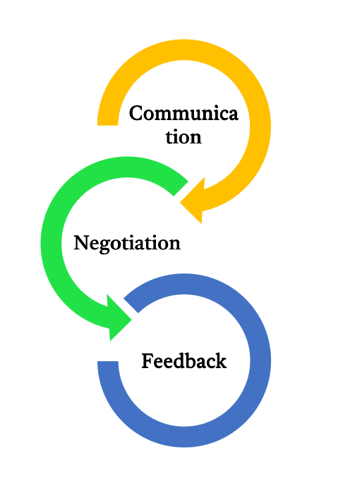
Figure: Steps needed for involvement in change
Source: (Self-designed)
Reinissch and Karimi (2020), illustrated that it is essential for multicultural organisations such as Energy Group and Universal Elect Plc as clarity between two cultures mitigates miscommunication, and workers working under the organisation can process with more effectiveness. This kind of approach prefers individual achievement, rather than aggregate. It is considered beneficial for leaders because people value beliefs and take less part in the change process of the organisation. Leaders and management have to bring all employees in front of both operating countries. It doesn't matter whether they belong to a linear or active culture. Their involvement in changes is highly effective for the whole organisation. However, leaders and managers have to negotiate for this. It means each employee of the organisation does not have the same values for the beliefs and culture of the organisation.
Feedback processing
According to Guzman et al. (2020), the negotiation process of organisations of the UK and UAE is necessary, which means how leaders interact with others. The process allows to bring the value of workers within an organisation that does not hurt their own beliefs too. The negotiation process primarily includes interaction and communication with employees about what the employee thinks about the organisation. The negotiation process in the involvement of change includes knowing the beliefs of employees and focusing on implementation based on this. The cultural change of the organisation does not allow it to hurt other sentiments and beliefs while addressing others. So, organisations have to focus on the negotiation process first while adapting to the cultural change in the organisation. Further Nahar et al. (2022) added that the feedback process during the first stage, allows the Energy Group of UAE to get regular updates on the negotiation process. In the negotiation process, there is only the need for employees who would be affected by the cultural change in the organisation. But it is the responsibility of the organisation to determine all the consequences of cultural change, and further negotiate with them. The negotiation process should not force any employee to change their beliefs and values, rather than aim at how the organisation can solve their cultural issues if they have. Further, Universal Elect Plc can take regular feedback from them after the successful implementation of the negotiation process. It means how the process affected them and what is their approach after negotiation. The feedback process for organisations in their involvement in change focuses on communication and feedback from each employee, who has been affected due to cultural change. So Li et al. (2021) said that the organisation has to process transparent and communicated feedback with their employees to produce a change in the organisation.
Knowledge sharing
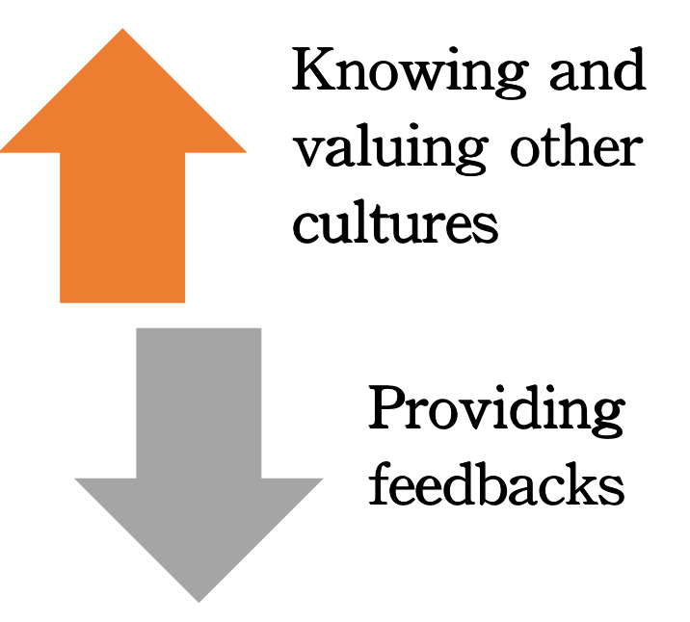
Figure: Knowledge-sharing approach
Source: (Self-designed)
According to Memon et al. (2020), the knowledge-sharing approach is essential for implementing cultural change in the UAE. It includes how employees can share their beliefs and values with others. For the communication process of two countries, while sharing knowledge, it is considered that both have to share their norms. It means the company belongs to the UK and holds special beliefs for their culture and it is similar for employees working in the UAE too. So, the knowledge-sharing process allows one to communicate with others based on cultural beliefs. That means an employee from the UK, can share their approach toward culture change in an organisation with an employee from UAE.​​ The knowledge-sharing process aims to share cultural norms, ideas, and perspectives for others' values. It is beneficial for employees as well as organisations. Employees can get to know about others' beliefs which allows for better cultural efficiency. Pereira and Mohiya (2021), state that in the negotiation process of knowledge sharing, the organisation allows both companies from different countries to have negative over positive outcomes. It means the employee can negotiate if their negative perspective is held by others. While working with a knowledge-sharing approach, there is a high chance for negotiation because the values of employees are different. They have different perspectives and ideas, so the negotiation allows them to stand with the right approach. For instance, employees in the UAE are not sharing the right words for the culture of the UK and are not responding well to knowledge sharing. It would be the responsibility of the UK’s employees to rectify this, by correcting mistakes and sharing the right and positive words.
Leadership
According to Li et al. (2021), employees look up to their leaders during these anxious times of change and seek advice from their dependable managers and supervisors in the UAE. One of the biggest obstacles to change is employee resistance, thus it's imperative that leaders provide guidance and mentoring to staff members. Effective leadership in UK communication during the change process helps to overcome resistance and enhances the change's outcome. Organisation risk having a big gap in change support if executives aren't taught how to communicate with staff and other stakeholders. When managing change, change agents don't confine themselves to one or two responsibilities. They must take the initiative and carry out their duty of bringing about change, the results of which are yet to be determined.
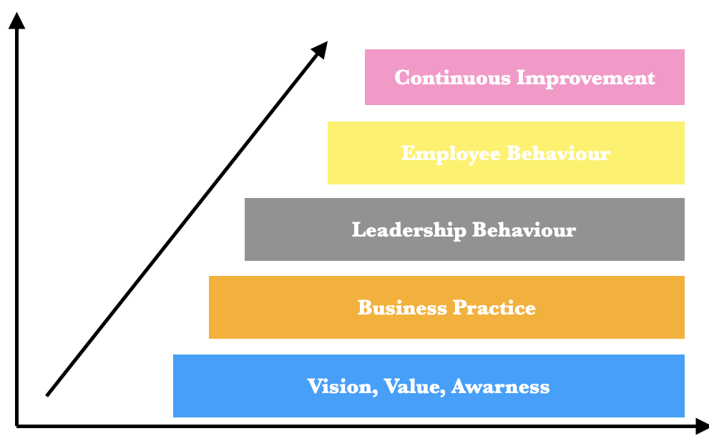
Figure: Leadership approach for cultural change
Source: (Self-designed)
In the very first process of leadership management, the leaders have to analyse the mission, value, and vision of both companies. It means leaders have to analyse the value of each employee belonging to both companies. The process of identifying the vision of a business allows leaders to implement an effective strategy for cultural change in the organisation.
Business practice
Bagga et al. (2023) added that it is also essential for leaders to process and practice as per their business to support cultural business change. The strategy allows us to know about the needs of businesses, especially cultures. So, the leaders can process the effective culture for both companies whether they are operating in the country.
Leadership behaviour
The leaders and their behaviour are responsible for implementing cultural change in the UAE. It means their communication and motivation for employees to accept the change in the organisation. The role of leaders and their behaviour is highly considerable from the UK’s perspective to facilitate multicultural organisation.
Employee behaviour
According to Anselmann and Mulder (2020), the behaviour of employees is a reflection of leadership behaviour. It means employees’ behaviour is facilitated by how leaders behave with them. Leaders must process with effectiveness and transparency in business organisation, to get the best employee behaviour.
Continuous improvement
In the final stage of leadership, the leaders have to monitor the improvement of the organisation. It means they have to analyse what has improved after implementing organisational change in them. Along with that, they also have to manage the rectification of changes. It means if there is any new change needed in an organisation to make it more effective.
Implementation of change
Errida and Lotfi (2021) illustrated that creating a vision for the UK’s culture is the first stage in putting an initiative to alter culture into action. The vision needs to be engaging. It should outline the organisation's ideal future state as well as how the new culture will contribute to it. Evaluating the current culture of the UAE is the second step in putting a culture change initiative into action. This means determining which aspects of culture should be modified and which should be maintained. Communicating is the fourth step in the implementation process. It means putting all the plans into action. The process aims for successful communication between the management of the UK and UAE to ensure the success of change. The strategy also comes under the responsibility of leaders as they have to implement clear, regular, and consistent communication. It should be adaptable for every employee and management affected by the change process. Further, organisations have to engage their employees in implementing and processing the strategy in action. It means the suggestions and feedback of the employee must be put into the change plan by the organisation. After that, the UK has to monitor the culture change of the organisation. The monitoring process will insight into the required changes. Maintaining cultural change in the company of UAE and UK is a continuous process that calls for constant work and dedication.

Ethnocentric and Polycentric Models and their Applicability in People Management
Ethnocentric Model:
Lemos et al. (2020) stated that a particular strategy for global acquisition follows the ethnocentric procedure in which human resources selects candidates based on their eagerness to integrate into the atmosphere of the company and their suitability for a certain role for multinational corporations. The reasoning behind it entails that the original organisation’s employees are superior to other workers and have a greater capacity to uphold headquarters’ interests. Therefore, this strategy is advantageous in terms of a fresh division being established in the host nation and the parent business staff travelling there to start business activities. It is easy to transmit the holding firm’s culture and working environment to its overseas affiliate bringing values and customs within the foreign nation.
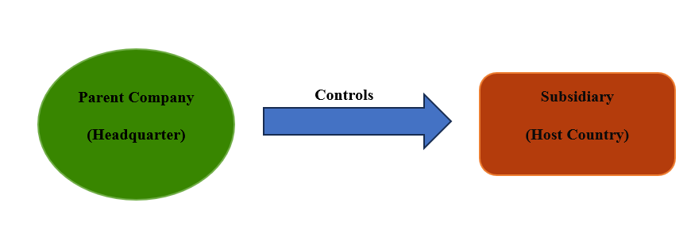
Figure: Ethnocentric Approach of a Business
Source: (Self-created)
According to Eklöf and Haniya (2023), the ethnocentric model defines the approach taken by any business firm when it has overtaken another enterprise and recruited staff. Nations that maintain outposts abroad must choose methods to allocate personnel to the management position. In addition, employing managers as well as other staff members for the entire operations who share the parent business’s country is termed ethnocentric employment. Therefore, Azungah et al. (2020) mentioned that an ethnocentric technique is implemented by businesses that exclusively select people who belong to the founding area’s population to perform duties in their host country. More advanced foreign posts are typically occupied by foreign nationals who are expatriates from the underlying nation. In the context of Energy Powers, during the time of takeover, there must be a smooth transition of employment. Therefore, the company can concentrate on an ethnocentric model for hiring people from the UK to facilitate functions in the Energy Powers branch opened in UAE. The main justification for the ethnocentric strategy revolves around how personnel representing the founding nation would successfully advocate the priorities of the office and establish strong ties alongside it.
Lee et al. (2022) highlighted that to make it simpler for any corporation’s rules and processes to be carried across the nation of its origin to the newly established unit, the firm employs the ethnocentric methodology while creating a brand-new division in a different region. The percentage of foreigners outside the parent area must be lower compared to the average with a foreign subsidiary to enable overall recruitment expenses and prevent losing touch with the local population. In addition, the parent firm and the place of business usually coordinate more successfully and communicate properly with each other.
Polycentric Model:
Zhong et al. (2021), pinpointed that businesses populate various roles in destination countries with locals thanks to the polycentric technique for staff enlistment. For instance, companies may sign a binding agreement with a nearby employment firm or post an advertisement on employment sites in the area. When corporations depend on the expertise of natives to carry out such company tasks, they employ this approach for hiring and selecting suitable staff members for their organisations. Gatto (2022), demonstrated that major companies would employ a local expert who is familiar with the area and capable of managing their sales activities if they wanted to increase their customers to include a certain nation. This strategy is being used to steadily lower the expenditures of operating abroad. Furthermore, businesses that adopt an ethnocentric mechanism at first might change to a polycentric procedure in the future for their accomplishment.
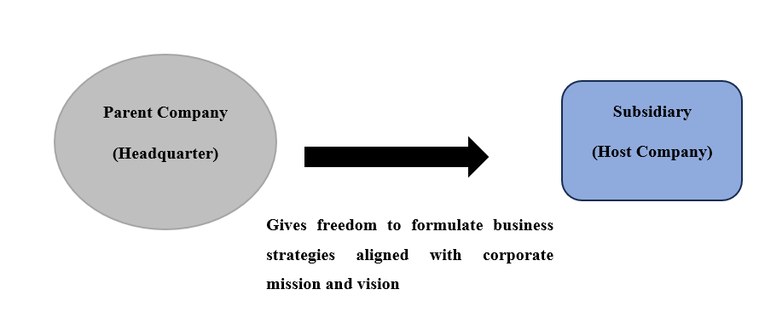
Figure: Polycentric Approach of an Organisation
Source: (Self-created)
Iwashita (2023), defined that if any enterprise’s objective is to grow its client base to a specific nation, the business may seek a regional specialist who has been acquitted with the area and can tackle marketing efforts aligned with its organisational purpose. As a result, people who are citizens of the nation where they are staying are sought after for executive roles to execute the day-to-day activities of the affiliated firm. Haeffele et al. (2023), opined positively toward the polycentric approach for recruiting and developing organisational culture within the multinational business context. Major businesses opt for the polycentric technique since, in comparison to their overseas counterparts, residents in the target nation are more adept at running the firm and have a deeper understanding of the local tradition and culture based on social background.
According to Ding et al. (2022), the main goal of transferring administration to locals is to make certain the business has an increased awareness of the current political circumstances. Social standards, and regulatory needs of that particular area. Businesses that use this approach typically include a regional HR team that oversees the organisation’s human capital in that nation. On the other hand, Ewing et al. (2024) showcased that the execution of the polycentric model can be beneficial for foreign businesses as the entire technique of staffing and ideology can enhance staff morale within the organisational context and this idea can immediately lessen the total costs of staffing as well as making team adjusted to each other.
In contrast, Diab (2022), narrated the difficulties that multinational firms can encounter with their practiced polycentric approaches, notably in the context of conflict. A problem with the polycentric method is that it may lead to a disconnection between the branches and the parent corporations. This may occur as a result of the fresh workers’ potential lack of familiarity with the past or traditions of the parent organisation compared to previous group members. Therefore, such firms must be careful about strategy implementation to encourage communication amongst staff throughout both regions to prevent this. Additionally, it might be challenging to comprehend the management framework of a multinational corporation especially if there are several supervisors, administrators, and executives.
Applications of Ethnocentric and Polycentric Models in People Management:
Transitional corporate activities are now the standard for numerous businesses in an environment where everything is linked more and more. In addition, enterprises are still required to establish a mindset or approach regarding dealing with organisations globally when they venture abroad. Bader et al. (2021), declared that an entity’s approach to international commercials can be shaped by both ethnocentric and polycentric mindsets, which have an impact on ranging from advertising campaigns to HRM. Several businesses can be persuaded to take an ethnocentric viewpoint toward their HR procedures to diminish the perception of danger in such novel initiatives. As a result, ethnocentric corporations assign foreign nationals to prominent positions and uphold identical laws and customs outside as they do domestically.
Hiring and choosing:
Aguzzoli et al. (2021), elaborated that an ethnocentric enterprise believes that competent workers would not be available in the host nation. Therefore, such corporations try to offer employment to locals for entry-level jobs, although the process will only hire professionals from their homeland for supervisory and specialised roles. Companies adopting ethnocentric ideology run the possibility of enforcing social conventions representing their native nations within their recruiting procedures. As it demands credentials not offered in the host nation or that lower-level staff members understand another language in order to interact with foreign management, it can have trouble hiring qualified candidates.
Compensation and benefits:
Schaefer (2020), described that overseas workers are frequently given increased compensation and additional perks to entice people to take on offshore postings. Such deals usually consist of higher additional benefits, airfare for the staff members alongside their families, and lodging costs in the destination nation. The salary gap between domestic and foreign workers should be handled with caution by HR since it can lead to conflict. As pay disparities might discourage citizens of the host region, premium compensation and other remuneration for foreign professionals may also negatively affect the organisation’s revenue.
The beneficial sides of the polycentric approach in terms of recruiting people and their administration within multinational enterprises while expanding their businesses to other nations.
Promoting understanding and awareness in the workplace community:
Local workforce and members may feel completely at ease dealing with prospective consumers and business clients. This can enhance client interactions and relations, determined by the kind of business and the manner in which recruitment is conducted as understood by Gatignon and Capron (2023). Employing in a polycentric manner might additionally assist a business in obtaining the backing of regional and domestic authorities.
Raising team morale:
Employees can contribute to improved spirits inside the organisation if they are content in the workplace setting and have a consciousness of the culture of the region as quoted by Jena (2022). Businesses stimulating a polycentric methodology can aid their people in the neighbourhood to assimilate within organisations and supply additional opportunities when they deploy this special strategy. By functioning this team members’ satisfaction and dedication can be maximised.
Eliminating employment and moving expenses:
Employing applicants within the selected firm can result in cost savings as depicted by Xiu (2021). The reason for this is getting together and chatting with foreign employees frequently incurs more expenditures than domestic alternatives. By not having to make arrangements for the workforce supplied by the parent corporation to move elsewhere, the company may additionally preserve capital by diminishing relocating costs.
Therefore, it can be better for Energy Powers to strengthen its HRM strategies by integrating both approaches together in UAE in its acquisition of Universal Elect Plc as through ethnocentrism the company can control its subsidiary while it utilises a polycentric method to keep local staff for knowledge and understanding of the local market.

Interview Transcript
The interview happened between two students who are from the UK and UAE. The interviewer was from UAE and was not completely significant for the multicultural approach in the organisation. However, the interviewee has a strategic perspective on this, as he thinks that a multicultural environment is effective for business success.
Interviewer: Good morning mate! Can you please start the process by giving a perspective on adaptability for different cultures and its necessity?
Interviewee: good morning. I have highly effective thinking toward a multicultural approach to the organisation. As of now in the UK, nearly every organisation processes this, it is because adaptability allows them to build a trustable and transparent organisation.
Interviewer: That’s good. So, why should organisations include diversity and multiculturalism in their organisation? Like, in UAE most people come from arab culture and foreigners are too accepting of our culture to live here.
Interviewee: Look. The multiculturalism approach is essential for providing value to each one's beliefs. In the UK, people come from diverse cultures such as black and white. We lived in societies where various types of beliefs were held by people. So, the diversity of culture shows the ethicality of management and reflects a needed perspective for the environment.
Interviewer: So, as per you what could be the strategy for this, if a business wants to expand in the UK from UAE?
Interviewee: I think that organisations have to provide training to their employees for implementing multicultural approaches in their organisation. It would be essential for both old employees and newly hired employees. The new recruitment process should not discriminate against applicants based on culture. I saw that some companies in the UK preferred white people over black, whereas most companies have diversity in their environment. Organisations can regularly process surveys and training for multiculturalism because people's beliefs change periodically based on the environment.
Interviewer: Okay, that’s effective. Just end the process by pointing to the role of leaders and managers for this.
Interviewee: Managers and leaders are essential because they interlink all the cultures at once. They are responsible for effective communication between the two companies and ensure the effectiveness of a multi-cultural approach.

Determination of Lewis model from the Findings of the Interview
The entire interview session focuses on the factor of the significance of cultural change and multiculturalism within any business setting. As the participants come from different cultural backgrounds, the interviewer is from UAE whereas the interviewee belongs to the UK. While interviewing with many questions, the cross-cultural segments are coming which reflects this case study as well. According to the Lewis model of Culture, both countries showcase their cultural behaviour differently as both of them are from distinctive segments implemented by Lewis in his approach. The UK is in the “linear active” dimension whilst the UAE belongs to the “multi-active” domain (Akour et al., 2022). The purpose of the Lewis Model consists of determining which specific cultural population a person feels most empathetic toward.
Therefore, the UK people are mostly task-driven, extremely structured strategists who value completing tasks individually at a moment in a predetermined order. Regulations must be obeyed although arguments are formed logically in the UK’s culture. This is shown through the presentation of the interviewee while answering questions from the interviewer. Comparing participant’s beliefs and choices to those of other ethnic groups is another option. On the other side, belonging to the UAE, citizens are in general profound, talkative, and energetic people who prioritise their connections, family, and sentiments before sticking to a schedule. In addition, they feel at ease doing numerous tasks concurrently, and in this context, the interviewer is exhibiting the same kind of characteristic in his or her behaviour. Both of them are well aware of the cruciality of the integration of multiple cultures within any organisational context in modern days.
In order to build more solid connections, the Lewis model may be helpful to recognise and understand distinctions between different cultures (Westlund et al., 2021). Therefore, this approach can be a great strategy for constructing a team as well since it allows the person to evaluate the entire team at once and everyone’s preferred area within the framework of cultural variation. Following evaluation, the person’s cultural characteristic is displayed around the triangle formulated by Lewis indicating how near or far they are from the main cultural groupings across the globe. It illustrates the degree to which their behaviour resembles the norms of different nations alongside how closely it reflects or deviates from their respective national pattern including how effectively they get along with other individuals. If participants of a prospective crew undergo assessments continuously, this is especially helpful.
By raising one’s comprehension about how that person interacts with others along with the way it could vary from colleagues’, the approach laid out by Lewis might aid that individual in interacting more effectively. People can prepare for unexpected difficulties and possibilities before engaging with other individuals having various cultures by being aware of the key traits associated with every cultural variety (Jones et al., 2020). In the case of this interview segment, a multi-active individual who is the interviewer here, on the other hand, may choose greater friendliness, openness, and sensitivity during their conversation. As the interviewee is a linear-active holder, therefore that individual might appreciate simplicity, productivity, and details, however, he or she could additionally come over as frigid, straightforward, and restless in front of the interviewer. Conversely, being a multi-active person, the interviewer might value randomness and innovation although that person may appear as unorganised, impetuous, and impolite to the interviewee or a linear-active believer who might seek greater organisation and preparation.
By utilising the Lewis ideology as a potent tool, organisations or leaderships hope to convert various distinctions into chances for enhancement and cooperation. In addition, managers may cultivate welcoming atmospheres, solidify connections, and make knowledgeable choices that value variety and inclusiveness by comprehending the subtleties of intercultural behaviours along with inclinations. The socioeconomic backgrounds of the people engaged have a big impact on the challenges presented by blending business cultures including working duties, hiring procedures, management, scheduling, and decision-making. Making the right accommodations and modifications is crucial for developing and synchronising corporate culture. Productive corporate partnerships are cultivated by efficient multicultural knowledge, and this results in an innovative environment that takes advantage of cultural inclusiveness and invention (Dinu et al., 2023). Additionally, supervisors can forge better bonds with coworkers, customers, and staff members from diverse cultures. As a result, they are well-versed in social expectations, ways to converse, and cultural distinctions. With this knowledge, they may avoid misconceptions, modify their interaction strategies, and nurture a diversified polite workplace that celebrates heterogeneity.
Individuals can modify their method of communicating through the application of the aforementioned model which offers useful advice on how to overcome cultural differences and capitalise on each group’s advantages. When interacting with the interviewee (linear-active) in this context, others might wish to stick to a defined target and deadline, be succinct, accurate, and reliable, and minimise interruptions. On the other hand, while speaking with the interviewer (multi-active), others can choose to be approachable, passionate, and sympathetic, give room for some experimentation, and pliability, and support others’ ideas with demonstrations and tales.
Decision-making gets better by having an in-depth grasp of cross-cultural interaction values and habits (Abdeldayem et al., 2022). Cultural dynamics have a big impact on the organisational ability to observe and assess insight, create opinions, and explore addressing concerns. In addition, understanding these divergent cultures enables employees as well as their supervisors to come up with accurate choices that take into account a variety of viewpoints and steer clear of prejudices. This fosters an attitude of justice and equality throughout the business in addition to rendering decision-making quicker and easier.
In order to successfully deal with the intricacies of multicultural interactions, managers and businesses have access to an array of materials and standards. These consist of interdisciplinary contractors, cultural training courses, and scholarly research. There are cultural differences in desires, attitudes, and professional practices. For the sake of talent acquisition and hiring tactics, it is essential to examine intercultural tendencies and interests. Corporations can draw and hold on to great people from a variety of areas by understanding and valuing these distinctions. Furthermore, by taking into thought the requirements and goals of a diverse employee pool, diversity-driven norms, and procedures may be developed and executed to uplift worker happiness, performance, and involvement.

Recommendations
Several suggestions are provided to promote a cross-cultural approach within the organisations notably in the time for its expansion and merging with other companies.
Advancement of communication:
Naturally, one of the biggest issues confronted when it pertains to coping with multinational staff is communication. Speaking at the same speed as native speakers may not be an excellent plan in ethnic workplaces. The ideal strategy is to express individuals a little more articulately, carefully, and with an affected intonation than usual. Make use of concise phrases and tine phrases and give the audience a little space to process individuals’ main points by halting briefly among them (Ogbogu et al., 2022). Individual gestures are supposed to render it clear how much they are observing throughout. In relation to interpersonal interaction, make an effort to make certain that all of the information organisations convey to their group is clear and intelligible to all parties. As this is possible, avoid leaving anything up for dispute. Instead, depend upon transparency to lead the entire group to success. Ultimately open communication policy promotes communication among members of the group. In addition, face-to-face communication improves association and creates confidence, which is divided and boosts efficiency.
Provide equal opportunities to employees:
A diverse workplace is produced by including equal opportunity for all workforce in any organisational cross-cultural leadership approach. By using cross-cultural leadership, organisations are stating unequivocally that the firms simply are going to oppose discrimination in hiring, pay, promotions, terminations, or different workplace procedures (McGee, 2023). Several businesses additionally create the norm regarding the way their staff members ought to interact with other staff by carrying out this. Employers must prevent prejudice when upgrading staff members by examining previous employment reports to determine whether any particular team is given preference.
Administer multicultural conflicts:
There are cultural disparities in the ways that personnel from different backgrounds engage and interact with their peers. These discrepancies could turn into confrontations under the strain and anxiety of professional obligations. Whenever this happens, settle the disagreement as quickly as the leaders can to avoid negative outcomes such as being sued (Yin et al., 2022). Companies are required to identify the underlying source of problems at work before enforcing necessary transformations to resolve them. Given that this occurrence was caused by racial bias, punishing racial bullying with termination could stop it from happening in the future and discourage similar behaviour. Restoring peace within working environments through multicultural oversight enables companies and their staff members to concentrate on productivity and achieving organisational objectives. Diversity along with inclusion tactics ought to put safeguards aside to try and steer clear of these circumstances with very initial effort and position.
Offer cross-cultural training:
It may be less easy for any firm and its staff to formulate a rapport with one another irrespective of how diversified they are. Investing in cross-cultural training and improvement programs along with multilinguistic training arrangements can help address this problem by giving employees the tools they need to communicate and carry out their work together with people of different cultural backgrounds (Mangla, 2021). Training initiatives are beyond job benefits. Firms can utilise such undertakings to effectively handle culturally diverse people and manage their conflicts.

Conclusion
Cultural change in organisations is a necessary approach in modern business organisations. It is because of the complex business environment process with a multifaceted approach, that businesses have to derive multiculturalism to achieve success. In this process, leaders hold a high role because they are responsible for ensuring the variety of cultures in the organisation. The communication between employees and their thought processes with management allows them to accept diversity in a more enhanced way. Energy groups that are planning to acquire a company in the UK, have to plan their cultural diversity effectively. This is because their main operating company is in the UAE, and the new UK has a different vision in terms of culture. The organisation has to implement leadership in their organisation, for both countries. It will allow for improved management in the internal workforce environment of the company because a multicultural approach for both operating countries will build brand image.

References
Abdeldayem, M.M., Aldulaimi, S.H. and Alazzawi, A., (2022), March. Leadership Cultural Intelligence to Improve Decision Making Process in Cross-Cultural Work Atmosphere. In 2022 International Conference on Decision Aid Sciences and Applications (DASA) (pp. 1182-1191). IEEE. Available at: https://www.researchgate.net/profile/Saeed-Aldulaimi/publication/360323603_Leadership_Cultural_Intelligence_to_Improve_Decision_Making_Process_in_Cross-Cultural_Work_Atmosphere/links/633d765f9cb4fe44f305982c/Leadership-Cultural-Intelligence-to-Improve-Decision-Making-Process-in-Cross-Cultural-Work-Atmosphere.pdf (Accessed on 11 March 2024)
Aguzzoli, R., Lengler, J., Sousa, C.M. and Benito, G.R., (2021). Here we go again: a case study on re‐entering a foreign market. British Journal of Management, 32(2), pp.416-434. Available at: https://onlinelibrary.wiley.com/doi/pdf/10.1111/1467-8551.12407 (Accessed on 11 March 2024)
Akour, I., Alnazzawi, N., Alshurideh, M., Almaiah, M.A., Al Kurdi, B., Alfaisal, R.M. and Salloum, S., (2022). A Conceptual Model for Investigating the Effect of Privacy Concerns on E-Commerce Adoption: A Study on United Arab Emirates Consumers. Electronics, 11(22), p.3648. Available at: https://www.mdpi.com/2079-9292/11/22/3648 (Accessed on 11 March 2024)
Anselmann, V. and Mulder, R.H., (2020). Transformational leadership, knowledge sharing and reflection, and work teams’ performance: A structural equation modelling analysis. Journal of Nursing Management, 28(7), pp.1627-1634. Available at: https://onlinelibrary.wiley.com/doi/full/10.1111/jonm.13118 (Accessed on 11 March 2024)
Azungah, T., Hutchings, K. and Michailova, S., (2020). Ethnocentric HRM practices: evidence from Western MNEs in Ghana. International Journal of Emerging Markets, 15(5), pp.829-848. Available at: https://www.researchgate.net/profile/Snejina-Michailova/publication/340005126_Ethnocentric_HRM_practices_evidence_from_Western_MNEs_in_Ghana/links/5ec31108458515626cb4b562/Ethnocentric-HRM-practices-evidence-from-Western-MNEs-in-Ghana.pdf (Accessed on 11 March 2024)
Bader, A.K., Bader, B., Froese, F.J. and Sekiguchi, T., (2021). One way or another? An international comparison of expatriate performance management in multinational companies. Human Resource Management, 60(5), pp.737-752. Available at: https://onlinelibrary.wiley.com/doi/pdfdirect/10.1002/hrm.22065 (Accessed on 11 March 2024)
Bagga, S.K., Gera, S. and Haque, S.N., (2023). The mediating role of organizational culture: Transformational leadership and change management in virtual teams. Asia Pacific Management Review, 28(2), pp.120-131. Available at: https://www.sciencedirect.com/science/article/pii/S1029313222000355 (Accessed on 11 March 2024)
Braslauskas, J., (2020). Effective creative intercultural communication in the context of business interaction: theoretical and practical aspects. Creativity studies, 13(1), pp.199-215. Available at: https://bmee.vgtu.lt/index.php/CS/article/view/12094 (Accessed on 11 March 2024)
Broeder, P., (2021). Informed communication in high context and low context cultures. Journal of Education, Innovation, and Communication, 3(1), pp.13-24. Available at: https://pure.uvt.nl/ws/portalfiles/portal/50689011/1_2021_JUNE_JEICOM_Broeder_13_24.pdf (Accessed on 11 March 2024)
Bush, T., (2020). Theories of educational leadership and management. Available at: https://www.torrossa.com/en/resources/an/5018841 (Accessed on 11 March 2024)
Cosman, O., (2021). Cultural differences in business communication. The USV annals of economics and public administration, 21(1 (33)), pp.78-87.Available at: http://annals.feaa.usv.ro/index.php/annals/article/viewArticle/1323 (Accessed on 11 March 2024)
Diab, O., (2022). The EPG Model in Multinational Companies: The Case of Mazaya. Management Studies and Economic Systems, 7(1/2), pp.17-24. Available at: https://www.msaes.org/article_148833_05225d3446ea0cf53177040ecb8355c7.pdf (Accessed on 11 March 2024)
Ding, R., Ren, C., Hao, S., Lan, Q. and Tan, M., (2022). Polycentric collaborative governance, sustainable development and the ecological resilience of elevator safety: evidence from a structural equation model. Sustainability, 14(12), p.7124. Available at: https://www.mdpi.com/2071-1050/14/12/7124 (Accessed on 11 March 2024)
Dinu, E., Vătămănescu, E.M., Stăneiu, R.M. and Rusu, M., (2023). An exploratory study linking intellectual capital and technology management towards innovative performance in kibs. Sustainability, 15(2), p.1356. Available at: https://www.mdpi.com/2071-1050/15/2/1356 (Accessed on 11 March 2024)
Duryan, M., Smyth, H., Roberts, A., Rowlinson, S. and Sherratt, F., (2020). Knowledge transfer for occupational health and safety: Cultivating health and safety learning culture in construction firms. Accident Analysis & Prevention, 139, p.105496. Available at: https://www.sciencedirect.com/science/article/abs/pii/S0001457519310784 (Accessed on 11 March 2024)
Eklöf, A. and Haniya, K., (2023). Empowering Performance: Unveiling the Tapestry of Cultural Diversity in Business: A qualitative understanding of multicultural team management. Available at: https://www.diva-portal.org/smash/get/diva2:1779244/FULLTEXT01.pdf (Accessed on 11 March 2024)
Errida, A. and Lotfi, B., (2021). The determinants of organizational change management success: Literature review and case study. International Journal of Engineering Business Management, 13, p.18479790211016273. Available at: https://journals.sagepub.com/doi/full/10.1177/18479790211016273 (Accessed on 11 March 2024)
Ewing, R., Lyons, T., Ameli, S.H., Hersey, J. and Kaniewska, J., (2024). Regional Policies, Practices, Tools, and Strategies to Implement Polycentric Development: Comparative Case Studies of Portland, Seattle, and Denver. Land, 13(2), p.238. Available at: https://www.mdpi.com/2073-445X/13/2/238/pdf (Accessed on 11 March 2024)
Gatignon, A. and Capron, L., (2023). The firm as an architect of polycentric governance: Building open institutional infrastructure in emerging markets. Strategic Management Journal, 44(1), pp.48-85. Available at: https://onlinelibrary.wiley.com/doi/pdf/10.1002/smj.3124 (Accessed on 11 March 2024)
Gatto, A., (2022). Polycentric and resilient perspectives for governing the commons: Strategic and law and economics insights for sustainable development. Ambio, 51(9), pp.1921-1932. Available at: https://link.springer.com/article/10.1007/s13280-022-01719-x (Accessed on 11 March 2024)
Guzmán, V.E., Muschard, B., Gerolamo, M., Kohl, H. and Rozenfeld, H., (2020). Characteristics and Skills of Leadership in the Context of Industry 4.0. Procedia Manufacturing, 43, pp.543-550. Available at: https://www.sciencedirect.com/science/article/pii/S2351978920307472 (Accessed on 11 March 2024)
Haeffele, S., Lofthouse, J.K. and Forzani, A., (2023). The Perils of Regulating COVID–19: Insights from Kirznerian Entrepreneurship and Ostromian Polycentricity. Economics of Governance, 24(3), pp.331-355. Available at: https://link.springer.com/article/10.1007/s10101-022-00284-z (Accessed on 11 March 2024)
Iwashita, H., (2023). Multilingual mediators in the shadows: a case study of a Japanese multinational corporation. The International Journal of Human Resource Management, 34(2), pp.313-343. Available at: https://www.researchgate.net/profile/Hitoshi-Iwashita/publication/353984922_Multilingual_mediators_in_the_shadows_a_case_study_of_a_Japanese_multinational_corporation/links/611df6dd169a1a01030f1db7/Multilingual-mediators-in-the-shadows-a-case-study-of-a-Japanese-multinational-corporation.pdf (Accessed on 11 March 2024)
Jena, L.K., (2022). Does workplace spirituality lead to raising employee performance? The role of citizenship behavior and emotional intelligence. International Journal of Organizational Analysis, 30(6), pp.1309-1334. Available at: https://www.researchgate.net/profile/Lalatendu-Jena/publication/348522603_Does_workplace_spirituality_lead_to_raising_employee_performance_The_role_of_citizenship_behaviour_and_emotional_intelligence/links/6043abb24585154e8c808814/Does-workplace-spirituality-lead-to-raising-employee-performance-The-role-of-citizenship-behavior-and-emotional-intelligence.pdf (Accessed on 11 March 2024)
Jones, G., Chace, B.C. and Wright, J., (2020). Cultural diversity drives innovation: empowering teams for success. international Journal of innovation science, 12(3), pp.323-343. Available at: https://www.emerald.com/insight/content/doi/10.1108/IJIS-04-2020-0042/full/pdf (Accessed on 11 March 2024)
Kazancoglu, I., Sagnak, M., Kumar Mangla, S. and Kazancoglu, Y., (2021). Circular economy and the policy: A framework for improving the corporate environmental management in supply chains. Business Strategy and the Environment, 30(1), pp.590-608. Available at: https://onlinelibrary.wiley.com/doi/full/10.1002/bse.2641 (Accessed on 11 March 2024)
Lee, H.J., Yoshikawa, K. and Harzing, A.W., (2022). Cultures and institutions: dispositional and contextual explanations for country-of-origin effects in MNC ‘ethnocentric’ staffing practices. Organization Studies, 43(4), pp.497-519. Available at: https://journals.sagepub.com/doi/pdf/10.1177/01708406211006247 (Accessed on 11 March 2024)
Lemos, C.M., Gore, R.J., Lessard-Phillips, L. and Shults, F.L., (2020). A network agent-based model of ethnocentrism and intergroup cooperation. Quality & Quantity, 54, pp.463-489. Available at: https://link.springer.com/article/10.1007/s11135-019-00856-y (Accessed on 11 March 2024)
Li, J.Y., Sun, R., Tao, W. and Lee, Y., (2021). Employee coping with organizational change in the face of a pandemic: The role of transparent internal communication. Public relations review, 47(1), p.101984. Available at: https://www.sciencedirect.com/science/article/pii/S0363811120301119 (Accessed on 11 March 2024)
Li, W.D., Li, S., Feng, J.J., Wang, M.O., Zhang, H., Frese, M. and Wu, C.H., (2021). Can becoming a leader change your personality? An investigation with two longitudinal studies from a role-based perspective. Journal of Applied Psychology, 106(6), p.882. Available at: https://psycnet.apa.org/record/2020-53810-001 (Accessed on 11 March 2024)
Mangla, N., (2021). Working in a pandemic and post-pandemic period–Cultural intelligence is the key. International Journal of Cross Cultural Management, 21(1), pp.53-69. Available at: https://journals.sagepub.com/doi/full/10.1177/14705958211002877 (Accessed on 11 March 2024)
McGee, R.W., (2023). Is It Possible to Be an Affirmative Action Employer and an Equal Opportunity Employer at the Same Time? A ChatGPT Answer. A Chatgpt Answer (April 8, 2023). Available at: https://www.researchgate.net/profile/Robert-Mcgee-5/publication/369972250_Is_It_Possible_to_Be_an_Affirmative_Action_Employer_and_an_Equal_Opportunity_Employer_at_the_Same_Time_A_ChatGPT_Answer/links/643723a04e83cd0e2fab3d84/Is-It-Possible-to-Be-an-Affirmative-Action-Employer-and-an-Equal-Opportunity-Employer-at-the-Same-Time-A-ChatGPT-Answer.pdf (Accessed on 11 March 2024)
Memon, S.B., Qureshi, J.A. and Jokhio, I.A., (2020). The role of organizational culture in knowledge sharing and transfer in Pakistani banks: A qualitative study. Global Business and Organizational Excellence, 39(3), pp.45-54. Available at: https://onlinelibrary.wiley.com/doi/abs/10.1002/joe.21997 (Accessed on 11 March 2024)
Nahar, N., Zhou, S., Lewis, G. and Kästner, C., (2022), May. Collaboration challenges in building ml-enabled systems: Communication, documentation, engineering, and process. In Proceedings of the 44th international conference on software engineering (pp. 413-425). Available at: https://dl.acm.org/doi/abs/10.1145/3510003.3510209 (Accessed on 11 March 2024)
Ogbogu, P.U., Noroski, L.M., Arcoleo, K., Reese Jr, B.D. and Apter, A.J., (2022). Methods for cross-cultural communication in clinic encounters. The Journal of Allergy and Clinical Immunology: In Practice, 10(4), pp.893-900. Available at: https://www.sciencedirect.com/science/article/am/pii/S2213219822000265 (Accessed on 11 March 2024)
Pereira, V. and Mohiya, M., (2021). Share or hide? Investigating positive and negative employee intentions and organizational support in the context of knowledge sharing and hiding. Journal of business research, 129, pp.368-381. Available at: https://www.sciencedirect.com/science/article/abs/pii/S0148296321001661 (Accessed on 11 March 2024)
Qi, J., (2023). Interpretation of Cultural Conflict in The Joy Luck Club from Perspective of High-context and Low-context Cultures. In SHS Web of Conferences (Vol. 171, p. 02016). EDP Sciences. Available at: https://www.shs-conferences.org/articles/shsconf/abs/2023/20/shsconf_mhehd2023_02016/shsconf_mhehd2023_02016.html (Accessed on 11 March 2024)
Reinisch, C. and Karimi, N., (2020). Implicit communication challenges in culturally diverse workplaces: A qualitative study on challenges employees in a culturally diverse organization face and how these challenges are dealt with. Available at: https://www.diva-portal.org/smash/get/diva2:1435886/FULLTEXT01.pdf (Accessed on 11 March 2024)
Sahoo, A.K., (2022). Cross-Cultural Management, Anyone? Everyone!: CCM Is Going to Be Ubiquitous in the New Normal Post COVID-19 Pandemic and How Corporates Ought to Address It. In Re-envisioning Organizations through Transformational Change (pp. 3-20). Productivity Press. Available at: https://www.researchgate.net/profile/Shilpa-Wadhwa/publication/365722184_HR_Transformations_in_Turbulent_Times_A_Progressive_Paradigm_Shift/links/647598956a3c4c6efbf0c352/HR-Transformations-in-Turbulent-Times-A-Progressive-Paradigm-Shift.pdf#page=27 (Accessed on 11 March 2024)
Schaefer, K.J., (2020). Catching up by hiring: The case of Huawei. Journal of International Business Studies, 51, pp.1500-1515. Available at: https://link.springer.com/article/10.1057/s41267-019-00299-5 (Accessed on 11 March 2024)
Stahl, G.K. and Maznevski, M.L., (2021). Unraveling the effects of cultural diversity in teams: A retrospective of research on multicultural work groups and an agenda for future research. Journal of International Business Studies, 52, pp.4-22. Available at: https://link.springer.com/article/10.1057/s41267-020-00389-9 (Accessed on 11 March 2024)
Westlund, O., Krumsvik, A.H. and Lewis, S.C., (2021). Competition, change, and coordination and collaboration: tracing news executives’ perceptions about participation in media innovation. Journalism studies, 22(1), pp.1-21. Available at: https://www.tandfonline.com/doi/pdf/10.1080/1461670X.2020.1835526 (Accessed on 11 March 2024)
Xiu, J., (2021). Human resource localisation strategy and employer branding: A qualitative study on the association between human resource localisation strategy of MNCs and local employer branding. Available at: https://www.diva-portal.org/smash/get/diva2:1566610/FULLTEXT01.pdf (Accessed on 11 March 2024)
Yin, J., Qu, M., Li, M. and Liao, G., (2022). Team leader’s conflict management style and team innovation performance in remote R&D teams—With team climate perspective. Sustainability, 14(17), p.10949. Available at: https://www.mdpi.com/2071-1050/14/17/10949 (Accessed on 11 March 2024)
Zhong, Y., Zhu, J.C. and Zhang, M.M., (2021). Expatriate management of emerging market multinational enterprises: A multiple case study approach. Journal of Risk and Financial Management, 14(6), p.252. Available at: https://www.mdpi.com/1911-8074/14/6/252 (Accessed on 11 March 2024)

Appendix
Interview Transcript:
The interview happened between two students, who are from the UK and UAE. The interviewer was from UAE and was not completely significant for the multicultural approach of the organisation. However, the interviewee has a strategic perspective on this, as he thinks that a multicultural environment is effective for business success.
Interviewer: Good morning, mate! Can you please start the process by giving a perspective on adaptability for different cultures and its necessity?
Interviewee: good morning. I have highly effective thinking towards a multicultural approach to the organisation. As of now in the UK, nearly every organisation processes this, it is because adaptability allows them to build a trustable and transparent organisation.
Interviewer: That’s good. So, why should organisations include diversity and multiculturalism in their organisation? Like, in UAE most people come from arab culture and foreigners are too accepting of our culture to live here.
Interviewee: Look. The multiculturalism approach is essential for providing value to each one's beliefs. In the UK, people come from diverse cultures such as black and white. We lived in societies where various types of beliefs were held by people. So, the diversity of culture shows the ethicality of management and reflects a needed perspective for the environment.
Interviewer: So, as per you what could be the strategy for this, if a business wants to expand in the UK from UAE?
Interviewee: I think that organisations have to provide training to their employees for implementing multicultural approaches in their organisation. It would be essential for both old employees and newly hired employees. The new recruitment process should not discriminate against applicants based on culture. I saw that some companies in the UK preferred white people over black, whereas most companies have diversity in their environment. Organisations can regularly process surveys and training for multiculturalism because people's beliefs change periodically based on the environment.
Interviewer: Okay, that’s effective. Just end the process by pointing to the role of leaders and managers for this.
Interviewee: Managers and leaders are essential because they interlink all the cultures at once. They are responsible for effective communication between the two companies and ensure the effectiveness of a multi-cultural approach.

