/

5CO01: Organisational performance and culture in practice
Level 5 Associate Diploma in
People Management,
Organisational Learning and Development

Joanne Roberts
CIPD Learner Number: 82901007
Centre Number: 669
Centre Name: University of Wales Trinity Saint David
Evaluate the advantages and disadvantages of both a divisional structure and a matrix structure. Within the evaluation, you should include the reasons underpinning each structure. (AC 1.1).

Matrix Structure:

This is an organisational structure that establishes two chains of command, where employees have two managers, a functional manager and a project manager (Tristancho, 2024). This structure reorganises companies by using cross-team collaboration.

Advantages:

The advantages of a matrix organisation are that multiple skill sets work together, so the organisation operates at maximum efficiency (Taylor and Woodham, 2022, p. 59), achieving goals at fast pace thanks to the sharing of skilled resources between functional units and projects (Tristancho, 2024).

This structure promotes cross-functional communication between teams.

Team members from different departments work closely together, encouraging improved decision-making through shared knowledge and experience.

Working in a cross-functional environment, team members can develop new skills, which motivates employees.

Disadvantages:

Having two managerial roles can lead to lack of clarity, as it can be difficult to reach a balance of power (Tristancho, 2024). This can lead to confusion, with team members not fully understanding their workload priorities and organisational goals.

There is a risk that you can overload employees with several priorities and competing tasks when using this structure.

The issue of overloading employees can be overcome by having a clear structure and through regular communication with your team.

Divisional Structure:

A divisional structure divides employees into divisions based on the company’s products or services.

Each division operates as a semi-autonomous unit, allowing greater flexibility while tailoring strategies and operations to suit their specific needs (George, 2023).

Each division has its own support functions such as finance, marketing and human resources operating like a mini company. This structure is often seen in larger organisations, for example The Walt Disney Company (Williams, 2024).

Advantages:

A divisional structure can lead to improved and quicker decision-making, as decisions can be made by a team focusing on a particular strategy, product or service.

This also promotes improved product quality, with teams investing all efforts into the development and support of specific, individual products.

Disadvantages:

This structure can lead to higher operating costs, with the duplication of resources across divisions. Often divisional structures are better suited for larger organisations that can afford the investment (Wellhub, 2024).

Achieving consistency in a company culture can be challenging, as divisions are often across multiple regions. As a result, it can negatively impact the sense of a shared culture and values across the organisation (AIHR, no date)

Analyse the extent to which the organisational strategy in your organisation (or an organisation with which you are familiar) helps to ensure products or services meet customers’ needs. (AC 1.2)

The organisational strategy for my organisation, Padda Group, centres around investment in people, placing a strong emphasis on building capabilities, well-being and motivation of employees.

The strategy aligns workforce development with the broader business objectives, recognising that people are a critical asset for sustained competitive advantage.

This positions Padda Group for long-term success. When employees feel supported, valued and are given the opportunity to grow, they perform better and are more motivated (Reilly, 2020).

This leads to lower levels of staff turnover, improved service and better quality of care, as well as increasing profitability through overall business performance and enhanced reputation.

As part of strategy development, we conducted a SWOT analysis to establish both internal and external factors affecting the company. These factors determine the best course of action to achieve our long-term goals:

Strengths  Personal-centred care - adopting a personal-centred approach to care plans, tailored to the needs of each resident, can build a strong reputation for high-quality care.  Compliance with regulations - good CIW ratings and reports can enhance the reputations of our care homes.  Training - a team of highly skilled healthcare professionals enhance a resident’s quality of life and improve company reputation. | Weaknesses  Domestic recruitment- the sector often struggles to recruit within the UK, leading to higher recruitment costs using visa routes.  Limited training resources - lack of funding in health boards, resulting in businesses self-funding training for staff, increasing costs.  Changes in regulations – this requires continual adaptation, so reliant on resource.
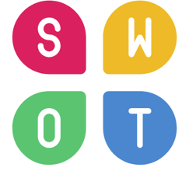
Opportunities  Growing demand for care - with an ageing population, the demand for care is growing.  Advancing technology - can improve resident care and efficiencies within the business.  Strategic partnerships - with local health boards and hospitals, to fill care home beds quicker. | Threats  Competitive market - increased number of care homes and competition from modern facilities.  Changes in regulations - tougher regulations could result in higher costs when implementing changes.  Rising operation costs - increased utility prices, food costs, training costs and wages can impact profitability.
Strategy Implementation:

To meet our organisational strategy we set objectives, ensuring we can measure success and return on investment. We assigned objectives and responsibilities to relevant departments and individuals.

The HR department is a crucial element in assuring that we align recruitment, training and performance management to directly support these goals through horizontal integration.

An example of alignment saw us work with our training provider to develop a bespoke course about working with the challenges of dementia. This course was then rolled out to all healthcare staff within the company.

To ascertain if the investment in training was used effectively with this course, we measured its success through employee supervisions, assessing competency and knowledge within practice.

This data was analysed to substantiate a return on investment following the integration of training and performance management.

1.3 Analyse the current impact of interest rates, inflation and one other external factor on your organisation (or one you are familiar with). Identify organisational priorities arising from your analysis (AC 1.3).

Interest Rate

Interest rates can influence the health & care sector, through borrowing costs, operational expenses and the reliance on government funding for care fees.

Interest rates were raised at the end of 2021, to help reduce inflation (Bank of England, 2024) with the current core interest rate in the UK at 4.75%.

In Wales, if you have combined assets worth over £50,000, you are unlikely to receive local authority funding for care fees. This is the highest threshold across the UK (Paying for Care, no date).

Interest rates can influence the value of a person’s assets.

Self-funding private care fees in the health & care sector are substantially higher than local authority-funded fees, as rising interest rates negatively affect the finances and budgets of local authorities (General Election Briefing, 2024).

As our care homes are situated in less affluent areas, 94% of our residents' care fees are paid for by the local authority. This means we have restricted revenue and net profits, compared to those care homes which have a larger proportion of self-funding residents.

Inflation

Inflation rates are a key issue that continues to challenge the care sector, with energy and food providing the biggest inflationary pressures.

Latest data from the Office of National Statistics (ONS) reported that in 12 months to April 2024, food inflation reduced to 2.9% (CPIH). However, falling inflation does not mean prices are coming down, but that they are rising more slowly (Day, 2024).

Post-pandemic food spend in care homes is up by 35% in just a three-year period (Care England, 2023).

Priority:

To minimise the impact of inflation on food, Padda Group needs to identify changes which can be made to kitchen operations. These include:

- Retention of skilled staff to reduce staff turnover costs.
- Minimising food waste by carefully planning menus.
- Re-educating kitchen staff about best practices to prevent food waste.
- Changing products for cheaper alternatives, without compromising quality.
- Increasing buying power – ie buying as Padda Group rather than as individual care homes.

Legislation Changes

Demand for adult social care is increasing throughout the UK with people living longer, while the number of people living with complex health conditions has increased (Healthwatch, 2023).

A higher demand for social care means an increase in the number of care staff required.

In March 2024, the Government made substantial changes to the Health & Care Visa. Care workers are no longer allowed to bring dependants to the UK, as ministers at the time believed immigration was too high (McKinney & Gower, 2024).

Immigration statistics show Health & Care Visa applications dropped by 81% to 6,564 between April-June 2024. Between April-June 2023, 35,470 visas were granted (Home Office, 2024).

These legislation changes have had a direct impact on operations at Padda Group, who rely heavily on overseas recruitment. The societal undervaluing of care work means the sector struggles to attract British workers (Guardian, 2023).

Priority:

Padda Group need to consider various strategies to adapt recruitment and retention to ensure they maintain adequate staffing levels to deliver our services. These include:

- Flexible working – adapt shift pattern to flexible schedules to become a more attractive employer.
- Retain existing employees by continuing to create a positive workplace.
- Integrate technology solutions to streamline processes and make the company more appealing.

In February 2024, Peter Cheese, current CEO of CIPD stated, “AI is transforming job, careers and workplaces. People professionals have a key role to play in encouraging safe experimental and rapid learning, so that we can reap the benefits and mitigate the risk.” Assess the extent that AI is, or could be, used in your organisation (or an organisation that you are familiar) and assess how AI impacts work (AC 1.4)

Artificial Intelligence (AI) can be described as a computer’s ability to perform cognitive functions that resemble human intelligence (CIPD, 2024c).

AI’s impact in the healthcare sector won’t ever be a substitute for human interaction but will augment humans’ efforts to care for patients (National Library of Medicine, 2021).

Padda Group use AI to streamline operational and HR administration processes. This promotes efficiency, consistency and personalised staff and resident experiences.

Acoustic Resident Monitoring:

Falls amongst the elderly remain one of the most frequently reported accidents in care homes, especially during the night (NHS, 2024).

Acoustic resident monitoring is a new AI-powered system that provides early alerts for fall prevention by using 4D mapping technology to track people’s movements. It also detects falls.

Impact on working practices:

- Reduction in the number of falls in care homes - pilots in care homes across England resulted in a 66% reduction (Department of Health and Social Care, 2024)
- Alleviate growing pressures on NHS – pilot scheme in care homes across England resulted in a 97.5% reduction in ambulances called or required post falls (Department of Health and Social Care, 2024).
- Better efficiency - integrates with electronic care management systems, meaning observations are recorded in real-time without the need for carers to update care plans manually.

Risks:

- Implementation - consent is required from resident advocates due to additional monitoring. This can be lengthy and a burden on resource.
- Additional operating costs – with all rooms needing individual powered monitors, set-up costs can be expensive. There are also ongoing utility costs.

Rota Scheduling Optimisation

Creating staff rotas is a laborious task, with considerations for all relevant rules and complex constraints such as role-skill requirements, availability, working hours and fair distribution of shifts.

Scheduling optimisation automates the creation of rotas by using AI.

Impact on working practices:

- Extremely efficient, accurate and streamlined processes as opposed to manual rota creation.
- Accuracy in rota planning – schedules are updated in real time, including annual leave and sickness reporting.
Risks:
- AI requires clear guidelines on what it needs to produce (RotaPlanning, no date), so implementation would be lengthy and require stringent testing.
- Employee information must be kept up to date to ensure accurate results.

Explain Charles Handy’s model of organisational culture and explain David Rocks SCARF theory. (AC 2.1)

Charles Handy’s model of organisational culture is a framework that describes four distinct management styles.

Power Culture – centres around a single person or a small group of key decision-makers at the top of the organisation who delegate tasks. Decisions can be reactive and made quickly but can lead to a lack of autonomy and creativity amongst other members within the organisation (CIPD, 2024d).

Role Culture – in role culture, all employees are delegated specific roles and responsibilities. This provides accountability, seen often in bureaucratic organisations. This culture can lead to consistency and reliability, but it can prevent flexibility and innovation (CIPD, 2024d).

Task Culture – teams are formed based on expertise and focus on completing specific tasks and projects. This promotes a dynamic atmosphere that is conducive to innovative thinking and rapid problem-solving (L&D Hero, 2023). Ensuring alignment to overall company objectives must be managed in this culture.

Person Culture – places emphasis on individual talent and autonomy (CIPD, 2024d). Often employees think they are more important than the organisation, as the organisation is entirely in service of the people who work there (Mulder, 2024). In this culture it is often unclear who has overall responsibility.

Handy’s model can allow people professionals to understand the culture within the organisation. This helps them to align business strategy with organisation culture through tailored HR processes.

David Rock’s SCARF Theory:

This is a brain-based model focusing on five domains to understand how social interactions impact human behaviour.

Status
Status deals with how we perceive our importance in relation to others. Positive feedback triggers a rewarding response within our brain, but when our status is threatened, this can cause someone to become angry or defensive (CIPD, 2024d).

Certainty
Predictability and having an understanding of what lies ahead are important in making us feel psychologically safe (Bitesize Learning, no date). Uncertainty can lead to stress and loss of focus, so it is important to be transparent, ensuring roles and responsibilities are well defined (vq solutions, 2024).

Autonomy
The need to feel in control of our environment and decisions. In organisational settings, promoting autonomy can make employees more motivated and engaged. Threats to autonomy can lead to negative outcomes (Janse, 2024).

Relatedness
This is the sense of belonging and connection with others. Working environments that encourage teamwork can have positive rewards, but team members sensing favouritism can create threats and damage trust (CIPD, 2024d).

Fairness
The perception of equitable treatment in social interactions. Perceived fairness can lead to positive emotions and trust, whereas perceived unfairness can result in negative emotions, leading to distrust and organisational conflict (Janse, 2024).

Assess how employee selection or employee development impact organisational culture and behaviour in your organisation (or one that you are familiar). (AC 2.2)

Employee selection:
There are two stages to selection: shortlisting and assessment. CIPD (2024b) explains “in both stages employers must ensure their selection methods treat candidates fairly, based on their ability to perform the role”.

Culture:
Whilst Padda Group have clear guidelines for recruitment on a skills-based level, aligning employee selection with company values plays a critical role in ensuring everyone on the team is operating under a shared set of values as they work to achieve strategic goals (Forbes, 2022).

Padda Group interviews feature value-based questions to achieve this. However, this could lead to misalignment if the hiring manager fails to identify signs of derailing behaviours which would suggest a candidate’s values do not match those of the organisation (Forbes, 2022)

Behaviours:
Organisational behaviours refer to the behaviour of employees within the organisation (Forbes, 2024). Employee selection is a critical driver of this to ensure alignment with company culture.

Selection based on value alignment and the personality of candidates is important to Padda Group.

Employees whose personal values align with company values are likely to feel more satisfied and committed to their job (Ellis, 2024). This can boost morale within the workforce. Having employees whose values do not align with those of the company can lead to higher turnover and job dissatisfaction.

Padda Group conduct thorough reference checks on all new employees, not only to check a candidate’s professional background, but to gain insight into work ethic and character, to ensure this alignment.

An organisation is planning to a change relating to hybrid working. Many employees moved to home working during the Covid-19 pandemic. Whilst this approach worked well at the time, the organisation now wants all employees to work at least two days a week on site. Explain how Kotter’s approach to managing change could be used to successfully implement this change. (AC 2.3).

John Kotter’s change model is a framework to help implement change in an organisation. Focusing on urgency to make change happen, it looks at initiating, managing and sustaining change via 8 steps:
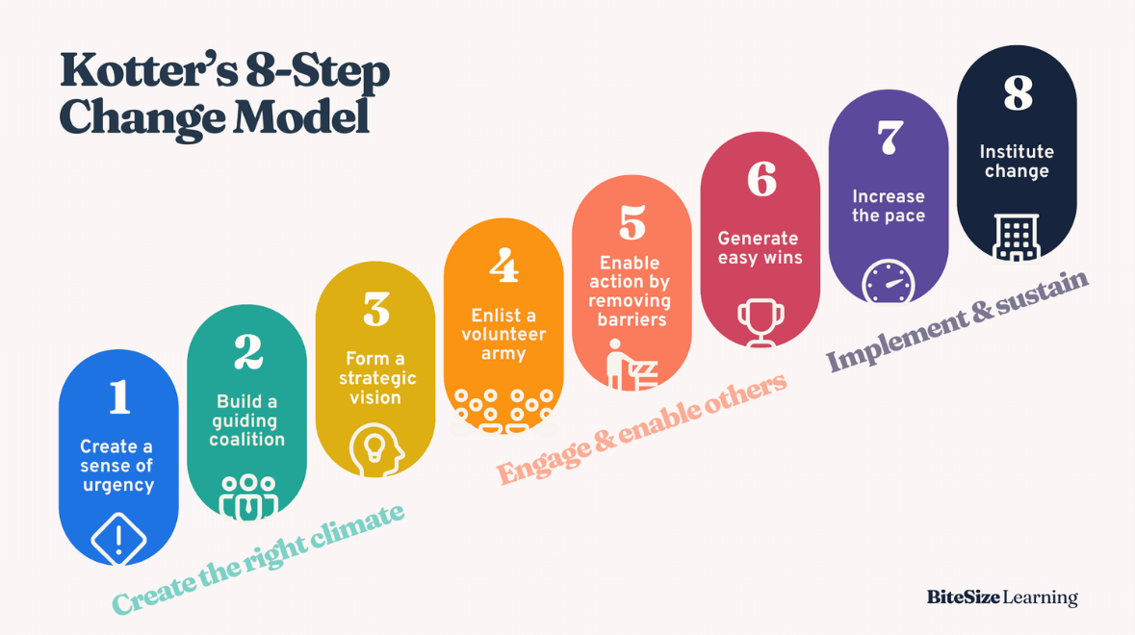
(Diag, BiteSize Learning, 2024)

Kotter’s model can be applied to facilitate changes from a fully remote environment to a hybrid model where employees work at least two days a week on site.

Create a sense of urgency

Objective: Help your team understand why change is necessary (Bitesize Learning, 2024)

Action:
- Discuss challenges within the organisation due to fully remote working – ie limited creativity threatening the organisation’s competitive edge.
- Discuss advantages of changing to a hybrid method – ie improved collaboration.
- Obtain evidence-based information about success stories in other organisations to demonstrate the need for change.

Build a guiding coalition

Objective: To lead change, you need to bring together a team of influential people across your organisation (Bells, 2024).

Actions:
- Hold meetings to find key individuals who will support the change to hybrid working.
- Empower them to provide clear communication and address resistance to change.

Form a strategic vision

Objective: Develop a clear vision for change and a roadmap of how the transition will be implemented.

Actions:
- Define the reason for change to hybrid working.
- Determine the values behind the changes.
- Decide on timescales for changes but be realistic.
- Decide on clear guidelines – ie when employees are expected to be in the office.
- Set measurable goals – what percentage of employees will do hybrid work and by what date?

Enlist a volunteer army

Objective: communicate your vision widely and embed it into everything you do.

- Use a variety of methods to communicate the change.
- Be transparent when addressing employee concerns.
- Highlight benefits of the hybrid model to employees.

Enable action by removing barriers

Objectives: identify and remove obstacles that might hinder your change.

- Use qualitative data collection methods, such a staff surveys, to identify barriers or obstacles to address resistance.
- Address these obstacles by offering support and flexibility where possible.
- Ensure there is regular communication with employees to make them feel involved and empowered.

Generate easy wins

Objective: Build momentum by achieving easy wins.

Actions:
- Trial the hybrid model with a group of individuals and keep track of successes.
- Communicate successes within the company through testimonials or people champions.
- Reward employees who invest in the change.

Increase the pace

Objective: Build on early successes to continue to embed hybrid working, but don’t let up.

Actions:
- Expand the trial to more individuals and keep track of successes.
- Use further qualitative data collection methods, to identify additional barriers or obstacles that are preventing the hybrid method being fully implemented.
- Challenge existing teams to propose new initiatives to help build on existing efforts.

Institute change:

Objective: make the changes a permanent part of your organisational culture.

Actions:

- Incorporate the new hybrid working practice into workplace policies.
- Ensure managers and staff continue to support the change.
- Talk about the success story of change – this could be at the start of staff engagement meetings.
- Regularly review employee feedback through supervisions and appraisals, celebrating the success story and addressing new barriers.

Using the Kubler-Ross change curve, discuss how change is experienced. (AC 2.4)

The Kubler-Ross change curve provides a framework for understanding the emotional progression of a person through change, with each stage being a step towards acceptance and adaptation (EKR Foundation, 2024).

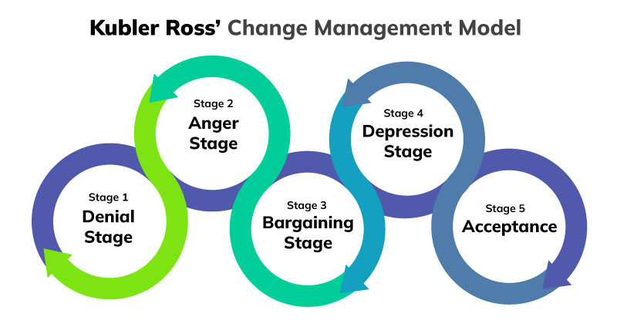
(Diag: Miller, 2022)

Denial
After the initial shock stage, employees may deny the acceptance of change and convince themselves that the change is not actually happening (Indeed, 2024). During a change from remote to hybrid working, an employee could ignore the changes that are happening and challenge compliance to the changes.

Anger
When the reality of a situation hits, employees often display signs of frustration, become angry and may look for someone to blame (Belyh, 2022). This could manifest itself in a drop in performance levels or through employees refusing to accept the new changes to hybrid working.

Bargaining
As anger subsides, employees will endeavour to try to negotiate in impractical or unrealistic ways in an attempt to manage the change so it does not affect them adversely (Belbin, no date). An employee could propose alternative solutions to those being proposed - for example, flexible in-office working days.

Depression
In this stage, employees may be overwhelmed by the reality that things will never be the same and be overcome by the feeling of hopelessness and despair (WalkMe Team, 2024). Employees may experience anxiety about the work-life balance of hybrid working, resulting in a drop in motivation and fatigue from the logistics.

Acceptance
During this final stage of the curve, employees come to terms with the change and start to explore favourable opportunities that result from it (Malik, 2024). Employees begin to see the positive effects of flexible working, including the creativity which comes from team collaboration.

The CIPD’s Health and wellbeing at work survey 2023 found the percentage of organisations that have a standalone wellbeing strategy has risen from 40% in 2018 to 53% in 2023. Although the percentage has increased, this means that 47% of organisations do not have a standalone wellbeing strategy. Assess the importance of wellbeing at work and assess how good work could impact wellbeing. (AC 2.5).

Wellbeing

Wellbeing in the workplace refers to the overall states of a person’s mental and physical health in relation to their work environment (The Cancer Coach, 2024). Reilly (2020) describes wellbeing as an “ethos and commitment in creating a happier, heathier and more productive workforce”.

Promoting wellbeing can prevent stress and create a working environment in which employees can thrive, which is ultimately good for business (CIPD, 2024e).

If an employee feels that they are looked after, this leads to improved productivity and quality of work, which also trans lates to reduced absence rate and employee turnover.

Failure to adopt a human-centred approach to wellbeing can take a personal toll on employees. This can harm both the physical and mental health of an employee, leading to job dissatisfaction and decreased productivity, which can have a negative impact on the culture of the organisation (Le Cuirot, 2024).

Good Work

According to CIPD’s (2024f) good work index report, good work is fundamental to employees' wellbeing.

The good work index is based on seven dimensions including – pay and benefits, contract, work-life balance, nature of work, relationships at work, employee voice and health and wellbeing. This covers important objective and subjective aspects of work (Young, 2024).

Tracking good work creates evidence-based insights for people professionals to improve the working life of employees (Young, 2024), to help them feel more motivated, engaged and aligned with company values.

By making jobs fulfilling and autonomous, as well as a fair pay structure can make employees happier, stay loyal and a rise in productivity will be seen (CIPD, 2024g).

As stated in the CIPD’s (2024f) report, 25% of employees experienced conflict at work in 2024. A focus on how employers deal with conflict in the workplace should be an important priority to ensure employees well-being is being looked after.

Provide a brief overview of the employee lifecycle and discuss people practice roles at the recruitment, development and separation stages of the lifecycle. (AC 3.1)

The employee lifecycle highlights the key stages of the journey an employee takes within a company.

People practice roles are linked to every stage of this journey.

Talking about people professionals, Taylor and Woodhams (2022) explain “part of your job is to understand this lifecycle and how it impacts people, and their ability to reach their full potential and overall performance in your organisation”.

The six stages to the employee lifecycle are:  - Attraction – how you are perceived  - Recruitment – sourcing and interviewing  - Onboarding – integrating new hires  - Development – growth and opportunities  - Retention – retaining talent  - Separation – offboarding an employee | 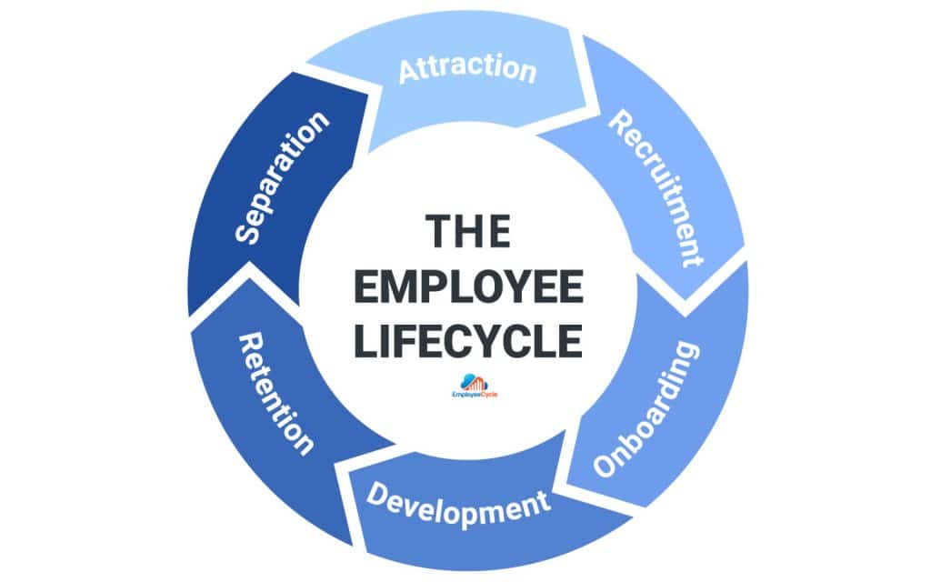  (Dia – Employee Cycle, 2024)
Recruitment:
During the recruitment stage, people professionals focus on attracting talented candidates who fit company values and culture. This can involve writing job requisitions, assisting interviews or providing recruitment metrics such as time to hire KPIs.

Using an application tracking system (ATS) can allow people professionals to manage the recruitment process in one place. This can improve efficiency by automating manual processes.

An ATS can allow people professionals to seamlessly integrate the recruitment process with the onboarding stage of the lifecycle.

People professionals ensure they control biases within recruiting and that the company is compliant with the Equality Act 2010, where a company has a legal responsibility to ensure that no unlawful discrimination occurs in the recruitment and selection process (Taylor and Woodham, 2022).

Development:
Employee development and retention are inextricably linked. People will leave if they feel they are stuck in a role with no chance for future growth (Verlinden, no date).

Having a robust performance management process - ie regular supervisions and appraisals - is an opportunity to identify learning and development needs. This assists people professionals in supporting employees' professional development and sourcing additional training.

People professionals are responsible for the learning and development strategy which aligns employees' competencies with the organisation's strategy and vision (Wilson, 2024). Developing capabilities of employees can assist in the success of the company, making it more profitable.

Separation:
This is the final stage of the employee lifecycle, with employees voluntarily leaving the organisation as well as through dismissals, redundancies or retirements.

People professionals are heavily involved in dismissals and redundancies, where they ensure processes and company policies are followed correctly and ethically. In addition, they ensure a smooth transition for those leaving voluntarily.

The offboarding stage is a great opportunity for companies to receive feedback on how they could improve the employee experience for existing and future hires (Bartram, 2024).

Exit interviews are an excellent way to gather qualitative data regarding employees' experiences and provide key information about staff turnover.

To gain effective insights, the exit interview should be conducted by a people professional, rather than a line manager, to ensure the employee can be open and honest in an unbiased environment.

Analyse how people practice supports organisational strategy through vertical integration and how people practice supports wider people through horizontal integration. (AC 3.2)

Vertical and horizontal integration in people practice are two concepts that help align organisational goals with employees' performance and HR policies to create a coherent work environment.

Vertical integration
Singh (2021) defines vertical integration as the alignment of people practices and HR strategies within the overarching business strategy.

Alignment of these strategies can effectively contribute to long-term success of the business by ensuring the employees are working towards common objectives (Bramly, 2024).

Vertical integration within people practice:

Recruitment:
A well-aligned recruitment process with overall business objectives will ensure that you attract, hire and retain talented employees that have the skills, experience and cultural fit to drive the business forward (Pragna Solutions, 2024).

Southwest Airlines use vertical integration to align hiring practices with their culture of low-cost, high customer service approach. They have a strong emphasis on attitude and cultural fit in candidates throughout the recruitment process to ensure alignment and long-term success. (Webster, 2023).

Training & Development:
A Learning & Development (L&D) strategy which is well-aligned with overall business objectives can create a culture of continuous skill development and a deep understanding of the critical skills required for business success (Intellek, no date).

If a company’s business strategy focuses on company innovation, the company may adopt an HR strategy that focuses on skills development, creativity and knowledge sharing as a priority to achieve innovation (Webster, 2023).

Horizontal integration

Horizontal integration refers to the alignment of various HR practices with one another. They are mutually supporting to achieve the business goals and to ensure a consistent and cohesive approach (Webster, 2023).

Horizontal integration within people practice:

Alignment of Training and Retention:
An employee leaving an organisation due to lack of training opportunities can impact the overall performance of a business and culture. It can lead to disruption in overall productivity, higher costs replacing staff and a change in team dynamics (Award.co, 2024).

One of Southwest Airlines' strategic objectives was to reduce employee turnover over a period of 5-10 years. To achieve this, they aligned HR practices by introducing continuous learning programmes and improving employee-management relations (Garrison & Keller, 2008).

Alignment of Performance Management and L&D:
Linking L&D and performance management is the first stage in creating a cohesive and effective employee development strategy (Acorn, 2024).

Appraisals and supervisions are an effective way to bridge the gap between performance reviews and L&D, by identifying knowledge and skill gaps, and then developing learning plan for employees to improve.

An organisation is planning to introduce a four-day working week. Discuss the processes the people function could use to consult and engage with managers and employees to understand their needs when moving from a five-day to a four-day working week. (AC 3.3)

Employee Surveys:

Employee surveys can be used to provide information and feedback about the proposed changes in moving to a four-day week.

Surveys are generally cheaper and faster to administer and typically more convenient (Taylor and Woodham, 2022).

Surveys can be used to identify trends, such as increased stress levels if employees feel they are not being heard during the consultation to move to a four-day working week, and the collective concerns that employees may have.

Taylor and Woodhams (2022, p. 128) state the disadvantage with qualitative surveys is that they do not allow for researchers to prompt individuals to provide more information.
Questions would need to be clear and specific, driven by the proposed changes of moving to a four-day week.
Interviews:
Horn (2012. P. 6) describes interviews as “a common method of investigation using a qualitative data collection method, therefore capturing the thoughts and feelings of employees”.
The interviews would be specifically tailored to the change to a four-day week and could provide the interviewer with the opportunity to prompt individuals.
The data from interviews can be critically analysed - looking for trends, themes or patterns that may need addressing - and used to present recommendations.
Interviews are advantageous as they can capture a significant amount of detail when investigating a small number of issues (Taylor and Woodhams, 2022) but can be time-consuming to conduct and analyse. Taylor and Woodhams (2022, p. 129) state: “Researchers need to decide whether the time commitments involved are offset by the potential benefits of gathering more detailed data.”

References:

Acorn (2024) Learning and Performance Management can’t be separated any longer – here’s how you link them. Available at: https://acorn.works/blog/learning-and-performance-management (Accessed 22 November 2022).

AIHR (no date) Divisional Structure. Available at: https://www.aihr.com/hr-glossary/divisional-structure (Accessed 15th October 2024).

Award.co (2024) Exploring the relationship between employee training opportunities and turnover rates. Available at: https://www.award.co/uk/blog/exploring-the-relationship-between-employee-training-opportunities-turnover-rates (Accessed 22 November 2024).

Bank of England (2024) Why are interest rates high and how quickly might they fall. Available at: https://www.bankofengland.co.uk/explainers/why-are-interest-rates-in-the-uk-going-up (Accessed 21 October 2024).

Bartram, B. (2024). The Employee Life Cycle in 2024: A Complete Guide. Avaialble at: https://peoplemanagingpeople.com/articles/the-employee-life-cycle/ (Accessed 22 October 2024).

Belbin (no date) The Change Curve and Belbin. Available at: https://www.belbin.com/resources/articles-directory/the-change-curve (Accessed 8th November 2024).

Bell, S. (2024) Kotter’s 8-step Change Model. Available at: https://www.mindtools.com/a8nu5v5/kotters-8-step-change-model (Accessed 8th November 2024).

Belyh, A. (2022) Understanding the Kubler-Ross Change Curve. Avaialble at: https://cleverism.com/understanding-kubler-ross-change-curve/. (Accessed 9th November 2024).

Bitesize Leaning (no date) The SCARF model of social threat & reward. Avaialble at: https://www.bitesizelearning.co.uk/resources/scarf-model-david-rock-explained (Accessed 1 November 2024).

Bitessize Learning (2024) Kotter’s 8-step change model, explained. Avaialble at: https://www.bitesizelearning.co.uk/resources/kotters-8-step-change-model (Accessed 1 November 2024).

Bramley, F. (2024) HR Management: How to Align HR Strategies with Business Goals. Available at: https://acacialearning.com/blog/human-resources/hr-management-how-to-align-hr-strategies-with-business-goals/ (Accessed 26th October 2024).

Care England (2023) Rising food prices reaches 35%: a catering conundrum for the care industry. Avaialble at: https://www.careengland.org.uk/creed/ (Accessed 22 October 2024).

CIPA (2024a) Organisational culture. Avaialble at: https://www.cipd.org/uk/views-and-insights/cipd-viewpoint/organisational-culture/ (Accessed 9 November 2024).

CIPD (2024b) Selection methods. Available at: https://www.cipd.org/en/knowledge/factsheets/selection-factsheet/ (Accessed 9 November 2024).

CIPD (2024c) AI and technology in the workplace: UK employment law. Available at: https://www.cipd.org/uk/knowledge/employment-law/ai-and-technology/ (Accessed 22 October 2024).

CIPD (2024d) Understanding organisational culture: Charles Handy’s model and David Rock’s SCARF theory. https://courses.vqsolutions.co.uk/understanding-organisational-culture-charles-handys-model-and-david-rocks-scarf-theory/ (Accessed 1 November 2024).

CIPD (2024e) Wellbeing at Work. Available at: https://www.cipd.org/uk/knowledge/factsheets/well-being-factsheet (Accessed 19 November 2022).

CIPD (2024f) Good Work Index 2024. Avaialble at: https://www.cipd.org/globalassets/media/knowledge/knowledge-hub/reports/2024-pdfs/8625-good-work-index-2024-survey-report-1-web.pdf (Accessed 19 November 2024)

CIPD (2024g) What’s hampering good work (Podcast). Available at: https://www.cipd.org/uk/knowledge/podcasts/whats-hampering-good-work/ (Accessed 19 November 2024)

Day, J. (2024) 25th April 2024 - https://foodfoundation.org.uk/news/food-prices-tracker-april-2024

Department of Health and Social Care (2024) 4D tech to prevent falls to be rolled out in social care settings. Available at: https://www.gov.uk/government/news/4d-tech-to-prevent-falls-to-be-rolled-out-in-social-care-settings (Accessed 9 November 2024).

EKR Foundation (2024) Kubler-Ross Change Curve. Avaialble at: https://www.ekrfoundation.org/5-stages-of-grief/change-curve/ (Accessed 9 November 2024).

Blanks, K. (2019) HR Metrics for every phase of the employee lifecycle. Available at: https://www.employeecycle.com/hr_metrics_for_every_phase_of_the_employee_lifecycle/ (Accessed 22 October 2024).

Ellis, S. (2024) Factors affecting organisational behaviour: A complete guide. Available at: https://www.theknowledgeacademy.com/blog/factors-affecting-organisational-behaviour/ (Accessed 22 October 2024).

Forbes (2022) 15 ways hiring mangers can ensure value alignment with prospective employees. Avaialble at: https://www.forbes.com/councils/forbeshumanresourcescouncil/2021/10/19/15-ways-hiring-managers-can-ensure-value-alignment-with-prospective-employees/. (Accessed 19 October 2024)

Forbes (2024) What is organisational behaviour? Avaialble at: https://www.forbes.com/advisor/business/what-is-organizational-behavior/ (Accessed 19 October 2024).

Garrison & Keller (2008) Moving you forward; Southwest Airlines Case Study. Avaialble at https://bookeditorhauck.com/pdfs/1southwest.pdf (Accessed 20 November 2024)

George, A. (2023) What is divisional organisational structure. Avaialble at https://youtu.be/zO9D0ScI4PI (Accessed 20 October 2024)

Guardian (2023) ‘The Guardian view on care workers: undervalued and underpaid’, The Guardian, 25 June. Avaialble at https://www.theguardian.com/commentisfree/2023/jun/25/the-guardian-view-on-care-workers-undervalued-and-underpaid (Accessed 2 November 2024).

Healthwatch (2023) Why are we calling for changes to social care? 7 December. Avaialble at: https://www.healthwatch.co.uk/blog/2023-12-07/why-are-we-calling-changes-social-care (Accessed 15 October 2024).

Home Office (2024) Why do people come to the UK? To work. Available at: https://www.gov.uk/government/statistics/immigration-system-statistics-year-ending-june-2024/why-do-people-come-to-the-uk-to-work (Accessed 16 October 2024).

Horn, R. (2012) Researching and writing dissertations: a complete guide for business. 2nd ed. London: Chartered Institute of Personnel and Development. Armstrong.
Indeed (2024) Understanding the Kubler-Ross change curve in the workplace. Avaialble at: https://www.indeed.com/career-advice/career-development/change-curve (Accessed 9 November 2024).

Janse, B. (2024) SCARF model by Davide Rock: the basics. Available at: https://www.toolshero.com/management/scarf-model-david-rock/ (Accessed 1 November 2024).

L&D Hero (2023) Charles Handy’s theory of organisational culture. Available at: https://workplacehero.co.uk/blog/understanding-charles-handys-theory-of-organisational-culture (Accessed 1 November 2024).

Le Cuirot, B. (2024) World Wellbeing at work week: the hidden cost of ignoring workplace wellbeing. Available at: https://channeleye.media/world-wellbeing-at-work-week-the-hidden-costs-of-ignoring-workplace-wellbeing/ (Accessed 22 November 2024).

Malik, P (2024) The Kubler Ross change curve in the workplace (2024). Available at: https://whatfix.com/blog/kubler-ross-change-curve/ (Accessed 9 November 2024).

Mckinney, C.J and Gower, M (2024) Changes to legal migration rules for family and work visa in 2024. Avaialble at: https://commonslibrary.parliament.uk/research-briefings/cbp-9920/ (Accessed 16 October 2024).

Mulder, P. (2024) Handy model of organisational culture (Handy and Harrison). Avaialble at: https://www.toolshero.com/management/handy-model/ (Accessed 10 November 2024).

National Library of Medicine (2021) Artificial intelligence in healthcare: transforming the practice of medicine. Available at: https://pmc.ncbi.nlm.nih.gov/articles/PMC8285156 (Accessed 22 October 2024).

NHS (2024) Falls. Available at: https://www.nhs.uk/conditions/falls/ (Accessed 22 October 2024).

Paying for Care (2024) Help with care fees from your local authority. Avaialble at: https://www.payingforcare.org/Help-with-care-fees-from-your-local-authority/ (Accessed 29 October 2024).

Pragna Solutions (2024) Aligning Recruitment with Business Strategy: The Ultimate Playbook. Avaialble at: https://www.linkedin.com/pulse/aligning-recruitment-business-strategy-ultimate-playbook-i1cjc. (Accessed 22 November 2022).

Reilly, C. (2020) Wellbeing positively impact firm performance. Avaialble at: https://www.forbes.com/sites/colleenreilly/2020/06/09/wellbeing-positively-impacts-firm-performance/ (Accessed 8th October 2024)

RotaPlanning (no date) The future of rota planning with artificial intelligence. Avaialble at: https://www.rotaplanner.app/blog/future-of-rota-planning (Accessed 22 October 2024).

Singh. H (2021) Lifecycle of an HR. 29 November 2021. Available at: https://www.linkedin.com/pulse/lifecycle-hr-harjot-singh (Accessed 10 November 2024).

Taylor, S and Woodhams, C (2022) Studying human resource management: a guide to the study, context and practice of HR. 3rd edn. London: Kogan page
The Cancer Coach (2024) What is wellbeing in the workplace? Available at: https://www.linkedin.com/pulse/what-wellbeing-workplace-thecancercoachdotorg-iqbre (Accessed 19 November 2022)
Tristancho, C. (2024) Matrix Organisational Structure: Examples & Template. Available at: https://www.projectmanager.com/blog/matrix-organizational-structure-quick-guide (Accessed 18 October 2024).

Verlinden, N. (no date) Employee Life Cycle: The Ultimate Guide for HR. Avaialble at: https://www.aihr.com/blog/employee-life-cycle/ (Accessed: 1 November 2024).
WalkMe Team (2024) The Kubler-Ross change curve. 13th June 2024. Avaialble at: https://www.walkme.com/blog/change-curve/ (Accessed 9 November 2024).

Webster, J. (2023) HR Strategy Guide. Avaialble at: https://www.practicus.com/what-we-do/hr/hr-strategy (Accessed 9 November 2024).

Wellbub Editorial Team (2024) (22 July 2024) Divide and Conquer: Definition, advantages and real-work examples of divisional organisational structures 1 November 2024. Avaialble at: https://wellhub.com/en-us/blog/organizational-development/divisional-organizational-structure/. (Accessed 18 October 2024).

Williams, A. (2024) Walt Disney’s Organisational Structure for Synergistic Diversification. Available at: https://panmore.com/walt-disney-company-organizational-structure-synergistic-diversification (Accessed 24 November 2024).

Wilson, T. (2024) Development strategy in 7 steps. Available at: https://peoplemanagingpeople.com/how-to-guide/learning-development-strategy/. (Accessed 15 October 2024)

Workplaceless team (2024) 17 benefits and challenges of remote working. Avaialble at: https://www.workplaceless.com/blog/benefits-and-challenges-of-remote-working (Accessed 10 November 2024)

Young, J. (2024) Good work; what do we know about the quality of UK jobs? Available at: https://www.economicsobservatory.com/good-work-what-do-we-know-about-the-quality-of-uk-jobs (Accessed 22 November 2024).

