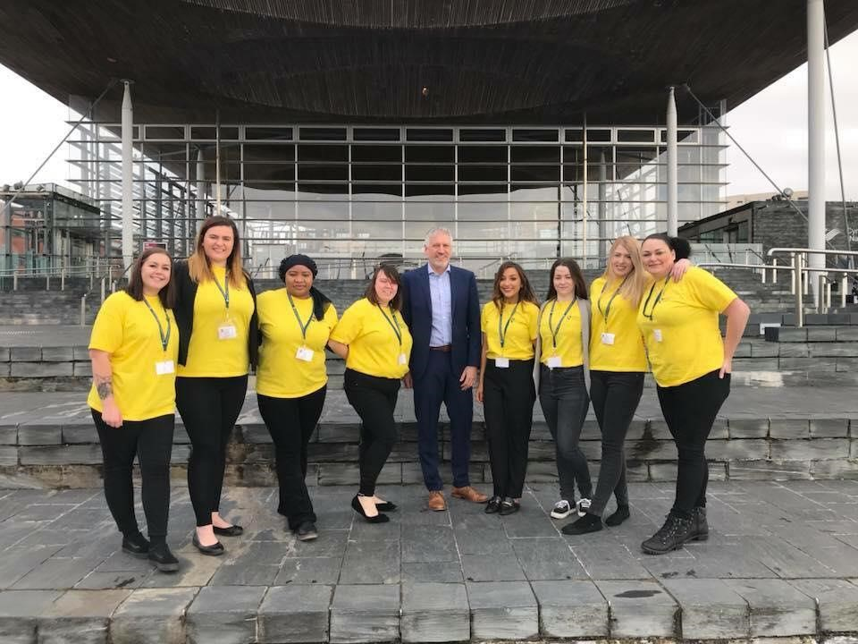
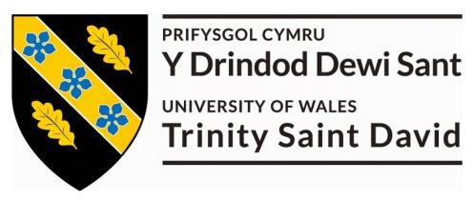

Lydia Smith
: P141878

C
onference Portfolio &

Reflective Review

The World is Our Lecture Theatre

Thursday 29th March 2018

My Portfolio

This portfolio includes the work I produced for The World is Our Lecture Theatre Conference, with a breakdown of number of hours completed, timescale and tasks.
1.1 Tasks Completed:
- Designed Invitation (4-5hours)
- Got invitation approved and sent out to colleges via MTOUR email account
- Mocked up concept logo / badges for concept T-shirts
- Filmed footage for trailer (5hours)
- Edited footage for trailer / produced trailer (10 hours)
- Liaised with group to send images, videos for personal videos
- Attended Senedd for 1 visit and attended meetings fortnightly
- Edit and produced 9 personal videos (45-50 hours)
- Edit and produced main MALAYSIA VIDEO (4 – 5 hours)
- Edit and produced UWTSD PROMO VIDEO (3 hours)

Total hours = 70-80

 | 01/02/18 | 08/02/18 | 15/02/18 | 22/02/18 | 01/03/18 | 08/03/18 | 15/03/18
Designed Invitations, approved them and emailed to colleges
Filming for Trailer, edit footage and produce
Mock up concept logos
Attended Senedd
Liaise with group regarding, images and videos
Edit and produce 9 Personal videos
Edit and produce Malaysia Promo vid and UWTSD Promo
Loaded and Transported chairs from University to the event and back
Attended event set up and set down
1.2 Personal Gant Chart

  - Evidence:
This section is a collection of evidence which supports the tasks that were completed.
1.3.1 Invitation Email

We Are Contacting You, to Invite You and Your Students to Our Annual Tourism Conference: The World is Our Lecture Theatre
The Theme This Year is Inbound Tourism to Wales.
The Conference will be held at The Senedd in Cardiff on the 19th March 2018

The Details of the Conference Are Attached, if You Are Able to Attend Please Could You Let Us Know the Following: The Amount of Students you Wish to Bring and Any Dietary Requirements They Have.
If You Have Any Queries Please do Not Hesitate to Contact us
Kind Regards
University of Wales Trinity Saint David, Masters Student.
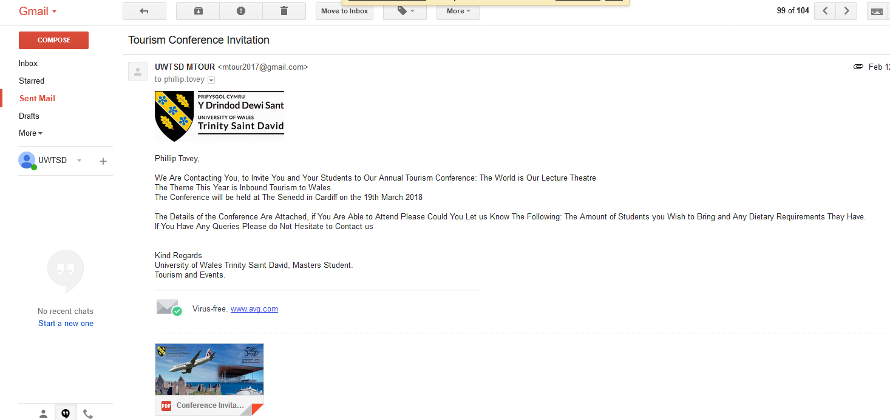
Tourism and Events
1.3.2 Concept Logo Designs




1.3.3 Evidence of video editing

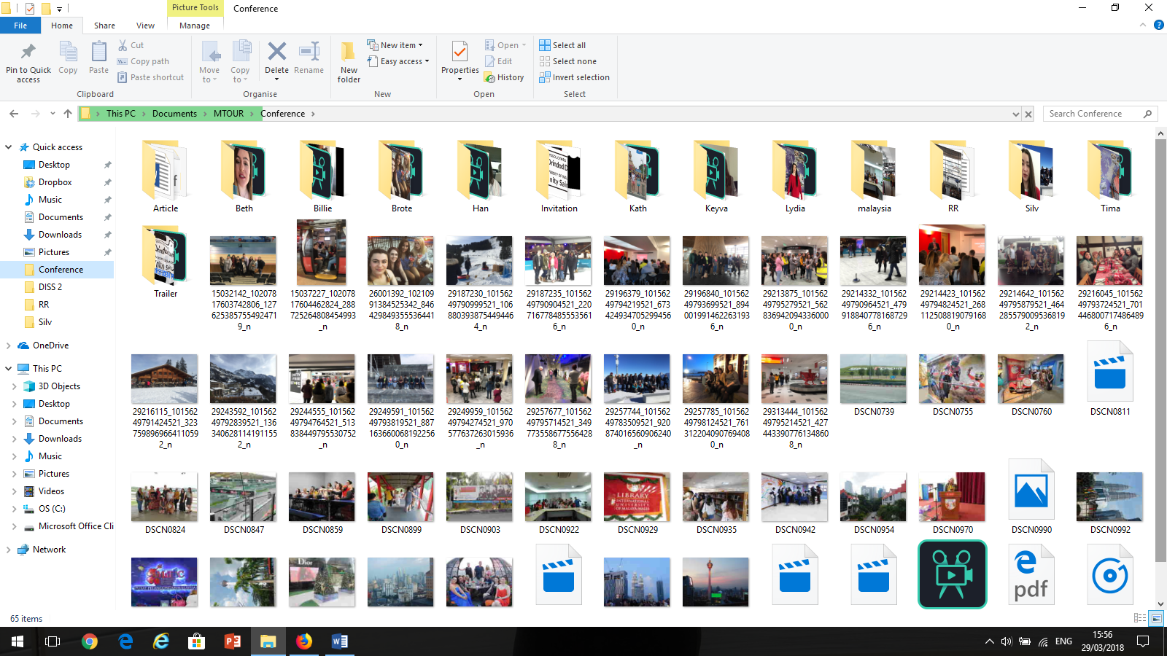

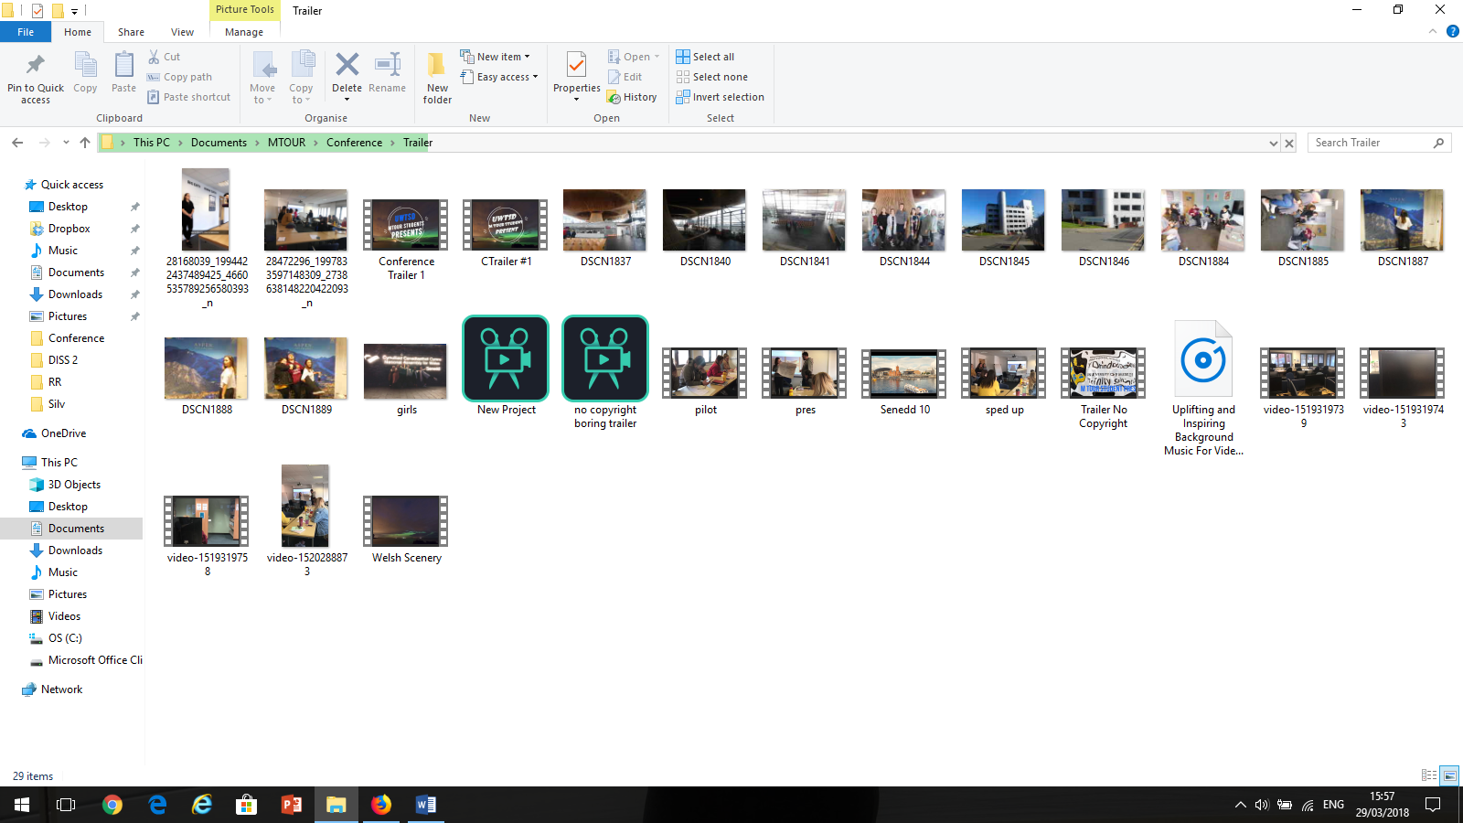

- Reflective Review
For the reflective review chapter, I will use a framework which will consist of time management vs hours contributed, work contributed to the conference and communication / professionalism to analyse my performance and the performance of the group.

2.1 Personal Review

This is my personal review on how I think my contribution towards the task went.

2.1.1 Hours contributed vs time management

I contributed around 70-80 working hours towards the conference, along with attending group meetings fortnightly; including a trip to the Senedd. I also felt I was present and involved in group decisions made in the group Facebook chat throughout the 3 months of which it was active. Personally, I felt I contributed one of the highest number of hours to the task than other members due to accepting the large task of editing and producing videos; which can be very time consuming. I therefore feel I contributed enough hours towards the task at hand, but feel I could’ve utilised my time much better in the month of February by helping organise sponsors etc. I felt my time management could also have been more spread out, so I had more time to work on the videos.

2.1.2 Work Contributed

I feel that the quality of my work was of a high standard. I tried to maintain high levels of creativity to produce a product that everyone would enjoy. During the actual conference the visuals of the event received very good feedback therefore I can say that I felt they were successful, thus meaning that the quality was of a good standard. During the editing process of the trailer I stumbled across some problems with using copyright material, I felt I liaised and researched the issue to try resolve this and eventually we decided not to use the footage for the trailer. In future I will be sure to make sure I am full aware of restrictions when using other people’s footage.

2.1.3 Professionalism / communication
During the process of organising the conference I feel that I maintained a good level of communication, and tried to reply to people within good time. My biggest flaw of this whole process however was my attendance to meetings, in hindsight I wish I had attended more. I feel that if I had attended all the meetings I could have had more input in the organising of the event due to my background of being a BA Event Management student. I feel that the group had overseen the fact I was an event student who had experience of working in events when they decided to put me in a marketing role, however I was fully aware of the amount of work I had to do with the videos and respect their decision to not pressure me with the planning side.
Summary
Overall, I feel that my contribution to the task exceeded that of other members of the team. I took on a large role with filming, editing and producing the videos which I wanted to do a good job of. My attendance to meetings could’ve lead to me to have better planning of the videos, by creating storyboards etc. plus my time could have been better utilised. But overall, I felt that the quality of my work reflects the effort and time I put in.

2.2 Group Review
This is my review of the group performance throughout the task of organising our conference.
2.2.1 Hours contributed vs time management
Event team – I felt that the event team contributed a large amount of hours to the task. They managed to share the workload effectively so that they each had time to work on other pieces of work. They put a lot of effort into the planning of the workshop and completed 2 successful pilots.
Marketing team- the marketing team as a collective contributed the most amount of hours to the task. There was good use of social media with a campaign that ran for nearly a month which had active updates per day. I felt that the time was managed effectively.

Venue team – personally I felt that the venue team made good use of their time at pre- venue trips in preparation to complete the risk assessment. However, I feel that their time was not managed effectively by spending 3 weeks completing a risk assessment which didn’t include the one risk we encountered on the day – the weather. I feel that their time could have been better used gaining sponsors for the event.

2.2.2 Work contributed
Event team – I feel that the workshop had been produced in depth and a lot of time was spent getting it to work and pilot it. I also think they made good use of their time emailing guest speakers, sponsors for the event.
Marketing team – I think that time management in the marketing team was managed reasonably well. The social media campaigns started within a month of the event, which was constantly updated. I also felt the extra touch of film in and live streaming the event on the day was a good use of time and good promotion for our event. On the downside I felt that the workload was not evenly spread amongst the team which meant that some members did more than others.
Venue team – overall, I felt the contribution from the venue team, was lacking. I felt they did complete the tasks they were set; however, it took them more time than it should have which meant they could not focus on other things like sponsors.
2.2.3 Professionalism/ communication
Event team - I felt that they would offer to help or complete tasks that other people either couldn’t do or hadn’t completed. They picked up the slack a lot of the time and pulled the team together. I felt their communication was sometimes unprofessionalism as we decided to use a Facebook group chat to liaise throughout the whole process. I think we should have in hindsight posted on the MTOUR group when discussing important issues.
Marketing team – as a member of the marketing team I think that we could have conducted our own separate meetings so we could discuss ideas more. But I feel that the group followed the same brand and theme in mind when conducting the campaign. Some members of the team made really good use of their time also working on organising the venue, securing the venue was one of the greatest successes.
Venue team – I think the venue team communicated well and made everyone aware of what they were doing and what information they needed. However, I felt sometimes they would ask things that we had already discussed which they did not know about, due to not attending an not reading group messages.
Summary
In summary I feel the success of the task has to be given to the event team who not only completed all the tasks they said they would, but also went out of their way to complete tasks which needed to be done in quick time (Sponsors, guest speakers). I felt like the marketing team had a successful campaign which made it very clear what the event was. We received very good feedback for the website for the event, but in hindsight it would’ve been a good idea to try gain more publicity from local media such as Wales Online to promote the event for the university.
One of our other failings was the communication we had between the colleges, the group email was set up in mind that everything would be sent from there however this was not the case and there were some miscommunications.
I feel that the visuals really added to the event and gave it that unique aspect.
On reflective the worst mistake of our planning was making sure the event ran on schedule even though we had started late, and maybe it was the job of the risk assessment team to ensure that the event was running to our time schedule as much as possible.
I believe the event to have been a success, and its recommendation to next year, if the event is going to be interactive then the workshop must be developed and there should only be a maximum of 3 speakers to ensure there is enough time to complete the workshop activity.



3

