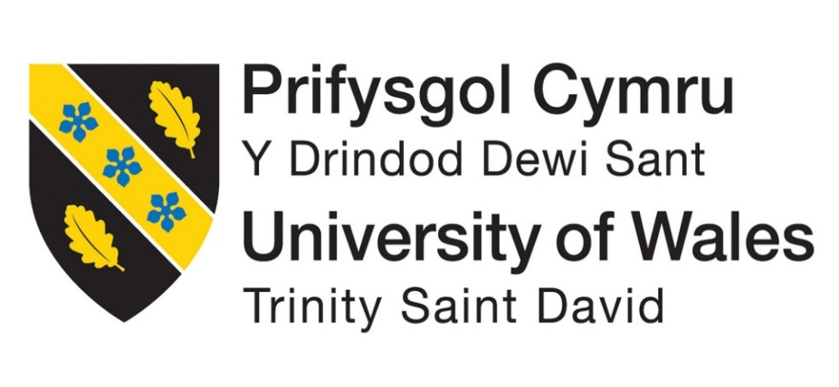

UNIVERSITY OF WALES TRINITY SAINT DAVID
Certificate in Higher Education Business Skills for the Workplace
Enterprise and Entrepreneurship (LCLM4006)
Individual Written Business Plan
EcoClean Industrial Services Ltd:
A Sustainable Industrial Cleaning Business in Nottingham
Student Name: Odion Terry Ajadalu
Student ID: 2512302
Lecturer: Fouziya Farheen
Submission Date: 29 June 2026

Executive Summary
EcoClean Industrial Services Ltd is a proposed industrial cleaning company based in Nottingham, United Kingdom. The business aims to provide specialist cleaning and sanitation services to factories, warehouses, food production facilities, offices, care homes and construction sites. The company has been developed in response to the increasing demand for professional cleaning services, workplace hygiene, health and safety compliance and environmentally responsible business practices.
The business will differentiate itself through a combination of specialist industrial cleaning expertise, eco-friendly cleaning solutions and personalised customer service. Unlike many larger competitors, EcoClean will offer flexible cleaning contracts tailored to the specific operational requirements of individual clients. The company will use biodegradable cleaning products, waste reduction practices and efficient route planning to support sustainability objectives while maintaining high cleaning standards.
Market analysis indicates that the UK cleaning industry continues to grow due to increasing hygiene awareness, outsourcing trends and stricter workplace compliance requirements. The business will initially target factories, warehouses, food production companies, offices, care homes and construction organisations within Nottingham and the East Midlands. SWOT, PESTEL and competitor analyses demonstrate that although competition exists from larger national providers, EcoClean can gain a competitive advantage through its local focus, sustainability commitment and customer-centred approach.
The company will operate as a Private Limited Company (Ltd), providing legal protection, enhanced credibility and future growth opportunities. The proposed management structure includes a Managing Director, Operations Manager, Cleaning Supervisors and Industrial Cleaning Operatives, ensuring effective control and operational efficiency.
The business requires an initial investment of £15,000, funded through personal savings (£5,000), family investment (£3,000) and a bank loan (£7,000). Financial analysis indicates that the business can achieve break-even after securing approximately five regular cleaning contracts per month. Cash flow forecasts also show a transition from initial start-up losses to positive cash flow during the first year of operation.
Overall, EcoClean Industrial Services Ltd presents a realistic, sustainable and commercially viable business opportunity. Through effective management, targeted marketing and environmentally responsible practices, the business has the potential to establish a strong presence in Nottingham and expand throughout the East Midlands and the wider United Kingdom.

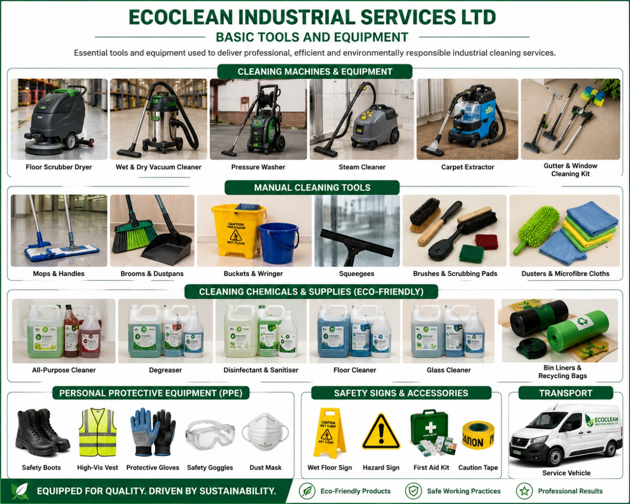

Table of Contents
Executive Summary 2
1. Overview of the Business Idea 5
2. Unique Selling Proposition 6
3. Mission and Vision Statement 6
4. Management Structure and Legal Format 6
Analytical Management Structure Diagram 6
5. Market Research 7
6. SWOT Analysis 8
SWOT Analytical Discussion 8
7. PESTEL Analysis 9
PESTEL Analytical Discussion 9
8. Competitor Analysis 10
Analytical Discussion Competitor 10
9. Marketing Communications 11
Figure 01: Marketing Methods. 11
10. Financial Plan 12
Start-Up Funding Chart 13
Figure 02: Sources of Funds for Project 13
First-Month Start-Up Costs 13
Year 1 Cash Flow Forecast 14
Cash Flow Trend Diagram 16
11. Break-Even Analysis 17
Break-Even Analytical Discussion 18
12. Sustainability and Community Support 19
13. Conclusion 20
14. Reference 21

1. Overview of the Business Idea
EcoClean Industrial Services Ltd is a proposed industrial cleaning company based in Nottingham, United Kingdom. The business will provide specialist cleaning and sanitation services to factories, warehouses, food production facilities, offices, care homes and construction sites. The business idea responds to the growing demand for safe, reliable and environmentally responsible cleaning services across commercial and industrial workplaces.
The founder’s experience in industrial hygiene operations and food manufacturing environments provides practical knowledge of sanitation standards, health and safety procedures, risk control, customer expectations and workplace compliance. This background gives the business a realistic operational foundation because industrial cleaning requires more than basic cleaning skills; it involves understanding chemical safety, hygiene standards, site risks and client compliance needs.
The core services of EcoClean Industrial Services Ltd will include industrial deep cleaning, factory and warehouse cleaning, food production sanitation, pressure washing, office cleaning, waste management support and hygiene compliance cleaning. According to IBISWorld (2025), the UK cleaning services industry is valued at approximately £12.5 billion, showing that there is a strong market opportunity for new providers. The British Cleaning Council (2025) also states that the cleaning industry contributes approximately £67 billion to the UK economy and employs over 1.5 million people. This suggests that the sector is important, competitive and capable of supporting new businesses that offer a clear point of difference.

2. Unique Selling Proposition
The unique selling proposition of EcoClean Industrial Services Ltd is its combination of specialist industrial cleaning, eco-friendly practice and personalised local service. Unlike larger national competitors that may provide standardised cleaning packages, EcoClean will offer flexible cleaning solutions based on each client’s workplace type, risk level and hygiene requirements.
This gives the business a competitive advantage because customers increasingly prefer suppliers that support sustainability, safety and compliance (Worthington and Britton, 2021). EcoClean will therefore position itself as a local Nottingham cleaning provider that delivers professional cleaning while reducing environmental harm through biodegradable products, waste reduction and efficient route planning.

3. Mission and Vision Statement
Mission Statement
To deliver reliable, safe and environmentally responsible industrial cleaning solutions that improve workplace hygiene, safety and operational performance.
Vision Statement
To become the most trusted sustainable industrial cleaning company in the East Midlands and a recognised national provider within ten years.

4. Management Structure and Legal Format
EcoClean Industrial Services Ltd will operate as a Private Limited Company. This structure is suitable because it separates the owner’s personal finances from the business and provides limited liability protection. It also improves credibility with clients, suppliers, lenders and potential investors (Burns, 2020).
A limited company structure is appropriate because the business will require start-up finance, insurance, specialist equipment, a vehicle and contracts with commercial clients. It also supports future expansion because shares can be issued and additional investors or directors can be introduced when required (Scarborough and Cornwall, 2019).

Analytical Management Structure Diagram
Level | Role | Main Responsibility | Strategic Importance
1 | Managing Director | Strategy, finance, marketing and business development | Provides leadership and long-term direction
2 | Operations Manager | Staff scheduling, client communication and service delivery | Ensures daily operations are organised
3 | Cleaning Supervisors | Quality checks, health and safety and staff monitoring | Maintains service standards
4 | Cleaning Operatives | Carry out cleaning tasks and follow client requirements | Delivers the service directly to customers

Managing Director
↓
Operations Manager
↓
Cleaning Supervisors
↓
Industrial Cleaning Operatives
This structure is suitable for a start-up because it is simple, cost-effective and allows clear control of responsibilities. As the business grows, the company can add finance, human resources and sales roles to support expansion.

5. Market Research
Market research shows that EcoClean Industrial Services Ltd will operate in a competitive but growing market. The cleaning industry is supported by demand from factories, warehouses, offices, care homes, food producers and construction firms. Many of these organisations outsource cleaning because they need professional hygiene standards but may not want to employ full-time internal cleaning teams. (IBISWorld, 2025).
Nottingham is a suitable location because it has commercial, industrial, logistics and public service organisations that require cleaning support. The East Midlands also has manufacturing and warehouse activity, which creates demand for industrial cleaning and hygiene compliance. However, the market is competitive, meaning EcoClean must not rely only on low prices. Instead, the business must use sustainability, reliability and customer relationships as its main competitive advantages. (Johnson et al., 2023; Worthington and Britton, 2021).

6. SWOT Analysis
Strengths | Weaknesses
Founder has industrial hygiene experience | New business with limited reputation
Eco-friendly positioning | Limited start-up capital
Flexible local service | Small workforce at the beginning
Knowledge of health and safety requirements | Limited brand awareness

Opportunities | Threats
Growth in warehousing and logistics | Large national competitors
Increased hygiene awareness after COVID-19 | Rising fuel and wage costs
Demand for sustainable suppliers | Economic uncertainty
Businesses outsourcing cleaning services | Difficulty winning first contracts

SWOT Analytical Discussion
The SWOT analysis shows that EcoClean has strong internal advantages, especially the founder’s practical cleaning and hygiene experience. This is important because industrial clients are likely to trust a provider that understands health and safety, cleaning risks and professional standards. The eco-friendly positioning also strengthens the business because sustainability is becoming more important to customers and organisations (Morrison, 2020).
However, the main weakness is that EcoClean is a new business without an established reputation. This means the company must work hard to build trust through testimonials, free site inspections, introductory offers and excellent service delivery. The key opportunity is the increasing need for outsourced cleaning services, while the main threat is competition from larger companies with more resources. (Johnson et al., 2023; Worthington and Britton, 2021).

7. PESTEL Analysis
Factor | Impact on EcoClean | Business Response
Political | Cleaning companies must follow workplace health and safety expectations | Follow UK safety standards and provide compliant cleaning
Economic | Inflation may increase fuel, wages and equipment costs | Monitor costs and price contracts carefully
Social | Customers now place more value on cleanliness and hygiene | Promote workplace wellbeing and hygiene benefits
Technological | Cleaning machines and scheduling software can improve efficiency | Use digital booking, route planning and modern equipment
Environmental | Customers increasingly prefer sustainable suppliers | Use biodegradable chemicals and reduce waste
Legal | COSHH, insurance and employment law affect operations | Train staff and maintain legal compliance

PESTEL Analytical Discussion
The PESTEL analysis shows that EcoClean operates in a market shaped by health, safety, environmental and legal pressures. Political and legal factors are particularly important because industrial cleaning involves chemical use, staff safety, risk assessment and client compliance. The company must therefore follow COSHH regulations, employment law and insurance requirements. (Worthington and Britton, 2021).
Economic factors may create pressure because inflation can increase fuel, equipment and wage costs. However, cleaning is still necessary for most businesses, meaning demand may remain relatively stable even during difficult economic conditions. (The Guardian, 2026; British Chambers of Commerce, 2025). Social factors also support the business because organisations are now more aware of hygiene, cleanliness and employee wellbeing. Technological improvements such as automated cleaning equipment and digital scheduling systems can help EcoClean reduce labour time and improve customer satisfaction.
Environmental factors are central to the business model. By using eco-friendly cleaning products, reducing chemical waste and planning efficient travel routes, EcoClean can appeal to customers that want responsible suppliers (Morrison, 2020).

8. Competitor Analysis
Competitor Comparison Table
Competitor | Strengths | Weaknesses | EcoClean Advantage
OCS Group UK | National reputation and large resources | Less personalised service | Local and flexible customer support
NIC Services Group | Experience with large contracts | May have higher overhead costs | Competitive pricing and local focus
Total Clean Nottingham | Established local presence | Less visible sustainability focus | Strong eco-friendly positioning
EcoClean Industrial Services Ltd | Sustainable, flexible and personalised | New entrant | Can build close client relationships

Analytical Discussion Competitor
The competitor analysis shows that EcoClean will face competition from both national and local cleaning companies. Larger companies such as OCS Group UK and NIC Services Group have strong reputations, established systems and larger workforces. However, their size may make them less flexible for smaller local clients. This creates an opportunity for EcoClean to compete through personalised service, quicker communication and tailored contracts.
Total Clean Nottingham may be a closer local competitor because it already operates in the area. However, EcoClean can differentiate itself by placing sustainability at the centre of its brand. Therefore, EcoClean should not compete only on price. Instead, it should compete through reliability, environmental responsibility and strong client relationships.

9. Marketing Communications
Marketing communications will focus on building awareness, attracting commercial clients and developing long-term contracts. The company will use digital marketing, direct marketing and promotional strategies.

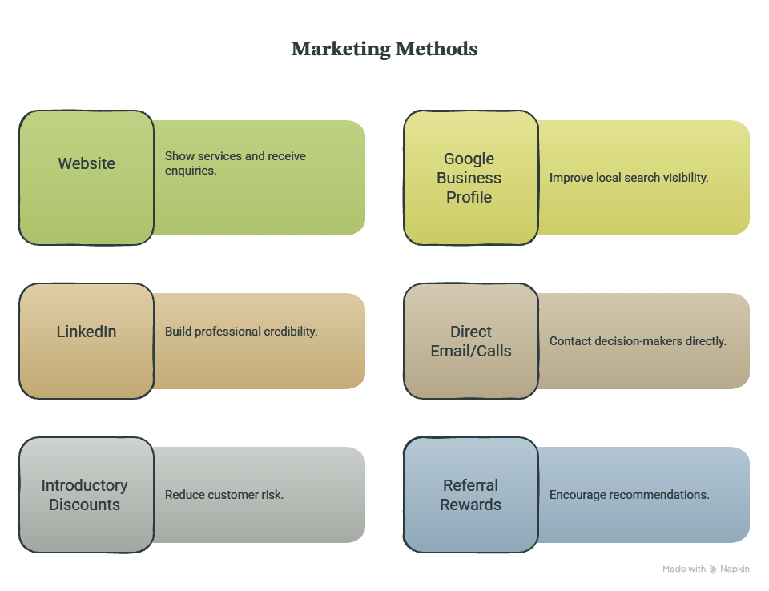

Figure 01: Marketing Methods.
Source: By Student.
Digital marketing is important because it improves visibility and helps small businesses reach target customers more efficiently (Kotler, Keller and Chernev, 2021). EcoClean will create a professional website, Google Business Profile and business pages on LinkedIn and Facebook. These platforms will allow customers to view services, request quotations and contact the business easily.
Direct marketing will also be important because industrial cleaning often depends on trust, communication and long-term contracts. The company will contact factories, warehouses, care homes, food production businesses and construction firms through email, telephone and networking. Relationship marketing can improve customer retention and profitability over time (Kotler, Keller and Chernev, 2021).
Promotional strategies will include free site inspections, introductory discounts and referral rewards. These strategies will reduce customer risk and encourage businesses to try EcoClean’s services.

10. Financial Plan
The business requires approximately £15,000 in start-up capital. This will be funded through personal savings, family investment and a bank loan.
Start-Up Funding Table
Funding Source | Amount (£) | Percentage | Purpose
Personal Savings | 5,000 | 33% | Shows founder commitment
Bank Loan | 7,000 | 47% | Equipment, vehicle deposit and working capital
Family Investment | 3,000 | 20% | Additional start-up support
Total | 15,000 | 100% | Full start-up requirement

Bank Loan and Repayment Plan
The loan will be repaid over a three-year period through monthly instalments funded from operating revenues. Based on the projected cash flow forecast shown in Appendix C, the business expects to generate increasing revenues during its first year of operation. As recurring service contracts increase, cash flow should remain sufficient to meet repayment obligations while supporting future growth and investment.

Start-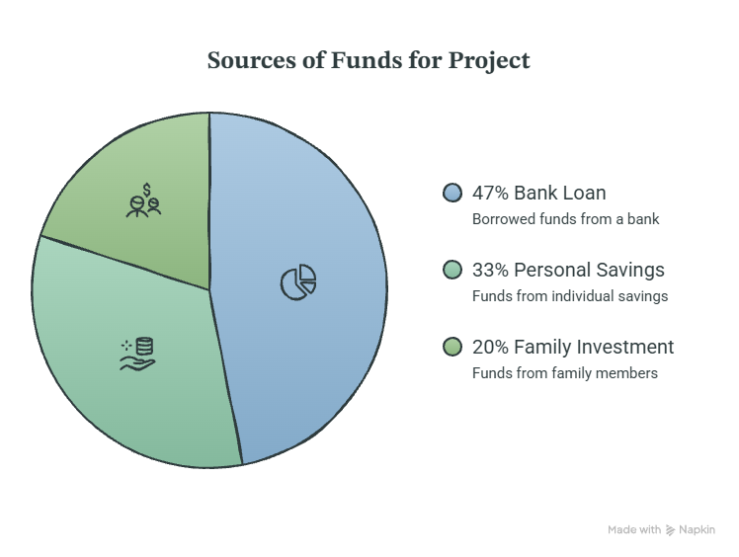Up Funding Chart

Figure 02: Sources of Funds for Project
The bank loan is necessary because the business requires professional equipment before it can deliver services and generate income. The loan will be repaid through monthly instalments over three years using income from cleaning contracts. Careful cash-flow monitoring will be used to ensure that the company can meet repayment obligations while covering operating costs.

First-Month Start-Up Costs
Expense | Amount (£) | Reason
Cleaning Equipment | 4,000 | Required for industrial cleaning
Eco-Friendly Chemicals | 1,500 | Supports sustainability promise
Vehicle Deposit | 3,500 | Needed for site travel
Insurance | 1,000 | Protects business and clients
Marketing | 1,000 | Builds brand awareness
Website Development | 500 | Supports digital enquiries
PPE and Uniforms | 1,500 | Protects staff and improves professionalism
Registration and Licences | 500 | Supports legal operation
Working Capital | 1,500 | Covers early running costs
Total | 15,000 | Full start-up budget

Year 1 Cash Flow Forecast
Period | Income (£) | Expenses (£) | Net Cash Flow (£) | Interpretation
Month 1 | 3,000 | 15,000 | -12,000 | High start-up spending
Month 3 | 7,500 | 4,000 | 3,500 | Positive cash flow begins
Month 6 | 12,000 | 5,000 | 7,000 | Contracts increase
Month 12 | 20,000 | 7,000 | 13,000 | Stronger business position

Cash Flow Trend Diagram
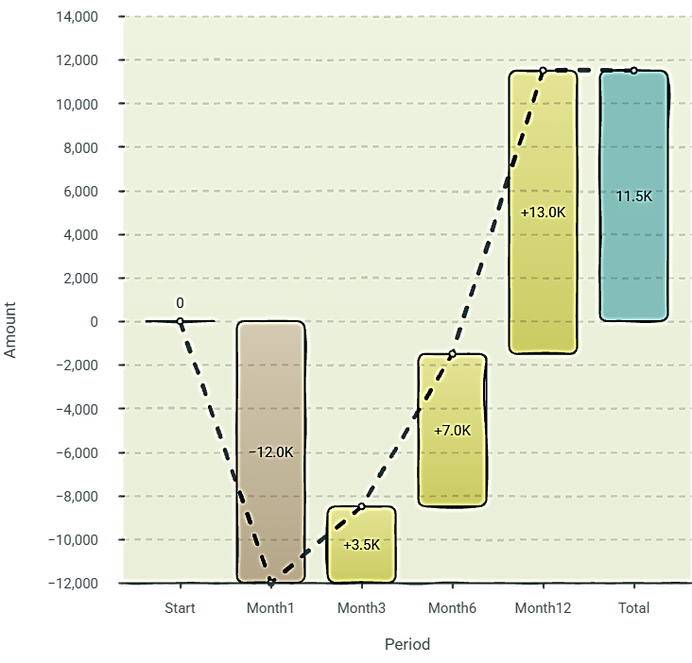
Figure 03: Cumulative Financial Performance Over Twelve Months
Financial Analytical Discussion
The financial forecast shows that EcoClean will experience negative cash flow in Month 1 because the company must purchase equipment, chemicals, uniforms, insurance and marketing materials before generating regular income. However, the forecast becomes positive by Month 3, showing that the business can become financially stable if it secures early contracts.
By Month 12, the projected net cash flow is £13,000. This suggests that the business has growth potential, but only if it controls costs and maintains regular customer contracts. The most important financial risk is the first three months, when spending is high and the business is still building its customer base.

11. Break-Even Analysis
Break-Even Table
Item | Amount
Average contract value | £800
Variable cost per contract | £200
Contribution per contract | £600
Fixed monthly costs | £3,000
Break-even point | 5 contracts per month

Break-Even Formula
Break-even point = Fixed costs ÷ Contribution per contract
£3,000 ÷ (£800 - £200) = 5 contracts per month

Break-Even Diagram
Contracts per Month Financial Position
1 contract Loss
2 contracts Loss
3 contracts Loss
4 contracts Loss
5 contracts Break-even
6+ contracts Profit

Break-Even Analytical Discussion
The break-even analysis shows that EcoClean must secure approximately five regular contracts per month to cover its fixed costs. This is a realistic target because the business will focus on factories, warehouses, care homes, offices and construction sites in Nottingham and the East Midlands.
However, the break-even target also shows that marketing and customer retention are essential. If EcoClean fails to secure regular contracts, the business may struggle to cover loan repayments and operating costs. Therefore, management must focus on winning repeat customers rather than relying only on one-off cleaning jobs.

12. Sustainability and Community Support
Sustainability is a key part of EcoClean Industrial Services Ltd. The company will use biodegradable cleaning products, reduce water consumption through efficient cleaning equipment, recycle containers, minimise chemical waste and reduce carbon emissions through route planning. These actions support environmental responsibility and help the business appeal to customers who value sustainable suppliers.
Sustainability Action Table
Sustainability Action | Business Benefit | Community/Environmental Benefit
Biodegradable cleaning products | Strengthens green brand image | Reduces environmental harm
Efficient route planning | Reduces fuel costs | Lowers carbon emissions
Waste reduction | Saves money | Reduces landfill waste
Staff training | Improves service quality | Promotes safe working practice
Free quarterly community cleaning | Builds reputation | Supports local organisations

The company will also support the local community by recruiting local employees, providing training opportunities and offering quarterly free cleaning services to selected community centres or charitable organisations. These actions show corporate social responsibility and can improve the company’s reputation in Nottingham. Corporate responsibility can improve business image and customer trust when it is connected to genuine community benefit (Johnson et al., 2023).

13. Conclusion
EcoClean Industrial Services Ltd presents a realistic and sustainable business opportunity within the UK cleaning industry. The business responds to demand for industrial hygiene, workplace safety, compliance and environmentally responsible cleaning services.
The analysis shows that EcoClean has clear strengths, including the founder’s experience, local focus and eco-friendly positioning. However, the business must manage weaknesses such as limited capital, low brand awareness and competition from established firms. The financial analysis shows that the company requires £15,000 to start and must secure at least five regular contracts per month to break even.
Overall, EcoClean can succeed if it focuses on high-quality service delivery, strong customer relationships, sustainable cleaning practices and careful financial control. With effective management and targeted marketing, the business has the potential to become a trusted industrial cleaning provider in Nottingham and later expand across the East Midlands.

14. Reference
British Cleaning Council (2025) Research Report 2025. Available at: https://www.bics.org.uk/wp-content/uploads/2025/04/RR2025.pdf
British Chambers of Commerce (2025) Business Conditions Survey. London: BCC.
Bridge, S. and O’Neill, K. (2018) Understanding Enterprise. 5th edn. London: Palgrave Macmillan.
Burns, P. (2020) Entrepreneurship and Small Business. 5th edn. London: Red Globe Press.
Companies House (2026) Nottingham Industrial Cleaners Limited. Available at: https://find-and-update.company-information.service.gov.uk/company/01161375
David, F. and David, F. (2020) Strategic Management. 17th edn. Harlow: Pearson.
IBISWorld (2025) Cleaning Services Industry in the UK. Available at: https://www.ibisworld.com/united-kingdom/industry/cleaning-services/200310/
Johnson, G., Whittington, R., Scholes, K., Angwin, D. and Regnér, P. (2023) Exploring Strategy. 13th edn. Harlow: Pearson.
Kotler, P., Keller, K. and Chernev, A. (2021) Marketing Management. 16th edn. Harlow: Pearson.
Morrison, J. (2020) The Global Business Environment. 5th edn. London: Red Globe Press.
Office for National Statistics (2025) Business and Industry Statistics. Available at: https://www.ons.gov.uk
Policy Bee (2026) UK Cleaning Industry Statistics and Trends. Available at: https://www.policybee.co.uk/blog/uk-cleaning-industry-statistics
Scarborough, N. and Cornwall, J. (2019) Essentials of Entrepreneurship and Small Business Management. 9th edn. Harlow: Pearson.
The Guardian (2026) UK GDP and Business Growth Report. Available at: https://www.theguardian.com/business
Worthington, I. and Britton, C. (2021) The Business Environment. 9th edn. Harlow: Pearson.

