Background of Golden Grove

The intervention that I have chosen for this assignment is based on the work experiences I have completed throughout the last three years, and also based on the strategies and effective teaching and learning approaches that I witnessed being implemented during my professional teaching experience.
The main school that I will be focusing on within this assignment and the school in which I will be a teacher of for the purpose of the individual video presentation is Gelli Aur/Golden Grove school in Pembrokeshire. The school is situated in Orange Way in Pembroke, catering for children within Pembroke and the surrounding area in both English medium and Welsh medium. This bilingual primary school offers ample opportunities for a vast variety of young children to engage bilingually in school, and ensures that all of their pupils, approximately 350, are catered for in a safe environment.
As well as being a dual stream school, Golden Grove also has a special education class for children with additional learning needs or for children who struggle within the school environment. The school offers or encourages children to engage in specific lessons within their year group class to slowly allow them to adapt to being in a normal mainstream classroom, thus showing how much emphasis is placed on children’s well-being throughout the school.
Throughout the whole school, children are praised for their good behaviour, as well as being given consequences for bad behaviour, as stated in the school’s behaviour policy. The headteacher himself, takes time to read and provide praise for children’s work within each class by awarding them with a certificate of good work, but has recently created a strategy to promote excellent work throughout the school which includes the star pupils of the week engaging in hot chocolate time with the head in the school staff room.
The good practise that I witnessed during my first professional teaching experience in Golden Grove based on pupil voice and parent engagement is one of the main reasons for my chosen intervention.

Background of Redhill
The intervention that I have chosen for this assignment is based on the work experiences I have completed throughout the last three years, and also based on the strategies and effective teaching and learning approaches that I witnessed being implemented during my professional teaching experience.
Although the main school that I am focusing on within this assignment is Golden Grove in Pembroke, Pembrokeshire, I also recently had the opportunity to complete work experience in Redhill Preparatory school in the Garth, St David’s road in Haverfordwest, Pembrokeshire. The school created great opportunities with both the parents and the children of the school based on pupil voice and parent engagement which has had a great emphasis on my chosen intervention for my video presentation.
Redhill Preparatory school is a private school for both boys and girls between the ages of 3 and 11, although it does also have an attached nursery which children can attend from a much younger age. The school caters for young children within Pembrokeshire but also from the surrounding areas such as Carmarthenshire and Ceredigion. There are currently approximately 85-90 pupils which the school of different ages, languages, cultures and backgrounds.
Altogether the school has seven classes, one of which is a reception class which is taught through the Montessori approach. Certain aspects of this approach are also carried in throughout year one and two of the foundation phase. Redhill has a brilliant school ethos and environment and ensures that all children feel safe and secure at all times.
The school also works closely with governing agencies and is constantly working alongside other members of the community to provide the best opportunities for all children. This includes working closely with parents and guardians at all times and involving them in everyday activities and events at the school. One strategy that Redhill have introduced is PFG’s (Parent Friendly Giant’s) which will be explained in further detail within this file.

Background of my chosen intervention
Parent voice and guardian guidance
My chosen intervention for this assignment is called parent voice and guardian guidance, based on two very important aspects of a school environment which are pupil voice and parent engagement. After careful consideration and much research, this intervention has been chosen based on different experiences within both mainstream schools and primary schools within Pembrokeshire.
The importance of pupil voice was first highlighted whilst on professional teaching experience (PTE) in Golden Grove school, where the children’s interests and opinions towards their learning were based at the heart of their lessons. This was then touched upon in Redhill preparatory school who emphasised the importance of pupil voice, but with much more consideration and involvement from parents and guardians. This was established through the system of parent friendly giants (PFGs), who were responsible for attending regular meetings with staff and giving their opinions on school matters on behalf of the other parents with children in the same year group.
A solid foundation for this intervention needed to be formed, rather than focusing purely on one’s own experience within schools. Therefore, relevant and important documentation from important authorities and organisations such as Estyn and the Welsh Government have provided further depth into this chosen area of school life.
Based on wider reading of transition and progression, it was noticed that the importance of parent involvement and engagement was consistently mentioned or highlighted throughout these documents. It was emphasised so strongly by these authorities and organisations that certain strategies and smaller organisations have been founded to meet the requirements of parent engagement in schools as they ‘mould how young people think about education’ (School-Home Support, 2015:10).
The most valuable research that was received and played an influential role in why parent engagement is the focus of this intervention, was the barriers that lack of parent involvement with schools can have on a child’s education, regardless of their circumstances, and the impact that non-involvement can have on families who feel as if they cannot provide the support needed for their children, especially in relation to their homework (Welsh Government, 2016).

Parent voice and Guardian guidance intervention (governor handout)
£100 for printing and resources
This intervention focusing on involving parents and guardians in the planning process of children’s learning. Working similarly to pupil voice, parents are provided with the opportunity to express their opinions and ideas of what the children should learning within all subject areas based on the chosen theme for the term. This gives parents the opportunity to learn and understand the curriculum, whilst also having the knowledge to provide their children with the academic support they need at home.

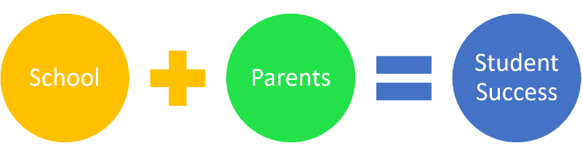
No training costs needed

When and how will this be achieved?
The intervention should be well integrated into the school by the 21/12/18 and should have made a major positive impact on the parents, pupils and school by the 25/02/19. This will be achieved by:
- Creating a welcoming and open school environment and ethos for all parents.
- Emphasising the importance of children’s interests being incorporated into lessons as a way of improving their well-being.
- Promoting and sharing Donaldson’s new curriculum with parents.
- Creating a parent success criteria for homework.
Positive impact on progression
Improved behaviour
Valid support provided at home
Improves well-being, confidence and self-esteem
Why has this intervention been chosen?
‘There is a need for schools and other agencies to improve both parent confidence and their knowledge of the curriculum in ways that will benefit their children’s learning’.
Research on parent engagement suggested that parents have an influential role in the levels of achievement and attainment that the children reach in all areas of their development. However, studies show that parent’s lack the confidence and understanding needed to provide their children with the crucial support they need, especially in relation to homework.


Guardians
Schools
Pupils
Governors
Parents
EXAMPLE
If one of the focuses within this theme was vegetables, the homework task could be to design your own vegetable patch at home. The success criteria for the children and the parents would be similar to those created below:
(Please tick the box to indicate who assessed the homework. The teacher will tell the children when the homework has been set, who will be assessing the work).
(Use green for tick and pink for think strategy to colour in the boxes).
Success criteria for parents/guardians:
Self-assessed
Child/pupil assessed
- I can appropriately support my child in developing their numeracy skills, for example, I know how to measure in mm’s and cm’s.
- I can help and support my child to design a vegetable patch for Peter rabbit and his family.
- I can provide knowledge and understanding of the vegetables that can be grown in the garden.

Success criteria for children:
Self-assessed
Teacher assessed
Parent assessed
- I can create and design a vegetable patch for Peter rabbit and his family.
- I can develop my numeracy skills by including measurements of different sized vegetable patches and flower beds.
- I understand what vegetables can be grown in the garden.

Parent voice and Guardian guidance intervention (parent pack)
Understanding the curriculum, engaging in the learning process and supporting your child at home.

Schools
Guardians
Pupils
Parents
Governors

Example of a parent pack that will be given to parents and guardians, as well as attending parent voice activities within the school.
All of this information within this parent pack will already have been explained in depth in a school-parent meeting. The parents/guardians will already know exactly how to complete the pack, for example, what to write in each box.
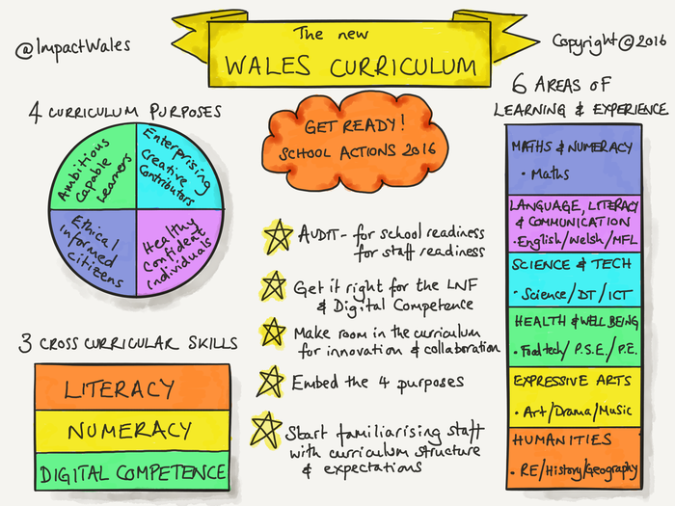
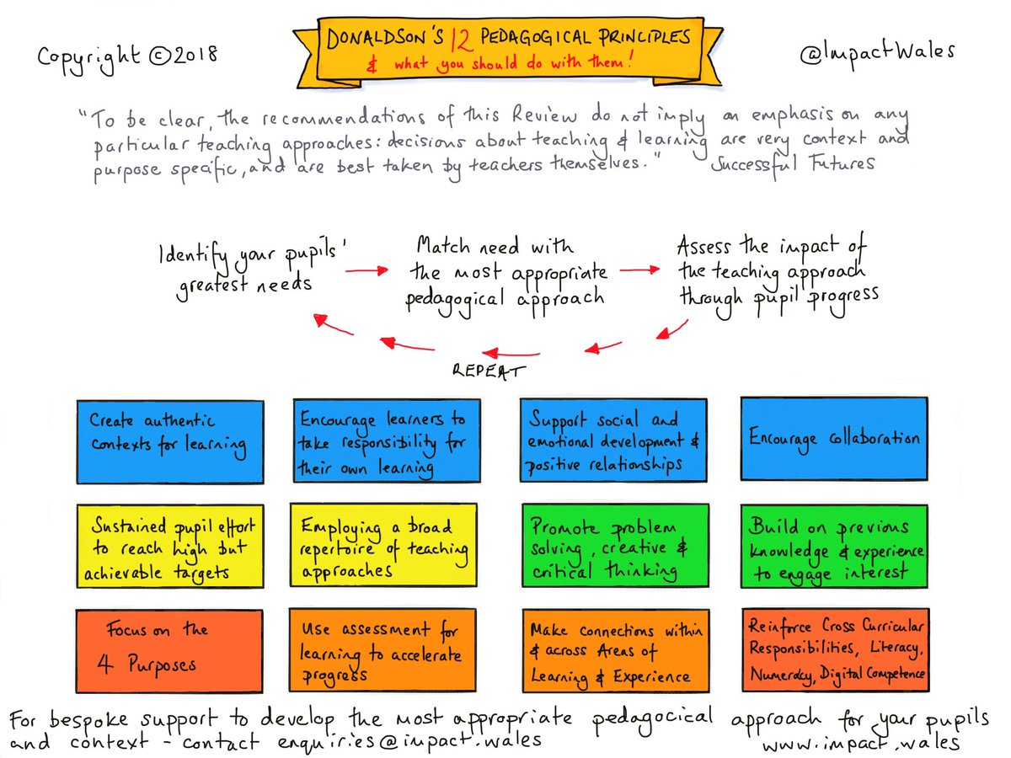

This terms theme/focus: Peter Rabbit

Enhanced learning opportunities/school trip ideas/extra-curricular activities:
Expressive arts:
Humanities:
Language, literacy and communication:
Mathematics and numeracy:
Science and technology:
Health and well-being:
Critical Evaluation
Within this assignment, I feel that I have developed a strong understanding of creating and maintaining professional relationships that will improve of the quality of children’s learning because my intervention is based mainly on working in effective partnerships with parents, whilst also establishing strong relationships with all teachers and governors to create a whole-school approach to children’s learning and well-being. This assignment has also provided me with a wider knowledge of the rights of children from the UNCRC and the importance of the Well-being of future generations act from 2015. I was able to use the knowledge that I discovered within these articles to further develop my own knowledge and understanding of the impacts and effects on children’s well-being, and how barriers can be overcome.
By creating an intervention based on parent engagement, I was able to meet many aspects from the qualified teacher status (QTS) standards within my research and my video presentation, including ‘S1.4 They recognise the importance of communicating information and expectations clearly and sensitively to parents and guardians and of fostering positive relationships between home and school’ (Welsh Government, 2009). Within this assignment, I was also able to meet QTS standard S3.3.1 which states ‘They have high expectations of learners and build successful relationships, centred on teaching and learning. They establish a purposeful learning environment where diversity is valued and where learners feel secure and confident’ (Welsh Government, 2009).
However, there are limitations within this assignment and my intervention. In order to improve this intervention, I feel that there should be greater emphasis on the use of digital competence for parents and pupils. For example, another way of engaging parent’s in the learning process could be using the seasaw app, which allows parents to receive pictures of their children completing their work or having fun in the classroom and shows strong communication between parents and teachers. More research could have been completed in regard to different digital applications that are available for schools and if there would be a simple way for parents to complete the parent voice activity without attending the school, even if this does lessen the impact of creating a welcoming environment for parents.
I also feel that my intervention would have been more engaging and appealing to the chosen order if I had created a questionnaire for parents to complete about parent engagement in schools in Pembrokeshire, as this would have provided more depth into my intervention and also would have provided me with statistics for my presentation. As well as this, I could have tested the strategy within Golden Grove community school to see how effective and beneficial it is for the parents, pupils and the teachers.
Lastly, I could have improved my questionnaire by recording it with myself present in the video. I feel that the video presentation would be a lot more appealing to the target audience if I had possibly regarded the video in a school, and put the power point up on the whiteboard. It may have better demonstrated my understanding of the intervention in regard to reading off a script.
In conclusion, I feel that there are many strengths to my intervention, as I feel that it has the capacity to benefit schools and parents. However, there are area’s which would need to be improved to implement this into a school successfully.

Bibliography
ACT Government. (Date unknown). Parental Engagement. Retrieved from https://www.education.act.gov.au/__data/assets/pdf_file/0005/807431/150897-Building-a-Strong-Culture-of-Parent-School-Engagement_2.pdf
Arshad, R., Wrigley, T., & Pratt, L. (2012). Social Justice Re-examined. London: UCL.
Aston, H., & Grayson, H. (2013, September). Teacher Guide: Parental Engagement and Narrowing the Gap in Attainment for Disadvantaged Children. Retrieved from https://www.nfer.ac.uk/publications/OUPP02/OUPP02.pdf
BBC. (2015). How to help with primary reading, maths, homework. Retrieved from http://www.bbc.co.uk/schools/parents/primary_support/print
Department for children, schools and families. (2008). The Impact of Parental Involvement on Children's Education. Retrieved from http://webarchive.nationalarchives.gov.uk/20130321053648/https://www.education.gov.uk/publications/eOrderingDownload/DCSF-Parental_Involvement.pdf
Donaldson, G. (2015, February). Successful Futures. Retrieved from http://gov.wales/docs/dcells/publications/150225-successful-futures-en.pdf
Early Years. (2007-2012). A Guide for Parents - Settling Young Children into Pre-School Settings. Retrieved from http://www.early-years.org/parents/docs/settle-in.pdf
Early Years Matters. (2018). Transitions. Retrieved from http://www.earlyyearsmatters.co.uk/eyfs/positive-relationships/transitions/
Estyn. (2003). Moving on... Effective Transition from Key Stage 2 to Key Stage 3. Retrieved from http://dera.ioe.ac.uk/5204/1/moving-on-effective-transit1.pdf%3Flang%3Den
Estyn. (2009, April). Good Practise in Parental Involvement in Primary Schools. Retrieved from https://www.estyn.gov.wales/sites/default/files/documents/Good%20practice%20in%20parental%20involvement%20in%20primary%20schools%20-%20April%202009.pdf
Estyn. (2013, October). Effective transition from primary to secondary school. Retrieved from https://www.estyn.gov.wales/effective-practice/effective-transition-primary-secondary-school
Estyn. (2014, June 2nd). A Report on Herbert Thompson Primary. Retrieved from https://www.estyn.gov.wales/sites/default/files/documents/Inspection_report_Herbert_Thompson_Primary_2014.pdf
Estyn. (2018, July). A Report of Ysgol Gelli Aur Golden Grove. Retrieved from https://www.estyn.gov.wales/sites/default/files/documents/Ysgol%20Gelli%20Aur%20Golden%20Grove%20en.pdf
Estyn. (2018, April). A Report on Redhill Preparatory School. Retrieved from https://www.estyn.gov.wales/sites/default/files/documents/Redhill%20Preparatory%20School.pdf
Golden Grove School. (Date Unknown). Meet the staff. Retrieved from https://ysgol-gelli-aurgolden-grove.j2bloggy.com/classes/
Goodall, J., & Vorhaus, J. (2010, May 11th). Review of Best Practise in Parental Engagement. Retrieved from https://assets.publishing.service.gov.uk/government/uploads/system/uploads/attachment_data/file/182508/DFE-RR156.pdf
Howard, C., Burton, M., Levermore, D., & Barrell, R. (2017). Children's mental health and emotional well-being in primary schools. London: Sage.
Impact School Improvement. (2016). Donaldson Readiness Workshop. Retrieved from https://www.smore.com/yg557-donaldson-readiness-workshop
Impact School Improvement. (Date Unknown). Impact - school improvement. Retrieved from https://twitter.com/ImpactWales
Knowles, G. (2009). Ensuring Every Child Matters - A Critical Approach. London: Sage.
Pound, L. (2010). How children learn. London: Practical Pre-school Books.
Prawny. (2014, May 7th). Prawny clipart cartoons and vintage illustrations . Retrieved from http://www.prawny.me.uk/media.details.php?mediaID=ODIzM2M3ZDM1ZGJiZWI=
Psychology notes. (2013, November 3rd). What is Bronfenbrenner’s Ecological Systems Theory? Retrieved from https://www.psychologynoteshq.com/bronfenbrenner-ecological-theory/
Redhill Preparatory school. (2016). Redhill Prep School. Retrieved from http://www.redhillprepschool.co.uk/
SHS (School Home Support). (2015). Parental Engagement. Retrieved from https://www.schoolhomesupport.org.uk/wp-content/uploads/2015/11/SHS-Parental-engagement-toolkit.pdf
Symonds, J. (2015). Understanding School Transition. London: Routledge.
The Chief Secretary to the Treasury by Command of Her Majesty. (2003, September). Every Years Matters. Retrieved from https://assets.publishing.service.gov.uk/government/uploads/system/uploads/attachment_data/file/272064/5860.pdf
Trodd, L., & Chivers, L. (2011). Interprofessional Working in Practise. Berkshire: Open University Press.
UNICEF. (2010). A summary of the UN Convention on the Rights of the Child. Retrieved from https://downloads.unicef.org.uk/wp-content/uploads/2010/05/UNCRC_summary-1.pdf?_ga=2.190313507.907024830.1541445531-1323890436.1541445531
Welsh Government. (2009, July 3rd). The Qualified Teacher Status Standards Wales 2009. Retrieved from https://gov.wales/legislation/subordinate/nonsi/educationwales/2009/3220099/?lang=en
Welsh Government. (2015). Theme 3: Welcoming Families to Engage with the School. Retrieved from http://learning.gov.wales/docs/learningwales/publications/150729-theme3-en.pdf
Welsh Government. (2015, May). Well-being of Future Generations (Wales) Act 2015. Retrieved from https://gov.wales/docs/dsjlg/publications/150623-guide-to-the-fg-act-en.pdf
Welsh Government. (2016). FaCE the challenge together: Family and community engagement toolkit for schools in Wales. Retrieved from http://learning.gov.wales/docs/learningwales/publications/160712-face-toolkit-main-en.pdf
Welsh Government. (2017). Education in Wales – Our national mission: Key planning milestones to 2022. Retrieved from https://beta.gov.wales/sites/default/files/publications/2018-03/171218-education-in-wales-key-dates-calendar-cyen.pdf
Welsh Government. (2017, September). Education in Wales: Our National Mission. Retrieved from https://beta.gov.wales/sites/default/files/publications/2018-03/education-in-wales-our-national-mission.pdf
Welsh Government. (2017). Professional standards for teaching and leadership. Retrieved from http://learning.gov.wales/docs/learningwales/publications/170901-professional-standards-for-teaching-and-leadership-en.pdf

