  Component One: Student Journal (learning log) 750 words +/- 10%  Contribution to Overall Module Assessment: 25% | Student No: | 2240770
 | Module Title: | Operating hotel facilities
 | Module Code: | BMIH4006
 | Lecturer: | Daniel Payne
The housekeeping department is a crucial aspect of hotel operations playing an important role in maintaining cleanliness and guest satisfaction. In this journal, I will share my work experience from work in a four-star Crew Hall Hotel. During my work experience, I was assigned several tasks to maintain high cleanliness standards and guarantee guest satisfaction. Working with housekeeping team members and having direct contact with a hotel guest helped me to know and understand more about how this department functions. In my work experience, I learned more about how hotels function and how little details like open curtains and switched desk lamps can make a room warmer which is a positive aspect for a guest.
At first, I had a mix of positive and negative feelings. I was stressed if I was doing my work in a good way to meet the hotel's standards. The biggest challenge for me was to make a bed and clean a room in a short time, as usually I’m doing it slowly. However, with time I spent with experienced team members helped me improve those skills and I settled quickly into my new role. After some time, I was more sure of what I was doing, and I noticed more things that needed to be done to meet hotel standards. The time I spent in the housekeeping department showed me that customer service is also here. On my first day in a hotel, my manager and I dealt with a client who was dissatisfied with the lack of another set of towels, which was in the room anyway. My manager showed me that in such situations I need to stay calm and find a solution. Crew Hall Hotel is a big hotel with many corridors, and I was lost on my way to the room one time. I was too shy to ask reception where I should go to find these room. From a time perspective, I should ask the front desk for a direction to save time and stress.
Reflecting on my performance, I see that all the time in the housekeeping department I was trying to meet the hotel's standards and I gained more experience with direct contact with guests. I had positive feedback from a team member with whom I worked. However, I found some areas in which I need to improve like time management when is a busier day, and I need to work out contact with guests as I am a shy person and I need to be more open to people. Also, my problem-solving skills need to improve. On my first day in the Crew Hall Hotel, I was nervous and stressed but with time begin on the housekeeping department I felt more confident in what I was doing. My manager shows me how important is communication with other departments like the front desk to provide the best guest service.
From my experience, I know the efficiency of teamwork and good communication is needed to provide the best service. Cooperation with team members makes it easier to complete a task and increase department efficiency (Brotherton, 2012). I also learned how important empathy and listening, communication is between the front desk and housekeeping (Bardi & Petit, 2010). Those skills increase guest experience and help me to develop my professional skills.
My experience in a four-star Crew Hall Hotel was very informative for me. It shows me that the cleaning department has a huge impact on the guest's experience, which I didn't realize before because I didn't think it mattered so much. Maintaining a high cleaning standard has an impact on the guest experience. Leaving a clean room with a tidy bed and a switched desk lamp made the room for guests nicer, which I didn’t notice earlier. Some details can make a positive impact on a guest. I need to work out on my time management skills, and communication with customers to achieve success in hospitality.
To improve my skills, I decided to take time management courses to improve my management skills and to have the opportunity to develop those areas that I highlighted (Kasavana & Brooks, 2011). For my problem-solving skills, I want to use online courses and to remember advice from my more experienced colleagues. I need to also practice more actively listening to customers which will help me in challenging situations (Jones et al., 2016). I want to improve my time management skills, problem-solving skills, and customers to achieve success in my future career in the hospitality area.

Word count: 751

Component Two: Health and Safety Guide
Contribution to Overall Module Assessment: 25%
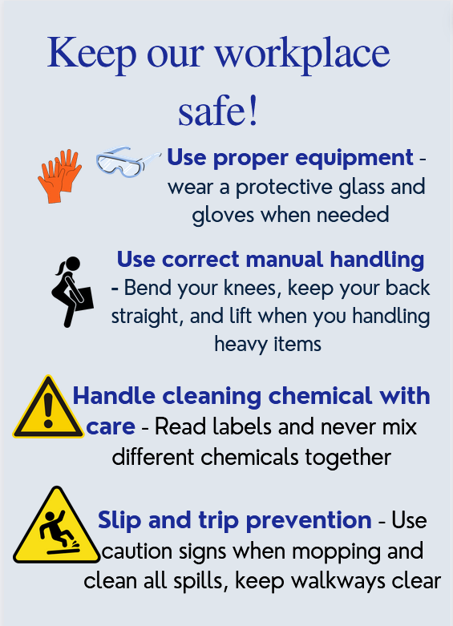
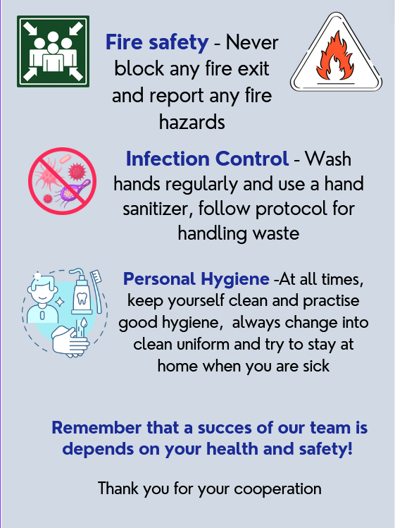

Reference List
1. Brotherton, B. (2012). *Handbook of Hospitality Operations and IT*.
2. Bardi, J. A., & Petit, M. B. (2010). *Hotel Front Office Management*. John Wiley & Sons.
3. Kasavana, M. L., & Brooks, R. M. (2011). *Managing Front Office Operations*. American Hotel & Lodging Educational Institute.
4. Sudhir Andrews *Hotel Housekeeping: A Training Manual*.
5. Jones, P., Hillier, D., & Comfort, D. (2016). *Sustainability in the Hospitality Industry: Principles of Sustainable Operations*.
6. Gibbs, G. (1988). Learning by Doing: A Guide to Teaching and Learning Methods. Oxford: Oxford Polytechnic.
7. Smith, P. (2009). *Hospitality Management Accounting*. SAGE Publications.
8. Brown, J. (2014). *The Hotel Business*.

