Electrical & Electronic Principles

Submitted to:
Dr Steve Mosey
School of Applied Computing

Submitted by:
Ashley Hughes
P149519

Intro
Using a simulation software such as Proteus, a circuit will be created following the diagram provided to measure a range of results. Those results will then be recorded in a table for use in a graph later. Using equations to find the resonant frequency and Q they will then be compared to the measured results. A resonant frequency is a small periodic driving force that has an ability to create large amplitude oscillations. “Q” or Q factor is a dimensionless parameter that shows how underdamped a resonator or oscillator is as well as show a resonators bandwidth relative to its frequency.
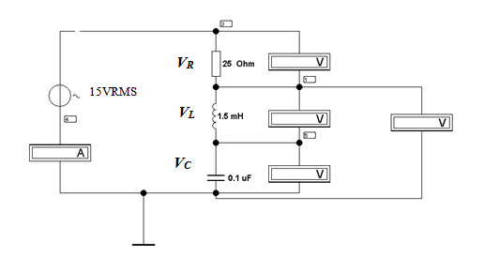
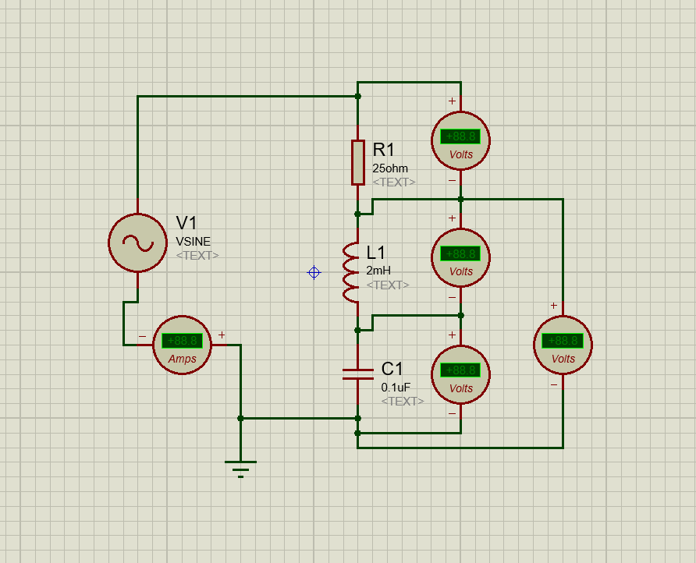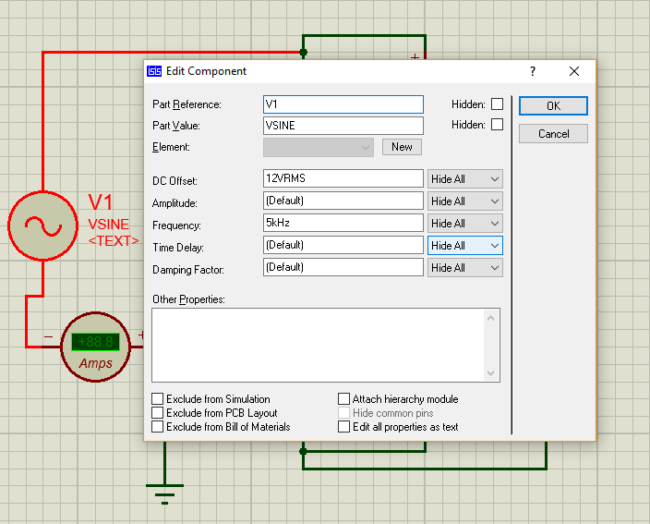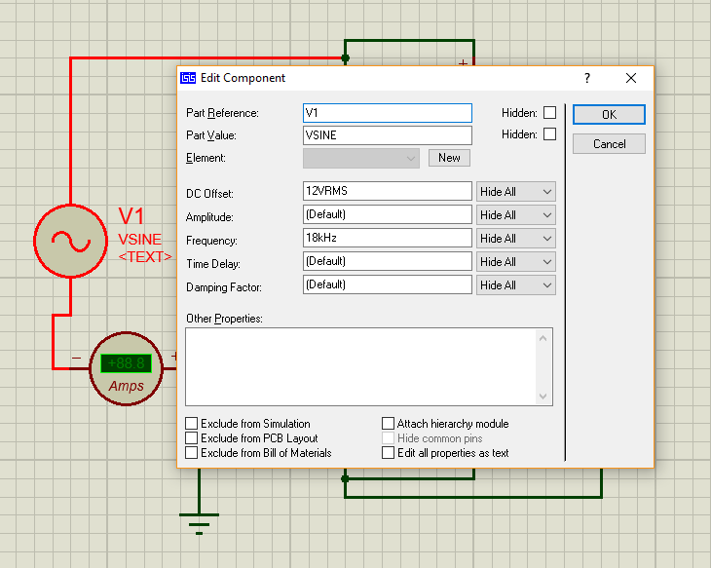

Frequency (f) kHz | V_{C} (Volts) | V_{R} (Volts) | V_{L} (Volts) | V_{LC} (Volts)
5 | 11.9 | 0.09 | 0.02 | 11.9
6 | 11.8 | 0.13 | 0.05 | 11.9
7 | 11.7 | 0.18 | 0.12 | 11.8
8 | 11.5 | 0.25 | 0.28 | 11.8
9 | 11.0 | 0.36 | 0.67 | 11.7
10 | 9.52 | 0.50 | 2.03 | 11.5
11 | 6.54 | 0.17 | 5.37 | 11.9
12 | 9.08 | -0.48 | 3.40 | 12.5
13 | 10.8 | -0.42 | 1.58 | 12.4
14 | 11.4 | -0.33 | 0.94 | 12.3
15 | 11.6 | -0.26 | 0.65 | 12.3
16 | 11.8 | -0.22 | 0.48 | 12.2
17 | 11.8 | -0.19 | 0.38 | 12.2
18 | 11.9 | -0.17 | 0.34 | 12.1

$$f=\frac{1}{2π\sqrt{LC}}= \frac{1}{2π\sqrt{2×{10}^{-3}×0.1×{10}^{-6}}}=11.2kHz$$
$$BW=f_{H}-f_{L}=12-10=2$$
$$Q=\frac{fr}{BW}=\frac{11}{2}=5.5$$
$$Q=\frac{1}{R\sqrt{L}÷C}=\frac{1}{25√2×{10}^{-3}÷0.1×{10}^{-6}}=2.82$$

Comparison of Theoretical and Measured Resonant Frequency
When using the equation $f=\frac{1}{2π√LC}$ to get a theoretical result, I ended up with an answer of 11.2kHz. Comparing this to the measured result I had of 11kHz shows they are both within a 10% margin of each other.

Comparison of Theoretical and Calculated “Q”.
Looking at the results for both theoretical and calculated “Q” they are very close figures. The calculated result being 2.82 is near enough half of the theoretical result 5.5.



