Unit code: BMIH5004
Unit title: Management &amp; Organizational Behaviour
Written Report
Name: Badrul Jamal
Student ID numbers: 2126642
Word count: 2009

Table of Contents
Executive Summary 3
Introduction 4
Organization Structure, Culture, and Goals 4
Organization Structure: 4
Organization Culture: 5
Organizational Goals: 6
Recent change initiatives 6
McKinsey 7S Framework Model Analysis 6
Digitalization 7
Sustainable Growth 8
Impact and Management of Change 8
Strategic Direction and Business Performance 8
Strategic Direction 8
Business Performance 9
Critical evaluation 9
SWOT Analysis 9
Conclusion 11
References 12

Executive Summary
This report evaluates IHG (InterContinental Hotels Group) based on theories and analysis. IHG is working on its structure which means it is a centralized organization. Here communication is just with the organization’s head. Also, it discusses the organizational culture means relationships and friendships that are present in IHG and make positive vibes in the work environment, Also evaluates its goals and current changes. Take some initiatives like McKinsey 7S model digitalization also take strategic direction and overview of its current business performance. They want to make their organization globalized in hospitality around the world.

Introduction
IHG (InterContinental Hotels Group) is one of the best international hotels around the world. They are well known for their brands, their internal environment, holiday trips to new destinations, etc. This report focuses on IHG's goals, structure, recent initiatives, strategies, and current performance.

Organization Structure, Culture, and Goals

Organization Structure:
IHG's organizational structure is some kind of old system that is centralized but in recent times they have changed it. They are going for individual’s department wise responsibility. Such departments like marketing, human resources, etc. have individual rights and responsibilities. They directly communicate with their sub-ordinates and the leaders are directly communicated with the assistant manager and the assistant manager communicates with the general manager (Argyris 2019). This organization is globalized and has a centralized structure. That means all the decisions are made by the top-level manager. If the manager makes a wrong decision, all of them work on it. The general managers control the overall decision and their sub-ordinates work under their decisions. Here the boss is always friendly with all the members, sometimes they are directly communicating for a strong relationship. If the upper manager says something that is a little bit confusing or needs to be updated, there is no chance to apply this confusion. Other hotels within IHG follow the headquarters' standards so that they survive the competition.
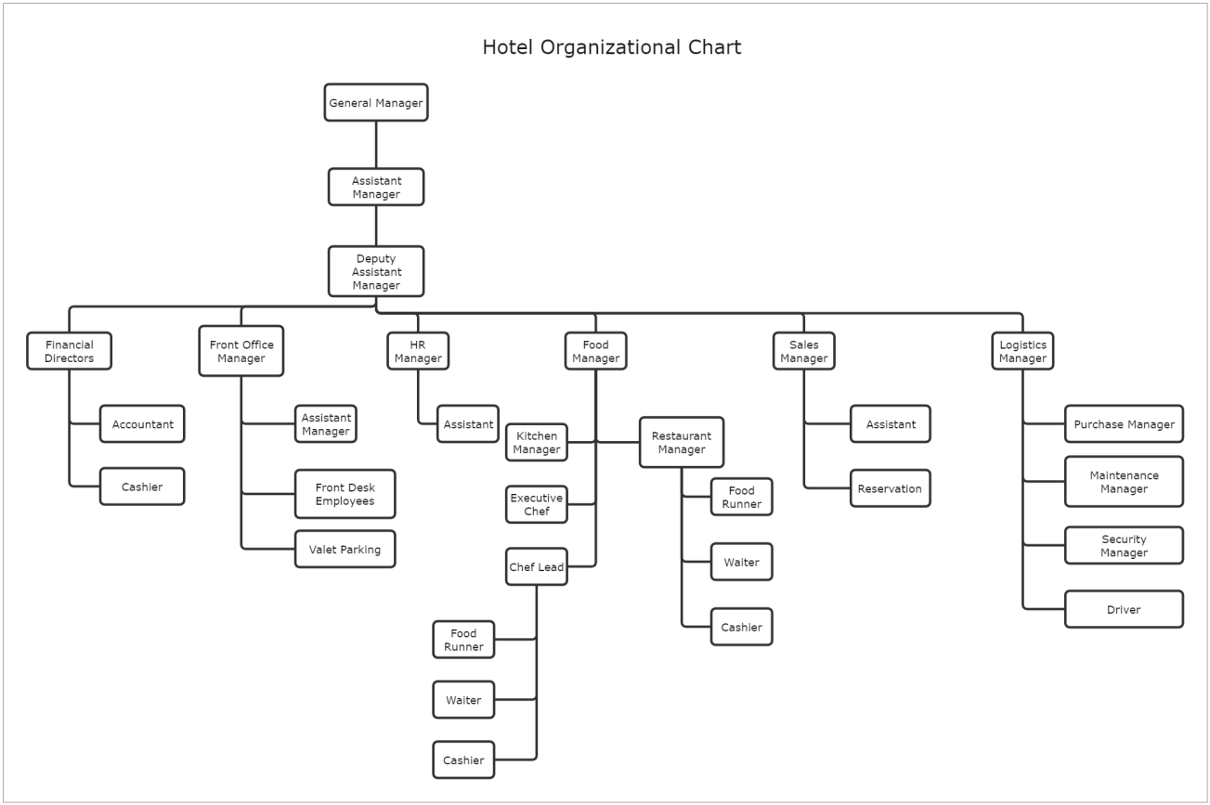
Figure: Organization Structure
Source: Arthur 2018

Organization Culture:
This organization is customer-based, which means IHG Hotel Group always focuses on the customer's needs and preferences. So, their organizational performance is always top because they are finding the problem of the customer and solving it as soon as possible. The organization also focuses on its service and product standards; they are providing top quality service. IHG also promotes collaboration with its internal sectors; as a result, the organization's employees, managers, and leaders all share information (Banks et al., 2023). They have created a relationship and friendships that makes them more positive in the work environment, and they are not bored when they are at work for a long time. The organization's culture is always committed to being flexible, adaptable, and continuously improving in the hospitality sector.

Organizational Goals:
IHG is a centralized organization, so all the decisions are made by the top manager. So, the manager sets its goal to be the best-preferred organization for all kinds of clients. They are achieving sustainable growth in their country so that they can expand their business around the world. So, they are enhancing their product quality through continuous improvement, loyalty to customers, and advancements in technology. The company's goal is to achieve long-term success so that they can add value to their products and services (Crant and Bateman 2020).

Recent change initiatives
IHG has changed in various sectors, like adding digitalization to their organization and sustainable growth, and they are also adding some new frameworks like the McKinsey 7S model. As a result, they are enhancing their service quality and brand loyalty (Edwards 2020). They aim to add them as a new hospitality organization, whose demand is very high and guests' first choice.

McKinsey 7S Framework Model Analysis
Strategy: IHG focuses on expanding its organization around the world, so it invests a huge amount in technological advancement (Fehr et al., 2019). The organization targets various market segments and represents its product as of standard quality. So they support the implementation of some standard strategies like proper discipline in the organization, contact with suppliers, collaboration with internal members, and always monitoring their work. They can focus on competitors' strategies and develop advanced strategies.
Structure: IHG's structure is old and centralized, but now all the levels of the members contribute their opinions. Most vital issues are solved by the top-level manager, and less important decisions or problems are solved by the middle- and low-level managers (Kinnunen et al., 2020). As a result, all the members are contributing their opinions.
Systems: The organization adds some systems that increase the customers' experiences. That system is customer relationship management and reservation that provides the collected data to the customers. As a result, customers can easily make their own decisions (Kumar and Beyerlein 2021). Also, IHG goes from centralized to decentralize. That means all the levels like marketing, sales, management, etc. have a leader and individually they have some power to make some immediate decisions.
Skills: IHG focuses on skills that mean expertise in a sector. So, the organization arranges some training programs for employees' development. In this organization, they have recently added some technological advancement, so they have upgraded equipment in the hotel. So, employees need to be trained by experts to use that equipment (Langevoort 2022). Also, employees need to know how to deal with customers' needs, so training is mandatory if IHG competes at the top and most favorite.
Staff: This resource is very closely related to IHG's organization. They are the controller of the other things. So, if they are well trained then IHG will achieve its success. The company is always friendly with its members so that they openly communicate with their seniors and take steps. IHG tries to provide the best working environment to its staff. The company's top officers are creating some rewards and entertainment time with all the members so that they are collaborating. (Malik 2019).
Style: IHG selects the best leadership style that is proactive, the employees are comfortable sharing anything and trust him that he or she will do the work. This style focuses on customer centralized which means customer preferences are the first. They want the customer's satisfaction and believe that continuous improvement is always staying ahead in one step from competitors. (Pinder and Moore 2018).
Shared Values: IHG is always committed to its service quality, its improvement, and its sustainable decisions. This responsible practice always increases its share value. It provides a common structure for a specific decision; all this part is very responsible in corporate society. (Rulke et al., 2020).

Digitalization
IHG tries to invest in its technological site for improvement. They want to give their guests the best comfort (Srivastva and Cooperrider 2018). They especially invest in biotechnology sites, if any guest wants to check in their room, then they need to scan their eyes or figure prints.

Sustainable Growth
IHG works on some initiatives, like reducing their waste, controlling their energy supply, and hiring some equipment so that the environment is not affected. Also, they are following trends to update their organizational environment (Starbuck and Mezias 2019). It gives guests the best experiences in their organization.

Impact and Management of Change
In recent times, IHG has made some changes in their organization, and as a result, they are improving some specific sites, like their customers' satisfaction and sustainable growth. They are also focused on technological advancement; as a result, they ensure their customers' privacy and easily move on. The best impact is adapting to day-to-day market changes and being flexible because they are following market trends. So, the customers relate to the organization and trust them. Also, the company invests in training sectors and their employees' development. IHG selects a perfect leadership style so that they communicate with their employees, staff, and shareholders to manage them very efficiently (Sung and Choi 2022). In this change, they gain their targeted market and get back to the top of the competition.

Strategic Direction and Business Performance

Strategic Direction
IHG's strategy is very different from that of other organizations. In this strategic direction, they add brand differentiation, technological improvement, and global expansion to achieve sustainable growth of the organization.
Brand differentiation: IHG creates a new brand so they can target some specific market segments (Tjosvold 2022). This strategy will capture the different ranges of customers' preferences. Also, this strategy will ensure that the target guest is enjoying their luxury service with a variety of customers.
Technological Improvement: IHG invests in their technological site, especially their biotechnology site, where if any guest wants to check in their room, they need to scan their eyes or figure prints. This investment will put this company at the top of the list and add value for them.
Global Expansion: IHG has always tried to capture some new markets. They aim to expand their company in the country through worldwide expansion. They are investing in research and development to find out the key information and resources that make the company a top contender. They understand the customer’s needs and wants based on demographics. So they can capture the different demographic sectors.

Business Performance
Financial Metrics: This is the key indicator for knowing the company's revenue or loss. IHG has this indicator. When they know from metrics that IHG's revenue is low and its profit margin is not satisfied, top-level executives take action on it (Vancouver 2023). In the COVID-19 pandemic situation, IHG is adapting to these problems, and they are significantly down in their travel and hospitality sectors.
Customer Satisfaction: In these recent changes, they have achieved customers' trust and satisfaction. According to their metrics, they achieve a healthy score. Customers always enjoy their journey the first time, and then again they want to come and enjoy their journey.

Critical evaluation

SWOT Analysis
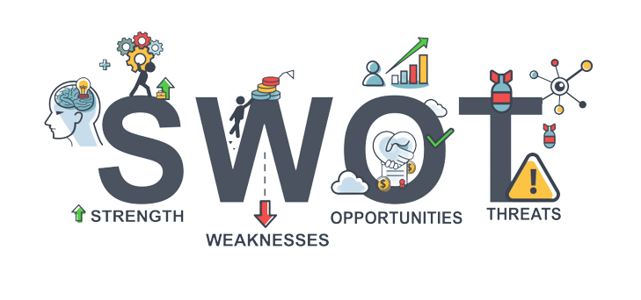
Figure: SWOT Analyses
Source: Wiesenfeld et al., 2019
Strength
IHG is the best-known hotel organization in the UK. IHG is always loyal to its guests and customers always trust them. This organization is famous for its service quality, and its budget-friendly offers. Now, they are investing in technology like figure print systems and eye scanning when guests check in or check out from the hotels. (Wilson 2018). The customer-centralized company has some initiatives, like low-class IHGs having to identify and provide them with materials, and they have to maintain the standard of the organization. It is also based on the organization's reputation. The most interesting part is that all the IHGs adopt the standard, and at present, most of the organizations can overcome the underclass.
Weakness
IHG faces very strong competition from its competitors (Yammarino et al., 2018). So, they need to upgrade with technological advancement. If they are consistent in providing the best service according to the customer's wants and needs, then it makes a change. As a result, the organization can reach its target. But here is a weakness of this organization, which is that all the brands are not consistent in upgrading; there is a huge need for advancement; and there is also a big challenge for IHG.
Opportunities
IHG is well known for its budget-friendly offers and its good quality of services so that low level of customers is freely interested in this budget-friendly offer. IHG focuses this low categories offers for those people; If a person gets a room in the hotel, then ensure his or her room has air conditioning, the fastest Wi-Fi facilities, etc. so that they do not move anyone for these services (Langevoort 2022). If the price of this room is reasonable, then maximum guests are preferable at this IHG hotel.
Threats
In any pandemic situation like COVID-19, political issues can be very harmful to IHG's Travel Industry. Also, it decreases the growth of the company. Also, the targeted customer's preferences are very important but when it is changed then it is a big issue for the organizational target. (Arthur 2018). The problem that there is no involvement of the organization, like political issues or any natural disasters like the COVID-19 economic downturn, etc., is the main threat to an organization. Also If IHG finds out the market, changing customers' needs and wants is very vital and most dangerous for every organization.

Conclusion
After the analysis of this organization, this organization is in the boom stage of its brand value. This report discusses the IHG's strengths, weaknesses, opportunities, and threats. The company captures the new geographic areas to expand its business around the world. In recent times, they have changed some strategies, and it is normal because when an organization's growth is high, they are facing some challenges. But the organization smartly handles this pressure. They change their management, add some innovation, and continue to succeed.

References
Argyris, C., 2019. Management and Organizational Development. The Path from XA to YB.
Arthur, M.B., 2018. The boundaryless career: A new perspective for organizational inquiry. Journal of organizational behavior, pp.295-306.
Banks, G.C., Woznyj, H.M. and Mansfield, C.A., 2023. Where is “behavior” in organizational behavior? A call for a revolution in leadership research and beyond. The Leadership Quarterly, 34(6), p.101581.
Crant, J.M. and Bateman, T.S., 2020. Charismatic leadership viewed from above: The impact of proactive personality. Journal of organizational Behavior, 21(1), pp.63-75.
Edwards, J.R., 2020. The study of congruence in organizational behavior research: Critique and a proposed alternative. Organizational behavior and human decision processes, 58(1), pp.51-100.
Fehr, R., Welsh, D., Yam, K.C., Baer, M., Wei, W. and Vaulont, M., 2019. The role of moral decoupling in the causes and consequences of unethical pro-organizational behavior. Organizational behavior and human decision processes, 153, pp.27-40.
Kinnunen, U., Mauno, S., Nätti, J. and Happonen, M., 2020. Organizational antecedents and outcomes of job insecurity: A longitudinal study in three organizations in Finland. Journal of organizational behavior, 21(4), pp.443-459.
Kumar, K. and Beyerlein, M., 2021. Construction and validation of an instrument for measuring ingratiatory behaviors in organizational settings. Journal of applied psychology, 76(5), p.619.
Langevoort, D.C., 2022. The Epistemology of Corporate-Securities Lawyering: Beliefs, Biases and Organizational Behavior. Brook. L. Rev., 63, p.629.
Malik, A., 2019. Efficacy, hope, optimism and resilience at workplace–positive organizational behavior. International Journal of Scientific and Research Publications, 3(10), pp.1-4.
Pinder, C.C. and Moore, L.F., 2018. The resurrection of taxonomy to aid the development of middle range theories of organizational behavior. In Middle range theory and the study of organizations (pp. 187-211). Dordrecht: Springer Netherlands.
Rulke, D.L., Zaheer, S. and Anderson, M.H., 2020. Sources of managers' knowledge of organizational capabilities. Organizational behavior and human decision processes, 82(1), pp.134-149.
Srivastva, S. and Cooperrider, D.L. eds., 2018. Organizational wisdom and executive courage. Lexington Books.
Starbuck, W.H. and Mezias, J.M., 2019. Opening Pandora's box: Studying the accuracy of managers' perceptions. Journal of Organizational behavior, 17(2), pp.99-117.
Sung, S.Y. and Choi, J.N., 2022. Effects of team knowledge management on the creativity and financial performance of organizational teams. Organizational Behavior and Human Decision Processes, 118(1), pp.4-13.
Tjosvold, D., 2022. The conflict‐positive organization: It depends upon us. Journal of Organizational Behavior: The International Journal of Industrial, Occupational and Organizational Psychology and Behavior, 29(1), pp.19-28.
Vancouver, J.B., 2023. Living systems theory as a paradigm for organizational behavior: Understanding humans, organizations, and social processes. Behavioral science, 41(3), pp.165-204.
Wiesenfeld, B.M., Reyt, J.N., Brockner, J. and Trope, Y., 2019. Construal level theory in organizational research. Annual Review of Organizational Psychology and Organizational Behavior, 4, pp.367-400.
Wilson, F.M., 2018. Organizational behaviour and work: a critical introduction. Oxford university press.
Yammarino, F.J., Dionne, S.D., Schriesheim, C.A. and Dansereau, F., 2018. Authentic leadership and positive organizational behavior: A meso, multi-level perspective. The leadership quarterly, 19(6), pp.693-707.

