Component 2 - Research Report
Student Name: Kamil Kazimierz Lenczowski
Student Number:2120445
Lecturer Name: Ngozi Ibeji
BMSW4003_BIRM
Digital Skills and Research Methods.

ABSTRACT

This section will overview this report, I will focus on the methods used in the research. During sessions, I was involved in group work with three people from the university and we were analysing research about Which digital tool is most commonly used for collaboration at UWTSD?.
The methods we have used
- A brainstorming session between our group
- Searching on the internet
- Literature
- Feedback from other students
- Microsoft form application
Our group worked from five responses given to our questionnaire.
My personal conclusion about the findings was similar to the result of the Microsoft form, I was sure that most people will choose the application according to their usage. I am happy that I have had similar feelings about finding. Students at our university were confused about how to do research and get proper results, we had to involve two Microsoft forms to get better clarification on the asked question.

CONTENTS PAGE

ABSTRACT 2
CONTENTS PAGE 3
INTRODUCTION 4
RESEARCH DESIGN 5
Microsoft form 5
Question number 1 5
Question number 2 5
Question number 3 5
Question number 4 5
Question number 5 5
Question number 6 6
Question Bank 7
RESULTS 9
DISCUSSION 14
CONCLUSION 18
REFERENCE PAGE 19
APPENDIX 21

INTRODUCTION

The content of this report is about our research regarding the task given during study at the University of Wales Trinity Saint David. The purpose of the task given is to research how we use technology to collaborate at the university and the research question is which digital tool is most commonly used for collaboration at the university. This report is my own work and is going to show the results of the research in which different methods were applied. Analysis and hypothesis will show an apparent outcome. This report has been created by all the students and the questions were given only to students in the above institution (UWTSD). This report has been supported with relevant literature to give the contents and the results of the questionnaire have been realised to clarify the personalized answer. This work will also show us how important it is to be able to collaborate with digital tools to improve and develop our skills.

RESEARCH DESIGN

According to the project, I am going to expand the view about the way how these results have been collected. I would like to point out that this is a result of group work issued for us by the university. The first instance was to look into the necessary and relevant literature. The group who have been involved was Kamil Lenczowski, Krystian Balog, and Michaela Zavalna. As a group, we did not know each other before we were gathered into teamwork to be working on the most popular question these days. The hardest thing to do was to work in a group to create an idea of how we can collect necessary data from other students. This report will state step by step what we had to do, to get a specified answer from other peers. Our skills in group work were limited but we were able to collaborate after a while. The next stage is to take you to the questions which have been created for other students. We used Microsoft forms to make it and sent it to several students at the university.

Microsoft form
QUESTIONS TAKEN

Question number 1
Rank these applications in order according to how frequently you use them to collaborate with others.

Question number 2
How do you feel about using technology to collaborate?

Question number 3
Would you rather like to study with or without digital tools?

Question number 4
Do you feel confident to use technology to collaborate?

Question number 5
Which digital tools do you commonly use?

Question number 6
Do I need any more training?
This research involved us to :
- look and identify a research question
- conduct a review of existing literature
- plan research methods and consider ethics
- present a proposal for approval
- create a questionnaire and collect data
- analyse report
- write up a full report of the data collected

Our research appears to be using different kinds of questions. Group F created Questions based on the models of questions. This report contains a few of type questions that have been discussed during our sessions at university. The way how the questions have been taken is constructed in an ethical way to collect necessary data from the survey and clearly state apparent answers to a reached question. Oftentimes the organizations who are taking a survey are using a wide range of methods to get the information. To be more specific, this group did not hesitate to do their own research about the type of questions for the chosen topic. However, in this research, we adopted the type of questions that were provided us by the university. Group F must have implemented a survey for peers from UWTSD only and fully be responsible for any ethics aspects, which were fully applied by informing other students about the anonymous questionnaire and taking the whole responsibility for that. The research was taken within a specific group of internal students because only these people could have answered adequately, and methods qualitative and quantitative could have been applied to this research. Only pertinent questions can be given a satisfactory answer. Group F was able to find which people would respond to the questionnaire and we had a minimum of required people in this instance.
These several responses have given us the chance to read the data in a quantitative way by using charts. Group F could have used a different type of questions available from the question bank:

Question Bank

- Closed questions. (yes or no answers)
- Rank Order questions – arrange words in rank order
- Likert Scale questions.

All of the students were informed about ethical considerations and we were accordable to this and based on the material given to us by the university

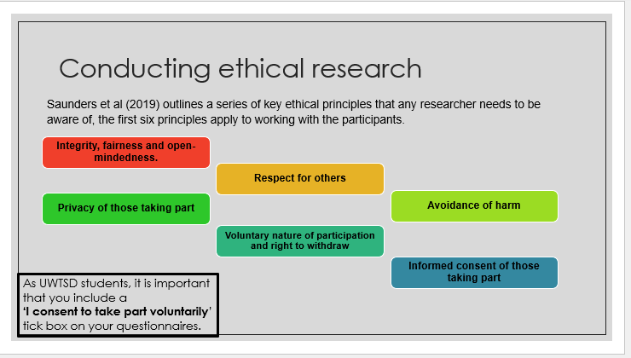

RESULTS

Another part of this research report will bring us a clear result of the questionnaire and will be explained in many ways to illustrate each question given and each answer got back from our student community at the University of Welsh. The way how we were gathering the information from students has been compressed into the charts. Each answer will be illustrated witch using a proper chart in our opinion. A visual analytics approach exact segment aims at determining the winner. Our report mentioned before about five questions.
- Rank these applications in order according to how frequently you use them to collaborate with others.
- How do you feel about using technology to collaborate?
- Would you rather like to study with or without digital tools?
- Do you feel confident to use technology to collaborate?
- Which digital tools do you commonly use?

We have adopted a sixth question to get knowledge about if our students currently need some extra training provided and can collaborate without any problem during their studies.
The academic structure is based on the learning platform it is important that all the students are collaborating well and feel happy and confident.

QUESTION 1
Rank these applications in order according to how frequently you use them to collaborate with
others.

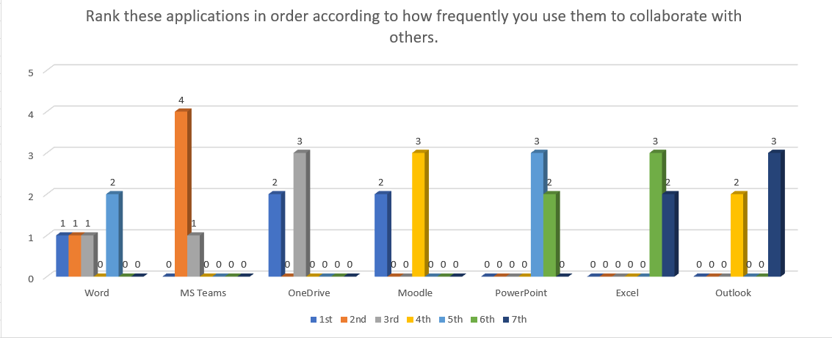
The majority of people said OneDrive and Moodle are in the first place as an application however more people ranked OneDrive higher in the third place. Furthermore most popular in the second rank is Microsoft Teams.
QUESTION 2
How do you feel about using technology to collaborate?
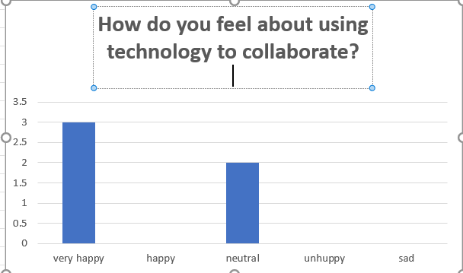
People feel happy

QESTION3
Would you rather like to study with or without digital tools?

People who have been asked like to study with digital tools

QUESTION 4
Do you feel confident to use technology to collaborate?
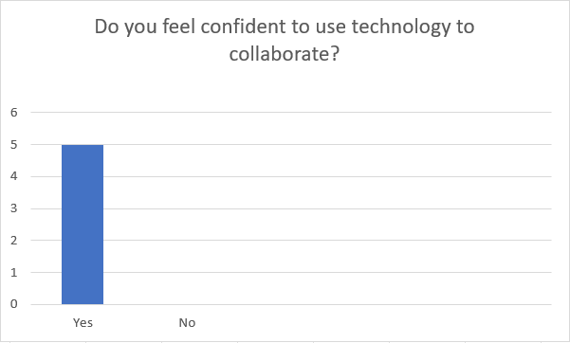
People feel confident

QUESTION 5
Which digital tools do you commonly use?

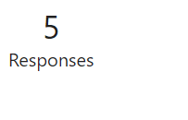
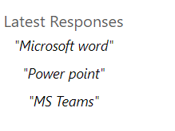

Here seems to be a bit different than in our ranking question but MS Teams looks to be commonly used still.

QUESTION 6
Do I need any more training?
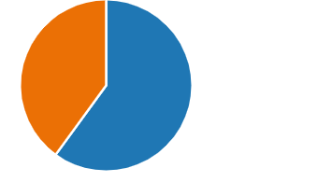
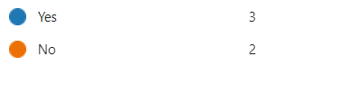

Students still need the training to be provided

DISCUSSION

This report is about the digital tool and about students feelings and the way how they look at digital platforms, tools created to collaborate on learning systems. This report used an advanced method to achieve a likely winner if we think about modern learning systems and advanced programs used to get knowledge. This report adopted the use of the application Microsoft form to create the questionnaire for students at UWTSD. According to the sources based on our group presentation, we can notice that there are several programs used for collaboration.

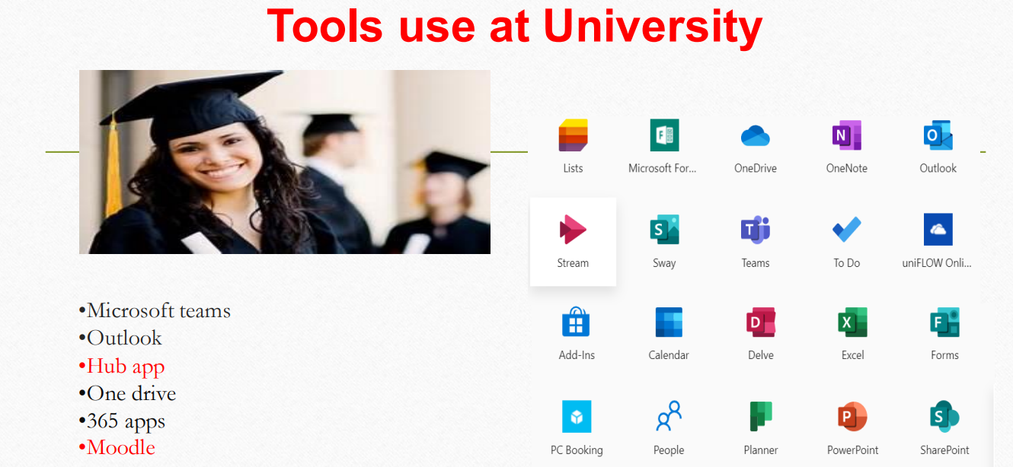

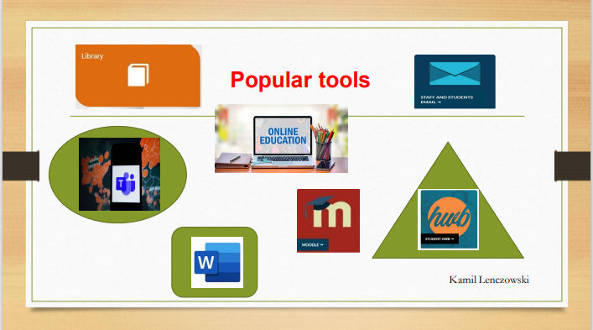
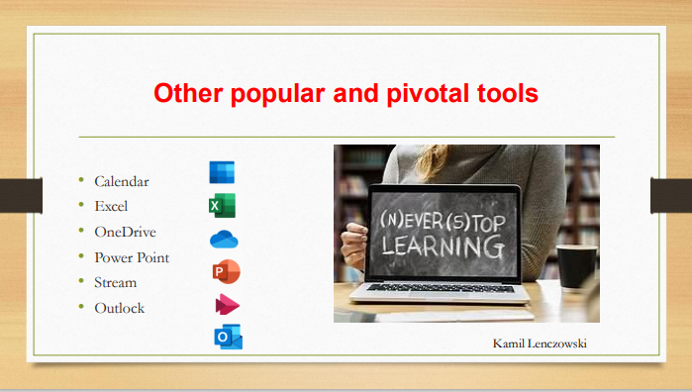

Many students are out of study for a long time and still have to chase themself to be able to diametrically. First and foremost, in 21 century, our capacity depends on if we are improved significantly and we can branch ourselves out. Oftentimes we have to create our own action plan and choose necessary and most like tools and utilize them with full capacity. This report is not only about a particular group at the University it is also highlighting how the whole teaching in high education has been gained. This report discusses the effective Microsoft programs and how the use of digital toll may effectively support students and the higher education system. The last three decades seem to be improved, 21 century brings in higher education a more modern learning model and gives us an opportunity and wide range of potential. The impact of getting countries economically stronger also improves the higher educational institutions to offer more spaces at the universities and provide the students with the best level of teaching adequately to possibilities. The questionnaire which was filled off by the students from UWTSD gives a concept, that lots of students are willing to learn with digital tools. For the question: Would you rather like to study with or without digital tools? 100 percent of students said YES. The student’s answers said also there do not feel any difficulties and felt confident to collaborate with digital tools. These results got a massive impact in affirmative that the higher education contributes witch expectations. The coherent way of using only a few simple questions in this survey did bring to the conclusion. Analysing this conclusion and looking into the relevant sources we can see immeasurable progress in students’ expectations, unfortunately, students still require more training more than half of the respondents did say they require more training provided. The enormous range of sources and a growing number of different and more advanced applications create students’ life happier, students are approaching a new level of their study.

CONCLUSION

The results confirm that digital tools without a doubt are smart tools and they are commonly used in the education process. If we look at many articles, and surveys we could see that nowadays only the learning systems where digital tools are in charge are most effective and most liked by the students. A number of higher education institutions are inspired by research and implement digital tools within learning methods. This specific report confirms the most popular tools at Trinity Saint David, based on the ranking question, the application OneDrive is the first one together with Moodle. The result of that shows important points that I have made in my discussion because these two applications support, supply, and scaffold students and make their studies easier. My thoughts could be the same as other students because most of the students at this University were out of study for quite a long time and I feel that these applications are very useful and entirely support the learning process.

REFERENCE PAGE

Duarte, N. (2008) Slide:ology : the art and science of creating great presentations. First edition. Sebastopol, California: O’Reilly Media.
Schneider, Z.M. and Fuller, J. (2018) Writing research proposals in the health sciences : a step-by-step guide. London: SAGE Publications Ltd.
Rashid T, Asghar H M (2016) Technology use, self-directed learning, student engagement and academic performance: Examining the interrelations, Computers in Human Behavior, volume 63, Science Direct, available at: https://www.sciencedirect.com/science/article/abs/pii/S0747563216304204
Poston J, Apostel S, and Richardson K ( 2019) Using Microsoft Teams to Enhance Engagement and Learning with Any Class: It’s Fun and Easy, Bellarmine University available at: https://encompass.eku.edu/cgi/viewcontent.cgi?article=1005&context=pedagogicon
Gunawan, Agung (2009) TEACHING WRITING THROUGH MICROSOFT WORD IN IMPROVING STUDENTS’ WRITING SKILLS, available at: http://repository.upi.edu/9209/6/t_bing_0704794_chapter5.pdf
Erstad, Flewitt, R., Kummerling-Meibauer, B., & Pereira, I. S. P. (2020). The Routledge handbook of digital literacies in early childhood, available at: https://librarysearch.uwtsd.ac.uk/permalink/44WHELF_UWTSD/11c0l68/alma99100357058702421
Jesson, McNaughton, S., Rosedale, N., Zhu, T., & Cockle, V. (2018). A mixed-methods study to identify effective practices in the teaching of writing in a digital learning environment in low income schools. Computers and Education, available at: https://www.sciencedirect.com/science/article/abs/pii/S0360131517302622
Lopes A P (2011) Teaching with Moodle in higher education, P Porto, available at: http://hdl.handle.net/10400.22/622
Kwok-Wing Lai (2011) Digital technology and the culture of teachingand learning in higher education, University of Otago available at:View of Digital technology and the culture of teaching and learning in higher education (ajet.org.au)
Reedy, K. and Parker, J. (2018) Digital literacy unpacked. Edited by K. Reedy and J. Parker. London: Facet. available at: https://librarysearch.uwtsd.ac.uk/discovery/fulldisplay?context=L&vid=44WHELF_UWTSD:44WHELF_UWTSD_VU1&search_scope=MyInst_and_CI&tab=Everything&docid=alma99100279559402421
Benjamin G. Thomas M. and Richard R. SMITH (2015) Enhancing students' learning process through interactive digital media: New opportunities for collaborative learning, Singapore Management University Institutional Knowledge at Singapore Management University available at:https://ink.library.smu.edu.sg/cgi/viewcontent.cgi?article=3533&context=sis_research

APPENDIX



