MODULE NAME AND CODE
Digital Skills for Personal and Professional Growth BMSW4008
ASSESSMENT TITLE
Evidence of Learning E-portfolio

Mihaela Elena Marin
UNIVERSITY OF WALES TRINITY SAINT DAVID
Student number: 2240233

Table of Contents
TASK 1 3
TASK 2 6
Video Link 6
TASK 3 6
INTRODUCTION 6
Analysis of Key Questions 6
CONCLUSION 10
TASK 4 12
INTRODUCTION 12
Website Design 12
Marketing Materials Design 15
Segmentation and Targeting 20
SEO Optimization 20
CONCLUSION 21
REFERENCES 22
Appendix 24
Raw Data for Task 3 24

TASK 1
Today's market is very competitive, so brands need to stand out to get and keep customers' attention. One very good way to do this is through telling stories (Rodriguez, 2023). When it comes to branding, storytelling isn't just about selling goods or services it's also about making a story that sticks with people, makes emotional link as well as the encourages loyalty. As a case study, Venus Bloom Beauty Salon is used to show how important stories are for building and developing company identity. This article will talk about what storytelling means in context of branding, look at a successful real-life example as well as the talk about how Venus Bloom can use storytelling to create a unique personality, keep customers coming back as well as the standout in beauty industry.
Storytelling in branding is smart use of stories to show what a brand stands for, what it wants to do as well as the who it is (Aimé, 2023). It means writing interesting story that fits brand's attitude and speaks to people it wants to reach. Brand storytelling that works goes beyond just marketing it connects brand with its customers on emotional level. Authenticity, relatability as well as the stability are all important parts of a good story. story behind a brand should be real to build confidence, understandable to get people interested as well as the similar across all platforms to keep brand's image consistent. By putting these parts together into a story that flows, brands can set themselves apart and leave image that lasts.
Dove's "Real Beauty" ad is a great example of how to tell a story about a brand. When it began in 2004, campaign aimed to question social beauty standards and push for a broader view of what beauty is (Allen, 2022). Dove told stories about real women instead of models, focusing on their unique experiences and praising different kinds of beauty. Dove's ad really hit home with their target group, making emotional link. Dove's brand trust and market visibility went up a lot because women felt seen and valued. campaign worked because it was real and relatable. Dove told a story that a lot of women could relate to that made a strong connection between brand and its customers (Huang, 2021).
We can see how Venus Bloom Beauty Salon, a new business that offers a wide range of beauty and skin care services, can use stories in a smart way to build and strengthen its brand identity. Hair removal, face treatments, tanning, pedicures, manicures, eyebrow treatments, lash extensions, body piercing as well as the different makeup packages for parties, weddings as well as the pre wedding events are just some of services that Venus Bloom Beauty Salon offers (Saint Thomas, 2023). Venus Bloom might have a unique story because it wants to bring out natural beauty and encourage people to take care of themselves. This story can show how committed hairdresser is to use ecofriendly, high-quality goods and giving each customer individualized services that meet their specific needs.
It is impossible to stress how important stories are for Venus Bloom Beauty Salon. In order to set itself apart from rivals, spa can use its story to create a unique character (Carlotto, 2024). For example, Venus Bloom's story could show how beauty should be looked at as a whole with customers not just getting a service but also starting a journey of self-discovery and freedom. Venus Bloom can make its brand stand out in crowded beauty market by telling this story over and over again through different marketing platforms.
Also, telling stories is a great way to keep customers coming back. When people relate to a brand's story, they are more likely to feel emotionally connected to that brand (Hong et al., 2022). For Venus Bloom, telling stories of real clients who have had beauty treatments that changed their lives is a strong way to gain trust and confidence. People can share these stories on social media, in blog posts as well as the as recommendations. This makes people feel like they are part of a group. Venus Bloom can build a loyal customer base that feels respected and understood by showing real experiences (Thompson, 2022).
Venus Bloom can also stand out in a crowded market by telling stories. beauty business is crowded with shops that all give same services (McCormack, 2021). But Venus Bloom can stand out with interesting business story. For instance, spa could talk about how its owners were deeply interested in health and beauty, how its name came to be as well as the how it all began. Venus Bloom can get people who share its beliefs and goal to buy from it by giving company a personality.
People like to hear stories that is why storytelling is such a useful tool for brands. Stories are easier to remember than facts because they use both thinking and feeling parts of brain (Armstrong, 2020). Customers are more likely to remember a brand and feel good when they hear interesting story about it. This emotional link is very important for company commitment and support. A strong company story can also help with marketing because it gives a consistent and interesting message that can be shared on many channels, from social media to in store experiences.
Furthermore, telling stories is important part of creating and promoting company personality. interesting story can help brands stand out in a crowded market, give themselves a unique personality as well as the make customers loyal. To make a unique and appealing brand image, Venus Bloom Beauty Salon can use stories to show how committed it is to natural beauty and personalised care. Dove's "Real Beauty" ad and other great ones show that good writing connects with people and keeps them interested. In today's fast paced business world, brands that want to do well need to use stories as essential part of their business strategy. To make this work, brands need to put money into telling real stories that connect with their fans and show what they stand for.

TASK 2

Video Link
Presentation for Video Task 2....mp4
Presentation for Video Task 2....mp4 (sharepoint.com)

TASK 3

INTRODUCTION
The Venus Bloom Beauty Salon poll data analysis gives useful information about what customers like and how they act. Focusing on four main questions will help us see patterns and trends that are important for making business plan better. These questions are: "How often do you visit a beauty salon?", "What factors influence your choice of a beauty salon?", "How important is availability of organic or natural beauty products to you?" as well as the "How do you usually learn about new beauty salons and trends?".

Analysis of Key Questions
1. Frequency of Beauty Salon Visits
- Question: How often do you visit a beauty salon?
- Findings: Based on answers, most people who took survey say they go to beauty centres either not often or every few months. In particular, 40% of those who answered visit very rarely as well as another 40% visit every couple of months. A smaller segment, 20%, visits once a month.
- Implications: This information shows that there is a steady customer base but getting people to come in more often could bring in a lot more money. Some ways to get people to come back more often are through loyalty programmes.
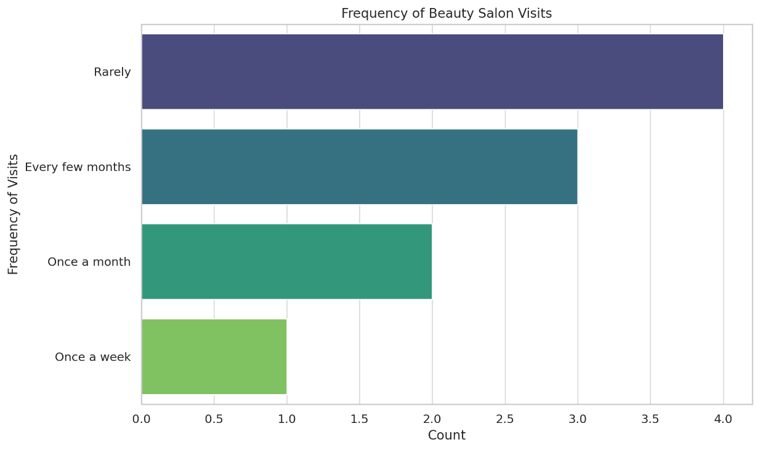
2. Factors Influencing Choice of Beauty Salon
- Question: What factors influence your choice of a beauty salon?
- Findings: overwhelming 90% of those who answered said that level of services is most important thing that makes them choose a beauty centre. Only 10% of those who answered said that price was important factor.
- Implications: This shows how important it is to keep service quality standards high. Venus Bloom Beauty Salon should make sure that all of their services and contacts with customers meet or go beyond what they expect. It will be very important to spend money on staff training, good items as well as the keeping place clean and friendly.
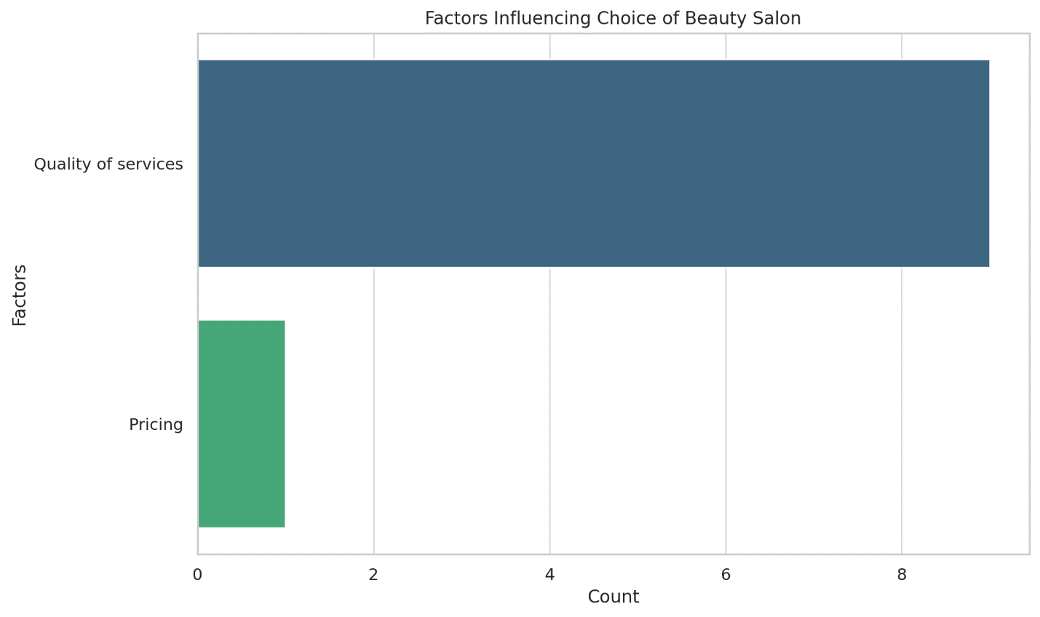
3. Importance of Organic or Natural Beauty Products
- Question: How important is availability of organic or natural beauty products to you?
- Findings: results show that people really want organic or natural beauty items 70% of those who answered thought it was very important as well as the 30% thought it was important.
- Implications: This trend shows that there is a big market for natural and organic goods. It is recommended that Venus Bloom make sure a big part of their product line includes natural and organic choices. To get people who care about their health to buy these goods, marketing efforts can make them stand out.
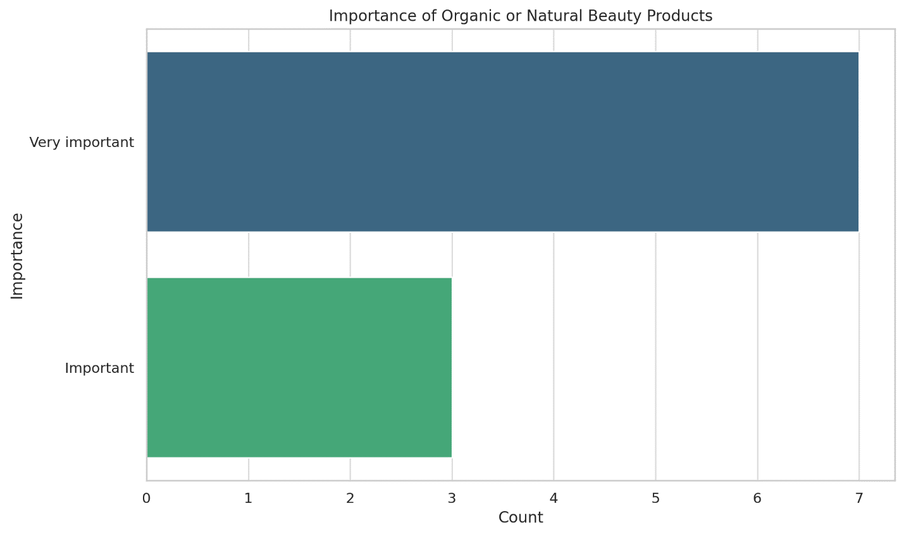
4. Sources of Information on New Beauty Salons and Trends
- Question: How do you usually learn about new beauty salons and trends?
- Findings: Social media leaders and writers are most popular ways to get information—50% of those who answered say they use them. 30% of those who answered said that online reviews and scores were second most popular source. For last 20%, word of mouth was responsible.
- Implications: In order to get new customers, this means that you need to have a strong online profile and work with influencers. Venus Bloom should think about working with well-known beauty blogs and influencers to get their name out there. Asking happy customers to post good reviews online can also help salon's image and bring in new customers.
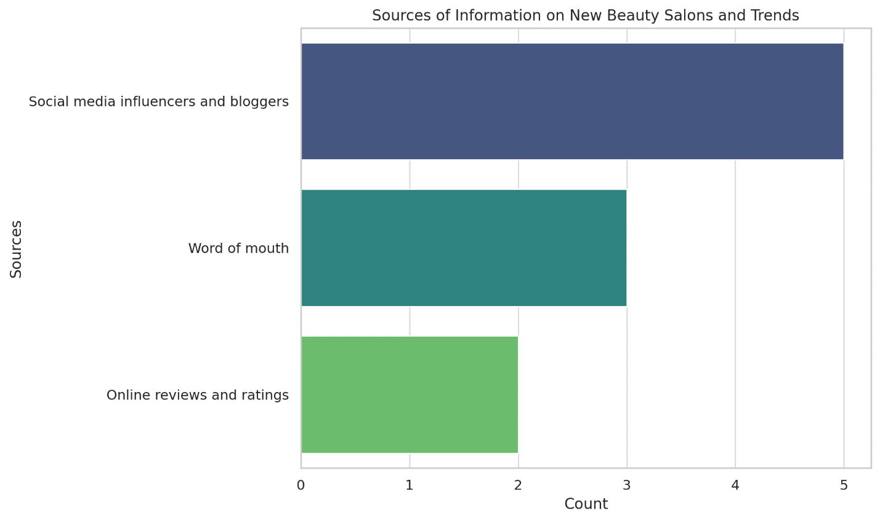
Trends and Patterns
The study finds several important patterns and trends that can help Venus Bloom Beauty Salon make business decisions:
- Visit Frequency and Customer Loyalty: Loyalty programmes and personalized deals can help increase number of times a customer comes back.
- Service Quality: It is important to keep and promote high quality services because they are main thing that makes people choose one salon over another.
- Organic and Natural Products: People really want organic and natural beauty products, so salon should emphasise these in their products.
- Digital marketing: Using social media stars, blogs as well as the online reviews can have a big effect on getting new customers and keeping old ones.

CONCLUSION
With information from inquiry, Venus Bloom Beauty Salon can clearly see how to improve its business plan. salon can better meet needs and wants of its target audience by focusing on improving service quality, pushing organic and natural products as well as the building its online profile through relationships with influencers and good reviews. Using these ideas will not only bring in more customers but it will also get current customers to come more often that will help Venus Bloom Beauty Salon grow and be successful.

TASK 4

INTRODUCTION
The concept in producing layout for website and marketing collaterals of Venus Bloom Beauty Salon is to make sure that company has a well-developed branding that can introduce salon’s services, products as well as the motto (Cohen, 2021). The process was based on a survey conducted in the form of a questionnaire that included questions to define users’ preferences and their behavior. This summary discusses how findings from the questionnaire were applied to the website and marketing aspects.

Website Design
Homepage Design
The web site of Venus Bloom Beauty Salon consists of its homepage, and it focuses heavily on understanding of luxury and professionalism. inviting tagline which is placed above site is “Unveil Your Inner Radiance with Venus Bloom (Colombi, 2020).”
Key elements of homepage include:
- Hero Image: first thing that is seen on website is a HD image of the salon to convey message of classy and professional servicing.
- Introduction: A greeting that refers to the goal of establishment to accentuate people’s features while offering tailor made solutions.
- Navigation Bar: It appears to be convenient when it comes to possibility to open various sections of website: Services, About, Updates, Contact (Islam et al., 2020).
- SEO Optimization: Integration of valuable keyword phrases like ‘beauty salon’, ‘personalized beauty care’, ‘luxury beauty treatments’ to headers and meta tags descriptions to enhance position at search engines.
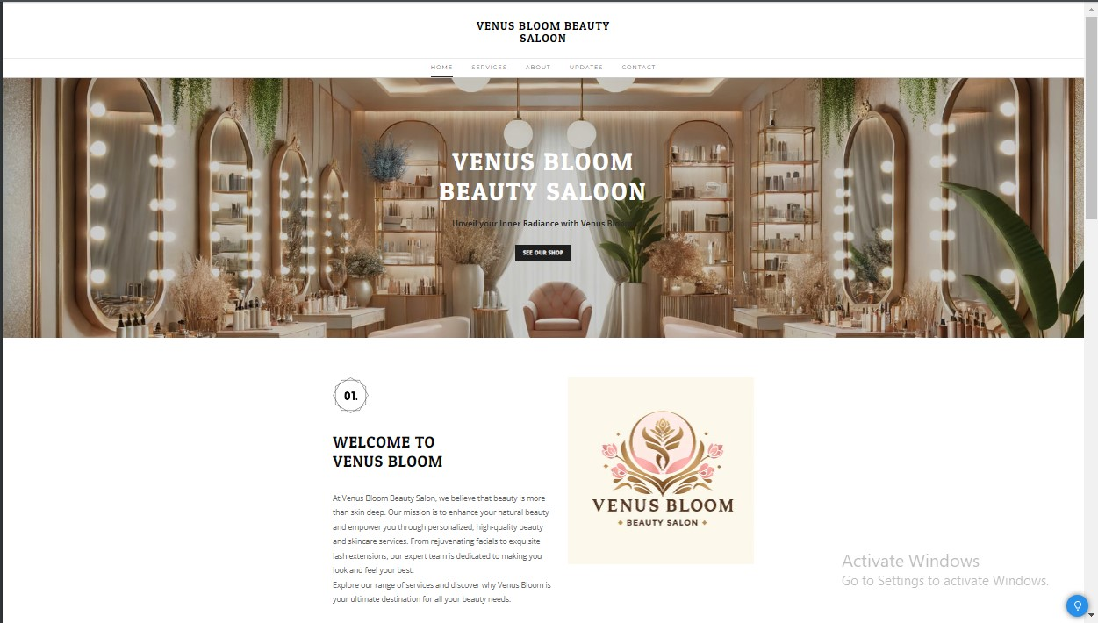
Figure 1 Home Page
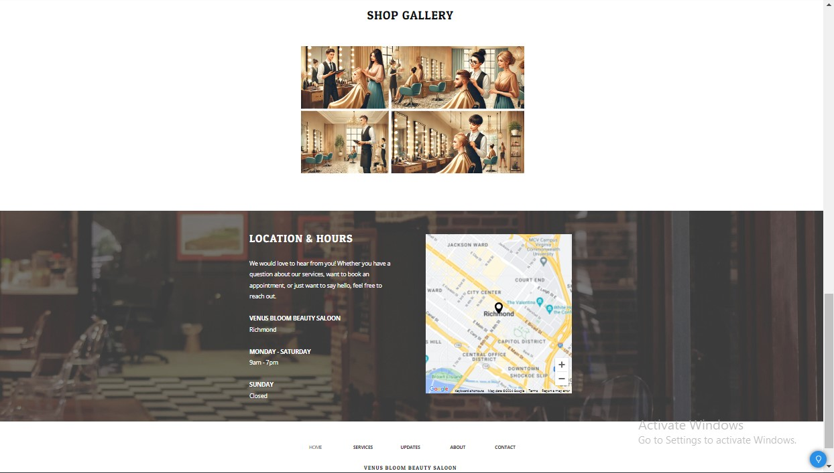
Figure 2 Home Page

Services Page Design
In services page, it is clearly described about various beauty and skincare services that is being offered in Venus Bloom. One of main trends of design is simplicity and singleness of structure, so that spur for cooperation is within reach and everyone can easily come across services (Tupy as well as the Pooley, 2022).
Key features of services page include:
- Service Descriptions: Straightforward service type descriptions like facial treatments, hair removal, nails, eyebrows and eyelashes, piercing and make up among others. Every description specifies advantages and distinctive features of service.
- Pricing Information: condition which includes various pricing codes for each service, thus enabling clients to make right decisions (Raja et al., 2020).
- Visuals: Images which best captures their services in better quality to make page more professional.
- Booking Call to Action: A clear yet large “Schedule Appointment” button taking clients to company’s online calendar.
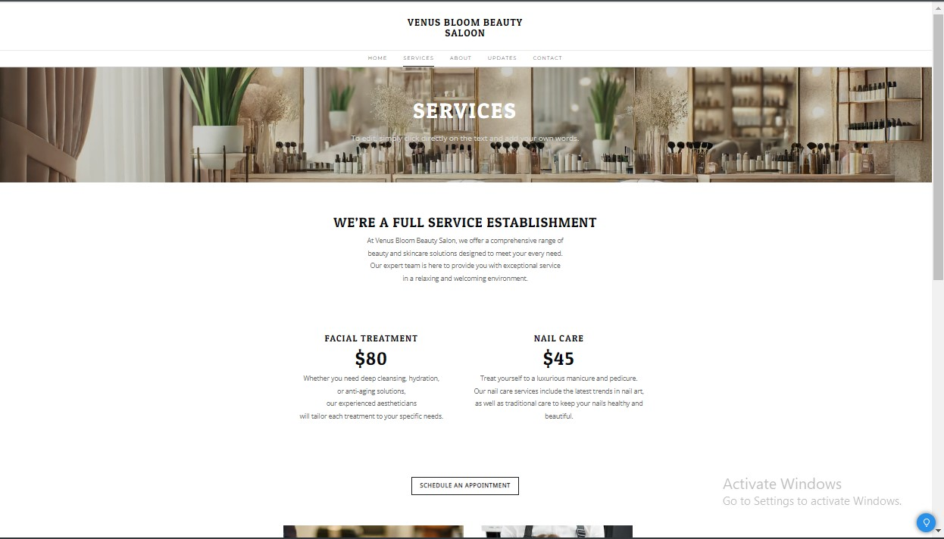
Figure 3 Service Page
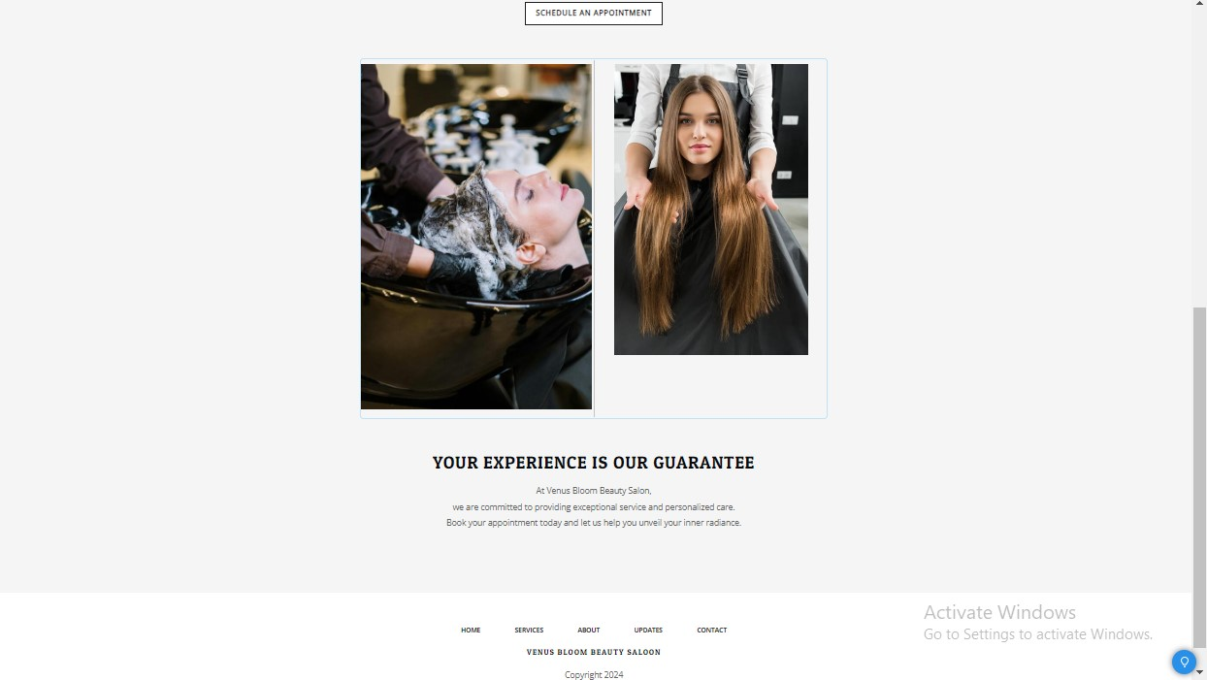
Figure 4 Service Page

Marketing Materials Design
Flyer Design
The flyer has a classy and exquisite look that reflects elegance of Venus Bloom Beauty Salon and personal touch given to its clients. Key design elements include:
- Color Scheme: Elaborate soft and neutral palette with elegant accents of colours provides space with welcoming and relaxing aura.
- Imagery: Pictures are well placed and clear with different attractive services being offered (Sutcliffe, 2022). Pictures of a professional doing facials and applying makeup provide clients with a picture of Salon as monumental and abreast with current trends.
- Typography: typographic is clear and uncluttered this ensures that printability is top notch accompanied by luxury feels.
- Logo and Tagline: logo of Venus Bloom and slogan of “Elevate Your Beauty Where Glam Meets Grace” are also used at center part of page to ensure brand recognition and to convey value orientations of salon popularizing high quality beauty services.
- Service Highlights: These are easy to read and identify major services being offered by company these are Makeup, Face Treatment and Hair Treatment.
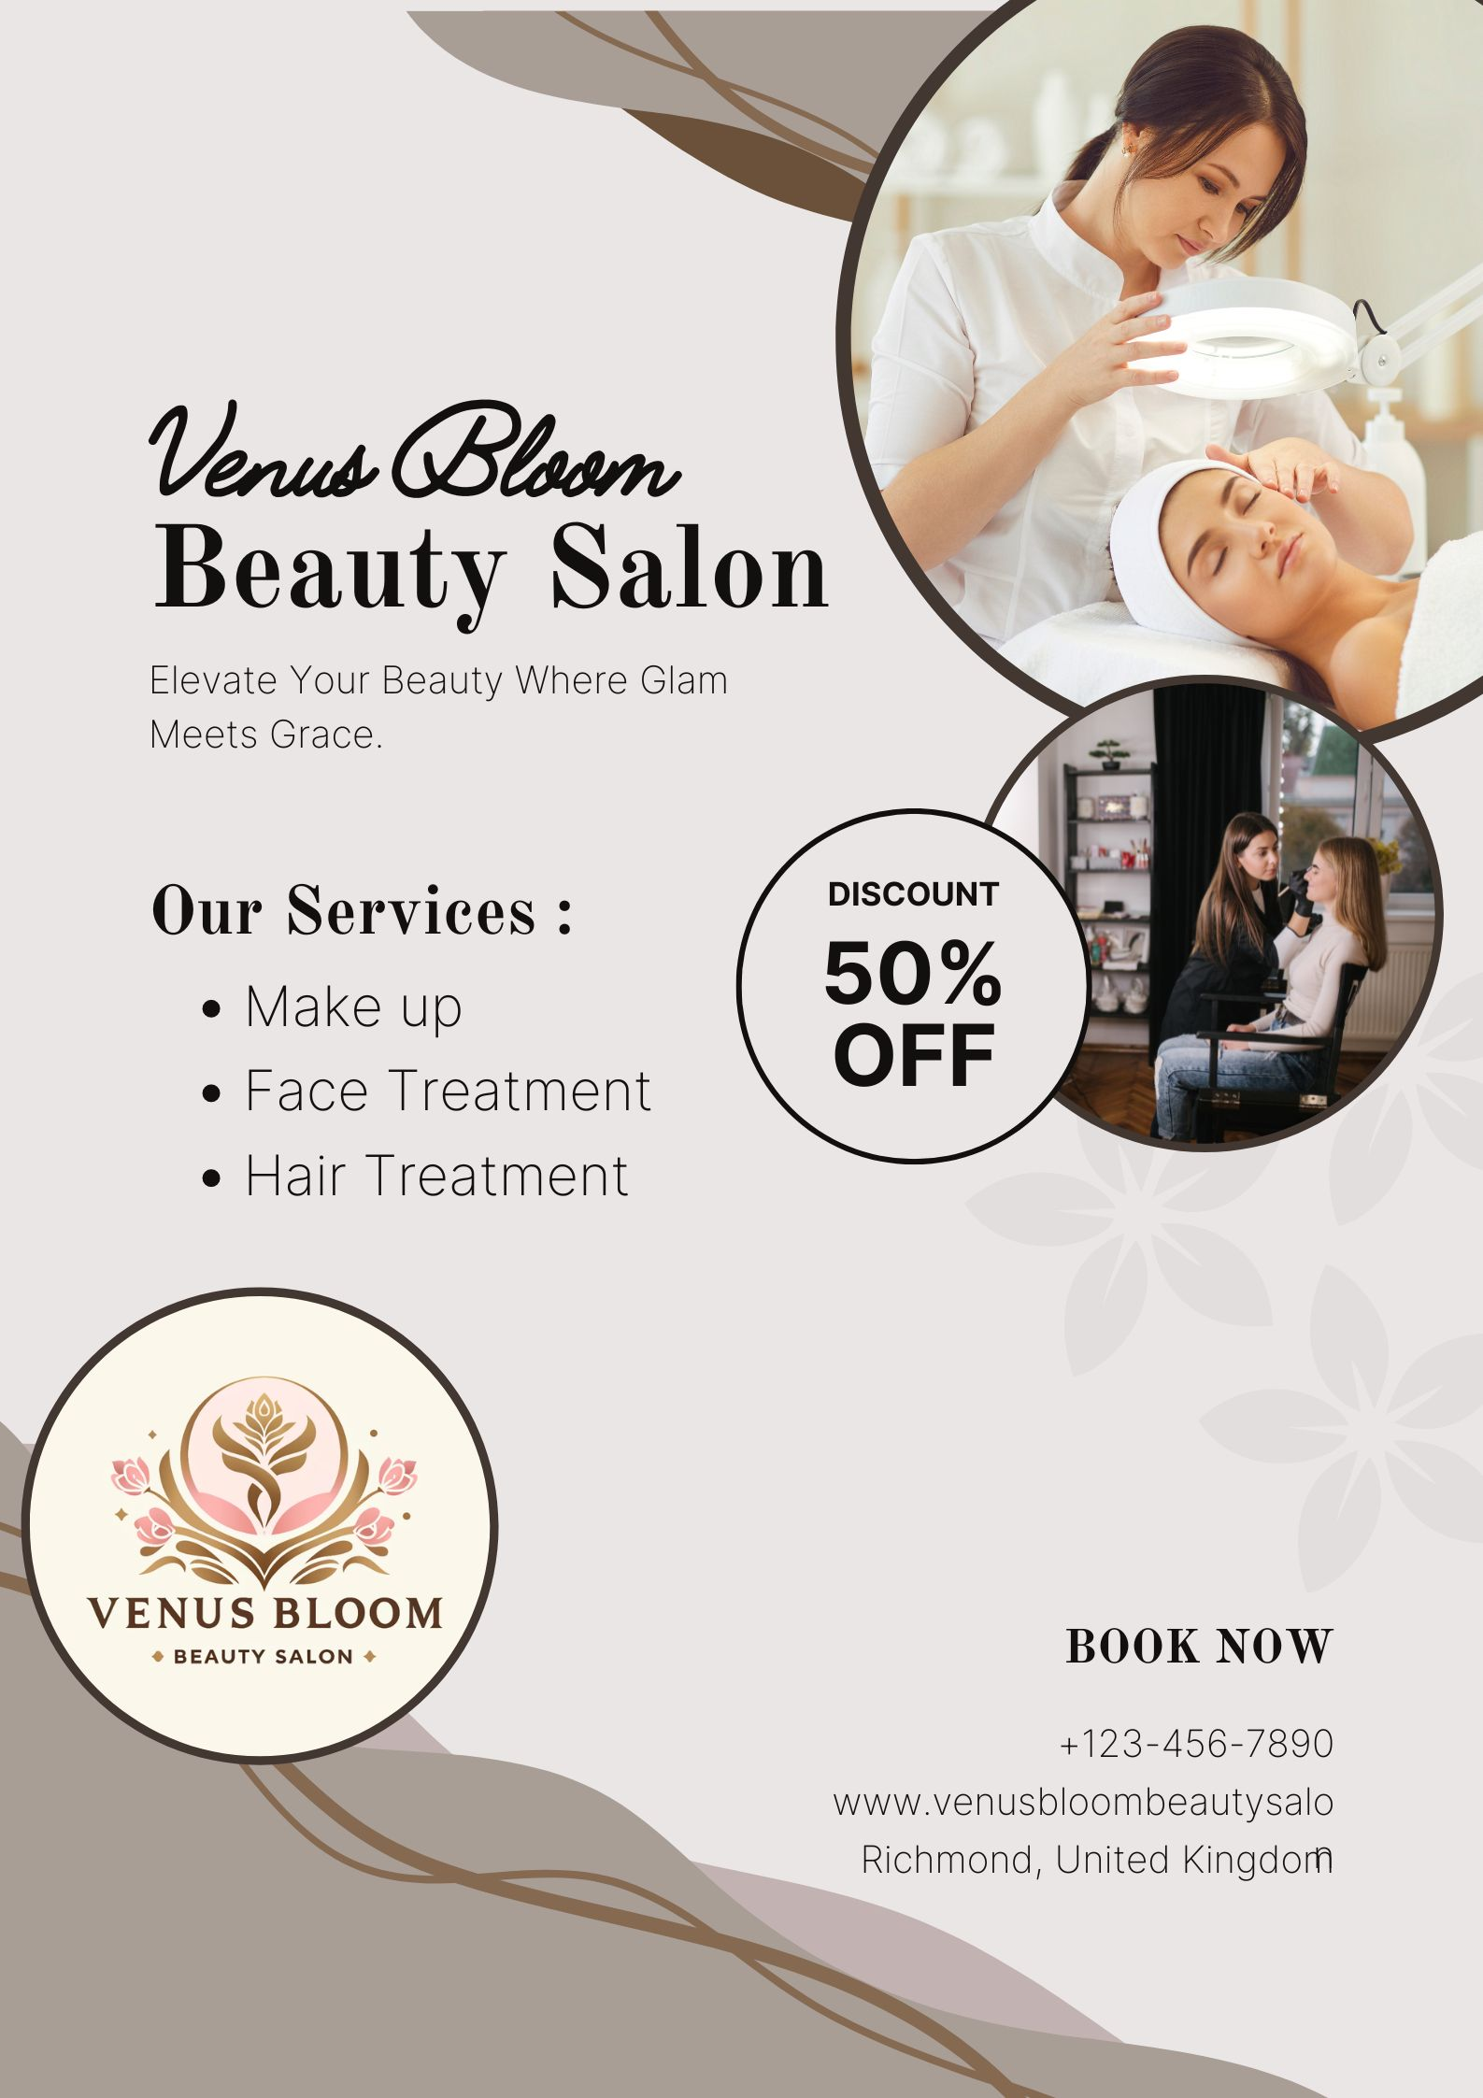
Figure 5 Flyer Ad
Brochure Design
The design of brochure is as basic as flyer, being elegant and having a calming color theme. Key elements include:
- Color Scheme and Imagery: As expected from design of flyer, color palette used and choice of images on brochure are soft and comparatively neutral, yet they give off a feel of luxury (Berne, 2024).
- Typography: It also does not go overboard with font and keeps it refined yet easily legible just like aesthetics of higher end products that are marketed in ads.
- Logo and Tagline: Brand identity is maintained here through displayed logo of Venus Bloom and ‘Experience luxury of personalized beauty treatment on you at Venus Bloom Beauty Salon and let out bloom ‘.
- Service Overview: list of service offered by centre is also stated clearly by categorizing into Body Spa & Massage, Hair Treatment, Facial & Skin Care, Makeup & Hairstyling, Nail Care.
- Contact Information: contact information and phone number, social media handle (@venusbloom) as well as the location are clearly communicated. This will guarantee that any potential clients whom salon wishes to attract have several methods of getting into touch with salon.
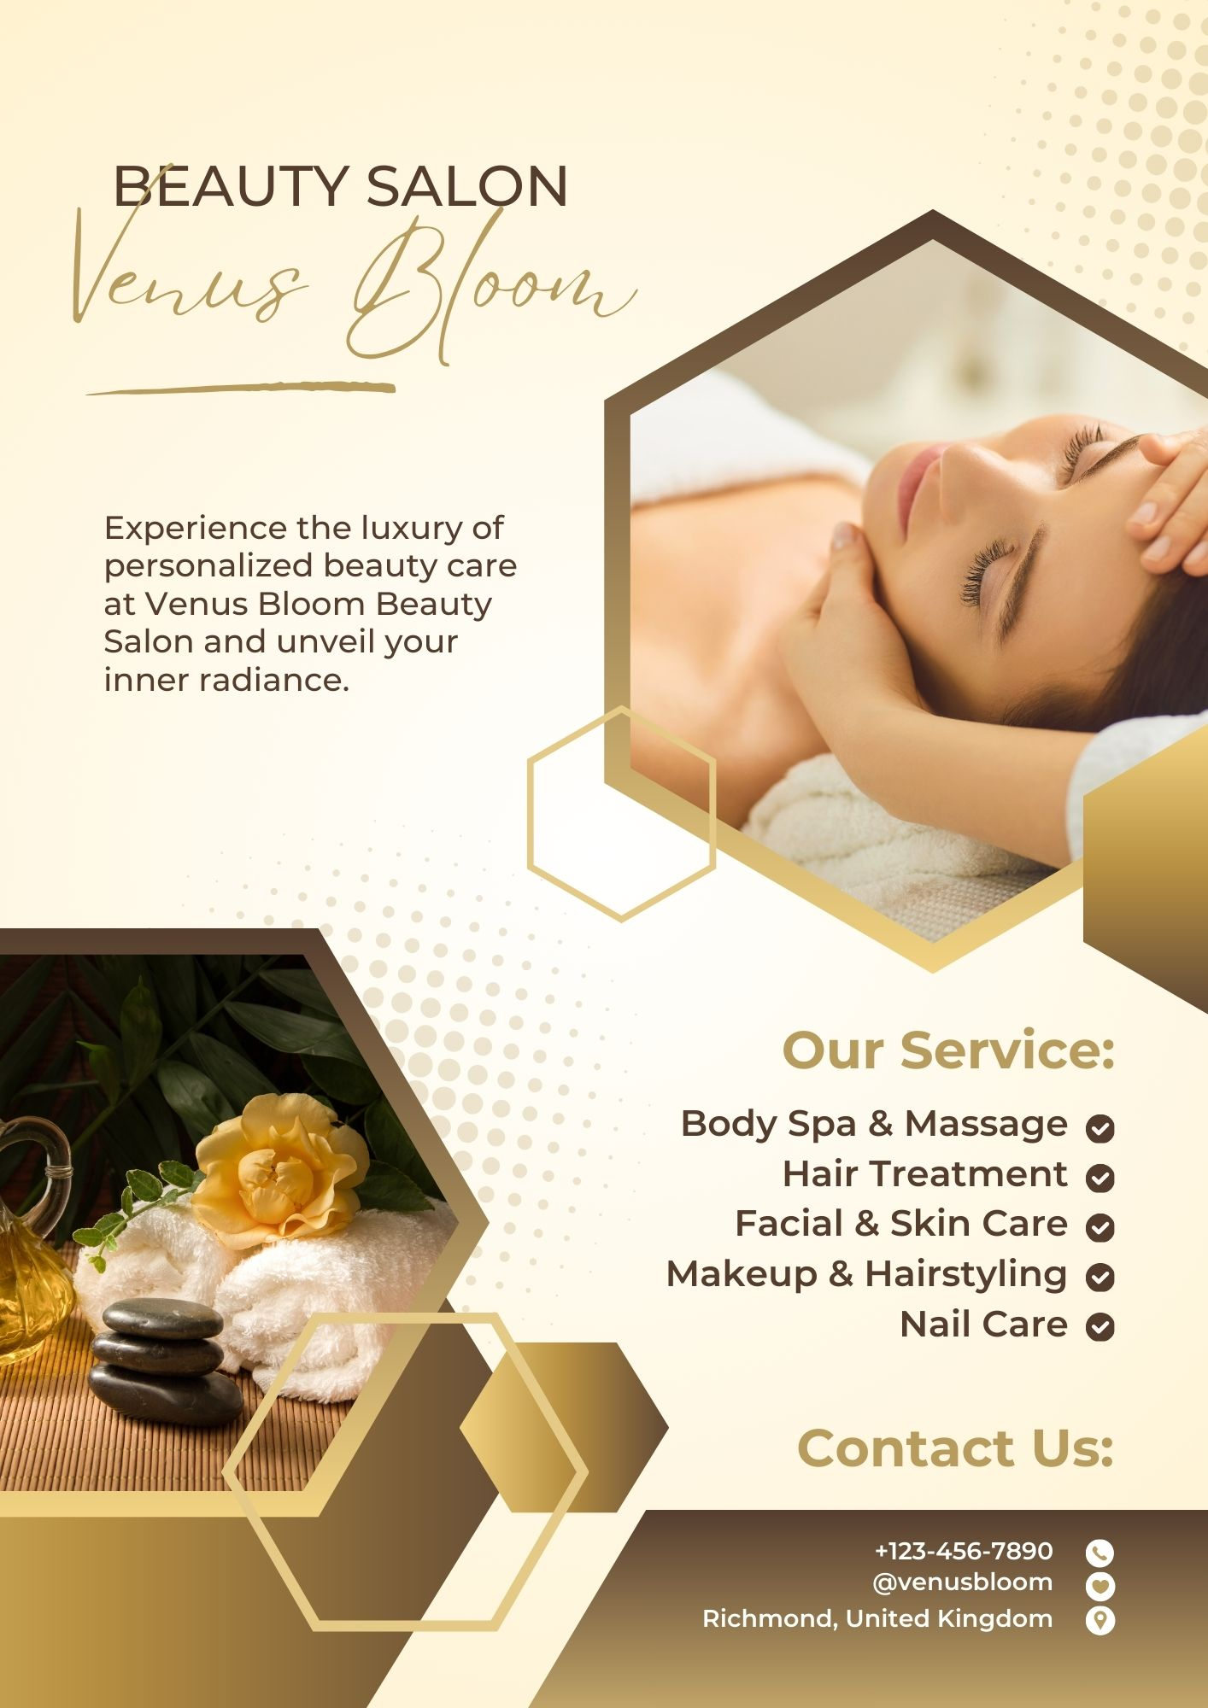
Figure 6 Brochure Ad

Segmentation and Targeting
The collected data helped in questionnaire to conduct segmentation of target clients by groups regarding to their age, frequency of visit to salon, interested beauty trends, services choice as well as the factors that affect their choice of salon. It can be noted that this kind of segmentation allowed focusing content of website and marketing materials on different segments’ needs and preferences (Weber, Reinhardt as well as the Rossmann, 2020).
For example:
- Young Adults (18 25): Special focus on hip procedures such as lash extensions and nail designs advertisement materials, for instance, coupons.
- Professionals (26 45): Concentrate on services in which concept of relaxation and recreation dominate like, facial treatments as well as the massages but branding should depict quality and easily accessible services.
- Bridal Parties: Focusing on a full-service makeup/list hairstyling solution, accentuating establishment’s readiness to make clients gorgeous for particular occasions.

SEO Optimization
Web promotion was integrated into website’s design and all such items as logo, company name, title tags, descriptions etc (Budhathoki as well as the Adhikari, 2020). Questions asked in questionnaire assisted in establishing most probable keywords and phrases that clients search for beauty services.
Key SEO strategies implemented include:
- Keyword Integration: This most likely involves including actual phrases that potential clients are likely to enter in search bar such as ‘beauty salon’, ‘facial treatments’, ‘hair removal’, ‘nail care’ within site’s content and headers as well as meta descriptions.
- Content Quality: For instance, guaranteeing that any content generated is useful and entertaining to intended audience is a sure way to help site’s ranking on SERPs (Chantarasiri as well as Funk, 2020).
- Local SEO: Geographical keywords and data added like “Richmond beauty salon,” to meet needs of clients searching for beauty parlours within locality (Natorina, 2020).

CONCLUSION
The logo design, navigation on website, appearance of advertisement and marketing content of Venus Bloom Beauty Salon was done based on results of questionnaire. outcome is creation of a united and professional image inside and outside salon that presents key services and attitudes of salon to clients. By implementing approaches of segmentation, Internet site optimization, as well as communicating with users, website and marketing materials are ready to bring in more and retain clients and, thus, contribute to business’s success.

REFERENCES
Aimé, I., 2023. dynamic construction of brand storytelling. Journal of Strategic Marketing, 31(7), pp.1243 1262.
Allen, E., 2022. Jess Weiner and dove real beauty campaign: selling feminism for profit or social change?. Women Leading Change: Case Studies on Women, Gender as well as the Feminism, 6(1), pp.18 37.
Armstrong, P.B., 2020. Stories and brain: neuroscience of narrative. Johns Hopkins University Press.
Berne, D., 2024. Design of Books: Explainer for Authors, Editors, Agents as well as the Other Curious Readers. University of Chicago Press.
Budhathoki, R. and Adhikari, M., 2020. E commerce website development for electronics store.
Carlotto, F., 2024. Luxury Brand and Art Collaborations: Postmodern Consumer Culture. Taylor & Francis.
Chantarasiri, A. and Funk, S., 2020. Pillar Pages Approaches Strategy towards Ranking on Google’s SERPs: Content Shifu Case Study (No. 304200). Thammasat University. Faculty of Journalism and Mass Communication.
Cohen, S., 2021. Colonial Advertising and Tourism in Crosscurrents of Empire. In Mobility, Spatiality as well as the Resistance in Literary and Political Discourse (pp. 23 56). Cham: Springer International Publishing.
COLOMBI, M., 2020. UNDERSTANDING LUXURY INDUSTRY’S MARKETING AND COMMUNICATIONS STRATEGIES.
Hong, J., Yang, J., Wooldridge, B.R. and Bhappu, A.D., 2022. Sharing consumers’ brand storytelling: influence of consumers’ storytelling on brand attitude via emotions and cognitions. Journal of Product & Brand Management, 31(2), pp.265 278.
Huang, S., 2021. Real Beauty Equals Real Feminism? How Femvertising (Re ) Frames Women’s Empowerment (master’s thesis).
Islam, J.U., Shahid, S., Rasool, A., Rahman, Z., Khan, I. and Rather, R.A., 2020. Impact of website attributes on customer engagement in banking: a solicitation of stimulus organism response theory. International Journal of Bank Marketing, 38(6), pp.1279 1303.
McCormack, C., 2021. Women in picture: Women, art and power of looking. Icon Books.
Natorina, A., 2020. Business optimization in digital age: Insights and recommendations. Економічний часопис ХХІ, 181(1 2), pp.83 91.
Rodriguez, M., 2023. Brand storytelling: Put customers at heart of your brand story. Kogan Page Publishers.
Saint Thomas, S., 2023. Glamour Witch: Conjuring Style and Grace to Get What You Want. Weiser Books.
Sutcliffe, A., 2022. Designing for user engagment: Aesthetic and attractive user interfaces. Springer Nature.
Thompson, G., 2022. Venus in Boston: A Romance of City Life. DigiCat.
Tupy, M.L. and Pooley, G.L., 2022. Superabundance: story of population growth, innovation as well as the human flourishing on infinitely bountiful planet. Cato Institute.
Weber, W., Reinhardt, A. and Rossmann, C., 2020. Lifestyle segmentation to explain online health information–seeking behavior of older adults: representative telephone survey. Journal of Medical Internet Research, 22(6), p.e15099.

Appendix

Raw Data for Task 3
Timestamp | Untitled Question | How often do you visit a beauty salon? | Which of the following beauty trends are you most interested in? | What services do you primarily seek at a beauty salon? | What factors influence your choice of a beauty salon? | How important is the availability of organic or natural beauty products to you? | How do you prefer your beauty products and treatments to be tailored? | What is your preferred method of booking an appointment? | How do you usually learn about new beauty salons and trends? | What is your budget range for a single salon visit? | How important is it for you that a beauty salon use the latest technology and equipment? | How likely are you to try a new beauty service if it includes innovative or cutting-edge treatments?
######## | 36-45 | Every few months | Personalized beauty treatments | Facial and skincare treatments | Quality of services | Very important | Bases on my skin type | Online booking | Online reviews and ratings | £20-£50 | Very important | Very likely
######## | 26-35 | Once a month | Personalized beauty treatments, Advanced skincare technology (e.g., LED therapy, microdermabrasion) | Facial and skincare treatments | Quality of services | Important | Bases on my skin type | Online booking | Online reviews and ratings | £20-£50 | Very important | Very likely
######## | 26-35 | Rarely | Natural and minimalist beauty routines | Haircut and styling, Manicure and pedicure | Pricing | Important | Bases on my skin type | Phone call | Social media influencers and bloggers | Less than £20 | Important | Likely
######## | 46 and above | Rarely | Advanced skincare technology (e.g., LED therapy, microdermabrasion) | Haircut and styling | Quality of services | Important | Based on specific beauty concerns (e.g., anti-aging, acne) | Walk-in | Word of mouth | £50-£100 | Important | Very likely
######## | 36-45 | Once a month | Personalized beauty treatments | Haircut and styling | Quality of services | Very important | Bases on my skin type | Phone call | Social media influencers and bloggers | £20-£50 | Very important | Very likely
######## | 36-45 | Every few months | Natural and minimalist beauty routines | Haircut and styling | Quality of services | Very important | Based on my hair type | Phone call | Word of mouth | £20-£50 | Important | Likely
######## | 36-45 | Rarely | Personalized beauty treatments, Advanced skincare technology (e.g., LED therapy, microdermabrasion), Natural and minimalist beauty routines | Facial and skincare treatments | Quality of services | Very important | Based on specific beauty concerns (e.g., anti-aging, acne) | Through a mobile app | Word of mouth | £50-£100 | Very important | Very likely
######## | 36-45 | Once a week | Natural and minimalist beauty routines | Haircut and styling | Quality of services | Very important | Based on my hair type | Online booking | Social media influencers and bloggers | £20-£50 | Very important | Likely
######## | 36-45 | Every few months | Sustainable and eco-friendly products, Personalized beauty treatments | Haircut and styling, Facial and skincare treatments | Quality of services | Very important | Bases on my skin type | Phone call | Social media influencers and bloggers | £50-£100 | Very important | Very likely
######## | 26-35 | Rarely | Natural and minimalist beauty routines | Haircut and styling, Manicure and pedicure, Facial and skincare treatments, Wellness and spa services | Quality of services | Very important | Bases on my skin type | Phone call | Social media influencers and bloggers | £20-£50 | Very important | Likely

