
Dwelling of two symmetrical houses in Swansea SA1
Mark Jones

Assignment 1
School: Built Environment
Subject: Site production and Project management
Hand In date: 14th of February
Lecturer: Juan A Ferriz-Papi
2019

Contents

1.1 Introduction 3
1.2 Methodology 3
1.3 Calculations and techniques used 3
1.3.1 Site clearance and preparation 4
1.3.2 Excavation 4
1.3.3 Foundations and ground floor slab 4
1.3.4 External masonry 5
1.3.5 Roof 6
1.3.6 External doors and windows 7
1.3.6.1 Windows 7
1.3.6.2 External Doors 8
1.3.7 Internal walls 8
1.3.8 Internal doors 9
1.3.9 stairs 9
1.3.10 Plumbing 9
1.3.11 Electrics 9
1.3.12 HVAC 10
1.3.13 Landscaping 10
1.3.14 Paint and Decoration 10
1.3.15 Snag and clean 11
1.4 Labourer’s calculation for worksite per week 11
1.5 Results obtained 11
1.6 References 12
1.7 Picture References 12
1.8 Appendixes 13
1.8.1 Appendixes 1 13
1.8.2 Appendixes 2 14
1.8.3 Appendixes 3 14
1.8.4 Appendixes 4 15
1.8.5 Appendixes 5 16

Introduction

The aim of this report is to have a schedule of works for the ‘dwelling of two symmetrical houses’ in Swansea. The activities needed to construct the dwelling need to be established, the duration of each activity will need to be included along with the number of labourers that will be used. This report will describe how the activity, duration and labour hours were found and what calculations were used to establish the total figures. From all the data collected a schedule on ‘Asta power project’ will be produced showing all the activity’s in order, the duration of works with cost and labour hours and when each activity will need to start and end to ensure a fast and less costly project (see figure 4).

Methodology

A list comprising 15-20 tasks will be established, these tasks will be found from researching recent construction project that are similar to the case study provided, the SPON’S book 2019 was available allowing me to choose relevant activities that will make up the task list. The SPON’S book 2019 gives different rates for most construction works on a project, this allowed me to pick certain activities that will be needed, and it gives an approximate price for both cheap and expensive materials and methods of construction. I will set up an interview with a construction manager to find out the main activities to include and find out how long each activity will take and how many labourers he thinks each activity will need, from this interview I will produce a chart of all the activities he thinks should be included, the duration he recommends and the amount of labourers it will take to complete the task. The SPON’S book along with research from recent projects will be used to establish how long each activity will take allowing me to come up with a total duration for the whole project and the number of labourers needed. All these factors will make the schedule of works that will be produced at the end.
As the plans were provided, I was able to print out the plans to measure them to scale, I worked out that the whole buildings is 75m2 (only building itself not the property boundary). By measuring the plans I was able to find out the sizes of all the walls, windows and roof, meaning I could find a more accurate material costs per m2 and calculate the total cost per m2 for the case study.

Calculations and techniques used

The activities shown below have been comprised from different sources, each activity below will describe the assumed duration and the calculations for labour and cost of materials, the source which allowed me to find out each activity will be provided.
An interview was set up with Mr Graham Jones (Construction Manager) to discuss what activities he would include for the case study provided, the duration and labour rates per worker was also discussed about and noted in Appendixes 1. Some Activities and calculations were used from knowledge I have gained from practical experience on site, most being dwellings similar to the case study provided. The SPON’S (2019) book was used to find out activities, cost and durations for the case study and any information that was not included in the SPON’S book or in the interview was sourced from the internet and referenced.
Note:
A table of the activities, duration, labour and total cost is shown in appendixes 1.
For this report most Labour rates will be assumed £100 a day, if a task takes under 8 hours to complete it will be labelled as 1 day.

Site clearance and preparation

The size of the site is unknown, although the buildings size is 75m2, in the SPON’S book an estimate for clearing site vegetation and tree stumps not exceeding 500 mm is £1.63 per m2 therefore an estimate of how much vegetation would need to be removed, would be £422.25 including labour rates.
Duration = 3 days
Total cost = £422.25

Excavation

To work out the amount of excavation needed, all the exterior walls were measured and added together = 24m, as the depth and width of the trench needs to be 1m x 1m the total excavation would be 24m3. The duration for an excavation for the cast study would take around 6 hours although this would be rounded to 1 day, this is known from my previous experience on a construction site of a two-story large house, similar to the case study. NPHGroup (2018) gives the hire cost of a 5 tonne JCB per day at £135, this is assuming a labourer on site know how to drive the JCB, if not the hire of an operator would cost £150 per day
Duration = 1 day
Cost of machinery = £135
Labour cost (assuming labourer cannot operate the JCB) = £150 for operator + £100 for 1 labourer = £250
Total cost = £385

Foundations and ground floor slab

In the SPON’S (2019) book it states that a strip foundation and floor slab built up to 150mm above floor level and ground floor slab 200mm thick to suit a residential building, similar to the case study would cost £200 per m2. Jones G, states the duration would take around 18 days (weather dependant), as time needs to be left for the concrete foundations and floor slab to set and it would take 3 labourers to complete this process.
Duration =20 days
Cost of materials = £200 x 75m2 = 15000
Labourers cost =£100 per labouer x 3 labouers = £300 per day x 18 days = £5400
Total cost = £20400

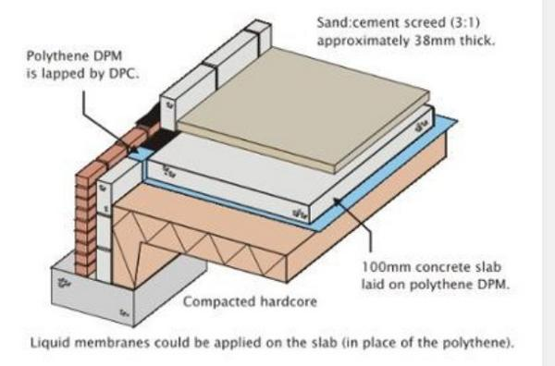
Figure 4

External masonry

The wall build up on the plans isn’t unspecified, therefore as shown in appendixes 2 the assumed wall build up is specified (render externally with insulation and block) along with the total price for the wall build. The duration to build the exterior walls, stated by Jones, G (2019) is 30 days with 3 labourers.
To calculate the amount of m2 that was going to be constructed for the external wall I found out the lengths of the walls (4.75 x 7 = 33.25) (6.5 x 4.75 = 30.875) x2 as there is two houses = 128.25 m2 – 20% (25.65 m2) for all windows = 102.60 m2 of masonry external wall.
Duration = 30 days
Labourer cost = 30 x £300 = £9000
Material cost = £198 per m2 x 102.60 m2 = £20314.80
Total cost = £29314.80

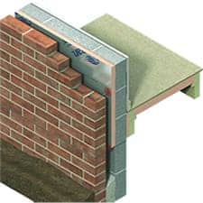
Figure 1

Roof

The roof needed for the case study is specified in SPON’S (2019 p. 174), the roof follows building regulations and includes all materials needed in the roof. The cost of the roof is £185 per m2 x 75 m2 = £13875
As told by Jones G (2019) in the interview, he recommends 15 days to finish the roof, this is with 3 labourer’s works on site, see appendixes 1
Duration = 15 days
Labour cost = £300 x 15 days = £4500
Material cost = £13875
Total cost = £18375
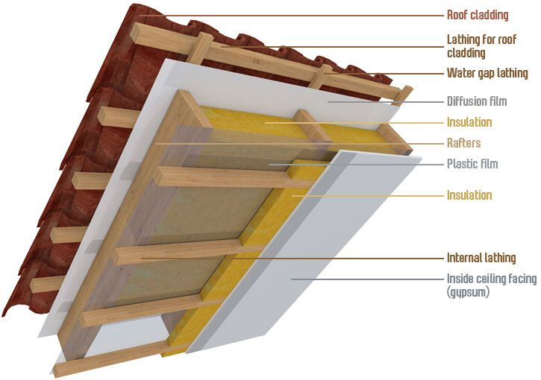
Figure 2

External doors and windows

6.1 Windows
As shown in the plans provided there are 9 windows per house meaning the whole building will need 18 Windows. 2 small size windows, 6 medium size window and 10 large windows are needed.
To calculate the cost of the windows I found all the types of windows in the SPON’S book, in this book the prices for all the windows (excluding labour) were shown:
2x 630mm x 900mm = £647.98
6x 915mm x 1050mm = £2643.96
10 x1770mm x 1200mm = £7036.50
Total for all windows = £10328.44
The duration to insert each window was described in the SPON’S book as 1 hour each window, with one labourer inserting the windows it would take 18 hrs = 3 days to inset all windows.
3 days x £100 (labourer price rate per day) = £300
Duration = 3 days
Labour cost = £300
Material cost = 10328.44
Total Cost = £10628.44

6.2 External Doors
From the plans it is obvious that there are 4 external doors, the SPON’S (2019 p. 454) book sets a cost for £395.04 each door and describes to insert each door it would take 3 labour hours, meaning it would take 2 days in total.
Duration = 2 days
Labourer cost = £200
Material cost = £395.04 x 4 doors = £1580.16
Total cost = 1780.16

Internal walls

There is approximately 22 m2 of internal partitioning in the case study provided (all the internal walls were measured using a scale ruler), 22 m2 x 22 m2 (as there is two symmetrical houses) = 44m2. In the SPON’S book (2019) it shows that a partition wall with plasterboard and skimming finish is £59 per m2. 44m2 x £59 = £2596. Jones, G (2019) states that the duration to construct the partition walls would be 28 days assuming there are 2 labourers on site per day.

Duration = 28 days
Labour cost = £200 x 28 days = £5600
Material cost = £2596
Total cost = £8196
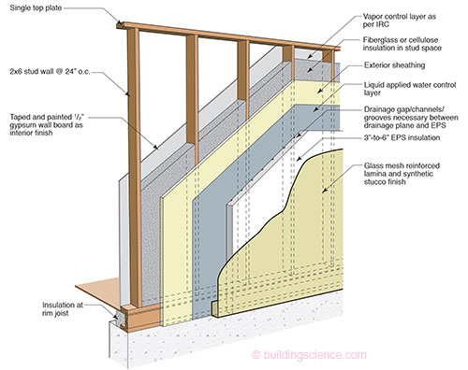
Figure 3

Internal doors

The plans provided show there are 10 internal doors in the building, the SPON’S book (2019 p.474) explain that each door costs £80.71, the time it takes to insert a door (including frames) is 1hr each, I would recommend 1 labourer for this task.
Duration = 2 days
Labourer cost = £200
Materials costs = £ 807.10
Total cost = £1007.10

Stairs

SPON’S (2019 p.179) has a set price for stair cases and the materials used on the stairs, as the plans show the stair case is straight, it is not needing to be personally made to fit. The cost for a stair case is £1175 as there is two parts to the building 2x stair cases will be needed = £2350
Jones, G (2019) states the duration to construct the stairs would be 8 days, with 2 labourers for both stair cases.
Duration = 8 days
Labour cost = £200 x 8 days = £1600
Material cost = £2350
Total cost = £3950

Plumbing

Snell, D (2014) states an approximate heating system would cost £13503 taking 16 days, first fix for a dwelling would cost £3973 and take 14 days, second fix would cost approximately £3756 taking 5 days, with a total of £7729 (prices include labour at £176 a day).
Duration = 35 days
Total cost (including labour) would be = £21232

Electrics

Snell, D (2014) describes an average cost for the electrical works on a new build dwelling similar to the case study, would be £6129 including labour rates at £174 per day.
Duration = 25 days
Total cost = £6129

HVAC

Jones, g (2019) states it would cost around £1000 for a HVAC system to be installed in a building similar to the case study, it would take around 4 days with a labour rate at £150 per day.
Duration = 4 days
Cost for materials = £1000
Cost for labour = £600
Total cost = £1600

Landscaping

Depending on the type of landscaping needed this price range can vary, small landscaping will more than likely be needed with this case study. With my previous experience on site I would estimate around £1000 (fencing and general landscaping including small patio etc) I would allow 8 days with 1 labourer to complete the landscaping.
Duration = 8 days
Material costs = £1000
Labour cost = £100 x 8 days = £800
Total cost = £1800

Paint and Decoration

Household quotes (2018) states for a large house containing 5+ rooms, it would cost £4000 (including labour costs) to paint and decorate the whole building with a duration of 14 days.
Duration = 14 days
Total cost = £4000

Snag and clean

Depending on the Project the snag and clean phase will vary in time and cost, an estimated cost given by Jones, G (2019) for the case study is £ 150 (including labour costs) and a Duration of 1 day
Duration = 1 day
Cost = £150

Labourer’s calculation for worksite per week
A calculation of the workforce at site per week is provided in appendixes 3

Results obtained
The total estimated cost of the building would be £111,013.00, see appendixes 1 or appendixes 5 for bar chart of the total cost per task. The cost is estimated as a relatively cheap building using relatively cheap materials, more expensive materials could have been added and that would have made the total cost different, see appendixes 5. The estimated cost does not included a kitchen or bathroom meaning if you want to include them in the total price it could be an extra £10,000 depending on the materials and type of kitchen and bathroom the client wants. The total time scale of the project is 28 weeks as shown in appendixes 3.
The Gantt chart shown in appendixes 4 outlines the tasks in order, the duration is shown with tasks overlapping to produce a fast construction.

References
Build It. (2019). Cost Guide: Walls and Insulation - Build It. [online] Available at: https://www.self-build.co.uk/cost-guide-walls-and-insulation/ [Accessed 8 Feb. 2019]. (in appendixes)
Householdquotes (2018). Painting and Decorating Prices in 2018. [online] Available at: https://householdquotes.co.uk/painting-and-decorating-prices-how-much-is-too-much/ [Accessed 10 Feb. 2019].
Jones, G (2019) – (Construction Manager) An interview was set up on the [6 Feb. 2019]
Nphgroup (2018). [online] Available at: http://www.nphgroup.co.uk/wp-content/uploads/2016/07/Plant-Tools-Hire-Rates-Final-Copy.pdf [Accessed 10 Feb. 2019].
Snell, D. (2014). Plumbing & Heating Cost Guide | Homebuilding & Renovating. [online] Homebuilding & Renovating. Available at: https://www.homebuilding.co.uk/plumbing-heating-cost-guide/ [Accessed 9 Feb. 2019].
SPON’S (2019). AECOM 2019, Architects and builders price book [Accessed 2 Feb. 2019]

Picture references
Figure 1
Just-insulation.com. (2016). External Wall Applications, build-up and product selection suggestions. [online] Available at: https://www.just-insulation.com/applications/external-wall-insulation-applications.html [Accessed 10 Feb. 2019].
Figure 2
Pinterest. (n.d.). Lean to roof build up. | Ciesielstwo. Pergole, wiaty, więźby itp. | Pinterest | Construction, Roof insulation and Timber frame homes. [online] Available at: https://www.pinterest.co.uk/pin/44402746310838295/ [Accessed 5 Feb. 2019].
Figure 3
Building Science Corporation. (2018). ETW: Wall - Exterior Insulation Finish Systems (EIFS) Wall Construction. [online] Available at: https://www.buildingscience.com/documents/enclosures-that-work/high-r-value-wall-assemblies/high-r-wall-exterior-insulation-finish-systems-eifs-wall-construction# [Accessed 10 Feb. 2019].
Figure 4
Twitter.com. (2019). Twitter. [online] Available at: https://twitter.com/passivelogical/status/507909042413768704 [Accessed 8 Feb. 2019].

Appendixes

Appendixes 1

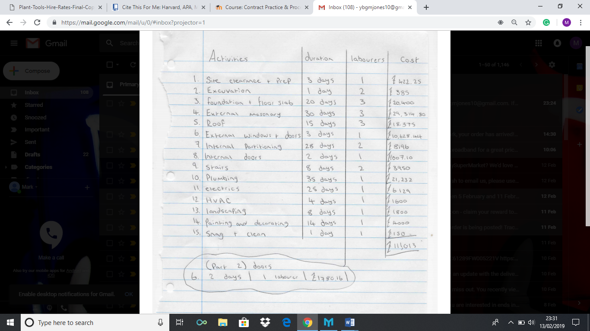

Appendixes 1 shows my draft of the information provided from Jones, G (construction manager) in the interview and the information I have gathered off SPON’S and internet sources. All this data has allowed me to come up with a total cost and time scale of the project with activities overlapping.

Appendixes 2
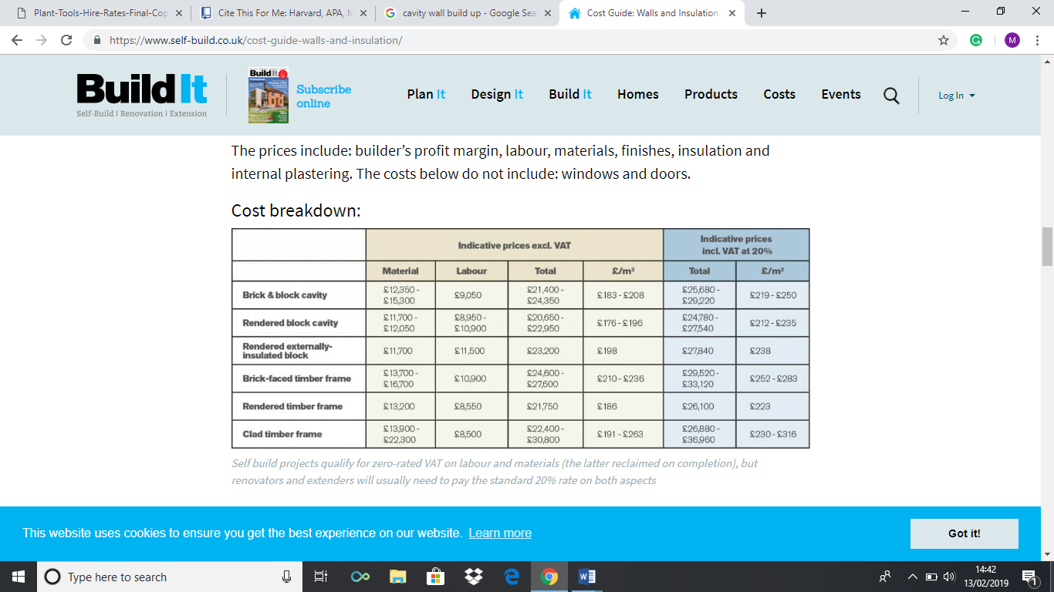
Build it (2019). Rendered externally insulated block would be the correct wall build up for the envelope of the building for the proposed case study. This would be a cavity wall that would suit the case study as the plans show a clear cavity wall with insulation.

Appendixes 3
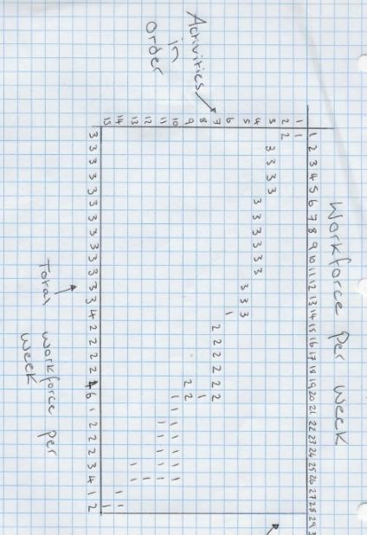
Appendixes 3 shows the amount of labour workforce on site each week, this is explained in the Gantt chart, the time is excluding weekends as work normally doesn’t take place on Saturday and Sunday.

Appendix 4
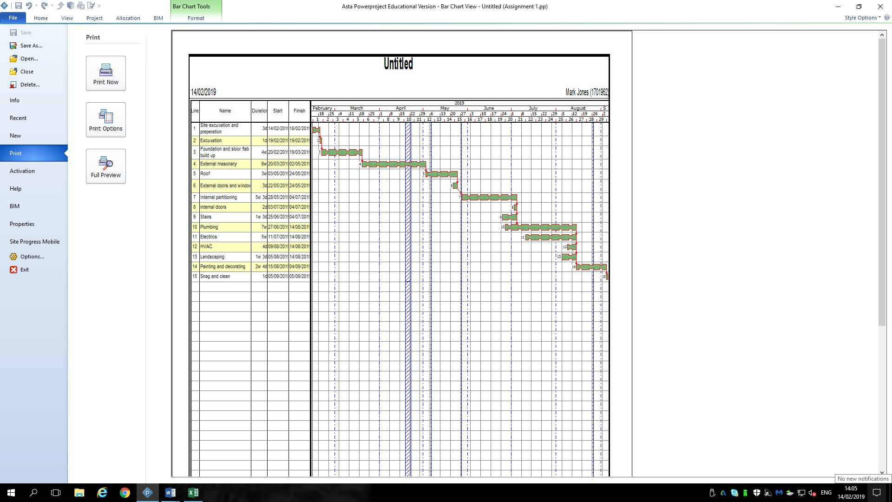
Appendixes 4 shows the diagram of the Gantt chart, all the tasks are laid out in order and the duration of the tasks is shown. The tasks are linked to each other to show when they start and finish with regards to the next task. With regards to what Jones, G (2019) has advised and the previous practical construction work I have undertaken I has set certain tasks to overlap to make the project faster e.g. all M+E services overlap. The etimated duration as seen in this imageis 28 weeks, which is a normal duration for a project like this.

Appendixes 5

Appendixes 5 is a bar chart of the total cost of each activity for the case study, the chart shows each activity cost and what tasks are the most expensive. This bar chart could be used if needed to see how the total cost of the project could be reduced, what activities could be changed to make a cheaper total cost.

