Written By Joanna Weedon

The Shard
The United Kingdom’s Tallest Building

Contents
Introduction: The Shard – The United Kingdom’s tallest building towering over the London Skyline 2
Description of Chosen Subject 3
The Construction Process 5
Conclusion 6
References 7

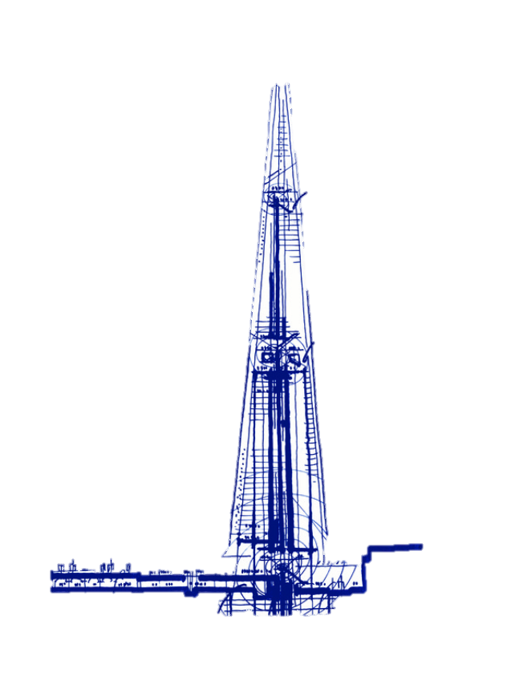

Figure 1(Viva, 2023) Illustrated architectural image of the shard

Introduction: The Shard – The United Kingdom’s tallest building towering over the London Skyline

The Shard is on the most noticeable London landmarks. The building employs cutting edge construction techniques and transformational engineering principles. This report explores the construction process, recognising the innovative design and materials used to create this iconic structure. The building represented a completely new way to grow an urban landscape in one of the most developed cities in the world.

Description of Chosen Subject

The Shard was built in one of the oldest cities of the world, London. The empowering mixed- use building sits alongside the River Thames located at London Bridge. Currently, The Shard is the tallest building to be built in the United Kingdom, with the tip of the building reaching 306m High with 72 habitable floors. (The Shard, ND)

‘It comprises world-class offices, award-winning restaurants, the 5-star Shangri-La Hotel, exclusive residences and the UK’s highest viewing gallery, The View from The Shard, offering 360-degree view’

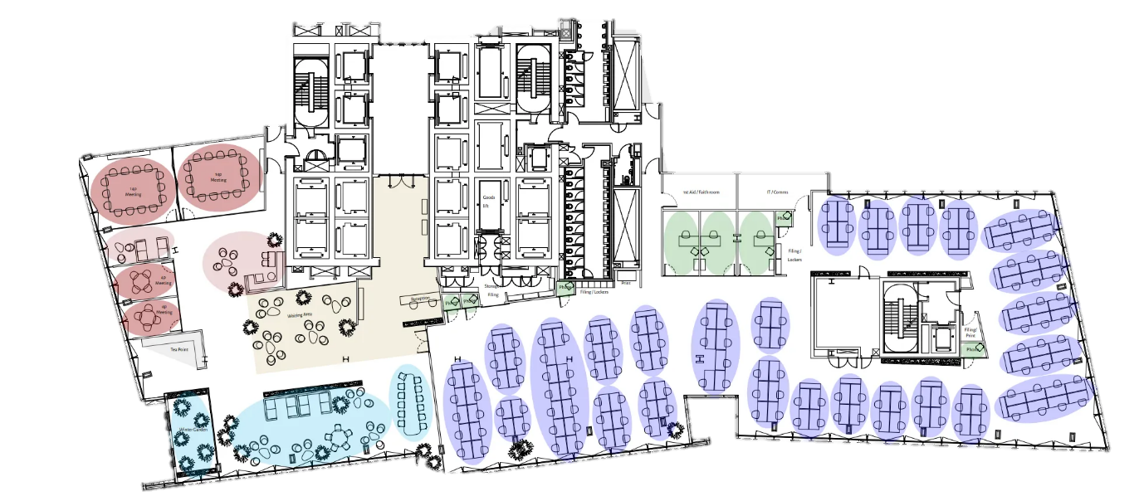

Figure 2 (Level 9, no date) GF Floor plan of The Shard

The owner of this project was the State of Qatar and Seller Property Group, with then the main contractors running and designing the project being, Main contractor – Mace, Main designer – WSP and finally the vision of the vertical city being award winning Pritzker Prize Architect – Renzo Piano. (Insider, 2023)

The Design and Engineering

Renzo Piano’s innovative design was inspired by the spires of London Churches and the masts of tall ships. Renzo designed the building to mimic the look of a sculpture that rises out of the riverbed. (Insider, 2024). The use of 11,000 glass panels covering a surface of 56,000 square metres created the look of a ‘vertical city’, seamlessly blending with London’s sky. These panels had the added benefit of providing natural light thereby reducing the need for artificial lighting. The particular use of extra white glass enhances the tower’s responsiveness to its environment, giving it a sense of lightness and allowing its colour and mood to shift with the weather and seasons. Apart from their ascetic appeal the glass was built with especially developed automatic blinds that adjust to changing light levels, ensuring efficient control of light and heat.
On the habitable floors with winter gardens, Renzo incorporated spaces between The Shard’s floors which allowed natural air to circulate. (Insider, 2024b)
The shard was built using a top-down construction method which allowed for the first 23 stories of the 72-story concrete core to be built before the basement had been fully excavated. The tower is effectively 3 separate structures. The first 40 floors are steel framed with a post tension concrete frame to level 72.
Finally, a steel spire prefabricated and preassembled offsite was installed to complete the shape to the equivalent of level 95. One of the benefits of using concrete in the centre of the building was to provide damping at the upper levels to reduce lateral acceleration, helping to control the sway of the building in the wind. (WSP, ND)
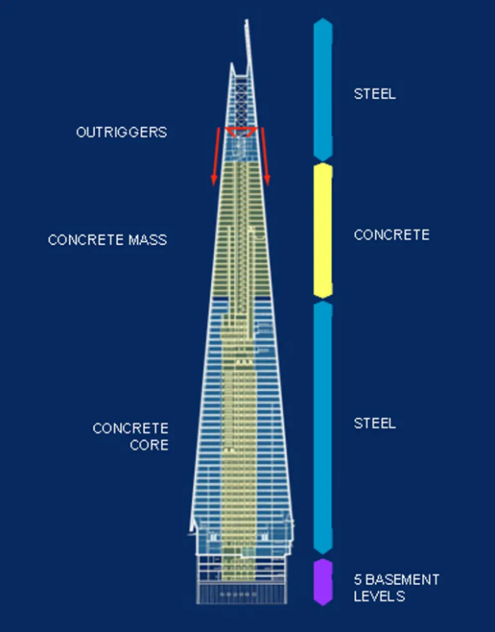

Figure 33 (Royal Academy of Engineering, no date) Diagram showing the different structural material elements.

The use of the concrete core eliminated the need for a tuned mass damper meaning that overall floors depths could be much shallower, allowing for another two floors within the total building height. WSP reduced the risks of working at such an unprecedented heigh by prefabrication and pre-assembly of the 500-tonnee and 66-metre steel spire off site. (WSP,ND)Engineering The Shard, London | WSP

The Construction Process

2009 the construction of The Shard begins, with it continuing throughout 2010 and by 2011 the core of The Shard reaches full height. In March 2012 the 500-tonne spire is finally winched into place. In January 2013, The Shards observation deck is open to the public marking the final completion of the construction process. Meaning this staggering building only took 4 years from breaking ground to public use.
There was several innovative structural engineering techniques employed during construction. Use of a hybrid concrete and steel frame structure with an innovative top-down construction method. This was helped by concrete piles driven into the ground below the concrete core to support the structure as it was built. Unusually, this allowed excavation and construction to happen concurrently, allowing significant savings in the construction programme - a complex undertaking and a first for the UK. The structure uses Vierendeel perimeter trusses along with hat trusses across the long spans which elevated rigidity. (Giuroiu, 2024)

Due to its proximity to the river Thames keeping the basement dry during construction was a challenge. Dr Richard Mawer, associate director WSP (no date), said ‘The presence of water at this level meant that the piles needed Bentonite. Roads, utilities and railway infrastructure all surrounded the construction site, which meant the design and construction of the sub structure, being critical to the project, was immensely challenging to design and build. (Conrad Consulting, no date)

Conclusion

The Shard is a testament to the innovative engineering and architectural prowess of modern construction. Its design, inspired by London's historic skyline, combines aesthetic appeal with functional versatility, creating a vertical city that serves multiple purposes. Using cutting-edge construction methods, such as the top-down approach and prefabrication, the project overcame significant challenges, including proximity to the River Thames and high-water tables. The Shard now welcomes just under 1 and a half million visitors per year, making it one of the most popular tourist attractions in London, highlighting what a success the project has been.

The Shard not only symbolizes progress in construction and engineering in the United Kingdom but also reflects a harmonious blend of creativity and practicality, making it a landmark achievement in the global architectural landscape.

References

Conrad Consulting look at the challenges faced by engineering teams on the Shard and Battersea Power Station | Conrad Consulting (ND). https://www.conradconsulting.co.uk/content/blog/conrad_consulting_look_at_the_challenges_faced_by_engi/.
Giuroiu, A. (2024) The Shard: an architecture landmark to visit in London. https://www.architecturelab.net/architecture/landmark/the-shard/.
Insider, S. (2023) 'A Structural Review: The Shard | London designed by WSP,' Structures Insider, 13 February. https://www.structuresinsider.com/post/a-structural-review-the-shard-london-designed-by-wsp.
Insider, S. (2024a) 'Architectural Review of the Shard | London | Renzo Piano,' Structures Insider, 8 July. https://www.structuresinsider.com/post/architectural-review-of-the-shard-london-renzo-piano.
Insider, S. (2024b) 'Architectural Review of the Shard | London | Renzo Piano,' Structures Insider, 8 July. https://www.structuresinsider.com/post/architectural-review-of-the-shard-london-renzo-piano.
Level 9 (ND). https://www.the-shard.com/offices/office-to-rent-level-9/.
Royal Academy of Engineering (no date) Building the tallest building in the UK - The Shard | This is Engineering. https://thisisengineering.org.uk/projects/building-the-tallest-building-in-the-uk-the-shard/.
The Shard (ND). https://www.the-shard.com/about/.
Viva, A. (2023) 'London Bridge Tower, London (project stage) - Renzo Piano Building Workshop ,' Arquitectura Viva, 17 May. https://arquitecturaviva.com/works/torre-london-bridge-londres-en-proyecto-0#lg=1&slide=0.
WSP. (2024) ‘The Shard, London,’ https://www.wsp.com/en-gl/projects/the-shard
WSP. (2024) ‘The Shard, London,’ WSPhttps://www.wsp.com/en-gl/projects/the-shard

