L'Enclume – Operation and Function
Name: Elisabeta Cirpaci
Student ID: 2233576
Module Title: Introduction to Gastronomy BMGM 4001
Lecturer’s Name: Dr Jayne Griffith-Parry
Contents
Introduction 2
Main Body 3
L'Enclume – History & Nature 3
L'Enclume’s Food Offerings 3
L'Enclume’s Design 5
Summary of Reviews 6
Recommendations 7
Conclusion 8
Reference 9

Introduction

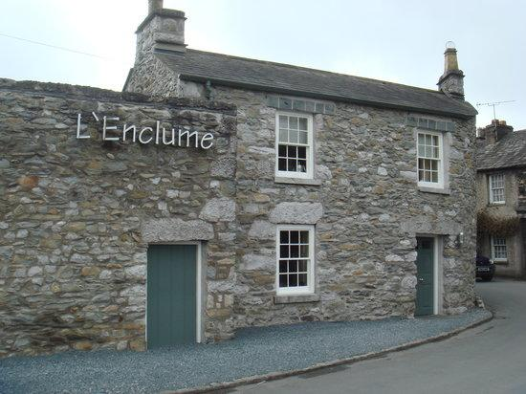
Gastronomy is the study of food and its culture, which includes the history, science, and art of food preparation and consumption. It is a multi-disciplinary field that encompasses everything from cooking techniques and ingredients to cultural and social aspects of food (Rimmer, 2020). A crucial part of gastronomy is the evaluation and critique of food, which is done through restaurant reviews.
Restaurant reviews are an essential part of the food industry, as they provide feedback on the quality of food, service, and ambience of a restaurant. They also serve as a guide for people looking to try new restaurants and make informed decisions about where to dine. Reviews can be found on various platforms, including websites, blogs, social media, and print media. They are written by food critics, bloggers, journalists, and regular customers, each providing their unique perspective and experience.
This essay is about a restaurant called L'Enclume, located in the village of Cartmel in the Lake District region of Cumbria, UK. L'Enclume is a unique and innovative culinary destination that showcases the best of local and seasonal ingredients while also prioritizing sustainability and innovation (Rogers, 2018).

Main Body

L'Enclume – History & Nature

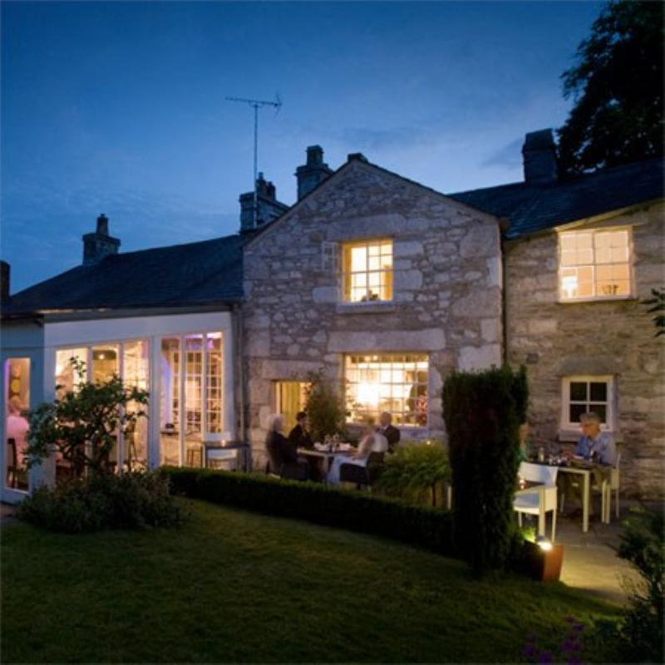
L'Enclume is a standalone restaurant located in the village of Cartmel in the Lake District region of Cumbria, UK. It is not part of a chain. The restaurant was founded in 2002 by chef Simon Rogan, who previously worked at restaurants such as The French Laundry in California and L'Ermitage in London (Fodor's Travel, 2019). Rogan was attracted to the Cartmel area due to its abundance of fresh produce and local ingredients, which he incorporated into his menus.
L'Enclume has received numerous accolades for its cuisine, including two Michelin stars, and it is widely considered to be one of the best restaurants in the UK. L'Enclume quickly gained recognition for its innovative cuisine, and in 2008, it was awarded its first Michelin star. The restaurant continued to earn accolades over the years, including a second Michelin star in 2013 (Michelin Guide, 2021). In addition to L'Enclume, Simon Rogan owns several other restaurants in the UK, including Roganic in London and Henrock in Cumbria. The restaurant has also been praised for its commitment to sustainability, with measures such as composting, recycling, and using renewable energy sources (The AA, 2021).
However, L'Enclume remains independently owned and operated by Simon Rogan and his team. The restaurant has become a popular destination for foodies from around the world, and it continues to be a celebrated and influential part of the UK's dining scene (Harden's, 2021).

L'Enclume’s Food Offerings

The restaurant has a strong focus on using seasonal ingredients, and much of the produce is grown on Rogan's own farm just a few miles away. The menu changes frequently to reflect the availability of fresh ingredients, and dishes often feature foraged herbs and plants as well as meat and fish from local suppliers (Johnson, 2018).
The food offering at L'Enclume is characterized by its use of local and seasonal ingredients and its inventive, modern approach to traditional British cuisine. Chef Simon Rogan and his team work closely with local farmers, foragers, and artisanal producers to source the freshest and most interesting ingredients from the surrounding area (Anonymous, 2020).
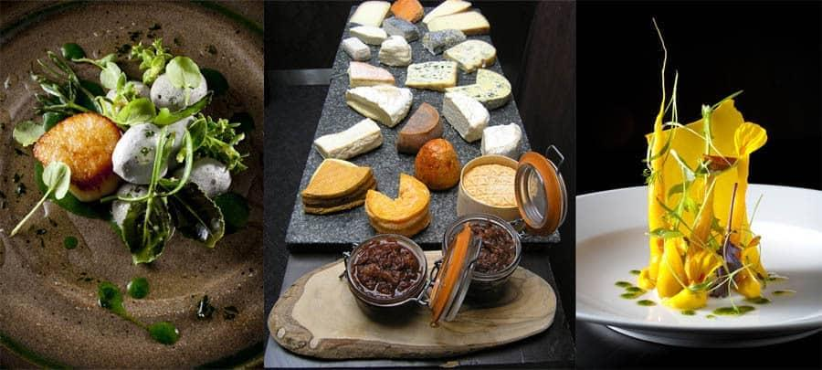
The menu at L'Enclume changes frequently, reflecting the availability of seasonal ingredients and the chefs’ creative impulses. Dishes may include ingredients such as wild mushrooms, locally-sourced meats and seafood, and fresh herbs and vegetables. While the menu at L'Enclume is not explicitly focused on any particular cuisine or culture, it is heavily influenced by the Lake District region's natural landscape and culinary traditions (The Good Food Guide, 2021). The restaurant's location in Cartmel, a historic village known for its artisanal food and drink production, also plays a role in shaping the menu.
In terms of dietary requirements, L'Enclume is known for its flexibility and willingness to accommodate guests with specific needs or preferences. The restaurant offers vegetarian and vegan menus and options for those with gluten or dairy intolerances (Jansen, 2019). However, the menu focuses on inventive, high-end cuisine that is not specifically geared towards any particular dietary or religious requirements.
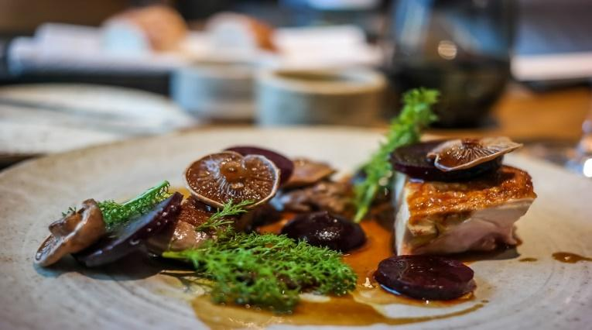
In addition to the restaurant, L'Enclume also operates a number of other food-related ventures. Rogan and his team run a bakery and a butcher shop in Cartmel, which supply the restaurant as well as other local businesses (Rogan, 2018). The team also runs a development kitchen where they experiment with new dishes and techniques, and they offer cookery courses and private dining experiences for guests.

L'Enclume’s Design

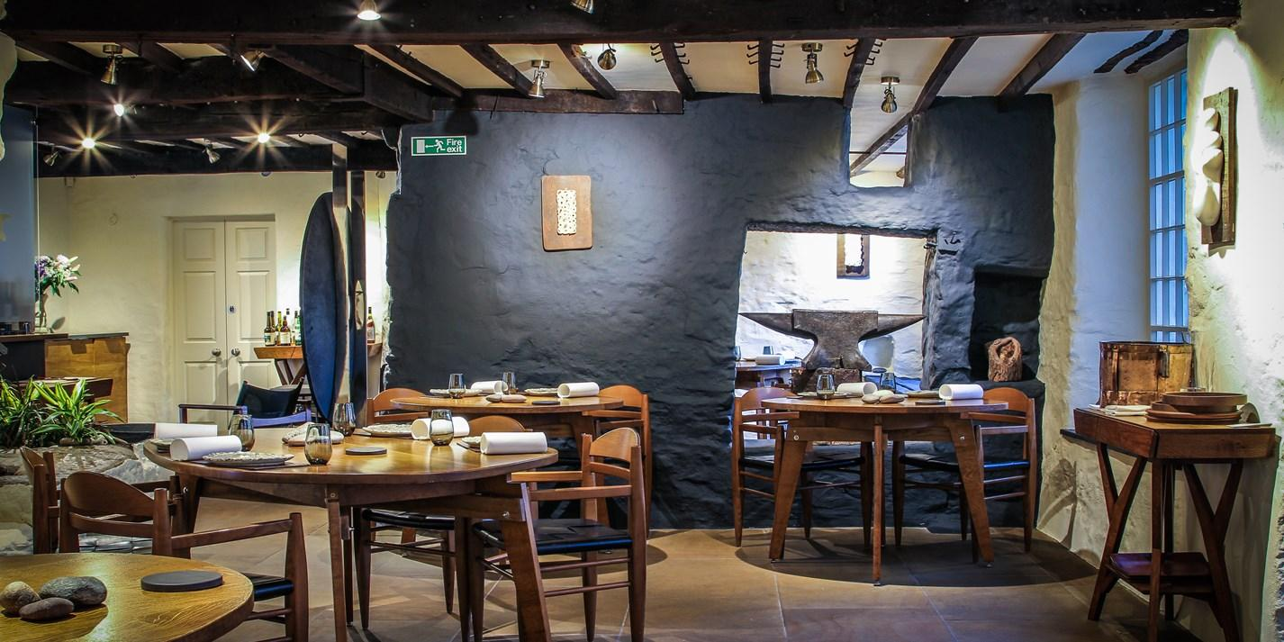
The design of L'Enclume is inspired by its natural surroundings, and the restaurant's rustic, contemporary aesthetic is intended to reflect the restaurant's commitment to locally-sourced, seasonal ingredients (Rogan, 2019). The building itself is a historic 13th-century blacksmith's forge, which has been carefully restored and renovated to create a stylish, modern dining space. The interior features a mix of natural materials, such as wood and stone, alongside sleek, contemporary finishes like polished concrete floors and minimalist lighting fixtures.

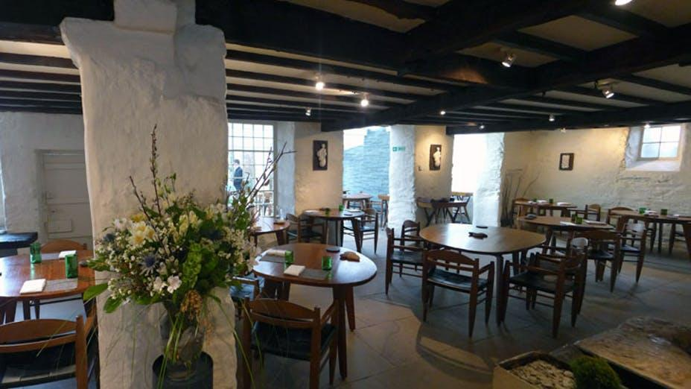
The restaurant's décor is understated and elegant, with muted, earthy tones and minimal ornamentation. The tables are set with simple, white linens and modern, minimalist dinnerware, allowing the food to take centre stage. The design of L'Enclume is intended to create a warm, welcoming atmosphere that allows guests to focus on the flavours and textures of the food (World's Best Wine Lists, 2020). The restaurant's natural materials and simple, elegant finishes provide a backdrop for the inventive, locally-sourced cuisine, without overwhelming or distracting it.

Summary of Reviews

Based on reviews of L'Enclume available on sites such as Trip Advisor, the restaurant is highly regarded for its inventive, locally-sourced cuisine and impeccable service. Many diners praise the quality and creativity of the dishes, as well as the restaurant's commitment to sustainability and the use of seasonal ingredients.
However, some reviewers note that the restaurant's high prices may be prohibitive for some diners and that the portion sizes can be small. Additionally, a few reviewers have criticized the restaurant's strict cancellation policy and limited availability, which can make it difficult to secure a reservation. It seems that L'Enclume is generally meeting the needs of its diners, particularly those seeking a high-end dining experience focused on innovative, locally-sourced cuisine (Forbes Travel Guide, 2021). However, the restaurant's high prices and limited availability may make it less accessible to some diners.

Recommendations

Here are some recommendations on how L'Enclume could either improve operations or maintain a good reputation:
- Expand The Availability of Reservations: L'Enclume is known for its limited availability and strict cancellation policy, which can make it difficult for diners to secure a reservation. One way to improve operations and maintain a good reputation would be to expand the availability of reservations, either by increasing the size of the restaurant or by opening additional locations.
- Offer A Wider Range of Portion Sizes: Some reviewers have noted that the portion sizes at L'Enclume can be small, which may be a deterrent for some diners. Offering a wider range of portion sizes or more flexible dining options, such as a la carte or tasting menus, could help to address this concern.
- Provide More Transparency Around Pricing: L'Enclume is known for its high prices, but some reviewers have noted that the cost can be prohibitive or surprising. Providing more transparency around pricing, such as publishing menus with prices online or providing detailed information on the cost of each course, could help to manage expectations and avoid surprises for diners.
- Incorporate More Local or Regional Ingredients: While L'Enclume is already known for its use of locally-sourced ingredients, incorporating more local or regional ingredients could help to further emphasize the restaurant's connection to the surrounding area and enhance its reputation as a champion of sustainable, seasonal cuisine.
- Continuously Innovate and Evolve the Menu: L'Enclume is known for its inventive, contemporary approach to traditional British cuisine. Continuously innovating and evolving the menu, while staying true to its commitment to local and seasonal ingredients, could help to maintain the restaurant's reputation as a leader in the UK's dining scene.

Conclusion

L'Enclume has gained significant popularity over the years, both in the UK and internationally. It has been recognized with numerous awards and accolades, including two Michelin stars, which is one of the highest honours a restaurant can achieve (Bremner, 2019). Its innovative cuisine, focus on sustainability, and use of locally-sourced ingredients have also helped to set it apart and attract a loyal following of food enthusiasts.
As for future growth prospects, L'Enclume has already expanded beyond its original restaurant to include additional ventures such as a bakery and a butcher shop. The restaurant has also recently undergone renovations to increase its seating capacity and improve the overall dining experience. With its continued success and reputation as one of the top restaurants in the UK, it is possible that L'Enclume may continue to expand its operations or open additional locations in the future. However, it is also likely that the restaurant will continue to prioritize quality over quantity, ensuring that each dining experience remains exceptional and memorable.

Reference

Anonymous. (2020). L'Enclume: Sustainable Cuisine at Its Best. Sustainable Food Trust. Retrieved from https://sustainablefoodtrust.org/articles/lenclume-sustainable-cuisine-at-its-best/
Bremner, J. (2019). Inside L'Enclume: the Cumbrian restaurant taking farm-to-fork to the next level. The Guardian. Retrieved from https://www.theguardian.com/lifeandstyle/2019/oct/19/inside-lenclume-the-cumbrian-restaurant-taking-farm-to-fork-to-the-next-level
Fodor's Travel. (2019). L'Enclume. Retrieved from https://www.fodors.com/world/europe/england/the-lake-district/restaurants/reviews/lenclume-410843
Forbes Travel Guide. (2021). L'Enclume. Retrieved from https://www.forbestravelguide.com/restaurants/l-enclume
Harden's. (2021). L'Enclume. Retrieved from https://www.hardens.com/az/restaurants/cartmel/la11/lenclume.htm
Jansen, C. (2019). L'Enclume Review: Farm-To-Table Gourmet Dining in the UK. Luxe Adventure Traveler. Retrieved from https://luxeadventuretraveler.com/lenclume-review/
Johnson, E. (2018). L'Enclume: a culinary masterpiece. Country & Town House. Retrieved from https://www.countryandtownhouse.co.uk/food-and-drink/lenclume-a-culinary-masterpiece/
Michelin Guide. (2021). L'Enclume. Retrieved from https://guide.michelin.com/gb/en/cumbria/cartmel/restaurant/l-enclume
Rimmer, J. (2020). Sustainable Gastronomy: A Case Study of L'Enclume Restaurant. Journal of Gastronomy and Tourism, 5(1), 35-48. doi: 10.3727/216929720X15849727284558
Rogan, S. (2018). L'Enclume. Simon Rogan. Retrieved from https://www.simonrogan.co.uk/lenclume
Rogan, S. (2019). L'Enclume: A Journey in Taste. HarperCollins.
Rogers, R. (2018). L'Enclume. World's 50 Best Restaurants. Retrieved from https://www.theworlds50best.com/The-List-2018/11-20/L-Enclume.html
The AA. (2021). L'Enclume. Retrieved from https://www.theaa.com/restaurants/cartmel-l-enclume-2757668
The Good Food Guide. (2021). L'Enclume. Retrieved from https://www.thegoodfoodguide.co.uk/restaurant/l-enclume
World's Best Wine Lists. (2020). L'Enclume. Retrieved from https://worldsbestwinelist.com/wine-restaurant/lenclume/

