NAME: Josephine Hagan Mantey
Moodle: Effective Teamwork and Communication ( Assignment 1)
Lecturer: Miss Diya Ganguly
Programme: Certificate for Higher Education Level 4 ( HSC)
Student ID: 1908217
Topic: Academic Essay on Developmental Psychology and life span theories.

Introduction
This is an Academic essay on Psychology and would like to discuss developmental psychology whereby I will be using the infancy developmental stage. I will be using two theories by Jean Piaget’s theory of cognitive development and Erik Erickson theory of psychosocial development including crisims of different psychologists.

Developmental psychology is the study of biological, social and personality development across the life span in a scientific way ( Griggs,1999).

Stage theory organises the changes of development into age range and gives as two stages of the life span such as prenatal development and infancy however, my academic essay will be focused on the infancy developmental stage.

Infancy
According to Healthy children’s website, infancy begins from birth to 3years of age where he or she grows into preschool age (3-5 years).
At the infancy stage, the baby communicates important information to the mother or Caregiver on how they want to be treated, talked to, comforted or held through their senses.
Major developmental stages babies develop through a movement milestone known as the Motor and the root reflex development from age 0-3 month. The motor reflexes are unlearned responses which newborn are equipped with when born ( Griggs, 2012). The baby’s eyes are used to monitor movement of the mum or caregiver and look to locate familiar sounds and voices. The neck control at this stage enables the baby to move his head around side to side. For instance seeing the first feeding, the rooting reflex prompts babies to turn to where the nipple is. Other reflexes include the sucking reflex which leads to the baby to suck whatever touches his or her lips etc. The baby’s Nervous system starts to mature and now certain reflexes give way to voluntary motions, movement becomes more fluid and wiggling. The baby continues with the movement of the head when lying on their tummies, though finger movement limited, he is able to clench tight little fists, moves hands when excited and shows gestures of amusement and attachment with a genuine smile and including a reflexive smile when asleep around 6 weeks. At three months old, the startle reflex is gone by now and the baby is becoming stronger and coordinating motions better. The baby starts rolling back, straightening out, gets a grip, bounce back etc.

During the first year, babies learn to prop up, support their body, then sit without support, stand while holding unto an object, then crawl, then stand without support and finally walk without support (Griggs, 2012).

From the age of 1-3 years, children also develop some progress of intellectual, emotional and social changes. The child continues to run, kick, climb and jump around.

This yearlong energy spurt between ages two and three certainly will keep you on the go and most amazingly, activity level strengthens his body and develops his coordination. The baby can do other things as he moves, such as using his hands, talking, and looking around.
This stage, the parent and caregiver must be vigilant and keep the safe to prevent injuries since his self-control and judgment lag considerably behind his motor skills whenever you are outdoors.
It is when most parents are recommended to start potty training. During this training some parents reward children for doing the right thing. It is also a combination of verbal, social, physical and other forms of training no matter what (healthychildren.org).

Jean Piaget’s theory of cognitive developmental 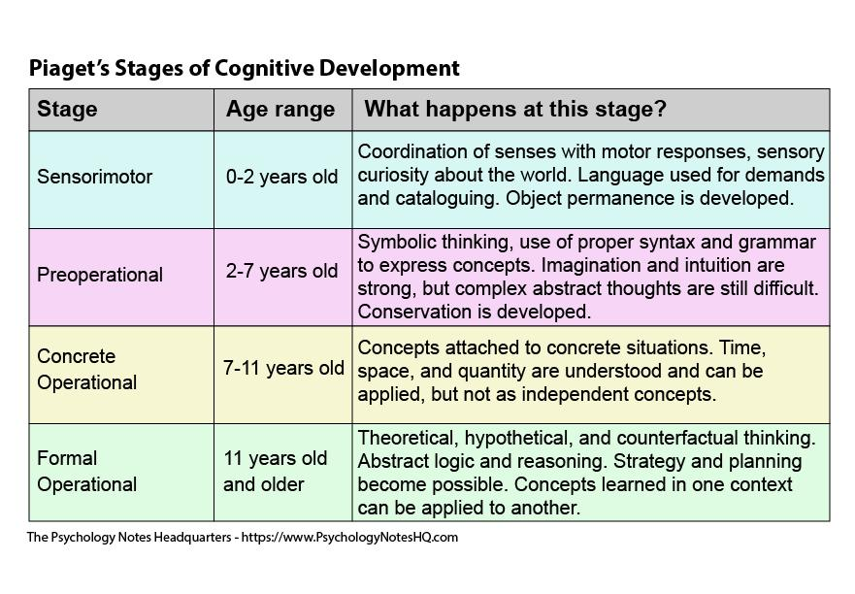
The cognitive development was a life’s work of psychologist Jean Piaget ( 1896- 1980) who was born in Switzerland, who became fascinated about biology and the nature of a child. Piaget believed that children go through 4 stages of development in their lives for them to acquire knowledge .
These stages are the Sensorimotor, pre- operational, concrete operational and finally the formal operational stage (E.Ralls & C. Riggs,2019).

Focusing on the first stage, which is the Sensorimotor beginning from 0-2 years or birth-2 years of their life development.
In this stage, infants develop through experiences and movements of their five senses which are smell , taste, hear, touching and seeing. For instance a baby knows when the mother or the caregiver enters his or her room through the smell of the mum. As a result of this , babies are able to differentiate a stranger who visits them and the mother.

At this stage, the brain of the baby wants to smell, take, see, hear and touch as much as it could. According to Piaget, children start to explore the world using their touching senses. They begin to develop object permanence and realise the object does not disappear when they can not see them.

The second lifespan stage according to Piagetis the Preoperational stage from 2-7. Children at this stage use words and images to represent their world. Languages of children develop and they begin to imagine and pretend play (Ralls & Riggs,2019). They use one thing to represent the other. For instance my three year old child telling me she is playing teachers and students pretend play in the house during COVID -19 lockdown . The child imagines she is in her class, mentions the names of her friends and greets them just as the teacher does. Children become egocentric at this stage which means they cannot separate their perceptions, thought and feeling from that of others.

Piaget’s cognitive theory was criticised for ending at the adolescence stage and it also did not take into consideration that our culture and social environment impact on a child’s cognitive development. This made Vygotsky came out with the sociocultural developmental approach.

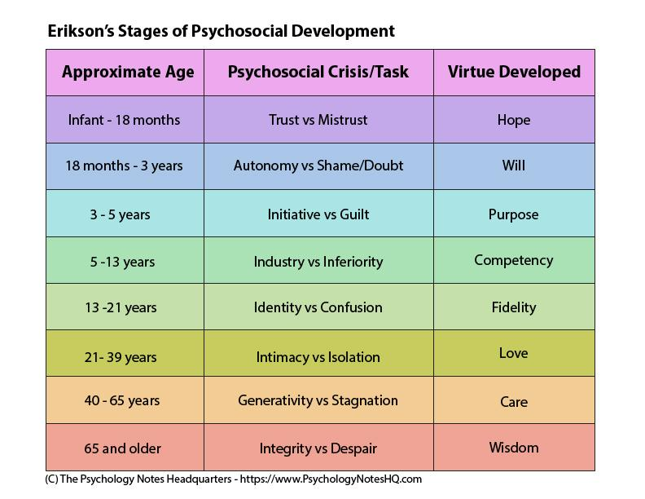
Erikson lifespan theory is one best known among others such as Buhler & Massaarik (1968) , Havighurst (1972). Erickson, who was a student of Fraud, differs from Freud’s theory and he emphasised on the psychosocial nature of development that needs to be taken into consideration. According to Erickson, factors like social, political and a person's geography affect their upbringing. Erickson secondly criticised that personality development does not end at the adolescence stage but continues throughout the whole lifespan of an individual (Niven,2000).

Erickson (1980) then Proposed 8 stages or developmental crisis which includes Basic trust vs mistrust ( birth - 18month, Autonomy vs Shame and doubt, initiative vs guilt, industry vs inferiority, identity vs role confusion, intimacy vs isolation, generativity vs stagnation and last but not the least is integrity vs despair. However, my focus will be on the infancy stages and will stick to the first and second stage.

The first Crisis stages ( Basic Trust vs Mistrust) begins in the first year of the child and upon successful completion of this stage, the infant develops a virtue of Will. The infant develops trust or mistrust towards the mother or the caregiver. For instance if the child’s mother or caregiver responds anytime he or she cries by way of expression of needs, the infant builds trust and secure attachment and carries these key elements of relationship to the next stage and vice versa.

The second stage is Autonomy vs Shame and doubt, (18months - 3years old). At this stage the infant develops the sense of being confident and independent vs shame and doubt. The infant at this stage experiences a new situation having confidence and believing in his or herself, then he will develop self control and self worth later in their lifetime and upon successful completion of this stage, infant develops a virtue of Hope.For instance, a child who is potty training urinates on herself when she attends nursery. The parents or caregiver takes the child to the toilet and explains to the child what to do anything she has the urge to urinate. Anytime the child goes to the toilet successfully, the confident and independent level in the child increases . On the hand when the child urinates herself and the parent and caregiver says abuse words to this child, he senses shame and it begins to develop self doubt.

The above theory was also criticised by Bee in 1992 as being overtly fuzzy and stated that the Erickson’s theory represents assumptions rather than precise descriptive causes and relationships (Niven,2000).

Cognitive, Emotional and behaviour patterns of infants
At the age of roughly six months of age, the infant is able to predict specific responses of their parents or caregivers to their distress and also shapes their behaviour and the way they think based on their daily interactions with the infants.
An example is an infant whose mother or caregiver responds consistently to the child in distress in a sensitive or loving manner such as picking the child up promptly and reassuring the infant when crying or wet herself and needs to be changed.
Behaviour of the infant is they feel safe ,secured and seek proximity to and maintain contact with the caregiver.
Emotional pattern of the infant is safe and secured with the caregiver or the mother and this child does not become distressed.
Cognitive patterns of the infant make them feel secure in their knowledge that they can freely express negative emotion which will draw out comfort from the mother or caregiver. The infant builds a secure attachment with the caregiver or the mother.

Research on Resilience in health and social Care.

Aim sample size, hypothesis, populations, ideas & assumptions, outcomes of the research.
Aim
The aim was a cross sectional resilience of healthcare workers in the uk. This survey is a journal of occupational medicine and toxicology and was published in May, 2015. The aim was quantifying resilience within NHS UK and exploring the relationship between the level of resilience and absence rates as a marker for health among healthcare workers. The motivational factor for this research was to create resilience data to be used by practitioners and researchers to aid in their decision making process when introducing health and well-being for the employees.
Sample size
All staff were eligible from August 2013- November 2013. 845 employees were targeted and 789 out of these employees completed the survey. 79% female and 21% male.
Outcome
Outcome of the research suggests resilience building strategies such as seeking mentoring relationships, achieving life balance and spirituality, positive emotion and personal growth and reflection were found to have
Conclusion of the research on resilience in health According to the study, it gives a snapshot of the resilience of NHS employees. It also suggests resilience alone cannot be measured as a marker for health as related to sickness absence among NHS Staff.

Research 2
The second research is on the role of empathy in health and social care professionals.

The aim of this report is about the link between empathy and healthcare professionals.
Empathy is the ability of understanding the state of an individual and sharing in their feelings. This is a core concept in psychodynamic, behavioural and person centred.
Developing empathy should be a continuous education not all in school but should be among health care professionals because it is a common denominator among nurses, doctors,students, health professionals, psychologists , social workers etc.
Outcome
Research outcomes suggest that social workers have protective factors like pro social behaviour towards work , positive personal and their environmental factors all affect a worker to be empathetic. However it is not always the case because of reasons presumptions, a sense of superiority from the health professionals, and a fear of boundary violation, time pressure, anxiety, a lack of self-awareness, and a lack of appropriate training, as well as the different socio-economic status, all the above do not favor empathy either.
Conclusion
It is important for development of empathetic skills in health and social care to be encouraged as it constitutes an important priority.
Although empathy is a core, quality principle for the health care professions, there are studies that show that health professionals cannot adequately express it and implement it [66,67] (Moudatsou et al,2020).

Research 3
Applying the ADAPT Psychosocial Model to War-Affected Children and adolescents
The Aim of this report is about the trauma that affects children and adolescents and applying the ADAPT Psychosocial as a correction measure which were the Safety, bonds and attachment, identity and roles, justice and existential meaning in all societies proposed by Silove(1999). The ADAPT model connects multiple issues, stress and resources facing individuals affected by war ( Yohani, 2015).
Some of the outcomes were 1. The review was limited by its wide- net approach to incorporate literature on children affected in war conflict and resettlement settings. 2. In the future, a focused approach by conducting systematic reviews of one domain and sub population of children affected by war.
Conclusion
Unfortunately it was realized that not all war affected are able to keep a positive outlook for life.

Conclusion
Erickson explains that Upon successful completion of one stage, the infant develops a virtue of will and hope.
Piaget explains object permanence and conservation are developed during the infancy stage.

Reference

- Benoit. D,(2004)Paediatr Child Health. Accessed [17AUGUST,2020]https://www.ncbi.nlm.nih.gov/pmc/articles/PMC2724160/
- Griggs, R. A. (2012) Psychology: A Concise Introduction, Third Edition, Worth Publishers.
- Long J, Powell C, Bamber D, et al. Development of materials to support parents whose babies cry excessively: findings and health service implications. Prim Health Care Res Dev. 2018;19(4):320-332. Accessed on [22 August 2020] https://www.ncbi.nlm.nih.gov/pmc/articles/PMC6452937/
- McLeod, S. A. (2008):Erik Erikson | Psychosocial Stages - Simply Psychology. Accessed on [05 August 2020] https://docuri.com/download/erik-erikson-psychosocial-stages-simply-psychology_59c1e23ff581710b286a64c6_pdf
- Moudatsou M, Stavropoulou A, Philalithis A, Koukouli S: The Role of Empathy in Health and Social Care Professionals. Healthcare (Basel). 2020;8(1):26. Accessed on [19 August 2020]https://www.ncbi.nlm.nih.gov/pmc/articles/PMC7151200/
- Niven.N.(2000): HEALTH PSYCHOLOGY for Health Care Professionals, Third Edition,Harcourt Publishers Limited.
- https://www.semanticscholar.org/paper/Developmental-Psychology%3A-Childhood-and-Adolescence-Shaffer-Kipp/298d15fd2e592055142368f3597363fd42f8a9a
- Wusthoff. C (2020)
- Yohani. S(2015) ‘Applying the ADAPT Psychosocial Model to War-Affected Children and Adolescents’https://doi.org/10.1177%2F2158244015604189

