Converse study case

Introduction:
Marketing is the activity and processes for creating, communicating, delivering and exchanging offering that have value for customers , clients , partners and society.
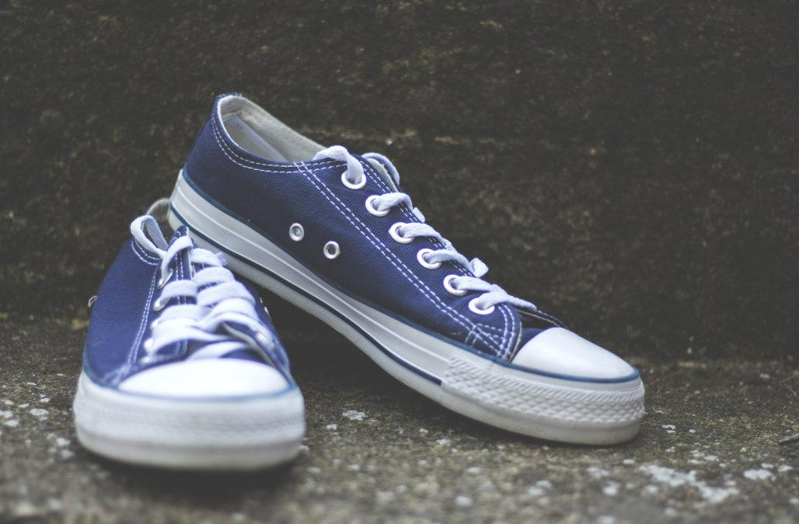
The study case that I decide to involve on my essay is about a Converse company, which all of us we mostly know the shoes as a main product , even if the company is actually involved in other differents types of production like and accessories.

Mission , implementation and control:
The main mission which the company is based on is the fact that Converse give to the them clients the possibility to express them self through the products. A part from the fact to be identify through the product , many people have decide to wearing the main product, like the shoes also for the comfort and satisfaction aspect.
A main action stage adopts by Converse is the fact that the company has created a multi generation marketing strategy where almost every generation had a pair of Converse .
With this aspect I would like to notice the action plan that Converse use, related an emotional state of mind , where between the consumers and the company is built an emotional connection, and like this Converse is keep continuing targeting the new and old generation.
The control or the evaluation of the company is actually based on different factors starting from the respect of the main value of the company arriving to the effectivenesses control from all the different departments adopting like this a Hierachical structure, easy and better to manage having more control in all the stages and departments.

Strategy:
Converse today has a strong position on the market , but we have also to identify the fact that the same market , presents an high level of competition and to be on the high position, Converse adopts the 3 main ways of strategy. Segmentation, targeting and positioning.
On the segmentation aspect we can define the fact that Converse is the first company to come up with the concept of self expression , using like this a demographic segmentation, having as a target young generation and all the people feeling comfort to wearing a Converse under the love and material aspect. Geographic segmentation, the company presence is worldwide even if we can find the main stores in west countries like USA or many countries in Europe.
Converse is targeting a materialistic and image of conscious people pointing like this a kind of strategy called differentiated targeting strategy. Of course to be mention the fact that the company is not doing a differentiation between the categories male and female gender.
Under the positioning strategy the company is having a sub targeting strategy , where the brand is positioning itself by figures like artists , rebels, rockers and original having like this an effect of strategy and promotion. At very begin the main target of the company was a sport categories people but Converse is having a focus more on the younger generation and the retro modern culture.



Marketing mix, 4PS :
Another way to identify a way of strategy is also to analyse the 4PS of marketing mix strategies. Product, Price, Place and Promotion.
Product ; Converse is one of the most popular footwear having a worldwide presence , starting in early year of 1908 with the collaboration of many famous people, like a basketballer Chuck Taylor , creating the classic shoes, that all of us we know , achiving an immense popularity. Converse now comes in a wide of variety of type and colours which few of them are funkys and modern , with a big variety of production like denim, leather, vinyl, hemp and many more. Today the product’s range is wide and the popularity is immense.
Price ; Being on the wide market, Converse price depends also on the competition, however the superior quality of the product is associeted with the brand giving a premium price , without affecting the sales. Converse like many others brand , has limited edition products where the price of those last one are literally out of the market competitions.
Place ; Converse is globally and it’s a worldwide spread, important fact to mention, related to Converse, is the fact that Nike is the “parent brand” of Converse, which implement in many factors, economical and not the name of the brand.
Converse a part to have the main and direct shops , is selling his product through different channel in an indirect way , using places like “footlocker” and many local sport / underground style shops. Converse is worldwide selling his product adopting the direct and indirect channel having on both situation the main advantages and disadvantages.
Promotion ; Converse believes in the strategy of rolling out modifications on its products , to encourage the customers to keep on track on the new items.
The name of the brand today is strong and this is already related at the promotion factor which the company is promoting itself under this aspect.
Like mentioned before the brand over the years has been sponsored by many famous people in fact is promoted also from many musician association . Even if the company is targeting certain kind of people , the company as anyway and huge popolarity.
The main promotion that the company is adopting is the identification between the people that over the years are still wearing Converse.

SWOT ANALYSIS ;
Strenghts are defined as what each business do best.
In Converse study case , to be mentioned is the fact that the products are not only trendy but they present also a comfortable quality aspect. The price as well is one that factor which made possible to be affordable to a big variety of customers.
Innovative design which is create every time is consider it as main factor to be rapresent on the strenghts paragraph.
Weaknesses is consider where any business need any kind of improvement.
The differentiation factor is one of those can create a weak point for this company because on that the differentiation of many products of Converse can create a confusion to the customers.
Opportunities, is consider it that area where any company can capitalize to increase the returns. Today the world in general is going to a digital system and the online shopping is increasing and consequently needs an improvement to be on track with the market.
Threats are those factors in the business environment consider it a determinated for the business. The competition can be one of the main point, also the countreifeit materials of the originals , which is quite popular nowadays , can create an issue on terms of distribution and sales of the company.

Porter’s 5 forces;
Competitive rivalry: Converse has a main product which is selling most are the shoes, today the we have a lot of competitors which the company has to face on, most of the time the same target or the same shape of the product on itself making a weak point to Converse on the market.
Bargaining power of suppliers: A large population of suppliers reduces the impact of local suppliers demand on large companies like Converse. Suppliers are among the least significant concerns determining Converse’s strategies in the shoes and apparel industry.
Substitution product: on this aspect we can find a moderate circumstances where we find a moderate availability product similar to Converse, because even if the market is quiet massive the product of Converse, like the shoes is unique, we have a moderate circumstance under the price availability where the competition present almost the same standard price
Threat of new entry: even , already mentioned above, Converse presents unique product it must to be consider it the fact that the competition is still high and mostly the customers can adopt a new product from another brand. It is actually easy to define than today the competitors are presenting in a large number on the market and even if the company like Converse is targeting certains kind of clients , those last one can be attract by other brand.
Bargaining power from the customers: this aspect can be probably one of the positive for Converse because in that we find the product with a low cost, easy to the clients, we find a really easy to achieve the product and how the company targets them clients.

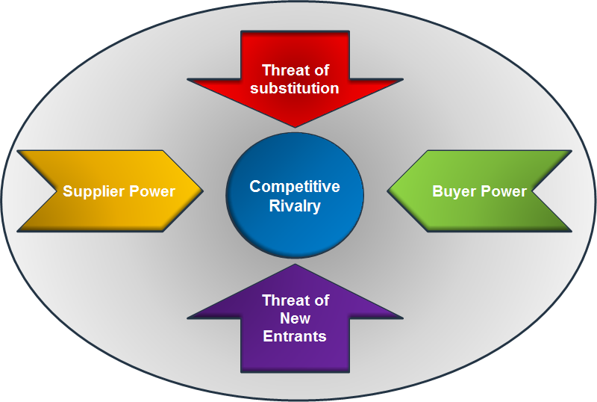

Question 2:
Marketing concept and appropriate branding strategy:
A marketing concept is the strategy that firms, businesses implement to satisfy customer needs, increase sales, maximize profit and beat the competition.
There are 5 mains points which this concept is based of,
the production concept, product concept, selling concept, marketing concept, and social marketing concept.
Applying this philosophy to our study case we can define the fact that Converse satisfy the customers need producing for them a product which the consumers can feel rappreset on itself, like this the firms , increase the sales producing always trendy and fashion items and producing more stakeholders to expand the promotion and the production , trying to beat the competition following the same concept and creating product for the customer’s needs.
If we want to find a definition of what is a brand we can do it saying that “branding is a name , term, design, symbol or any other feature to identify one good or service from others.
Converse has more than 100 years of history and over the time, different generation and targets has been passed and consequently also the way to produce and do promotion has been affected in some changes, The only, in some ways, which has not change is the brand strategy which consists on the preservation of the logo, leverage the existing brand trust and a reconnections with the new boomers.
The advantages on this is the fact the company has a strong reputation on the brand itself and also the fact that the brand has been used from many popular people becoming most of the time brand ambassador.
The fact of the long history and the right target which the company has chose over the years has permited to be today a strong brand, which can have a competition on a strong market.

The Ansoff’s matrix;
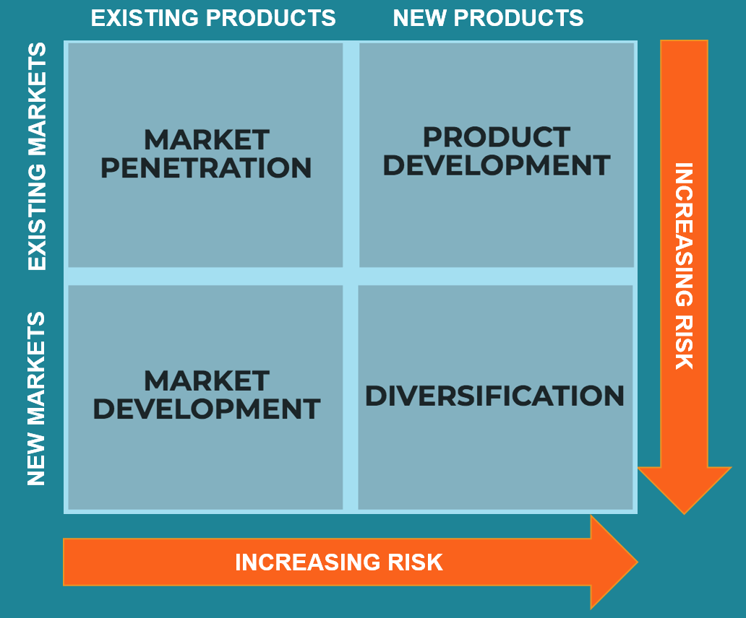
The Ansoff’s matrix system is used mostly to give to the leaders a simple and quick idea about the growth of the business, and Converse is adopting exactly the same strategy to understand better the economic situation in a details.
Market penetration: Converse is selling the same product in the same market, this encourage new people to have the same philosophy over the generation and use the “Nike”, which is a partner to have a penetration on the market. Product development: here the company is selling to the same target but with a different products. As we know , Converse is famous for his main product the shoes, and the company is developing selling differents products like jumpers , jackets, t- shirt.
Market development: Converse is always looking for an new markets or new areas and is doing this keeping the same products. Converse is start to implement online channel or using mostly an indirect channel like the UK example of JD sport or any local sport stores.
Diversification: This aspect is the risky stage of the four, Here the company doesn’t adapt the concept of the diversification but actually has been adopted from Nike as “parent brand”.

Question 3
Stakeholders, concept and definition of internal and external.
Giving a definition of stakeholder is right to say that the stakeholder is that party which has an interest in a company and can be affect or affected by the business. The main stakeholders that we know today can be employees , customers and suppliers.
The internal stakeholders are those that we found in any business and they can define like a employees, investors or either the customers mostly, that figures which are affecting the company.
The external like the same word describe are those which in a certains ways are affected by the company. example; a company which producing raw materials creates consequently environmental pollution, the community affected by the pollution can be consider it as an external stakeholders.
In our study case of Converse, the main internal stakeholders are the employees, we can find also as an internal example of stakeholders the investors, in that the company is based on stock market. By our study case , we can find the majority of our stakeholders external part, first of everything the customers, sequently the suppliers , we do have as well all the different government involved on the company because Converse is present worldwide and is adopting different policy and law system, another important external stakeholders are the partnership and all the local, or middlemen which are selling Converse products in an indirect channel, Footlocker is the base example.
The company is adopting an hierachical structure and the communication between all the sectors and department is happening on different shapes and types.
In internal way, so internal stakeholders , the company is acting from the top of the CEO arriving to all the managers department or having a internal platform where the employees or internal stakeholders can visualize.
On the external factor the communication system is happening in different way depending by the external stakeholders to be mentioned. Converse being a big company presents many department like for example the Human Resources ,marketing strategy where all of those are actually communicating with the new suppliers, the middlemen, the goverments or community in base at the requirement which the company needs,

Question 4
Definition of communication and how the company act his promotion;
Communication is that process where any information is exchanged between individuals through a common system of symbols, sign or behavior.
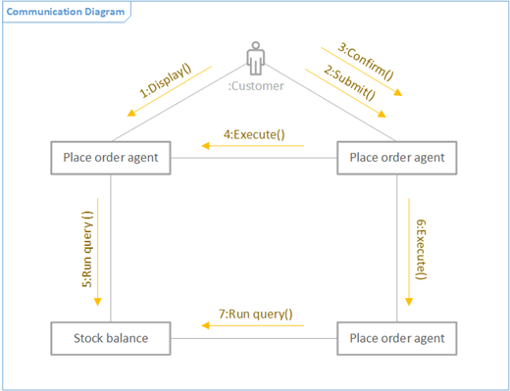
Up on the left hand side we can find a quick explanation and figure of what communication is.
In a business speaking we can clear see how the customer place the order and how effectively is getting trhough by the submission and the confirmation.
After this stage is starting the process of the stock balance and the process of the good or service required.

Integrated marketing communication is a simple concept, it ensures that all the communication and information are linked together, this when we are meaning the basic type of communication, other levels of integration we do have also an horizontal system, vertical , internal and external integration.
In our study case Converse is adopting a promotion strategy based in one simple fact, the aspect to be classic design and unique colours. This aspect it might be sound simple for a big company like Converse but on the reality this concept make every single customer special, and this is consider it as strength point because in that , the company is still using the same method over the year being always traditional and the same.
The brand has utilised several types of promotion including personal selling, public relations, sales promotion like example that made by Chuck Taylor, basketballer which has become the brand ambassador for Converse. Be sponsored by popular people can be a favorite point for the company, a part to be a huge promotion the common people try also to emulate people who consider it as a mentor, which Chuck Taylor can be one of those for many future baskeballers.
Another strategy adopted by the company is on the digital world, where Converse has decide to penetrate on platforms like Facebook or Twitter, to have it a wide range of target to achieve.
For sure, like mentioned above, the world is changing in many different aspect and the digital aspect is having huge impact in our lives and company like this with many competitors it must to provide a good service and platform on the digital aspect.

Conclusion and recommendations;
Converse is very old brand, and over the year has gained the respect and high place on the market, probably the classicism and the fact to be unique are the strength factors to the company. Over the years the Converse has gained also how to treat the new the economic situation which was always in a mutation over the time , keeping always on track to be singular brand. Thanks today many other sponsor or partnership which the company is affiliated, which permitted at Converse to have a wide target, a wide clients to achieve it and focus on the main core and values of the company.
Converse is adopting on my personal opinion a good strategy on keeping the trust by the customers. the excellent philosophy to remain unique over the years, but following the globalisation , it made a credibility to the clients, the target that the company are adopting giving personalization on something is another of my favorite idea and strategy. Be a part or feeling be part of something is something that I want to call as a winner point, which probably many others brands are adopting as a tactical strategy.
One of the negative point that I want to recognize to the company is the fact to be more powerful on the term of the digital marketing where in this, me personally, and by my research I didn’t see like a major point for the company.
So, Highlighting those factors I already mentioned my suggestions under the negative and positive aspects.
Personal opinion: at the begin I was in doubt on the choice of this company but being Honest at the end I found it a lot information and an interest on it.

References:
https://goodonyou.eco/how-ethical-is-converse/
http://marketing91.com/marketing-strategy-of-converse/
https://contentwriters.com/blog/converse-multi-generational-marketing/
http://marketing91.com/swot-analysis-converse/
http://slideshare.net/annavarghese1485/analysis-on-shoe-industry-based-on-porters-5-force
http://robertkatai.com/marketing-concept/
http://merriam-webster.com/dictionary/communication
http://tutor2u.net/business/reference/ansoffs-matrix

