

LEVEL 4

SEMESTER 2

MODULE CODE: SHSS4078
Adventure: A Risk worth Taking

aSSESSMENT TYPE: aSSIGNMENT
Assessment/Component: 1 (Part A)
COMPONENT WEIGHTING: 55 %
WORD COUNT: 2000 WORDS
MODULE TUTOR: Denise leonard

Assignment:

With reference to a critical incident case study that we have examined, identify one key contributing hazard. Evaluate your own personal logged experiences in different activities, of risk management in relation to this identified hazard.

You should include a logbook recording every activity session you complete during this module and a synopsis of the critical incident case study as appendices to this submission.

SUBMISSION DETAILS:

Deadline:
Date: 19th April 2019
Time: 3.00pm
Portal: Turnitin

School of Sport, Health & Outdoor Education

Assessment Feedback Sheet

Student No./Name: 1803017/ Erin Smith
Module: SHSS4078
Module Code: Adventure: A Risk Worth Taking

Personal Evaluation – to support your academic progress please complete the section below BEFORE submitting your work.
What do you consider to be the best aspects of this work? |  |  | I covered the facts of the case and understood what went wrong in the activity and how one hazard made such an advanced consequence.
Which aspects do you consider could have been improved in this piece of work? |  |  | Trying to make the essay flow a bit better and maybe not go off track with what I was trying to talk about
What have you found most satisfying whilst undertaking this submission? |  |  | Writing about the hazard and relating it back to the logbooks, it made me realise how much the lecturers do for us to keep us safe.
ASSESSMENT CRITERIA | Learning  Outcomes |  | GRADE
ASSESSMENT CRITERIA |  |  | Poor  0 – 25% | Unsatisfactory  26-39% |  | Satisfactory  40 – 49% | Good  50 – 59% | Very Good  60 – 69% | Excellent  70 – 85% |  | Exceptional  86– 100% | %
Complete logbook for each session | All |  |  |  |  |  |  |  |  |  |  | 15%
Provide a synopsis of a critical incident case study | All |  |  |  |  |  |  |  |  |  |  | 15%
Identify a specific significant hazard and the risk it poses to undertaking adventurous outdoor activities | 1,2,3,5 |  |  |  |  |  |  |  |  |  |  | 30%
Discuss a range of appropriate measures that might effectively control the identified hazard and consequent risks. | 1,2,3,5 |  |  |  |  |  |  |  |  |  |  | 30%
Appropriate references used and correctly formatted | All |  |  |  |  |  |  |  |  |  |  | 10%
It is expected that students will present work that is proof read, correctly referenced and adheres to the Assessment Checklist. Therefore a range of 0 – 10 marks will be deducted for non-completion of any of the points on the checklist below.
TUTOR COMMENTS:

Submission date:  via Turnitin |  | Return date:  (at least within 4 weeks) |  |  | Tutor: Denise Leonard |  |  |  |  | Mark:

Assignment Checklist

- Please complete the Personal Evaluation section of the Assessment Feedback sheet, add your name and details, and paste the whole of this assignment document into the front of your assignment

- Submission is a single word file, clearly labelled with your name and module code
- Font style - Times New Roman, size -12 for text and 14 for headings
- Ink colour – black only
- Line spacing – 1.5 line spacing and 2cm- 2.5cm page margins
- Quotations more than three lines to be indented 1 line spacing
- One line space between paragraphs, paragraphs must be left aligned
- Pagination (your assignment should have page numbers)
- All tables and figures are internally referenced and have a title
- Word count checked and written at end of text (before references and any appendix)
- Assignment is within 10% of the word limit (excluding references and any appendices)
- All references in the text are included in the reference list
- Correct referencing following the Harvard style, as described in the Palgrave study skills book ‘Cite them Right’.
- Correct spelling using UK English
- Correct use of punctuation
- Grammar and syntax correct- double check anything that has a green line under it
- I have read my assignment out loud to myself and it makes sense and is easy to read
- Somebody else has read my work and it makes sense to him or her!
- I have checked and I have not plagiarised
Failure to follow these guidelines will cost you marks!
Assignment 1a- Denise

Introduction:

In this assignment I will be focusing on one extreme hazard that can happen whilst being outdoors or whilst being an outdoor instructor, I will be talking about why this hazard is crucial in terms of preventing a disaster from happening, I will also be talking about experiences where that hazard helped my group say safe whilst being out on activities, and I will be talking about how the lectures put control measures in place to keep us safe.

One important thing to consider when being outdoors is knowing that there are a variety of hazards that you have to look into to prevent an incident from happening. The hazard I will be focusing on is lack of competency. Having the lack of ability to do something is very dangerous, a lot of people trust that you know what you are doing and that you can keep them safe. But if you cannot do this, there are consequences that might take place.

I will be focusing on the Glenridding incident, one reason why the Glenridding incident took place was because there was a lack of competency. Paul Ellis, was the lead, instructor at the time, he thought he knew everything he needed to do whilst taking a group of school kids plunge pooling, but in reality, he was more confident then competent and did not know fully what he was doing, which resulted into a disastrous event.

The background to this event is that Ellis ‘who took 11 children and 4 adults’ (App.croneri.co.uk, 2019) plunge pooling, thought it was safe for them jump ‘into 8 degrees Celsius water,’ (Mail Online, 2019) with limited safety equipment, comprising of just shorts, t-shirts and trainers. Ellis clearly has no idea about how cold the water was or the effects of cold- water shock or hypothermia. Ellis did not give the group of young children any wetsuits, buoyancy aids or helmets. These are the most common personal protective equipment (PPE) you should take with you when going out on activities such as this.

Ellis’ lack of competency when making the decision to let children jump into water with just shorts and t-shirts made the whole experience at Glenridding a disaster. When one of the students, Max, jumped into the water and panicked, because of how cold the water was, Ellis made the decision to jump in without thinking of what might happen to him, he also left the rest of the group unattended. Ellis became overwhelmed with the cold, just like Max, because he also didn’t have the correct PPE on, Ellis let go of Max and left him in the water as he, himself, was struggling to swim, Ellis was not, therefore, competent enough to know how to rescue a victim in the water, ‘leaders of these activities need to be competent and diligent and should always put the safety and best interests of the pupils first’ (App.croneri.co.uk, 2019) however Ellis failed to do so. Max’s mother, Mrs Palmer, did everything she could to help her little boy, so jumped in, she also got cold and the situation got much worse, she became disorientated and although initially had hold of Max, she let go and Max was pulled away from her by the current. Unfortunately, Max died as a result of this situation, he was 10-years old. Ellis should not, in any instance, have let anyone else jump into the water, because they would also be at risk of being in danger. Ellis was not competent enough to manage the group and stop the situation getting worse. He ‘failed to provide adequate care for the rest of the pupils.’ (Mail Online, 2019) if he had a throwline, he could have probably been able to save Max, but he didn’t, as he had left this in the mini-bus, Ellis therefore did not even have the competency to check what equipment he had with him when taking the children to do plunge pooling.

Within my session 1, paddling sport logbook, our lecturers made sure we had the right equipment and that it is in good condition when going out on activities. They give us wetsuits, sometimes they even advise us to wear 2 wetsuits, so we can keep warm in the cold water. They give us buoyancy aids so we can stay afloat whilst being in the water, buoyancy aids are also good as an extra layer to keep us warm, the lecturers also give us helmets for protecting our head by any objects that are in the way. They make sure we have a throwline and belt and also, a river knife if we ever need to cut ourselves free. The instructors also regularly check the equipment and were shown at the start of the course how to apply the PPE correctly, it is then our responsibility to ensure the equipment is safe to use and in good working order, reporting any defects if we see them. These are all control measures that are put in place to keep us as safe as possible. The lecturers are, therefore, competent enough to make the right choices and keep us safe because they have had experience and know what to expect when being outdoors and are competent to predict if an activity is safe to do.

I believe that you have to trust someone right at the beginning, if you feel you cannot trust an instructor when they are doing a simple task, what makes you think you can trust them when they take you out on a activity that provides a lot of skill? If Ellis didn’t have the ability or the competence to give the children PPE, then he’s not competent enough to take a group of children out on an activity. Another time Ellis lacked competency was when he made ‘serious errors of judgement in planning and leading the activity.’ (Hse.gov.uk, 2019) Ellis gave 11 children and 4 adults the opportunity to jump into a pool of fast flowing water. However, what he failed to understand was, there was heavy rainfall for several days, it does not matter how nice the weather is the next day, the water levels will naturally be higher and more vigorous.

Maybe there was some scarcity involved and Ellis felt that he had no other choice but to take the kids plunge pooling, or maybe his ego got the better of him and thought he had the ability to keep the children safe in dangerous water conditions, I feel his confidence in his abilities overruled his competency levels, for this Ellis made a big mistake, he had no idea where the escape routes were, he did not know the area well, he didn’t have the capability to think ahead and come up with a plan B. He should have looked at the water and dynamically risk assessed whether it is safe enough to go in, but he did not have experience in plunge pooling meaning he did not know if the flow of water was safe or not.

As mentioned in my paddle sport session 2 logbook, we were unable to go kayaking in the river because of the high-water levels, we as a group dynamically risk assessed the water and correctly decided that the water wasn’t safe enough to go in. instructor A and B asked us if we felt it was safe enough to go in and why/why not we should/shouldn’t take that risk, this was a great way to make us be aware of our surroundings. Luckily instructor A and B had the competency to have a plan B ready for us if we needed. Because they have been to Llandysul many times and know that there is a lake we can use as a backup. Ellis, on the other hand has only been to Glenridding once and thought the experience he had before would be the same, but as competent people know, ‘you cannot step into the same river twice.’ (Goodreads.com, 2019) You as an instructor have to always be prepared with what to expect, you have to assess the situation fully, understand the water levels, PPE equipment and make the judgment that the activity will be safe, if Ellis was in any doubt he should be pre-prepared a plan B.

When we as a group do activities the lecturers always dynamically risk assess as we go, they have experience, they know what they are doing. As mentioned in my rock climbing log book we went to 3 cliffs at the Gower to do climbing by the coast and did a dynamic risk assessment, we checked how far away the tide was and then checked it again a couple of hours later to see how much it had come in, so we could calculate how long we can spend on the beach before we got stranded, we also looked at tide times before we left to see what time the tide will be going in and out. We also looked for exit routes if we ever needed to get out. The lecturers and students were always checking for hazards and doing control measures that needed to be put in place to keep safe.

Ellis should have constantly dynamically risk assessed, he should have looked at the conditions of the water and if they ever changed, he should have seen whether the students where comfortable, warm enough and see if their energy levels had changed. All these things can be hazardous, and it is important to notice these things as a competent instructor. If Ellis dynamically risk assessed these hazards, he could have been able to make the decision to stop or not, because it is never too late to back out of a situation, especially if you feel it is too dangerous to carry on. Our lecturers are always changing and adapting to our abilities, if they feel we aren’t ready to do something or if they feel we will be at risk, they are not afraid to stop an activity if they feel it’s not safe, because they can competently think about what is best for us and will try something else. Another time where the lecturers competently dynamically risk assessed was when we went mountain biking. As mentioned in my mountain biking logbook instructor A and B where constantly dynamically risk assessing the area and how everyone’s energy levels were. Instructor B also taught us that dynamic risk assessment is King and should always be at the forefront of your mind because it is the most important out of the three and without it can cause serious consequences.

Conclusion:
In writing this assignment, overall, I feel Paul Ellis made a massive mistake of making the decision of taking the children plunged pooling, there were warning signs that should have been noticed right from the start, he should have been better prepared, he should have risk assessed the activity in advance of it taking place. He obviously felt confident in his abilities, but confidence does not make up for competence levels of outdoor activity instructors. It is good to have confidence, but it is also very important that your skills base is at a competent level. When taking an activity you are responsible for the health, safety and welfare of those students and it should be expected that those instructors have a competency level, in the case of Paul Ellis a child lost their life, not something any instructor would wish to have on their conscience.

There were too many “lemons” lined up, if one “lemon” is not in the right place at the right time this has a knock-on event, which unfortunately caused a disastrous event. There are a lot of ‘what ifs’ that come to mind when an incident happens, what if he admitted right from the start that he wasn’t competent enough? What if the children wore the correct equipment? What if they didn’t even go to Glenridding in the first place? Maybe this tragic accident would have never happened. Personally, I feel risk assessments are very important in the outdoors and the lectures do a great job at keeping us safe and notice the hazards when needed. I can confidently say that all the lectures are competent enough to take a group of people on an activity.

Word Count: 2,052

Reference List
App.croneri.co.uk. (2019). Glenridding School Trip Tragedy [2002] HSE | Croner-i. [online] Available at: https://app.croneri.co.uk/law-and-guidance/case-reports/glenridding-school-trip-tragedy-2002-hse [Accessed 18 Apr. 2019].

Goodreads.com. (2019). A quote by Heraclitus. [online] Available at: https://www.goodreads.com/quotes/117526-no-man-ever-steps-in-the-same-river-twice-for [Accessed 18 Apr. 2019].

Hse.gov.uk. (2019). Investigation - Glenridding Beck - AALA. [online] Available at: http://www.hse.gov.uk/aala/glenridding-beck-investigation.htm [Accessed 6 Apr. 2019].

Mail Online. (2019). Teacher jailed over death of pupil. [online] Available at: https://www.dailymail.co.uk/news/article-197221/Teacher-jailed-death-pupil.html [Accessed 6 Apr. 2019].

Logbook- hill walking

Hazards | Control measures | Further actions
Trips/slips. | Qualified instructor, with good knowledge to the area. | Clear brief to staff regarding roles and responsibilities.
The weather. | Ensure appropriate clothing, food, drink and equipment. | Monitor students and staff for sign of hypothermia.
Getting lost. | Accompanied by staff.  Appropriate training given.  Emergency equipment. | Don’t let students go off on their own if they aren’t confident in the routes.
Foot injuries, ankle sprain and blisters. | Appropriate footwear.  Carry a first aid kit.  Call emergency services. | Review accidents on a regular basis.
Getting separated. | Supervision, briefing and personal survival equipment. | Staff observe group.  Brief group on what to do if they get separated.
Getting dark. | Choose a route with enough time in daylight to allow for delays.  Carry torches. | Ensure you have survival equipment.
Rocks falling. | Selections of appropriate venue.  Wear helmets. | Keep group away from areas that could cause potential falls.
Instructor injured. | Always have a second instructor. | Emphasise the name of location.  Actions to undertake in the event of instructor injury.

Site specific risk assessment
- Fog/ lack of visibility
- Cliffs, might fall especially if the visibility was poor
- Marsh/ bogs, could get trapped
- Rain/ mist, get cold and wet, which could lead to hypothermia
- Wind, you might get wind chill
- Chucking stones, could be someone or something below the cliff
- Disused mine, could collapse at any minute
- Lack of equipment/food/water/ clothing could be life threatening

Relevant NGBs
Mountain leader award
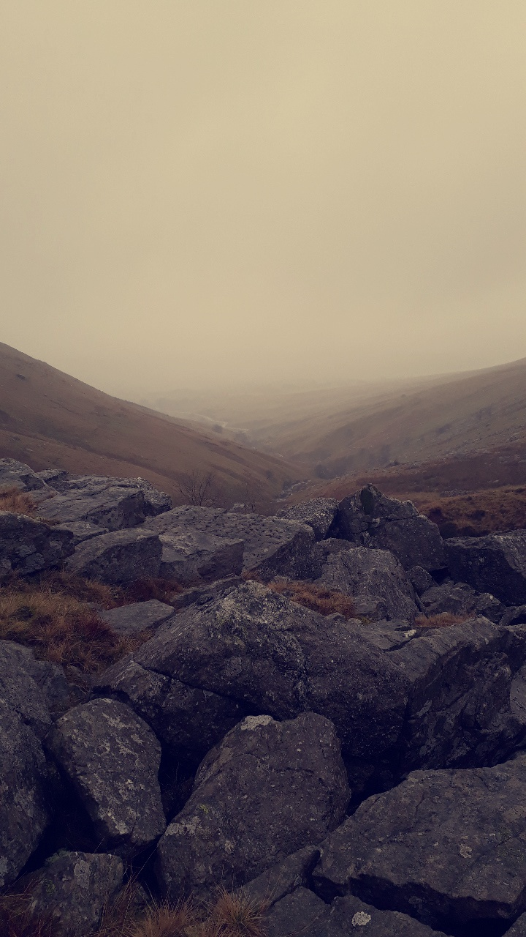
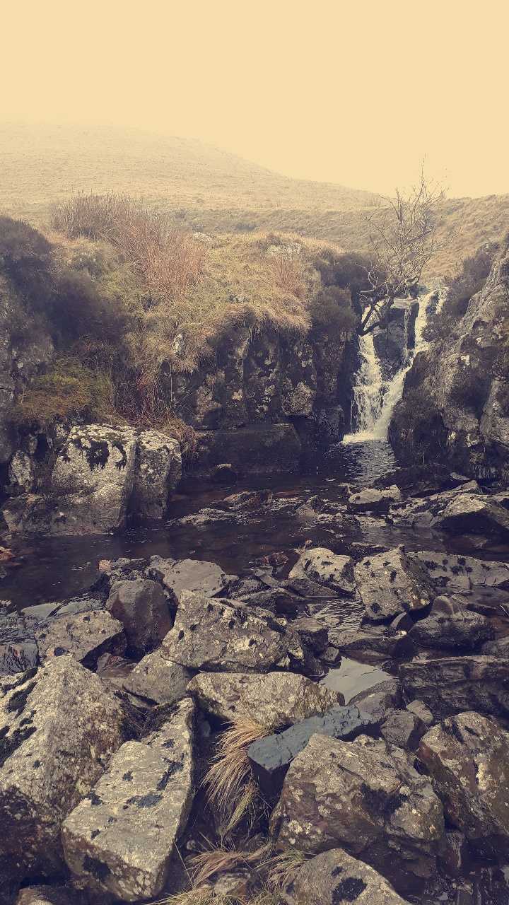
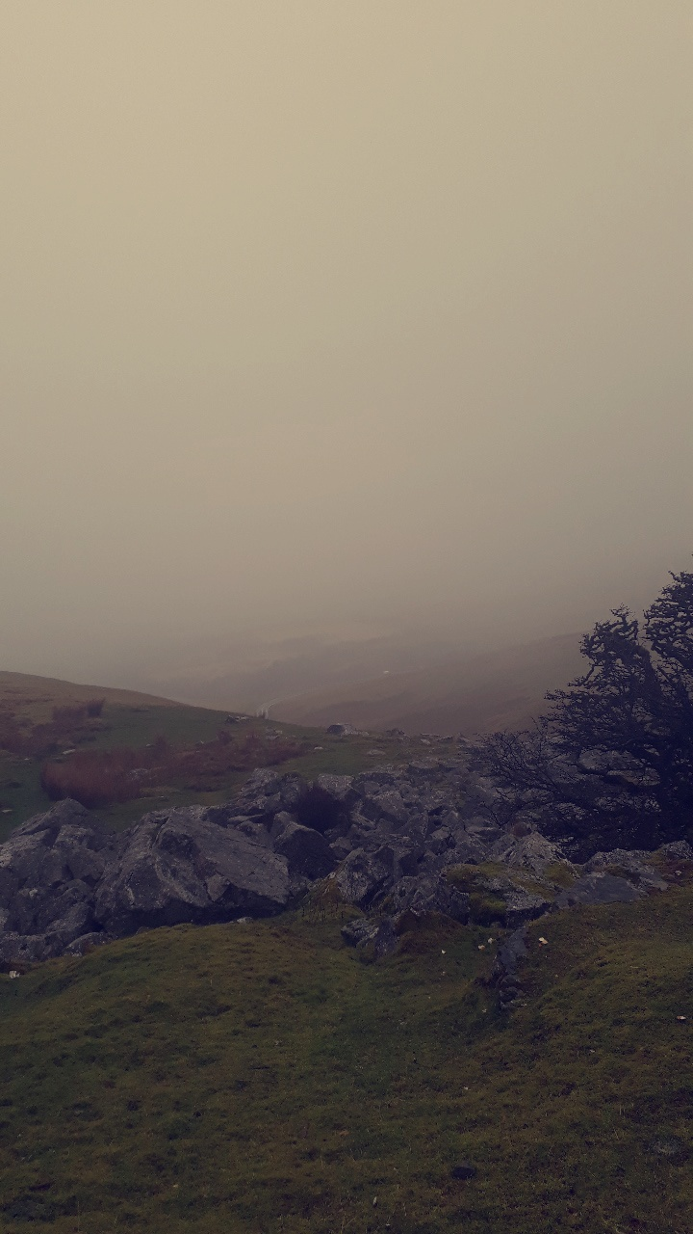
Destination: Black Mountain- Herberts Quarry to Llyn Y Fan Fach

Weather: cloudy, 6 degrees feels like 1 degree, gentle breeze from the southwest. When we reached the mountain, it did start to rain but this might have been from the clouds because it was slightly foggy while we were up there.
Number of people: 10 people
One thing I learnt today: contour lines- these are lines which join up points of equal heights on land. They are usually 10 metres apart. They are orange in colour. If the land is steep contour lines are close together, if the land is flat, they are far apart.

Naismith’s rule- helps with the planning of a walking expedition by calculating how long it will take to travel the intended route, including any extra time taken when walking uphill.
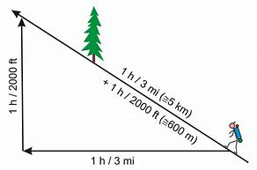
We did test this out by walking from one car park to another, if we walked 500m at 2 metres per second it should take about 10 minutes, I timed from when we started to when we finished, and it took us just over 9 minutes. This time could vary for certain people we all have different walking speeds.

Key words
1. Cold Front- The forward edge of an advancing mass of cold air that pushes under a mass of warm air. Cold fronts often cause precipitation; water vapor in the rising warm air condenses and forms clouds, often resulting in heavy rain, thunderstorms, hail, or snow.
2. Temperature Inversion- a reversal of the normal behaviour of temperature in the troposphere, in which a layer of cool air at the surface is overlain by a layer of warmer air
3. Lowland Leader- The Lowland Leader is a nationally accredited award scheme from Mountain Training, designed to train and assess those who want to gain a qualification to lead groups on day-walks in lowland countryside, woodland and coastal areas in summer conditions
4. Ordnance Survey- an official survey organization, originally under the Master of the Ordnance, preparing large-scale detailed maps of the whole country.
5. Contour Line- line on a map joining points of equal height above or below sea level.
6. Ring Contour-
7. Trig Point- These are concrete pillars, about 4' tall, which were used by the Ordnance Survey in order to determine the exact shape of the country. They are generally located on the highest bit of ground in the area, so that there is a direct line of sight from one to the next.
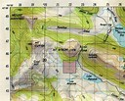
8. Naismiths rule- (see above)
9. Grid Lines-

10. Moel (Welsh)- Moel Famau is the highest hill within the Clwydian Range,
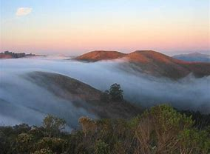
11. Hill Fog-

12. Freezing Level- The lowest level in the atmosphere at which the ambient temperature is 0°C.
13. Aspect of slope- Using slope aspect can be a very useful tool to help you relocate. In its simplest form just use the points of the compass - north, east, south and west - to work out which direction the slope you are on is facing and then look at the map to find the slope which faces this way.
14. Mountain Rescue- Mountain rescue refers to search and rescue activities that occur in a mountainous environment,
15. Wind Chill- is the lowering of body temperature due to the passing-flow of lower-temperature air.

Summary of the day
We went hill walking on the Black Mountain in the Brecon Beacons, when we got to the top it was very foggy, this was something that didn’t show up on the weather forecast what I got from the met office, I thought I was prepared and had the right clothing but when we finished hill walking I soaked through 3 layers, but the plus side was, I was really warm and that is very important because you are less prone to hyperthermia and this can be life threatening on a mountain. We had a map which was really important for getting to point A to B, we got it from Digimap and really focused in on the area we are going, it was in good detail and quite easy to find where the lectures wanted us to get to. As I walked, I learnt the natural elements the black mountain has and the surroundings of the mountain. The conditions on a mountain vary and you don’t know what to expect so you have to be prepared for it. My energy levels and positivity were still quite high whilst being on the mountain, others not so much, they were cold hungry and tired and just wanted to get back on the mini bus.

Mountain Biking

Hazard | Risk | Control Measure
Fall from mountain bike | Cuts/ bruises, head injury, broken bones. | Wear helmets  Instruction on how to use brakes and gears  Leave adequate space between riders.
Coming into contact with other people or animals | Cuts, bruises, broken bones | Pre-ride instruction on identifying hazards and when to slow down in proximity to other forest users.
Injury due to bike malfunction | Cuts, broken bones, entrapment | pre-ride bike check and maintenance between activity sessions
Injury due to loss of control whilst riding | Hitting your head, cuts | Pre-ride instruction on riding under control with emphasis on controlling speed and braking
Participants becoming detached from the group | Fear, getting dark | Re-group at junctions and other points. Leader at rear of group.
Strains and injuries during and after | injury | Recognise coaching methods used.  Adequate warm and cool down.  Wear suitable clothing and footwear.
Weather conditions | Dehydration  Heatstroke  Sunburn  Hypothermia | Regular breaks and access to drinking water.  Assess weather conditions with respect to the safety of the activity under adverse conditions.
Unacceptable behaviour from participants and spectators | Injury | Brief each participant about the hazards of activity.  Make participants aware that unacceptable behaviour will not be tolerated.

Site specific risk assessment
- Car park- get run over
- Other bikers- collision
- Cliffs with big drops- fall and injure yourself
- Tree branches on the track- injury
- Hail- get in your eyes and not know where you are going, also gets quite slippery on the ground
Relevant NGBs

The national governing body for mountain biking is British Cycling

Key Terms-

1. NRW- national resources wales
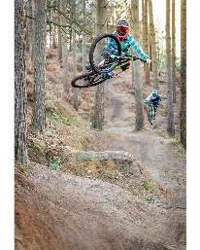
2. Table Top- Tabletop is one of the fundamental BMX tricks. Bring the bike up to one your sides to make it look flat.

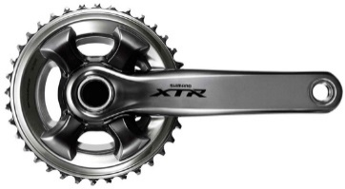
3. Crank-

4. Attack Position-
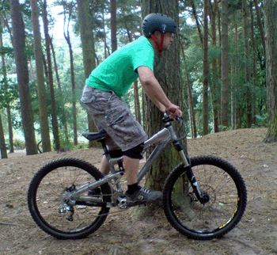
5. Drop Off- where you place all of your body weight to the back of the bike like there is a pole in the way and you have to crouch down to go under it.
6. Brechfa Forest- one of the forests where we go mountain biking
7. Ash Die Back- a serious fungal disease of the European ash, characterized by the progressive death of the tree's branches.
8. Rose Bay Willow Herb- A native perennial weed which spreads by seed and rhizomes and is unsuitable in a small garden. It is found growing on waste land, scrub, rocks, woodland and also gardens where it can become a serious weed.
9. Fire Track- is a gap between the trees so if a forest fire does start it wouldn’t spread across the whole forest because the fire track should prevent that.
10. Grade- there are different levels at which you can mountain bike at there is a green trail which is easy, blue for moderate, red for difficult and black for severe.
11. Berm- is a corner that has a banked outer edge that runs the entire length of the corner. ... Ride into the berm rather than cutting across it.
12. BMBLA- British mountain bike leader award
13. MIAS- Mountain bike instructors award scheme
14. PMBI- Professional mountain bike instructors award
15. Cycling UK- Cycling UK is a brand name of the Cyclists' Touring Club, which is a charitable membership organisation supporting cyclists and promoting bicycle use.

Destination: Brechfa Forest
Weather: light rain showers, there was also some hail when we were there, temperature- 7 degrees feels like 4 degrees, Wind- 23km/h WNW Gust- 27km/h
Number of people: 2
One thing I learnt today: how to ride on a berm correctly.
When riding a berm you have to start off high, look at where you want to go, not at the floor and then you will naturally start going downwards, if you start off low you will be at risk of riding off the edge.
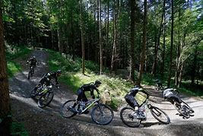
Summary of the day
Firstly, we went into the classroom and did a timeline of the beginning of the day right to when we ride down the bike trail. There was a lot to think about and a lot to consider when planning on going on a bike ride in order to make the day as safe as possible. We then checked our bikes by doing an ‘M’ check. Then did a little warm up in the car park, instructor A taught us well, he showed us how to do a task then made us copy, he gave us feedback everytime, so we knew what we needed to work on. The warm-up was a lot of fun. We then went on the bike track and practiced the ‘monkey’ technique, angry monkey when going up a ramp, happy monkey when going down a ramp. We then got taught how to ride around a berm that was a lot of fun. Instructor A taught us to look where you want to go not at the floor when riding a berm. This was a really good technique and worked well.
When we got to Brechfa we had a ride around different terrain and had a go at testing the gears. We also learnt how to stay on the bike without moving or putting our foot on the floor, that was a lot and took a lot of concentration.
We then went on our journey instructor A and B told us beforehand where they wanted us to meet them each time. They knew exactly where each meeting point, they wanted to stop at because they had been to Brechfa Forest many times before. Throughout the journey we dynamically risk assess the area, at one point there was a site specific hazard, where there were a group of people that had stopped in the middle of the bike track where we were planning of riding down at the end of the day, so instructor A asked if they were okay just in case he had to change his plan and make us go down a different bike track. Instructor B taught us the dynamic risk assessments are king and should be at the forefront of your mind, because that’s the main one that holds the most likely hazards. Instructor A also constantly made us away that as soon as we ride down the bike track, it is your responsibility to notice the hazards and dynamically risk assess as you go because they will not be with you the whole time to keep an eye on you.

Logbook- Paddle sports Session 1

Hazard | Risk | Control Measures
Pollution | Get infections/ diseases | Avoid known polluted areas.
Paddles | Head injuries | Wear helmets
Awkward capsize or capsize recovery | Shoulder injuries/ cuts and scrapes/ entrapment in boat | Correct capsize technique taught. Close proximity of instructor to clients.
Cold water/ weather | Hypothermia | Appropriate clothing worn. Carry spare clothes, hot drink plus a group shelter. Monitor group/weather conditions.
Wind | Drifting beyond ability to return to group | Instructor carries a towline.
Kayaking for a long period of time | Repetitive strain injuries, blisters | Teaching of good paddling technique. Tape or gloves carried to treat blisters.
Water | Drowning | Capsize drill on dry land at start of session with beginners. People fitted into boats properly. Good group management. Buoyancy aids worn at all times.
Loading/unloading kayaks | Various injuries | Encourage use of safe lifting techniques.
Collision with other boats and water users | Collision and injury | Brief group about hazards. Awareness of other water users.
Rescues | Long term back injury | Use good technique when emptying boats full of water.
Sun | Sunburn | Suncream, glasses hats and shade.

Site specific risk assessment
Car park- people could get run over
Water- people could drown
Grass and mud- you could slip
Carrying the boats- injury/ strains
Slips/trip/falls
Paddles- hit your head with one
Colliding with people in the water- causes a variety of injuries.

Relevant NGBs
The national governing body for kayaking and sit on top kayaking and canoeing is British Canoeing.
The national governing body for stand-up paddle boarding is BSUPA- British Stand Up Paddle Boarding Association.

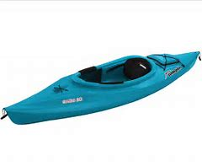
Key Words
1. Kayak-

2. Silurian Mudstone- it is a type of fossil found at llandysul
3. Eddy- are pieces of slack or slower moving water caused by an introduction from the main flow.
4. Edge- edging or "taking hull out of the water" on one side of a kayak; induces a turning movement for a kayak.
5. Breaking in and out- break in is moving out of an eddy into a fast flow of water and a break out is moving out of the fast flow into an eddy.
6. CLAP- communication, line of sight, avoidance and position.
7. Afon Teifi- what the river is called at llandysul.
8. Grade-
9. Flow rate- the speed or rapidness of a fluid that flows through a channel or a vessel. This rate is a means of measuring the speed or velocity of liquid that is meant to flow from a particular channel, pipe or a vessel.
10. Slalom- Canoe slalom is a competitive sport with the aim to navigate a decked canoe or kayak through a course of hanging downstream or upstream gates on river rapids in the fastest time possible.
11. Catchment area- The area drained by a river or body of water. Also called catchment basin.
12. Sewin- another name for a sea trout
13. Salmon- a type of fish
14. Japanese Knotweed- a tall fast-growing Japanese plant of the dock family, with bamboo-like stems and small white flowers. It has been grown as an ornamental but tends to become an aggressive weed.
15. Appropriate Footwear- important when kayaking especially when you have to walk into the water, I never know what is below your feet.
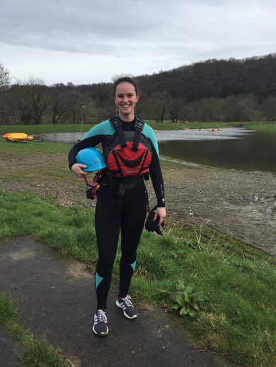
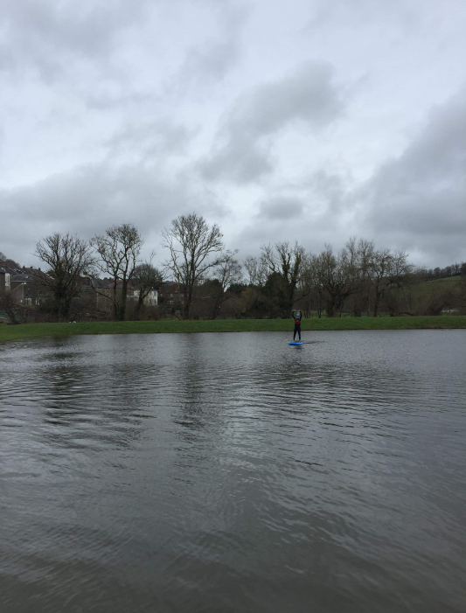
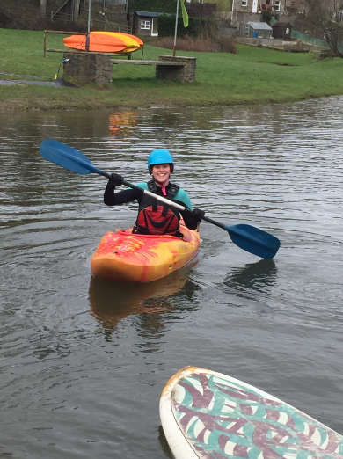
Destination: llandysul

Weather: rain and cloud, 5 degrees feels like 1, SSW winds 10mph with 21mph gusts of wind.
Number of people: 11 but 3 people did take part because of personal reasons
One thing I learnt today: There are two footrest bolts at the side of a capsized kayak to know where the front of the kayak is, making it easier for the person that fell out of the boat to get back in.
How to empty a kayak full of water, whilst still being in the water
Step 1: Have the kayak assisting paddle to your location so that their kayak’s bow is perpendicular to your kayak’s bow.
Step 2: Slide your kayak on top of the kayak assisting enough so that the cockpit comes out of the water.
Step 3: Flip the kayak away from the kayaker assisting.

summary of the day
Today we were on the lake using sit on top kayaks, stand up paddle boards and kayaks. Before we left, instructor A reminded us to get the correct personal protective equipment (PPE) which involved, a buoyancy aid, helmet, wetsuit, cag and spray deck. I made sure I ate a little something before we started to get my energy levels up. Firstly, we had a look at the different boats and the hazards that are on the boats. As a group we went through the potential hazards that are on the boats and basically dynamically risked assessed. For paddle boarding- entanglement, rubber burns, how you carry it. Sit on top kayak- hitting it, its heavy, which means it stretches exploration in competence, easy to do rescues on and hard edges meaning weight can cause damage. for Kayaks- entrapment and collision and for Sea kayaks- tangled in rope. Finally, for canoes- trip over seats, heavy and hard to roll and entrapment on the middle piece. We then went and got boat of our choice and made sure we were comfortable enough in it. I felt my kayak tipped way too much that when I moved a little bit I was at risk of capsizing and that kind of made me lose my confidence a bit. Instructor A and B were very helpful and told me ways to stop the tilting from happening so much. Instructor A did a guided discovery teaching style by telling us to paddle around the lake and have a feel of paddling in a kayaking and how good you feel your technique is. Being in a kayak was a lot of fun, one thing that I would do in the future is use a spray deck because I feel that would make a lot of difference. Because at some point throughout the day I had to get out of the water and drain the kayak, this was time consuming and something that could have been easily avoided. Instructor A showed us how to use a towline, there were a variety of ways you can towline someone, so instructor A allowed us to have a go ourselves with towing another boat. Personally, I preferred the one where you tie it to the front of the boat and have it on your belt rather than tying it to the front of the boat and having the rope wrapped around your shoulder. I had a go on the stand-up paddle board, that was a lot of fun you can do a lot of tricks on that and be able to challenge yourself. Then at the very end instructor A showed the group how to empty a capsized kayak and how to get the casualty out of the water an in the kayak.

Paddling- session 2

Hazard | Risk | Control Measures
Pollution | Get infections/ diseases | Avoid known polluted areas.
Paddles | Head injuries | Wear helmets
Awkward capsize or capsize recovery | Shoulder injuries/ cuts and scrapes/ entrapment in boat | Correct capsize technique taught. Close proximity of instructor to clients.
Cold water/ weather | Hypothermia | Appropriate clothing worn. Carry spare clothes, hot drink plus a group shelter. Monitor group/weather conditions.
Wind | Drifting beyond ability to return to group | Instructor carries a towline.
Kayaking for a long period of time | Repetitive strain injuries, blisters | Teaching of good paddling technique. Tape or gloves carried to treat blisters.
Fast flowing water. | Drowning | Capsize drill on dry land at start of session with beginners. People fitted into boats properly. Good group management. Buoyancy aids worn at all times. Have someone with a throwline.
Loading/unloading kayaks | Various injuries | Encourage use of safe lifting techniques.
Collision with other boats and water users | Collision and injury | Brief group about hazards. Awareness of other water users.
Rescues | Long term back injury | Use good technique when emptying boats full of water.
Sun | Sunburn | Suncream, glasses hats and shade.
Trees/ branches in water | Collisions  Cuts and bruises  Broken bones | Avoid them.  Be 100% certain that you want to go into water with loads of debris floating around.
Upstream or downstream gates. | Collision  Hit your head | Try to push them out the way making sure you are aware of where your moving them out the way.

Site specific risk assessment
- High water levels- drowning
- Debris/ trees/ large rocks in the water- collision and entrapment
- Slalom poles- hit your head
- Carrying the raft boat for long periods of time- injury/ muscle strain
- Car park- you may get hit by a car

Relevant NGBs
National governing body for kayaking is British canoeing.
National governing body for white water rafting is also British canoeing.

Key Words
1. Kayak-

2. Silurian Mudstone- it is a type of fossil found at llandysul
3. Eddy- are pieces of slack or slower moving water caused by an introduction from the main flow.
4. Edge- edging or "taking hull out of the water" on one side of a kayak; induces a turning movement for a kayak.
5. Breaking in and out- break in is moving out of an eddy into a fast flow of water and a break out is moving out of the fast flow into an eddy.
6. CLAP- communication, line of sight, avoidance and position.
7. Afon Teifi- what the river is called at llandysul.
8. Grade-
9. Flow rate- the speed or rapidness of a fluid that flows through a channel or a vessel. This rate is a means of measuring the speed or velocity of liquid that is meant to flow from a particular channel, pipe or a vessel.
10. Slalom- Canoe slalom is a competitive sport with the aim to navigate a decked canoe or kayak through a course of hanging downstream or upstream gates on river rapids in the fastest time possible.
11. Catchment area- The area drained by a river or body of water. Also called catchment basin.
12. Sewin- another name for a sea trout
13. Salmon- a type of fish
14. Japanese Knotweed- a tall fast-growing Japanese plant of the dock family, with bamboo-like stems and small white flowers. It has been grown as an ornamental but tends to become an aggressive weed.
15. Appropriate Footwear- important when kayaking especially when you have to walk into the water, I never know what is below your feet.

Destination- llandysul
Weather- 95% rain, temp 5 degrees feels like 1, wind/wind speed- 11mph west, wind gust 22mph.
Number of people- 6
One thing I learnt today- there are 15 points of connectivity on a kayak.

Summary of the day
As a group we were supposed to develop our skills further by going on the river in our kayaks but when we got to llandysul, instructor A and B wanted us to dynamically and site specifically risk assess whether or not we should go into the water, straight away I could see the water was dangerous to go into because the water was fast flowing, white and brown, these are signs to say that it’s not safe enough to do kayaking in the river. Although we didn’t kayak on the river, we did use the lake to develop our skills. Instructor A and B had the competency to come up with a plan B, so us as a group didn’t miss out. I really enjoyed being on the lake I learnt so much gained more confidence being on the water in a kayak. This time I decided to use a different kayak because I felt the one before made me tip too much, I also brought a spray deck with me, it was much better and didn’t have to keep going to shore to empty my kayak. In today’s session we got taught how to turn whilst being still and how to move a kayak sideways, we also had the challenge to try getting through slalom poles without touching them this was a lot of fun, but you needed a lot of concentration. We also had a race in the water where we had to chase instructor A or B. Although we didn’t go into the water with our kayak’s, instructor A did give us the opportunity to go down the river in a raft boat, but before we did he made sure we knew what we needed to do before going down, it was a lot of fun and I’m glad he taught us first and didn’t just put us straight into the deep end, it showed that we could trust him and that he is competent enough to keep us as safe as possible. It was time to go down the river, I was very excited but also quite nervous. When we were on the water the only thing, I focused on was instructor A’s voice and the instructions he was giving us. instructor A made sure he was autocratically leading the group to make sure we were kept safe. He was very skilled and controlled the boat perfectly I put all my trust into him, and he did not let the group down. As we were going down the river instructor B was on the side the throwline ready to safe someone if they did fall off the boat. This was very good because he risk assessed the area and thought that this spot was the most dangerous. When we got out of the water, we then had to carry the raft back. Instructor A made sure the group took in turns carrying the raft, so we didn’t get tired or get any injuries.

Logbook- Rock Climbing
Hazard | Risk | Control Measures
Faulty equipment. | Come loose.  Not safe.  You could fall.  Anything could happen. | All equipment should be checked and cleaned regularly, if it doesn’t meet the standards it should be moved to quarantine.
Equipment system failure. | Rope falls.  You might fall.  Hurt yourself and others. | Everything is checked before use by a competent member of staff.
Ill fitting equipment. | Fall out of harness.  Helmet falls off when you need it to save you. | Check and see if you think the equipment is on correctly, if you’re not sure ask someone else to check for you or ask your lecturer.
Falling from a height. | Cuts/ bruises bad injury.  Hurting yourself and others. | Lecturer goes through the dangers of the area, or just observe the area yourself.  Instructor should supervise the belayer, especially when lowering the climber.
Blow to the head. | Unconscious  Deep cuts  Forgetfulness/ clumsiness | Don’t throw stones/ rocks, stay away from the bottom of the climb when you’re not participating.  Always wear a helmet.
Entanglement in ropes. | Get trapped.  Rope burn.  Pull hair out. | Tie back long hair.  Remove loose clothing, toggles and jewellery.
Panic attack/refusal | Put themselves and others in danger.  More prone to make mistakes. | Should select a suitable venue for the group.  Instructor carries out appropriate rescues if required.
Hyperthermia/ hypothermia | Affects your ability to think properly.  Clumsiness/ fatigue. | Ensure hat the group is appropriately prepared for the activity and conditions.

Site Specific Risk Assessment
- Escape routes
- Tide coming in
- Beach is hidden away from a busy location
- Uneven rocks
- High winds- causes you to get cold or knocked off your feet
- Check weather forecast
- No toilets at the site
- Getting off the mini bus on a main road
- Don’t leave valuables on the bus
- Walking to and from the beach

Relevant NGBs
National Governing Bodies needed for rock climbing is the BMC (British Mountaineering Council) and MLTUK (Mountain Leader Training UK)

Key Terms
- UIAA- international climbing and mountaineering federation
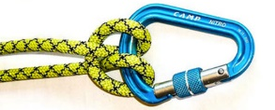
- Half Hitch-
- Belay- The simplest belay is a climbing rope that runs from a belayer, the person holding the rope securely, to another person who climbs a rock face. The belayer either gives out or takes in rope, keeping it snug on the climber.
- Lock-off- the act of pulling on a hold until your arm is in a bent position, then holding that position using body tension in order to reach the next hold with your free hand.
- ‘Static’ Rigging Rope- A static rope is a rope that is not designed to stretch when placed under load, in contrast to a dynamic rope. Static ropes have a wide variety of uses.
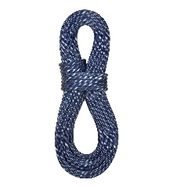
- Dynamic single rope-
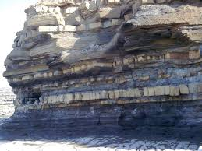
- Jurassic limestone-
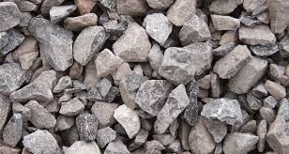
- Carboniferous limestone-
- Tidal range- Tidal range is the height difference between high tide and low tide. Tides are the rise and fall of sea levels caused by gravitational forces exerted by the Moon and Sun and the rotation of Earth.
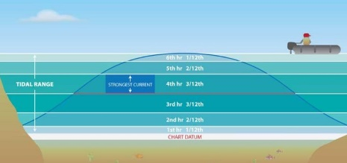
- Rule of the 12^{th-}
- Three cliffs bay- the destination at which we went climbing its called three cliffs because there are three cliffs next to each other in a row.
- Barnacle- a marine crustacean with an external shell, which attaches itself permanently to a surface and feeds by filtering particles from the water using its modified feathery legs.
- Samphire- grown in the tidal zone, on muddy, sandy flats, often around estuaries and tidal creeks.

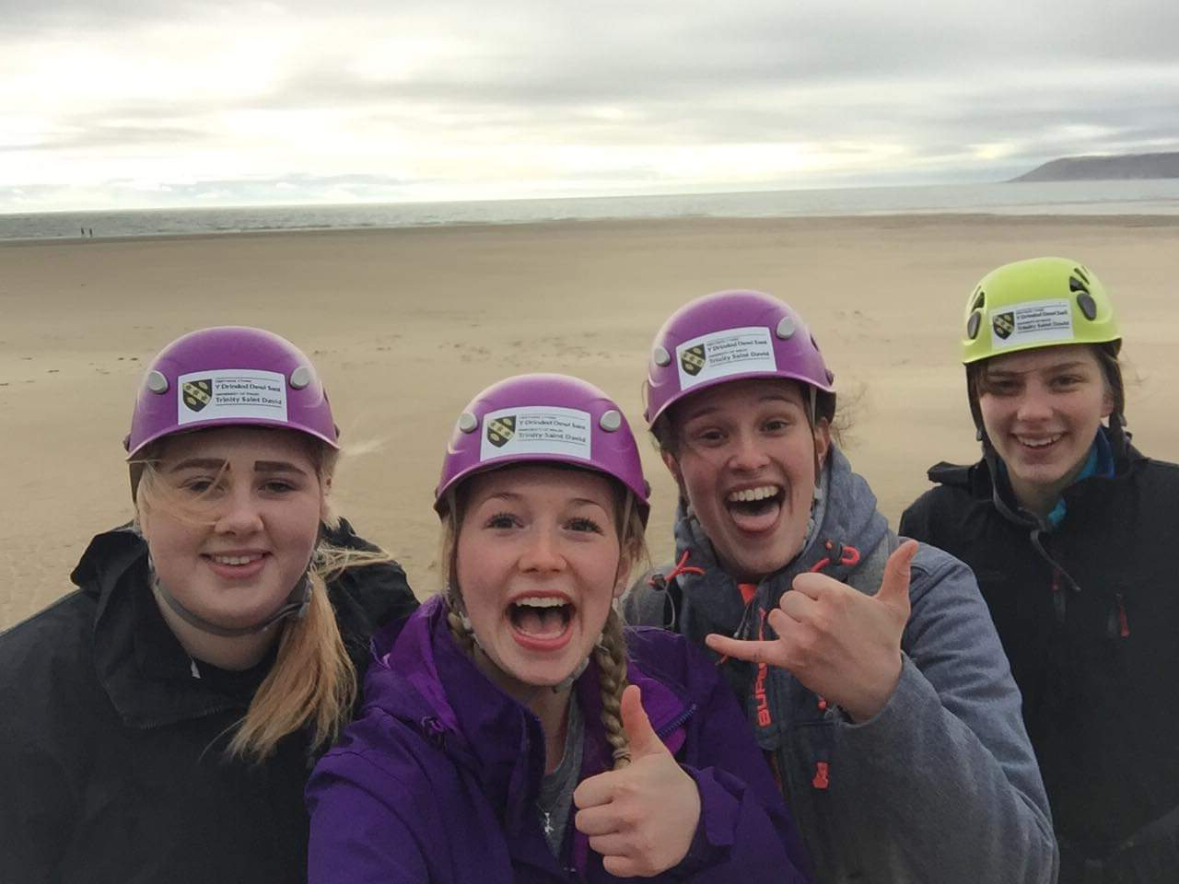
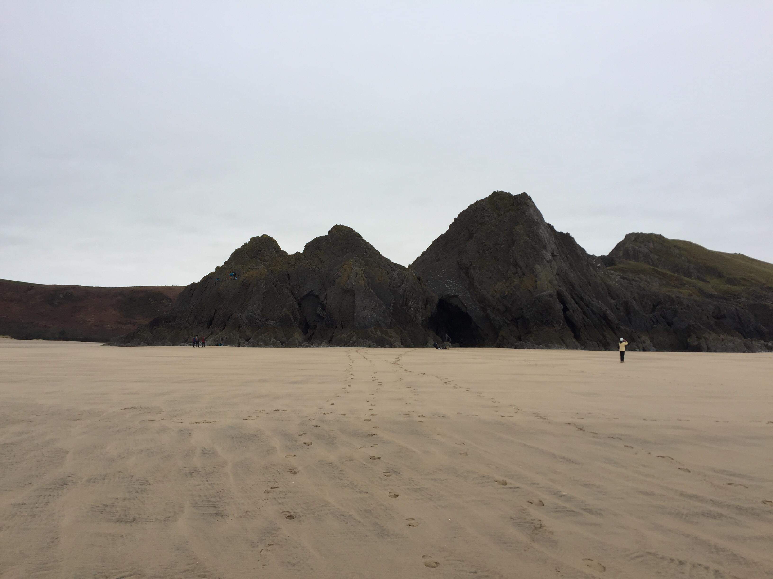
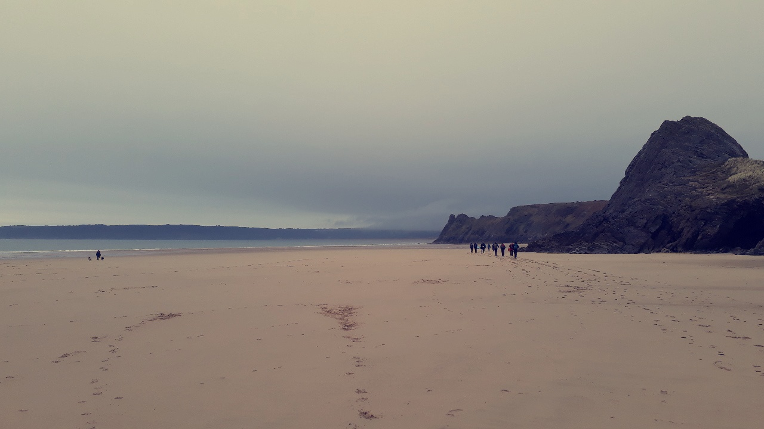
Destination: Oxwhich Bay, The Gower, 3 cliffs.

Weather: 10 degrees feels like 6 degrees. Light rain showers and fresh breeze. Wind speed 15mph, West. Low tide 12:51
Number of people: 16
Exit routes: go the way back we came, through the cave, over the top of the cliff.
One thing I learnt about today: the rule of twelfths - During the first hour, (this is low tide at this point), the water level rises by 1/12th of the total tidal range. In the second hour, it rises by an additional 2/12ths of the total. During the third and fourth hour, it rises by 3/12ths. (This is the point where it is high tide). Then the increase begins to slow down. In the fifth hour, the water only rises by 2/12ths, and in the sixth hour it rises by 1/12th. This is the point where it is low tide again the pattern is 1,2,3,3,2,1

Comfort Zones

Comfort
Stretch
Panic

Summary of the day

Instructor A purposely parked the minibus on the side of the road with the door facing the pavement so we could get off safely and not worry about getting hit by a car. Instructor A told us to stay on the pavement until we were told to walk single file down the road before heading off to the left-hand side towards a lane. Instructor A then explained that at the bottom of the lane you will come across a wooden gate on the right hand side that we have to walk through (this is hierarchical leadership) as we were walking along the muddy footpath I was becoming aware of my surroundings there were a few hazards that were noticeable such as trees, brambles, cliffs and a golf course. The risks involve a blow to the head, scratches/ cuts, falling and getting knocked out by a flying golf ball. I noticed that instructor A and B walked off and let us find the beach ourselves they did this because they knew we are old enough to look after ourselves ( this is autonomous leadership) we got to the 3 cliffs, instructor A C and D set up the ropes while Instructor B talked us through what we need to do throughout the day, they got us to walk around the beach and look for any hazards and risks. There were quite a few key hazards around us such as rocks falling which can cause a blow to the head, unconsciousness or potential death. To minimise the risks, wear a helmet. Foot entrapment can cause breakages, potential amputation or potential drowning due to the tide coming in. Hypothermia due to the cold harsh wind, which can cause drowsiness, lack of concentration etc. To minimise the risks, wrap up warm. The sea, if the tide comes in, we are trapped if you haven’t planned a exit route, you could drown, freeze to death, there are a huge range of risks related to the sea. Barnacles are also a hazard because they are quite sharp, the risks are cuts and bruises. But barnacles are very useful because they help with grip and you can see on the side of the cliff where the barnacles stop and start, so you know how far the water rises at high tide. The boys went off and looked at the hazards around the cliff while the girls measured the distance between the cliff and the sea so we could see the difference a couple of hours later (this was autonomous leadership) while we were waiting for instructor A, C and D to finish setting up the ropes instructor B made up a game to get our hearts racing and our blood flowing so we can keep warm, it was a lot of fun instructor B would call out different tasks and we would have to do them, it was a competition to see which pair was the last one standing (this was hierarchical and co-operative leadership) we started doing some climbing then did some scrambling, there was a lot of waiting around and I started to get cold and bored. I wasn’t very excited about doing scrambling it was quite stressful and seeing a massive drop below you was not a good sight. It was getting near the end of the day and I was not happy, I was cold, tired and hungry I just wanted to go home at that point.

The adventure experience paradigm

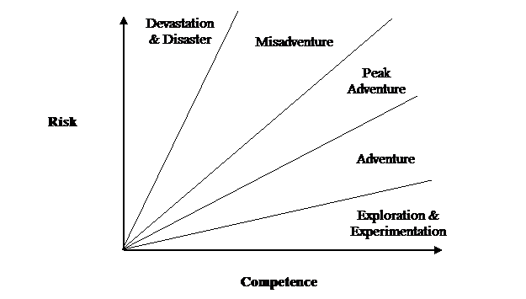
Skills and experience
/challenge
(Real or Perceived)

Sit on top kayaking

Hazard | Risk | Control Measures
Lack of safety awareness | Injury to self or others | Give clear instruction on group responsibilities
Falling in when entering and exiting the SOT kayak | Injury  Capsize  Wet chill | Clear simple instruction on how to enter and exit boats
Capsizing | Entrapment  Cold chill | Clear instructions on what to do in an event of capsize
Collision with other paddlers or objects | Collision  Injury  Capsize | Be aware of your surroundings  No ramming rule
Inappropriate clothing | Trauma  Sunburn  Hypothermia  Hyperthermia | Wear a hat for sun protection  Wear appropriate footwear
Natural extremes lightening, flood, cold | Lightning strike  High flow strainers  hypothermia | Have a back up activity for bad weather  Alert students to dangers of poor water quality after rain
Travelling by vehicle | Injury from vehicle accident | Wear seatbelts
Dehydration | Hyperthermia | Instruct to drink regularly, carry drink in boat.  Have regular stops in hot weather
Equipment | Flotation or handloop failure | Check boats for safety  Check for loose screws etc  Check PPE are okay
Lack of response to instruction | Potential risk to self or others | Instruction must be in a quiet area without distraction  Have frequent briefings on and of the water
Site hazards | Lack of awareness could lead to danger | Identify site specific hazards and alert participants  Hazards can change as river levels or conditions change
Late return due to change of plans or conditions | Exposure,  tiredness | Contingency plan in place
Medical risk | Allergies  injury | First aid kit carried  Medical forms are filled out

Site specific risk assessment
- Carrying kayaks- injury over a long period of time
- Roads- might get hit by a car
- Tide- get stranded if you didn’t check tide
- Members of the public- anything could happen
- Fish factory- pollution- illness
- Rocks around and beneath us/cliffs- could hit into them/have rocks fall from a height

Destination- Newquay beach
Weather- Sunshine with a little bit of cloud, temperature- 10 degrees, feels like 8 degrees, wind- 14km/h WNW Gust- 17km/h.
Number of people- 5
One thing I’ve learnt today- Limpets move around over the rocks when the tide is in, but always return to their own favourite spot when the tide goes out, following the mucus trail that they have deposited. No matter how far they go they will always find the exactly some spot they started at.

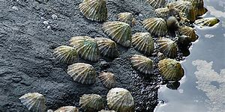

Summary of the day- we were supposed to go to Pembrokeshire but we had to get the sit on top kayaks from llandysul, which was in the opposite direction so we went to Newquay beach instead, because it was in the right direction, so we could have more time on the water. The only problem we had was instructor B had never been to this beach and didn’t know the area, so some scarcity was involved, but luckily instructor A knew the area very well and was competent enough to take us on the water.
Instructor B parked in a car park, so it was safe enough to load and unload the boats. instructor A and B carried their boats first then we followed so we knew were we were going. I made sure I put suncream on and had a water bottle with me, and a chocolate bar in my buoyancy aid. The weather was beautiful, and the water conditions were perfect for sit on top kayaking.
Before we went further out to sea instructor A and B made us paddle around in the bay away from the wind so we could have a feel of what the boats were like. When they thought we were confident we started our journey. Throughout the whole journey the instructors made sure we were against the cliffs away from the wind if they needed to talk to us so we could hear them clearly and so we were at risk of drifting away. They also made sure we wore helmets to prevent getting hurt if rocks fell from above us. the instructors gave everyone the chance to lead the group, this was a great way for them to notice which route was the safest. Instructor A was also there to direct us in the right direction. When we were on the sea I noticed one instructor would be near the front and one would be at the back. this was a great way to keep the group together.
The instructors made sure we had a little break so could have something to eat and drink. I’m glad they did this because my energy levels were getting a bit low. We then made our way back to the minibus.

Glenridding Beck synopsis

On the 26th May 2002 a geography teacher Paul Ellis aged 42, took 12 year 8 pupils, 3 primary aged children, and 3 staff and accompanying adults to Glenridding beck to go scrambling, hill walking plunge pooling around the beauty spot of Ullswater. If you don’t know what plunge pooling is, it ‘involves jumping into a rock pool in a mountain stream and swimming to an exit point.’ (Hse.gov.uk, 2019) however Ellis ignored warnings of heavy rainfall over several days. Liam George who visited the pool that morning with a group of pupils warned Ellis it was too dangerous to jump in. the children had no buoyancy aids, no safety and no rope yet Ellis judged the pool safe enough for the children to jump into. The water temperature was 8 degrees Celsius and was the temperature of the English Channel in February.

One of the pupils, Max, jumped into the pool after a boy called Bruce Budden jumped in and landed in the current which propelled him to the lip of the pool where he got out. Max was less confident then some of the pupils and did not hit the stream of white water and landed slightly off to the side. Max panicked and was in a state of utter terror. Ellis jumped in to try and rescue but unable to help because of the extreme cold, the other teachers waited at the shallow end and shouted for rope, but Ellis didn’t have a safety rope with him. Max’s mum Mrs Palmer jumped in to try and save her son, she managed to rescue him, but she became disorientated due to the intense cold and Max drifted from her grasp and sipped down the beck and sadly died.

Gareth Rooney dived in to save Mrs Palmer and Max because Ellis and his group where leaving. Unfortunately, he only managed to save Mrs Palmer.

Max’s body was recovered by a mountain rescue team and Mrs Palmer was airlifted to hospital with hypothermia.

Paul Ellis was sentenced to 12 months for manslaughter and a six-month concurrent sentence for failing to provide adequate care for the rest of the pupils.

Three months after max’s death the government published guidelines for schools taking pupils on potentially dangerous outdoor activities. They were told to appoint a specific teacher trained to make risk assessments and to also appoint an adviser to oversee and monitor trips and work closely with EVCs.

