

Hospitality and Guest Services
BMIH4003
Assessment 2: Hotel standards, reputation management and service culture
Name: Florin Buzan
ID:2222994

Executive Summary
In a competitive market, hotels need to change with the times to meet the ever-higher demands of their patrons. Using global business insights, this paper looks at reputation management, hotel standards, and service culture in the hotel and hospitality sectors. Exceptional guest experiences are fuelled by hotel service culture, which is different from corporate culture. Hotel success is significantly impacted by efficient reputation management, particularly through the use of guest reviews. Customization, sustainability, and technology should be prioritised in industry adaptation. Hotels thrive despite manpower shortages by focusing on quality and being nimble with trends.

Table of Contents
Executive Summary 2
Introduction 4
Main Findings 5
Hotel Standards 5
Reputation Management 6
Service Culture 7
Conclusion 9
Recommendations 10
References 11

Introduction
In the hospitality industry, the topics of service culture, hotel standards, and reputation management are all investigated in this study. These topics are essential to the development and growth of the industry and the market. Throughout the research, an examination of these essential aspects will be conducted utilising examples and case studies drawn from the real world. By conducting research in these areas, we may gain a deeper understanding of the dynamics of the industry as well as the significance of those dynamics for firms that are attempting to maintain their competitive edge while also meeting the shifting expectations of their customers.

Main Findings

Hotel Standards
Purpose of brand consistency standards: To provide a uniform guest experience throughout all properties, hotel chains must adhere to strict brand consistency rules. These characteristics include service, amenities, room design, and branding elements like colour schemes and logos (Chan, Gao and McGinley, 2021). The objective of these standards is to establish a consistent level of service and quality for all hotels, regardless of their location, to foster consumer trust and reliability. Consistency is key to retaining brand loyalty and attracting repeat business. Marriott International is a famous hotel chain in the world. Marriott carefully establishes brand standards for every aspect of the visitor experience, including room mattresses and linens, as well as lobby access. Their wide range of hotel brands, which includes the pricey Fairfield Inn and the opulent Ritz-Carlton, adhere to these standards (Rivaldo, 2021). Marriott's consistency enables them to serve a diverse spectrum of passengers with varying interests and budgets while maintaining a reliable corporate identity.
Hotels standards: Still, standards vary throughout establishments. The market position of a brand has a significant impact on the quality of hotels (Walker, 2017). The Ritz-Carlton and St. Regis are two examples of luxury hotel brands with high expectations for guest experience, amenities, and service. Huge spas, gourmet dining, and butlers are possible amenities in these upscale hotels. Conversely, low-cost hotels such as Motel 6 place a higher priority on tidy, low-cost rooms devoid of extras (Wong and Kim, 2020). Geography may also affect hotel standards. High-end accommodations in crowded cities could have higher standards than those in less travelled regions. These discrepancies in standards are frequently the result of local competition and customer expectations. To cater to affluent tourists, luxury hotels in major cities could have exclusive club lounges, luxury retail stores, and chauffeur-driven cars.
Standards for brand consistency guarantee a uniform guest experience across hotel brands. However, because of their market positioning, target demographic, and location-specific considerations, these needs differ significantly amongst hotel brands and locales (O’fallon and Rutherford, 2019). By adapting their standards to the specific circumstances they face, hotels can remain competitive and satisfy the diverse needs of their guests while maintaining their brand identity and customer trust.

Reputation Management
Managing a hotel's reputation: It is crucial to drawing in business and preserving its positive reputation. Hotels can enhance their image by taking proactive steps. They must first consistently provide exceptional service and surpass guests' expectations (Jackson, 2018). The Four Seasons' commitment to providing exceptional service has earned them an impressive reputation. Second, lodging establishments ought to actively seek out and keep an eye on Yelp, TripAdvisor, and social media evaluations (Perez-Aranda, Vallespín and Molinillo, 2019). Involvement from the guests prompt resolution of issues and gratitude are essential. Marriott International demonstrates its dedication to visitor satisfaction by responding to reviews and feedback from guests on a variety of platforms.
Importance of effective guest reviews management: In hotels, managing guest reviews is essential. Most of the time, guests use guest evaluations to make reservations. Cornell University found that a hotel's income improves by 11% and its room prices by 9% for every one-point improvement in the hotel's ranking on review websites (Chakravarti, 2018). Good ratings have an instant financial impact on a hotel. Evaluations also offer opportunities for improvement. By routinely monitoring and analysing reviews, hotels may find trends, evaluate customer sentiment, and make data-driven decisions to enhance the guest experience.
Impact of negative reviews: A hotel's revenue and reputation can suffer from negative reviews. Research indicates that potential guests are more impacted by negative reviews than by positive ones. A Harvard Business Review study found that a restaurant's revenue can increase by 5–9% based on a one-star Yelp rating (Alrawadieh and Dincer, 2019). Unfavourable evaluations have the power to terrify travellers, undermine confidence, and harm a hotel's brand. For example, the Union Street Guest House's infamous policy of fining guests for negative reviews sparked a significant backlash and damaged the establishment's reputation. Improving the hotel's image through prompt and efficient resolution of negative reviews is essential to good reputation management. By doing this, hotels can lessen unfavourable remarks and show that they are committed to making their guests happy.
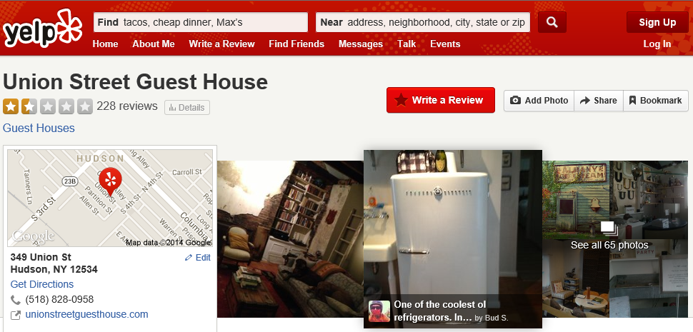
Figure 1: Reviews on Yelp
Source: (Alrawadieh and Dincer, 2019)

Service Culture
Service culture: Service culture in the hospitality business refers to the industry's guiding philosophies and concepts for delivering outstanding customer service (Choi et al., 2020). Every employee at the hotel should have a frame of mind, attitude, and practice that is geared towards giving the greatest possible service to guests. A good illustration of this is the "guest-first" service culture at Disney hotels (Radojevic, Stanisic and Stanic, 2019). Their crew is known for the thoughtfulness, attention to detail, and extra efforts they put forth to provide extraordinary vacations for their clients.
Difference: The culture of service needs to be differentiated from the culture of the company (Baum, 2019). The concept of service culture (service culture model) is more narrowly defined in comparison to the concept of corporate culture, which refers to the ideas, ideals, and behaviours of an organisation (Chakravarti, 2018). It focuses on distinguishing characteristics, practises, and behaviours that enhance the quality of service provided to customers. A distinct subset of company culture that possesses its own set of core values and standard operating procedures is known as service culture. While the business culture of a hotel may emphasize economic responsibility and operational efficiency, the service culture of a hotel emphasizes ensuring that each guest feels treasured, and cared for and that they have been thoroughly attended to.
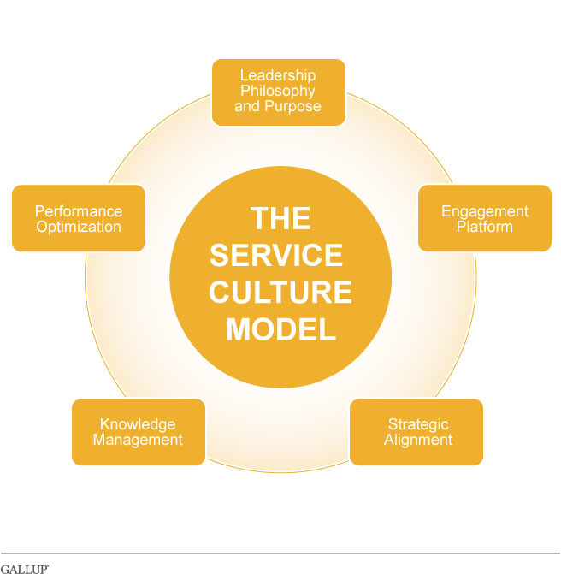
Figure 2: Service culture model
Source: (Chakravarti, 2018)
Importance: Service culture is essential in hotels since the level of guest satisfaction and loyalty is directly influenced by it (Sarhan et al., 2020). It influences the entire guest experience, from the check-in to the check-out, as well as all of the interactions that take place in between. The service culture of Hilton Hotels, which stresses the idea that "every guest is a valued guest," encourages a high level of care and attention (Zeng, 2021). A high level of customer satisfaction is directly correlated with increased repeat business and robust word-of-mouth marketing. In this day and age, when online reviews and social media can make or break a hotel's image, having a strong service culture can help a hotel stand out in a competitive market and keep customers coming back.

Conclusion
The competitiveness of the hospitality sector depends on its proactive response to changes and customer expectations. Reputation management, hotel standards, and service culture must all be addressed for success. In contrast to corporate culture, service culture influences hotel patron experiences and brand loyalty. Travellers' decisions are heavily influenced by guest assessments, thus proactive reputation management—including addressing unfavourable feedback is crucial. To thrive in the dynamic hotel industry, technology, sustainability, and personalization are key. Some companies struggle with a lack of workforce, so they must find innovative ways to find and keep skilled employees. In this changing climate, the industry's growth and profitability are contingent upon unwavering service quality and market adaption.

Recommendations
- Embrace Technology: To remain competitive in the modern hospitality industry, hotels need to integrate technology into their operations (Walker, 2017). The mobile app offered by Marriott features mobile check-in and keyless entry, both of which improve the convenience for guests and reduce the amount of physical interaction required, reflecting current trends in health and safety.
- Sustainability Initiatives: As issues affecting the environment on a global scale become more pressing, hotels should make sustainability a top priority (O’fallon and Rutherford, 2019). The Accor Group's efforts to reduce waste, improve energy efficiency, and get green certifications help the company follow the trend towards sustainability and attract environmentally conscious tourists.
- Personalisation: The trend towards personalization is gaining momentum. The use of data to provide visitors with individualised service should be encouraged in hotels. The Ritz-Carlton makes use of data collected from visitors to anticipate and fulfil the specific desires of each guest, producing tailored and unforgettable experiences (Jackson, 2018).
The lack of available labour presents a significant obstacle for hotels. It is difficult for the sector to locate and keep skilled individuals, which hurts both the quality of services and their efficiency. The cyclical nature of the sector, along with global events such as the COVID-19 epidemic, make this challenge far more difficult (Choi et al., 2020). The reduction of demands placed on the workforce and the maintenance of high service standards may require the implementation of new measures such as career advancement opportunities, competitive pay, and automation.

References
Alrawadieh, Z. and Dincer, M.Z. (2019). Reputation management in cyberspace: evidence from Jordan’s luxury hotel market. Journal of Hospitality and Tourism Technology, 10(1), pp.107–120. doi:https://doi.org/10.1108/jhtt-09-2017-0093.
Baum, T. (2019). Hospitality management. Los Angeles: Sage.
Chakravarti, B.K. (2018). Hotel management. New Delhi: A.P.H. Pub. Corp.
Chan, J., Gao, Y. (Lisa) and McGinley, S. (2021). Updates in service standards in hotels: how COVID-19 changed operations. International Journal of Contemporary Hospitality Management, 33(5), pp.1668–1687. doi:https://doi.org/10.1108/ijchm-09-2020-1013.
Choi, Y., Oh, M. (Moon), Choi, M. and Kim, S. (Sam) (2020). Exploring the influence of culture on tourist experiences with robots in service delivery environment. Current Issues in Tourism, 24(5), pp.1–17. doi:https://doi.org/10.1080/13683500.2020.1735318.
Jackson, E. (2018). Hotel management. New York, Ny: Larsen & Keller.
Nadar, S. (2023). The St. Regis Goa Resort Promises Luxury -- Here’s How! [online] Travel and Leisure Asia | India. Available at: https://www.travelandleisureasia.com/in/hotels/the-st-regis-goa-resort/ [Accessed 18 Oct. 2023].
O’fallon, M.J. and Rutherford, D.G. (2019). Hotel management and operations. Hoboken, N.J.: Wiley.
Perez-Aranda, J., Vallespín, M. and Molinillo, S. (2019). Hotels’ online reputation management: benefits perceived by managers. International Journal of Contemporary Hospitality Management, 31(2), pp.615–632. doi:https://doi.org/10.1108/ijchm-07-2017-0460.
Radojevic, T., Stanisic, N. and Stanic, N. (2019). The culture of hospitality: From anecdote to evidence. Annals of Tourism Research, [online] 79, p.102789. doi:https://doi.org/10.1016/j.annals.2019.102789.
Rivaldo, Y. (2021). Leadership and Motivation to Performance through Job Satisfaction of Hotel Employees at D’Merlion Batam. The Winners, 22(1). doi:https://doi.org/10.21512/tw.v22i1.7039.
Sarhan, N., Harb, A., Shrafat, F. and Alhusban, M. (2020). The effect of organizational culture on the organizational commitment: Evidence from hotel industry. Management Science Letters, [online] 10(1), pp.183–196. Available at: https://growingscience.com/beta/msl/3400-the-effect-of-organizational-culture-on-the-organizational-commitment-evidence-from-hotel-industry.html [Accessed 18 Oct. 2023].
Walker, J.R. (2017). Introduction to hospitality management. Boston: Pearson.
Wong, A.K. and Kim, S. (Sam) (2020). Development and validation of standard hotel corporate social responsibility (CSR) scale from the employee perspective. International Journal of Hospitality Management, 87, p.102507. doi:https://doi.org/10.1016/j.ijhm.2020.102507.
Zeng, L. (2021). Analysis of Hilton Worldwide Hotel Group’s Transnational Operation Strategy. Academic Journal of Business & Management, [online] 3(11). doi:https://doi.org/10.25236/AJBM.2021.031104.

