University of Wales Trinity Saint David
Wales institute of Science and Art


Examining the effectiveness of an organisational change and how it was managed.

Llewellyn Higgins

2237146

Material Science Engineering

9/4/25

Management Innovation and Sustainability (ACMA5007)

1. Table of contents
Contents
1. Table of contents ii
2. Executive summary iii
3. Introduction 1
4. Case study overview 2
5. Critical analysis of change management 2
6. Application of a change management model 4
7. Employee support and motivation 5
8. Main findings 7
9. Conclusion 8
11. References 9

2. Executive summary
The focus of this report is to understand different motivational or other models that can be used to help management achieve different goals such as a change. During this report used and unused models will be taken into consideration along with what the task at hand was and any obstacles that appeared before or during the analysis/completion of the task.
The change this organisation wanted to implement was relocating and re-organising the material retention system. Originally the material was stored in large grey boxes outside, adjacent to a building. There was no cover nor protection from the elements which caused issues when it came to scrapping off material, the main one being that some scrap material was unidentifiable to the point it had to go into a mixed scrap bin. This can cause significant loss to the organisation overtime so it had to be addressed.
The large grey boxes were brought inside and organised chronologically so that not only are they protected from the elements, but it would also be quicker to identify what is scrap and what isn’t.
This report also highlights any gaps in the models as well as any obstacles that came to light during the change. There will always be issues that arise when something is changing but by implementing models and accurate measurements of the task, it can be insured to run as smoothly as possible.

3. Introduction
Working in an aerospace forge means that there is usually change in one form or another, this could either be a method of manufacturing alteration or it could be a physical change to the layout of the company. The innovation that this report shall cover is the test material retention. This report will highlight any areas for improvement as well as why retention of this material is necessary or is it wasting space and time within the organisation. To achieve a positive organisational change use of structured models is required to address challenges (Esther Cameron, 2019). A case study will be used to attempt to verify any of the bigger issues like location.

4. Case study overview
Any product that the organisation produces must be tested to aerospace standards. This requires at a minimum that 12” of material is retained for at least 6 years after production, this is referred to as “box B” retention. Due to the sheer volume of material retention, a concrete and effective material retention is required. If a plane fails the material may need to be located in a mound of boxes if it is unkept. Additionally, there is “box A” which is material kept for 40+ years and “box C (1/2/5)” where, box C (1) is kept for 1 year and C (2) is for 2 years and so on. Any broken test pieces from the mechanical tests shall be kept for at least 1 year and any metallurgical test samples shall be kept for at least 40. Finally, the material retention also includes customer specific retention which is kept indefinitely. This follows the organisation’s own internal documents QP-009 and SOP-0466.
Relocation of the retention material was addressed as a priority. Originally, the material was stored inside large grey boxes, stacked 3 high and placed outside. This caused delays in the process due to one of the boxes collapsing and material scattering, as well as being exposed to the elements which affect the traceability of the material. The boxes were brought inside into a dry empty space so that the weather isn’t affecting the material and if a box was to give way again the material would not spill over the road. The boxes were then segregated by material types; steel, titanium and nickels, to mitigate the time it would take to locate one piece. The last big change made to this process was the order in which the boxes were kept. They no longer are unorganised but are kept neatly and chronologically ordered.
The following people all had their own individual roles within this change, there was Steve Bull (a forklift driver), Evan Pearce (Lab apprentice), Luke Lewis (Lab manager), Shaun Cronin (head of operations). Steve and Evan’s role was to use the forklifts to weigh the boxes then move them to the correct location. Luke’s role was to supervise everyone and answer any queries. Shaun’s role was to search around site and find an applicable area where we could keep this material indefinitely. This change was mostly carried out by shop floor due to its handling requirements.
My role in the process was to help organise the test material into correct boxes as well as how the layout of the boxes would be. This consisted of collecting all spilt material and ensuring it was placed back in the correct box, labelling the boxes with correct dates and weights while organising the placement of the boxes so that they were chronologically stored. The scrap metal had to been separated and sorted into the respective material so that the highest value upon resale could be achieved.

5. Critical analysis of change management

The process revealed some shortcomings that suggest planning and execution need to be improved. The largest failure was stacking the boxes three high while knowing safety limitations. This resulted in the collapse of the boxes causing a day’s delay in the process, partnered with a drop in productivity and morale. Lewin’s Force Field Analysis (Donald James Swanson, 2013), is an effective tool to find the key driving and restraining forces however, identifying an issue does not solve the issue. In this instance restraining forces “communication” was not addressed clearly causing delays.
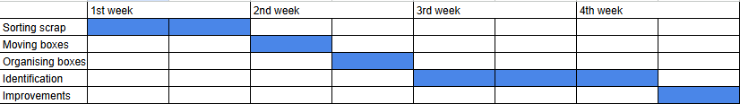
Figure 5.1 – Ghantt chart for material relocation expected completion time.

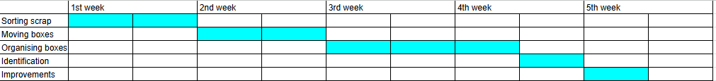
Figure 5.2 – Ghantt chart for actual relocation completion time.
Figure 5.1 and Figure 5.2 were made by Luke Lewis and show the actual time it took to complete the change was longer than desired. This was caused by the delays mentioned earlier and throughout this report. An increase in the ghantt charts (Geraldi, 2012) demonstrate that communication is key in carrying out an effective process.
A more step by step process which focusses solely on communication would have produced a more favourable outcome. Kotter’s 8-step change model would have been beneficial to use for example, step 4 and step 5 discuss the communication skills needed to empower employees for change. (Kotter, Leading change , 2012)
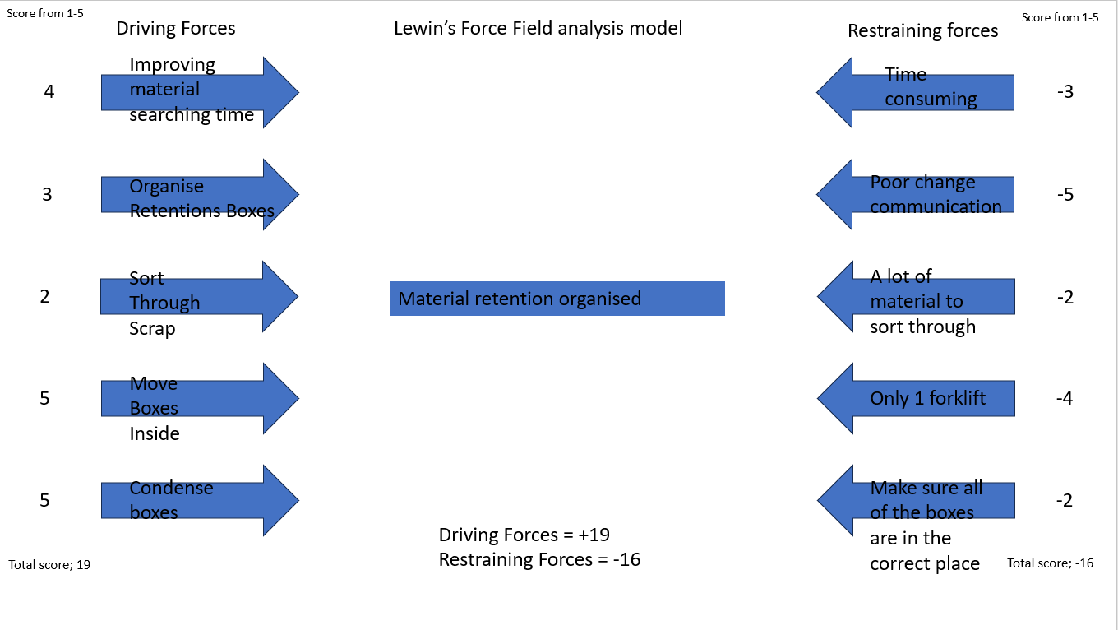
Figure 5.3 - (Malik, 2022)

6. Application of a change management model
By using the nudge theory model to compare to Lewin’s forces analysis we can find areas needing improvement. The below model shows a basic step by step process in which management can take to achieve a set out task. The nudge theory delves a bit deeper into the task such as it highlights areas that could cause delays within the change or who are the correct employees to make the change happen. This slight but impactful increased knowledge of the task proves to be quite useful. It could help to boost the overall moral of the employees carrying out the job due to them having a clear pathway or by using the correct employees it won’t get held back by other jobs.
For these reasons the nudge theory model is slightly more useful than Lewin’s forcefield analysis. Nudge theory (Adkisson, 2008) starts with the dos and don’ts within a task, identifying any major obstacles and where to start with the motivation of the employees(nudges). Whereas Lewin’s forcefield analysis Only takes into consideration the Driving and restraining forces rather than providing a solution.
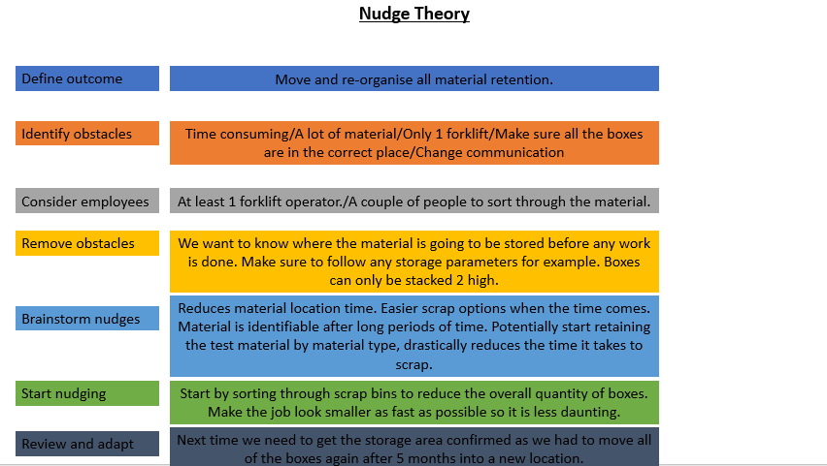
Figure 6.1 - (G, 2022)

7. Employee support and motivation
The employees were left pretty much alone to their devices. The task at hand wasn’t one that needed much supervision but it did need approval of the location of the stored material before the employees could move anything. Management did do an investigation but this only covered what material we retained along with where the material was to be stored.
There was a lack of communication with management due to the forklift drive moving the boxes but stacking them three high originally. This did cause some defects within the process due to having lower levels of motivation but it did also arise later on. After 5 months of the completion of the task the higher ups needed the space so all of the retention bins had to be moved for a third time where the moral was low in all aspects due to repeating the same task over and over.
Maslow’s hierarchy demonstrates a clear pathway to achieve the goal, but it was very time consuming even without any delays. The below image shows the 5 different section of the pyramid each designated to the different needs of an employee to feel motivated within a job to carry out tasks efficiently. The higher one’s morale is in their day-to-day life the higher levels of implication are shown within their role in an organisation. For example, if an employee had low moral at home and then was asked to carry out the same mundane task repeatedly, then the organisation might get some backlash or a lack of productivity from the employee. Maslow’s hierarchy follows a simple pyramid that is to insure a person’s basic needs are being met so that they can achieve the highest levels of productivity in a working day. 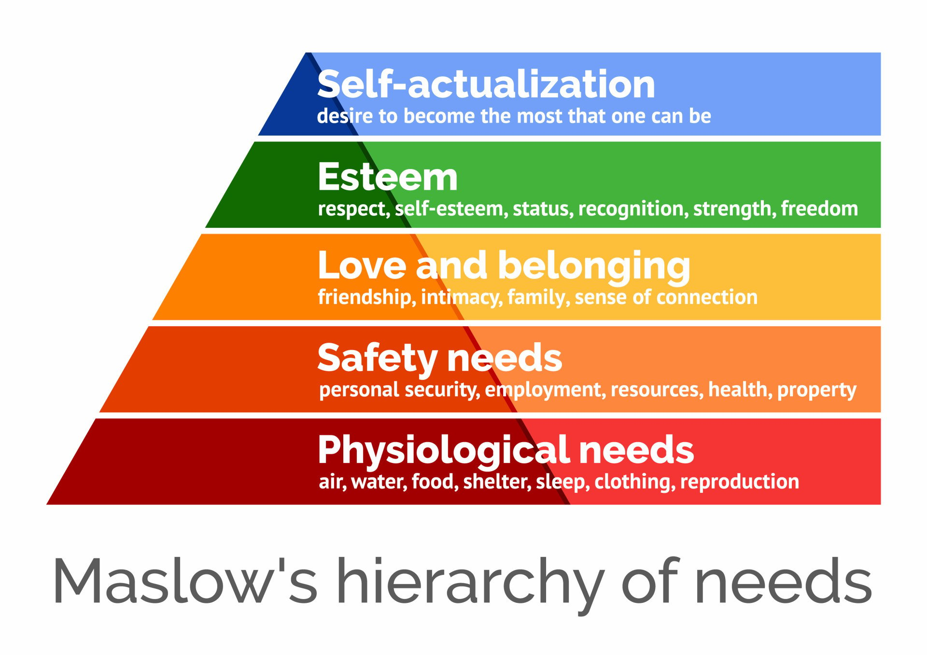
Figure 7.1 - (Mcleod, 2025)

There were a few gaps in the process that with a bit more consideration could have been completely avoided. One area was that if there was better communication between management and the fork lift operator then the boxes would not have been stacked three high the first time around. Due to this not only did it cause a delay in the completion of the task but the task had to be put on hold until every box was stacked only two high and re-organised. This could have been easily prevented if the correct storage location was identified properly rather than the manager just saying to use this bit of spare area.
Another gap in the process would be that there was a considerable amount of material to go through by hand. Due to the material being rusty and damaged by the prolonged exposure to the elements, it was very difficult to identify scrap (Nakamura, 2019). This caused a significant drop in scrap value as mixed scrap is considerably cheaper than allocated scrap. This was one of the driving forces into moving all of the retention material but to further the chances of identifying the material even after corrosion management have now implemented a scribing operation which is applied to all retention material. Pieces are inscribed and marked up with the works order number instead of just having a bit of paint that is easily scratched off.

8. Main findings
The organisational change to improve the material retention and storage system highlighted a few key findings, which have resulted in relevant changes that need to be addressed promptly.
Firstly, the initial relocation of the boxes revealed significant communication inefficiencies. This resulted in the stacking of boxes three high. Despite knowing that this will lead to the crumpling then collapsing of the stack, it resulted in a reorganisation and delayed the productivity of the change. The relocation demonstrates a lack of communication between management and the shop floor, which reflects a common challenge normally associated with a top-down change (Kotter, 1996).
Secondly, it was clear that there was environmental exposure that had been compromising the state of the retention material. The material was stored outside without any protection from the elements which lead to corrosion, making the retained material identification improbable which reduces the potential value of the scrap metal due to it being mixed scrap (Howells, 2007). Relocating the material inside and the introduction of separated storage for steel, titanium and nickel has drastically improved material traceability and reduces the handling time whether sourcing the material or scrapping it.
Various change management models were during this process; Lewin’s Force Field Analysis was used to calculate the driving and restraining forces. Lewin’s model is useful to evaluate but its limitations are easily shown while addressing behavioural resistance and dynamic process barriers (Cameron, 2019). On the other hand, the nudge theory was more effective in employee motivation and productivity, which validates the need to maintain motivation during and organisational change (Edward L. Deci, 2020). Employee motivation is a key aspect of any task, if moral is too low it leads to a declining rate of productivity and combined with repetitive tasks it will only cause delays.
The introduction of a new scribing system which indents the material with work order numbers. This change leads to an incremental increase in material traceability while also demonstrating organisational learning and a positive approach to improvements, now considered essential to create a sustainable operational success (Jeffrey K. Liker, 2011)
The findings found above demonstrates that change and adapt are always dependent on a proper communication system which takes into accounted structured models with thought through plans as to not impede motivation.

9. Conclusion
The report critically examined the change made by this organisation to relocate and reorganise material retention, by applying various models such as Lewin’s Force Field Analysis and Nudge Theory to evaluate the effectiveness of the process. There were some key findings that showed the communication was lacking between management and shop floor and insufficient planning led to delays and safety hazards. As well as a 30-50% reduction in the resale in scrap value due to the inability to identify certain material (al, 2018).
Before any significant change is made within an organisation use of different models should be protocol as they not only allow the management and employees visualise the job at hand, but it will also improve trust and transparency between the two. This organisational change had various complications, but it was still achieved with slight delays, this should be avoided in future by proposing concrete steps, so that every step is clear which would help improve the morale of the employees but also it may result in completion of the task before the completion date.

10. References
Adkisson, R. V. (2008). Nudge:improving decisions about health,wealth and happiness. The social science Journal, 700-701.
al, N. e. (2018). Scrap metal economics . Resources Conservation and recycling , 122,176-184.
Anon. (2023). Maslow hierachy of needs. Retrieved from Simply psychology : https://www.simplypsychology.org/wp-content/uploads/maslow-hierachy-of-needs
Cameron, G. (2019). Making sense of change management. Kogan Page pyblishers .
Donald James Swanson, A. S. (2013). Sharpening the Focus of Force Fiels Analysis . Journal of change management , 28-47.
Edward L. Deci, R. M. (2020). Intrinsic motivation and self-determination in human behabior . Boston: Boston, MA.
Esther Cameron, M. G. (2019). Making Sense of Change Management. Kogan Page Publishers.
G, D. (2022, January 9). Nudge theory explained. Retrieved from expert program management: https://expertprogrammanagement.com/2022/01/nudge-theory-explained/
Geraldi, J. (2012). Gantt charts revisited: A critical analysis of its roots and implications to the management of projects today. International Journal of Managing Projects in Business, 27.
Howells, P. (2007). Financial Markets And Institutions . Londonq: FT Publishing international .
Jeffrey K. Liker, G. L. (2011). The Toyota Way to Lean Leadership: Achieving and Sustaining Excellence through Leadership Development. McGraw Hill Professional.
Kotter, J. P. (1996). Leading change. Boston: Boston,Mass.
Kotter, J. P. (2012). Leading change . Boston : Havard Business School Press.
Malik, P. (2022, march 10). How to conduct a force field analysis. Retrieved from The whatfix blog: https://whatfix.com/blog/force-field-analysis/
Mcleod, S. (2025, March 14). Maslow's hierachy of needs. Retrieved from simply psychology: https://www.simplypsychology.org/maslow.html
Nakamura, S. K. (2019). The value of scrap: Economic and environmental impacts of metal recycling. Resources,Conservation and recycling , 291-300.

