Student name: Shahzia Ahmed
Student number: 1813330
Lecturer: Abdi Rehman
Module code: M5X01921
Human Resourcing research Project on Marriot Hotel Birmingham

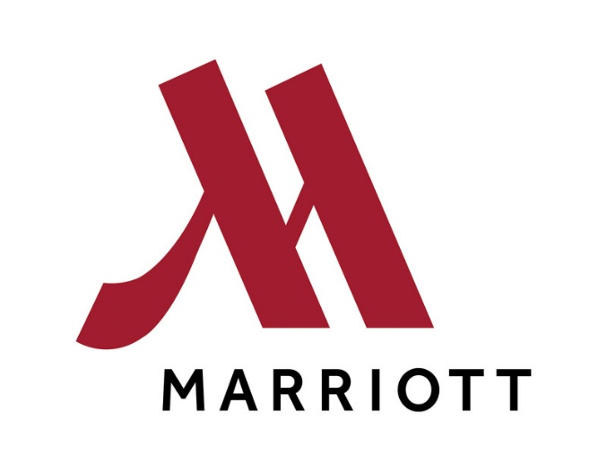



TABLE OF CONTENTS

- Introduction
- Recruitment and selection
- Application process
- Interview procedure
- Beginning your journey with the Marriot
- Talented work force theory
- Conclusion
- References

Human resourcing report for the Marriott hotel Birmingham central
I have chosen to discuss and report on how the Marriot hotels achieve a happy and diverse work force, The Marriot is multinational hotel company and has 7000 plus hotels worldwide according to www.satista they employed approximately 176 thousand people worldwide in 2018. Reporting on the human resourcing procedures and recruitment process. I will be able to evaluate how associate engagement along with the development of a talented work force theory is implemented, it is a paramount factor to the success of the business. The key topics I will explore are the recruitment process, the interview process, the experience and requirements of the new starter, CPD and the benefits of CPD, what benefits the Marriot has to offer to its associates and where improvements could be made.
(https://www.statista.com/statistics/297269/number-of-marriott.)(accessed 21/11/19)

Recruitment and selection
“Here’s to the journey’’ (Marriott careers)
Marriot Hotels have generic recruitment and selection processes, the jobs are advertised via the careers website where the job specification along with location and the date it was posted, its statement to the brand its unique qualities, opportunities for graduates as well non graduates, apprenticeship’s, international opportunities. There is no mention or stated desirability to which qualities or skill set an induvial may require to do the job in the specification, whereas if you look at the competitors the Hilton Hotels, Hilton careers state ‘what we are looking for’ the specification are highlighted as to what is required, which skill set and attitude an induvial should have to make an application with them.
(https://jobs.hilton.com)(acsessed19/11/19)
(www.careers.marriott.co.uk)(acsessed19/11/19)

The application Process
Making an application requires the applicant to create a user ID and account, they can upload a CV or just continue to the application where you are asked to complete the on line application all typical personal data including job status and current responsibilities at present and current or last job referee and one other.(Marriott careers 2019) After completing the online application the user is required to fill a pre employment assessment customized to the job specification, This enables the employer to gain and assess whether the applicant has the right Character, personality, relevant experience, training or education which will enable them to perform for the position applied for.(indeedjobs.co.uk accessed 16/11/19) ( job test prep accessed 16/11/19)
(https://jobs.hilton.com)(acsessed19/11/19)
(www.careers.marriott.co.uk)(acsessed19/11/19)

Interview procedure
As I have completed a placement recently this year at the Birmingham Marriot, I was able to gain insight and witness applicants being interviewed for various positions at the hotel, successful applicants are sent an interview time and date. The interview is set in a formal environment where a senior manager and department manager both interview the applicant in some cases a third manger may be asked to attend also for eliminate any conflicts if they arise. The interview questions are varied, the questions are based on personality testing, problem solving and how empathic they can be to the customer’s needs, this is set out under the Marriott’s legislation and policies set out by the HR department. Unfortunately, I was unable to view this document as they felt it may give me an unfair advantage over other applicants if I were to apply for a similar position. After completing the interview, the candidate is given a tour of the department and any future details of the positions requirements and answer any questions they may have. Alternately I was told by Sherman the General manager of the hotel that in some cases telephone or Skype interviews were also used to interview candidate i.e. internal candidates from abroad could conduct Skype interviews or even telephone interviews had also occurred in the past. Successful applicants usually receive a call first followed by a confirmation letter in a email within 14 days of applying. However according to indeed unsuccessful applicants are sent a generic email commiserating they were not successful with no other explanation or feedback in some cases people don’t even get a response, which reflects badly as bad news travels faster than good and in an heightened digital age all is transparent and this may discourage applicants to apply or progress through the Marriott.

Beginning your journey with the Marriot
The Marriot in Birmingham and across the board employ and train a mainly diverse work force, this in turn helps to identify and enhance cultural exchange, helping to engage and heighten customers experiences and leave a lasting impression. When a new starter is introduced to the job, he or she is given a Marriot online account where the art of hosting is out lined to them indicating the values of the Marriot and the expectations of guest as well as fellow associates. I was able to take pictures of the induction process and modules all associates must achieve as part of their professional development within the organisation, this is an obligation upon each associate to continuously develop and enhance their skills future throughout their employment at the Marriot. The Marriot is promoter of investing in the staff to future benefit the customer and their experience.

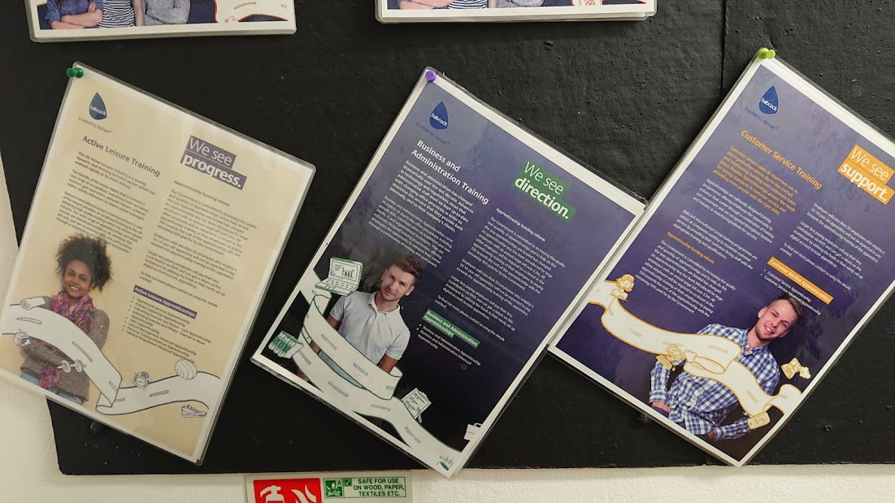

The Opportunity to progress and take new directions for associates and advance their career prospects is prevalently promoted at the hotel, these information leaflets are on notice boards in staff areas promoting career development opportunities.

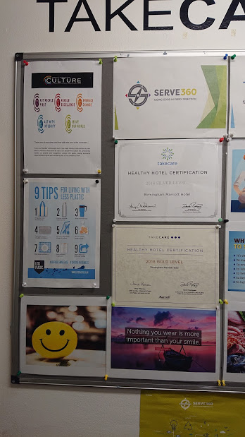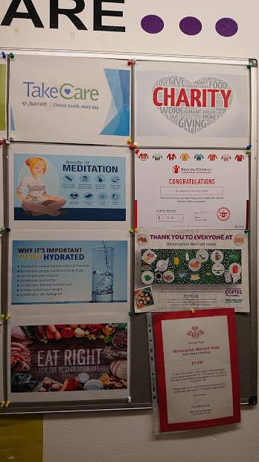
This board shows how the Marriot are promoting health and wellbeing reminding the associates the importance of maintaining a happy and healthy attitude towards the customer and the importance of understanding cultural diversity. These are important contributing factors to the continued growth of hospitality and increasing revenues.
A reminder to the associates of how important self-preservation is as with out health and wellbeing associates cannot perform to their best.
The Marriott showing gratitude to the associates for giving and raising funds as well as awareness for worthwhile causes
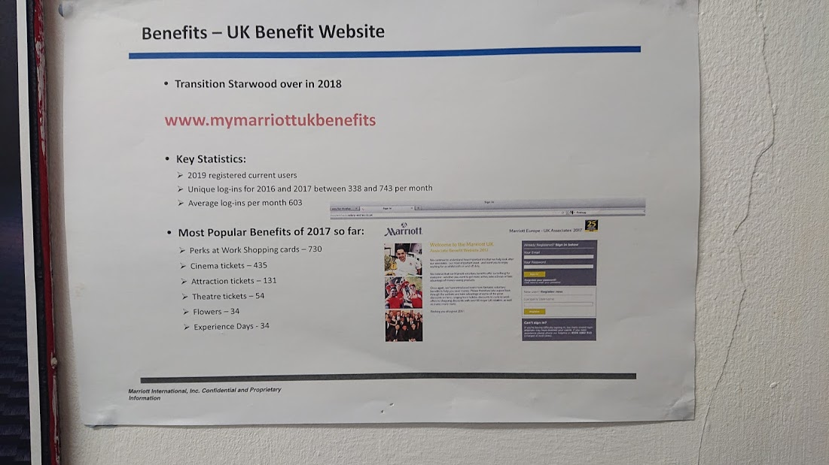s
The Marriot has a benefits programme which they endorse and recommend associates join and take advantage of when they join the family. A helpful reminder is placed on a notice board in the communal associate’s areas.

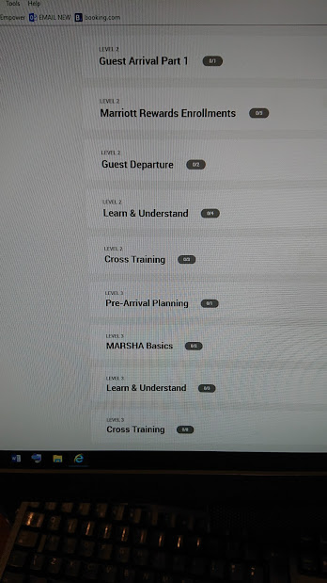
An Introduction to the compass system, all new starters are given acsess to the systems used at the Marriott, training is administered to all new associates, they are given modules with timed completion dates.
CPD is delivered through members personal online account, this allows the associate to develop at there chosen pace and continuously progress and develop their skills, senior associates have told me they often refresh and can enhance there score by retaking the test again when the opportunity arises.
The training is delivered in levels, the more senior the position the higher the level of training is required to be taken by associates.

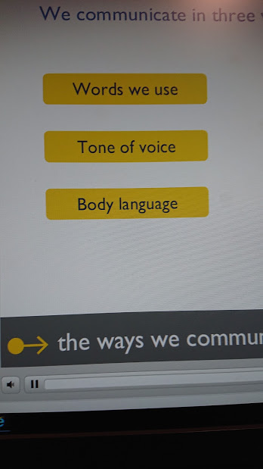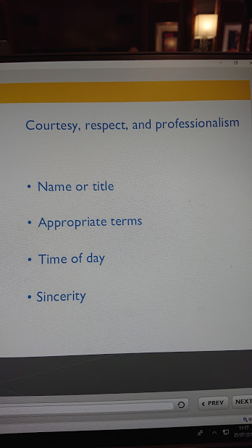

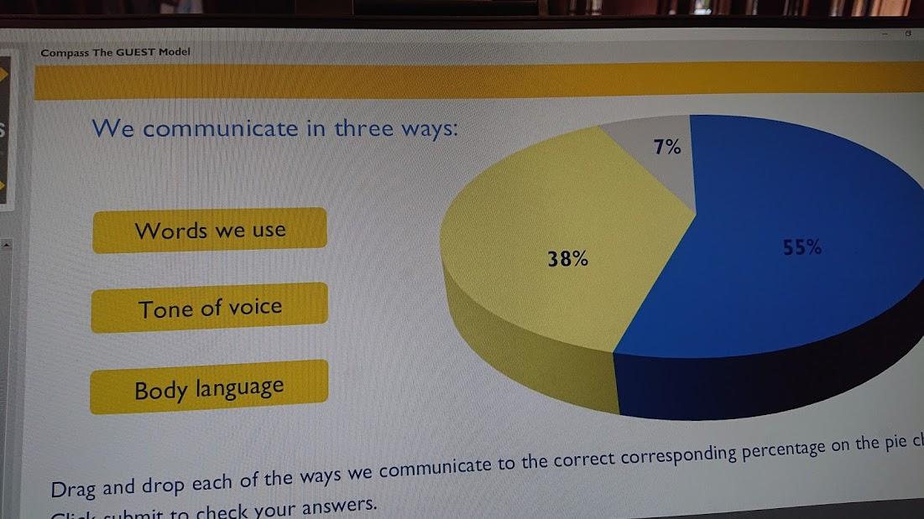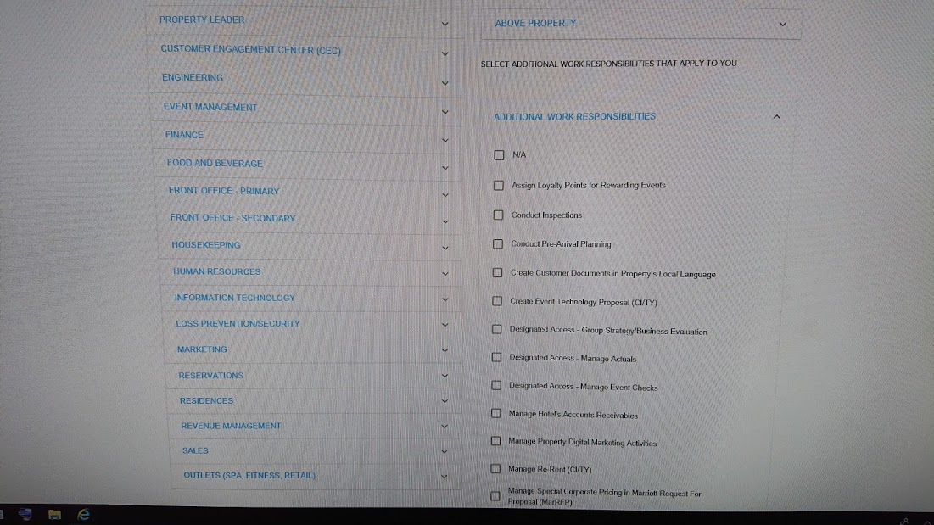

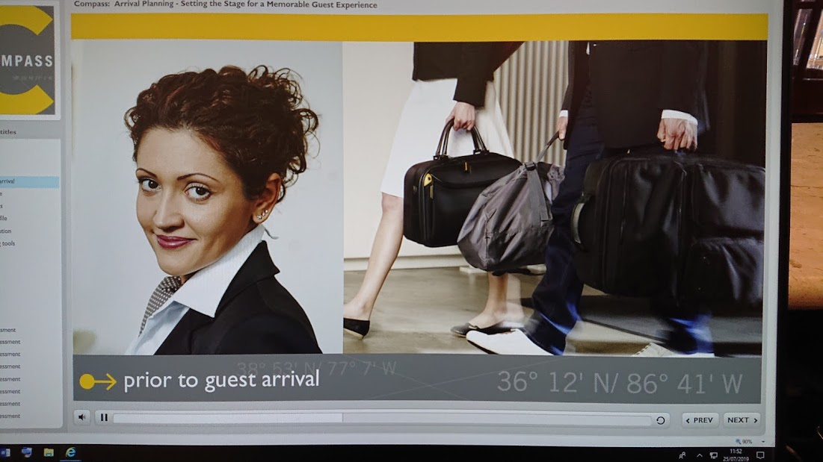

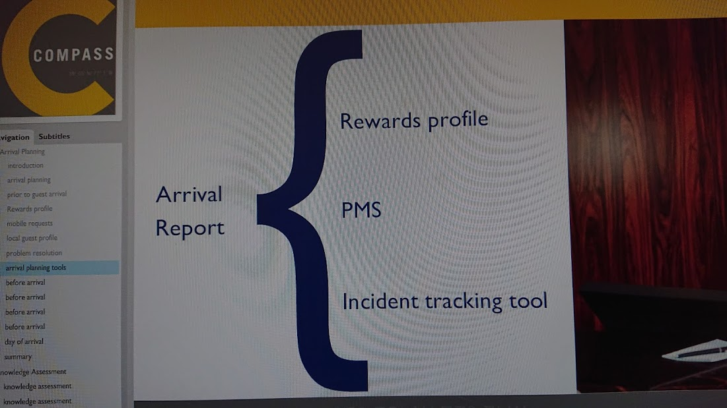
The compass system is a generic system used throughout the Marriot hotels and allows the associate to acsess and continuously develop their skill no matter of which Marriot they work at in the world.
As illustrated in the above pictures the system is user friendly and highlights all aspects of the jobs requirements.

The Talented workforce theory.

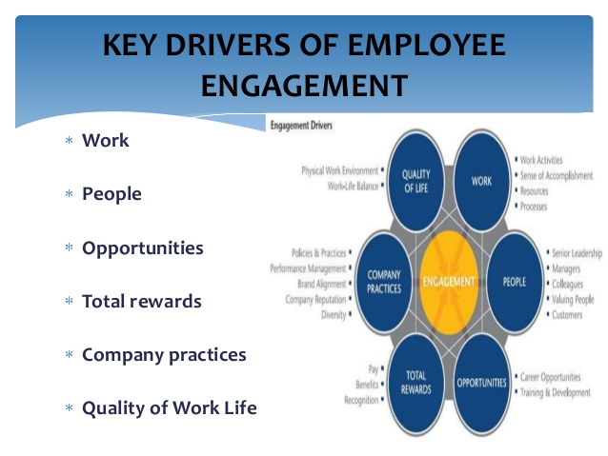

The Theory supporting a talented work force can be seen from the employee engagement model above and allows the effective use of open communications and transparency allowing associates to feel engaged, happy, secure and give there best so this can future benefit the company by increasing revenues. The Marriott and the Hilton use this theory within their organisations, they are working with the employees to create an environment in which they can thrive and increase customer loyalty through services delivered. While on work placement I conducted a survey of staff satisfaction.
When looking online for personal experiences of applicants the reviews on Indeed.co.uk reflect the mixture of feelings and opinions people have of their experience.
Reviewers Rated the areas highlighted are out of five stars
- 3.8 stars work life balance, the reviews reflect the hospitality sector can be unpredictable and some occasion or situations may require you to sacrifice personal time.
- 3.9 stars Pay and Benefits, most reviewers reported it could be better but was fair.
- 3.7 stars Job security and advancement, varied replies and feelings towards this answer mostly positive but some very negatives reviews illustrated lack of confidence in the management.
- 3.7 stars Management, mixed reviews some reviews suggest poor leadership skills let down the whole team which does not promote self-worth to progress future, and other reviews give management a glowing reputation.
- 3.9 stars Culture, the diversity and cultural expansion is prevalent from the reviews mostly positive.
These scores are given by previous employees giving the Marriot a three point eight stars out of five from 19.4 k reviewers, this is a respectable score and indicates even though there are areas that can be improved upon most employees like and have enjoyed working at a Marriot hotel leaving mostly positive feedback. From my personal experience of completing fifteen weeks of placement at the Birmingham Marriot I was pleasantly surprised to see and hear how happy the staff were at the Birmingham Marriot, always working to the best of there abilities and always displaying a positive attitude, I felt this was down to a good mix of people and supportive management. Looking at the rivals Hiltons reviews and feedback suggest from the figures its slightly lagging, averaging a three point seven stars out of five based on 12.4k reviews on indeed.
Reviewers Rated the areas highlighted are out of five stars
- 3.8 stars work life balance, mostly positive again emphasise placed on unpredictability of nature of the job.
- 3.7 stars pay and benefits, generally satisfied would like more.
- 3.6 security and advancement, being awarded mostly 3 starts from reviewers reflect satisfaction but some insecurity to.
- 3.6 Management, illustrating from reviews in some locations very positive and outstanding reviews and in some location’s negative reviews in others reflecting some locations need future attention and progression for management.
- 3.8 Culture, positive reviews showing the advancement and progression to integrating culture and diversity.
(www.Hiltoncareers.com)(acsessed17/11/19) (www.indeed.co.uk) (accessed on 17/11/19)
(https://www.indeed.co.uk/cmp/Indeed/reviews)(acsessed 20/11/19)

I asked 12 associates the following 9 questions, dividing them in to four areas job satisfaction, advancement, security and progression.
1. Do you enjoy working for the Marriott group?
2. How Satisfied are you in your current job role?
3. Are the benefits and incentives good?
4. Do you feel at ease with your pears (management) do you feel supported?
Yes
No
5. Do you feel you have job security?
6. Are you given the chance to advance your career here?
7.What is the one thing you liked most about your job?
8. Would you recommend the Marriot to your friends or relative?
9. Please Rate Your Overall Experience working here

The evidence shows 10 out 12 persons I questioned were happy in their current positions and were satisfied with their jobs roles, 7 out of 12 were happy with progress of the job, from the comments I received back it did suggest that if a associate wanted progression in housekeeping for example this could take many years as limited supervisor of management positions held them back. 9 people out of 12 felt secure, I found the older members were securer as opposed to the younger members who did not have permanent contracts. 8 out of 12 felt they were able to advance their skill set and learn new skills; I found the younger members being the majority in this area.

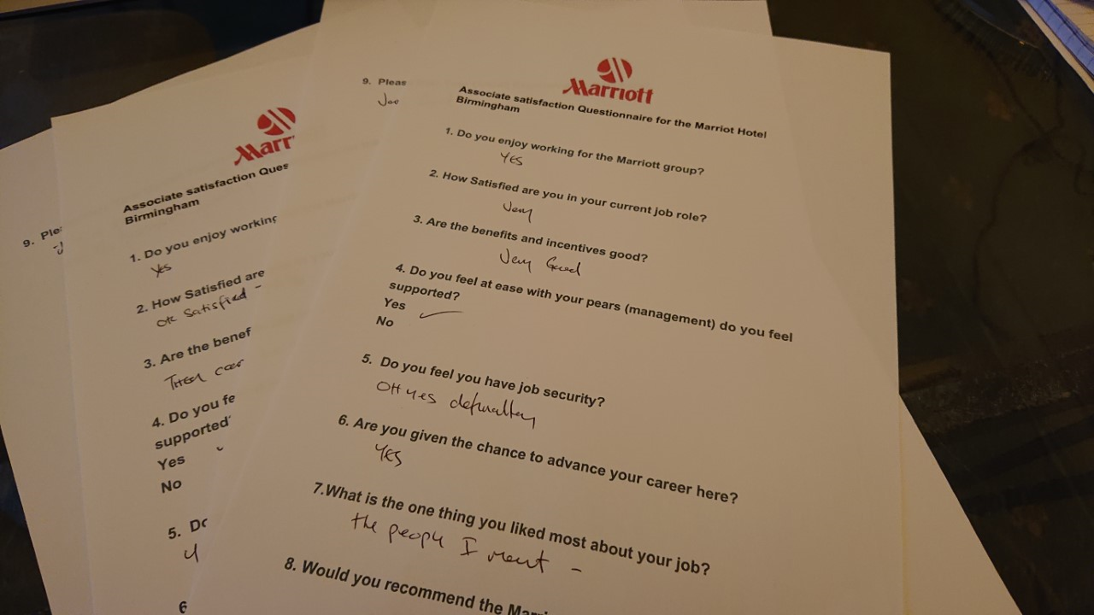

Conclusion
Whilst researching and drawing from my personal experience of working at the Marriot Birmingham hotel, I would conclude as an employer they are committed to enhancing and nurturing the talented work force in to lifelong employment, all the necessary requirements are fulfilled and offered to the staff for future development and career progression. I feel some areas may be improved upon, enhancement of management skills seems to be a clear case according to indeed reviews and in some cases clearer progression paths for outstanding induvials.

References
Cannon J.A., McGee R. (2007), Talent Management and Succession Planning. London: Chartered Institute of Personnel and Development
(https://www.statista.com/statistics/297269/number-of-marriott.)(accessed 21/11/19)
(https://jobs.hilton.com)(acsessed19/11/19)
(www.careers.marriott.co.uk)(acsessed19/11/19)
(www.Hiltoncareers.com)(acsessed17/11/19)
(www.indeed.co.uk) (accessed on 17/11/19)
(https://www.indeed.co.uk/cmp/Indeed/reviews)
(www.Hiltoncareers.com)(acsessed17/11/19)
(https://www.indeed.co.uk/cmp/Indeed/reviews)(acsessed 20/11/19)
Rothwell W.J., Kazanas H.C. (2003), The Strategic Development of Talent. HRD Press
(https://www.researchgate.net/publication/311357150_The_impact_of_recognition_on_retention_of_good_talent_in_the_workforce)
Mngomezulu, Nonhlanhla & Challenor, Martin & Munapo, Elias & Mashau, Pfano & Chikandiwa, Christopher. (2015). The impact of recognition on retention of good talent in the workforce. Journal of Governance and Regulation. 4. 10.22495/jgr_v4_i4_c3_p2.
www.managementjournals.com/journals/ig/vol1/21-1-1-1.pdf

