

Enhancing User Acceptance testing in the Welsh Nursing Care Record

by
Emily Rose Stockdale

Supervisor: Dr Nik Whitehead
Second Marker: Divya Chidambaram

Project submitted as part of the
requirements for the award of
BSc (Hons) Computing (Data and Information Systems)

July 2023

DECLARATION

I, Emily Rose Stockdale declare that I am the sole author of this Project; that all references cited have been consulted; that I have conducted all work of which this is a record, and that the finished work lies within the prescribed word limits.

This work has not previously been accepted as part of any other degree submission.

Date : 21/07/2023

FORM OF CONSENT

I, Emily Rose Stockdale hereby consent that my Project, submitted in candidature for the B.Sc.(Hons) Computing (Data and Information Systems) degree, if successful, may be made available for inter-library loan or photocopying (subject to the law of copyright), and that the title and abstract may be made available to outside organisations.

Date : 21/07/2023

ABSTRACT

The Welsh Nursing Care Record (WNCR) is a multi-instance application managed and maintained by Digital Health and Care Wales (DHCW) and used in inpatient Adult Nursing settings across Wales. Aimed to standardise nursing forms and offer a digital alternative. WNCR has brought significant improvements, enabling the completion of online assessments at a patient’s bedside improving accuracy, reducing duplication, and saving time. Due to its rapidly evolving requirements and ever-growing functionality, WNCR requires robust and well-organised processes from the design phase through to the deployment phase.

A review of literature together with the collection of primary data lead to the conclusion that current User Acceptance Testing (UAT) documentation was vague and required updating. Additionally, an interactive and informative Power BI dashboard would be beneficial for progress updates and reporting purposes.

This report aims complete an analysis of current UAT practices and processes in the Welsh Nursing Care Record and propose improvements for future releases. This will be done by:
- Analysing current processes to identify where improvements should and could be made.
- Working collaboratively with the National WNCR Support team, service leads and Chief Nursing informatics Officers (CNIOs) to collect feedback and identify process and product requirements.
- Introducing a robust UAT process for the WNCR.
- Creating a user friendly, informative WNCR UAT dashboard (MVP to be developed by July 2023).
The main source of data collected for this project came from primary sources through the collection of qualitative data. Questionnaires were circulated to the relevant participants enabling the collection of process and product requirements. Due to the specialist nature of the topic at hand, it was not necessary to distribute the questionnaire to a large pool.
The main recommendations are:
- Continue adopting the ‘Watergile’ approach to development and testing.
- Ensure that testing is completed against Mobile Devices
- The addition of a ‘sand box’ environment

CONTENTS PAGE
Table of Contents
ABSTRACT 3
CONTENTS PAGE 4
TABLE OF FIGURES/TABLES 6
Table of Figures 6
Table of Tables 6
ACRONYMS 7
ACKNOWLEDGEMENTS 8
CHAPTER 1 - INTRODUCTION 9
1.1 Introduction 9
1.2 Project aims and objectives 11
CHAPTER 2 - RESEARCH & REVIEW OF LITERATURE 12
2.1 Introduction 12
2.2 Software development Methodologies 12
2.3 History of UAT 25
2.4 UAT Testing Process 25
2.5 Challenges in UAT Testing 29
2. 6 Best Practices for UAT testing 31
2.7 Conclusion 33
CHAPTER 3 - RESEARCH AND/OR DEVELOPMENT METHODOLOGY 34
3.1 Research Methodology 34
3.2 Development Methodology 40
3.3 Resources 40
CHAPTER 4 - DESIGN & IMPLEMENTATION 41
4.1 The WNCR UAT Process 41
4.2 Updates to the current flow and SharePoint list 42
4.3 SharePoint List Changes (front end) 43
4.4 The creation of the dashboard 46
CHAPTER 5 – EVALUATION 50
5.1 Conclusions drawn from Data collected 50
5.2 Aims and objectives 53
5.3 Conclusion of the results 54
CHAPTER 6 - CONCLUSIONS AND RECOMMENDATIONS 55
6.1 Conclusion 55
6.2 Recommendations 56
6.3 Avenues for future Research 57
CHAPTER 7 – REFLECTION 58
CHAPTER 8 – REFERENCES 59
References 59
APPENDICES 64
Appendix 1 64
Appendix 2 65
Appendix 3 67
Appendix 4 68
Appendix 5 71
Appendix 6 72
Appendix 7 76
Appendix 8 78
Appendix 9 86

TABLE OF FIGURES/TABLES

Table of Figures
Figure 1 WNCR Monthly User Statistics [3] 9
Figure 2 The Waterfall Model [16] 13
Figure 3 Agile Life Cycle [28] 16
Figure 4 Agile Manifesto [29] 17
Figure 5 Sprint Flow 19
Figure 6 RUP Phases 20
Figure 7 Key UAT Stages [52] 25
Figure 8 Flow Diagram 42
Figure 9 Status comparison 44
Figure 10 Category comparison 45
Figure 11 DHCW WNCR UAT 2.2 Data Dashboard 47
Figure 12 Implementing Row Level Security 48
Figure 13 Powys Dashboard 48
Figure 14 Roles and Responsibilities 51
Figure 15 Flow Update 51
Figure 16 Feedback on questionnaire (Appendix 2) 52
Figure 17 Responses from question 7 (Appendix 3) 52
Figure 18 Aim and Objectives 53

Table of Tables
Table 1 Comparison of Agile vs Waterfall 23
Table 2 Types of Testing 27

ACRONYMS

WNCR – Welsh Nursing Care Record
DHCW – Digital Health and Care Wales
UAT – User Acceptance Testing
CNIO – Chief Nursing Informatics Officer
SDLC – Software Development Life Cycle
SIT – System Integrated Testing
FDD – Feature Driven Development

ACKNOWLEDGEMENTS

I would like to thank my family and friends who have supported me and given me the strength to complete this piece of work. To my partner Rhys for being extremely patient with me even during my weekly breakdowns. To my parents for the continuous encouragement, I hope I’ve made you proud.

I would also like to thank my good friend and colleague Kieran Guy for mentoring me throughout this period. Thank you for your continuous support, patience, and assistance.

A special thank you to the staff at Starbucks Corryton for supplying endless coffee and being patient and creative when I ask for a ‘surprise’ to drink!

To my peers, Sharla, Bryoni, Brandon and Katie thank you for laughing, crying, and helping me through this piece of work. Making this experience a fun one.

A big thank you to Stephen Hole for being a great student liaison officer and continuously supporting and motivating me not only through this project but throughout the whole degree.

Finally, thank you to my supervisor Dr Nik Whitehead for the continuous support and taking the time to understand my unique ways of working. Providing guidance and support while maintaining a calm approach.

CHAPTER 1 - INTRODUCTION

1.1 Introduction

The Welsh Nursing care record (WNCR) [1] is a multi-instance application used by nursing staff across Wales managed and maintained by Digital Health and Care Wales (DHCW) [2]. WNCR went live across multiple Health boards in Wales in April 2021.

Prior to the development of WNCR, E-forms were a priority for Welsh Government and Digital Health and Care Wales (Previously NWIS). Funding for WNCR was acquired through the Efficiency Through Technology Fund (ETTF) and was supported due to the significant benefits associated with standardising nursing forms and introducing a digital alternative [1].

Since April 2021 WNCR has been introduced to all Health Boards across Wales, each Health Board introduced WNCR at different times depending on internal project scope [3].

- Swansea Bay University Health Board – April 2021
- Velindre University NHS Trust – April 2021
- Hywel Dda University Health Board – April 2021
- Powys Teaching Health Board – June 2021
- Cwm Taf Morgannwg University Health Board – August 2021
- Betsi Cadwaladr University Health Board – March 2022
- Cardiff and Vale University Health Board – August 2022
- Aneurin Bevan University Health Board – November 2022

WNCR allows nurses in inpatient settings to complete online assessments at a patient’s bedside. Prior to the development of WNCR research found that the paper-based forms that nursing staff were required to complete were complex and time consuming, and as a result were often not completed in full [1]. The aim of WNCR is to digitalise paper-based form filling to improve accuracy, minimise duplication and save time.

Since WNCR go-live in April 2021 there has been a total of 7,670,648 risk assessments completed across NHS Wales. With a total of 193,422 users accessing the application since then (Appendix 1). Figure 1 displays user activity from April 2021 – June 2023.
.
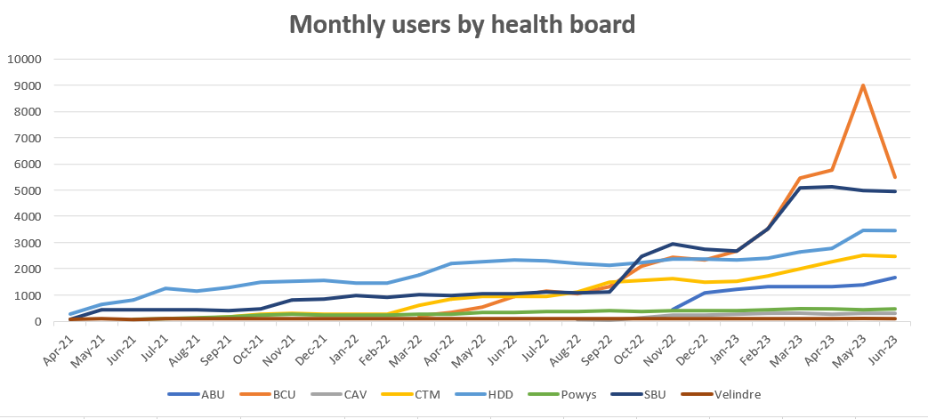
Figure 1 WNCR Monthly User Statistics [3]

As WNCR is a relatively new application, processes have been put in place but have evolved during each deployment cycle, adapting to stakeholder needs and implementing new techniques based on lessons learned. However, DHCW aims to introduce a single instance version of WNCR (version 2.3) in quarter two of 2023.

The final stage of development prior to deployment is User Acceptance Testing [4], this task is completed by stakeholders otherwise known as all Local Health Boards across Wales. This process has evolved during every version release, meaning that there has been a lack of consistency despite a formal process being in place. The aim of this project is to evaluate and improve the UAT process in readiness for Version 2.3 of WNCR with the addition of a user friendly, informative dashboard.

1.2 Project aims and objectives

Aim: To complete an analysis of current UAT practices and processes in the Welsh Nursing Care Record and propose improvements for future releases.

Objectives:
- To analyse the current process and identify where improvements should and could be made.
- To work collaboratively with the National WNCR Support team, service leads and Chief Nursing informatics Officers (CNIOs) to collect feedback and identify process and product requirements.
- To introduce a robust UAT process for the WNCR.
- To create a user friendly, informative WNCR UAT dashboard (MVP to be developed by July 2023).
Project Deliverables:
- The creation of robust UAT process documentation for the WNCR.
- A user friendly informative WNCR UAT dashboard containing data from issued raised during UAT testing of WNCR Version 2.2.

CHAPTER 2 - RESEARCH & REVIEW OF LITERATURE

2.1 Introduction

2.1.1 Purpose of the literature review
This aim of this literature review is to gain an understanding of existing research and debates relevant to user acceptance testing. Previous research and theories, areas of controversy, and gaps in research to date will be analysed and identified. This will provide context relating to the topic at hand and reduce duplication.
2.1.2 Definition of User Acceptance Testing
User Acceptance Testing (UAT) is defined as the final stage of testing in software and application development [5]. The UAT process is used to gather feedback from users to ensure that software meets user requirements. Additionally, the UAT process is used to determine where problems such as bugs may exist in a new software application or a major upgrade [6].
2.1.3 The importance of User Acceptance Testing
The UAT process is used to validate testing at the end of a development cycle, formally UAT is completed after unit testing, quality assurance and integration testing [7]. Gills [8] suggested that UAT safeguards against, unfinished, ineffective, and defective software being released into a live environment.

2.2 Software development Methodologies

Software development methodology is defined by Hoffer, George, and Vlacich [9] as “A standard process followed in an organisation to conduct all the steps necessary to analyse, design, implement and maintain information systems.”
To enhance the software development process several software development methodologies have been introduced and adopted globally [10]. Dima [11] states that Internet technology is one of the most innovative fields, encountering tremendous development over the last three decades. The increase of digitalisation across all sectors has resulted in increased pressure on innovation necessity, resulting in the establishment of new software development models.
2.2.1 Overview of the Waterfall Model
The waterfall model was formally introduced in software development by Winston Royce in 1970 [12]. Prior to this there were no other formal software development methodologies in existence [13]. The waterfall model was the first software development model introduced and was widely accepted by corporate organisations with large software projects [10]. It was thought that the control mechanisms introduced by the waterfall model would aid in minimising cost and time while ensuring that applications were meeting user requirements [14].
When using the waterfall model, to enable the development process to begin a design review must first be completed. There are four critical reviews which must be completed to enable the development stages [15]:
- Conceptual design review
- Requirements review.
- Preliminary design review (PDR)
- Critical design review (CDR)
The Waterfall method works in a sequential order following a formal step by step process. According to Lawal [10] these steps are repeated until the software has been completely developed. These steps include but are not limited to [15]:
- Software analysis, identifying requirements and specifications.
- Software/application design
- Implementation (into test environments)
- Testing and Maintenance
- Implementation (into a live environment/s.)
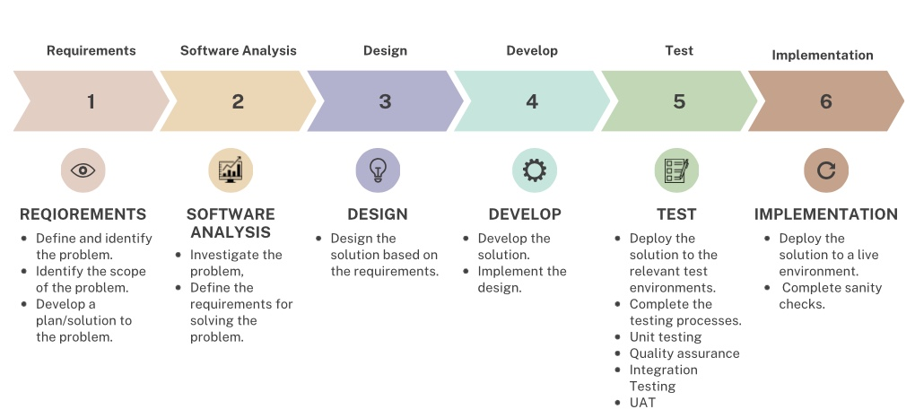
Figure 2 The Waterfall Model [16]
Eason [13] agrees that the waterfall model is characterised by separate and distinct phases of specification and development, following this model each phase must be complete before moving on to another. Following the completion of each phase, a review is completed to ensure compliance with requirements outlined in phase one of the process. Figure 2 displays a flow diagram and a brief description of how each step works when adopting the waterfall model.
2.2.2 Benefits of the Waterfall Model
The waterfall model is a traditional software development model which follows a linear and sequential approach [17]. While the waterfall model remains commonly used globally, although there are modern development practices that are favoured such as Agile methodologies.
There are many benefits associated with the waterfall model with many agreeing that the simplistic nature of the model, makes it straight forward and easy to follow with its step-by-step process [14]. Therefore, making the waterfall model suitable for small well-defined projects with pre-defined requirements. The waterfall approach continues to be the most popular model used for software development, Adetokunbo et al [18] suggest that due to its linear and structured approach it is simple to implement and less expensive. Khan et al [19] agree that due to its linear structure obstacles are easier to identify and rectify making projects more likely to be completed and less likely to be abandoned halfway through the development process.
The promotion of extensive documentation at each phase ensures that there is a clear record of project decisions, requirements, and design choices at each stage [13]. Additionally, the use of documentation can be beneficial for regulatory compliance, maintenance, and future reference.
The emphasis on upfront on requirement gathering and documentation requirements, helps define clear objectives and milestones from the very beginning. Khan et al [19] highlights that this is useful in projects where the scope is well defined and unlikely to change significantly. When managing a project and developing a product using the waterfall framework, requirements, final objectives, and deliverables are agreed as the first step of the process, this can be seen as one of its key benefits [19].
Mahadik [20] highlights that the waterfall model is best suited to stable environments, meaning that it is better suited to environments where there are minimal uncertainties and changes expected. McCormick [12] agrees that the waterfall model is suitable for software that doesn’t require major changes. This is because the sequential nature of the model requires each phase to be completed prior to moving on to the next.
Awad [21] states that a positive aspect of the waterfall model is the stakeholder engagement at the early stages of the project such as requirement gathering and the initial design, this is said to establish clear communication and expectation between both the stakeholder and development team. Javanmard et al [22] agrees that stakeholder engagement and good working relationships are critical to delivering an effective service.
2.2.3 Criticisms of the Waterfall Model
When the waterfall model was first introduced by Royce in 1970 [12], it was introduced as a flawed software development method and described as vulnerable due to its many shortcomings.
Contradictory to Adetokunbo et al [18] Redkyn [15] states that the waterfall model is unstable due to its specification phases requiring fixed client requirements prior to the development process, meaning that any requirement evolution destabilises the development process. Similarly, Balaji [23] suggests that despite having distinct phases of specification and development often problems which arise during early phases are not completely solved, occasionally resulting in poorly structured software.
Adetokunbo et al [18] suggest that the ‘most obvious’ disadvantage of the waterfall model is the inability to evaluate the outcome at each stage before moving on to the next. This can be especially difficult when stakeholders identify that initial requirements are no longer appropriate as there is no scope for revisiting a previous phase.
Despite stakeholder engagement being seen as a benefit of the waterfall model it has also been highlighted as a disadvantage as stakeholder engagement is limited to initial requirement gathering and design stages. Stakeholders typically have little to no involvement post requirement gathering and initial design until the testing phase begins, leaving little to no opportunity prior to testing for feedback. Resulting in the product potentially not meeting stakeholder requirements or expectations [19].
Khan et al [19] argue that due to the structure of the waterfall model, testing is not completed until late in the development stage meaning that any bugs and major defects identified may take a prolonged period to fix. Therefore, resulting in delays to completion of the software and live deployment. Kramer [24] agrees that due to the late introduction of testing using this model any changes in requirements or major functionality changes may cause a significant delay.
2.2.4 The Agile Approach
Agile has been defined as “a wide umbrella of software development beliefs” and is known as a conceptual framework for software engineering [25]. Agile is the most recent model to be introduced to the software development industry. This model encompasses multiple methodologies based on iterative and incremental models of software development [26]. The principle of this model is to provide stakeholder satisfaction by providing continuous delivery of small and useful software. It has been statistically proven that over the last twenty years projects using agile software implementation methods have produced three times as many successful outcomes in comparison to the waterfall model [27].
Agile software development methodologies are a set of approaches that prioritise flexibility, collaboration, and iterative development to deliver high quality software products [28]. Unlike the waterfall model Agile emphasises adaptability, responsiveness to change and frequent stakeholder engagement. Essentially, Agile promotes a constant cycle of development (Figure 3).
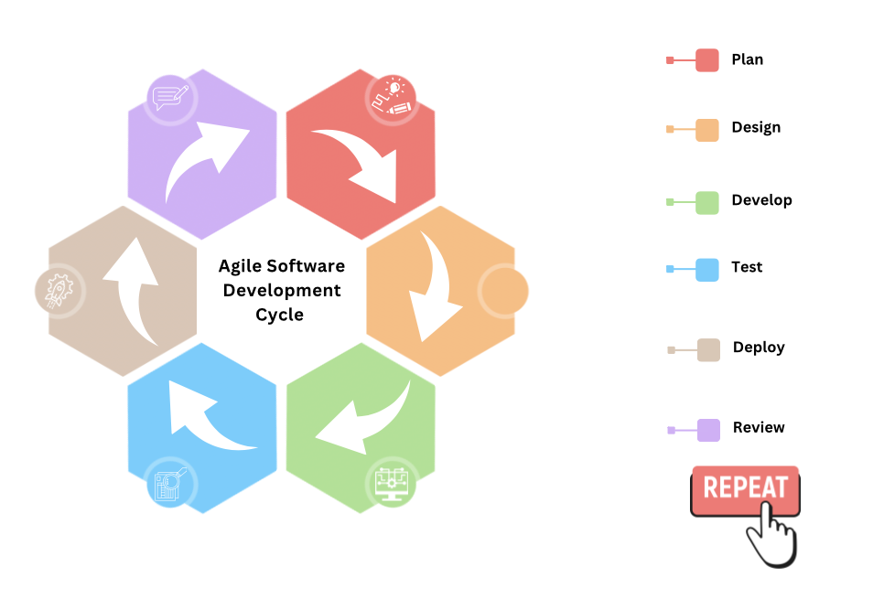
Figure 3 Agile Life Cycle [28]
Additionally, Agile is guided by the Agile Manifesto. The agile manifesto incorporates four main values and 12 principles (Figure 4), each focusing on collaboration, flexibility, and responsiveness to change [29].
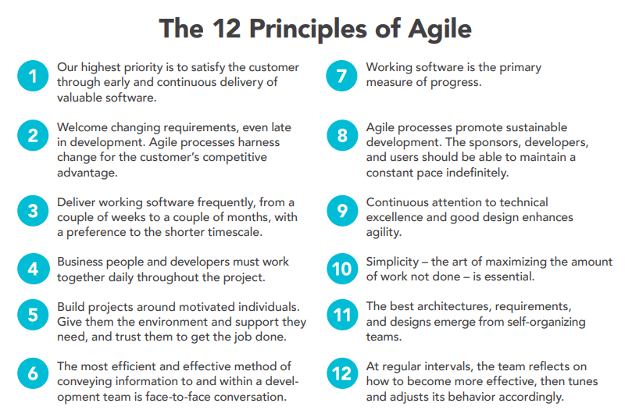
Figure 4 Agile Manifesto [29]
Agile is a framework that encompasses multiple methodologies these can include but are not limited to:
2.2.5 Feature Driven Development (small projects)
Feature driven development (FDD) was introduced in 1997 by Jeff De Luca and Peter Coad [30]. FDD was introduced by a project manager managing a project which was deemed too complex to be completed with the available resources and traditional software development strategies [30].
FDD is an agile, highly adaptive software development process that is [25]:
- Highly and short iterative.
- Emphasises quality at all steps.
- Delivers frequent, tangible working results at all steps.
- Provides accurate and meaningful progress and status information while minimising disruption to developers.
- Liked by stakeholders, managers, and developers.
FDD works by breaking down features, each feature that is identified as too complex for implementation within two weeks is further decomposed into smaller features until each sub-problem is small enough to be considered a feature [31].
There are six main roles in FDD method, each role can be done by more than one person, and one person can take on many roles. These roles include [25]:
- A project manager, responsible for leading on the project at hand.
- A lead architect, responsible for the overall design of the product, final design approval should be done by this individual.
- Lead developer, the lead developer is responsible for the development team. This individual is responsible for managing complex development issues and managing conflict between teams where required.
- Lead programmer, this individual is required to lead the development process in small teams, leading analysis, design, and implementation steps of a project. Additionally, this individual is responsible for selecting which features are required during each iteration and resolving complex implementation problems.
- Class owner, the individual responsible for designing, coding, and testing features.
- Domain expert an expert in the business who has clear understanding of business processes and requirements. This individual is responsible for providing knowledge about the business and the requirements of the product.
2.2.6 Scrum
Scrum methodology was first introduced in the mid-nineties by Ken Swaber [32]. Scrum is recognised as the most popular agile development method. The Scrum process involves collaborative working with a team mentality to deliver a project in good time at minimal cost. Scrum has been defined in The Scrum Guide 2020 [33] as “a lightweight framework that helps people, teams and organisations generate value through adaptive solutions of complex problems”.

The Scrum workflow requires a Scrum master to foster an environment where [34]:
- A product owner orders work for a complex problem into product backing.
- The Scrum team turns a selection of the work into an increment of value during a sprint.
- The Scrum team and its stakeholders to work into an increment of value during sprint.
- Repeat
As part of the workflow Scrum encompasses a sprint, a sprint is the smallest block of Scrum where a team works collaboratively on a small task [35]. A sprint can last between one and four weeks. Sprints are typically made up of four key phases: plan, build, test, review [28].
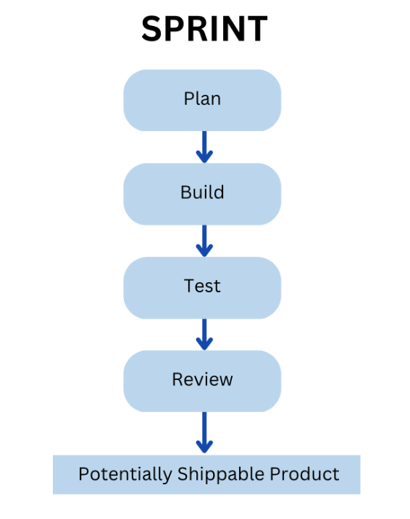
Figure 5 Sprint Flow
The aim of each sprint is to deliver a potentially shippable product. Fagarasan et al [27] emphasise that changes can only be made in Scrum when a new sprint starts. To enable Scrum to be highly adaptable, during a sprint a daily Scrum takes place, the aim of the Scrum is to evaluate progress of daily assigned tasks [28].

2.2.7 The Rational Unified Process (RUP)
The rational Unified Process (RUP), used for larger Agile projects was first marketed and developed by Rational Software corporation, a division of IBM [36]. RUP is known for its disciplined approach to the management and assigning of tasks and responsibilities during development [37].
RUP is a web-enabled, object-oriented development methodology said to pose as an online mentor providing guidelines, templates, and examples on all stages of development [38]. RUP focuses on the Unified Modelling Language (UML), an industry-standard language that promotes well communicated requirements, architecture, and design [39].
RUP uses a unifying framework to combine procedural aspects of development such as well-defined phases, techniques, and practices with other components of development such as documentation, diagrams, training tools and models [39].
Despite adopting an agile approach RUP follows incremental iterations to enable the collection of user feedback, this helps ensure that the software solution aligns with user requirements. RUP is defined by following three central elements these include key principles for business-driven development, A framework of reusable method, product building blocks and finally the underlying method and process of definition language. Focusing on software engineering key principles formally known as a best practice.
There are four main phases when adopting RUP methods (figure 6) [37]:
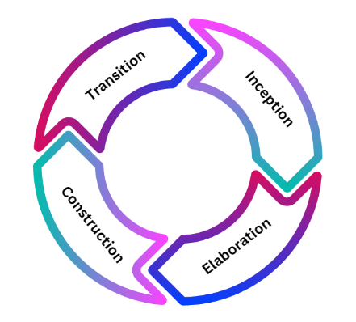
Figure 6 RUP Phases
Additionally, there are disciplines associated with each iteration these are known as [37]:
- Business modelling
- Requirements
- Analysis and design
- Implementation
- Testing and deployment.
Like other software development methodologies, UAT is completed during the final stages of development. When adopting RUP testing is done during the transition phase which focuses on the testing and deployment of a product. However, specific timing of UAT can vary depending on the project at hand and the organisation.
2.2.8 Criticism of the Agile Model
Despite agile methodologies being the most modern and recently introduced model there are still criticisms of the models. Agile methodologies are criticised for their lack of predictability, both Scrum and FDD are known for their iterative and incremental approach, however it is suggested that this can make it challenging to accurately predict project deliverables and deadlines. It is argued that the focus on flexibility and adaptability can result in difficulties linked to long term planning and meeting fixed deadlines [19].
Different from the waterfall model agile methodologies prioritise working products over documentation. According to Agrawal et al [40] this can lead to inadequate documentation making it difficult for future maintenance and compliance.
Agile methodologies work best when working on small to medium sized projects [41]. It is argued that co-ordination, communication, and consistency can be made difficult when using agile across larger originations and projects, this is due to scalability [42]. As the scale increases maintaining this is key. However, it becomes more difficult resulting in reduced productivity across the project.
Elkhatib et al [43] argue that the use of agile methodologies can result in scope creep, this is because of the project scope continuously increasing without control protocols. Álvarez [44] agrees that this can be a result of frequent changes in requirement and poor change management causing an impact to project timelines and scheduling, budgets, and overall project stability.
2.2.9 Benefits of the Agile Model
Contradictory to Seeda et al [42], Kautz et al [45] state that agile methods can lead to increased productivity, specifically Scrum. The use of sprints in Scrum is suggested to foster productivity, this is because workload is broken into manageable chunks with clear deliverables within each sprint. Khan et al [19] agrees that by breaking down tasks within a project in agile improves manageability of projects and in turn enables the effective delivery of project deliverables. Similarly, the incremental feature driven approach of FDD breaks the development process down into manageable features [31]. This allows teams to appropriately prioritise workload, deliverables and manage and react to change effectively.
The use of agile methodologies is said to improve working relationships due to its emphasis on team working. It is said that individuals can work collaboratively on the same common goals leaving individual interests behind [46]. The emphasis on clear ownership and accountability across agile models specifically Scrum is suggested to increase productivity, collaboration and as a result improve the quality of the final product [47].
A key benefit associated with agile methods is continuous and enhanced stakeholder collaboration; Scrum specifically emphasises close collaboration with stakeholders throughout the development process [48]. This ensures that the product aligns with stakeholder needs which in turn results in higher stakeholder satisfaction. Additionally, ability for users to review and test product functionality throughout the project and make changes where appropriate makes the project more adaptable in nature [46].

2.2.10 A comparison of agile vs waterfall
Aspect | Waterfall Model | Agile Model
Primary goals | Stability, high assurance, predictability | Rapid value, responding to change
User Requirements | Detail, documentation and definition prior to design, development, and implementation. | Continuous input throughout each stage.
Stakeholder/client relations | Clear engagement at the beginning of the project and during the testing phase. | Continued stakeholder engagement throughout.
Communications | Formal | Informal
Requirements | Specific predicted and developed using detailed planning. Requirements are established at the beginning of a project and well documented. | Feedback based and adaptable. Focuses on continued improvement, development, and testing.
Development | Fixed, changes to requirement are not permitted. | Flexible, changes can be made during development.
Testing | Done at the end of the development phase. | Continuous testing throughout the development phase.
Quality Control | Testing is done at the very end of the development stages and can be difficult to co-ordinate. | Testing is done continuously throughout the design and development process.
Table 1 Comparison of Agile vs Waterfall [13] [19]

2.3 History of UAT

UAT testing is part of all standard software development methodologies, however it is implemented at different stages within each methodology. UAT testing is completed by stakeholders to validate product usability, functionality and ensure that the product meets user requirements regardless of the methodology used [7].
When using the waterfall method, UAT is done at the very end of the development process. Product requirements are identified and agreed prior to the development process and UAT is completed following Unit testing, and System Integrated Testing (SIT Testing) and is the last step before deployment into a live environment [18]. Typically, UAT testing is done once when applying the waterfall model making testing more cost effective.
Similarly, in Agile methodologies UAT is performed during the later stages of each iteration or sprint toward the end of the development lifecycle [49]. The timing of UAT can vary depending on the method used and depending on team preferences and specific project requirements [5]. When implementing Scrum UAT is done at the end of each sprint [50].
However, regardless of its timing agile emphasises continuous development, collaboration, and stakeholder involvement throughout the SDLC [29]. Agile methodologies promote a continuous loop of feedback with stakeholders enabling active participation in UAT [49]. Due to the nature of Agile methodology UAT is often completed multiple times throughout the development process which can result in increased cost.

2.4 UAT Testing Process

2.4.1 Overview of User Acceptance Testing process
During the development process software developers use a range of environments these are known as system integrated testing (SIT) environments, User Acceptance Testing (UAT) environments and LIVE environments [51]. Both SIT and UAT are environments used only for the purpose of testing and contain test data only, whereas LIVE environments contain live patient/client data.
The UAT process is a process which varies depending on internal organisational processes and procedures [52]. The process of user acceptance testing is completed by subject matter experts and target users, it is often repeated multiple times throughout the development process [19].
To enable the UAT process to work effectively there are many key stages (Figure 7) these key stages aid in ensuring product validity throughout the UAT cycles.
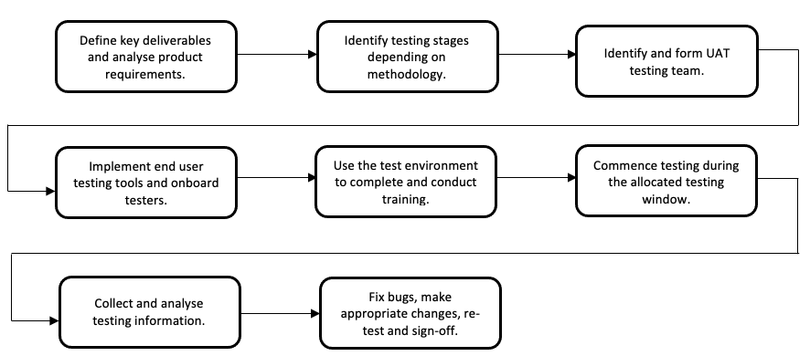
Figure 7 Key UAT Stages [53]
Prior to UAT testing, product requirements must first be analysed, and key deliverables should be identified and agreed. This stage enables those testing to have a benchmark to measure against to ensure that the application meets business requirements.

Cimperman [54] states that to ensure that all stakeholders and assigned testers are aligned with the same testing objectives a UAT plan should be provided. This plan should contain a list of all elements of the application should be tested, this will vary depending on the application and what stage of development the application is in.
This plan should contain [55]:
- Main functionality to be tested.
- Changes in functionality (in the case of an upgrade)
- Bug fixes.
- Known issues that may not be resolved until a future version upgrade.
For each element a description of expected behaviour should be provided, this allows the test teams to identify if an application is working as intended or if there is a bug present.
2.4.2 Types of UAT Testing
Depending on the context and requirements of the project at hand, the approach to testing can vary. Additionally, a combination of multiple approaches can be used for the completion of UAT (Table 2, page 27). Nadiyah et al [56] state that alpha and beta testing are among some of the most used approaches during UAT.

There are many testing approaches that could be used, these can include but are not limited to:
Testing Type | How it works
Alpha Testing | Conducted by a select group of end users in a controlled environment. The main aim of alpha testing is to validate software functionality, usability, and overall performance. Typically, Alpha testing helps identify potential bugs, issues with functionality, and suggestions for improvement.
Beta Testing | Beta testing involves a larger testing pool with more participants, these participants are representative of the target audience. Like alpha testing beta testing helps gather user feedback and validate product performance using a wider range of scenarios. Additionally, Usability issues are identified during beta testing.
Contract Acceptance Testing | The aim of contract testing is to ensure that the software meets the agreed requirement specifications outlined in a formal contract. The focus is to verify that all contractual obligations have been met before formal acceptance.
Regulatory Compliance Testing | Regulatory compliance testing is used specifically to test software that needs to adhere to industry specific regulations, standards, and legal requirements. This type of UAT ensures that mandatory compliance requirements and mandatory audit checks are completed prior to acceptance.
Operational Acceptance Testing | Operational acceptance testing focuses on a products readiness for operational use. Testing focuses on performance, scalability, reliability, security, and compatibility. The aim is to ensure that the product can be successfully and smoothly integrated into its intended environment and can handle the anticipated operational load.
Usability Testing | Usability testing focuses on testing if the product is user friendly and simple to use. Usability testing involves multiple tests such as click tests, A/B testing, and cognitive walk throughs followed by feedback on user experience. This type of testing identifies if there are any improvements required associated with the usability of a product to improve overall user experience.
Table 2 Types of Testing [53] [55]

2.4.3 UAT roles and responsibilities
To enable the completion of UAT testing a team is required from both the service provider and stakeholder perspective. UAT testers are responsible for conducting the testing during the UAT period, this requires various teams and participants. These participants include but are not limited to [57]:
- Subject matter experts (stakeholders)
- Test team (Service provider)
- Support teams (Service provider)
The stakeholders are responsible for validating product usability, functionality and ensuring that the product meets user requirements regardless of the methodology used. According to Digital Health and Care Wales UAT testers are responsible for [55]:
- Assisting with the creation of UAT test plans.
- Creating UAT test cases.
- Assisting with the creation of test scripts.
- Executing UAT test scripts.
- Providing feedback to the project team for what is being implemented.
- Signing off UAT test plans, scripts, and reports.
- Logging and re-test defects as required.

2.5 Challenges in UAT Testing

2.5.1 Common Challenges
During UAT various challenges can arise, these challenges can be related to both the testing process, environment, and the product itself.
To enable successful, accurate and meaningful testing the test environment needs to accurately mimic the live environment [58]. It is critical that the UAT environment is a replica of the live environment incorporating the correct data, services, and infrastructure to enable accurate testing of functionality, user experience and performance. Mcclung [58] suggests that often organisations ‘settle’ for an environment that is limited, increasing risks of bugs and issues with functionality being released to a live environment.
UAT time frames are often agreed at the beginning of a project, the criteria for standard time frames are agreed to set expectations [58]. Often UAT is set to a two-week timeframe however, this can vary depending on projects. Pillai et al [59] agree that timeframes are agreed an early stages to help manage expectations.
However, unforeseen circumstances can arise which can lead to delays in UAT release [54]. Additionally, UAT testing can identify unexpected issues with a product which can result in further release and testing prolonging the initial testing period and delaying acceptance and live releases [15].
Often projects contain ambiguous requirements, at the testing phase it can be identified that the product doesn’t meet requirements or that the initial requirements have changed since the design and development phase [15]. These issues are likely to then be logged as a defect or a bug resulting in further development in readiness for the same release [10]. It is argued that stakeholders don’t often consider the impact these changes can have on release planning.
2.5.2 Mitigation strategies for UAT challenges
Addressing challenges during the UAT process can be complicated however steps can be taken to mitigate these challenges. Proactive planning, communication and collaborative working between developers, stakeholders and test teams can help mitigate these challenges before they arise. This can be done by ensuring that all participants are aligned and clear on their roles and responsibilities during the test period [60].
Release notes are used to communicate what is being delivered to the target environment. This document is used to assist testers during UAT providing detail on what to expect from the product and specific functionality [49]. The contents of release notes will vary depending on the stage of development, whether this is the first release of a product or a system upgrade. Additionally, this document will change between release to test environments and live environments [61].
As timeframes are agreed early into the development process it’s recommended that an additional week or two are added to the testing period to allow for potential delays, this could be seen as a remediation period [62].

2. 6 Best Practices for UAT testing

2.6.1 Information Governance
Test data is used to accurately reflect real world scenarios; therefore, this data needs to replicate the data in the live environment. In some cases, particularly within the NHS there are complexities linked to test data. It is suggested by Digital Health and Care Wales manually inputting data for large testing pools can be seen as time consuming [55]. Therefore, it’s recommended that for each project the utilisation and anonymisation of live patient data is used to mimic complicated scenarios that occur in the live environment. Anonymisation and data scrambling is essential to ensure compliance with GDPR [63] and The Data Protection Act 2018 [64].
Additionally, artificial test data could be generated and utilised in test environments. It is said that artificial test data enables flexibility and can be customised to meet testing needs. BCS [65] suggests that artificial test data provides testing teams with full control over the data generation process, this is seen as a key benefit as it supports the capability of testing various scenarios [66].
Test data requirements vary depending on project requirements, in a commercial setting based on the creation of unique scenarios artificial test data could be deemed appropriate. However, scrambled data provides the benefit of realism, retaining the properties and relationships present in original data [67]. Additionally, the use of scrambled data preserves the integrity of the data and overall structure and relationships [55].
2.6.2 Factors contributing to successful UAT
There are many contributing factors to successful UAT cycles, collaborative working between service providers and stakeholders is key to ensure that each contributing factor is considered to enable seamless testing [60].
Early involvement of stakeholders ensures that from the beginning of the design and development process both the development team and the stakeholders have a clear understanding of requirements [68]. Additionally, early stakeholder involvement aids in setting clear expectations and ensures that goals are aligned. Engaging stakeholders from the beginning avoids miscommunication and allows for better collaboration.
Ensuring these acceptance criteria are well defined is crucial for a successful outcome. Outlining these criteria will ensure that measurable objectives can be set [69]. Additionally, these criteria provide guidance throughout the testing process and further ensures that stakeholders have a clear understanding of what is expected from the software [70].
Defining scope, identifying test scenarios, outlining test cases, and determining necessary timelines are all part of test planning [55]. Thorough test planning is essential for a successful UAT cycle. Comprehensive test planning enables the execution of thorough tests, optimisation of resources, and ensures sufficient coverage of critical functionality.
The aim of UAT is for products to be tested to ensure that a product is suitable for deployment to its indented environment [6]. Testing happy and unhappy paths are critical to ensure that testing has been completed to the highest standard [71].
Happy path testing also known as positive testing, is a technique to ensure that the most common use cases are tested thoroughly [72]. This technique should be used in conjunction with other testing techniques and is beneficial for regression testing as it said to be an easy way to ensure that no new bugs have been introduced to the product [73].
Additionally, testing unhappy paths also known as negative testing aims to identify product defects [73]. Unhappy testing is completed by inputting unexpected data such as special characters. The aim is to ensure that errors are managed gracefully and that a product does not crash because of negative inputs [72]. Overall ensuring that both happy and unhappy paths are tested ensures that a product has been tested thoroughly and improves both the quality and stability of a product while ensuring there are no bugs present.
Communication and collaboration are vital, this ensures that expectations are understood, feedback is shared, and issues are addressed and resolved promptly during UAT. Collaborative working, effective communication and transparent feedback are essential to enable a successful UAT cycle [60].

2.7 Conclusion

2.7.1 Summary of Key findings
In conclusion, this literature review provides insight into the concepts of User Acceptance Testing (UAT) and software development methodologies, with focus on the Waterfall and Agile Models.
The waterfall model, characterised by its linear approach offers benefits such as clear documentation, stakeholder engagement and structure [13]. However, is criticised for its lack of flexibility, limited stakeholder involvement post-requirement gathering and delayed testing and bug fixing [18].
In contrast Agile methodologies such as Scrum and feature driven development (FDD) prioritise flexibility, adaptability, and constant stakeholder engagement [25]. Agile methods are said to foster productivity with its emphasis on continuous feedback and adaption. However, Agile is criticised for its challenges in terms of predictability, lack of documentation, scalability, and scope creep [43].
Ultimately, the methodology used depends entirely on the scope and requirements of the project at hand. It is emphasised that the waterfall model is well suited to stable environments [20] whereas agile is suited to rapidly evolving projects [29].
UAT testing however, is completed regardless of the methodology used. UAT safeguards against, unfinished, ineffective, and defective software being released into a live environment [8].

CHAPTER 3 - RESEARCH AND/OR DEVELOPMENT METHODOLOGY

3.1 Research Methodology
This chapter outlines, explains and describes the research methodology used to identify appropriate changes to the Welsh Nursing Care Record UAT process. Research is undertaken to find things out in a systemic way, thereby increasing knowledge [74]. Throughout this chapter the research methodologies used for this project will be reviewed and justified.
To begin the research exploratory research will be conducted, exploratory research is used to collect preliminary data. Exploratory research helps identify a problem, to enable the exploration of a resolution [75].
The main source of data will come from primary research methods [76], as WNCR is a new application an analysis of the UAT process has not been done before. This data will be collected using Microsoft Forms in the form questionnaires (Appendix 2, Appendix 3). These questionnaires will be sent to staff across all Local Health Boards in Wales [77] and will be completed by:
- Chief Nursing Informatic Officer’s (CNIO)
- Health board WNCR Testing Teams
- WNCR Support Team
These individuals are responsible for completing UAT and supporting the UAT process therefore, they will have knowledge of what went well and improvements that could be made based on experience. To enable collection of meaningful data the questionnaire will collect qualitative data, leaving the data open to interpretation enabling participants to provide their opinions.
3.1.1 Philosophy

This project uses a combination of both positivist and phenomenological methods [78], as this project aims to improve a real-life process and data is collected from real-life experience. However, the collection of data required a mixed method approach. Combining the objective and empirical elements of positivism with the subjective and interpretative aspects of phenomenology enabled thorough investigation of the topic at hand.

The methods used for this project include:
Positivistic
- Structured questionnaire
- Software development?
Phenomenological
- Document Analysis
- Action Research
Despite the questionnaire being a structured questionnaire with well thought out questions, responses require participants to provide their opinion. Resulting in the collection of rich and subjective data; the aim is to collect in depth and complex data based on experience.

Additionally, current documentation and formal processes will be evaluated and restructured based on feedback.

Action research methodologies will be implemented [79]. Action research is a phenomenological method, used to bring a positive change to a specific setting. Action research is used to address real world problems, the aim is to bridge the gap between theory and practice by involving stakeholders in the research process empowering stakeholder participation.

As this project is based on stakeholder feedback and improving processes, stakeholder feedback is critical. The combination of both positivist and phenomenological methods allows for thorough collection of data.

3.1.2 Approach
This project combines both inductive and deductive methods [80], by combining both methods the project benefits from a balanced approach. Using existing knowledge and principles with the deductive approach and being open to insight emerging from new data and observations.
For this project deductive methodology was implemented by:
- Setting clear project aims and objectives
- Using general principles and theories from both secondary and primary data
- The execution of a project plan
- The use of project specific requirements to shape the deliverable
Additionally, the inductive methods used include:
- Gathering new data and observations, including user feedback and data from previous UAT cycles.
- Implementing change and gathering feedback
3.1.3 Strategies
3.1.3.1 Literature Review
To enable full understanding of the topic, a literature review was conducted this can be found in chapter 2. This enabled the collection of secondary data based on what has previously been done in this topic and identified potential areas of improvement prior to primary and exploratory research.
3.1.3.2 Software Development
For the purposes of this project, a Dashboard will be built using Power BI Desktop and implementing FDD methodology. This dashboard will capture data based on issues raised against WNCR UAT processes.
3.1.3.3 Document Review
To enable full analysis of the current processes and procedures associated with WNCR UAT, a thorough documentation review was completed. Following this analysis relevant updates were made using an action research approach. Action research aims to solve problems and improve professional practices.
3.1.4 Risks & Limitations
The success of this project relies on effective communication and collaboration with stakeholders. It’s critical that the relevant participants remain engaged throughout to enable the success of the project. Regular communication will be maintained throughout the project to mitigate risks. There are eight Health boards across Wales, each health board has one CNIO and a WNCR UAT test team of up to three individuals. These individuals are responsible for testing and signing off each release.
The main source of data collection will be qualitative data collected via questionnaires, this could be seen as a limitation as qualitative data can be difficult to quantify and statistically evaluate. However, to accurately collect the required data for the purposes of this project in depth responses are required.
3.1 5 Ethical Issues
It is said that each step of a research project should be guided by ethical principles. Many ethical principles will be adhered to throughout this project:
- Confidentiality
- Anonymity
- Informed consent
- Professionalism
There is minimal risk of physical, mental, or reputational harm to participants associated with this project. However, some participants may feel uncomfortable working with new technology. Each participant will be informed of the nature of the project and how the data collected will be used, the choice to complete the questionnaires will be seen as consent. Additionally, each questionnaire will contain a declaration informing participants of the nature of the project and how the data will be used.
Confidentiality and anonymity will be maintained throughout the questionnaire process; however, participants will be asked which Health Board that they currently work for. As this project focuses on the WNCR UAT process, any testing completed will contain test patient data only and no live patient data will be used, viewed nor included in this document.
3.1.6 Validity, Reliability & Generalisability
3.1.6.1 Validity
To enable thorough investigation of the problem at hand, it was identified that the appropriate participants included, the individuals undertaking and supporting the UAT process. To enable initial investigation of the improvements that could be made to the process it was deemed that these participants would be most appropriate and would provide most value.
The questions asked were first drafted and discussed with the national support team and re-drafted where appropriate. Each question was tailored to ensure that responses could provide maximum value. The aim was to identify where the current process requires improving and how it can be improved. The data collected from the questionnaires successfully enabled the identification of both where and how improvements can be made.
3.1.6.2 Reliability
Software development methodologies and UAT techniques vary and evolve throughout the lifecycle of a project. If a different researcher were to investigate the same problem at the same time, it is likely that the results would remain consistent. However, as the application evolves it is likely that processes and requirements will evolve with it.
3.1.6.3 Generalisability
The results found during this project are application specific therefore it’s unlikely that the specific results would be useful to other organisations. However, the approach used research this topic and the methods used to identify problems could be repeated in similar organisations facing similar problems. The questionnaires and results would require tailoring to meet the specific needs of other organisations, but this study could be repeated globally.

3.1.7 Data Evaluation Methods
3.1.7.1 Data Collection
Primary data will be collected in the form of questionnaires:
- Provide feedback on what went well and what didn’t go well during the previous UAT release for WNCR V 2.2?
- How could the UAT process be improved for future releases?
Questionnaire 1 (Appendix 2) will be used to identify what did and didn’t go well in the previous UAT release, the aim of this questionnaire is to identify where improvements are required initially. Questionnaire 2 (Appendix 3) will focus on how these improvements can be made and where. Additionally, questionnaire 2 will include how the addition of an informative dashboard could be beneficial and what the dashboard should display.
There are a total of 34 participants for the purpose of the collection of the above data. Although the sample pool may appear small, it is important to note that this project is centred around a highly specialised topic. Therefore, it would not be appropriate to consider increasing the sample size. The participants will be notified through a formal WNCR meeting of the project and the questionnaire will be sent via email with the request of completion within two weeks.
3.1.7.2 Data Evaluation
It is hypothesised that the WNCR UAT process requires improvement, consistency, standardisation, and the addition of an informative dashboard for the UAT cycles to provide most value.
The data collected from the questionnaires will be used to shape the design, development and implementation stages of this project.
Given that the questionnaire responses contain qualitative and quantitative data, all responses will be collated, compared, and analysed. The qualitative data will be analysed and inputted to a central spreadsheet. All similar responses will be grouped to enable easy identification and comparison. This will provide detailed insight into future improvements to shape the updated process and facilitate the creation of a dashboard.
Additionally, the quantitative data will be collated and compared, this data will be from ‘yes’ ‘no’ questions and converted into graphs to appropriately display the data.

3.2 Development Methodology
An agile method will be used for the purpose of this project, specifically feature driven development. As the project scope is small, FDD was deemed appropriate. Changes to the current process will be based on stakeholder feedback.
Additionally, the development of a WNCR UAT dashboard will be created focusing specifically on stakeholder requirements. An initial dashboard design will be created using Power BI for testing purposes based on data collected from previous UAT cycles. This dashboard will then be reviewed, and appropriate changes will be made in readiness for future WNCR UAT releases (July 2023).

3.3 Resources
3.3.1 Hardware Resources
An NHS standard networked PC will be used for the purposes of this project. All NHS machines operate on Windows 10.
3.3.2 Software Resources
To collect UAT feedback a Microsoft form will be created and linked to a power automate flow and all issues will be collected via a SharePoint list (Appendix 4).
In line with current DHCW information management guidelines power BI Desktop will be used for the creation of a dashboard. Using data collected via the WNCR UAT SharePoint List.
Microsoft forms will be used for the purpose of collecting data and evaluating the updated process.

CHAPTER 4 - DESIGN & IMPLEMENTATION
This chapter will define and outline the design and implementation process for the improvement of the UAT process and creation of the WNCR UAT dashboard. There were many stages associated with the improvement of the UAT process along with the creation of the dashboard. In this chapter each step will be discussed including design requirements and implementation strategies.

4.1 The WNCR UAT Process

To begin the design and implementation process current UAT documentation and processes required evaluation and improvement. Over time the WNCR UAT process has evolved. Since the introduction of version 2.2 (November 2022) UAT is managed and maintained primarily by the WNCR National Support team with support from the WNCR test team and developers.

To enable improvements to the process it was necessary to conduct a thorough evaluation of current documentation and collect feedback from stakeholders. The document review highlighted that written process did not reflect the full process (Appendix 5) and provided minimal guidance to the support and testing teams. As a result, relevant updates and appropriate additions were added to the document such as (Appendix 6):
- What each status means and when they should be used
- The definition of each category
- The responsibility of each team during testing

Participants were provided a questionnaire (Appendix 2) to identify what went well and what didn’t go well during previous UAT cycles.

Feedback highlighted that the use of Microsoft forms and a SharePoint list was beneficial as it provided a central repository to enable access and review of issues logged. However, it was highlighted that increased communication would be beneficial at certain stages of investigation.

As a result, the current process (Appendix 5) has been updated to reflect this and provide stakeholders with updates throughout the investigation process at certain stages, this will be done by triggering an automated email based on specific categories and status’s (Appendix 7) using Power Automate (figure 8).

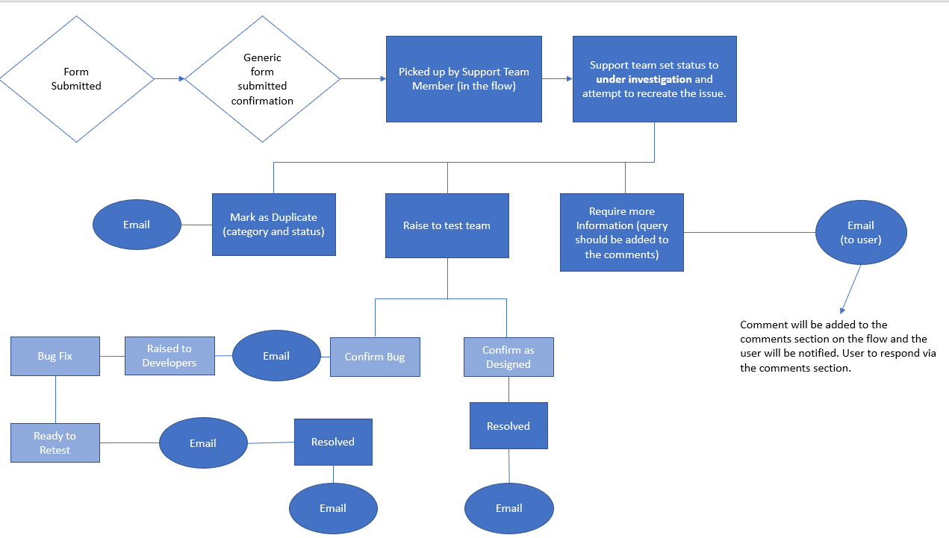
Figure 8 Flow Diagram

4.2 Updates to the current flow and SharePoint list

4.2.1 Updates to the flow (back end)

To accurately represent the modifications made to the process, it was necessary to update elements of the SharePoint list.

The first amendment required additional Power Automate email triggers. During the UAT cycles for version 2.2 of WNCR weekly meetings were held with stakeholders, WNCR project, test, development, and Business Analyst teams to streamline and refine the testing process. Additionally, feedback highlighted that improved communication between DHCW and stakeholders throughout the UAT process would be beneficial.
As a result, additional email triggers have been introduced (figure 6), previously stakeholders have not been actively notified of stages of investigation throughout the process meaning that the only way to view progress of an issue would be to find the issues logged via the SharePoint list.

4.3 SharePoint List Changes (front end)

For future releases (July 2023) stakeholders will be emailed at certain stages of investigation, stakeholder feedback allowed the support team to identify the appropriate stages of investigation to inform the users of changes. The triggers have since been updated to email users at appropriate stages and categories during investigation, these included:

- As designed
- Raised to test team
- Bug
- Raised to developers
- Require more information
- Resolved

Additionally, stakeholder feedback highlighted that the statuses and categories contradicted each other making it difficult for reporting purposes. To resolve this the statuses and categories were reviewed and amended.

The statuses aim to represent the stage of investigation and resolution of an issue, however the statuses combined both status and categories.

There were three statuses removed:
- As designed
- Set for release
- Responded to
It was highlighted by stakeholders that as designed should be set as a category following investigation as opposed to being a status. Additionally, set for release was vague and its definition was deemed unclear. It was identified that responded to and under investigation provided similar definitions therefore the list was refined to include ‘under investigation’ only.
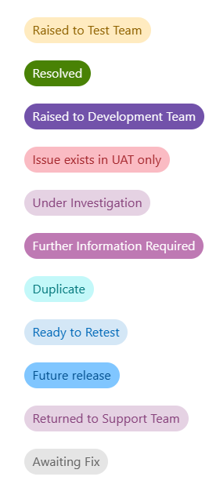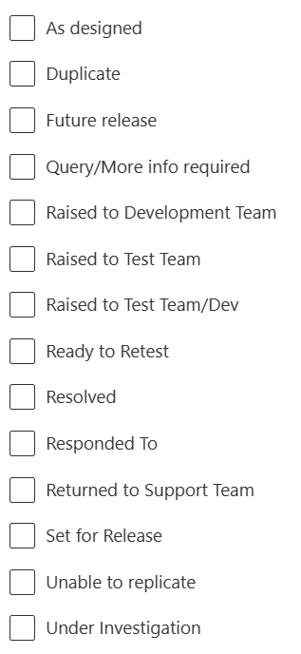
Figure 9 Status comparison

Additionally, the status ‘query/more info required’ was removed and replaced with ‘further information required’ the purpose of this status is to inform stakeholders when further information is required based on the issue raised. Figure 9 displays a comparison of the original statuses (updated statuses on the left and original statuses on the right)

To further refine the process, the categories were reviewed. The categories aim to inform the stakeholders of the outcome of the investigation. It was identified that ‘query/more’ info was no longer required as a category as it’s better suited as a status. Additionally, ‘not yet classified’ was removed and ‘known issue’ was added, known issue reflects known bugs or problems which have previously been identified but will not be resolved until a future release, these issues are captured in the release notes (Figure 10).
Categories
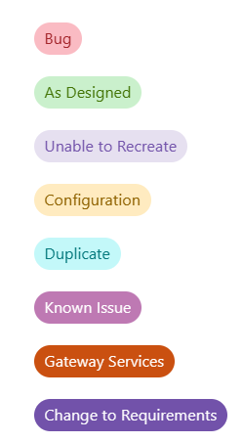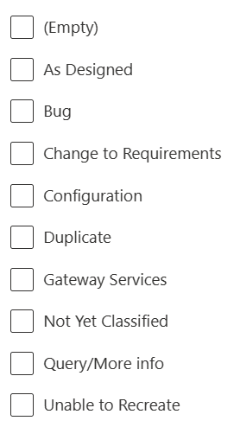
Figure 10 Category comparison

The software development methodology for the development of WNCR is waterfall and therefore, change to requirements should not be a category option due to the linear structure of the methodology. However, feedback highlighted that the stakeholders benefited from regular meetings during the UAT cycles for version 2.2 introducing a ‘watergile’ approach combining a primarily waterfall approach to development with an agile approach to UAT. As a result, this category has remained.

4.3.1 SharePoint Guidance

Additionally, it was highlighted that the SharePoint list can be difficult to navigate due to the volume of data, the SharePoint list requires filtering and re-ordering to enable viewing of issues raised as it holds data from multiple releases. Stakeholders suggested that a how to guide would be beneficial. With that in mind, a user guide was created (Appendix 8).

4.4 The creation of the dashboard

During the research phase a questionnaire was sent to the relevant participants, participants were asked if the UAT process would benefit from the addition of a dashboard. 100% of respondents agreed that a dashboard would be beneficial. A follow up questionnaire asked what information would be beneficial for progress updates and reporting purposes.

Following the collection of responses, a meeting was held to discuss scope and streamline requirements. The outcome of this meeting identified that there were six data sets that would be beneficial both for progress updates and reporting. This was agreed by all Health Boards and DHCW service leads. The six data sets include:

- How many issues have been raised per Health Board
- What device has been used for testing purposes
- Issues raised by priority
- Issue Status
- Issues logged per section
- Issue category

To test the validity and test the functionality of a dashboard an MVP was created using data from Version 2.2 of WNCR with a view of piloting the dashboard in version 2.3 (UAT to begin 24th July 2023).

The dashboard was created using Power BI Desktop, exporting the Live SharePoint list.
Following the importation of the SharePoint data, a data cleanse was completed to capture relevant data to reflect the requirements outlined above.

The selected data included:
- Issue ID
- Priority
- Section
- Date Logged
- Connection
- Device
- Browser
- Status
- Health Board
- Risk Assessment
- Category
- WNCR instance

The completion of data importation and cleansing enabled the design and visualisation process to begin. First, the DHCW Power BI template was downloaded and loaded into Power BI to ensure standardisation in line with organisational guidelines.

Power BI was used to develop the dashboard in line with DHCW information management guidelines. Using the DHCW Power BI developer’s best practice guide [3] each specific dataset was loaded, and the most appropriate visualisation tool was selected. The WNCR UAT dashboard is made up of two tables and four graphs. Tables have been used to display actual data values for look up purposes. Additionally, graphs were introduced to enable comparison.
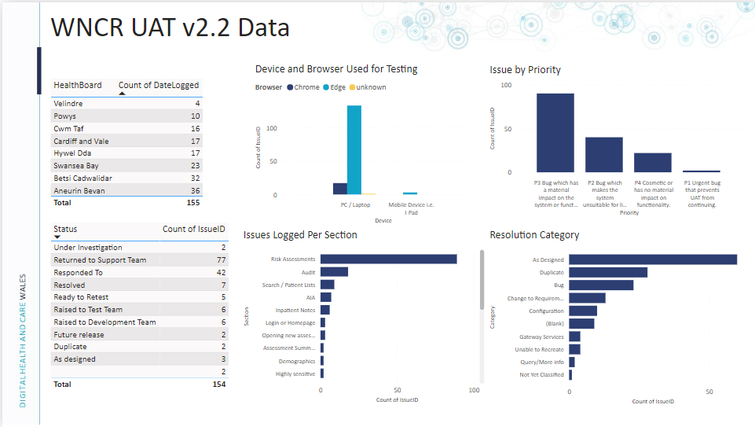
Figure 11 DHCW WNCR UAT 2.2 Data Dashboard
Using the modelling functionality, appropriate groups were made (figure 12). This enables Row level security; enabling the relevant users to be added to a specific group viewing Health Board specific data. Additionally, figure 11 displays all Wales data which would be used for progress monitoring and reporting purposes for DHCW. Similarly, figure 13 displays Health Board specific data, for the purposes of this report figure 13 displays data from Powys Teaching Health board.
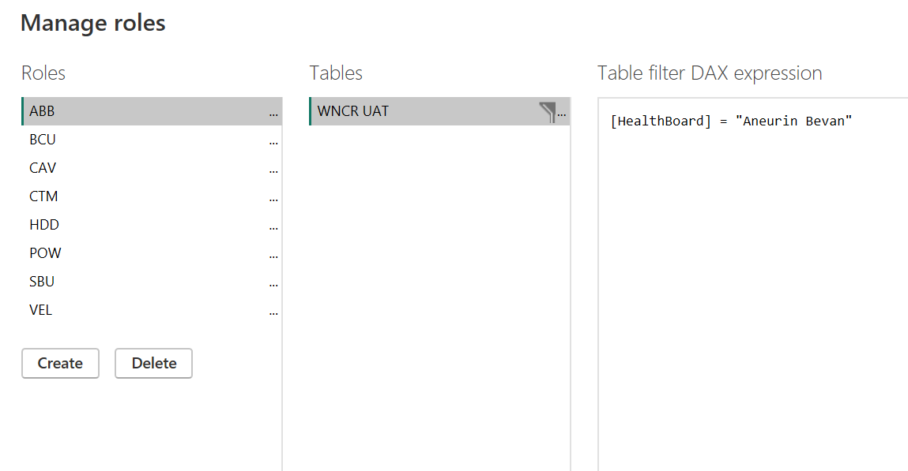
Figure 12 Implementing Row Level Security

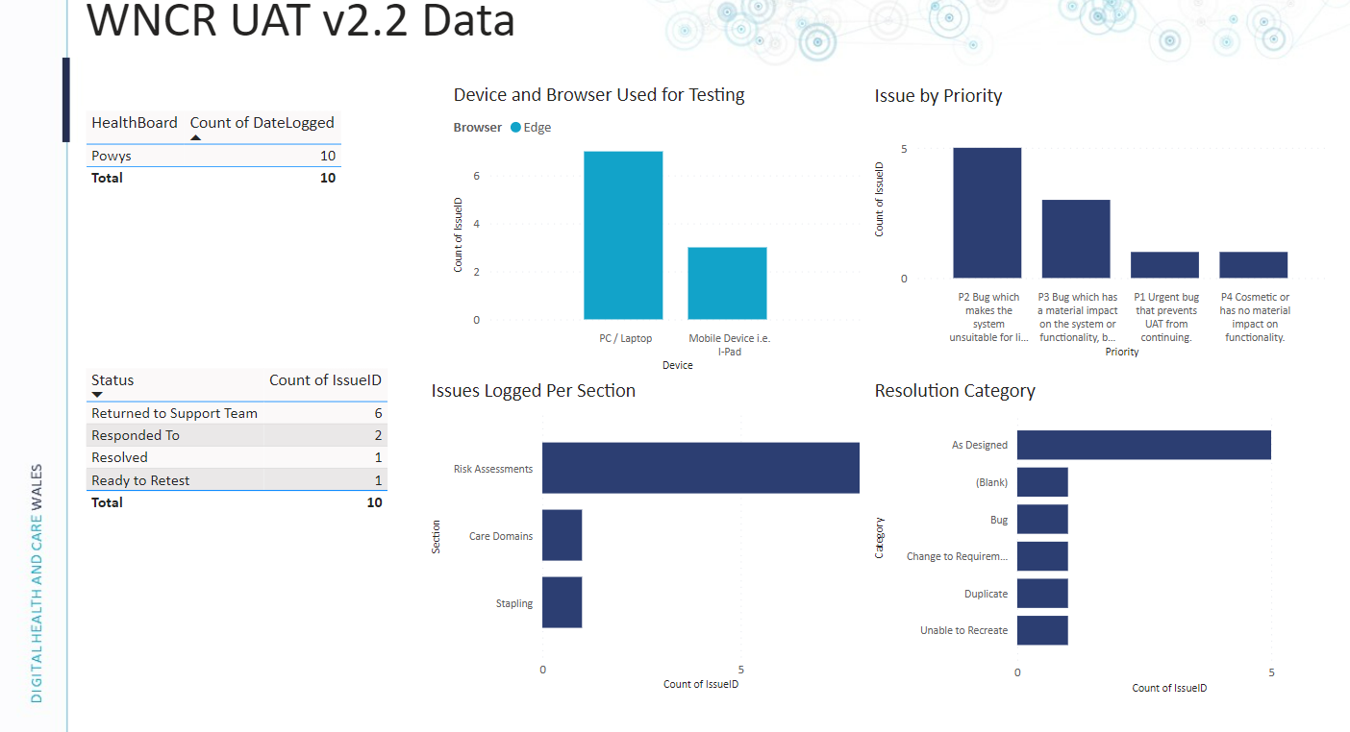
Figure 13 Powys Dashboard
Following the dashboard approval, the design and requirements were shared with the Corporate Power BI team in line with DHCW information services policies for review and publishing, enabling access to the required users. Additionally, the requirements were sent for the duplication of the dashboard in readiness for UAT version 2.3, this meant changing the WNCR instance at the data transformation layer. Due to the data in the SharePoint list being well structured data was easily extracted and the completion of requirement gathering enabled the build to be straight forward.

CHAPTER 5 – EVALUATION
In this chapter conclusions drawn from the data collected will be discussed and compared to findings from the literature review conducted in chapter 2. Additionally, the success of meeting project aims, and objectives will be discussed. Followed by a conclusion and suggestions for future research.

Conclusions drawn from Data collected

From the data collected, it was evident that changes made to the WNCR UAT process introduced with Version 2.2 have had a positive effect. The use of SharePoint Lists and Power Automate enabled the stakeholders to remain informed throughout the process. Although, just like the application it’s self the UAT process will continue to evolve beyond this project.

WNCR follows a waterfall approach to development, as discussed in the literature review documentation is a critical part of waterfall methodologies [15]. This ranges from clear concise documentation of requirement gathering, release notes, and process documentation. There were three main conclusions drawn from the document analysis:

- The formal WNCR UAT documentation was vague and did not capture the full process. Additionally, roles and responsibilities were not clearly defined.
- Aside from release notes, there was no guidance available for stakeholders on how to access and monitor the issues raised.
- The process did not capture communication between DHCW and stakeholders.
It was identified that the lack of detail in the documentation made it difficult to define roles and responsibilities for both the WNCR National Support team and the WNCR test team (internally). Resulting in potential overlap and duplication of work. As stated in the literature review planning, communication and collaborative working between developers, stakeholders and test teams can help mitigate these challenges before they arise, ensuring that all participants are aligned and clear on their roles and responsibilities during the test period [60]. As a result, processes and procedures were appropriately updated to clearly define roles and responsibilities and to enable improvement in communication
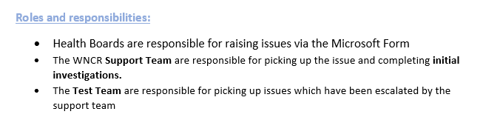
Figure 14 Roles and Responsibilities
Additionally, updates to the power automate flow introduced new triggers to keep users informed throughout the investigation progress.
Figure 15 Flow Update
The original process can be found in appendix 5. Additionally, the complete updated process can be seen in appendix 6.
Feedback identified that the SharePoint list provides a central repository for all UAT data. However, it was highlighted that the list was difficult to navigate without guidance. After some investigation it was identified that stakeholders were provided little to no guidance on how to navigate this list resulting in the introduction of a user guide.
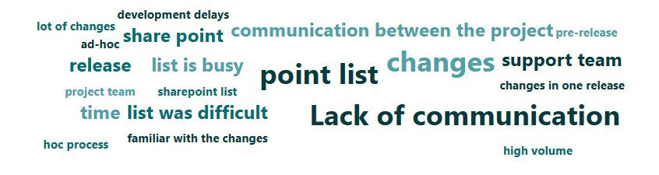
Figure 16 Feedback on questionnaire (Appendix 2)
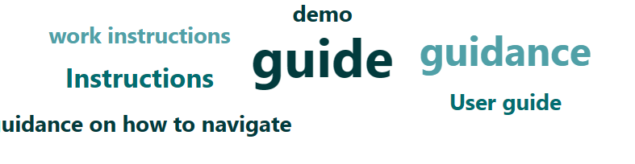
Figure 17 Responses from question 7 (Appendix 3)
Similarly, it was stated that due to the volume of data captured in the SharePoint heavy filtering was required to enable reporting. 100% of participants agreed that to improve this a WNCR UAT dashboard would be beneficial.
As well as challenges there were some benefits that were seen from the UAT process. Contradictory to findings in the literature review, 98% of results collected stated that the ability to change requirements during UAT was beneficial. However, literature review findings suggested that methodologies should not be used interchangeably [81]. It is stated that when implementing the waterfall method that changes to requirements are not possible due to the linear structure of the method [15].
Additionally, it was stated that this negatively impacts the stability of a project. However, previously the Waterfall approach to development combined with an agile approach during UAT increased productivity and stakeholder engagement. This was defined as a ‘watergile’ approach.
The hybrid ‘watergile’ approach works for WNCR due to the adoption of the waterfall method for development, upfront requirements are agreed at the early stages resulting in potential changes post development. It was identified from version 2.2 that agreed some requirements were not appropriate or not as expected requiring small changes. Enabling this by implementing a hybrid approach at UAT enables the relevant changes to be made. This does, however, support the statement that there is no ‘one size fits all’ approach to software development and each project has its own unique requirements.

Aims and objectives

All objectives below were met however, due to the ever-changing nature of software development life cycle all elements will require continuation. This will ensure that that the process remains up-to date in line with natural progression and changes to the application. Additionally, based on future UAT cycles the dashboards will require continuous review. This will ensure that the data remains informative and relevant.

Additionally, the aim of the project was met. The WNCR UAT process was analysed, and relevant improvements have been proposed and implemented in readiness for future releases.

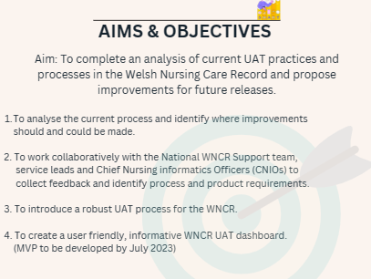
Figure 18 Aim and Objectives (re-cap)

Conclusion of the results

The results collected during this project were expected and hoped for. Enabling the introduction of a robust process for the purposes of WNCR UAT testing. The introduction of a user-friendly informative dashboard enables the ability for progress updates and reporting at a glance. Resulting in an increase in productivity and reducing time spent filtering and managing data.
Working collaboratively with the National WNCR Support team, Service leads and CNIO’s enabled thorough investigation of the process. Additionally, this enabled collaborative working and comprehensive requirement gathering to enable the creation of a product.
    - Future research

If this project were to be repeated, certain elements would be done differently:
- Involving the stakeholders at an earlier stage
- In person meetings to enable brainstorming and further improve communication
- Support and implementation done collaboratively with a team as opposed to individual working.
- A longer time frame for completion
These improvements would aid in improving engagement and enable more meaningful conversations between stakeholders and DHCW. Additionally, the involvement of the whole WNCR National Support team would enable delegation and reduce pressure. Potentially resulting in a higher standard of work. However, this project was a success, and all objectives were met in readiness for the next cycle of WNCR UAT (version 2.3).

CHAPTER 6 - CONCLUSIONS AND RECOMMENDATIONS

6.1 Conclusion

In conclusion, this project aimed to improve the WNCR UAT process and create an informative user-friendly dashboard. Findings indicate that the changes made to the UAT process with version 2.2 of WNCR, such as the use of Power Automate, and SharePoint lists have positively impacted the overall process with 100% of users finding it useful.

There were several conclusions revealed while evaluating the data collected for this project. There were improvements required including improvements to documentation and communication, defining roles and responsibilities, improving communication with the use of Microsoft tools such as Power Automate and SharePoint. The introduction of a user-friendly informative dashboard addressed problems linked to difficulty monitoring investigations and reporting. Additionally, the WNCR UAT dashboard serves as a valuable tool for the purposes of monitoring and managing the UAT process.

This project has contributed to the field by addressing service improvement needs linked to the UAT process within the context of a new application like WNCR. It fills a gap by providing insight to real world challenges linked to UAT and offers practical solutions for improvement.

Combining both inductive and deductive research methodologies enabled a balanced and comprehensive analysis of the UAT process. Furthermore, the literature review provided valuable insight into UAT best practices guiding the research and identifying potential areas of improvement.
Despite project aims and objectives being met, there are limitations to consider. Due to the specialised nature of the topic the sample size was small. This could limit the generalisability of the findings. In addition, as software development methodologies and product requirements continue to evolve continuous evaluation and adaptation of the process and the dashboard will be required to maintain relevance and validity.

Following the completion of this project, a demonstration of the updated process and the WNCR UAT dashboard to the Single Record Team at DHCW.

To conclude, this project has successfully improved the WNCR UAT process by creating an informative dashboard (Appendix 9), increasing productivity, and improving communication.

6.2 Recommendations

It's recommended that for the purposes of WNCR version 2.3 a ‘watergile’ approach is continued, with a view to migrate to an agile approach for future releases. Version 2.3 contains 26 changes with an addition of becoming a single instance application. A future move to agile would be beneficial to introduce small iterative changes, reducing the volume of testing to improve accuracy and increase productivity.
The dashboard identified that health boards are completing majority of testing using PC’s and Laptops. Data shows that 3% of issues raised during UAT for version 2.2 were tested against mobile devices. These issues were raised by Powys Teaching Health Board only, suggesting that 97% of testing is completed against PC’s and laptops.
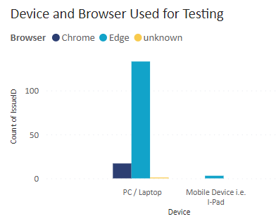
WNCR is primarily accessed using mobile devices and therefore it’s recommended that all health boards complete dedicated testing using a combination of PCs, laptops, and mobile devices to ensure that testing is completed to the highest standard and to reduce the risk of mobile device only bugs and defects being missed.
Finally, the creation of a ‘sandbox’ environment to enable users to view a partially developed application would be beneficial for the purposes of WNCR. At present, users are unable to familiarise themselves with upcoming changes due to the waterfall approach used for development. It is believed that this will reduce overwhelm and aid the testing process. In turn reducing the number of issues logged due to familiarisation with the product prior to testing.

6.3 Avenues for future Research

Further research could explore the integration of UAT within Agile, specifically addressing challenges linked to predictability and documentation while harnessing the benefits of iterative development and constant stakeholder collaboration. Additionally, investigating the impact of different development methodologies on UAT outcomes and user satisfaction would provide further understanding of the relationship between software development methodologies and successful product delivery.
This project successfully met its aim and objectives by improving the WNCR UAT process and creating a dashboard to enable enhanced monitoring and reporting. Despite the success of the project, it is important to note the limitations. Due to the specialised nature of the project the sample size was small. Future research should consider expanding the sample size to include project teams, WNCR testing teams and developers while considering the long-term benefits of the updated process and dashboard on product quality and stakeholder satisfaction.

CHAPTER 7 – REFLECTION
This project has taught me many lessons both personal and professional. This project has given me confidence in my ability to review and improve technical processes. It has helped me grow as a person and understand my strengths. Prior to joining DHCW in August 2022 I didn’t know that User Acceptance Testing was a thing. This project reflects just how much I’ve learned in my short time as a support analyst.

I was able to use knowledge gained from other modules to further enable me to complete this project. Modules such as data analysis and visualisation, Data warehousing and data mining and User Experience. This enabled me to successfully apply my learning.

Suffering with ADHD and dyslexia I struggle to structure and start large pieces of work. Chat GPT enabled me to seek guidance giving me the kick start that I needed. Throughout the project I have continuously asked chat GPT for feedback based on the work completed. Thus, giving me confidence that my project has been completed to a high standard while also suggesting potential improvements. It has truly worked like a second supervisor providing support at any hour.

Additionally, completing particularly tough parts of this project has been extremely satisfactory. I started this project with no confidence that I would get to the end.

To conclude this project has taught me that just how much I have learned since starting this degree in 2019. I feel extremely proud of myself for getting here.

CHAPTER 8 – REFERENCES

References

[1] | Welsh Government, “Nursing Records go Digital - a case study,” 25 10 2021. [Online]. Available: https://digitalpublicservices.gov.wales/nursing-records-go-digital-a-case-study/. [Accessed 20 05 2023].
[2] | Digital Health and Care Wales, “About Digital Health and Care Wales,” Digital Health and Care Wales, [Online]. Available: https://dhcw.nhs.wales/about-us/. [Accessed 10 07 2023].
[3] | Digital Health and Care Wales, Internal DHCW Documentation, 2023.
[4] | P. Pandit and S. Tahiliani, “AgileUAT: A Framework for User Acceptance Testing based on User Stories and Acceptance Criteria,” International Journal of Computer Applications , vol. 120, no. 10, pp. 16-21, 2015.
[5] | H. Leung and P. W.L, “A study of user acceptance,” Software Quality Journal, vol. 6, pp. 137-149, 1997.
[6] | K. S. &. A. C. Robin Poston, “Managing User Acceptance Testing of Business Applications,” HCI in Business, pp. 92-102, 2014.
[7] | M. A. Umar, “Comprehensive Study of Software Testing: Categories, levels, techniques, and types,” International Journal of Advanced Research, Ideas and Innovations in Technology, vol. 5, no. 6, pp. 32-40, 2019.
[8] | A. S. Gills, “User Acceptance Testing,” Software Quality, 03 2022. [Online]. Available: https://www.techtarget.com/searchsoftwarequality/definition/user-acceptance-testing-UAT. [Accessed 05 04 2023].
[9] | J. S. Valacich and J. F. George , “Modern Systems Analysis and Design,” Google Scholar Digital Library, 2017.
[10] | A. Lawal and R. C. Ogbu, “A Comparative Analysis of Agile and Waterfall Software Development Methodologies,” Bakolori Jornal of General Studies, vol. 11, no. 2, 2021.
[11] | A. M. Dima and M. A. Maassen, “From Waterfall to Agile software: Development models in the IT sector, 2006 to 2018. Impacts on company management,” Journal of International Studies, no. 2, pp. 315-325, 2018.
[12] | M. McCormick, “Waterfall vs. Agile Methodology,” MPCS, 2012.
[13] | O. K. Eason, “Information Systems Development Metholdoly Transitions: An Analysis of Waterfall to Agile Methodology,” University of New Hampshire - Main Campus, New Hampshire, 2016.
[14] | H. K. Aroral, “Waterfall Process Operations in the Fast-paced World: Project Management Exploratory Analysis,” International Journal of Applied Business and Management Studies, vol. 6, no. 1, pp. 91-99, 2021.
[15] | O. Redkyn, “Analysis of the Waterfall Model for the Software Development Process and Possibilities for Its Improvement.,” Ryerson University, 2003.
[16] | F. Heriyanti and . A. Ishak, Design of logistics information system in the finished product warehouse with the waterfall method: review literature, IOP Conference Series: Materials Science and Engineering, 2020.
[17] | N. Dwivedi, D. Katiyar and G. Goel, “A comparitive Study of Various Software Development Life Cycle (SDLC) Models,” International Journal of Research in Engineering, Science and Managemen, vol. 5, no. 3, pp. 141-144, 2022.
[18] | A. Adenowo and B. Adenowo, “Software Engineering Methodologies: A Review of the Waterfall Model and Object-Oriented Approach,” International Journal of Scientific & Engineering Research, vol. 04, no. 07, pp. 427-434, 2013.
[19] | S. Khan and S. Mahadik, “A Comparative Study of Agile and Waterfall Software Development Methodologies,” International Journal of Advanced Research in Science, Communication and Technology (IJARSCT), vol. 2, no. 1, 2022.
[20] | S. S. Mahadik, “A comparitive study of agile and software devleopment methodologies,” International Journal of Advanced Research in Science, Communication and Technology, vol. 2, no. 1, pp. 399-402, 2022.
[21] | M. Awad, A Comparison between Agile and Traditional Software Development Methodologies, The University of Western Australia, 2005.
[22] | M. Javanmard and M. Alian, “Comparison between Agile and Traditional software development methodologies,” Science Journal (CSJ),, vol. 36, no. 3, 2015.
[23] | S. Balaji and D. Murugaiyan, “WATEERFALLVs V-MODEL Vs AGILE: A COMPARATIVE STUDY ON SDLC,” International Journal of Information Technology and Business Management, vol. 2, no. 1, 2012.
[24] | M. Kramer, “Best Practices in Systems Development Lifecycle: An Analyses Based on the Waterfall Model,” Review of Business & Finance Studies, vol. 9, no. 1, pp. 77-84, 2018.
[25] | S. Al-Saqqa, “Software Development: Methodologies and Trends,” International Journal of Interactive Mobile Technologies, vol. 14, no. 11, pp. 246-270, 2020.
[26] | T. Dyba and T. Dingsoyr, “Empirical studies of agile software development: A systematic review,” Information and Software Technology , vol. 50, pp. 833-859, 2008.
[27] | C. Fagarasan, O. Popa, A. Pisla and C. Cristea, “Agile, waterfall and iteractive approach in information technology projects,” IOP Conference Series: Materials Science and Engineering, 2021.
[28] | V. Hema, S. Thota, S. N. Kumar, C. Padmaja, C. R. Krishna and K. Mahender, Scrum: An Effective Software Development Agile Tool, IOP Conf. Series: Materials Science and Engineering, 2020.
[29] | K. B. E. Al, The Agile Manifesto, 2001-2019.
[30] | S. Goyal, “Agile Techniques for Project Management and Software Engineering,” Technical University Munich, 2008.
[31] | F. Anwer, S. Aftab, U. Waheed and S. S. Muhammad, “Agile Software Development Models TDD, FDD, DSDM, and Crystal Methods: A Survey,” International Journal of Multidiscpalinary Sciences and Engineering, vol. 8, no. 2, pp. 1-10, 2017.
[32] | M. Hron and N. Obwegeser, “Why and how is Scrum being adapted in practice: A Systematic Review,” The Journal of Systems & Software, vol. 183, no. 111110, 2022.
[33] | K. Schwaber and J. Sutherland, “The Definitive Guide to Scrum: The Rules of the Game,” 2020. [Online]. Available: https://scrumguides.org/docs/scrumguide/v2020/2020-Scrum-Guide-US.pdf#zoom=100.
[34] | L. A. Garcia, E. Oliviera Jr and M. Morandini, “Tailoring the Scrum framework for software development: Literature mapping and feature-based support,” Information and Software Technology, vol. 146, 2022.
[35] | A. Srivastava, S. Bhardwaj and S. Saraswat, SCRUM model for agile methodology, International Conference on Computing, Communication and Automation (ICCCA, 2017, pp. 864-869.
[36] | P. Krutchen, The Rational Unified Process An Introduction - Third Edition, Boston: Pearson Education Inc, 2004.
[37] | S. Shafiee, Y. Wautelet, L. Hvam, E. Sandrin and C. Forza, “Scrum Versus Rational Unified Process in facing the main challenges of product configuration systems development,” The Journals of Systems & Software, vol. 170, pp. 1-23, 2020.
[38] | A. Anwar, “A review of RUP (rational unified process),” International Journal of Software Engineering, vol. 5, no. 2, pp. 12-19, 2014.
[39] | P. Dragos, “Overview of the Agile Rational Unified Process (Rup) in the Context of Software Development Projects,” Journal of Business and Economics, vol. 12, no. 6, pp. 681-684, 2021.
[40] | A. Agrawal, M. A. Atiq and L. Maurya, A Current Study on the Limitations of Agile Methods in Industry Using Secure Google Forms, Procedia Computer Science, 2015.
[41] | G. Kumar and P. K. Bhatia, “Impact of Agile Methodology on Software Development Process,” International Journal of Computer Technology and Electronics Engineering (IJCTEE), vol. 2, no. 4, pp. 46-50, 2012.
[42] | H. Saeeda, F. Arif, N. M. Minhas and M. Humayun, “Agile Scalability for Large Scale Projects: Lessons Learned,” Journal of Software, vol. 10, no. 7, pp. 893-903, 2015.
[43] | M. Elkhatib, A. A. Hosani, . I. A. Hosani and K. Albuflasa, “Agile Project Management and Project Risks Improvements: Pros and Cons,” Modern Economy, vol. 13, no. 9, pp. 1157-1176, 2022.
[44] | C. G. Álvarez, Overcoming the limitations of Agile Software Development and Software Architecture, Karlskrona: Blekinge Institute of Technology, 2013.
[45] | K. Kautz, H. J. Thomas Heide and A. Uldahl, “The perceived impact of the agile development and project management method scrum on information systems and software development productivity,” Australasian Journal of Information Systems, vol. 18, no. 3, pp. 303-315, 2014.
[46] | R. Kumar, D. A. Gupta and D. H. Singh, “Agile Methodologies: Working Mechanism with Pros and Cons,” Gian Jyoti E-Journal, vol. 4, no. 2, pp. 18-27, 2014.
[47] | A. C. Sassa, I. A. d. Almeida, T. N. F. Pereia and M. S. d. Oliveria, “Scrum: A Systematic Literature Review,” International Journal of Advanced Computer Science and Applications, vol. 14, no. 4, pp. 173-181, 2023.
[48] | S. Shahzad, W. N. Awan, F. Amin, A. Abro, M. Shoaib and S. Alyaha, “Framework for Effective Utalization of Distributed Scrum in Software Projects,” Computer Systems Science & Engineering, vol. 44, no. 1, pp. 407-422, 2021.
[49] | I. Otaduy and O. Diaz, “User acceptance testing for Agile-developed web-based applications: Empowering customers through wikis and mind maps,” The Journal of System and Software, vol. 113, pp. 212 - 229, 2017.
[50] | S. Segal, “User Acceptance Testing and the Application Lifecycle,” 03 02 2017. [Online]. Available: https://www.red-gate.com/simple-talk/development/dotnet-development/user-acceptance-testing-application-lifecycle/. [Accessed 29 06 2023].
[51] | D. Stankoviski and D. Radev, Key steps and parameters for Digital Transformation in big Telco Organizations, 2021.
[52] | A. Cociorva, N. Onofrei and A.-L. Vilcea, “Tool Integrations for Montiroing Solutions and Associated Performance Analysis,” Proceedings of the International Conference on Business Excellence, vol. 17, no. 1, 2023.
[53] | Altecsoft Software r&d engineering, “How to Conduct User Acceptance Testing: Process Stages, Deliverables and End-User Testing Place in Quality Assurance,” 03 02 2023. [Online]. Available: https://www.altexsoft.com/blog/engineering/user-acceptance-testing/. [Accessed 27 06 2023].
[54] | R. Cimperman, UAT Defined: A Guide to Practical User Acceptance Testing, Pearson Education, 2006.
[55] | Digital Health and Care Record, Internal DHCW Document, 2021.
[56] | R. S. Nadiyah and S. Faaizah, “ The Development of Online Project Based Collaborative Learning using ADDIE Model,” Procedia - Social and Behavioral Sciences, vol. 195, pp. 1803-1812, 2015.
[57] | Z. Nawaz, S. Aftab and . F. Anwer, “Simplified FDD Process Model,” I.J. Modern Education and Computer Science, vol. 9, pp. 53-59, 2017.
[58] | T. Mcclung, “What are the challenges faced during UAT testing?,” Release, 20 12 2021.
[59] | N. S. R. Pillai, R. R. Hemamalini, V. Padmavathy and S. Nasrin, “Framework for Multiple User Acceptance Testing to Avoid Chaos,” IEEE International Conference on System, Computation, Automation, and Networking (ICSCAN), pp. 1-6, 2019.
[60] | R. Jain, “An Adaptive Agile Process Model for Global Software Development,” International Journal on Computer Science and Engineering, vol. 9, no. 6, pp. 436-445, 2017.
[61] | J. E. Bentley, W. Bank, Charlotte NC and N. Charlotte, “Software Testing Fundamentals—Concepts, Roles, and Terminology,” Proceedings of SAS Conference, pp. 1-12, 2010.
[62] | E. J. Jeong, J. H. Bae and S. R. Jeong, “Guidelines Aimed at Reducing the Risks of User Acceptance Delay in the Context of an IT Service Project Management Plan,” International Journal of Electrical and Computer Engineering (IJECE), vol. 5, no. 4, pp. 832-839, 2015.
[63] | ICO, UK GDPR guidance and resources.
[64] | GOV UK, The Data Protection Act, 2018.
[65] | International Software Testing Qualification Board, Software Testing - An ISTQB-BCS Certified Tester Foundation Guide (Third Edition), Swindon: BCS, 2015.
[66] | Datprof, “Synthetic data generation,” Datprof, [Online]. Available: https://www.datprof.com/solutions/synthetic-test-data-generation/#:~:text=Synthetic%20test%20data%20is%20%27fake,with%20the%20help%20of%20algorithms.. [Accessed 01 07 2023].
[67] | T. Chu , “The Importance and Challenges of User Acceptance Testing,” Ninestone, 09 2017. [Online]. Available: https://www.ninestone.com/topics/importance-and-challenges-user-acceptance-testing. [Accessed 28 06 2023].
[68] | A. Fruhling and G.-J. de Vreede, Collaborative usability testing to facilitate stakeholder involvement. Value-based software engineering, Springer, Berlin, Heidelberg, 2006.
[69] | P. Pandit and S. Tahiliani, “AgileUAT: A Framework for User Acceptance Testing based on User Stories and Acceptance Criteria,” International Journal of Computer Applications, vol. 120, no. 10, pp. 16 - 21, 2015.
[70] | C. Newbould, Software Testing Advances Test Analysis (Measuring Usability), AiFlex Publishing UK, 2019.
[71] | J. Lin, “Negative testing for more resilient APIs,” Medium, 27 05 2021. [Online]. Available: https://medium.com/better-practices/negative-testing-for-more-resilient-apis-af904a74d32b. [Accessed 08 07 2023].
[72] | . J. A. Whittaker, Exploratory software testing: tips, tricks, tours, and techniques to guide test design, Pearson Education, 2009.
[73] | Software Testing Help, “What Is Negative Testing And How To Write Negative Test Cases?,” Software Testing Help, 25 06 2023. [Online]. Available: https://www.softwaretestinghelp.com/what-is-negative-testing/#:~:text=Positive%20testing%2C%20many%20times%20referred,would%20run%20for%20his%20use.. [Accessed 08 07 2023].
[74] | A. Jankowicz, “What is research anyway?,” Business Research Projects for Students, pp. 89-96, 1991.
[75] | R. Swedberg, "Exploratory research." The production of knowledge: Enhancing progress in social science, 2020, pp. 17-41.
[76] | University of Southampton , “Primary Research - what is it?,” 22 05 2023. [Online]. Available: https://library.soton.ac.uk/sash/primary-research. [Accessed 20 06 2023].
[77] | Welsh Government , “NHS Wales health boards and trusts,” Welsh Government, 03 02 2023. [Online]. Available: https://www.gov.wales/nhs-wales-health-boards-and-trusts. [Accessed 21 06 2023].
[78] | D. Sinha, “Phenomenology and Positivism,” International Phenomenological Society, vol. 23, no. 4, pp. 562-577, 1963.
[79] | O. e. Zuber-Skerritt, Action research for change and development. Routledge, 2021., Routledge, 2021.
[80] | R. Streefkerk, “Inductive vs Deductive Reasoning | Difference & Examples & Examples,” Scribbr, 04 05 2022. [Online]. Available: https://www.scribbr.co.uk/research-methods/inductive-vs-deductive-reasoning/#:~:text=The%20main%20difference%20between%20inductive,reasoning%20the%20other%20way%20around.. [Accessed 10 07 2023].
[81] | J. Duvall, “Scrumfall: When Agile becomes Waterfall by another name,” Trade Journal, 2022.
[82] | P. Krutchen, The Rational Unified Process An Introduction - Third Edition, Boston: Pearson Education Inc, 2004.

APPENDICES

Appendix 1
User Activity across All Wales since WNCR ‘Go Live’

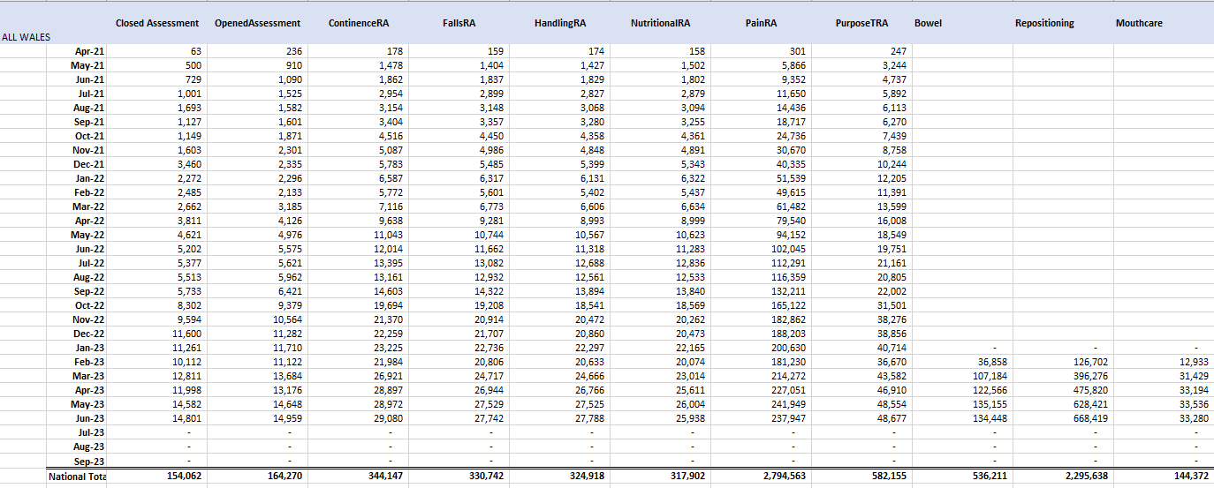
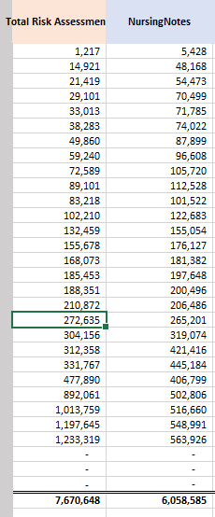

Appendix 2
Questionnaire 1: Designed to gather preliminary data

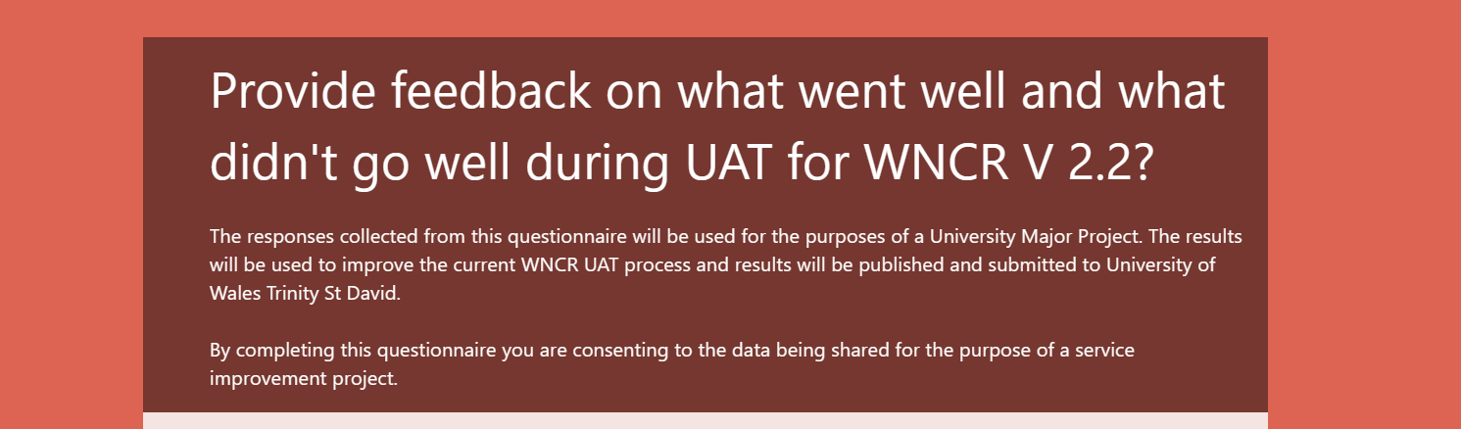

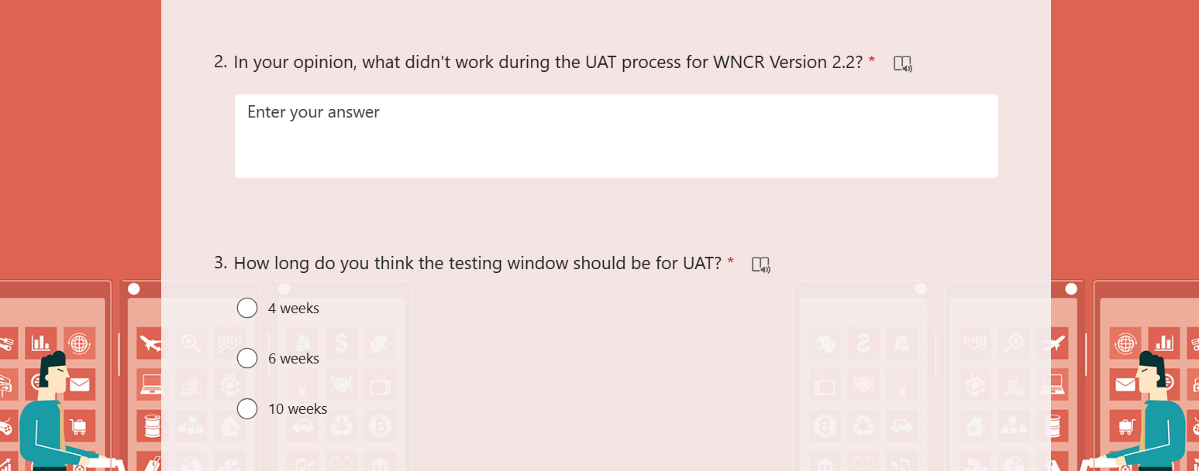
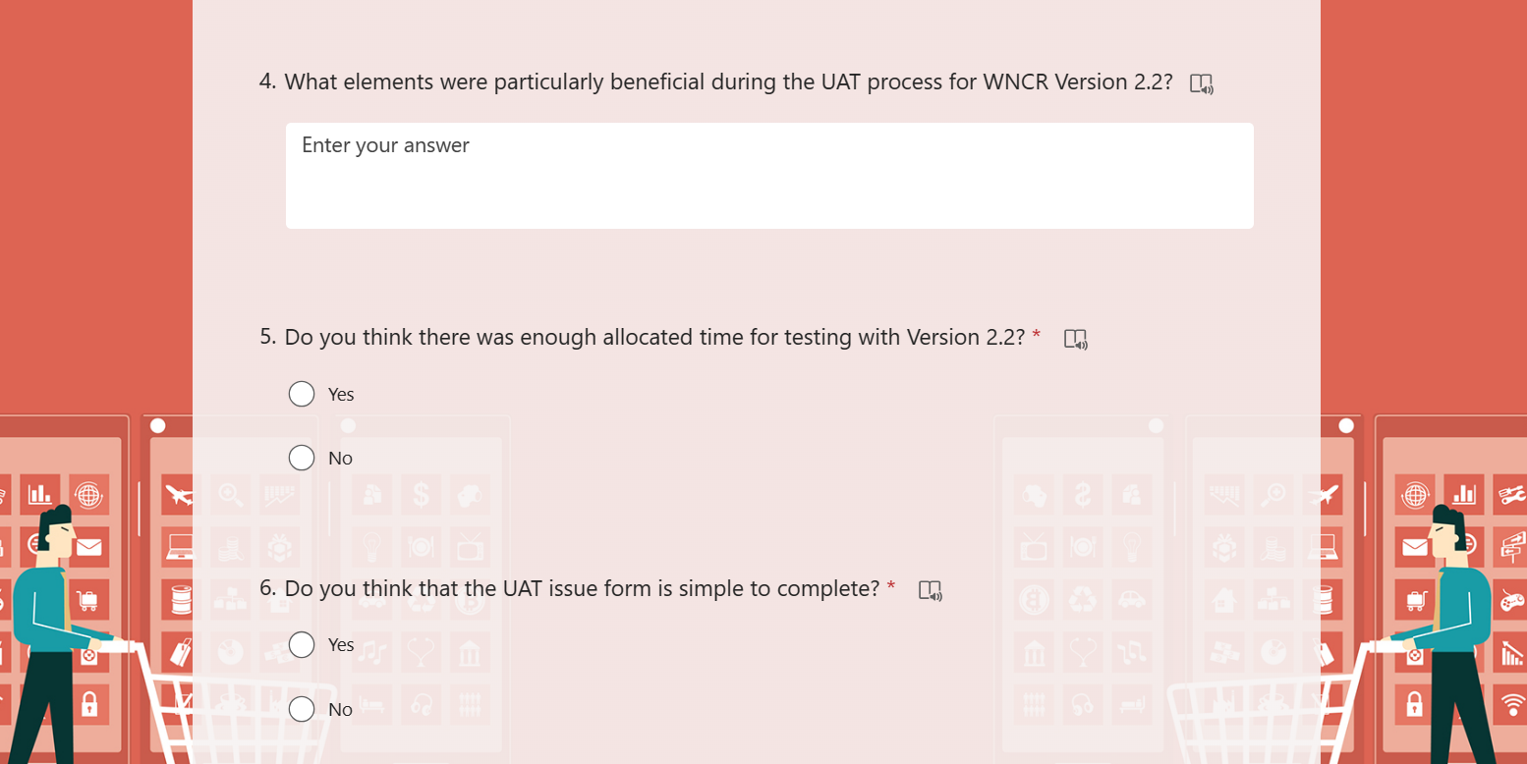
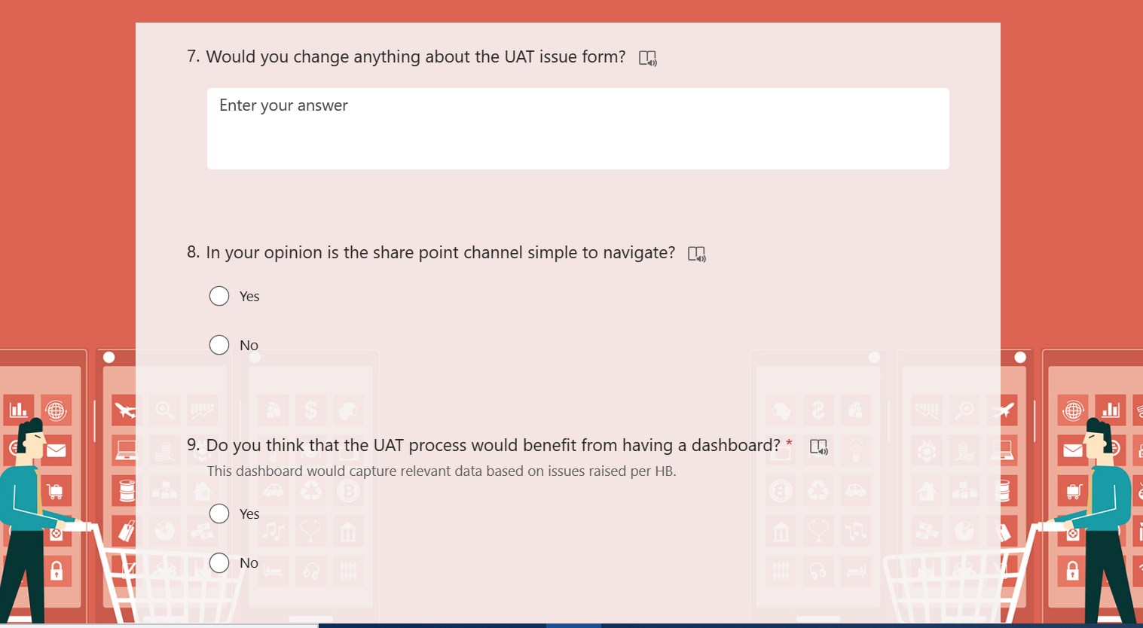
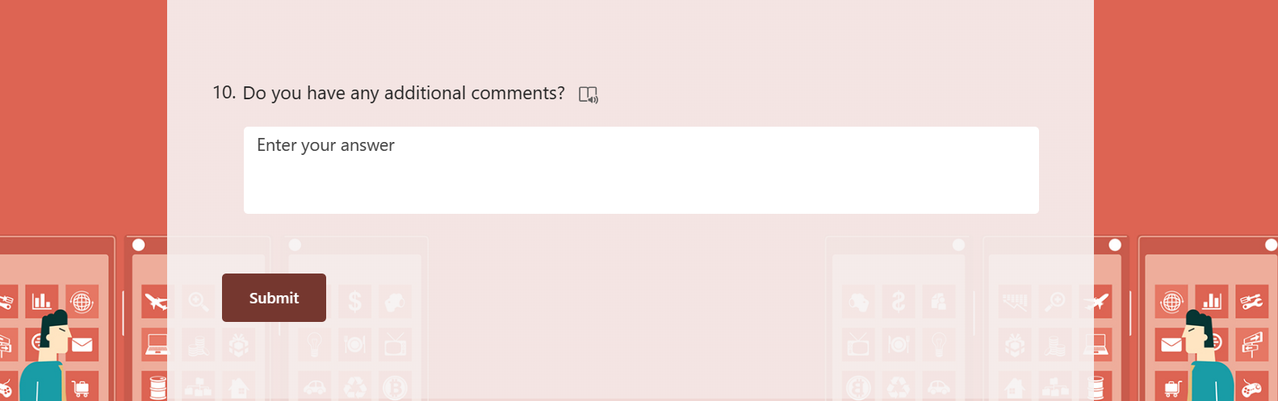

Appendix 3
Questionnaire 2: Designed to collect specific data on potential improvements

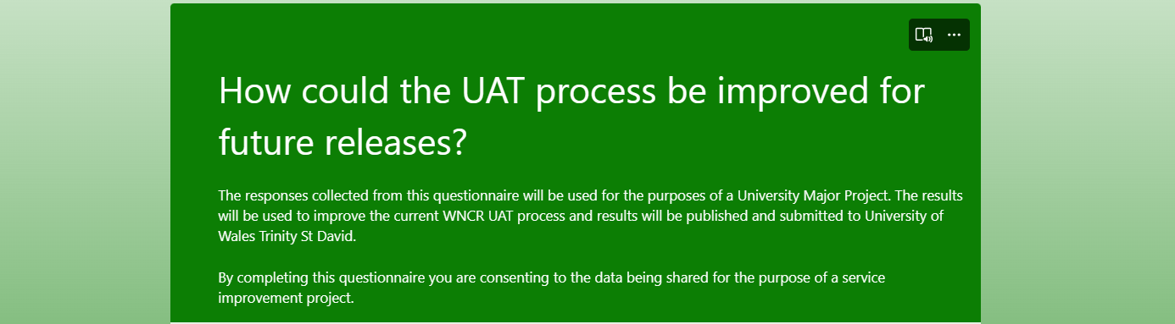
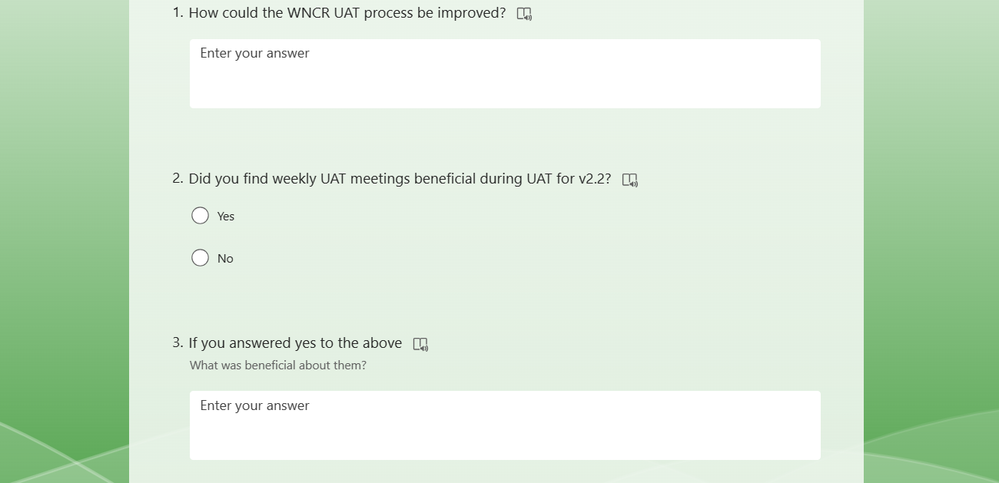
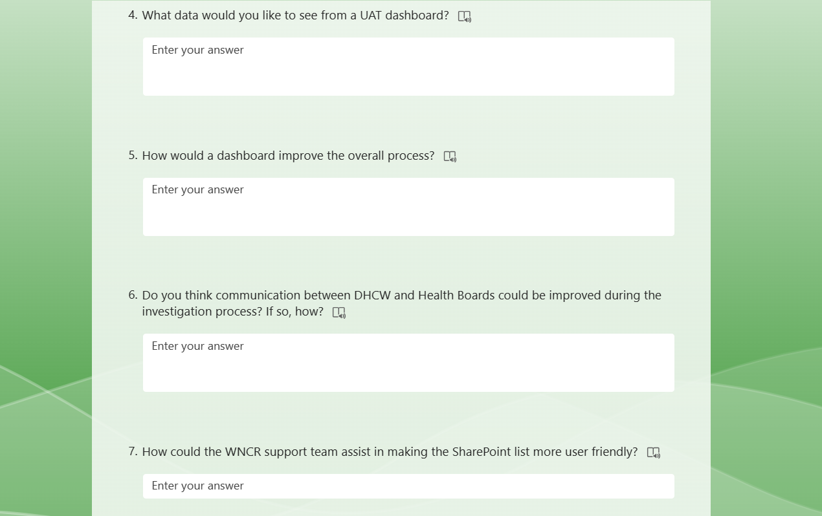

Appendix 4
Microsoft form for Logging issues relating to UAT

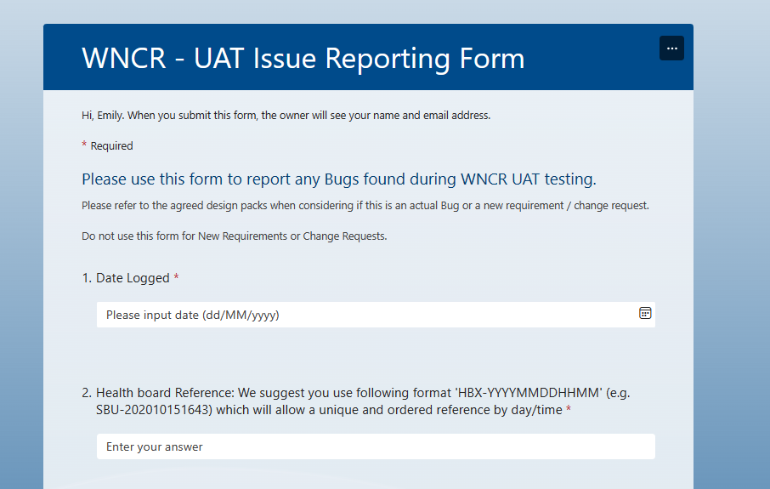
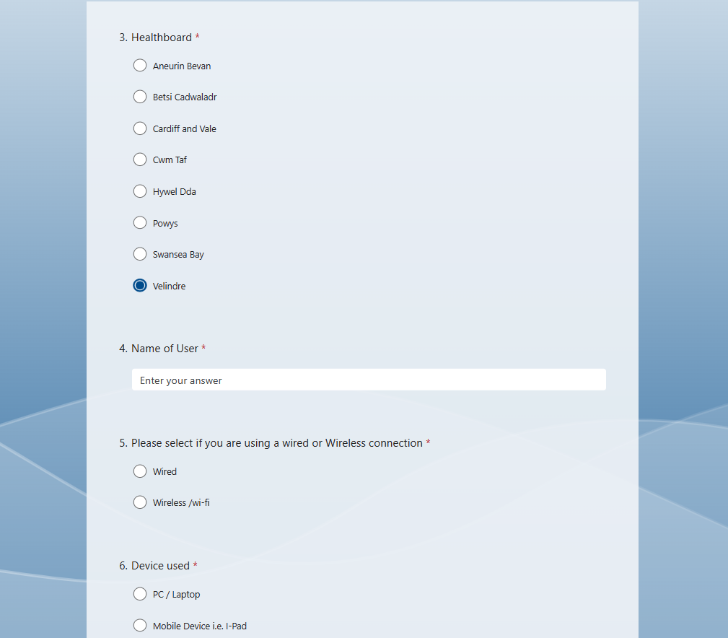
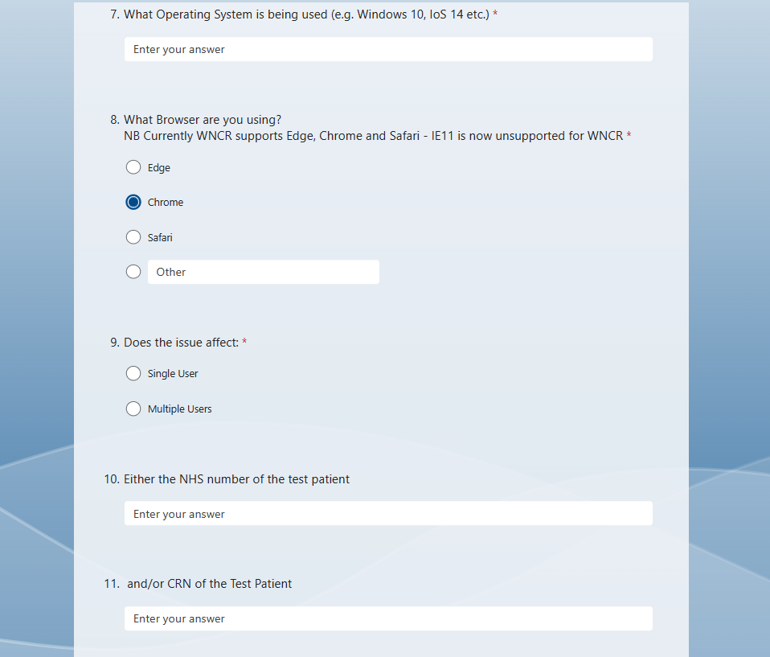
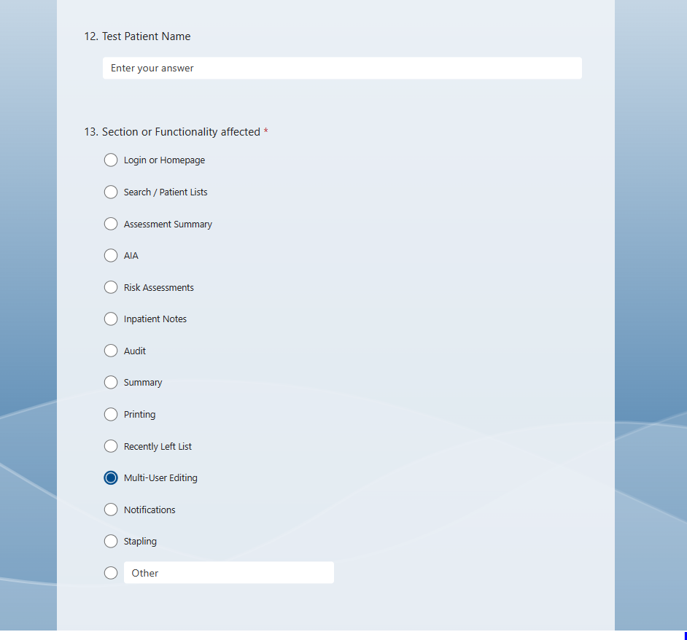

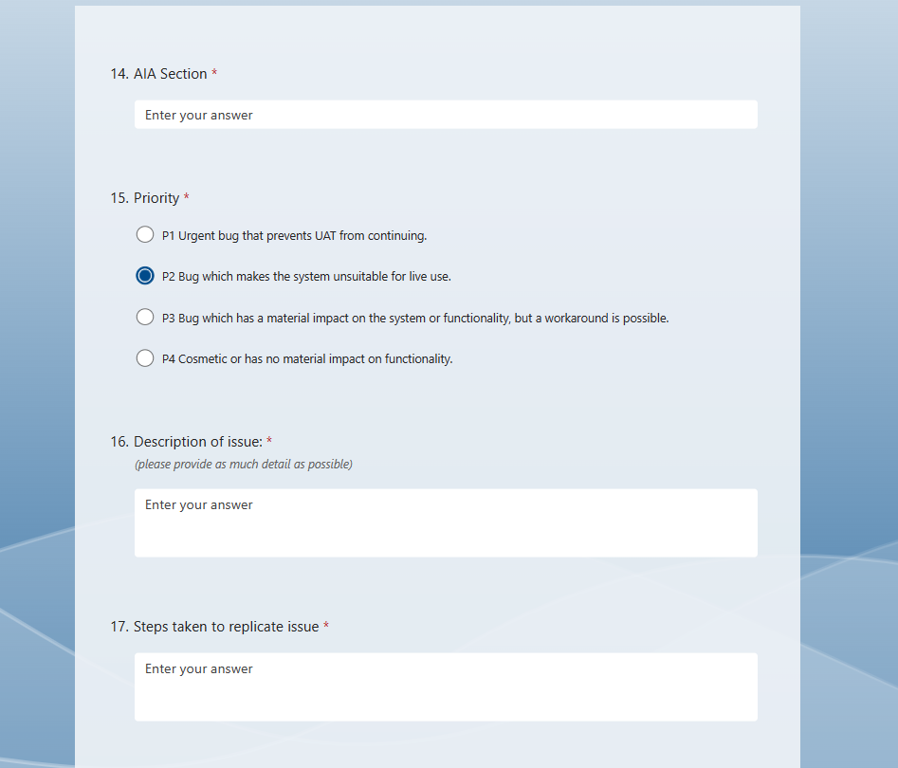
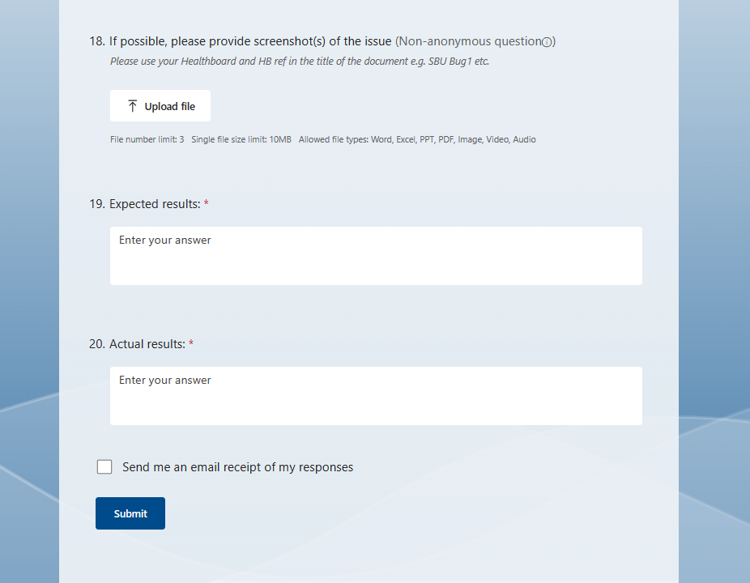

Appendix 5
Current WNCR UAT process

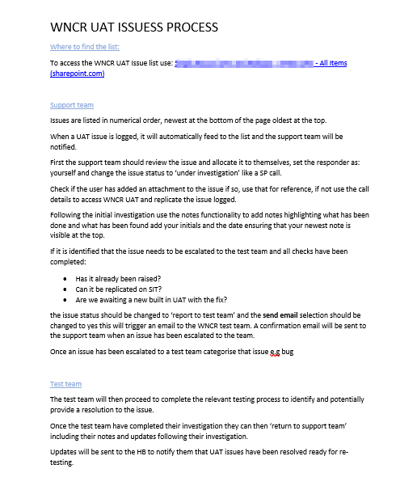

Appendix 6
Updated and Improved Process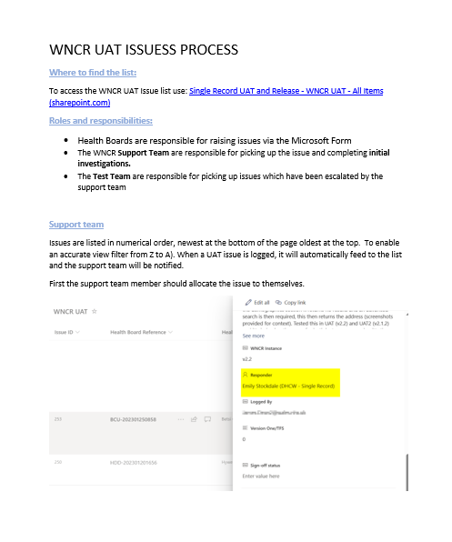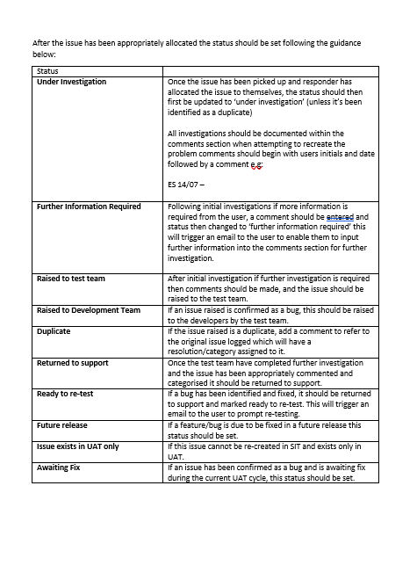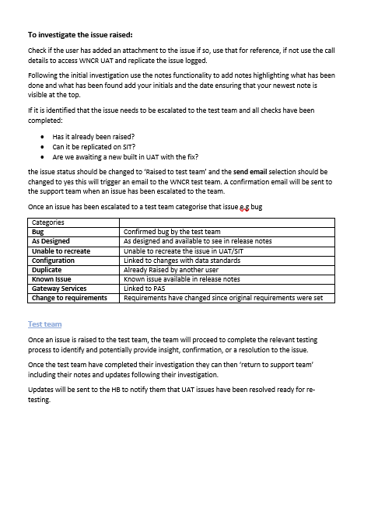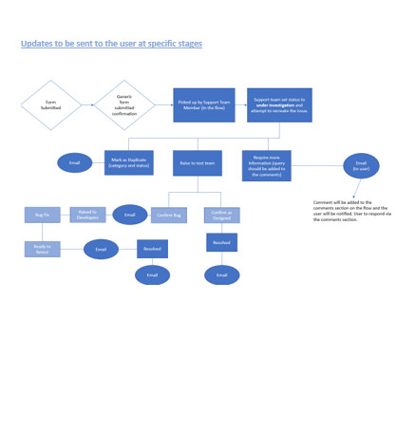

Appendix 7
Power Automate Flow

Overall Flow
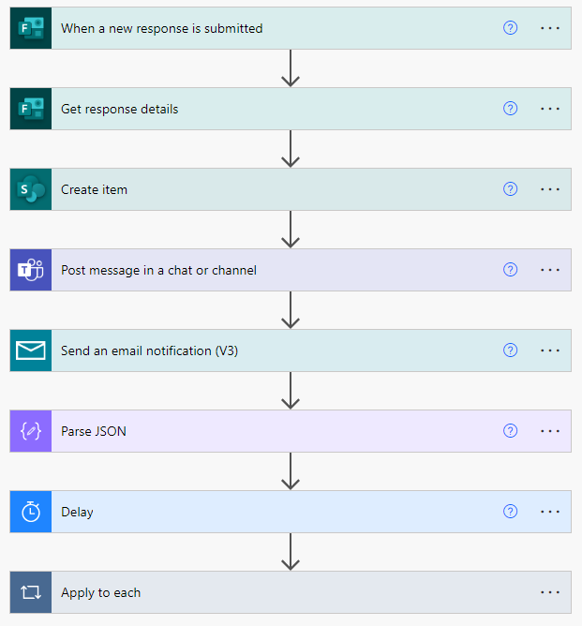
Confirmed Bug
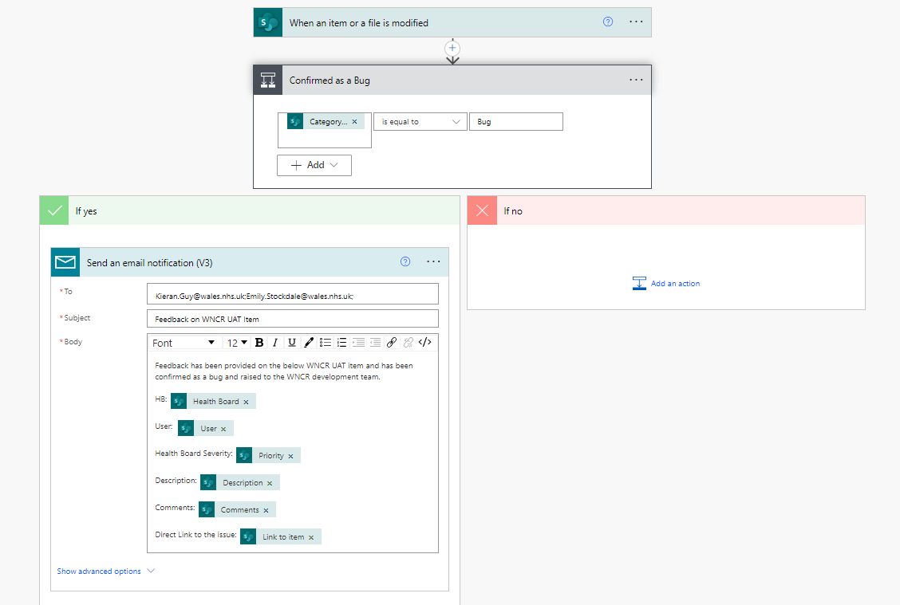
Raised to the Test Team
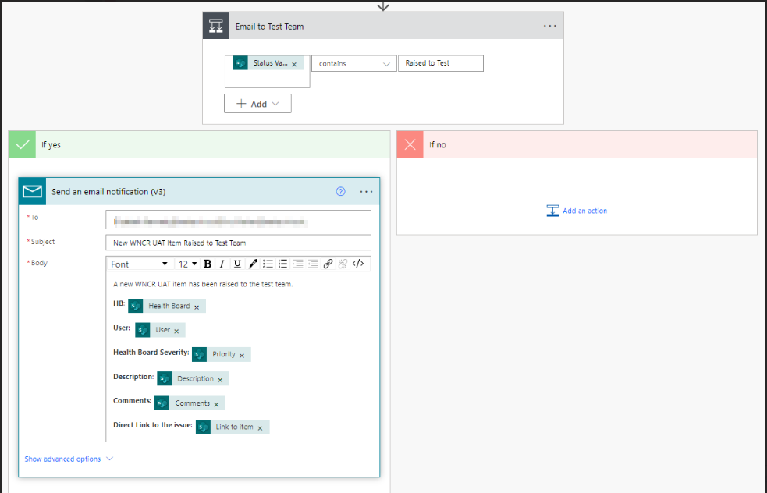
Ready to re-test
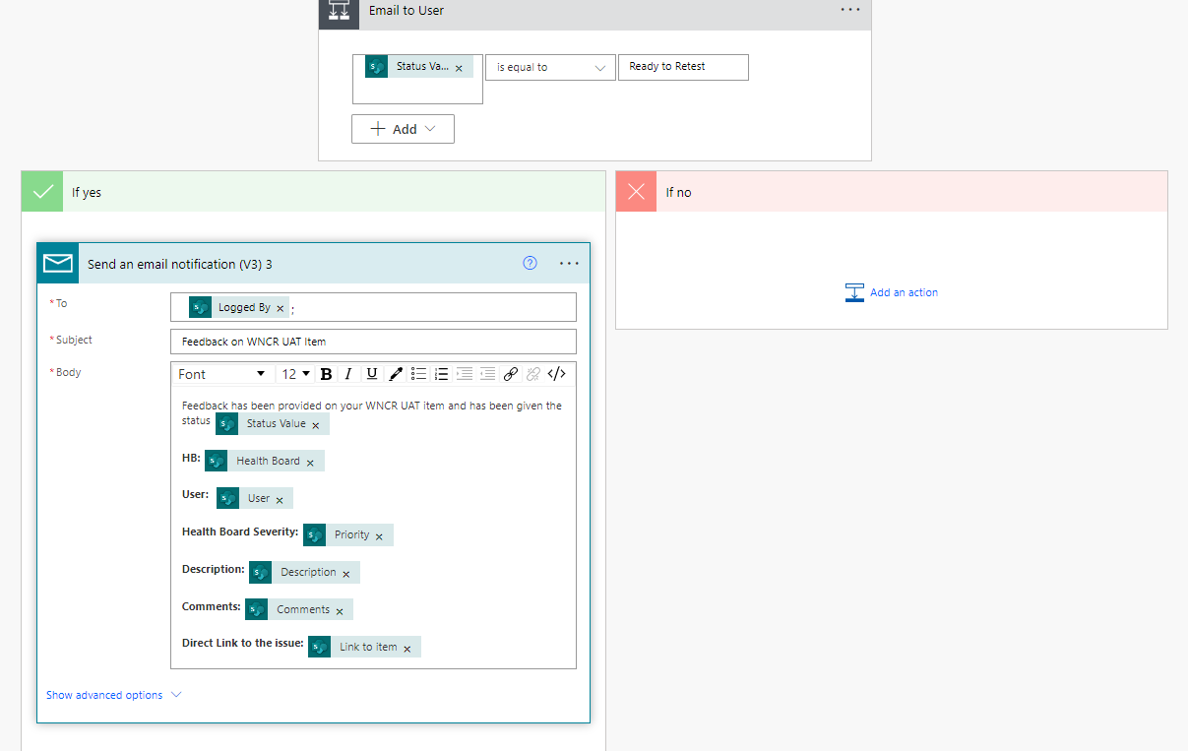

Appendix 8
SharePoint List User Guide to be used by Stakeholders.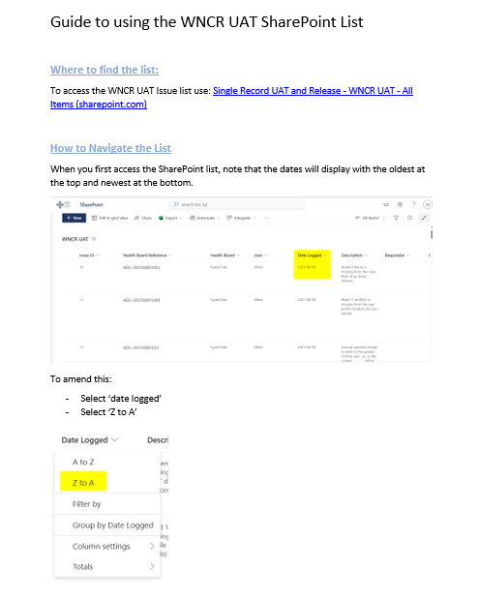
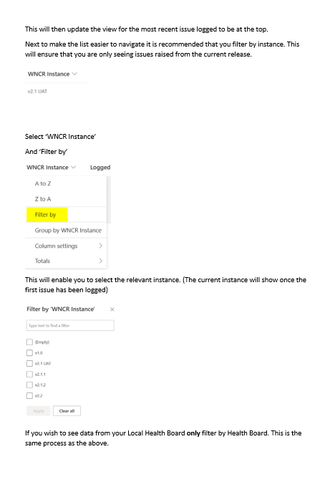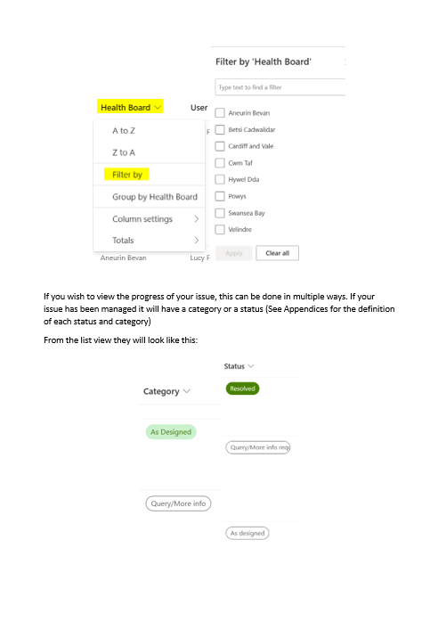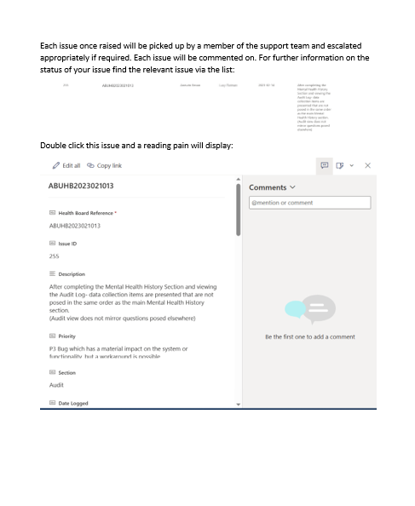
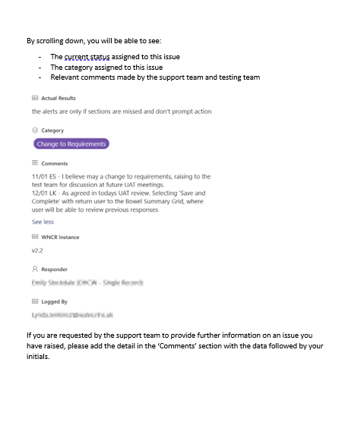
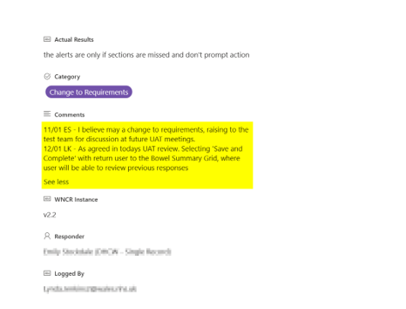
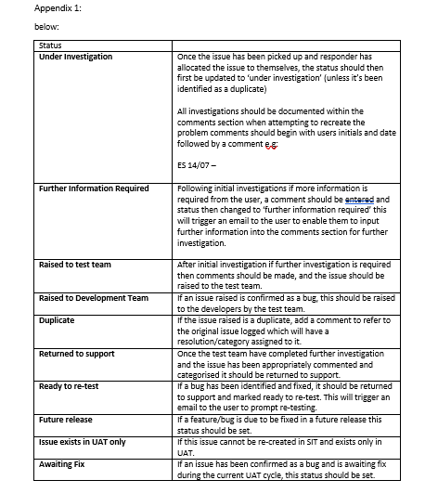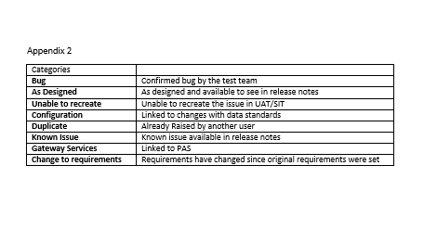

Appendix 9
Complete Dashboard design including All Health Boards.

This is an all-Wales view, used by DHCW. This can be filtered to view HB specific data.
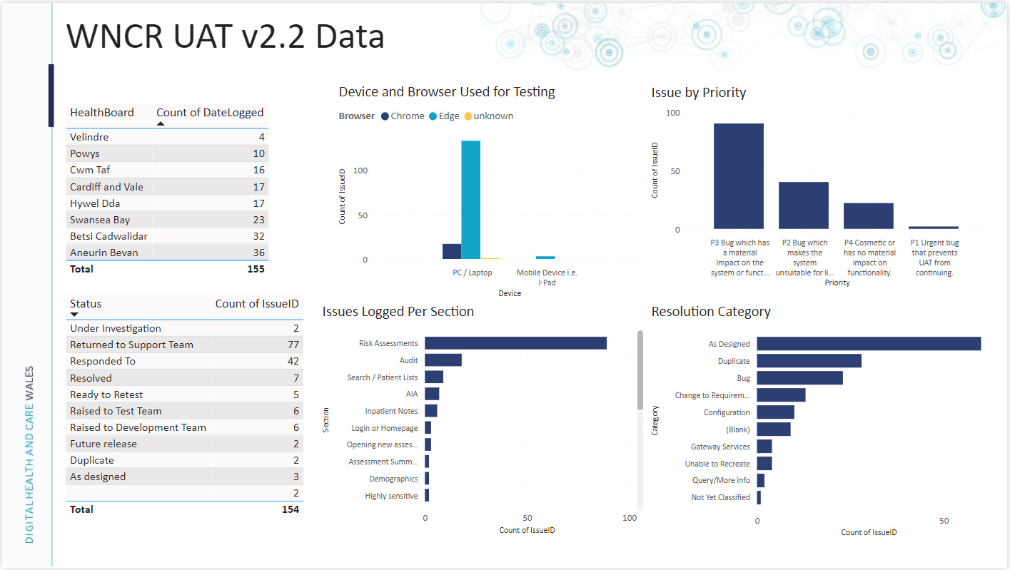

Below are the views that health boards would have access to specific data - Row Level Security.



