`
Lewy Harrison (2321772)

Designing an automatic traffic light controller for a t-junction road
Electronics 1
ACDB5002
Table of Contents:
- Introduction

- Background Research

- Circuit design

- Pseudocode

- Software listings

- Details of testing, simulated outputs and results

- Future Work

- Conclusion

Introduction
Effective traffic control systems are vital for managing vehicle flow and ensuring safety at intersections, especially in urban environments where road usage is dense and diverse. T-junctions, though simpler than cross-junctions, often experience uneven traffic distribution, leading to congestion and delays. This paper presents the simulation of a traffic light control system for a T-junction using Proteus, a popular tool for microcontroller circuit simulation. The control logic is implemented in C, allowing precise and structured programming of signal timing and behavior.
The system incorporates both vehicular and pedestrian lights, coordinated by a global 40-second timer cycle. Each direction is given a green light for 10 seconds, followed by a dedicated 10-second pedestrian phase, ensuring safe crossing opportunities without disrupting vehicle flow. This fixed-time strategy allows for predictable and systematic traffic movement, while the inclusion of pedestrian signals reflects a more holistic approach to junction safety. The simulation serves as a low-cost, effective means to model, test, and refine traffic light logic before physical deployment in real-world infrastructure.

Background Research
Traffic Control Theory
One of the foundational aspects of traffic signal design is the choice between fixed-time and adaptive control systems. Fixed-time control operates on a pre-set cycle, allocating equal or predetermined green, yellow, and red durations to each direction, regardless of real-time traffic conditions. This method is simple to implement and easy to simulate, making it suitable for low-to-moderate traffic scenarios and early-stage system design. In contrast, adaptive control systems dynamically adjust signal timings based on real-time inputs from sensors, cameras, or traffic flow data. These systems aim to minimize vehicle delay and improve overall throughput by responding to current traffic demand.
As highlighted by the KONSULT knowledgebase [1], these adaptive systems aim to optimize traffic flow by reducing congestion, delays, and environmental impact through dynamic coordination of traffic signals. While adaptive systems can significantly enhance intersection efficiency in high-traffic or rapidly changing environments, they often require more complex infrastructure and higher costs. As a result, fixed-time systems remain a practical and widely implemented solution in simpler junctions or budget-constrained projects—such as microcontroller-based T-junction simulations—where predictability and low cost are prioritized.
In the context of this project, a fixed-time control strategy has been implemented using a global 40-second timer, with each traffic light assigned a 10-second green interval, followed by a final 10-second pedestrian crossing phase. This approach aligns with the principles of fixed-time control described in the literature, offering a predictable and easily manageable signal cycle. By using fixed intervals, the system ensures regular opportunities for each direction of traffic to proceed, while also guaranteeing a dedicated phase for pedestrian safety. The simplicity of this timing scheme makes it highly suitable for microcontroller-based simulation in Proteus, where limited resources and the absence of real-time traffic sensing equipment make adaptive control impractical. Although this method may not respond dynamically to fluctuations in traffic volume, it provides a reliable framework for understanding the fundamentals of traffic signal logic and serves as a strong foundation for future development of more advanced or sensor-based systems.

Pedestrian Safety in Traffic Systems
Ensuring pedestrian safety is a vital component of modern traffic signal systems, particularly at intersections where pedestrians and vehicles often share space and compete for right of way. Poorly timed or missing pedestrian signals significantly increase the risk of accidents, especially in urban environments where foot traffic is dense.
According to the World Health Organization (WHO), over 300,000 pedestrians are killed on roads globally each year, with a significant proportion of these fatalities occurring at intersections without proper signalling infrastructure [2]. Research has shown that dedicated pedestrian phases, clearly indicated crosswalk lights, and sufficient crossing time all contribute to reducing pedestrian injury rates and improving overall intersection safety. Signalized crossings, especially those that separate pedestrian and vehicle movement in time, are particularly effective at preventing conflict between pedestrians and turning vehicles.
In this project’s T-junction simulation, pedestrian safety has been addressed by allocating the final 10 seconds of the global 40-second cycle exclusively for pedestrian crossing. During this phase, all vehicle lights are red, and pedestrian signals are activated, allowing safe passage across the road without vehicle interference. This mimics an exclusive pedestrian phase, which is widely recommended in traffic engineering literature for minimizing conflict points and improving crossing safety. The use of a fixed-time pedestrian interval also ensures that pedestrians are not left guessing when it is safe to cross, which is especially important in environments lacking sensor-based detection or button-activated crossings. By including this logic in the C code and simulating it in Proteus, the project demonstrates how even basic traffic systems can effectively incorporate pedestrian safety measures through well-designed timing and control logic.
Circuit Design
Circuit Layout
When designing the hardware circuit for a traffic light simulation, one of the most important considerations is ensuring that the layout and behaviour closely resemble a real-world implementation. This includes arranging the LEDs to visually represent traffic lights in their actual physical positions—typically in vertical or horizontal sequences with standard colour ordering (red, yellow, green). Proper labelling and spacing of the components help simulate how users would interact with the system in reality. Additionally, incorporating dedicated pedestrian lights in the circuit enhances realism and reinforces safe crossing behaviour. From a technical perspective, the choice of microcontroller is critical; it must have enough I/O pins to control multiple LEDs and inputs (if buttons or sensors are used). The timing logic coded in C must be accurately synchronized to match the 40-second cycle and switching intervals. Furthermore, power management and stability must be considered to ensure the circuit can run continuously without glitches. By designing the hardware to mirror real-world traffic systems, the simulation becomes more intuitive, educational, and closer to being ready for real-world prototyping.

Component Selection and Justification
Choosing the right components is essential to ensure that the traffic light simulation operates effectively and closely resembles a real-world system. At the core of the circuit is the PIC18F4550 microcontroller, which is an excellent choice for this project due to its versatility, performance, and wide range of input/output capabilities. The PIC18F4550 offers 35 I/O pins, more than sufficient to independently control each traffic and pedestrian light across a T-junction without the need for additional multiplexing hardware.
It also supports high-speed operation (up to 48 MHz), allowing for smooth and precise timing in the 40-second global cycle. The microcontroller's internal timers and interrupt features enable accurate state transitions and delay management, which are critical for maintaining a reliable and consistent traffic signal cycle.

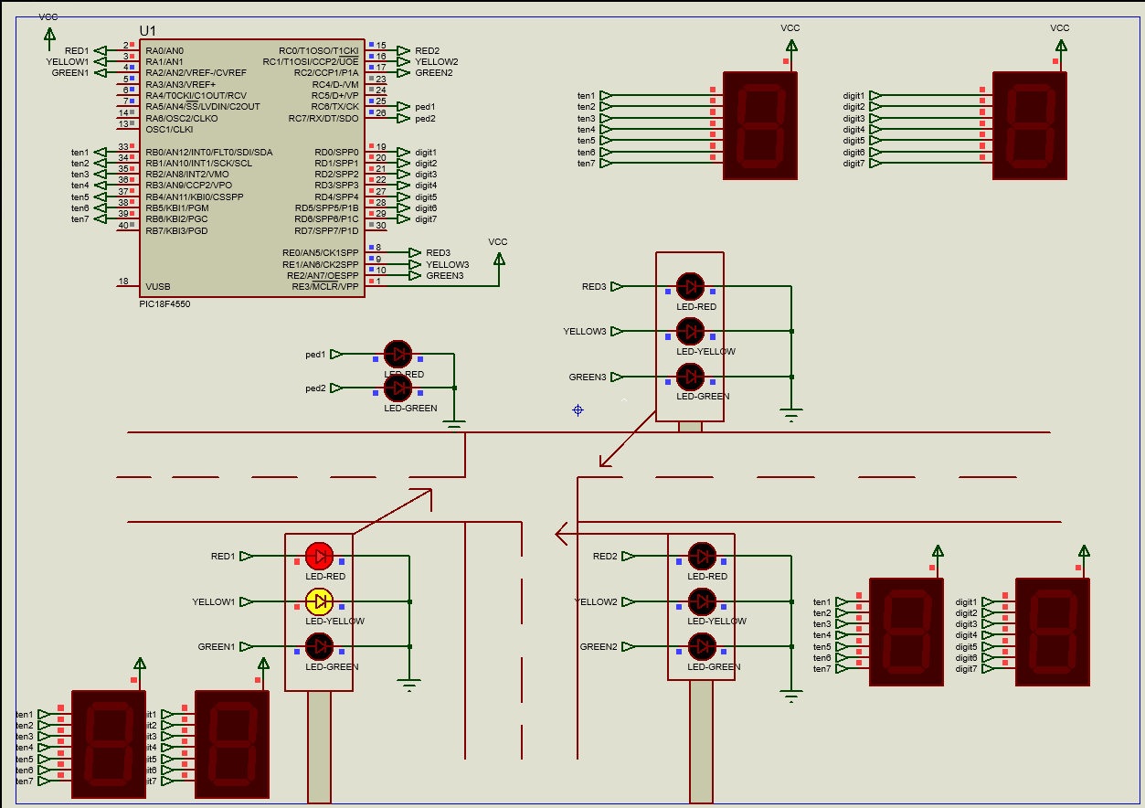
Figure 1: Proteus design of hardware with circuit off.
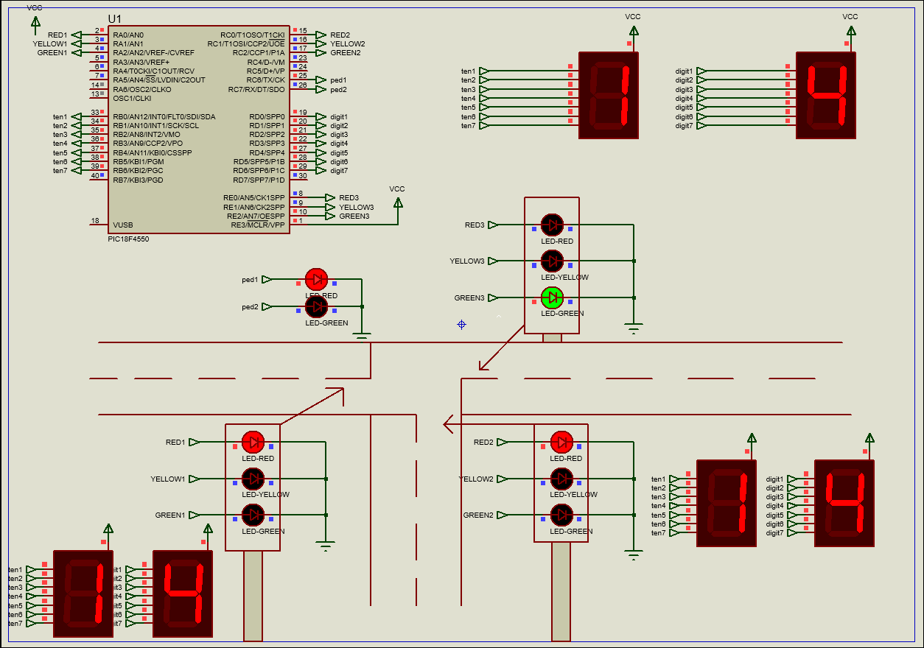
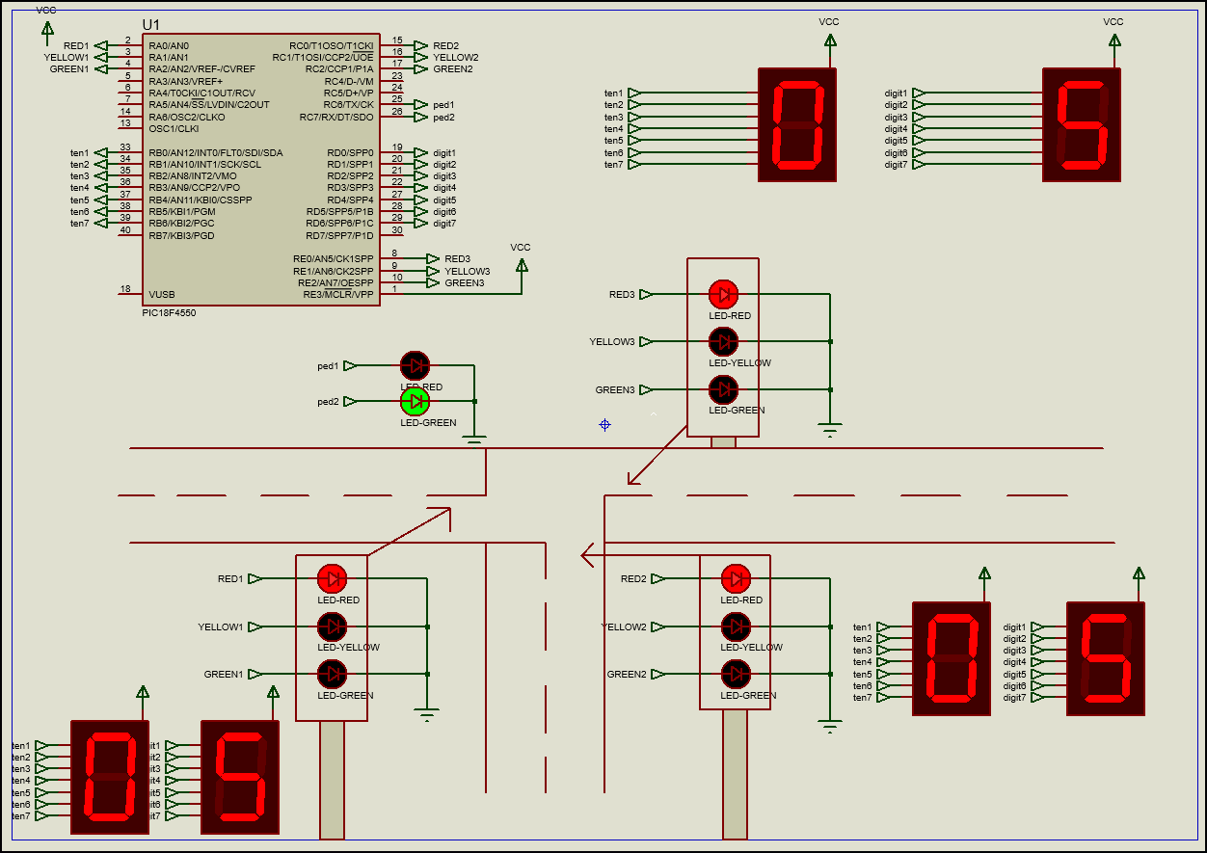
Figure 2 and 3: shows the proteus design of the circuit in the middle of a run-through of the code. Figure 2 shows the lights when a set of cars can pass and figure 3 shows when all the traffic lights are red, and pedestrians can cross.
Pseudocode
The process of writing the code for a traffic light simulation involves translating real-world traffic rules and timings into precise, programmable logic that can be executed by a microcontroller. In this project, the code was written in C and developed with the aim of simulating a realistic T-junction intersection using the PIC18F4550 microcontroller.
The first step involved clearly defining the requirements of the system, such as the global 40-second cycle, individual 10-second intervals for each traffic direction, and the final 10 seconds reserved exclusively for pedestrian crossing. With this structure in mind, a fixed-time approach was used, where the program transitions through different light phases in a loop.

Pseudocode Breakdown
- 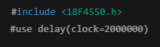
This includes the appropriate device header for this PIC and defines the clock speed as 2MHz
- 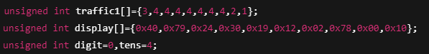
- Traffic1 stores binary values corresponding to various traffic light states, 1 is red, 2 is yellow, 3 is yellow and red, and 4 is green.
- Display holds hexadecimal values that represent digits 0-9 on a 7-segment display
- Digit and tens are used to track and output the current second on the timer (starting at 40s)
- 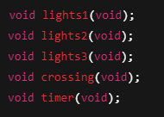
These subroutines define the main phases of the traffic lights system and the countdown timer update routine.

- 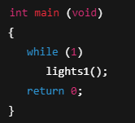
The program begins execution in the main() function and repeatedly calls lights1(), which in turn calls the other phase functions in sequence, thereby forming a continuous loop.
- 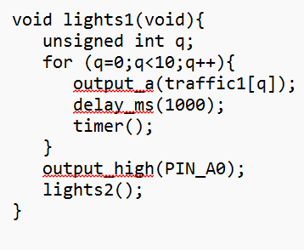
This function controls the first direction of traffic using port A. It displays each traffic light state for 1 second, while also calling the timer() function each time. After the 10 second cycle, the light is set to red “output_high(PIN_A0)” and the next function is called.
- 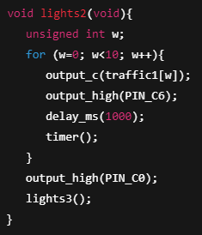
Controls the second traffic direction via port C. As with lights1, the timer function is called every second and the red light is turned on just before moving to the 3rd set of lights.
- 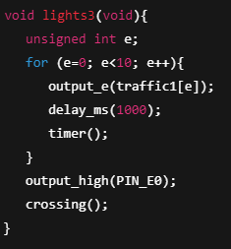
The same happens in lights3 but for port E. When the cycle is completed, crossing() is called.
- 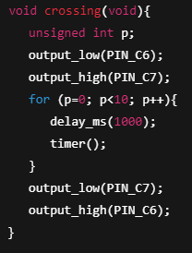
First, the function turns the red light off and the green light on, allowing pedestrians to cross. After the 10 seconds is up, the red light is turned on and the green light is turned off, and the subroutine ends, sending the code back to main where the cycle begins again.
- 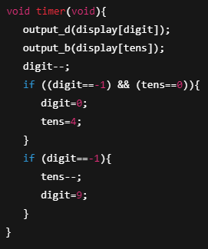
The timer function drives two 7-segment displays connected to port B and D. It decrements the time by one second for each call. When digit reaches -1, it wraps to 9 and tens decreases. When the full countdown reaches 00, it resets to 40 (tens=4 and digit=0).

Software Listing
Code:
/* Main.c file generated by New Project wizard
*
* Created: Tue Feb 25 2025
* Processor: PIC18F4550
* Compiler: CCS for PIC
*/

#include <18F4550.h>
#use delay(clock=2000000)

unsigned int traffic1[]={3,4,4,4,4,4,4,4,2,1};
unsigned int display[]={0x40,0x79,0x24,0x30,0x19,0x12,0x02,0x78,0x00,0x10};
unsigned int digit=0,tens=4;

void lights1(void);
void lights2(void);
void lights3(void);
void crossing(void);
void timer(void);

int main (void)
{
while (1)
lights1();
return 0;
}

void lights1(void){
unsigned int q;
for (q=0;q<10;q++){
output_a(traffic1[q]);
delay_ms(1000);
timer();
}
output_high(PIN_A0);
lights2();
}

void lights2(void){
unsigned int w;
for (w=0;w<10;w++){
output_c(traffic1[w]);
output_high(PIN_C6);
delay_ms(1000);
timer();
}
output_high(PIN_C0);
lights3();
}

void lights3(void){
unsigned int e;
for (e=0;e<10;e++){
output_e(traffic1[e]);
delay_ms(1000);
timer();
}
output_high(PIN_E0);
crossing();
}

void crossing(void){
unsigned int p;
output_low(PIN_C6);
output_high(PIN_C7);
for (p=0;p<10;p++){
delay_ms(1000);
timer();
}
output_low(PIN_C7);
output_high(PIN_C6);
}

void timer(void){
output_d(display[digit]);
output_b(display[tens]);
digit--;
if ((digit==-1) && (tens==0)){
digit=0;
tens=4;
}
if (digit==-1){
tens--;
digit=9;
}
}

Details of testing, simulated outputs and results
Testing Procedure
- Initial Circuit validation – the microcontroller (PIC18F4550), LED configurations and 7-segment displays were connected according to the schematic. The simulator verified that all components were correctly powered and that output pins functioned as expected.
- Function testing of each phase – each light control function was tested in isolation by temporarily disabling the function chaining. This ensured that each section correctly activated the appropriate lights for 10 seconds and transitioned smoothly.
- Timer and display validation – the timer function was tested extensively to ensure the 7-segment displays correctly represented a countdown from 40 seconds to 0. It was confirmed that the timer rolled over correctly and reset after the full cycle.
- Full system integration – the complete program was run in a continuous loop, allowing observation of the full traffic light sequence in real-time. Each traffic phase, followed by the pedestrian phase, executed for 10 seconds, with a visually accurate countdown displayed throughout.

Simulated Outputs
During the simulation, the following outputs were confirmed:
- Traffic LEDs: Red, amber, and green LEDs lit in the correct sequence for each traffic direction (as represented by PORTA, PORTC, and PORTE).
- Pedestrian Signal: PIN_C7 reliably activated the pedestrian green signal during the final 10 seconds of the cycle, while all vehicle lights were red.
- Countdown Display: The 7-segment displays connected to PORTB and PORTD accurately displayed each second from 40 to 0. Both digit transitions and rollover logic were correct.
- Signal Handovers: At the end of each 10-second phase, control passed smoothly to the next function without delays or overlapping outputs.

Results and Observations
The simulation ran without errors or logic faults, confirming the stability of both the hardware layout and the software implementation. The 40-second global cycle was consistently maintained, with no drift in timing. The 7-segment display timer offered a clear and intuitive user interface, simulating how real-world systems communicate remaining time to pedestrians or drivers. Realistic light sequencing helped validate that the system could easily be adapted for physical deployment with minimal modification.
In summary, the testing process confirmed that the traffic light controller is functionally sound, accurately timed, and visually coherent. The successful simulation in Proteus provides confidence that the system can be deployed on physical hardware with predictable and safe behaviour.

Future Work
Pedestrian Push Button
Currently, the pedestrian crossing phase runs every 40 seconds regardless of whether anyone is waiting. Adding push-button input would allow pedestrians to trigger the crossing only when needed. This would increase efficiency by skipping unnecessary pedestrian phases, improve vehicle flow during low foot traffic periods and make the model more realistic.
Use Real-Time Clock
The code currently uses delay_ms() functions, which block the processor and can limit scalability. Replacing these with hardware timer interrupts or integrating a real-time clock module would allow for more precise timing and free up the processor to perform other tasks in future versions—such as traffic density sensing or live status display.
Adaptive Traffic Lights
Unlike fixed-time systems, which operate on a set cycle regardless of traffic conditions, adaptive systems use real-time data—often from vehicle detection sensors, cameras, or loop detectors—to dynamically adjust the duration of green and red phases. This can greatly enhance efficiency by reducing unnecessary waiting times for vehicles when no cross traffic is present. For example, if one direction experiences a higher volume of traffic during peak hours, the system can allocate a longer green light period to that lane, thereby improving traffic flow and reducing congestion. Implementing adaptive control would require additional hardware, such as infrared or ultrasonic sensors, and more complex logic in the software to analyse input data and make timing decisions on the fly.

Conclusion
This project successfully simulated a microcontroller-based traffic light control system for a T-junction, using the PIC18F4550 and the Proteus simulation environment. The system operated on a global 40-second timer, dividing the cycle into three 10-second phases for vehicle traffic, followed by a dedicated 10-second pedestrian crossing interval. Through modular coding in C, the simulation effectively mirrored real-world traffic signal behaviour, including countdown timing via 7-segment displays and logical state transitions for each direction of traffic. The integration of pedestrian safety and clear visual outputs helped to demonstrate the practical considerations of designing embedded traffic systems.
The simulation served as a valuable platform for exploring core principles in embedded systems, traffic engineering, and digital control logic. It also provided a solid foundation for future enhancements, such as the integration of sensors, pedestrian push-buttons, and adaptive timing algorithms. Overall, the project highlights how low-cost, microcontroller-driven solutions can be designed, tested, and refined in software before transitioning to real-world implementation. The successful execution of this simulation not only reinforces the relevance of traffic control systems in urban planning but also showcases the potential of embedded development tools in solving everyday challenges.

References

[1] |  | U. o. Leeds, “Urban Traffic Control Systems,” Konsult, [Online]. Available: https://www.its.leeds.ac.uk/projects/konsult/private/level2/instruments/instrument014/l2_014a.htm.
[2] |  | W. H. Organization, Pedestrian safety: a road safety manual for decision-makers and practitioners, WHO, 2013.

