Environmental Protection and Sustainable Manufacturing Systems
Assignment: Research Report

HNC Process Operations Engineering
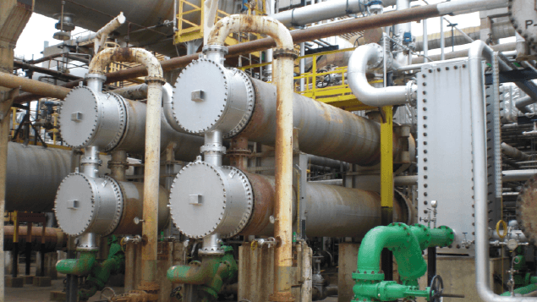

Name: Ashley Howard
Student Number: 2221736


Submission Date: 27/04/2023

Abstract

A report into the use of Shell and Tube heat exchangers within an oil refinery and how they help to conserve energy in the overall process.
Heat exchangers are used to cool or heat up a product depending on the application. Two products can transfer heat from one another in order to heat one up whilst simultaneously cooling the other down. The conservation of energy is critical for this process in order to not waste energy when it can be put to use by transferring it to another product. For example, feed product that is going into the process requires heating up in the fired heaters. This uses a lot of energy. If the feed can be preheated in a heat exchanger then less energy is required from the fired heater to achieve the same final temperature result.
Without the use of heat exchangers, the fired heaters would need to be fired higher and for longer, as well as fin fans being used more often too cool the product, using up energy therefore creating more toxic emissions that are released into the environment. Heat exchangers use various techniques to ensure the conservation of energy such as lagging to keep the heat in and finned tubes to increase the surface area of the tubes which increases the heat transfer coefficient. There are still improvements to the exchanger that could be used such as helical baffles on the shell side and swirls in the tubes to aid the heat transfer and make the process more energy efficient.
The waste water treatment plant is responsible for removing any oil, grease and solids from the waste water on the refinery. The water effluent is tested and monitored to ensure it is of the correct specification before being released back into the water ways. The solids that are removed from the water are compacted and treated so they can be used as biosolids such as compost and fertiliser. There are regulations that the water and the biosolids must meet before they are to be disposed of or recycled.

Contents
Abstract 1
Table of Figures 3
Acronyms 4
Introduction 5
Task 1 – Shell and Tube Heat Exchangers 6
Task 2 – Waste Water Treatment Plant 12
Conclusion 14
References 15
Bibliography 17

Table of Figures
Figure 1- Shell and tube exchanger diagram (TUBETECH, 2022) 6
Figure 2- finned tubes from a heat exchanger (Turbull & Scott, 2020) 7
Figure 3- Diagram of Heat Exchanger finned tubes (Thomas, -) 8
Figure 4- Heat exchanger pipework lagging (The Piping Talk, 2020) 9
Figure 5- Segmental and Helical Baffles 10

Acronyms

WWTP – Waste Water Treatment Plant
HTU 1 – Hydrotreater Plant 1
3-E-1s – Feed Effluent Heat Exchangers
N₂ – Nitrogen
CO₂ – Carbon Dioxide
CO – Carbon Monoxide
EPA – Environmental Protection Agency
IED – Industrial Emissions Directive
NPDES - National Polluant Discharge Elimination System

Introduction

A report into the use of Shell and Tube heat exchangers on an oil refinery and how they help to conserve energy in the overall process.
This report is aimed at audience who have little to no experience or knowledge of shell and tube heat exchangers. The report will give an insight into the implications that shell and tube heat exchangers already have on a refinery, methods that are already being used to reduce energy losses within the process and any improvements that could be made to heat exchangers to recover more energy in order to meet local and global standards and regulations.
The second report is into the Waste Water Treatment Plant on the refinery. The audience that the report is aimed at is those with limited or no current knowledge of the waste water treatment plant. The report explains how waste products from the refining process are segregated and where possible recycled into useful produce.

Task 1 – Shell and Tube Heat Exchangers

Shell and tube heat exchangers are a common and efficient piece of plant equipment on an oil refinery that are used to transfer heat from one product to another. They consist of a bundle of tubes that are enclosed in a cylindrical container known as the shell. One side of the exchanger will have a hot product whilst the other side a cold product (TUBETECH, 2022). The exchange of heat can be used to heat up a product, cool down a product or both simultaneously. Figure 1 shows a shell and tube heat exchanger diagram.
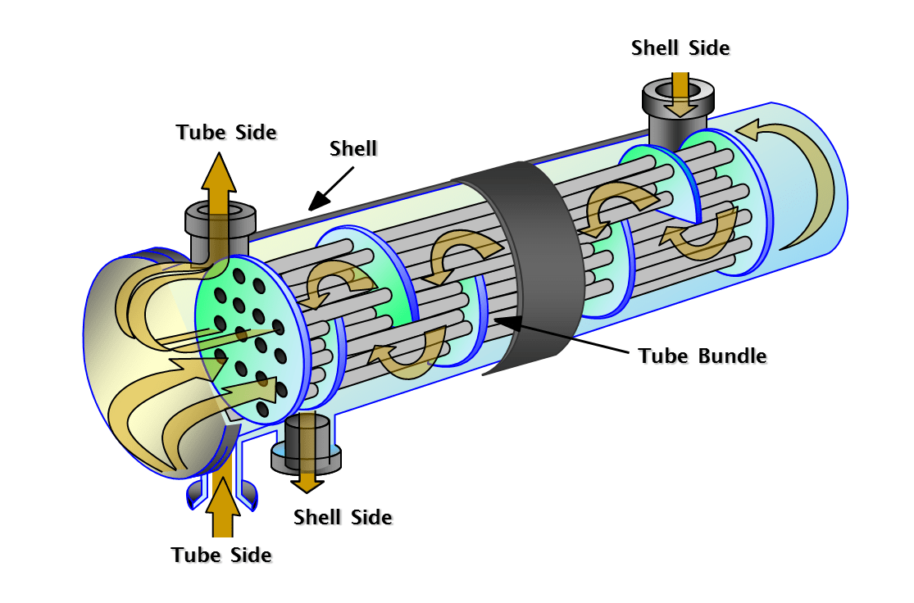
Figure 1- Shell and tube exchanger diagram (TUBETECH, 2022)

Shell and tube heat exchangers have a very high rate of heat transfer. For example, on the Hydrotreater Plant 1 Unit (HTU 1) there is a bank of heat exchangers (3-E-1s) used to transfer heat from the product of the outlet from the reactors and into the product feed that is entering the process. The product feed coming into the process on the shell side of the 3-E-1 heat exchangers is around 107⁰C. After passing through a series of three exchangers the output temperature is increased to approximately 212ºC (Valero, 2019). The heat energy is transferred from the reactor product which is in the tube side of the exchangers. The product from the reactors requires cooling before entering the high-pressure separator. Both the unit feed and the reactor effluent require opposing changes in temperature, if these were done separately using fin fans to cool the reactor effluent and heaters to heat up the unit feed a great amount of energy would be required to achieve the same results that the heat exchangers give. The conservation of energy is huge within this small part of the overall process. If heat exchangers didn’t exist across the whole refinery, the energy from heating and cooling would not only come at an incredibly large cost but also have a huge environmental impact. (Gupta, 2021)
Heating the product feed would require the heaters to be fired up much higher and for longer, effecting the environment in a number of different ways. Firing the heaters up to a higher temperature requires more fuel gas to be combusted. This in turn increases the quantity of flue gas being emitted from the flue stack. Flue gas contains many components that are harmful to the environment. Nitrogen (N₂), Carbon Dioxide (CO₂) and Carbon Monoxide (CO) are all elements of flue gas which are harmful to the environment (Keison, 2018). An article on the US Environmental Protection Agency website states ‘Excess nitrogen in the atmosphere can produce pollutants such as ammonia and ozone, which can impair our ability to breathe, limit visibility and alter plant growth. When excess nitrogen comes back to earth from the atmosphere, it can harm the health of forests, soils and waterways’ (EPA, 2022). By producing more flue gas to achieve product temperature increases the environment would be greatly impacted by the amounts of nitrogen being released. By using a heat exchanger to heat up the product feed from the reactor effluent, not only is the energy saved that would otherwise be wasted from cooling the reactor effluent but a further heating/cooling process isn’t required to achieve the same result.
Shell and Tube heat exchangers have various different methods that are used to reduce the amount of energy lost during the process. The first method is to have fins on the tubes within the exchanger. This is shown in Figure 2.
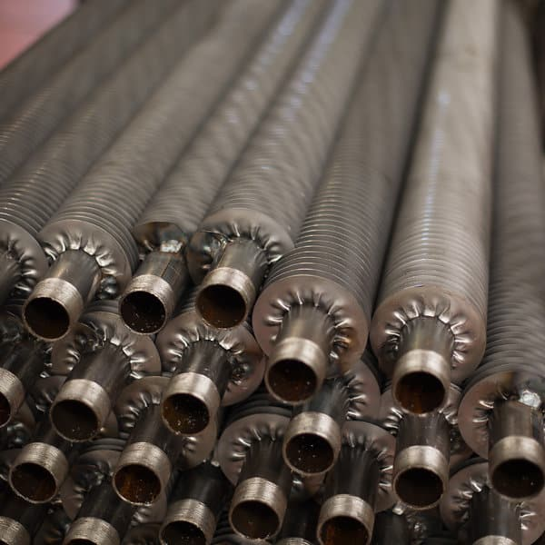
Figure 2- finned tubes from a heat exchanger (Turbull & Scott, 2020)

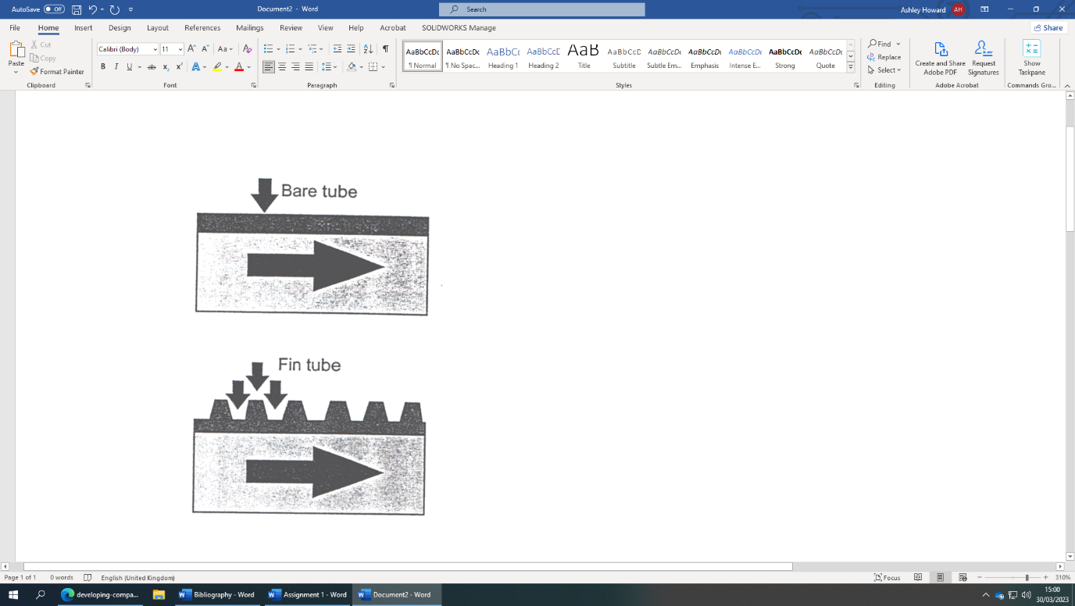
The purpose of the fins on the tubes is to increase the surface area of the shell side within the same length of tube. By increasing the surface area on the tubes, the rate of heat transfer increases. This is supported by a case study by Craig L. Thomas. The study is into the development of shell and tube heat exchanger designs with titanium finned tubes (Thomas, n.d.). The study states ‘The typical increase in area for finned tubes versus bare tubes is greater than 150%. This increased surface area means it is possible to put the product with the lowest heat transfer coefficient on the shell side of the heat exchanger so that the benefits of the additional surface area can be fully utilised. Figure 3 shows a diagram of the gain in surface area through fitting fins on exchanger tubes. By increasing the heat transfer coefficient, the less energy is required from the heaters and fin fans to heat or cool the products. This is a good way to reduce the energy losses within the process. The initial cost of the tubes would be slightly higher but this would be re-paid quickly with the energy cost saving. From an environmental point of view, any kind of reduction in the loss of energy is a positive, the finned tubes are therefore a necessity to use on heat exchangers.
Figure 3- Diagram of Heat Exchanger finned tubes (Thomas, n.d.)

Another method of reducing the loss of energy during the heat exchanger process is the fitting of lagging to the inlet and outlet piping that runs to and from the exchangers. The lagging is wrapped around the lengths of pipework so that the cooler atmosphere doesn’t cool the pipework and product whilst it is moving between vessels. Figure 4 shows a pair of heat exchangers with lagging on the E-1 tube outlet pipework, reducing the energy loss as it moves over to the E-2 exchanger.

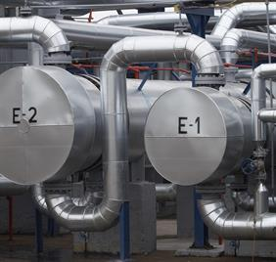
Direction of Flow
Figure 4- Heat exchanger pipework lagging (The Piping Talk, 2020)
E-1 Tube Outlet
E-2 Tube Inlet

A third method that is used to reduce the energy losses within a shell and tube heat exchanger is the chemical injection of the feed product with an anti-foulant chemical that aims to stop the build-up of unwanted deposits on the tubes of the heat exchangers. (Valero, 2019) If these deposits build up within the exchangers, then there may be heat transfer degradation. If the deposits were to build up, more energy would be required through heating and cooling the products to achieve the same temperatures as you get from a correctly operating heat exchanger. The anti-foulant chemical injection is therefore reducing the lost energy within the process. This is backed up in a case study compiled by E. M. Ishiyama, W. R. Paterson and D. I. Wilson. The study identifies that ‘Over the last decade the industry has moved from treating fouling as a chronic problem, to one which should be treated and, where possible, eliminated.’ One of the key factors for this is the environmental impact of the raised firing of heaters to make up for the reduction in heat transfer efficiency. (Ishiyama, 2016)
One improvement that can be used to improve the shell and tube heat exchanger process is to change out the segmented baffles and instead use helical baffles to improve the heat transfer coefficient. Helical baffles give an increase in heat transfer efficiency as well as reducing the amount of pressure loss. By using helical baffles, the heaters wouldn’t need to fire as hard to achieve the same temperature results, also the pumps wouldn’t be working as hard to keep the pressure up as it exits the exchangers. Both of these positives make the use of helical baffles a reasonably practicable improvement that can be made. A report into methods to improve heat transfer in heat exchangers justifies this idea (Vaclav, 2015). Figure 5 shows diagram that compares the segmental and helical baffles.
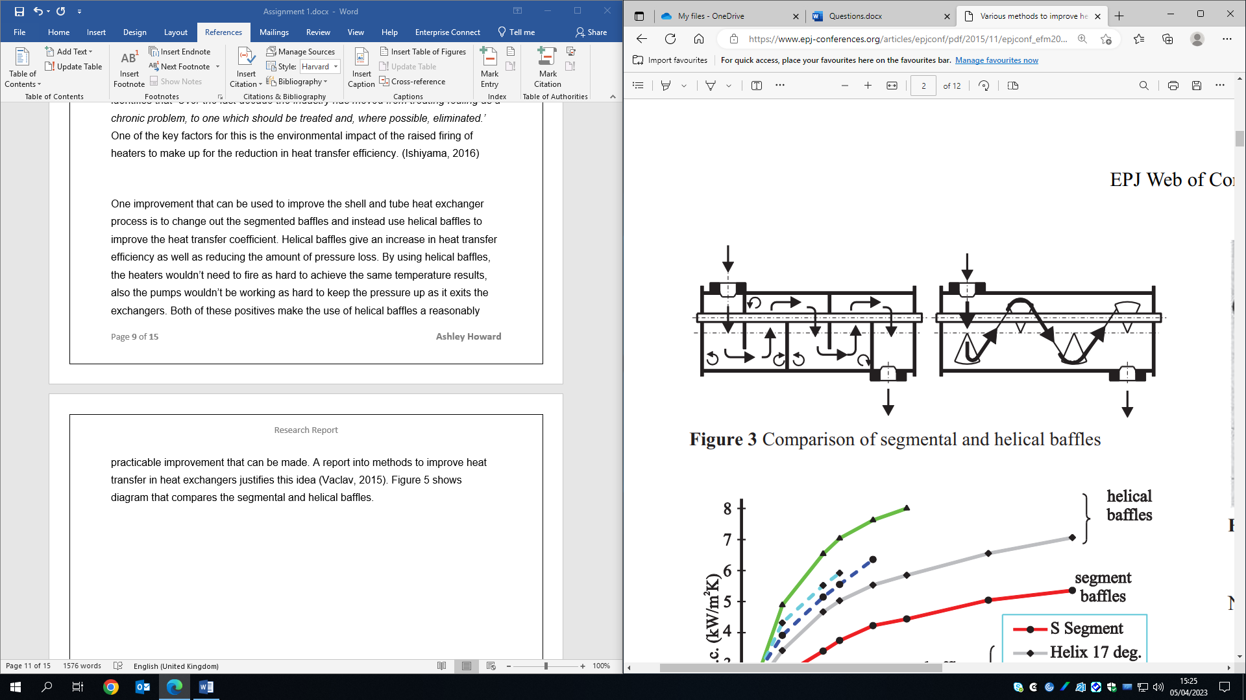
Figure 5- Segmental and Helical Baffles

The helical baffles would allow the unit to lower the firing rate of the heaters which would reduce the emissions emitted from the flue stacks. The Environmental Protection Agency (EPA) issued further control on the toxic air from oil refineries. Refineries are now required to monitor the emissions within the refinery and around the fence line. When it was implemented in 2018 there was a reduction of 5,200 tonnes every year of toxic pollutants (EPA, 2016). By reducing the rate of the heater firing the emissions that are measured during the constant fence side monitoring will be lower.
Another improvement that can be made to heat exchangers to improve the heat transfer efficiency rate and therefore save energy from being used through cooling is to add swirls to the tubes inside of the exchanger. The swirling motion throughout the length of the tube increases the convective heat transfer coefficient that occurs under the forced convection (Abeykoon, 2014). By increasing the heat transfer coefficient, the fans that cool the product down won’t need to be used as often or for a long duration as most of the heat would have been dissipated in the heat exchanger. This will therefore conserve and reduce the amount of energy usage across the refinery. The Industrial Emissions Directive (IED) is the European body that regulates industrial pollutant emissions. This body is also still in effect in the UK following the split from the EU. IED covers any kind of pollution from the whole environment including air, water, land and energy efficiency (European Comission, 2016). In order to comply with these regulations’, energy conservation is required wherever possible on the refinery. The saving that is made from firing down the heaters combined across the whole refinery would accumulate and contribute massively to satisfy the IED.
The Clean Air Strategy 2019 details how standards and laws have been put in place in order to reduce the pollution and improve the air quality in the UK. The policy states ‘We will maintain our longstanding policy of continuous improvement in relation to industrial emissions, building on existing good practice to deliver a stable and predictable regulatory environment for business as part of a world-leading clean green economy’ (UK Government, 2019). This will be achieved by setting targets and limitations for industrial companies in terms of how much pollution they release into the environment. By making the proposed improvements to the heat exchangers. The refinery will have a much lower emissions rate, helping them satisfy the Clean Air Strategy.

Task 2 – Waste Water Treatment Plant

During the refining process large amounts of water are used for different applications such as cooling, distillation, desalting and fractionation (Parkson Corporation, 2018). As well as this crude oil that is imported contains high amount of water that are to be drained off before the crude is sent into the process.
At Pembroke refinery there is a Waste Water Treatment Plant (WWTP) that separates the water from oil, as well as removing solids, organics, metals and other contaminants. Once the water reaches the end of the plant and it is of the correct specification it can be discharged back into the waterways. The solids that are removed are recycled or sold and used outside of the refinery (Singh, 2018). The recycling of the products is ensured by a contract company who are responsible for coming onto site and removing the full containers of the solids.
The water that is separated out from oil and solids is stored at the bottom of the treatment plant in the storm pond. It is segregated here away from the contaminated water before being released back into the water ways after it has passed the required tests. The water is held in a sump before being released into the storm pond. It is held here where the lab will carry out tests on it, checking ammonia and sulphide levels twice every shift. If these tests have to high a range of either then the water wouldn’t be released to the storm pond as it would contaminate the rest of the effluent. (Valero, 2020)
The solids and sludge that is removed from the water is compacted down and treated so it can be recycled into biosolids. They can then be used as fertiliser, compost or landfill cover (Tuser, 2021). Given their organic properties the recycled biosolids add nutrients and improve the soil structure when used as a fertiliser. With the refinery through putting 270,000 barrels of oil per day there is a lot of waste water and biosolids that are produced from this. There therefore has to be a planned method of disposal or reusing it. All of the biosolids are sold and taken offsite. They are segregated into different types of biosolids and stored into separate containers until they are taken away.

As Valero is an American company they have to work to US standards and regulations. ‘The Clean Water Act prohibits anybody from discharging pollutants through a point source into a water of the United States’ unless they have an NPDES (National Pollutant Discharge Elimination System) permit’ (Parkson Corporation, 2018). The permits state limits of what can be discharged and the requirements for reporting and monitoring the effluent. The regulations ensure that only the correct specification water is released back to the environment.
As well as the US regulations, the refinery has to follow the UK environmental permitting laws. The regulation that was put into place in 2016 states you need an environmental permit if you are a site where ‘waste is recycled, stored, treated or disposed of’ (UK Government, 2016). In order to follow the laws these permits are required in order to ensure of the safe recycling and disposal of the waste produce.

Conclusion

To conclude shell and tube heat exchangers are a vital piece of equipment used on an oil refinery in order to conserve energy. There are many different methods such as lagging or chemical injection that are currently used to enhance their heat transfer coefficient. There are however, a few different methods that aren’t currently used on the HTU-1 that could be adopted and would further the heat transfer rate which in turn would reduce the energy required from the fired heaters and fin fans. These energy recovery proposals would help the refinery to meet the global and national standards that they are required to meet.
On the refinery waste segregation is ensured through the management of product placement as well as the requirement to comply with regulations and standards. The recycling is ensured through the mass amounts of produce that is coming through the process daily as well as having a contractor responsible for recycling the solids into useful biosolids.

References

Abeykoon, C., 2014. Improving the Performance of Shell-and-Tube Heat, Wrexham: The University of Manchester Research.
EPA, 2016. Petroleum Refinery Sector Rule (Risk and Technology Review and New Source Performance Standards). [Online]
Available at: https://www.epa.gov/stationary-sources-air-pollution/petroleum-refinery-sector-rule-risk-and-technology-review-and-new
[Accessed 11 04 2023].
EPA, 2022. Nutrient Pollution. [Online]
Available at: https://www.epa.gov/nutrientpollution/issue#:~:text=Excess%20nitrogen%20in%20the%20atmosphere,of%20forests%2C%20soils%20and%20waterways.
[Accessed 30 03 2023].
European Comission, 2016. Industrial Emissions Directive. [Online]
Available at: https://environment.ec.europa.eu/topics/industrial-emissions-and-accidents/industrial-emissions-directive_en
[Accessed 12 04 2023].
Gupta, S. K., 2021. A comprehensive review of energy saving in shell & tube heat exchanger. Materials Today: Proceedings, 13 September.
Ishiyama, E. M., 2016. THE EFFECT OF FOULING ON HEAT TRANSFER, PRESSURE DROP AND THROUGHPUT , Cambridge: The Berkeley Electronic Press.
Keison, 2018. What is Flue Gas?. [Online]
Available at: https://www.keison.co.uk/guide_whatisfluegas.shtml
[Accessed 30 03 2023].
Parkson Corporation, 2018. Wastewater Treatment In Oil Refineries. [Online]
Available at: https://www.wateronline.com/doc/wastewater-treatment-in-oil-refineries-0001#:~:text=Typical%20refinery%20wastewater%20treatment%20includes,before%20discharge%20into%20the%20environment.
[Accessed 13 04 2023].
Singh, S., 2018. Treatment and Recycling of Wastewater from Oil Refinery/Petroleum Industry. 1 ed. Singapore: Springer.
The Piping Talk, 2020. Heat Exchanger equipment layout (shell & tube). [Online]
Available at: https://thepipingtalk.com/heat-exchanger-equipment-layoutshelltube/
[Accessed 30 03 2023].
Thomas, C. L., n.d. Developing Compact Shell and Tube Heat Exchanger Designs with Titanium Finned Tube. [Online]
Available at: https://neotiss.com/images/publications/pdf/developing-compact-shell.pdf
[Accessed 12 03 2023].
TUBETECH, 2022. Shell and Tube Heat Exchangers and How They Work. [Online]
Available at: https://tubetech.com/5-types-of-shell-and-tube-heat-exchangers-and-how-they-work/
[Accessed 30 03 2023].
Turbull & Scott, 2020. Heat Exchanger Finned Tubes. [Online]
Available at: https://www.turnbull-scott.co.uk/heat-exchangers/heat-exchanger-finned-tubes/
[Accessed 30 03 2023].
Tuser, C., 2021. What is Solids Handling?. [Online]
Available at: https://www.wwdmag.com/editorial-topical/what-is-articles/news/10940159/what-is-solids-handling
[Accessed 13 04 2023].
UK Government, 2016. The Environmental Permitting (England and Wales) Regulations. [Online]
Available at: https://www.legislation.gov.uk/uksi/2016/1154/contents/made
[Accessed 13 04 2023].
UK Government, 2019. Clean Air Strategy 2019: executive summary. [Online]
Available at: https://www.gov.uk/government/publications/clean-air-strategy-2019/clean-air-strategy-2019-executive-summary#chapter-8-action-to-reduce-emissions-from-industry
[Accessed 13 04 2023].
Vaclav, V., 2015. Various methods to improve heat exchangers, Pilsen: EDP Sciences.
Valero, 2019. Refining Plant Operator HTU-1 Manual. [Online]
[Accessed 30 03 2023].
Valero, 2020. WWTP - Waste Water Treatment Plant. [Online]
[Accessed 13 04 2023].

Bibliography

Abeykoon, C., 2014. Improving the Performance of Shell-and-Tube Heat, Wrexham: The University of Manchester Research.
EPA, 2016. Petroleum Refinery Sector Rule (Risk and Technology Review and New Source Performance Standards). [Online]
Available at: https://www.epa.gov/stationary-sources-air-pollution/petroleum-refinery-sector-rule-risk-and-technology-review-and-new
[Accessed 11 04 2023].
Gupta, S. K., 2021. A comprehensive review of energy saving in shell & tube heat exchanger. Materials Today: Proceedings, 13 September.
Parkson Corporation, 2018 Wastewater Treatment In Oil Refineries. [Online]
Available at: https://www.wateronline.com/doc/wastewater-treatment-in-oil-refineries-0001#:~:text=Typical%20refinery%20wastewater%20treatment%20includes,before%20discharge%20into%20the%20environment.
[Accessed 13 04 2023].
Singh, S., 2018. Treatment and Recycling of Wastewater from Oil Refinery/Petroleum Industry. 1 ed. Singapore: Springer.
Thomas, C. L., n.d. Developing Compact Shell and Tube Heat Exchanger Designs with Titanium Finned Tube. [Online]
Available at: https://neotiss.com/images/publications/pdf/developing-compact-shell.pdf
[Accessed 12 03 2023].
UK Government, 2016. The Environmental Permitting (England and Wales) Regulations. [Online]
Available at: https://www.legislation.gov.uk/uksi/2016/1154/contents/made
[Accessed 13 04 2023].
UK Government, 2019. Clean Air Strategy 2019: executive summary. [Online]
Available at: https://www.gov.uk/government/publications/clean-air-strategy-2019/clean-air-strategy-2019-executive-summary#chapter-8-action-to-reduce-emissions-from-industry
[Accessed 13 04 2023].
Vaclav, V., 2015. Various methods to improve heat exchangers, Pilsen: EDP Sciences.
Valero, 2019. Refining Plant Operator HTU-1 Manual. [Online]
[Accessed 30 03 2023].
Valero, 2020. WWTP - Waste Water Treatment Plant. [Online]
[Accessed 13 04 2023].

