
Master of Business Administration
International Business pathway



Contemporary employability skills
Assessment 1: Individual report. Weight: 100%
Module name: International Business Concepts
Module code: LCMB7034
Lecturer name: Jean Wang
Student name: Vivekananda Reddy Singireddy
Student ID: 2529561
Word count: 5,491SS
Submission date:14th August 2026
AI Use Declaration
I confirm that this assignment is my own original work and has been completed independently without the use of generative artificial intelligence (AI) tools for researching, generating, paraphrasing, analysing or writing the content. All information has been obtained from appropriate academic sources, including peer-reviewed journals, books, official publications and credible industry reports, which have been acknowledged through proper referencing. I have followed the University's academic integrity policy throughout the preparation of this assessment. I understand the importance of academic honesty and confirm that the ideas, analysis and conclusions presented in this submission are based on my own research and understanding of the topic.

Contents 3
Main Body 4
Section 1: International Market Entry Report 4
1. Introduction 4
1.1 Company Background 4
1.2 Purpose of the Report 4
1.3 Report Structure 4
2. Organisational Classification and Global Strategy 5
2.1 International Strategy Classification 5
2.2 Global Value Configuration 6
2.3 Critical Summary 7
3. Macro-Environmental Appraisal and Market Attractiveness 7
3.1 Introduction 7
3.2 Political and Legal Environment 7
3.3 Economic Environment 8
3.4 Cultural Environment 10
3.5 Industry Attractiveness 11
3.6 Market Entry Evaluation using Dunning's OLI Paradigm 14
4. Entry Mode Strategy and Strategic Synthesis 16
4.1 Historical Internationalisation Pattern 16
4.2 Evaluation of Alternative Entry Modes 17
4.3 Recommended Entry Mode 18
4.4 Strategic Recommendations 19
Section 2: Reflection 20
5. Gibbs' Reflective Cycle 20
5.1 Description 20
5.2 Feelings 20
5.3 Evaluation 21
5.4 Analysis 21
5.5 Conclusion 22
5.6 Action Plan 22
References 24

Main Body

Section 1: International Market Entry Report

1. Introduction

1.1 Company Background
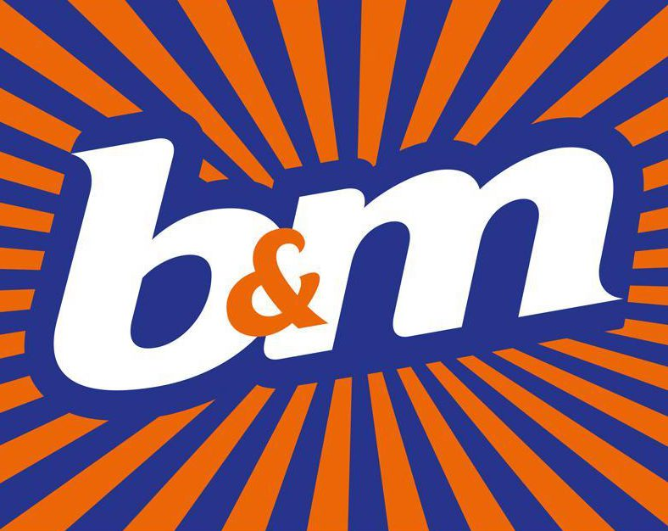
Figure 1: B&M Logo
Source: B&M European Value Retail plc (2026).
B&M European Value Retail plc is a multinational retail company (MNC) with retail operations in the United Kingdom and France. The business is based on a cost leadership strategy with centralised purchasing, slim operations and a high inventory turnover, with products available in branded and own label in FMCG, homeware and general merchandise. B&M's revenue in FY2026 was £5.78 billion, cementing its status as one of the top variety discount stores in Europe. The Group did not have any significant operational presence in the United States as of 1 June 2026 and the United States is an appropriate market for the Group to consider its foreign direct investment (FDI) strategy (B&M European Value Retail plc, 2026).

1.2 Purpose of the Report
The purpose of this report is to critically evaluate the suitability of the USA as a possible new market for B&M's international expansion. It analyses the external business environment, market attractiveness and strategic considerations which may impact successful market entry. The report also examines B&M's existing international strategy and looks at other possible avenues for market penetration before recommending the most suitable one for B&M to pursue in the United States.

1.3 Report Structure
The report starts by categorizing B&M's international strategy and looks at the existing global structure. It then analyses the political, economic, legal and cultural context of U.S. business and determines the attractiveness of the market with the appropriate theories and frameworks of international business. Last, the report reviews appropriate modes of market entry, offers strategic suggestions for B&M's expansion into the U.S., and includes a reflection of the research and learning process.

2. Organisational Classification and Global Strategy

2.1 International Strategy Classification
B&M can be said to be following an international strategy that has emerging transnational features, based on the International Strategy Framework developed by Bartlett and Ghoshal (1989). It has a centralized strategic decision making, supplier management, procurement and merchandising process to leverage economies of scale and minimal adaptation in overseas markets. This balance is reinforced by the Integration Responsiveness (IR) Grid, where B&M has a high pressure for global integration, given that purchasing efficiency and supplier relationships, as well as cost control, are the most important factors for its competitive advantage, while local responsiveness is moderate, and means adapting product ranges, promotions and regulatory compliance in various countries (Pudelko, 2023).

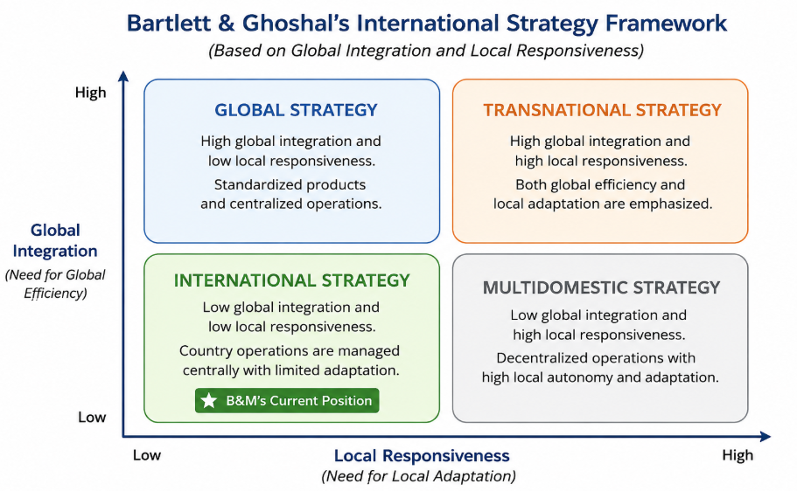
Figure 2: Bartlett and Ghoshal's International Strategy Framework and Classification of B&M
Source: By Author, adapted from Bartlett and Ghoshal (1989)
B&M European Value Retail plc (B&M) is one of the top value retailers in Europe with 777 B&M stores and 343 Heron Foods stores in the UK and 135 stores in France (B&M European Value Retail plc, 2026). The Group opened 64 new stores, including 12 in France, during the FY2026 and French revenue grew by 13.4% to £616 million and discount market share rose from 8.1% to 8.4% (B&M European Value Retail plc, 2026). The findings show that B&M is not a purely global or multidomestic approach, but it is a transnational approach that integrates a standardised value retail concept with a selection of product lines to the local consumer market (Verbeke and Kano, 2023). The relatively low cultural and institutional distance has helped B&M to stay focused on the UK and France as this enables them to procure and coordinate the supply chain efficiently and minimise internationalisation risk. This geographic focus does, however, restrict the company's revenue diversification and puts it at risk of economic conditions in the region, which may make expansion into the United States a sensible next step for the company's long-term growth (Verbeke and Kano, 2023).

2.2 Global Value Configuration
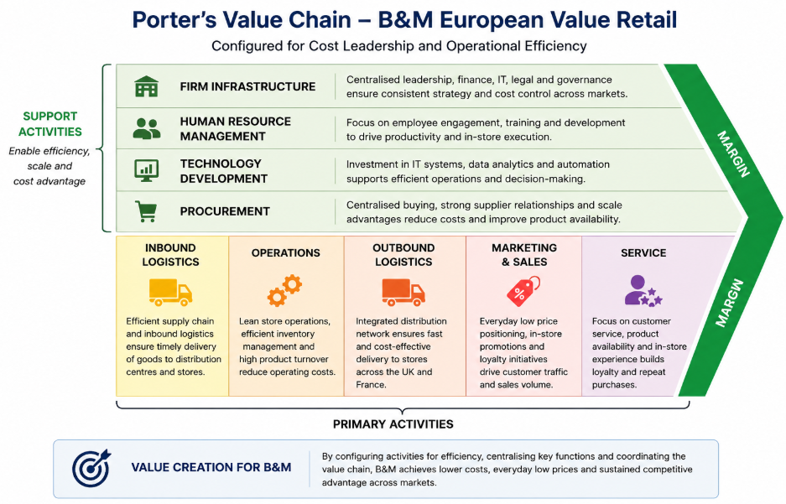
Figure 3: Porter's Value Chain Applied to B&M European Value Retail
Source: By Author, adapted from Porter (1985)
The concepts, configuration and coordination of the Porter's Value Chain (Figure 3) can be used to understand the competitive advantage of B&M. The company has a centralised procurement function and supplier management, inventory control and distribution are integrated throughout the company's activities across the UK and France, offering economies of scale and cost savings. Support activities are those that complement primary activities like logistics, store operations and customer service for improving efficiency, such as infrastructure, technology and human resource management. Moreover, the 'Back to B&M Basics' programme has enhanced the availability of stocks and merchandising execution, which has boosted the operational coordination, value proposition for customers, and cost leadership and sustainable competitive advantage (S.C.A.) of B&M (Porter, 1985; B&M European Value Retail S.A., 2026).

2.3 Critical Summary
The overall analysis suggests that B&M is following an international strategy with emerging transnational characteristics following Bartlett and Ghoshal (1989) International Strategy Framework and using the Integration–Responsiveness (IR) Grid. The company is high on global integration, centralised procurement and supplier management and operational coordination and moderately responsive to local market needs (Bartlett and Ghoshal, 1989). The combination of these two strategies has enabled B&M to grow successfully in France and provided a good foundation for evaluating the potential of such a strategy in the extremely competitive United States market.

3. Macro-Environmental Appraisal and Market Attractiveness

3.1 Introduction
This section critically appraises the United States as a potential host market based on the assessment of B&M's international strategy by exploring the external factors that are likely to impact the success of a value discount retailer. Instead of giving a general overview on the environment, the analysis will be based on the political, legal, economic and cultural environment that has an impact on B&M's cost leadership model, procurement strategy and retail operations. Despite the current trade and geopolitical uncertainties, the US is still a very appealing market for foreign retailers, with the National Retail Federation projecting retail sales growth of 4.4% in 2026 to reach US$5.6 trillion (National Retail Federation, 2026). The results are then combined using Dunning's OLI Paradigm to evaluate the strategic appropriateness of market entry.

3.2 Political and Legal Environment
The political and legal environment is an important factor in B&M's proposed expansion into the United States because its competitive advantage is based on cost leadership, global sourcing and high-volume retailing. Political decisions affecting international sourcing, import costs, regulatory compliance and supply chain efficiency directly influence B&M's cost leadership strategy. Although the United States continues to provide a transparent institutional framework for foreign investment, recent trade policy reforms and stricter retail regulations have increased compliance requirements and supply chain uncertainty for international retailers (OECD, 2024).

One of the major political events is the revival of protectionism. In July 2026, the Office of the United States Trade Representative (USTR) announced Section 301 tariffs on imports from 60 trading partners for about 99.4% of US imports. Tariff rates were determined as 10% for those countries that have banned imports of forced labour and 12.5% for most of the other economies studied (United States Trade Representative, 2026a). Higher tariffs may impact B&M's ability to keep procurement costs low, and pricing flexibility in the FMCG, homeware, toys and seasonal categories. They also promote supplier diversification and more resilient sourcing, which will force B&M to expand its supplier base but keep prices competitive (United States Trade Representative, 2026a).

The legal one is also crucial as there are federal and state laws that regulate competitive markets, employment and product safety and consumer rights in the United States retail market. Even with the big boys like Walmart and Target, competition law is still in place to ensure a clear business environment, which is enforced by the FTC and DOJ. Meanwhile, the product safety regulations and state level labour laws, raise compliance costs and boost consumer confidence and workforce protection. Tariffs and labour regulation and regulatory compliance are also among the top policy concerns for US retailers in 2026, according to the National Retail Federation (2026).

The political and legal climate is fairly conducive to B&M. The more transparent the regulation, the more investment it will attract, while tariffs and compliance costs will increase operating costs. In order to achieve successful expansion, B&M will need to source from a diverse set of suppliers, have robust compliance operations, and be operationally efficient to maintain its value retail proposition, the United States Trade Representative (2026b) stated.

3.3 Economic Environment
The economic part of PESTLE analysis indicates that the U.S. is a favourable environment for B&M to expand because of the high economic performance, large retail market, and high demand of consumers. However, ongoing inflationary pressures, exchange rates and weak job growth could impact cost of operations and pricing. Therefore, it is important to consider the economic environment in relation to B&M's cost leadership strategy, which is based on low procurement costs and high customer demand.

Despite the geopolitical uncertainty, the International Monetary Fund (IMF, 2026) forecasts that the US will grow by 2.4% in 2026, supported by productivity growth and robust domestic demand, and the unemployment rate will remain around 4%, indicating a relatively stable job market. The employment sector is decelerating but the labour market is relatively stable, which is helping to keep household incomes stable and retail consumption, particularly B&M's value-led retail, stable. In the meantime, the IMF anticipates an average consumer inflation rate of 3.2% in 2026, while the rising price of energy and tariffs will continue to put a strain on purchasing power (International Monetary Fund, 2026). This usually pushes consumers to look for more value in the U.S. retail market, providing B&M with an opportunity to offer value-for-money.

The retail industry in the United States is driven by consumer spending, and consumer purchasing behaviour is especially significant for retailers that are seeking to have a high volume of sales and low margin, like B&M. Although the economy is uncertain, retail sales are projected to grow by 4.4% in 2026, surpassing the 10-year average growth rate of 3.6% prior to the pandemic (National Retail Federation, 2026). The GBP – USD exchange rate may have an impact on B&M's import costs and financial results, however, as the sterling weakens against the USD, imports from overseas will cost more and therefore impact the financial results reported. Therefore, proper currency risk management and diversified sourcing would be crucial for ensuring operating margins.

The results are in line with the Market Size Hypothesis which posits that firms are more inclined to engage in FDI in countries where there is significant market size and purchasing power. The U.S. has sustained GDP growth, a resilient consumer spending base and one of the world's largest retail markets, which offer substantial revenue opportunities to balance higher operating and compliance expenses. Thus, B&M has a good reason to invest in FDI in the face of inflationary and exchange rate risks in the economic environment, as a long-term international growth strategy.

3.4 Cultural Environment
As seen in Figure 4, both countries are found with relatively low power distance (UK: 35; US: 40), which means that B&M would have to adapt their decision-making process in the country to become more decentralised, meaning that employees can make decisions without the need to consult management. Both countries are also relatively low on power distance (UK: 35; US: 40), which implies that B&M would need to adapt the decision-making process in the country to become more decentralised, meaning that the employees can make decisions without the need to consult management. The United States, however, has a slightly higher uncertainty avoidance score (46 compared to 35), which indicates that Americans are more concerned with reliability and consistency of the product and service. Similarly, both societies are achievement-oriented (UK: 66; US: 62), but US companies tend to be more focused on measurable results and recognition for the individual, which can have an impact on employee management and incentives.
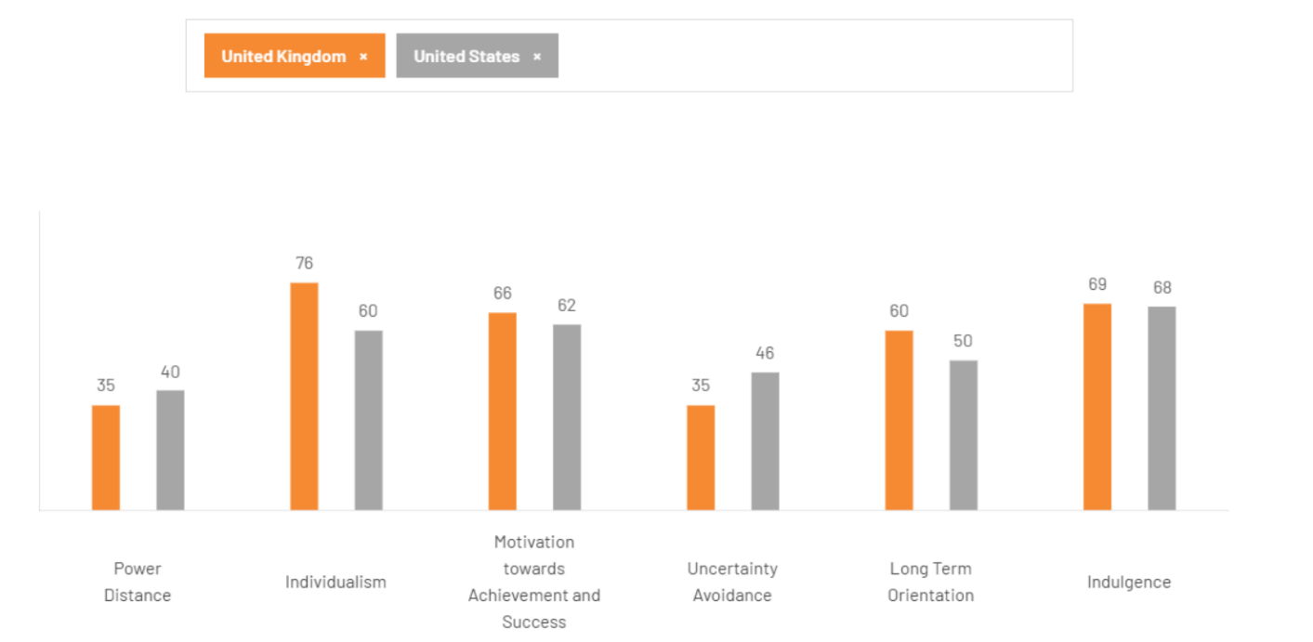
Figure 4: Comparison of Hofstede's Cultural Dimensions between the United Kingdom and the United States
Source: By Author, adapted from The Culture Factor Group (2026).

These cultural similarities also have an impact on consumer buying habits in the US retail market. Deloitte Digital (2026) reveals that more than half of consumers in the US are spending less than they did a year ago, but they still want the same seamless online and in-store shopping experience that retailers must deliver be it through value or through the experience they provide. This is especially true for B&M as its value-retailing offering can appeal to price-conscious shoppers, but the convenience of store layouts, product availability and an increasingly seamless omnichannel experience will be key to its success over the long-term. Furthermore, Deloitte (2026) highlights digital engagement and AI-driven retailing and personalised customer experiences as major trends influencing consumer purchasing habits in developed retail markets.

Managers will find the similarities in power distance and individualism as good news because B&M can apply many of its current management practices in the UK without much adaptation. However, the more performance driven culture in the USA indicates that more attention should be given to individual incentives, performance measurement and employee empowerment to motivate employees effectively (The Culture Factor Group, 2026). In general, the cultural distance is low, which lowers the risk of market entry, but B&M should add value to its low-price approach by improving the customer experience, digital interaction, and performance management of their employees, to remain competitive in the US retail market.

3.5 Industry Attractiveness
Based on Porter's Five Forces, the value retail segment of the US retail market has potential for strong growth due to the market's strong demand for low-cost products. But the industry's profitability is limited due to fierce competition, changing consumer expectations and cost pressures. Thus, the success of B&M will rely not only on its entry into the market but also on its ability to build a competitive advantage through cost leadership, efficient procurement system and differentiation in its products.

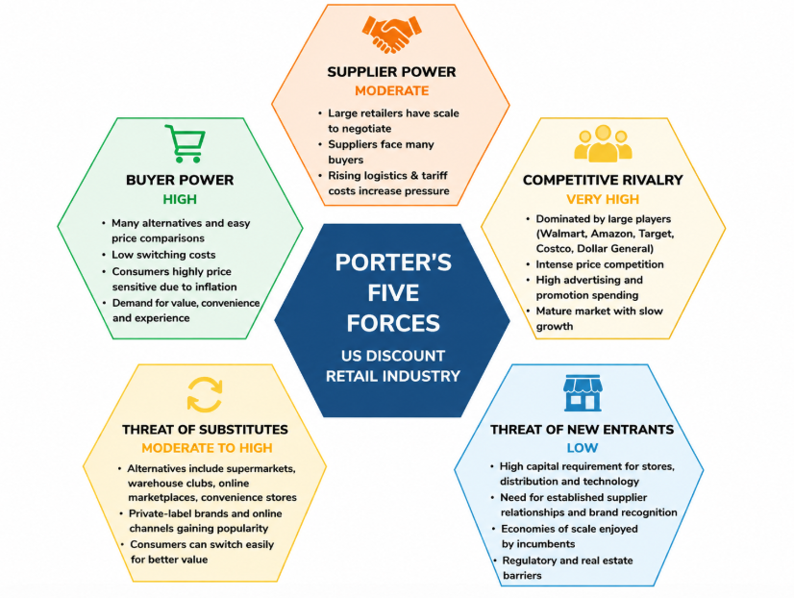
Figure 5: Porter's Five Forces Analysis of the US Value Retail Segment
Source: By Author, adapted from from Porter (1985)

Force | Assessment | Critical Evaluation
Competitive Rivalry | Very High | Led by huge retailers like Walmart (US$579.99bn), Amazon (US$293.85bn) and Costco (US$198.73bn). Dollar General reported US$43.13bn and a growth of 6.3%, showing the high competition and high economies of scale (National Retail Federation, 2026).
Buyer Power | High | Lower switching costs and greater price transparency gives consumers more bargaining power. The rise in inflation has led to increased demand for value retailers, forcing B&M to fight back with pricing, merchandising and product availability, not just price (Barron's, 2026).
Supplier Power | Moderate | Large retailers mitigate supplier influence by diversifying their sourcing and by purchasing in large quantities. Dollar General's two largest suppliers accounted for just 11% and 8% of purchases, respectively, indicating a lack of supplier dependence (Dollar General Corporation, 2026).
Threat of Substitutes | Moderate–High | Competition is growing due to consumers' ability to switch to supermarket, warehouse club, online market place and convenience stores.
Threat of New Entrants | Low | There are high capital costs, existing distribution channels, economies of scale and strong brand loyalty, which make it difficult to enter the market (Chenarides et al., 2024).

B&M value retail is moderately attractive overall, with strong consumer demand and favourable location advantages and high barriers to entry despite intense competition and tariff uncertainty. The results support the need for continued research on the foreign direct investment (FDI) potential of B&M using Dunning's Ownership, Location and Internalisation (OLI) Paradigm. The Dunning's OLI Paradigm is used to evaluate the market entry.

3.6 Market Entry Evaluation using Dunning's OLI Paradigm
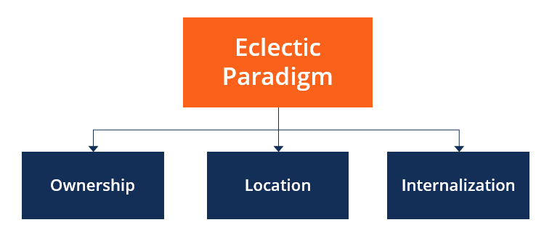
Figure 6: Dunning's OLI Paradigm
Source: (Dunning, 1988)
Dunning's Eclectic (OLI) Paradigm serves as a complete model for determining the best method for B&M's growth in the United States, which is foreign direct investment (FDI). The model suggests that companies are more likely to invest abroad when they have Ownership (O) advantages, can benefit from the favourable Location (L) advantages in the host country and can gain efficiency from Internalisation (I) advantages over other contractual arrangements (Dunning, 1988). The United States is a favourable country for B&M's long-term market entry strategy, based on the previous macro-environmental analysis, the country is good in all three aspects.

Ownership Advantages
B&M has a few attributes that are specific to its business that can be applied to the US market. The company's well-known brand reputation in value retailing combined with the successful cost leadership strategy allows it to sell branded and own label products at competitive prices without compromising on operational efficiency. The company's revenue for FY2026 was £5.78 billion, and the company has continued to expand its store network, which indicates financial strength and operational capability to support international expansion (B&M European Value Retail S.A., 2026).

Another key benefit to ownership is B&M's centralised procurement and buying process. The company can leverage from economies of scale in terms of multiple product categories and secure better supplier terms through large-scale purchasing. This is especially important in the US retail market where big box retailers are price and inventory competitive. In addition, the integrated supply chain, lean inventory management and a high stock turnover further optimise the operating costs, ensuring the availability of the product, which further strengthens B&M's competitive position. These are the firm-specific capabilities, which are not easily replicable by new entrants, and thus are sustainable ownership advantages as per Dunning's definition.
.
Location Advantages
The United States provides significant benefits to foreign investors that are location specific. The US Bureau of Economic Analysis (BEA) reported that in 2025, new foreign direct investment expenditure was US$232.2 billion, up 49.5% from 2024, and continuing to show investor confidence in the business environment in the United States. The total investment in acquisitions was US$218.4 billion and planned future expenditure was US$284.5 billion (US Bureau of Economic Analysis, 2026).

Further, there is a robust retail network in the country, making the market even more attractive. In 2026, US retail e-commerce sales increased by 9.8% year-on-year to US$326.7 billion, while online retail sales accounted for 16.9% of total retail sales (US Census Bureau, 2026). These numbers show the sophistication of the U.S. retail landscape, and indicate where B&M can use digital retail to complement its physical retail presence.

The United States also has extensive transportation networks, advanced distribution systems, and a large and highly trained workforce to enable inventory management and product delivery throughout the country. The retail sector is the country's biggest private employer, providing over 55 million jobs, which suggests that there are a wealth of retail employees and management who are up to the task. For long-term retail investment (National Retail Federation, 2026), the United States has many advantages, such as positive economic and cultural conditions mentioned in the previous sections.

Internalisation Advantages
The last part of the OLI Paradigm is the question of whether B&M should own and control its international operations or use licensing or franchising. The internalisation provides great strategic value as B&M's competitive edge relies on the uniformity of procurement processes, inventory management, pricing policies, and merchandising practices. Having direct operational control allows the company to safeguard its proprietary supplier relationships, maintain product quality and quickly adapt to consumer demand.

Internalisation would also enhance supply chain integration between sourcing, distribution and retail, minimising transactional cost with external partners and providing consistent implementation of B&M's value retail proposition. The direct ownership also helps to ensure brand consistency as it allows for a standard pricing policy, store design and service level throughout the markets. Operational control would also give B&M the flexibility to adapt to consumer tastes and preferences, optimise inventory, and enhance cost efficiency by aligning purchasing and logistics (Verbeke and Kano, 2023).

Overall OLI Assessment
Overall, Dunning's OLI Paradigm suggests that there is a high level of support for B&M's expansion strategy in the United States through foreign direct investment. The company has the cost leadership and procurement expertise and supply chain management transferable ownership advantages, and the United States has the large retail market, advanced infrastructure and investment environment as ownership advantages. The case is further reinforced by the possibility of internalisation which will allow B&M to have operational control, safeguard its competitive edge and provide a uniform value proposition. These benefits taken together make the United States an attractive market in which to directly enter and offer a solid theoretical basis for doing so in the next section.

4. Entry Mode Strategy and Strategic Synthesis

4.1 Historical Internationalisation Pattern
B&M's internationalisation development is very similar to the Uppsala Internationalisation Model, which proposes that companies grow into international markets by making small market commitments over time to gain experiential knowledge and to decrease uncertainty (Johanson and Vahlne, 2009). Instead of going for a quick international expansion in a number of countries, B&M first developed its own competencies in its home market before launching into the French market, geographically and institutionally similar to its own, with the acquisition of Babou in 2018. This step-by-step strategy allowed the company to roll out its value retailing concept without exposing itself to too many risks in the market.

The acquisition was not followed by a large-scale operational integration, but by a phased one. In FY2026, all of the former Babou stores were successfully rebranded as B&M France and the business grew to 150 stores. Moreover, B&M France recorded 2.9% like-for-like sales growth, and held a market share of 8.4% in the French discount market, as a result of its successful gradual internationalisation strategy in a competitive market (B&M European Value Retail plc, 2026).

This expansion pattern also lends to the Internalisation Theory, which states that firms will choose to keep control of foreign operations if internal control provides higher efficiency than contractual arrangements (Buckley and Casson, 2009). B&M has retained full ownership of its French business, ensuring control of its procurement, merchandising and supply chain coordination. This has resulted in B&M's internationalisation being characterised by incremental, high-control expansion, which gives the company a solid base for assessing an incremental, high-control move into the United States.

4.2 Evaluation of Alternative Entry Modes
The choice of entry mode is critical as it will affect the degree of investment, control, risk and future competitiveness of internationalization. In recent years, the literature on entry mode suggests that the choice of entry mode should be determined not by a uniform strategy but rather be aligned with the organisational capabilities, host country conditions and strategic objectives of the firms (Wan et al., 2023). In light of B&M's value retailing approach, the potential alternative entry modes may be assessed as follows.

Entry Mode | Investment | Risk | Control | Speed | Strategic Suitability for B&M
Exporting | Low | Low | Low | High | Not feasible because of logistics costs and low-margin products.
Licensing | Low | Low | Low | High | Poor brand and merchandising management.
Franchising | Low–Moderate | Moderate | Moderate | High | Hard to ensure the same prices and standards in stores.
Joint Venture | Moderate | Moderate | Shared | Moderate | Lacks strategic autonomy is restricted and provides local expertise.
Acquisition | High | Moderate | High | High | Most appropriate; ready to use and control in the market.
Greenfield Investment | High | High | High | Low | Appropriate for long-term growth, but slower market entry.

Acquisition is the most appropriate equity-based entry mode for B&M for the following reasons: B&M will gain instant access to the existing stores, supplier networks, local knowledge and experienced staff, and at the same time retain a high level of operational control. The literature indicates that acquisitions are especially successful when firms are looking to quickly enter a market and acquire strategic assets in developed markets (Dikova, Sahib and Van Witteloostuijn, 2022). This is further supported by recent restructuring in the value retail market in the United States. B&M could go after the regional retailers, like Ocean State Job Lot (170+ stores) or Gabe's (140+ stores in 20 states) that have a similar value proposition to B&M. Furthermore, with the restructuring of Big Lots, Variety Wholesalers was able to buy 200-400 stores and up to two distribution centres, which would provide B&M with acquisition opportunities similar to its French Babou acquisition (Big Lots, 2025).

4.3 Recommended Entry Mode
From the above analyses, it can be concluded that acquisition is the best entry mode for B&M to expand in the United States due to its level of investment, operational control, speed of implementation and competitiveness in the long term (Dikova, Sahib and Van Witteloostuijn, 2022).
- The ownership advantages that OLI Paradigm: B&M has is its procurement expertise, value retail proposition and operational efficiency, whereas the location advantage of the US is its market size, retail infrastructure and consumer demand. The other major benefit of full ownership is the internalisation benefit that B&M can retain their own procurement systems, pricing strategy and merchandising capabilities through direct operational control (Buckley, 2026; Strange, 2026).
- Historical internationalisation: B&M's successful acquisition and integration of Babou prove its ability to deal with internationalisation of acquisitions and to transfer the operating model. This would lower the risk of implementation and speed up market penetration in the US.
- US market conditions: the retail market in the USA is very competitive and fast market entry and immediate access to existing stores, supplier networks and experienced employees are required. The literature shows that the preference of direct retail FDI by multinational retailers is more suitable than exporting or licensing or franchising, as the research suggests that the former is used to build brand control and to create value in the long term (Herz and Thomson, 2025).

4.4 Strategic Recommendations
B&M should adopt a gradual approach to its expansion in the U.S. that is consistent with their cost leadership strategy and recommended entry mode for acquisition.
- Supply chain localisation: After the acquisition, B&M should focus on building a regional distribution centre and connecting local suppliers to its global supply chain to create a more resilient and technology-driven supply chain. This will help in improving the inventory replenishment and lower the logistics costs. This is supported by 66% of retailers saying they will redesign their supply chains and 59% saying they will see positive returns from supply chain initiatives powered by AI, highlighting the critical role of resilient and digitally-enabled retail operations (Deloitte, 2026).
- Digital strategy and phased rollout: B&M should start with a gradual rollout in specific markets in the US where there is demand for value retailing and then gradually expand across the country. At the same time, it must be able to be omnichannel, with click-and-collect, real-time visibility and personalised promotions. According to PwC (2026), AI-powered retail technologies and omnichannel integration are emerging as key differentiators for retailers in established markets.
- Risk management and human resources: B&M needs to diversify its suppliers, add currency hedges and improve regulatory compliance, with the recruitment of experienced US retail managers, with structured knowledge transfer from the UK and French operations. Other key factors cited by the National Retail Federation (2026) for retail competitiveness are operational resilience and workforce capability and technology adoption.

Section 2: Reflection

5. Gibbs' Reflective Cycle

5.1 Description
As part of the preparation of this report, I critically assessed the viability of B&M European Value Retail plc in the United States as a new international market. Instead of a descriptive report, I used a structured research process to analyse B&M's international strategy, the macro-environment in the USA, industry attractiveness and alternative methods of entering the market before making a recommendation for the best international strategy. I used Bartlett and Ghoshal's International Strategy Framework, the Integration–Responsiveness Grid, PESTLE, Hofstede's Cultural Dimensions, Porter's Five Forces, Dunning's OLI Paradigm and the Uppsala Model and Internalisation Theory to analyse various aspects of the market entry decision. Gibbs' Reflective Cycle helped me to reflect on the learning process that contributed to my understanding of the assignment throughout as well as the final outcome of the assignment (Gibbs, 1988).

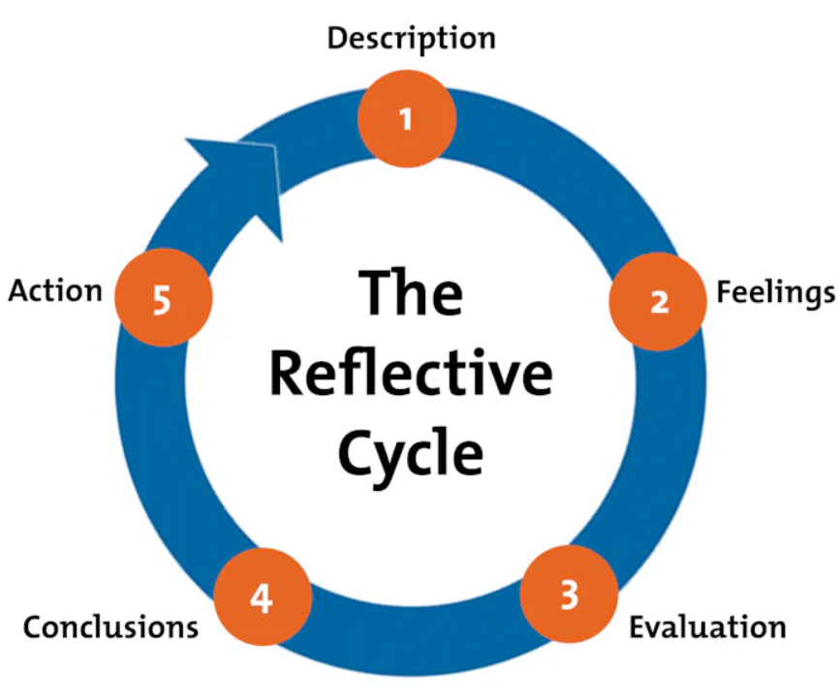
Figure 7: Gibbs' Reflective Cycle
Source: Simply Psychology (2024).

5.2 Feelings
Initially, I was confident with the understanding of the concepts of international business, but not so confident in my ability to select the most suitable framework and apply it to a real organisation in a critical manner. At first, it was hard to see the difference between frameworks that analyse the external environment and frameworks that justify market entry decisions. As I progressed, I recognised how the theories complemented one another. PESTLE and Porter's Five Forces were used to evaluate the attractiveness of the US market, while Dunning's OLI Paradigm and Internalisation Theory were used to recommend the acquisition as the preferred entry mode. This experience gave me more confidence in using theory in real world decisions in international business.

5.3 Evaluation
Overall, I believe the research process was successful because it helped me develop a clear and evidence-based market entry strategy. One of its main strengths was the use of recent academic journals, company reports, government publications and industry reports, which made the analysis more reliable. I also made sure that each framework had a different purpose instead of repeating the same points. For example, PESTLE was used to analyse the US business environment, Porter's Five Forces assessed industry attractiveness, and the OLI Paradigm supported the recommendation of acquisition as the most suitable entry mode. This approach made the report more structured and analytical.

But there were problems as well. The U.S. retail landscape is constantly evolving and finding accurate and up-to-date information can be challenging. To get around this, I used evidence from several reliable sources to reach conclusions. Another difficulty was to refrain from descriptive writing. The process of revising the report led me to further reinforce the relationships between theory and evidence and strategic recommendations, which led to a more critical discussion that better fulfilled the assessment requirements (Aguinis, Bergh and Molina-Azorín, 2023).

5.4 Analysis
This assignment helped me to better understand the importance of combining international business theories to assist in strategic decision making instead of using them separately. I realised that the choice of a suitable framework was related to the purpose of analysis. The international strategy of B&M was analysed using Bartlett and Ghoshal's framework, and PESTLE and Porter's Five Forces were used to determine whether the United States offered a conducive environment for expansion. It was then argued that acquisition was the most appropriate market entry strategy based on Dunning's OLI Paradigm and the Uppsala Model and Internalisation Theory. The application of these frameworks in sequence allowed me to build up a coherent argument with theory and evidence that was not disconnected analyses as described by Johanson and Vahlne (2009).

Another significant learning outcome was the need to use a systematic research approach. The findings were based mainly on peer-reviewed journals, official company reports, government publications and recognised industry reports to ensure that the findings were current and credible. Comparing information from various sources also helped me to develop skills in assessing conflicting ideas before making decisions.

The lectures and module content (International Business Concepts - LCMB7034) emphasized the need to learn and apply concepts in relation to managerial decision making rather than to describe concepts as stand-alone units. Thus, I concentrated on the explanations of how each framework helped B&M to pursue its cost leadership strategy and expand into the U.S. market. This helped build my confidence in using academic knowledge to solve business problems and develop my research, analytical and critical thinking skills. It also showed that reflective practice can facilitate continuous learning and professional development, as it allows for a critical examination of strengths as well as areas for improvement (Mohamed, Rashid and Alqaryouti, 2022).

5.5 Conclusion
Overall, this assignment reinforced my knowledge on the application of international business theories to assess market entry decisions and the most appropriate market entry mode – acquisition. It illustrated the importance of using the right analytical tools, critically assessing evidence, and making recommendations that are suitable to the organisation's capacities to expand internationally. The reflection also emphasized the need to consult reliable sources, to use theory in the analysis, and to have a critical approach to research throughout the process. As a result, I have become more confident in analysing the international market and in providing evidence-based strategic recommendations. Reflective learning has also helped me to apply academic knowledge to future professional practice (Alt, Raichel and Naamati-Schneider, 2022).

5.6 Action Plan
This assignment has revealed to me a number of areas that I plan to focus on in my future research in international business.
- First, I'll develop the skills to compare and contrast the various theories before deciding on the one that suits the business situation.
- Second, I will expand the use of a variety of recent peer-reviewed journals, government publications and industry reports to enhance the quality and reliability of evidence. I will also be working on my critical writing, being more involved in analysing the implications of the findings, than in describing information.
- Lastly, I will further develop my knowledge of the international market entry strategies through increased interaction with lectures, case studies and academic literature. In the future, as I continue with academic and professional writing, I will be able to write more rigorous and strategic analyses as a result of these actions (Alt, Raichel and Naamati-Schneider, 2022).

References
Aguinis, H., Bergh, D.D. and Molina-Azorín, J.F. (2023) ‘Methodological challenges and insights for future international business research’, Journal of International Business Studies, 54(2), pp. 219–232.
Alt, D., Raichel, N. and Naamati-Schneider, L. (2022) ‘Higher Education Students’ Reflective Journal Writing and Lifelong Learning Skills: Insights from an Exploratory Sequential Study’, Frontiers in Psychology, 12, 707168. Available at: https://doi.org/10.3389/fpsyg.2021.7071681/
B&M European Value Retail plc (2026) At a Glance. B&M European Value Retail Plc. Available at: https://www.bandmretail.com/about-us/at-a-glance
B&M European Value Retail S.A. (2026) Annual Report and Accounts 2026. Luxembourg: B&M European Value Retail S.A. Available at: https://staticcontents.investis.com/html/b/bandmretail/annual-report-2026.xhtml
Barron's (2026) Retail earnings season could be the messiest yet. Available at: https://www.barrons.com/articles/retail-earnings-walmart-target-dollar-general-five-below-94b548e5
Bartlett, C.A. and Ghoshal, S. (1989) Managing Across Borders: The Transnational Solution. Boston, MA: Harvard Business School Press.
Big Lots, Inc. (2025) Big Lots Closes Sale to Gordon Brothers Retail Partners. Available at: https://www.sec.gov/Archives/edgar/data/768835/000076883525000002/ex991pressrelease_biglot.htm
Buckley, P.J. (2026) ‘The future of the multinational enterprise: An appreciation and an assessment’, International Business Review, 35(4). DOI: https://doi.org/10.1016/j.ibusrev.2026.102598.
Buckley, P.J. and Casson, M.C. (2009) ‘The internalisation theory of the multinational enterprise: A review of the progress of a research agenda after 30 years’, Journal of International Business Studies, 40(9), pp. 1563–1580.
Bureau of Economic Analysis (2026) New Foreign Direct Investment in the United States, 2025. Available at: https://www.bea.gov/news/2026/new-foreign-direct-investment-united-states-2025
Chenarides, L., Gómez, M.I., Richards, T.J. and Yonezawa, K. (2024) ‘Retail markups and discount-store entry’, Review of Industrial Organization, 64(1), pp. 147–181. Available at: <https://doi.org/10.1007/s11151-023-09926-w
Deloitte (2026) 2026 Retail Industry Global Outlook. Available at: https://www.deloitte.com/us/en/insights/industry/retail-distribution/retail-distribution-industry-outlook.html
Deloitte (2026) Retail and Consumer Trends 2026: Human-led intelligence. Available at: https://www.deloitte.com/uk/en/Industries/consumer/perspectives/retail-trends.html
Deloitte Digital (2026) B2C commerce research: Bridging the commerce divide. Available at: https://www.deloittedigital.com/us/en/insights/research/b2c-commerce-experiences.html
Dikova, D., Sahib, P.R. and Van Witteloostuijn, A. (2022) ‘Cross-border acquisition or greenfield entry? A meta-analysis of foreign establishment mode choice’, Journal of International Business Studies, 53(8), pp. 1453–1482.
Dollar General Corporation (2026) Annual Report 2025 (Form 10-K). Available at: https://www.sec.gov/Archives/edgar/data/29534/000110465926032325/dg-20260130x10k.htm
Dunning, J.H. (1988) 'The Eclectic Paradigm of International Production: A Restatement and Some Possible Extensions', Journal of International Business Studies, 19(1), pp. 1–31.
Gabe's (2026) About Gabe's. Available at: https://gabesstores.com/about-gabes/
Gibbs, G. (1988) Learning by Doing: A Guide to Teaching and Learning Methods. Oxford: Oxford Polytechnic.
Herz, B. and Thomson, R. (2025) ‘Retail Foreign Direct Investment by Brand Manufacturers’, Journal of Economics & Management Strategy. DOI: https://doi.org/10.1111/jems.70018.
International Monetary Fund (2026) IMF Executive Board Concludes 2026 Article IV Consultation with the United States. Available at: https://www.imf.org/en/news/articles/2026/04/01/pr-26102-usa-imf-executive-board-concludes-2026-article-iv-consult
Johanson, J. and Vahlne, J.-E. (2009) ‘The Uppsala internationalization process model revisited: From liability of foreignness to liability of outsidership’, Journal of International Business Studies, 40(9), pp. 1411–1431.
Minkov, M. and Kaasa, A. (2022) ‘Do dimensions of culture exist objectively? A validation of the revised Minkov–Hofstede model of culture with World Values Survey items and scores for 102 countries’, Journal of International Management, 28(4), 100971.
Mohamed, M., Rashid, R.A. and Alqaryouti, M.H. (2022) ‘Conceptualizing the complexity of reflective practice in education’, Frontiers in Psychology, 13, 1008234.
National Retail Federation (2026) NRF forecasts 4.4% annual retail sales growth with new economic model. Available at: https://nrf.com/media-center/press-releases/nrf-forecasts-4-4-annual-retail-sales-growth-with-new-economic-model
National Retail Federation (2026) NRF Releases 2026 Top 100 Retailers. Available at: https://nrf.com/media-center/press-releases/nrf-releases-2026-top-100-retailers
National Retail Federation (2026) Retail policy priorities for 2026. Available at: https://nrf.com/blog/6-retail-policy-priorities-for-2026
National Retail Federation (2026) Retail Supports More Than 55 million American Jobs. Available at: https://nrf.com/media-center/press-releases/retail-supports-more-than-55-million-american-jobs
National Retail Federation (2026) What retail and industry leaders are watching in 2026. Available at: https://nrf.com/blog/what-retail-and-industry-leaders-are-watching-in-2026
Ocean State Job Lot (2026) About Ocean State Job Lot. Available at: https://about.oceanstatejoblot.com/
OECD (2024) OECD Investment Policy Reviews: United States 2024. Paris: OECD Publishing. Available at: https://www.oecd.org/investment/
Porter, M.E. (1985) Competitive Advantage: Creating and Sustaining Superior Performance. New York: Free Press.
Pudelko, M. (2023) ‘Global Integration versus Local Responsiveness’, in Global Strategy and Organizational Design. Abingdon: Routledge
PwC (2026) Retail's Big Show 2026: The Industry Embraces AI. Available at: https://www.pwc.com/us/en/industries/consumer-markets/nrf-2026.html
Simply Psychology (2024) Gibbs' Reflective Cycle. Available at: https://www.simplypsychology.org/gibbs-reflective-cycle.html
Strange, R. (2026) ‘The future of the multinational enterprise: An appreciation and an assessment’, International Business Review, 35(4). DOI: https://doi.org/10.1016/j.ibusrev.2026.102598.
The Culture Factor Group (2026) Country comparison tool: United Kingdom and United States. Available at: https://www.theculturefactor.com/country-comparison-tool?countries=united+kingdom%2Cunited+states
United States Census Bureau (2026) Quarterly Retail E-Commerce Sales: First Quarter 2026. Available at: https://www.census.gov/retail/ecommerce.html
United States Trade Representative (2026a) USTR Takes Action in Forced Labor Section 301 Investigations. Available at: https://www.ustr.gov/about/policy-offices/press-office/press-releases/2026/july/ustr-takes-action-forced-labor-section-301-investigations
United States Trade Representative (2026b) USTR Makes Findings and Proposes Action in 60 Section 301 Investigations Relating to Failures to Take Action on Trade in Forced Labor Goods. Available at: https://ustr.gov/about/policy-offices/press-office/press-releases/2026/june/ustr-makes-findings-and-proposes-action-60-section-301-investigations-relating-failures-take-action
US Bureau of Economic Analysis (2026) New Foreign Direct Investment in the United States, 2025. Washington, DC: US Department of Commerce. Available at: https://www.bea.gov/news/2026/new-foreign-direct-investment-united-states-2025
Verbeke, A. and Kano, L. (2023) ‘Theories of the multinational enterprise: Evolution, contributions and future directions’, Journal of International Business Studies, 54(6), pp. 1033–1052.
Wan, C., Sousa, C.M.P., Lengler, J. and Tan, Q. (2023) ‘Entry mode choice: A meta-analysis of antecedents and outcomes’, Management International Review, 63(2), pp. 193–246. Available at: https://link.springer.com/article/10.1007/s11575-022-00499-6

