Ioana Avramescu
Cheltenham, Gloucestershire
07300 21 85 35
2514739@student.uwtsd.ac.uk

SUMMARY

Motivated, solution focused mindset and results-oriented professional with a proven ability to take ownership of tasks, support colleagues, and drive team success. Experienced in mentoring new starters, coordinating workflows, and ensuring high quality outcomes in fast paced environments.

KEY COMPETENCIES

- Excellent organizational skills
- Strong interpersonal skills
- Great communication skills
- Team player
- Perseverance and motivation
- Delivery coordination
- Fostering positive workplace relationships
- Responsiveness and adaptation to new
- Self-motivated
- Good drive to complete tasks
- Upbeat and energised
- Ability to organise work duties in a timely fashion

PROFESSIONAL EXPERIENCE

Spirax Sarco, Cheltenham, Global Supply Chain, May 2024 - Present

Goods Inwards Inspector
Collaborated closely with all the departments (stores, purchasing, goods in, planning and engineering teams) to ensure timely release of goods for production/customers.
Maintained accurate inspection records, logs and reports to support quality management systems
Supported continuous improvement initiatives and contributed to a culture of quality and compliance within the supply chain
Carried out inspection of incoming goods, materials and components against purchase orders, drawings, and quality specifications.
Checked and verified supplier documentation (3.1 Certs, CofC’s, material test reports etc)
Identified, documented, and reported non-conformances; liaised with suppliers and internal departments to resolve quality issues
Used measuring tools and equipment (e.g. calipers, micrometers, gauges, PMI gun, Faro Arm) to perform dimensional checks Ensured correct labelling, traceability, and handling of goods in accordance with company and regulatory requirements

Spirax Sarco, Cheltenham, Global Supply Chain, Nov 2018 - May 2024

Logistics Coordinator

Highly organised, problem solving, detail oriented and determined logistics operative interacting closely with different departments to achive delivery of excellence service to customers and company
Ensuring orders are entered and monitored, goods are packaged and dispatched on time and incoming shipments are re-stocked promptly and accurately
Using Enterprise Resource Planning System (ERP)
Booking in all goods received, making sure all paperwork is accurate
Liasing with third party logistics (3PL) companies/material planners and customers regarding deliveries and order enquiries
Attending Teams meetings with other departments to ensure highest level of service and support to our customers Great time management
Excellent administrative and organisational skills
Maintain stock integrity (support stock take, cycle counting per plan) Comply at all times with the Health and Safety standards and procedures.

Wavin, Chippenham, Nov 2013 - Oct 2018

Quality Control / Trainer / Assembly Operator

Communicate duties to the new employee, identifying each core task and demonstrating how to complete it, in a simple and professional way
Inspect, test and sample materials or assembled parts or products for defects and deviations from specifications, observe and monitor production operations and equipment
Involvement in continuous improvement programme within department
5 S daily routine
Make or offer suggestions on changes to improve the manufacturing process
Excellent hand-eye coordination and physical condition Time management

EDUCATION & CERTIFICATIONS

Business Skills for The Workplace, University of Wales Trinity Saint David, Birmingham - started 2025
Romanian American University, Economics, Bucharest 2006-2009
Economic College, The Economy of Tourism, 2002-2006
Safety Leadership at Work Course Cert - Spirax Sarco UK
Forklift Certificate, Spirax Sarco UK
First Aid Certificate, Spirax Sarco UK
Excel Course, Spirax Sarco UK
Fire Coordinator Training, Spirax Sarco UK
Introduction to Steam Technology Course, Spirax Sarco UK

Job Advert:

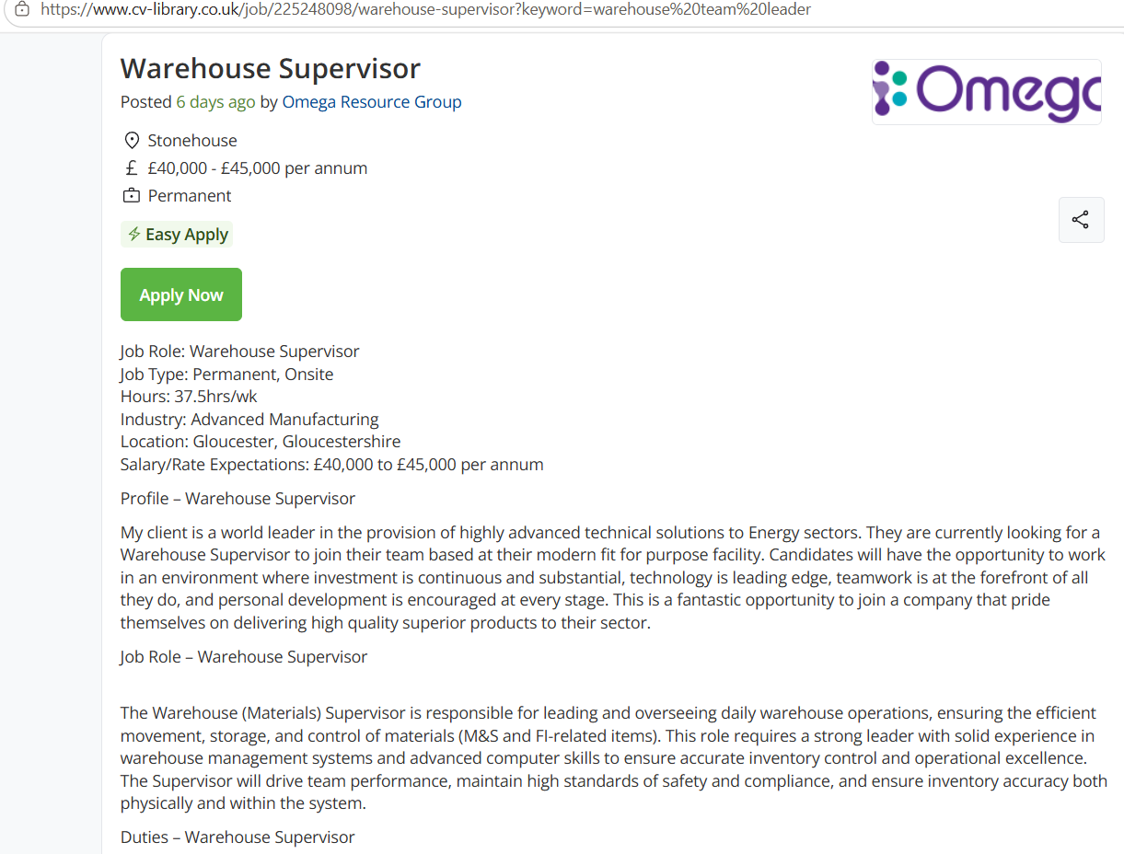
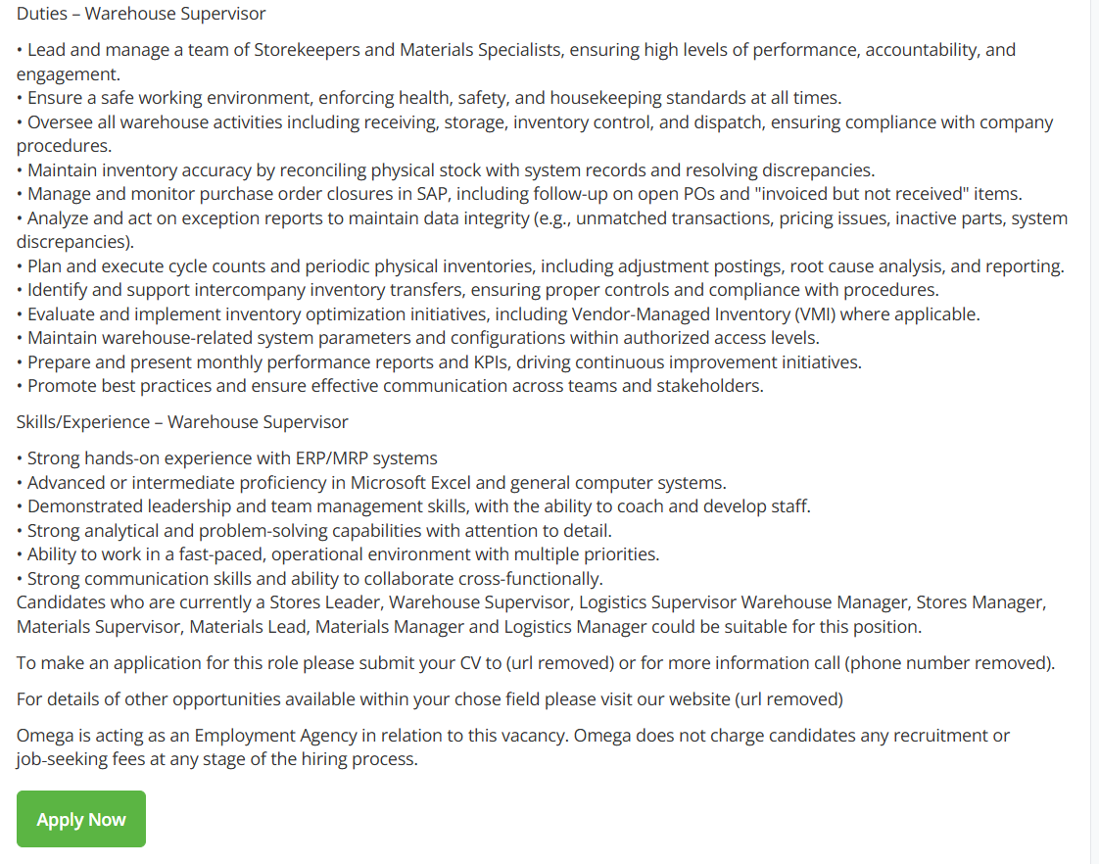
Cover Letter

Dear Hiring Manager,

I am excited to apply for the Warehouse Supervisor role, with strong experience, from Spirax Sarco and Wavin, in logistics coordination, fast-paced warehouse operations and goods in quality inspection.
I ensured smooth material flow, maintained accurate system records, inspecting incoming deliveries, giving me soring knowledge of inventory stock accuracy and traceability processes.
I am confident that my strong work ethic, attention to detail, my experience and commitment to maintaining high standards position me as a strong candidate for this role.

Yours sincerely,
Ioana Avramescu

